Aryan Behal

2019026

CN Assignment-2

-------------------------------------------------------------------------------------------------------------

Ans 1. Commands for Server: gcc -pthread tcpServer.c -o tcpServer

./tcpServer

Commands for Client: gcc -pthread tcpClient.c -o tcpClient

timeout 120s ./tcpClient (for 2min)

🡪For .pcap file for Wireshark

sudo tcpdump -i lo port 4444 -s 65535 -w socket_capture.pcap

🡪 Filtered data from server using wireshark and export file as csv file

🡪 Ran python script to generate graph.

Graph

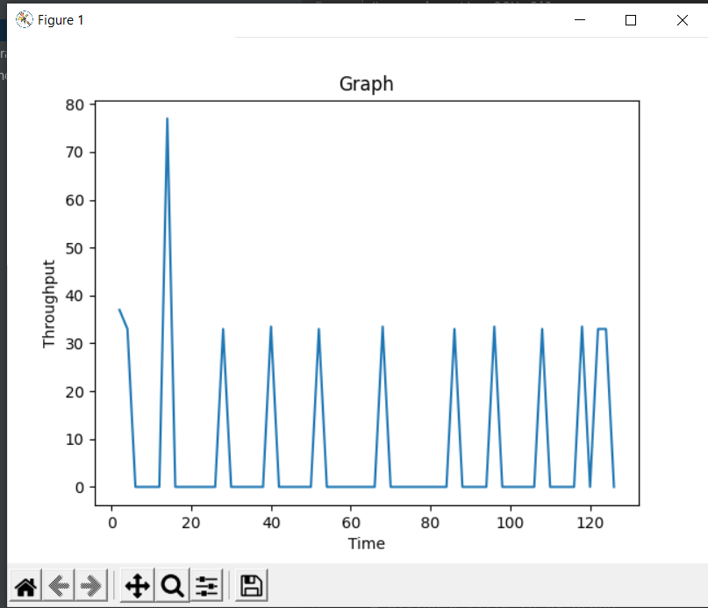

Ans 2.

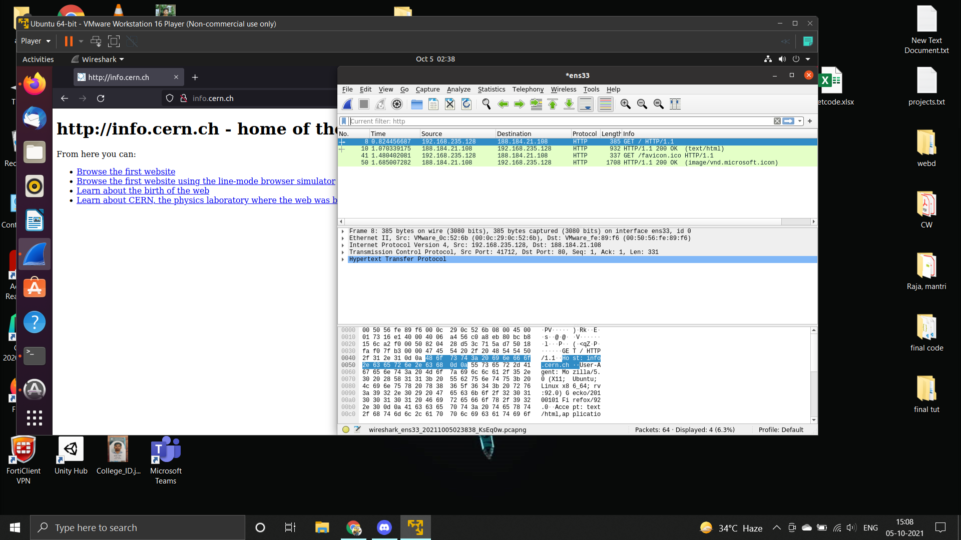

---------------

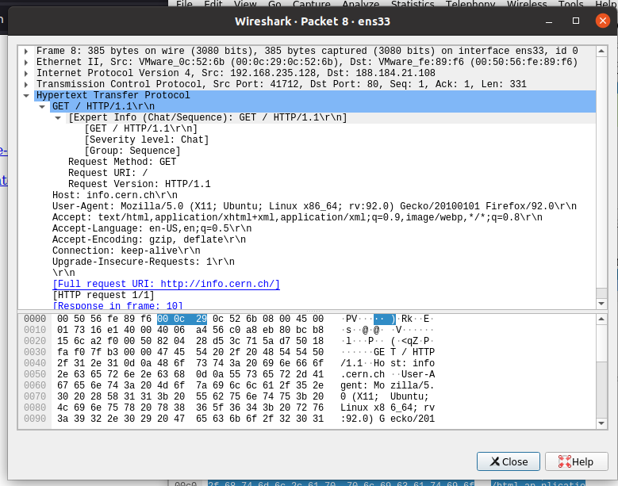

1. HTTP Request
   * Request Type: GET
   * User Agent: Mozilla/5.0 (X11; Ubuntu; Linux x86_64; rv:92.0) Gecko/20100101 Firefox/92.0
   * Full request URI: http://info.cern.ch/

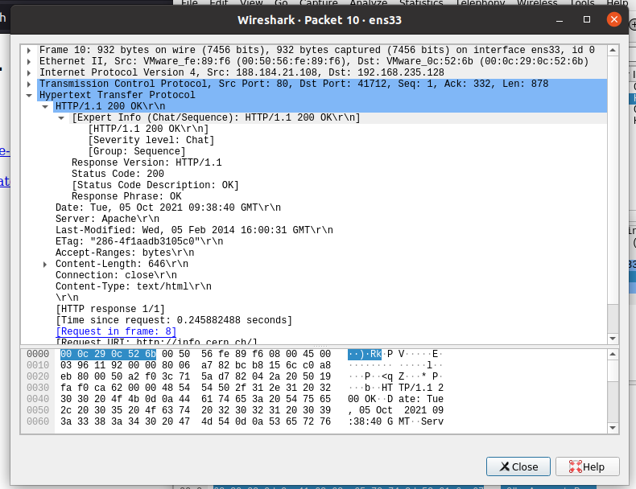

1. HTTP Response
   * Response Code: 200
   * Response description: OK
   * Name and version of Web Server: Apache

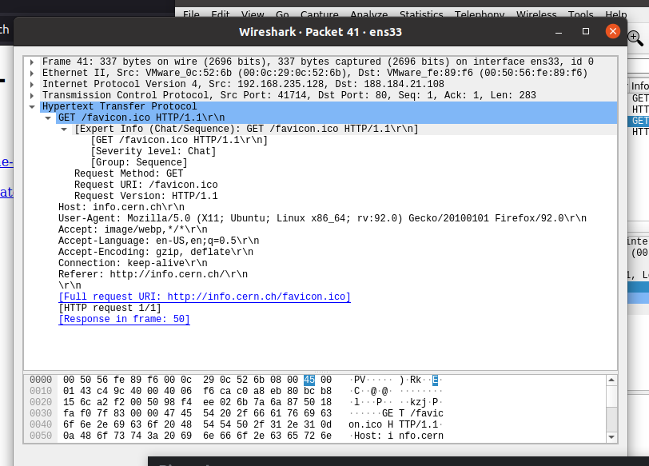

1. HTTP Request
   * Request Type: GET
   * User Agent: Mozilla/5.0 (X11; Ubuntu; Linux x86_64; rv:92.0) Gecko/20100101 Firefox/92.0
   * Full request URI: <http://info.cern.ch/favicon.ico>

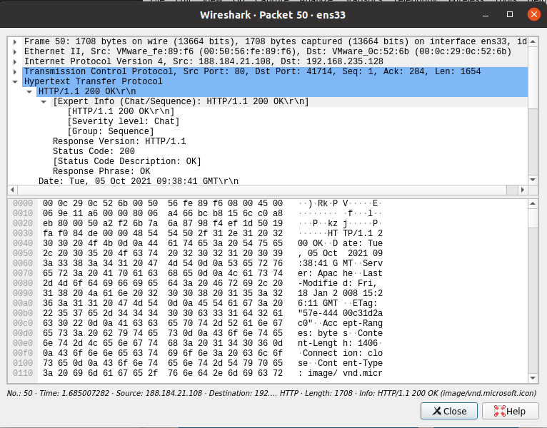

1. HTTP Response
   * Response Code: 200
   * Response description: OK
   * Name and version of Web Server: Apache

-------------

Ans 3

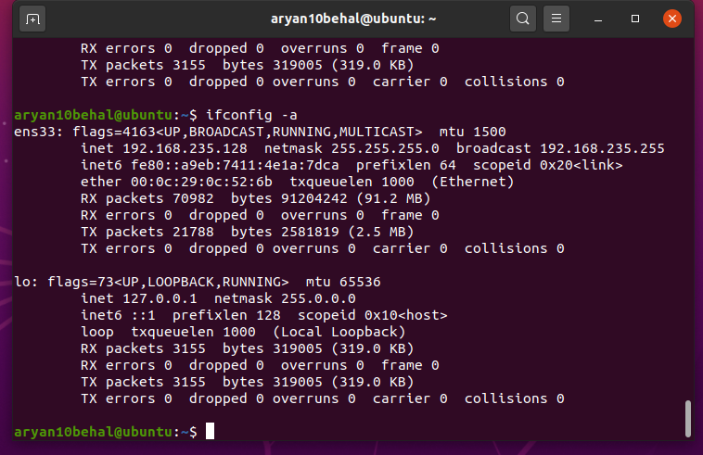

IP address here: 192.168.235.128 (inet)

-----------

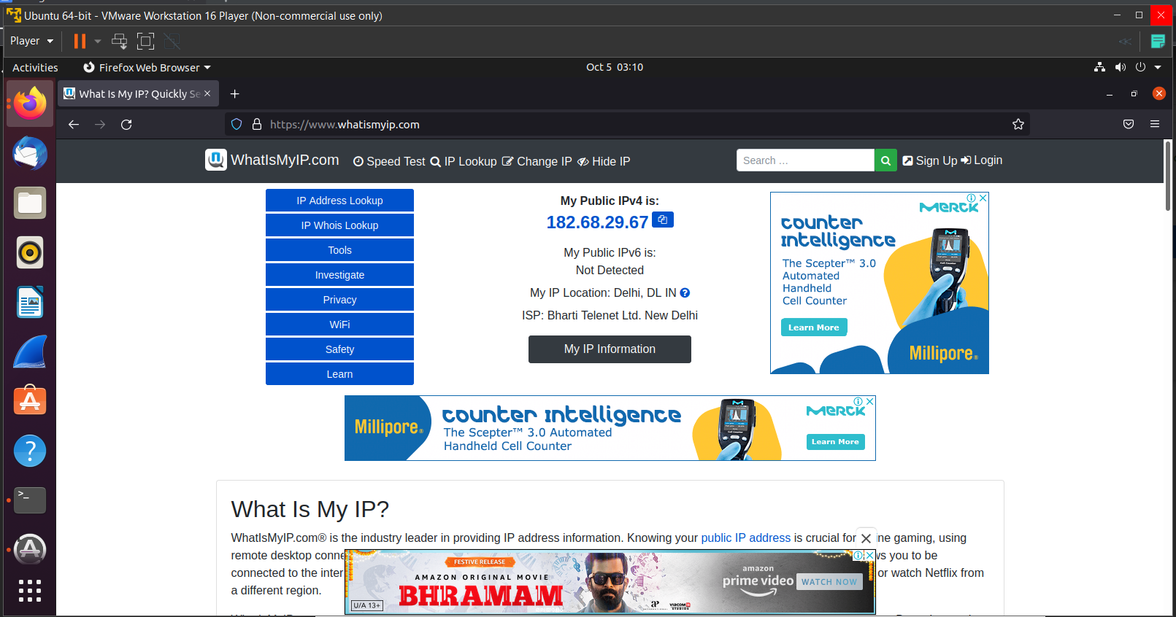

IP address (on site): 182.68.29.67

The 2 IP addresses are different. The IP address given by ifconfig was the private IP address of my system whereas the IP address on the site is the public IP address. This public IP is assigned to my wi-fi connection. When I search my IP even on my phone connected to wi-fi, public IP stays the same as long as I am using wi-fi. But private IP is different. When I connect to my mobile network, my public IP also changes.

--------------

Ans 4) a)

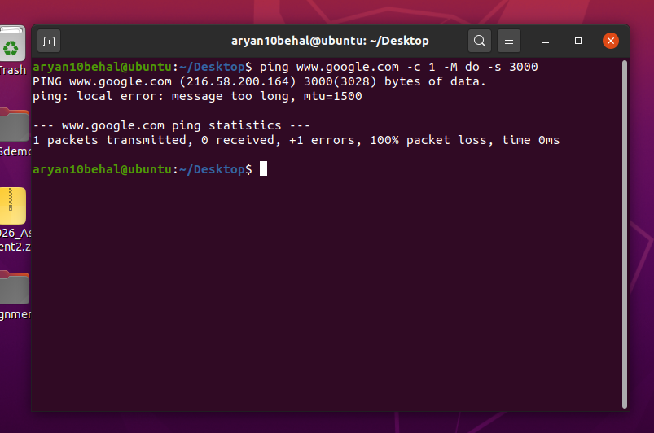

The command is “ping [www.google.com](http://www.google.com) -c 1 -M do -s 3000”. The command failed because we can send packet of max size of 1500 bytes (as mtu = 1500) but we tried to send 3000 bytes packet which will result in 100% packet loss

b)

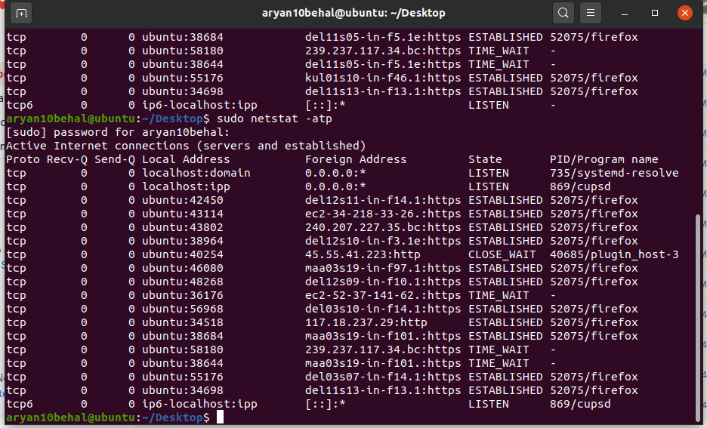

-----------

Ans 5)

* Non-Authoritative

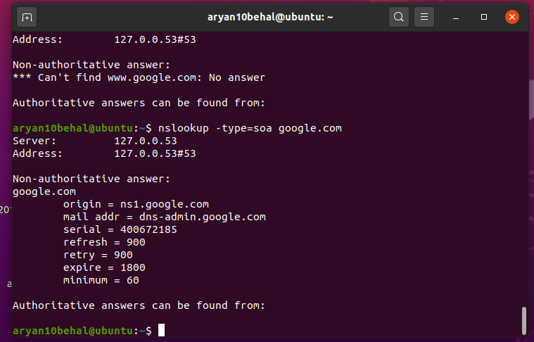

* Authoritative

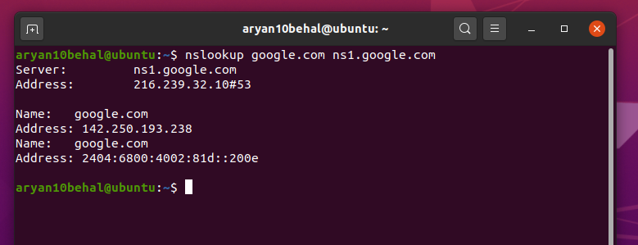

First, I found origin using nslookup from non-authoritative response then ran the 2nd command with the origin found to get authoritative result.

b)

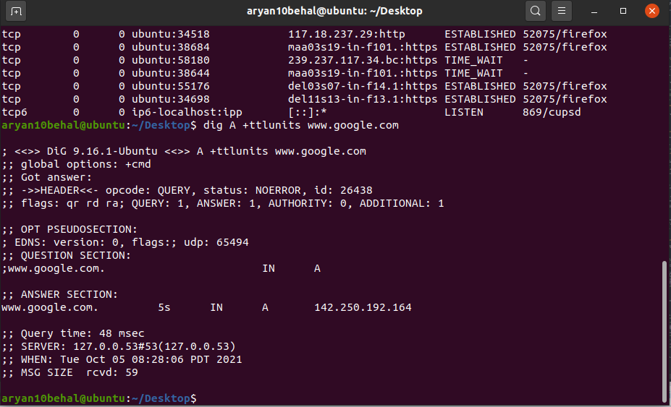

* Time to live for “google.com” on the local DNS = 5 sec and this entry would expire after 5 sec.

Ans 6) Done on Windows

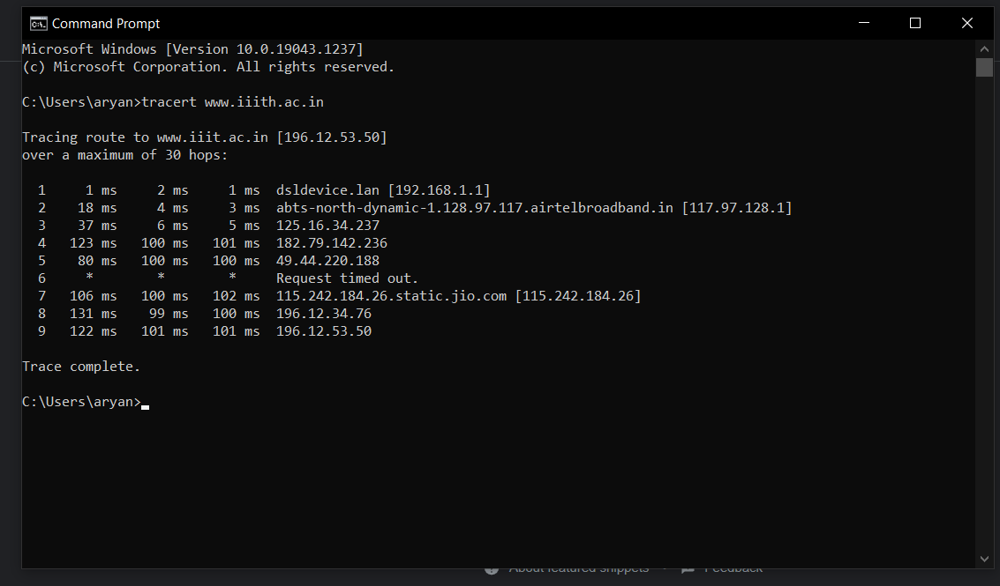

1. I can see 9 intermediate hosts. 1 of them failed to reply to our request.

|  |  |
| --- | --- |
| Ip ADdress | Average Latency |
| 192.168.1.1 | 1.33 ms |
| 117.97.128.1 | 8.33 ms |
| 125.16.34.237 | 16ms |
| 182.79.142.236 | 108ms |
| 49.44.220.188 | 93.33ms |
| Request timed out. | - |
| 115.242.184.26 | 102.66ms |
| 196.12.34.76 | 110ms |
| 196.12.53.50 | 108ms |

b) Average Latency = 118ms

Command used: ping -n 100 www.iiith.ac.in

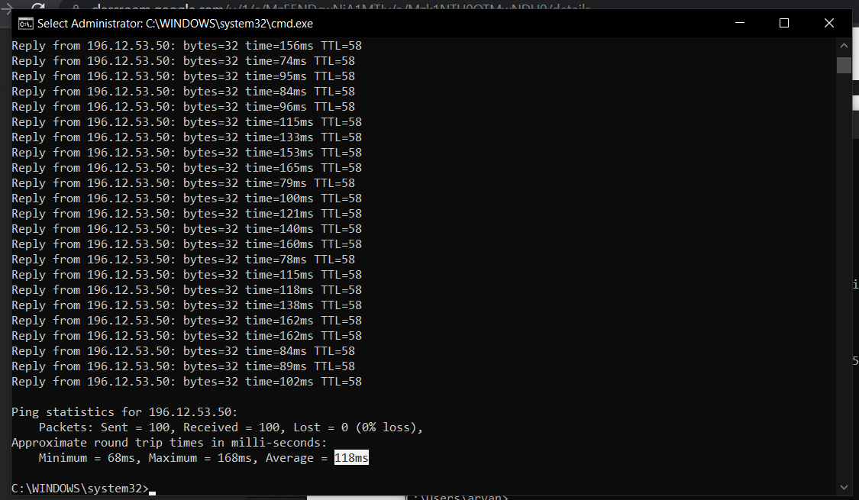

c) Command use: ping -n 100 [IP address]

1. 192.168.1.1

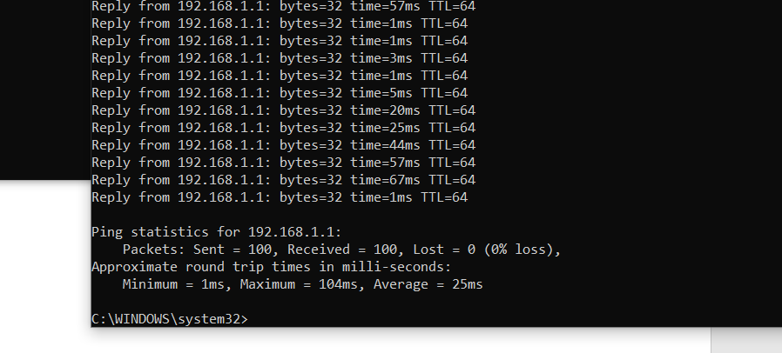

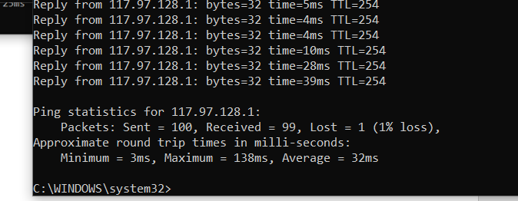

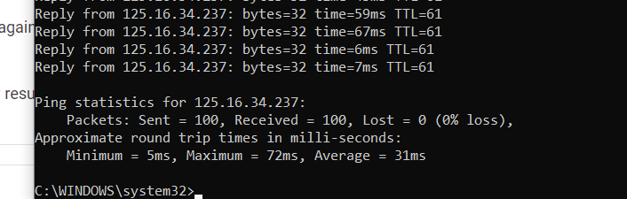

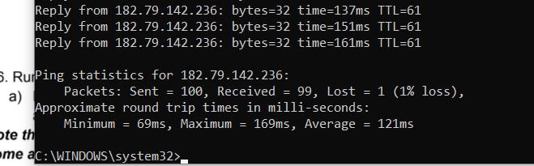

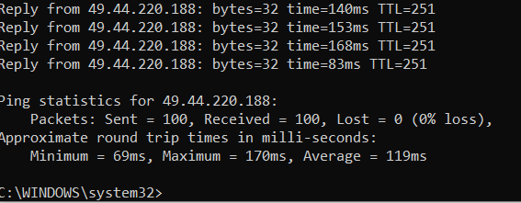

1. Did not respond

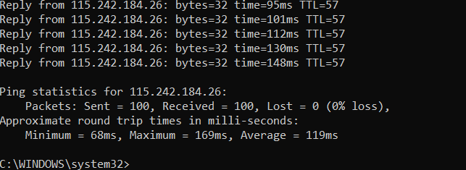

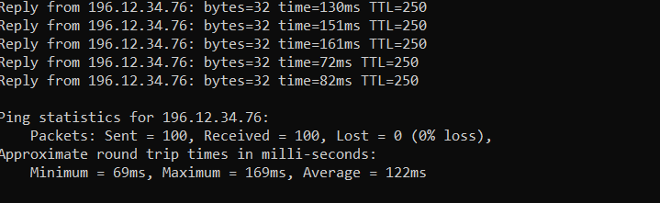

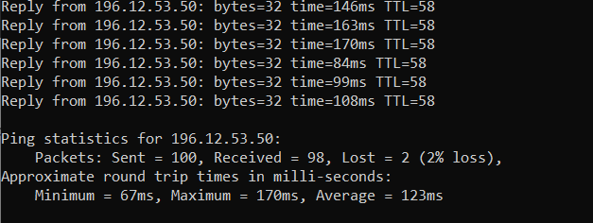

Sum of all average Latencies = 25 + 32 + 31 + 121 + 119+ 119+122 + 123 = 692ms.

To reach the final IP address, we need to go through all the intermediate locations. So, getting to any intermediate host, we need to go through all the previous intermediates. So, the times are getting added again and again. It is similar to going from 0 to X, we can either go from 0->1, 1->2, …..., X-1-> X as in Q2 but in Q3 we are moving like 0->1->0, 0->1->2->1->0 and so on. So, we are going back and forth again and again which results in extremely large value for the sum.

d) Averages (From C)

1. 25ms

2. 32ms

3. 31ms

4. 121ms

5. 119ms

6. No response

7. 119ms

8. 122 ms

9. 123 ms

Max of averages = 123ms. Maximum of averages will be comparable to average found in Q2 (118ms). This is because here we are not adding the times. Average time for intermediates will increase as we move away from the source. The intermediate near to the destination will have approximately similar time as for destination as we have almost reached the destination. The path will more often than not stay the same so average time will stay the same.

(In both c) and d), I am assuming the most efficient path will stay more or less the same until and unless any severe thing happens)

e)

1) 192.168.1.1

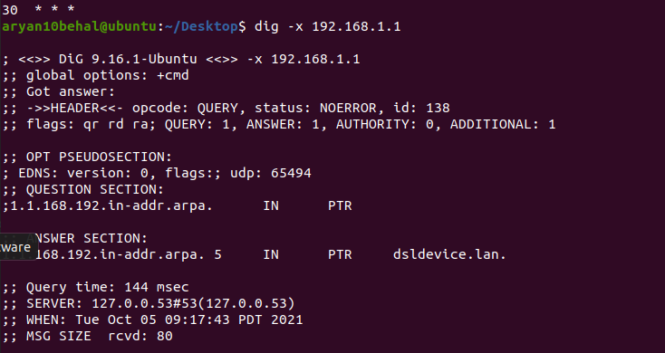

Name: dsldevice.lan.

2.



Name: abts-north-dynamic-1.128.97.117.airtelbroadband.in.

3) 125.16.34.237

No Name

4) 182.79.142.236

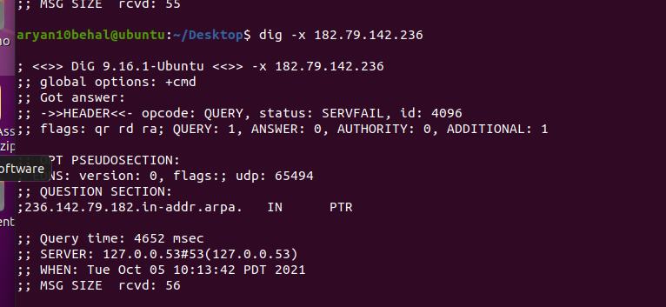

No Name

1. 49.44.220.188

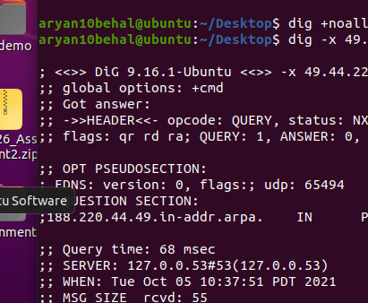

No Name

1. Request timed out

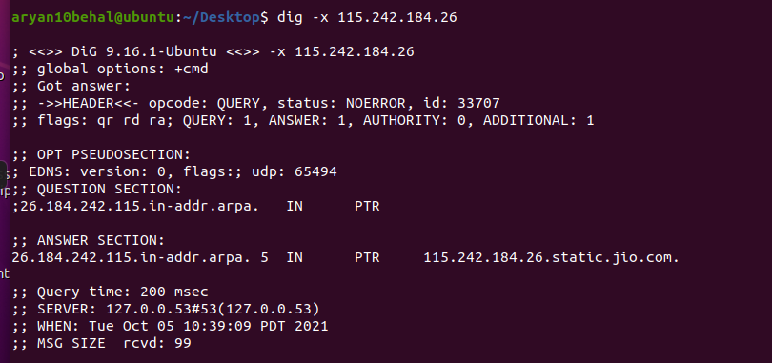

Name: 115.242.184.26.static.jio.com

1. 196.12.34.76

No Name

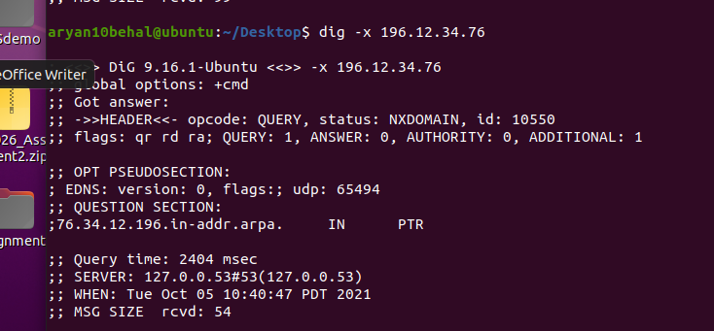

1. 196.12.53.50

No Name

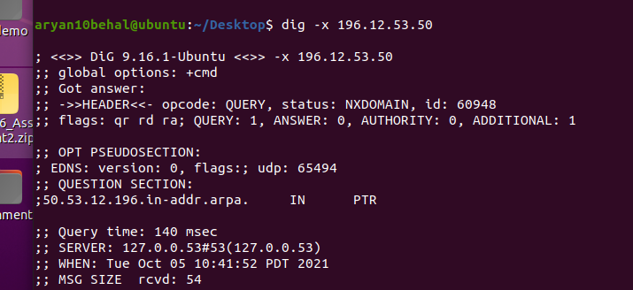

No alias could be found. For aliases, we need to talk to the ISP.

Ans 7.

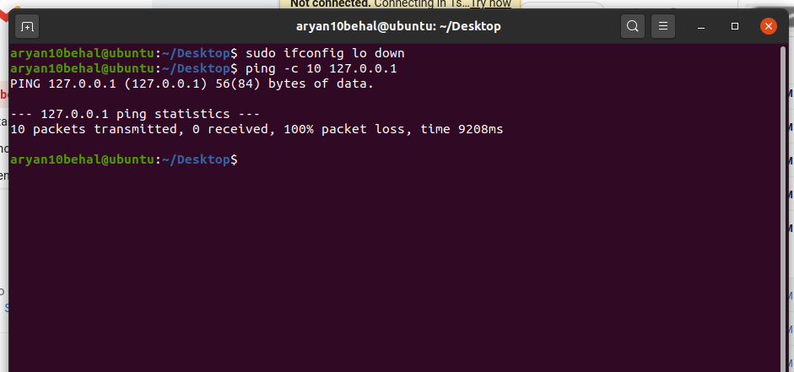

I have disabled the loopback interface using “ifconfig lo down” which causes 100% packet loss as 127.0.0.1 is the loopback address and we can’t receive any message when “lo” is down.