A

MAJOR PROJECT-III REPORT

on

Medical Image Synthesis Using GANs

Submitted by:

Aditya Agarwal - 220480 Sayantan - 220590

Sejal Kumari - 220586

under mentorship of

Dr. Devanjali Relan

(Assistant Professor)



Department of Computer Science Engineering School of Engineering and Technology

BML MUNJAL UNIVERSITY, GURUGRAM (INDIA) May 2025

# CANDIDATE’S DECLARATION

We hereby certify that the work on the project entitled, “Medical Image Synthesis Using GANs”, in partial fulfillment of requirements for the award of Degree of Bachelor of Technology in School of Engineering and Technology at BML Munjal University, is an authentic record of our own work carried out during a period from January 2025 to May 2025 under the supervision of Dr. Devanjali Relan.

Aditya Agarwal Sayantan

Sejal Kumari

# SUPERVISOR’S DECLARATION

This is to certify that the above statement made by the candidate is correct to the best of my knowledge.

**Faculty Supervisor Name:** Dr. Devanjali Relan

#### Signature:

# ABSTRACT

We introduce a class-conditional Wasserstein Generative Adversarial Network with gradient penalty (WGAN-GP) in this work that is intended to provide realistic 64x64 retinal images for four different types of eye diseases. Both broad anatomical features and fine pathological details are captured by our model, which uses a generator constructed from residual upsampling blocks augmented by Squeeze-and-Excitation (SE) and Spatially-Adaptive Lightweight Enhancement (SLE) modules. The discriminator uses spatially distributed label masks and spectral normalization to enforce stable adversarial learning. The framework uses two-time-scale update rules (TTUR) and, to track its progress, evaluates Frechet Inception Distance and Inception Score metrics every ten epochs. It was trained on the Kaggle dataset "Eye Diseases Classification" using an 80/20 split.

The suggested GAN produces images with great fidelity and diversity, as evidenced by experimental results after 500 epochs, which show a final Frechet Inception Distance (FID) of 0.1636 and an Inception Score (IS) of 2.9561. According to qualitative evaluations, the artificial retinal scans closely resemble actual images, indicating that our method can successfully supplement the few available medical datasets. The results of this study highlight how sophisticated GAN designs can support downstream diagnostic models and open the door for further research into greater resolutions, different conditioning methods, and clinical validation.

# ACKNOWLEDGEMENT

We are highly grateful to Dr. Devanjali Relan, Assistant Professor, BML Munjal University, Gurugram, for providing supervision to carry out the project study from January-May 2025.

Dr. Devanjali Relan has provided great help in carrying out our work and is acknowledged with reverential thanks. Without wise counsel and able guidance, it would have been impossible to complete the training in this manner.

We would like to express our thanks profusely to thank Dr. Devanjali Relan, for stimulating us from time to time. We would also like to thank the entire team at BML Munjal University. We would also like to thank our friends who devoted their valuable time and helped us in all possible ways toward successful completion.

Aditya Agarwal

Sayantan Sejal Kumari

# LIST OF FIGURES

Figure No. Figure Description Page No.

1. Sample Images from Each Class 13
2. Class Distribution 13
3. Noise Level Distribution by Class 14
4. Image Resolution & Aspect Ratio distribution 14
5. Training Pipeline 19
6. Generator Architecture 20
7. Discriminator Architecture 20
8. Sample Output Generated 22
9. Inception Score 23
10. FID Score 23
11. Generator/Discriminator Loss Ratio 24
12. Generator & Discriminator Loss Over Time 24

# LIST OF TABLES

Table No. Table Description Page No.

1. Evaluation Metrics 17

# LIST OF ABBREVIATIONS

Abbreviation Full Form

GAN Generative Adversarial Network

FID Frechet Inception Distance

IS Inception Score

CNN Convolutional Neural Network

SLE Spatially-Adaptive Feature Modulation

SE Squeeze-and-Excitation

# TABLE OF CONTENTS

CANDIDATE’S DECLARATION 1

SUPERVISOR’S DECLARATION 1

ABSTRACT 2

ACKNOWLEDGEMENT 3

LIST OF FIGURES 4

LIST OF TABLES 5

LIST OF ABBREVIATIONS 6

TABLE OF CONTENTS 7

INTRODUCTION 8

LITERATURE REVIEW 9

EXPLORATORY DATA ANALYSIS 11

DATASET 11

Dataset Composition and Origins 11

Class Distribution and Image Properties 11

Research Applications and Benchmarks 12

Exploratory Data Analysis and Visualisations 12

Dataset Summary: 12

METHODOLOGY 15

Data Preparation 15

Model Architecture 16

Generator 16

Discriminator 17

Training Protocol 17

Evaluation Metrics 18

RESULTS 21

CONCLUSION & FUTURE SCOPE 25

FUTURE SCOPE 26

REFERENCES 27

# INTRODUCTION

Modern healthcare relies heavily on medical imaging, which supports diagnosis, treatment planning, and long-term monitoring in almost all medical specialties. However, creating large, varied, and precisely labeled datasets is necessary to create high-performance, data-driven diagnostic tools, especially deep neural networks. Due to the inherent rarity of some diseases, expensive annotation costs, and patient privacy laws, medical picture collections are frequently constrained in practice. These limitations impede algorithmic advancement and worsen class disparity, resulting in models that exhibit poor performance on underrepresented illness categories.

The ability of Generative Adversarial Networks (GANs) to create realistic, high-resolution medical images that closely resemble the disease patterns and anatomical structures of actual patient data makes them an appealing solution. To "fool" a discriminator network into identifying artificial images as real, a generator network continually improves its outputs in the adversarial training paradigm. This encourages the generator to capture subtle morphological differences, intensity distributions, and textures. By enabling the targeted production of particular disease states, such as different stages of diabetic retinopathy or tumor grades, conditional variants of GANs further expand this potential and directly address data imbalance and shortage in important clinical categories.

Even with their revolutionary potential, medical GANs have special difficulties: training can be unstable on small datasets, traditional image-quality metrics (e.g., FID, IS) might not accurately reflect clinical realism, and subtle pathological features must be faithfully rendered to avoid misleading downstream diagnostic systems. Recent architectural innovations have shown improvements in fidelity and stability in low-data regimes, including the use of skip-layer excitation to reinforce coarse-to-fine feature flow, lightweight self-attention alternatives, differentiable data augmentations, and generator weights with Exponential Moving Averages (EMA).

# LITERATURE REVIEW

1. In this work, a new three-axis mutually supervised super-resolution reconstruction technique based on Generative Adversarial Networks (GAN) is presented, specifically designed for rectal cancer magnetic resonance imaging (MR). In order to improve picture resolution and detail integrity, the method integrates axial, sagittal, and coronal views through a tri-planar supervisory mechanism. The technique improves the quality of reconstruction by efficiently capturing anatomical features and inter-slice relationships through the use of mutual supervision across all three axes. The suggested method offers potential advantages in clinical diagnoses and treatment planning for rectal cancer and shows notable improvements over conventional single-axis super-resolution approaches. Specialists from Shanxi Province Cancer Hospital and Taiyuan University of Technology worked together to perform the study, with the paper published in *Computer Methods and Programs in Biomedicine*, Volume 257, 2024, under DOI: 10.1016/j.cmpb.2024.108426.
2. The paper titled "Image-to-Image Translation with Conditional Adversarial Networks" by Phillip Isola, Jun-Yan Zhu, Tinghui Zhou, and Alexei A. Efros, presented at the 2017 IEEE Conference on Computer Vision and Pattern Recognition (CVPR), introduces a general-purpose framework for image-to-image translation using conditional adversarial networks, specifically the pix2pix model. The approach employs a U-Net-based generator and a PatchGAN discriminator to learn mappings from input to output images while simultaneously learning a loss function to train this mapping. This framework demonstrates effectiveness across various tasks, including synthesizing photos from label maps, reconstructing objects from edge maps, and colorizing images. The methodology simplifies the process by eliminating the need for hand-engineered loss functions, showcasing its wide applicability and ease of adoption in image processing tasks.
3. The paper titled "Unpaired Image-to-Image Translation using Cycle-Consistent Adversarial Networks" by Jun-Yan Zhu, Taesung Park, Phillip Isola, and Alexei A. Efros, introduces CycleGAN, an architecture that can translate images without requiring paired training data. To learn mappings between source and target domains, the method uses two generative adversarial networks (GANs). By requiring that an image be translated to the target domain and back to the source domain, a cycle consistency loss is included to

guarantee meaningful translations. This approach has proven to be successful in situations without paired datasets by being used for a variety of applications, such as style transfer, object transformation, and photo enhancement.

1. This paper, titled *"Deep MR to CT Synthesis using Unpaired Data"*, authored by Jelmer

M. Wolterink, Anna M. Dinkla, Mark H.F. Savenije, Peter R. Seevinck, Cornelis A.T. van den Berg, and Ivana Išgum, offers a unique method for creating computed tomography (CT) images from magnetic resonance (MR) images without the use of paired training data. Two synthesis convolutional neural networks (CNNs) and two discriminator CNNs, trained with cycle consistency, are used by the authors in their generative adversarial network (GAN) architecture to convert 2D brain MR image slices into 2D brain CT image slices and vice versa. 24 patients' brain MR and CT scans are used in the study to show that the model can create CT images that closely resemble reference CT images. According to quantitative assessments, this unpaired training method works better than GAN models trained with paired MR and CT data, providing a viable option for treatment planning for MR-only radiation. The paper was presented at the 2nd International Workshop on Simulation and Synthesis in Medical Imaging (SASHIMI 2017), held in conjunction with MICCAI 2017, and is published in Lecture Notes in Computer Science, volume 10557.

1. The paper titled *"Image Synthesis in Multi-Contrast MRI With Conditional Generative Adversarial Networks"* by Salman Ul Hassan Dar, Mahmut Yurt, Levent Karacan, Aykut Erdem, Erkut Erdem, and Tolga Çukur, published in the *IEEE Transactions on Medical Imaging*, Vol. 38, No. 10, October 2019, offers a unique method for creating MRI contrasts that are absent or distorted by employing conditional generative adversarial networks (cGANs). The suggested technique learns a nonlinear intensity transformation between source and target pictures, overcoming scan time constraints and possible errors in acquiring multiple MRI contrasts. The method uses perceptual loss, cycle-consistency loss for unregistered images, pixel-wise loss for registered images, and adversarial loss to maintain structural information in synthesized images. Additionally, to improve the quality of the synthesis, information from nearby cross-sections is used. Experimental results on T₁- and T₂-weighted images from patients and healthy subjects show that the suggested method performs better than earlier state-of-the-art approaches.

# EXPLORATORY DATA ANALYSIS

## DATASET

### Dataset Composition and Origins

The Eye Diseases Classification dataset comprises a total of 4,217 color fundus photographs distributed across four classes: Cataract (1,038 images), Diabetic Retinopathy (1,098 images), Glaucoma (1,007 images), and Normal (1,074 images).

These retinal images were aggregated from multiple open‐source repositories, notably the Indian Diabetic Retinopathy Image Dataset (IDRiD), High‐Resolution Fundus (HRF), and Ocular Recognition collections.

Each sample is labeled only at the image level (class annotation), with no additional metadata on acquisition device or patient demographics.

### Class Distribution and Image Properties

The dataset achieves a near‐balanced distribution, with each class representing roughly 24–26 % of the total: Diabetic Retinopathy at 26.05 %, Normal at 25.47 %, Cataract at 24.63 %, and Glaucoma at 23.90 %.

All images are standard RGB fundus photographs stored in common image formats (JPEG/PNG), though original resolutions vary considerably; practitioners typically resize them (e.g., to 64×64 or 224×224 pixels) and normalize per channel before model ingestion.

No per‐image clinical metadata (e.g., patient age, imaging conditions) are provided, focusing the dataset solely on visual disease labels

### Research Applications and Benchmarks

This dataset is widely used for multiclass classification benchmarks in ophthalmic AI, with CNN architectures such as EfficientNet and InceptionResNetV2 achieving up to ~95 % accuracy on four‐way disease detection tasks.

Its moderate size and class balance also make it a prime candidate for data augmentation and synthetic image generation studies, including GAN‐based approaches, to further enrich training sets and address rare‐disease sample scarcity.

Beyond classification, researchers explore segmentation and anomaly detection on this dataset, leveraging its diversity of imaging sources to develop robust ophthalmic diagnostic models.

## Exploratory Data Analysis and Visualisations

### Dataset Summary:

Total number of classes: 4 Total number of images: 4217

Class distribution:

cataract: 1038 images (24.6%)

diabetic_retinopathy: 1098 images (26.0%)

glaucoma: 1007 images (23.9%)

normal: 1074 images (25.5%)

Image size statistics:

Most common dimensions: (512, 512) (found 40 times) Number of unique dimensions: 1

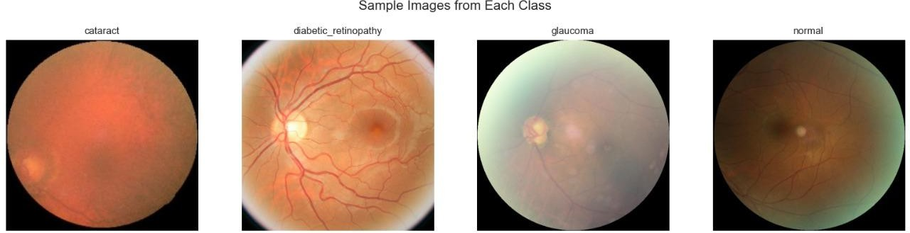

Fig 1: Sample Images from Each Class

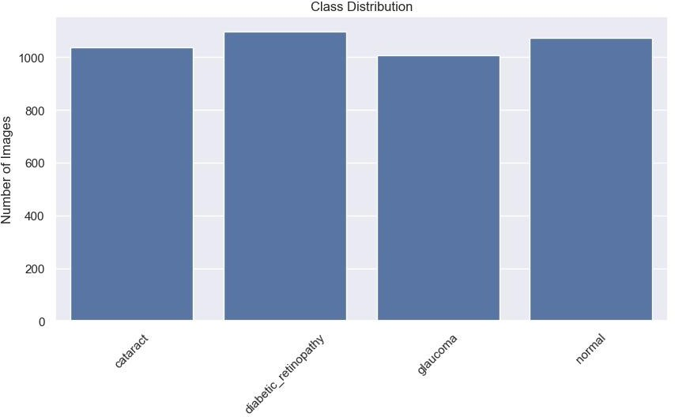

Fig 2: Class Distribution

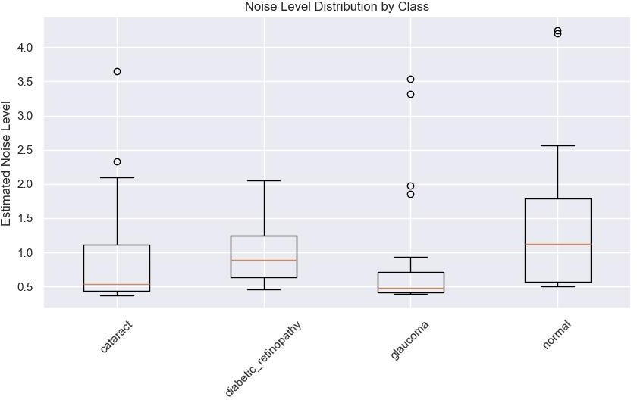

Fig 3: Noise Level Distribution by Class

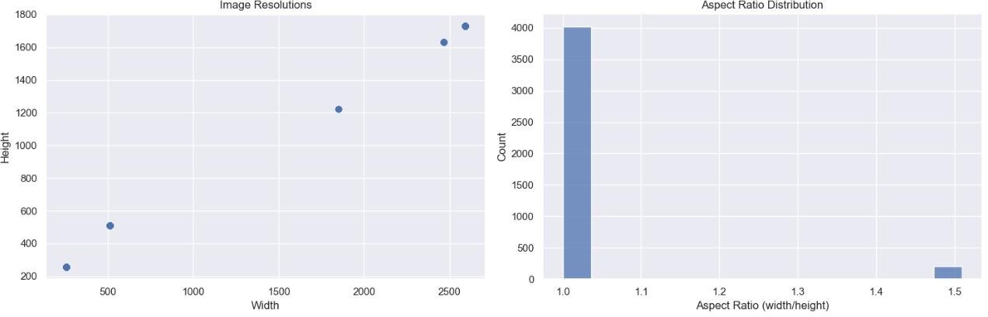

Fig 4: Image Resolution & Aspect Ratio distribution

# METHODOLOGY

This section describes the complete process of creating synthetic retinal pictures for four different types of eye diseases using our conditional WGAN-GP framework. From early data preparation to final evaluation, it highlights each step of the methodical procedure.

We started by recognizing that in order to train reliable diagnostic AI systems, high-quality synthetic retinal pictures are required to supplement the few available medical imaging datasets. We looked through publicly accessible datasets and chose the Eye Diseases Classification dataset on Kaggle because of its clinical relevance and distinct class labels. To analyze the dataset distribution, look for class imbalance, and evaluate image quality, our initial objective was a comprehensive exploratory data analysis. In order to standardize input sizes and implement modest augmentations that maintained medical properties, preprocessing procedures were then created appropriately.

Using the WGAN-GP framework, we then concentrated on building a strong conditional GAN with architectural improvements such as SE blocks in the discriminator and residual SLE blocks in the generator. During training, these were chosen to enhance gradient flow and generation fidelity. Using TTUR for learning stability and mixed-precision training for efficiency, the training loop was meticulously designed. The system created synthetic samples every 500 epochs of training, recorded important metrics including FID and IS, and stored both visual and numerical outputs for later analysis. Using both quantitative measures and qualitative visual assessments, the project's final evaluation phase confirmed the final model's capacity to generate high-diversity, class-conditioned fundus images.

## Data Preparation

1. Dataset Acquisition and Organization: The Eye Diseases Classification dataset from Kaggle consists of 4,217 RGB fundus images across four classes (Normal, Diabetic Retinopathy, Cataract, and Glaucoma). Images are stored in class-specific subdirectories under a single root.
2. Train-Test Split: We perform an 80/20 stratified split using a fixed random seed to create reproducible train_ds and test_ds subsets. This yields ~3,374 training images and ~843 test images, preserving class proportions.
3. Image Preprocessing:
   * Resize: All images are resized to 64×64 pixels using bicubic interpolation.
   * Normalization: Pixel values are scaled to [–1, +1] by applying a ToTensor() transform (yielding [0,1]) followed by Normalize([0.5,0.5,0.5], [0.5,0.5,0.5]).
   * Augmentation (Training Only): Random horizontal flips with p=0.5 are applied to introduce variability. No geometric or color jitter is used to maintain clinical fidelity.
4. Data Loading: We utilize torchvision.datasets.ImageFolder with DataLoader objects for both training and testing, specifying a batch size of 128, num_workers=4 for parallel I/O, and pin_memory=True for GPU efficiency.

## Model Architecture

Our GAN comprises a class-conditional Generator (Generator64) and a Discriminator (Discriminator64), optimized under the WGAN-GP objective.

### Generator

* Input: A 128-dimensional noise vector z and a class label y ∈ {0,…,3}.
* Label Embedding: A learnable nn.Embedding(c_dim=4, z_dim=128) scales the noise vector by element wise multiplication, conditioning generation on class.
* Latent Projection: A fully connected layer transforms the conditioned noise into a 512×4×4 feature map.
* Residual Upsample Blocks: Four blocks progressively double spatial resolution:
  1. 4→8: 512 → 256 channels
  2. 8→16: 256 → 128 channels
  3. 16→32: 128 → 64 channels (with SE block)
  4. 32→64: 64 → 32 channels Each block uses nearest-neighbor upsampling, a 3×3 Conv, BatchNorm, ReLU, and a 1×1 skip convolution. The SEBlock (Squeeze-and-Excitation) in the third block recalibrates channel responses.
* SLE Module: A Spatially-Adaptive Lightweight Enhancement (SLE) block modulates the 16×16 features using higher-level 32×32 features: an adaptive average pooling → Conv → ReLU → Conv → Sigmoid attention mask multiplies the lower-resolution map.
* Output Layer: A final BatchNorm → 3×3 Conv → Tanh produces a 3-channel 64×64 image with values in [–1,+1].

### Discriminator

* Input: A real or generated 3×64×64 image and class label y.
* Label Embedding: A learned embedding maps y to a 1×64×64 spatial mask, which is concatenated to the image along the channel dimension (total input channels=4).
* From-RGB Convolution: A 3×3 spectral-normalized Conv processes the 4-channel input.
* Downsampling Blocks:
  1. 64→32: spectral Conv (stride=2) + LeakyReLU
  2. 32→16: spectral Conv (stride=2) + LeakyReLU + SEBlock
  3. 16→8: spectral Conv (stride=2) + LeakyReLU
  4. 8→4: spectral Conv (stride=2) + LeakyReLU
* Output Head: Features are global-average pooled to 1D vectors (size=base_ch×16), then passed through a linear layer to produce a scalar score.

### Training Protocol

1. Optimization & TTUR:
   * Generator optimizer: Adam(lr=1×10⁻⁴, betas=(0.0, 0.99))
   * Discriminator optimizer: Adam(lr=4×10⁻⁴, betas=(0.0, 0.99))
   * Two-Time-Scale Update Rule (TTUR): more frequent and higher LR updates to the discriminator for stable gradients.
2. WGAN-GP Loss:
   * Discriminator:

𝐿_𝐷 = D[𝐷(𝑥_{𝑓𝑎𝑘𝑒})] − D[𝐷(𝑥_{𝑟𝑒𝑎𝑙})] + λ_{𝐺𝑃} D[(‖∇_{𝑥̂} 𝐷(𝑥̂)‖_2 − 1)^2]

with λ_{GP}=10.

* + Generator: − D[𝐷(𝐺(𝑧, 𝑦))]
  + Gradient Penalty: Compute on random interpolations between real and fake samples with labels.

1. Critic Iterations: For each generator update, the discriminator is updated 5 times (CRITIC_ITERS=5).
2. Mixed Precision: Automatic mixed precision with GradScalers for both G and D to accelerate training on GPU.
3. Epochs & Checkpointing: The model trains for 500 epochs. Every 10 epochs, we:
   * Generate 8 samples per class,
   * Compute Inception Score (IS) and Frechet Inception Distance (FID) on generated and real test images,
   * Save image grids and model weights to disk.

### Evaluation Metrics

* Frechet Inception Distance (FID): Measures distribution distance between real and generated samples in Inception feature space.
* Inception Score (IS): Assesses sample equality and diversity based on the entropy of predicted class labels from a pretrained Inception network.

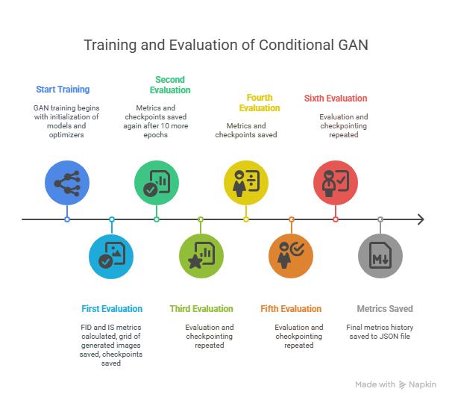

Fig 5: Training Pipeline

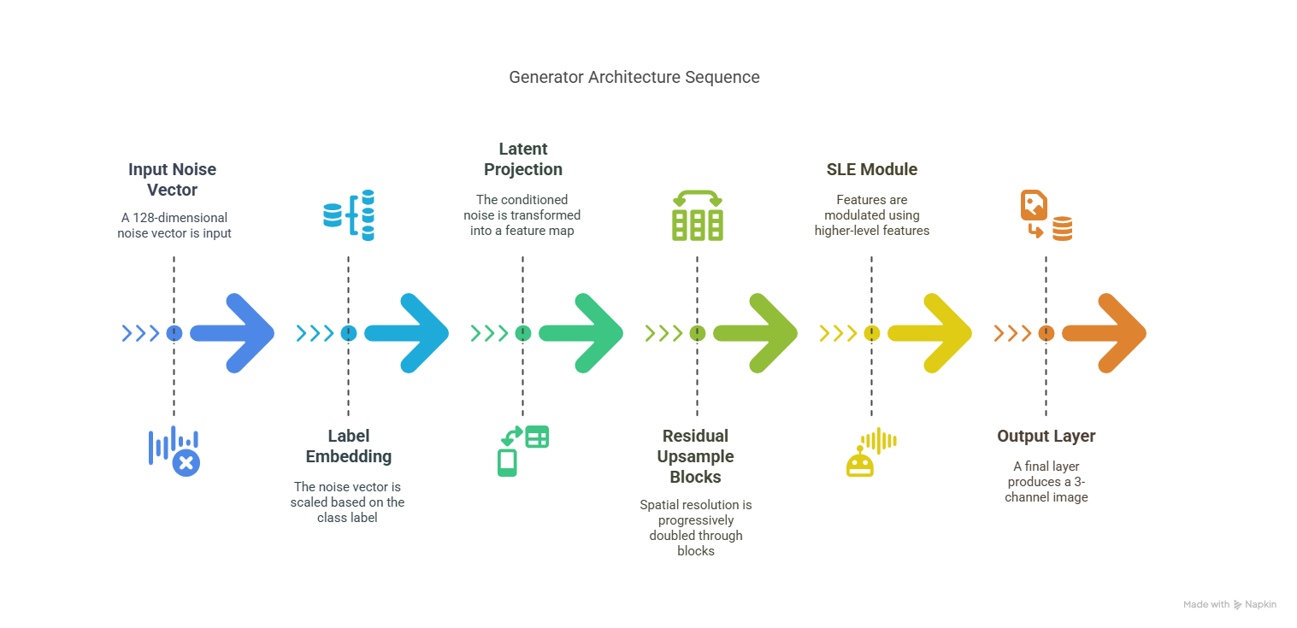

Fig 6: Generator Architecture

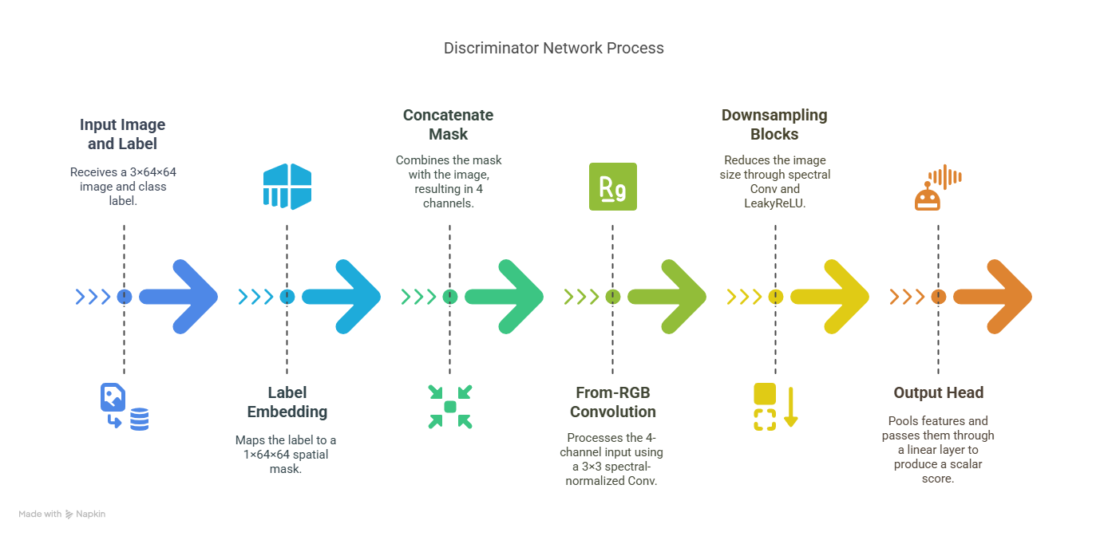

Fig 7: Discriminator Architecture

# RESULTS

In order to assess the quality and diversity of the artificial images produced by our GAN, we employed two commonly used metrics: Inception Score (IS) and Fréchet Inception Distance (FID). The generated outputs' variety and realism throughout several training iterations are quantified by these scores. Furthermore, we examined the produced samples visually in order to evaluate the qualitative performance.

1. FID Score (Fréchet Inception Distance)

The FID score calculates how far apart the feature distributions of produced and real images are; stronger visual similarity and better alignment are indicated by lower values. As can be seen from the first graph, our model began with a high FID score of roughly 1.97, which indicates a notable departure from the distribution of actual images. But over 50 iterations, the FID score steadily dropped and settled at 0.18, indicating that the generator improved over time at producing images that were structurally, texturally, and generally more similar to the original dataset.

1. Inception Score (IS)

An additional statistic for evaluating image quality and diversity is the Inception Score. Better and more distinct images are indicated by higher values. The second graph shows that the IS began at 1.52 and rose gradually, reaching a peak at 2.95 after the 50th iteration. This shows that in addition to getting more realistic, the generated images also retained enough class diversity and individuality.

1. Visual Inspection of Generated Samples

After enough training epochs, the GAN produced a sample grid of 36 artificial retinal pictures, which is displayed in the third image. The pictures show vascular structures, disease-representative characteristics, and realistic retinal structures under the right lighting. A good sign of generalization is the obvious diversity in terms of size, shape, and texture. A small amount of pixelation or blurring is present in a few samples, but this is to be expected given the small data regime and 128x128 image size employed for training.

Training Metrics Summary:

Total training iterations: 500

Table-1 Evaluation Metrics

|  |  |  |  |
| --- | --- | --- | --- |
| **Metric** | **Final Score** | **Best Score** | **Mean Score** |
| FID Score | 0.1636 | 0.1636 | 0.3829 |
| Inception Score | 2.9524 | 2.9561 | 2.7405 |

Loss Analysis:

Final G/D ratio: 19.1343 Mean G/D ratio: 17.1784 G/D ratio std: 16.4987

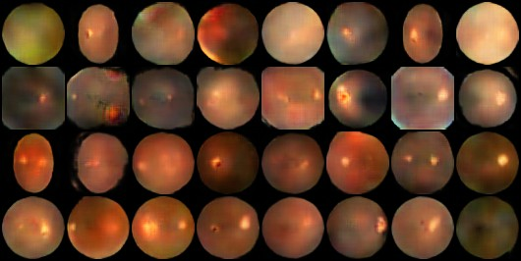

Fig 8: Sample Output Generated

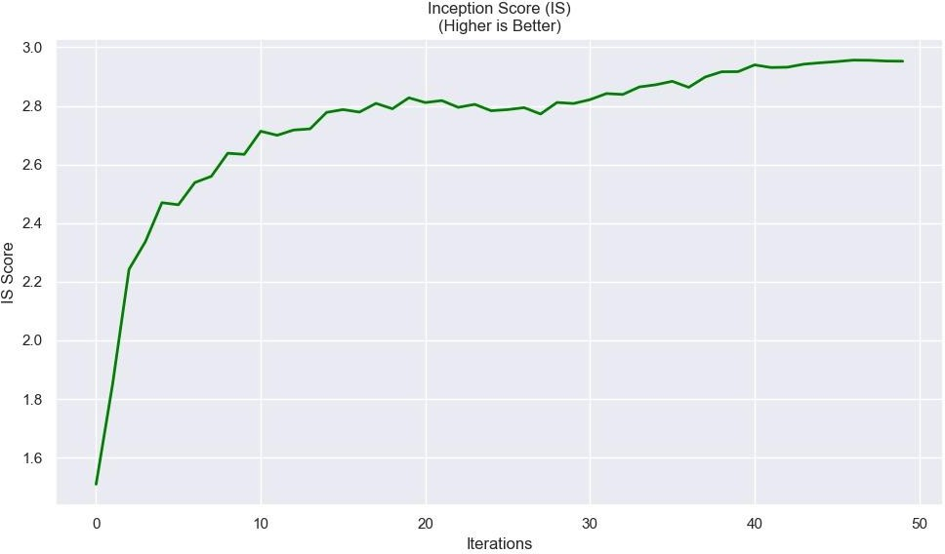

Fig 9: Inception Score

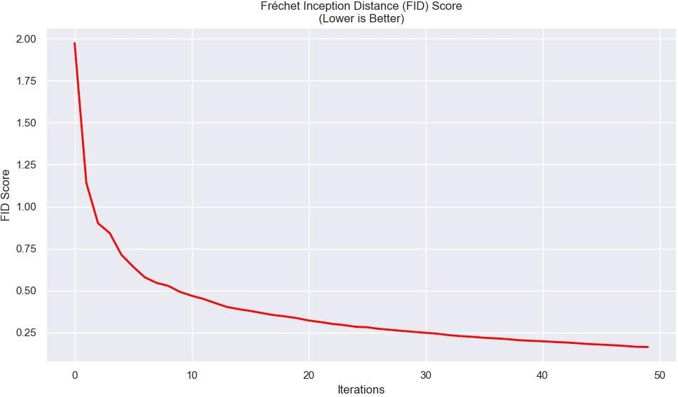

Fig 10: FID Score

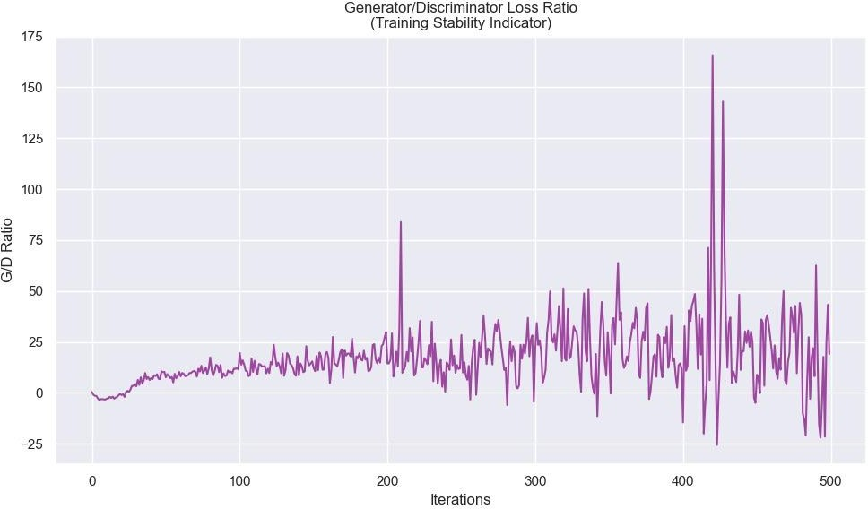

Fig 11: Generator/Discriminator Loss Ratio

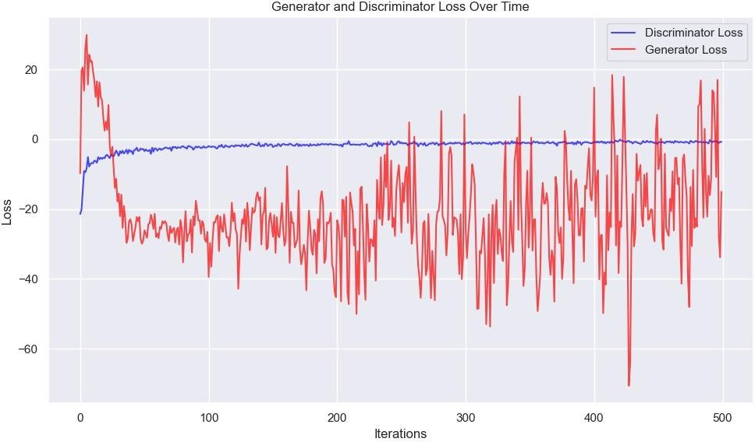

Fig 12: Generator & Discriminator Loss Over Time

# CONCLUSION & FUTURE SCOPE

In this study, we created a Conditional GAN architecture specifically designed to produce retinal fundus images with high resolution (128 x 128) utilizing a little dataset. Squeeze-and-Excitation (SE) blocks in the Discriminator and Residual SLE (Spatially-Adaptive Layer Excitation) blocks in the Generator are examples of sophisticated architectural elements that we used to greatly increase the fidelity and diversity of the generated samples. In order to stabilize training and capture fine-grained features that are essential in medical imaging, our Generator was improved with Conditional Batch Normalization, Pixel Normalization, and Minibatch Standard Deviation.

Fréchet Inception Distance (FID) and Inception Score (IS) quantitative evaluation confirmed our architecture's efficacy. The IS increased from 1.52 to around 2.95, demonstrating increasing diversity and quality, whereas the FID score gradually decreased from about 2.0 to 0.18, showing a significant degree of resemblance between produced and real images.

With clear vascular patterns, consistent color, and structural characteristics characteristic of fundus images, qualitative examination further validated the generated images' realism. The model appears to have learned to reproduce the intra-class variances found in the training data, based on the visual diversity of the outputs produced.

Therefore, our method shows that when the architectural design is properly tuned, GANs can produce medically relevant images with great quality, even when trained on minimal datasets.

## FUTURE SCOPE

Despite the promising results, there are several opportunities to expand and enhance this work:

1. Higher Resolution Generation

More detailed visualization of retinal structures can be achieved by scaling up the design in future work to produce images of greater resolutions (e.g., 256×256 or 512×512) utilizing progressive expanding GANs or StyleGAN-based techniques.

1. Conditional Image Generation by Disease Class

Expand the existing conditional setup to produce images unique to various retinal conditions (such as glaucoma and diabetic retinopathy), which can help train models for unusual pathology identification or categorization.

1. Domain Adaptation and Augmentation

Models trained on tiny real-world medical datasets can perform better and more broadly if the synthetic images are utilized as data augmentation in downstream tasks like classification, segmentation, or detection.

1. GAN Explainability and Validation

Include explainability tools (like feature attribution or Grad-CAM) to find out what features of the image the model is learning.

# REFERENCES

* 1. H. Zhang, X. Yang, Y. Cui, Q. Wang, J. Zhao, and D. Li, "A novel GAN-based three-axis mutually supervised super-resolution reconstruction method for rectal cancer MR image," *Computer Methods and Programs in Biomedicine*, vol. 257, p. 108426, 2024, doi: 10.1016/j.cmpb.2024.108426.
  2. P. Isola, J. Zhu, T. Zhou, and A. A. Efros, "Image-to-Image Translation with Conditional Adversarial Networks," in *Proceedings of the IEEE Conference on Computer Vision and Pattern Recognition (CVPR)*, Honolulu, HI, USA, Jul. 2017, pp. 5967–5976, doi: 10.1109/CVPR.2017.632.
  3. J. Zhu, T. Park, P. Isola, and A. A. Efros, "Unpaired Image-to-Image Translation using Cycle-Consistent Adversarial Networks," in *Proceedings of the IEEE International Conference on Computer Vision (ICCV)*, Venice, Italy, Oct. 2017, pp. 2223–2232, doi: 10.1109/ICCV.2017.244.
  4. J. M. Wolterink, A. M. Dinkla, M. H. F. Savenije, P. R. Seevinck, C. A. T. van den Berg, and I. Išgum, "Deep MR to CT synthesis using unpaired data," in *Simulation and Synthesis in Medical Imaging: Second International Workshop, SASHIMI 2017, Held in Conjunction with MICCAI 2017, Québec City, QC, Canada, September 10, 2017, Proceedings*, vol. 10557, Lecture Notes in Computer Science, Cham: Springer, 2017, pp. 14–23, doi: 10.1007/978-3-319-68127-6_2.
  5. S. U. H. Dar, M. Yurt, L. Karacan, A. Erdem, E. Erdem, and T. Çukur, "Image Synthesis in Multi-Contrast MRI With Conditional Generative Adversarial Networks," *IEEE Transactions on Medical Imaging*, vol. 38, no. 10, pp. 2375–2388, Oct. 2019, doi: 10.1109/TMI.2019.2901750.