ARYAN JUNG CHHETRI  Fullstack Developer | Mobile App Developer | UI/UX Enthusiast | Computing Student  Dhobighat, Lalitpur | chhetriaryanjung@gmail.com | +977-9840530090  GitHub | LinkedIn | 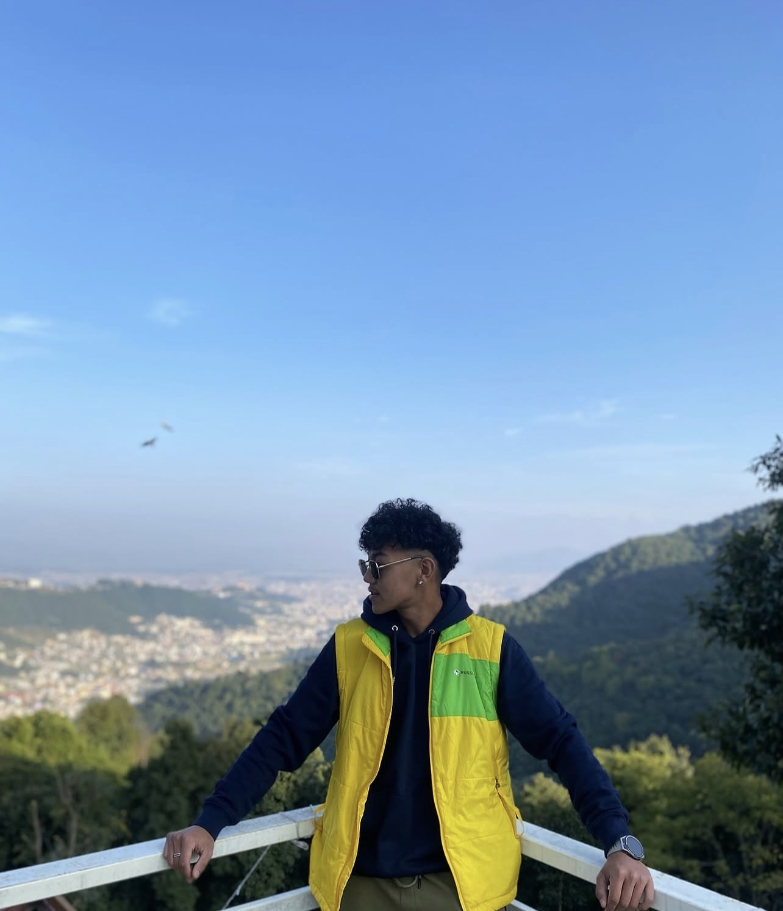
PROFESSIONAL PROFILE
BSc (Hons) Computing student with a practical blend of fullstack development, mobile app development, UI/UX design, cybersecurity learning, and data science and analytics. Builds clean, accessible, recruiter-ready digital experiences with strong attention to visual hierarchy, usability, and secure web fundamentals.

TECHNICAL SKILLS
React | JavaScript | Flutter
Figma | Burp Suite | Python
Java | HTML | CSS
UI/UX Design | Data Analytics | Web Security

EDUCATION
Softwarica College of IT and E-Commerce: BSc (Hons) Computing
+2 Nightingale College: Management with Maths and Computer

PROJECTS
- ChautariKuraKani: Full social media application for web and mobile where users connect and join Chautari communities inspired by Nepali conversation culture. Tech: TypeScript, Flutter, NodeJS.
- TeamSphere: Team management platform for coaches to analyze player performance and support structured decisions. Tech: React, Fullstack, Tailwind.
- Caption: Mobile application for multi-language translation and scan-based translation workflows. Tech: Kotlin, Java.
- GuffGuthi: Reddit-like communication app inspired by Nepali Guthi culture, focused on community discussion and user interaction. Tech: React, JavaScript.
- Data Science Data Analytics: Analytics project for a UK county dataset, focused on insight generation and informed decision-making. Tech: R, R-Studio, Excel.
- ML/AI Player Recommendation System: ML/AI project for IPL franchises to support squad building and identify domestic players with growth potential. Tech: Python, Excel.
ACADEMIC & PERSONAL EXPERIENCE

- Personal Web Application Development: Built fullstack interfaces and practiced component-driven development with modern JavaScript workflows.
- Personal Mobile Application Development: Built functional mobile interfaces using modern Flutter and Riverpod workflows.
- UI/UX Design Practice: Created clean user flows, wireframes, and interface concepts with focus on usability and visual hierarchy.
- Academic Team Collaborations: Worked with classmates on computing assignments, shared responsibilities, and presented technical outcomes.
- Cybersecurity Learning: Explored web application security fundamentals, HTTP behavior, and testing workflows using Burp Suite.

LEADERSHIP & SOFT SKILLS

- U19 District Cricket Captain: Demonstrated leadership, teamwork, discipline, communication, and decision-making under pressure.

Soft skills: Leadership, Team Collaboration, Communication, Problem Solving, Adaptability, Strategic Thinking

