ITUE301: Advance Web Development Framework 24CS011
Student ID : | 24CS011 | Student Name: | Aryan Chanpa
Subject code & Name : | ITUE301: Advance Web Development Framework | Practical : | 1 | Academic Year | : | 2026-27
Task - 1
Aim
To set up a React development environment using Vite and develop a simple student portfolio application using reusable functional components, demonstrating component-based architecture and data passing through props.
Code
GitHub Link Repository Link: https://github.com/aryan13102006/24cs011-awdf-practical1
Output
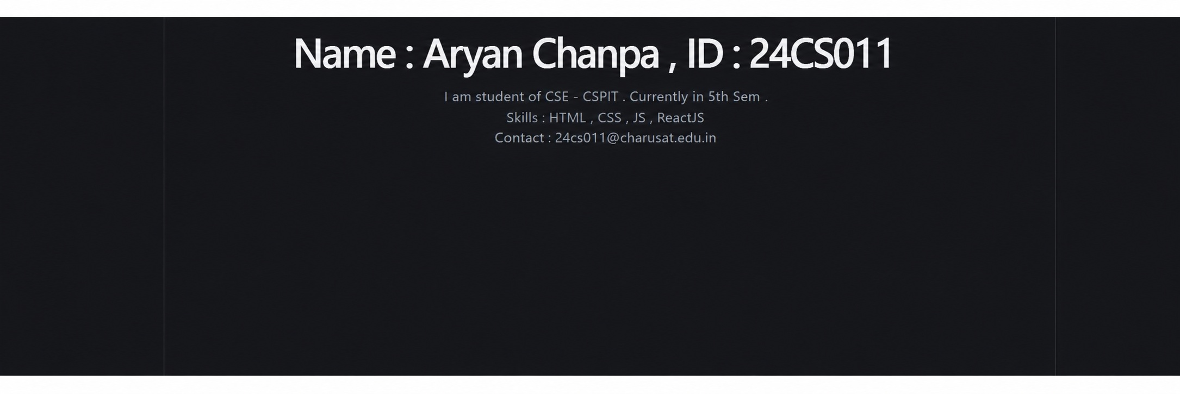
++
Email: 24cs011@charusat.edu.in | Semester: 5th
Degree: B.Tech | Department: CSE | Institute: CSPIT
Department of Computer Science and Engineering, CSPIT Page 1
Output images are illustrative adaptations of the supplied reference screenshots with the updated student details.

