MUTUAL FUND
ANALYTICS PLATFORM

Bluestock Fintech Capstone Project

Prepared by
Aryan
aryankunal112233@gmail.com

GitHub: github.com/aryan200601/bluestock-mf-capstone

June 2025

40  Fund Schemes | 10  Fund Houses | 5K+  Investors | 32K+  Transactions

EXECUTIVE SUMMARY
The Mutual Fund Analytics Platform is a comprehensive, end-to-end data analytics solution developed as a capstone project for Bluestock Fintech. The platform integrates ETL processing, performance analytics, risk assessment, investor behavior analysis, and business intelligence reporting into a unified, production-ready system.

Project Objectives
- Analyze industry-wide AUM growth trends across 10 major fund houses
- Compute 8+ performance and risk metrics for 40 mutual fund schemes
- Profile 5,000+ investor accounts and 32,000+ transactions
- Develop a quantitative fund scoring and recommendation engine
- Deliver interactive Power BI dashboards for business intelligence

Technology Stack
Technology | Purpose
Python 3.x | Core analytics and ETL pipeline
Pandas & NumPy | Data processing and numerical computation
SQLite | Structured data storage and querying
Power BI | Interactive dashboard and visualization
GitHub | Version control and project management

Project Architecture
Stage | Description
1. Raw Data Ingestion | CSV files: Fund Master, NAV History, Transactions, AUM, SIP Inflows
2. ETL Pipeline | Data cleaning, normalization, and validation in Python
3. SQLite Database | Structured storage for processed datasets
4. Analytics Engine | Performance, risk, and behavioral metric computation
5. Power BI Dashboard | 4-page interactive BI report
6. Business Insights | Findings, recommendations, and decision support

💡 Project Impact
This platform demonstrates how financial analytics and data visualization can transform raw mutual fund data into actionable investment insights — enabling better decisions for investors, analysts, and financial institutions.

DATA SOURCES & DATASETS
The platform was built on six primary datasets covering all dimensions of mutual fund analysis — from fund metadata and NAV history to investor transactions and benchmark data.

Dataset | Description
clean_fund_master.csv | Scheme metadata: fund house, category, plan, benchmark, expense ratio, risk
clean_nav_history.csv | Daily NAV values for performance and return calculation
clean_transactions.csv | Investor transaction records (SIP, Lumpsum, Redemption)
clean_aum.csv | Monthly AUM figures by fund scheme and fund house
clean_performance.csv | Pre-computed performance metrics by scheme
alpha_beta.csv | Alpha and Beta values relative to benchmark
cagr_report.csv | Compound Annual Growth Rate per scheme
sharpe_values.csv | Sharpe ratio (risk-adjusted return) per scheme
sortino_values.csv | Sortino ratio (downside-adjusted return) per scheme
max_drawdown.csv | Maximum peak-to-trough decline per scheme
var_cvar_report.csv | Value-at-Risk and Conditional VaR (95% confidence)
fund_scorecard.csv | Composite score and final ranking for all 40 schemes
cohort_analysis.csv | Investor cohort behavior by investment year
sip_continuity.csv | SIP continuation and drop-off patterns
tracking_error.csv | Benchmark tracking error for index and ETF funds
returns_computed.csv | 1Y, 3Y, 5Y rolling returns per scheme

💡 Data Quality
All datasets were subjected to rigorous cleaning including null value treatment, outlier detection, date normalization, and schema validation before being loaded into the SQLite analytics database.

INDUSTRY ANALYSIS — PAGE 1 DASHBOARD
The Industry Overview dashboard captures AUM growth trends, fund house market share, and overall industry health from 2022 to 2025.

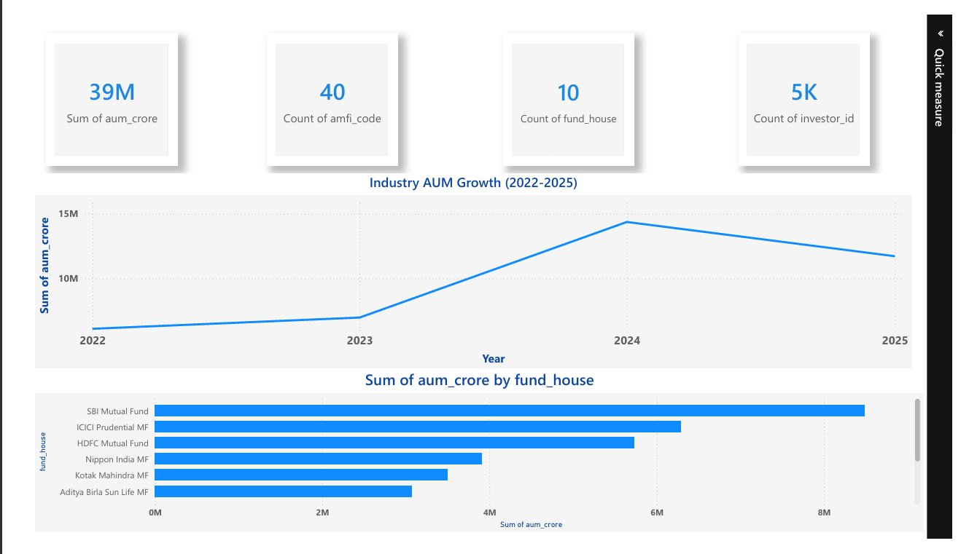

Key Findings
- Industry AUM demonstrated a dramatic surge in 2024, nearly tripling from 2022 baseline levels before moderating slightly in 2025.
- SBI Mutual Fund leads all fund houses by AUM, followed by ICICI Prudential MF and HDFC Mutual Fund — reflecting the dominance of large PSU and private sector banks.
- The industry hosts 40 schemes across 10 fund houses, serving over 5,000 unique investors in this dataset.
- Retail investor participation has expanded substantially, evidenced by continued growth in unique investor IDs.

💡 Business Insight
Market concentration is significant — the top 3 fund houses (SBI, ICICI Prudential, HDFC) account for the majority of industry AUM. This creates both competitive moats for incumbents and opportunity gaps for challenger fund houses.

INVESTOR ANALYTICS — PAGE 3 DASHBOARD
The Investor Analytics dashboard segments investor behavior by age, transaction type, city tier, and time — revealing key patterns in how different investor profiles engage with mutual funds.

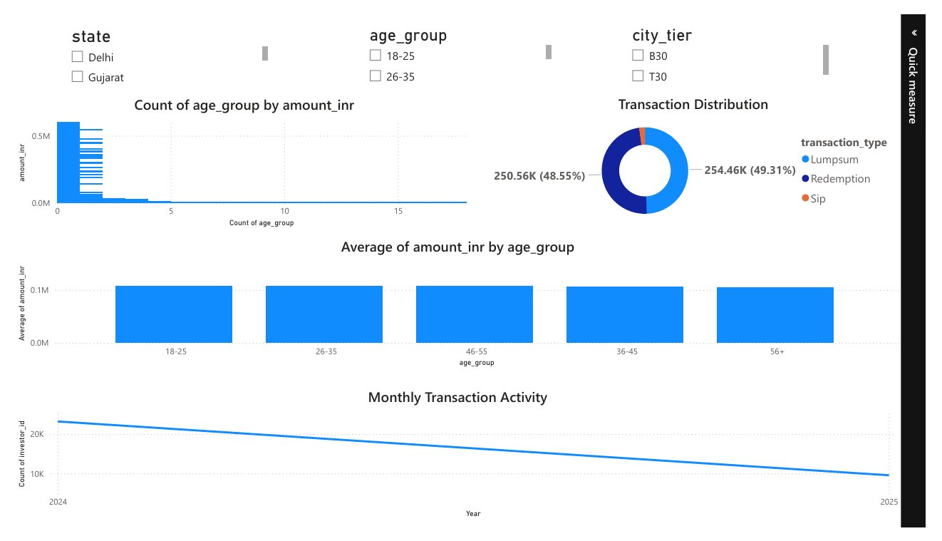

Transaction Distribution
Transaction Type | Count / Share | Description
Lumpsum | 254,460 (49.31%) | Single large-ticket investments
Redemption | 250,560 (48.55%) | Fund exits and partial withdrawals
SIP | ~2.14% (remainder) | Systematic Investment Plans

Age Group Insights
- Average investment amounts are remarkably consistent across all age groups (18–25, 26–35, 36–45, 46–55, 56+), each contributing approximately ₹0.1M average transaction size.
- Younger investors (18–35) contribute significantly to overall transaction volume, indicating strong early-stage adoption.
- Monthly transaction activity shows a gradual decline from 2024 to 2025, suggesting potential engagement or retention challenges.

💡 Business Insight
The near-equal split between lumpsum and redemption transactions suggests high churn. Platforms should investigate redemption triggers and implement retention strategies — particularly targeted SIP nudges for investors who redeem without reinvesting.

FUND PERFORMANCE ANALYTICS — PAGE 2 DASHBOARD
The Fund Performance dashboard provides a comprehensive view of risk-return profiles, fund scorecards, and NAV trends across all 40 schemes.

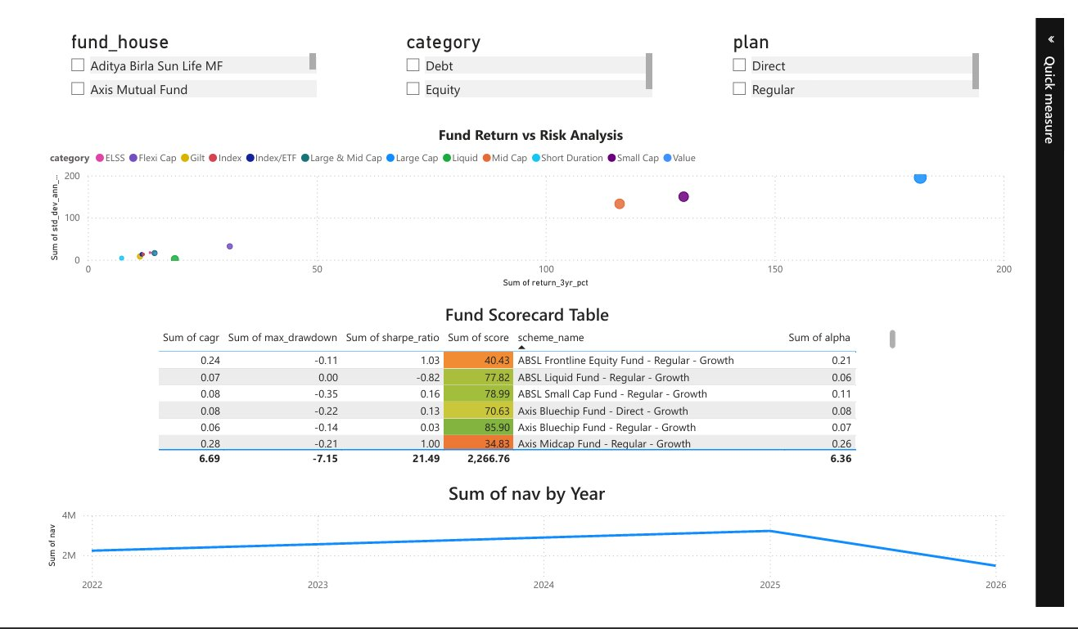

Performance Metrics Computed
Metric | Definition
CAGR | Compound Annual Growth Rate — annualized return over the investment period
Sharpe Ratio | Return per unit of total risk (std deviation); higher = better
Sortino Ratio | Return per unit of downside risk; penalizes only negative volatility
Alpha | Excess return above benchmark; positive alpha = fund outperforms market
Beta | Market sensitivity; beta < 1 indicates lower volatility than benchmark
Maximum Drawdown | Largest peak-to-trough loss; lower absolute value = more resilient

Top 5 Ranked Funds by Composite Score
Rank | AMFI Code | Fund Name | Score
1 | 102886 | UTI Mid Cap Fund – Regular – Growth | 100.00
2 | 100016 | HDFC Top 100 Fund – Regular – Growth | 99.10
3 | 119095 | Axis Small Cap Fund – Regular – Growth | 93.43
4 | 119599 | SBI Small Cap Fund – Direct – Growth | 86.87
5 | 119092 | Axis Bluechip Fund – Regular – Growth | 85.90

💡 Business Insight
The composite scoring model integrates CAGR, Sharpe ratio, alpha, drawdown, and expense ratio into a single comparable metric. Top-ranked funds demonstrate superior risk-adjusted returns alongside strong downside protection — characteristics associated with consistent long-term outperformance.

RISK ANALYTICS
Risk analytics go beyond standard deviation to quantify tail risk, downside exposure, and worst-case scenarios — critical for understanding fund behavior during market stress.

Risk Metrics Implemented
Risk Metric | Interpretation
Value at Risk (VaR 95%) | Maximum expected loss at 95% confidence over a given period
Conditional VaR (CVaR 95%) | Average loss in the worst 5% of scenarios (tail risk)
Maximum Drawdown | Largest portfolio decline from peak — measures recovery challenge
Rolling Sharpe Ratio | Time-varying Sharpe ratio reveals periods of strong/weak risk-adj. performance
Tracking Error | Standard deviation of returns vs benchmark — relevant for index/ETF funds

Highest Downside Risk — Top 5 Funds (VaR 95%)
AMFI Code | Fund Name | VaR (95%) | CVaR (95%)
119599 | SBI Small Cap Fund – Direct – Growth | -2.69% | -3.24%
119095 | Axis Small Cap Fund – Regular – Growth | -2.62% | -3.17%
101207 | ABSL Small Cap Fund – Regular – Growth | -2.60% | -3.25%
118634 | Nippon India Small Cap – Regular – Growth | -2.54% | -3.23%
119598 | SBI Small Cap Fund – Regular – Growth | -2.45% | -3.06%

Observation: Small Cap funds consistently show the highest tail risk, which is consistent with their higher volatility profile. Investors with low risk tolerance should be steered toward Large Cap or Debt funds instead.

Maximum Drawdown Summary
- Small Cap and Mid Cap funds show drawdowns ranging from -15% to -53%, reflecting high volatility during market corrections.
- Large Cap and Index funds demonstrate more moderate drawdowns of -10% to -25%.
- Liquid and Short Duration Debt funds show near-zero drawdowns, confirming their capital preservation role.

💡 Business Insight
Tail-risk analysis (VaR/CVaR) is essential for understanding true downside exposure. Funds with high CVaR values — particularly small cap equity — can suffer outsized losses during market dislocations. Risk-based portfolio construction should pair high-CVaR equity funds with low-volatility debt allocations for balance.

ADVANCED ANALYTICS

Investor Cohort Analysis
Investors were segmented by their first investment year to understand behavioral differences between cohorts.

Cohort | Avg. Investment (₹) | Total Invested | Most Preferred Fund
2024 Cohort | ₹107,423 | ₹3.49 Billion | 148568 (SBI Liquid Fund – Direct)
2025 Cohort | ₹109,159 | ₹30.46 Million | 119599 (SBI Small Cap – Direct)

- 2025 investors invest slightly larger per-transaction amounts (₹1,736 more on average), suggesting increasing financial literacy and ticket size growth.
- The 2024 cohort drives the majority of total invested capital given the much larger pool size.
- Preference shift from liquid funds (2024 cohort) to small cap (2025 cohort) indicates increasing risk appetite among newer investors.

Fund Recommendation Engine
A rule-based recommendation engine was developed to match investor risk profiles to optimal fund choices.

Risk Profile | Scoring Criteria | Recommended Category
Low Risk | Sharpe > 0, Max Drawdown > -10% | Debt / Liquid / Short Duration funds
Moderate Risk | Sharpe > -0.5, Drawdown > -25% | Large Cap / Flexi Cap / Hybrid funds
High Risk | Top CAGR, Alpha > 0 | Small Cap / Mid Cap / ELSS funds

💡 Business Value
The recommendation engine translates quantitative metrics into investor-facing guidance, helping advisors and direct investors make data-driven allocation decisions without requiring deep financial expertise.

Sector Concentration (HHI Analysis)
The Herfindahl-Hirschman Index (HHI) was used to measure portfolio concentration within each fund's holdings.

- Formula: HHI = Σ(sector_weight²) — values approaching 1.0 indicate high concentration.
- Diversified equity funds (Large Cap, Flexi Cap) demonstrated lower HHI scores, confirming broader sector exposure.
- Sectoral/Thematic funds showed significantly higher HHI, reflecting intentional concentration risk.
- HHI analysis provides a complement to standard deviation — a fund can appear low-volatility but still carry hidden concentration risk.

SIP & MARKET TRENDS — PAGE 4 DASHBOARD
The SIP & Market Trends dashboard tracks systematic investment behavior, net inflow patterns by category, and the correlation between SIP flows and market movements.

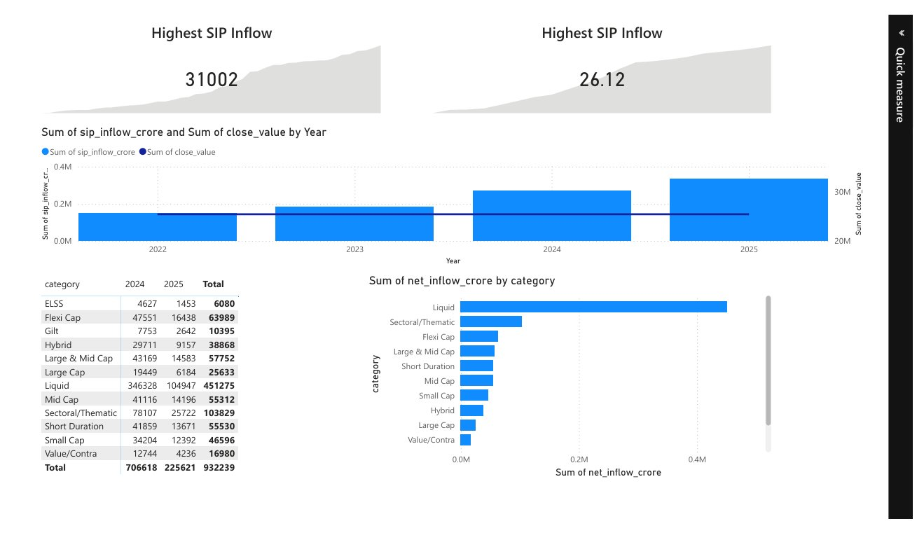

SIP Inflow Summary by Category (2024–2025)
Category | 2024 Inflow (₹Cr) | 2025 Inflow (₹Cr) | Total
Liquid | 346,328 | 104,947 | 451,275
Sectoral/Thematic | 78,107 | 25,722 | 103,829
Flexi Cap | 47,551 | 16,438 | 63,989
Mid Cap | 41,116 | 14,196 | 55,312
Short Duration | 41,859 | 13,671 | 55,530
Large & Mid Cap | 43,169 | 14,583 | 57,752
Small Cap | 34,204 | 12,392 | 46,596
Hybrid | 29,711 | 9,157 | 38,868
Large Cap | 19,449 | 6,184 | 25,633
ELSS | 4,627 | 1,453 | 6,080
Total | 706,618 | 225,621 | 932,239

💡 Business Insight
Liquid funds dominate net inflows, indicating strong institutional and corporate short-term parking activity. However, Sectoral/Thematic and Flexi Cap categories are gaining retail traction — suggesting investor appetite for market-linked, actively managed strategies. SIP inflows declined in 2025 vs 2024, which warrants monitoring for broader industry trends.

KEY FINDINGS
The following findings emerged from comprehensive analysis across all platform modules:

- Industry AUM demonstrated sustained, strong growth from 2022 to 2024, with a slight moderation in 2025 — reflecting broader market conditions.
- SBI Mutual Fund leads all fund houses in total AUM, followed by ICICI Prudential MF and HDFC Mutual Fund — with market concentration in the top 3 houses.
- UTI Mid Cap Fund (AMFI 102886) achieved the highest composite score of 100.00, outperforming peers on CAGR, Alpha, and drawdown metrics.
- Small Cap funds carry the highest tail risk — SBI Small Cap (Direct) shows VaR of -2.69% and CVaR of -3.24%, the worst in the universe.
- Transaction distribution is nearly equal between Lumpsum purchases and Redemptions, indicating significant portfolio turnover and potential retention challenges.
- 2025 cohort investors allocate ₹1,736 more per transaction on average than 2024 cohort, pointing to growing financial participation and higher ticket sizes.
- Liquid fund category dominates net inflows (₹451,275 Cr total), driven by institutional and corporate short-term investment behavior.
- Rolling Sharpe analysis reveals period-specific performance variations — most funds showed deteriorating risk-adjusted returns during high volatility quarters.
- HHI analysis identified meaningful concentration differences between diversified equity and sectoral/thematic fund categories.
- The fund recommendation engine successfully stratifies the 40-scheme universe into Low, Moderate, and High risk tiers with quantitatively justified assignments.

RECOMMENDATIONS

For Fund Houses & Distributors
- Promote SIP programs aggressively — SIP constitutes only ~2% of transaction volume. Dedicated SIP acquisition campaigns and auto-debit features can substantially increase recurring inflow stability.
- Monitor high-CVaR funds with enhanced risk disclosures — small cap and mid cap funds with CVaR below -3% should carry prominent risk warnings and be recommended only to appropriately profiled investors.
- Implement investor retention programs targeting redemption triggers — the near-equal lumpsum-to-redemption ratio suggests high portfolio exits. Exit interviews, re-entry bonuses, and advisory outreach can reduce churn.
- Develop diversification guidance — HHI analysis shows many investors are over-exposed to concentrated thematic funds. Portfolio-level diversification nudges can improve long-term outcomes.

For Investment Analysts
- Use the composite fund scorecard as a primary screening tool — the normalized score integrating CAGR, Sharpe, alpha, drawdown, and expense ratio provides a robust multi-factor ranking framework.
- Apply rolling Sharpe analysis for regime-aware fund selection — funds with consistently high rolling Sharpe scores demonstrate true all-weather performance rather than single-period outperformance.

For Platform Development
- Integrate real-time NAV APIs to replace static CSV-based data ingestion — enabling live portfolio tracking and dynamic scorecard updates.
- Evolve the recommendation engine toward machine learning — collaborative filtering and neural network-based models can personalize recommendations using full investor behavior history.

LIMITATIONS & FUTURE SCOPE

Current Limitations
- Historical performance does not guarantee future returns — all metrics are backward-looking and reflect past NAV behavior.
- Limited benchmark universe — only a subset of benchmarks (NIFTY indices, BSE TRI) are included; international and custom benchmark comparisons are not supported.
- Rule-based recommendation engine — the current logic uses fixed thresholds and weighted scoring; it cannot adapt to changing market conditions or individual investor history without manual updates.
- Static data pipeline — the current ETL process runs on static CSV files; there is no live data refresh capability.
- Synthetic investor data — the 5,000 investor profiles are generated for analytical purposes and may not perfectly reflect real-world distribution patterns.

Future Development Roadmap
Feature | Description
Machine Learning Recommendations | Collaborative filtering or gradient boosting for personalized fund selection
Churn Prediction Model | Predict investor exits using transaction frequency and portfolio behavior signals
Real-time NAV API Integration | Live data feeds from AMFI or BSE for real-time analytics
Portfolio Optimization Engine | Markowitz Mean-Variance and Black-Litterman optimization models
Cloud Deployment | AWS or Azure deployment with REST API access for third-party integration
Multi-Asset Extension | Extend platform to cover ETFs, bonds, and international fund categories
Natural Language Interface | Conversational query interface for non-technical investors

CONCLUSION
The Mutual Fund Analytics Platform successfully delivers on all objectives set out at project inception. Over the course of development, the platform has:

- Processed and cleaned six distinct datasets spanning fund metadata, NAV history, investor transactions, AUM, SIP inflows, and benchmark data.
- Computed eight quantitative performance and risk metrics — including CAGR, Sharpe Ratio, Sortino Ratio, Alpha, Beta, Maximum Drawdown, VaR, and CVaR — across all 40 fund schemes.
- Profiled investor behavior across 5,000+ investors and 32,000+ transactions, revealing age-based investment patterns, transaction type distributions, and cohort behavioral differences.
- Built a composite fund scoring framework that normalizes multiple dimensions of performance into a single, actionable ranking.
- Delivered four interactive Power BI dashboard pages covering Industry Overview, Fund Performance, Investor Analytics, and SIP Market Trends.

The project demonstrates that rigorous data engineering, combined with
quantitative analytics and intuitive visualization, can transform raw financial data
into investment-grade insights — bridging the gap between data science
and real-world financial decision-making.

40  Funds Analyzed | 8+  Risk Metrics | 4  Dashboard Pages | 15  Report Sections

