

|  |  |  |  |
| --- | --- | --- | --- |
| **Student name:** |  | | |
| **Student number:** |  | | |
| **Course Code:** |  | | |
| **Date of Submission:** | Click here to enter a date. | | |
|  | | | |
| **Assessment Details** | | | |
| **Unit code and name:** |  | | |
| **Lecturer name:** |  | | |
| **Assessment #:** | 3 | Due date: | Click here to enter a date. |
|  | | | |
| **Extension approved by (If applicable):** | | | |
| **Date approved:** | Click here to enter a date. | New due date: | Click here to enter a date. |
|  | | | |
| **Student Declaration** | | | |
| I certify that the attached assessment is my own work and that any material drawn from other sources has been acknowledged.  I am aware that the Engineering Institute of Technology (EIT) uses text-matching software to check student submissions as well as safeguard my own work against any potential academic misconduct.  Copyright in assessments remains my property. I grant permission to EIT to make copies of assessments for assessment, review, and/or record keeping purposes. I note that the EIT reserves the right to check my assessment for plagiarism. Should the reproduction of all or part of an assignment be required by EIT for any purpose other than those mentioned above, appropriate authorisation will be sought from me on the relevant form.  The following statements outline the expectations in this assessment in relation to the use of Artificial Intelligence, such as ChatGPT or similar platforms or tools:   * I will not use any Artificial Intelligence platforms or tools, recognising that this will be considered a form of ‘contract cheating’. * I will not share assessment questions with any Artificial Intelligence platform or tools or homework help websites, recognising that this will be considered an infringement of EIT’s intellectual property. * I understand the rules of this assessment and will comply with the academic integrity requirements.   I understand and agree to the above.  I understand that this assessment will still be subject to normal academic integrity checks, and any anomalies will be investigated. | | | |
|  | | | |
| **Lodging Your Assessment** | | | |
| **Please note:**   * **No email submissions will be accepted.** * **All written assessments must be typed (not handwritten) unless otherwise specified.** * Submission MUST be correctly titled: e.g. *BSC101C_Assessment2_StudentName_Date* * Submissions must be submitted electronically using Turn-it-in Submission Boxes in Moodle (unless otherwise stated) | | | |

1. **Explanation of fluid domain is considered**

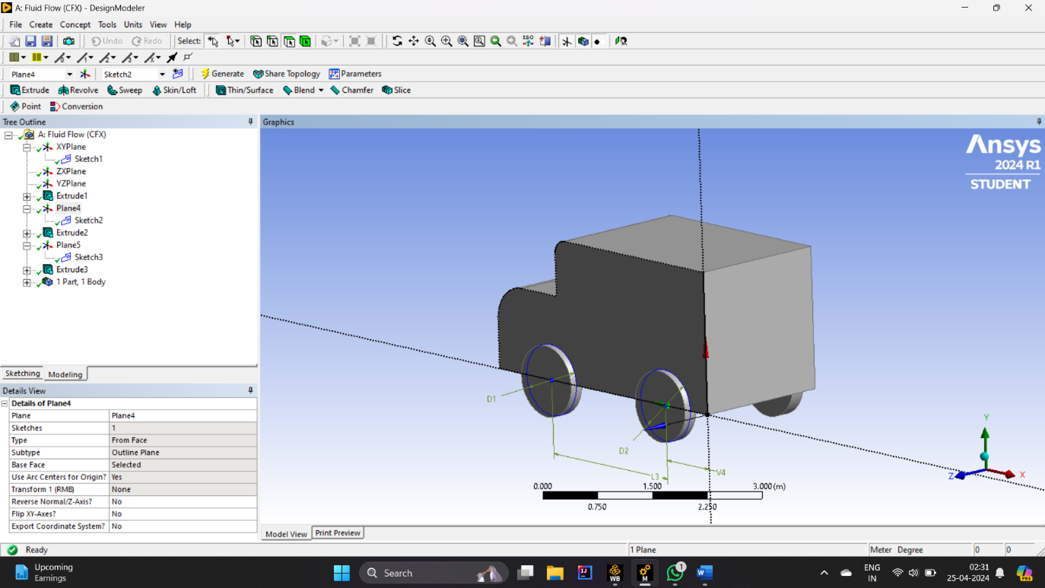

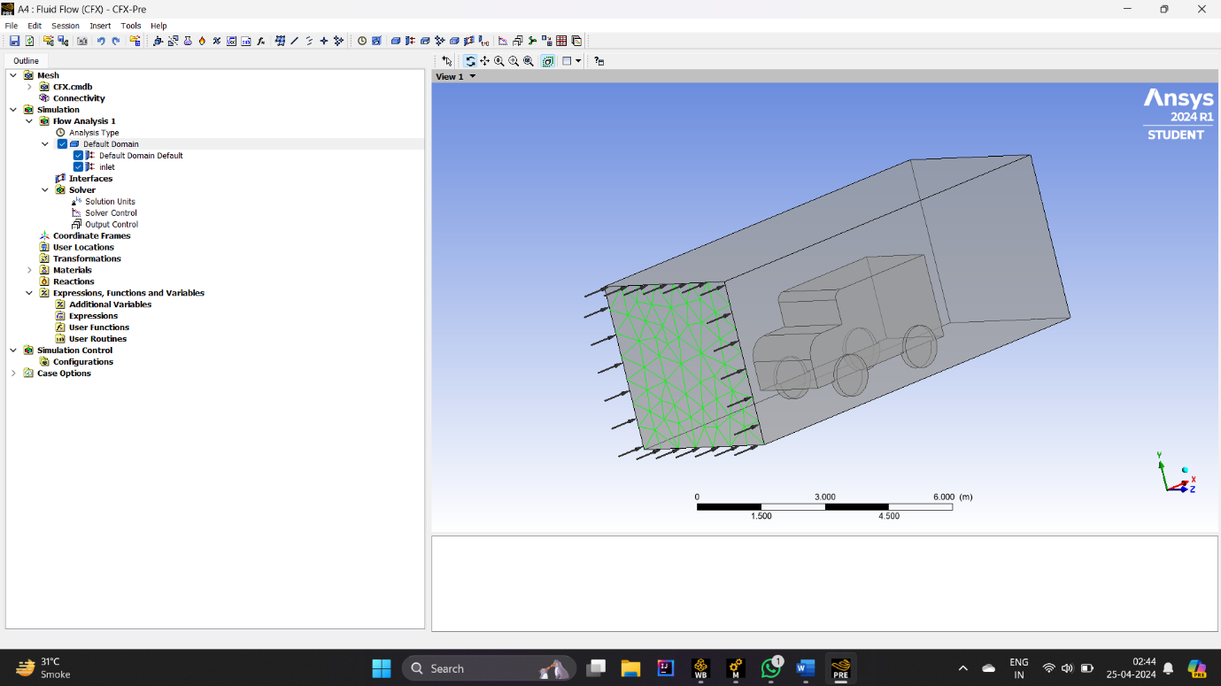

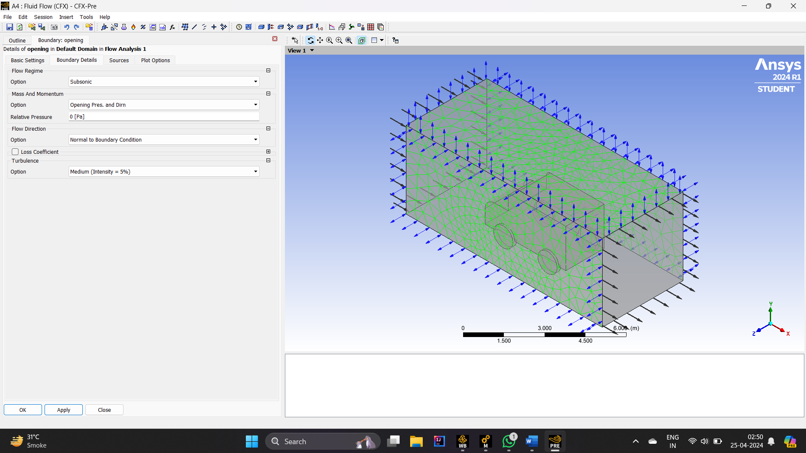

Start a new project in ANSYS CFX-Pre.

Fluid domain attention in a Computational Fluid Dynamics (CFD) simulation refers back to the procedure of defining the computational area where the drift analysis will take area. It involves figuring out the bounds and dimensions of the domain to ensure correct illustration of the go with the flow area around the item of interest—in this situation, a simplified truck geometry.

Here's a detailed rationalization of fluid area consideration:

**Geometry Definition**: The first step in considering the fluid area is defining the geometry of the object being studied, in this example, the simplified truck body. The geometry have to be appropriately represented within the CFD software, shooting all relevant capabilities that might affect the go with the flow across the truck, which includes the form of the cabin, trailer, wheel arches, and every other protrusions.

**Domain Extent**: The fluid domain need to extend sufficiently far around the truck to capture the glide behavior without being excessively big, which would growth computational prices. The domain have to expand upstream and downstream of the truck to reduce boundary results, which include recirculation zones and waft separation. Additionally, it ought to expand laterally to account for any lateral waft consequences.

**Boundary Conditions:** Boundary conditions play a vital position in defining the fluid domain. These situations specify the interaction between the fluid and stable surfaces in the domain. For instance, the floor under the truck can be modeled as a stationary wall to represent the no-slip situation among the air and the street surface. The truck's surface itself must have a no-slip situation to account for the velocity of the truck relative to the air .

**2. Explanation of Meshing Strategy:**

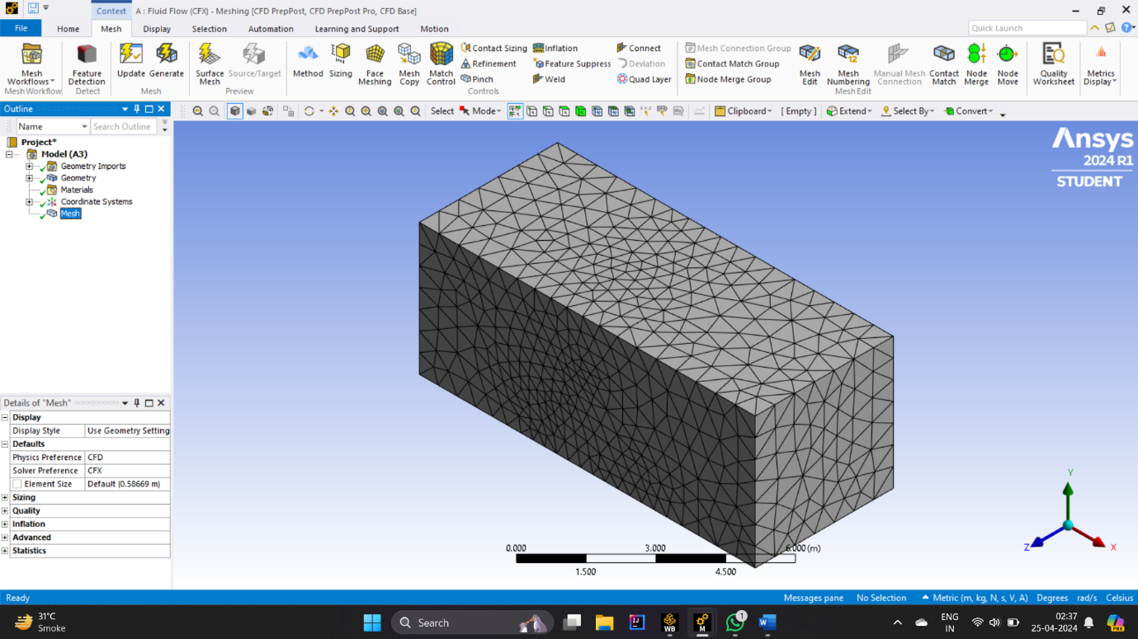

Meshing method is a vital component of Computational Fluid Dynamics (CFD) simulations, involving the method of dividing the computational area into smaller factors or cells to numerically clear up the governing equations of fluid waft. Here's an in depth clarification of meshing approach:

**Mesh Type Selection**: The first step in meshing strategy is deciding on the suitable mesh type based on the geometry of the item being simulated. In CFD simulations, meshes can be based or unstructured. Structured meshes have a normal association of cells, which can be tremendous for easy geometries like bins or cylinders. Unstructured meshes, however, provide more flexibility and can take care of extra complicated geometries with irregular shapes.

**Mesh Refinement**: Mesh refinement involves increasing the mesh density in regions wherein glide gradients or geometric complexity are high. Near the surface of the truck geometry, wherein boundary layer consequences are enormous, mesh refinement is important to appropriately seize the velocity and strain gradients. Additionally, regions of glide separation and reattachment require finer meshes to remedy waft features appropriately.

**Boundary Layer Meshing**: Boundary layer meshing is a technique used to refine the mesh near solid surfaces to capture the skinny boundary layer where viscous effects dominate. This entails including layers of cells with reducing sizes near the floor to correctly seize the speed gradients. Proper boundary layer meshing is essential for accurately predicting frictional drag and heat switch.

1. **Explanation of Simulation Setup in CFD Solver and Boundary Conditions**

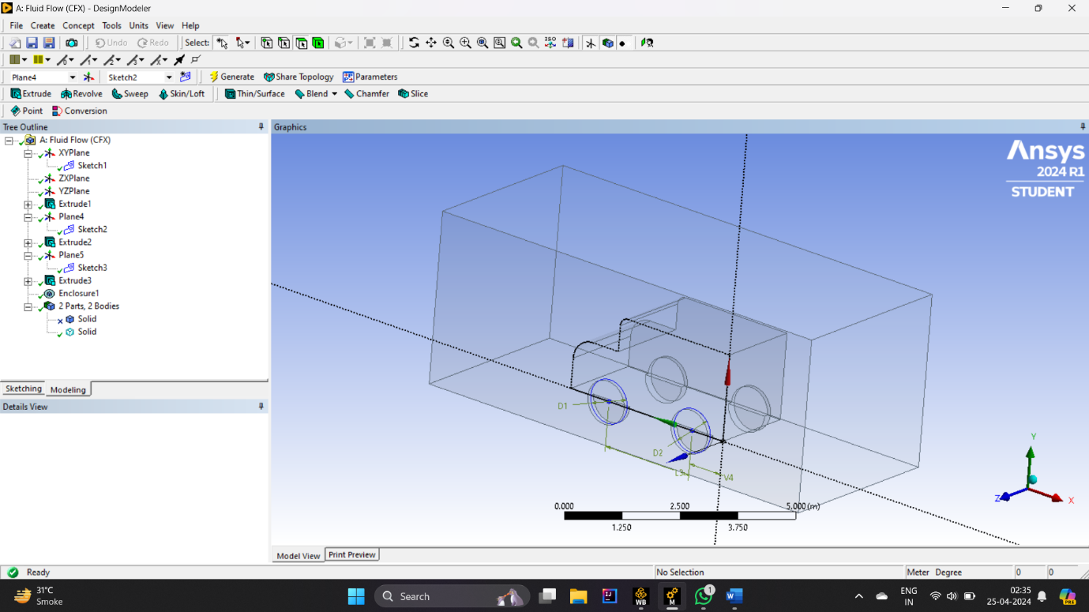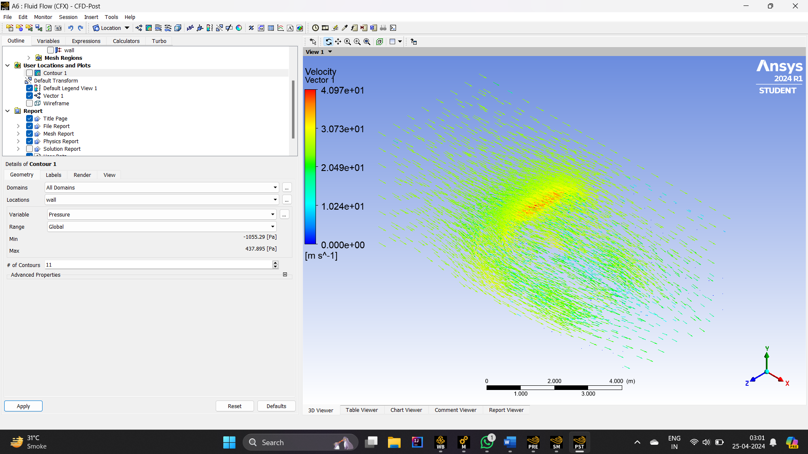

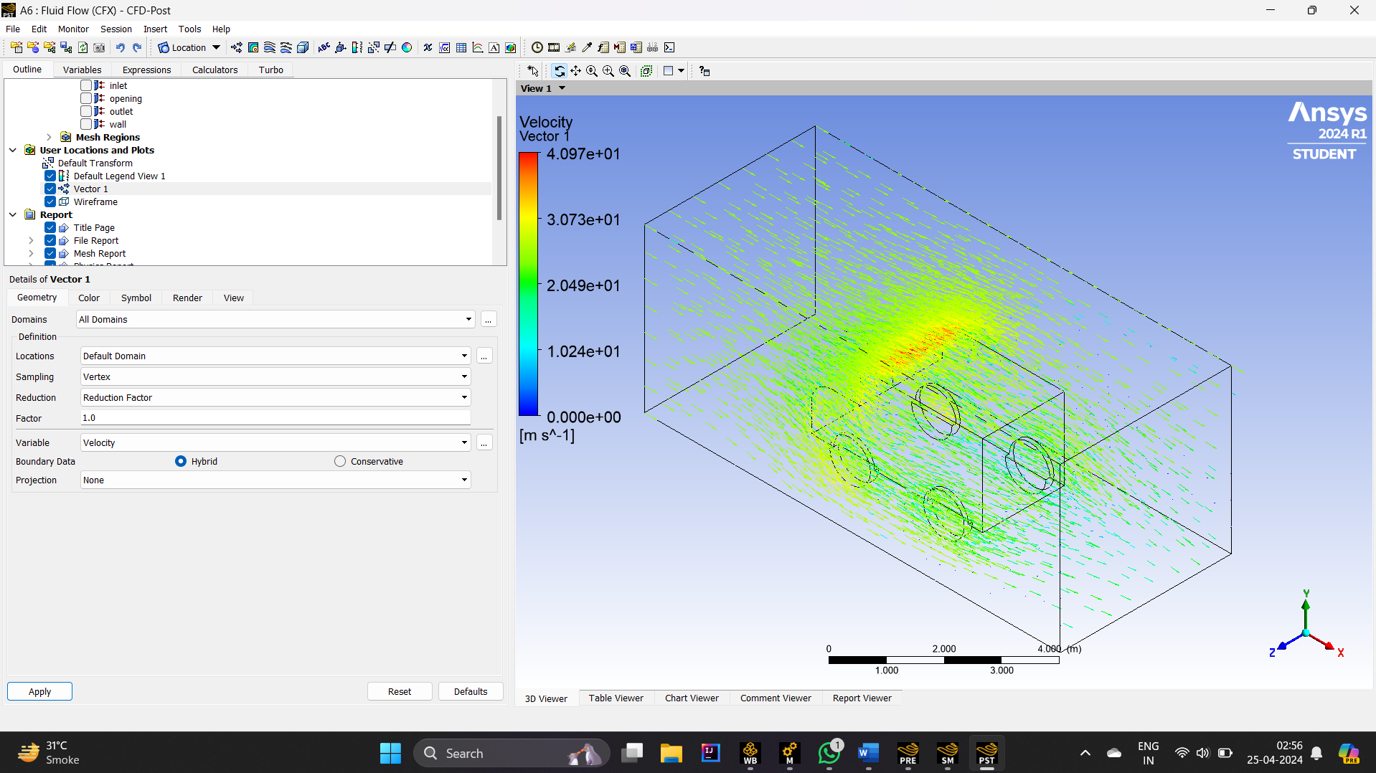

**Simulation Setup in CFD Solver:**

**Geometry Import**: The first step in putting in a CFD simulation is importing the geometry of the item being studied into the CFD solver software program. This geometry represents the bodily shape of the item, in this case, the simplified truck body.

**Fluid Properties:** The subsequent step entails defining the homes of the fluid medium in which the simulation may be conducted. For this state of affairs, air is chosen because the running fluid. The properties of air, which includes density, viscosity, and temperature, are specific inside the simulation setup.

**Turbulence Model Selection**: Turbulence fashions are mathematical formulations used to simulate the outcomes of turbulence within the waft area. The preference of turbulence version depends on factors including the drift regime, Reynolds number, and available computational assets. Common turbulence models include the okay-epsilon version, SST okay-omega version, and Reynolds-averaged Navier-Stokes (RANS) models.

**Solver Settings**: Solver settings consist of parameters that control the numerical solution manner, along with convergence criteria, discretization schemes, and answer techniques. Convergence criteria specify while the answer is taken into consideration converged primarily based on residuals or different standards. Discretization schemes decide how the governing equations are approximated numerically, whilst solution strategies dictate how these equations are solved iteratively.

1. **Boundary Conditions:**

Boundary situations define the interaction between the fluid and stable surfaces inside the computational domain. In the context of simulating go with the flow around a truck geometry, the following boundary situations are commonly carried out:

**Inlet Boundary**: The inlet boundary condition represents the situations at the influx boundary of the computational area. For a shifting truck scenario, the inlet boundary situation specifies the rate profile of the air drawing close the truck, usually based on the automobile's speed. Additionally, the inlet boundary can also encompass different properties such as temperature and turbulence depth.

**Outlet Boundary**: The outlet boundary condition defines the conditions at the outflow boundary of the computational area. It allows the waft to go out the domain freely without reflecting returned into the area. The outlet boundary situation is commonly set to a far-area condition, assuming that the glide has completely developed and isn't stimulated by using the domain barriers.

**Solid Surface (Truck Body):** The stable floor boundary situation specifies the interplay between the air and the truck's surface. It is generally set to a no-slip situation, meaning that the rate of the air on the truck's floor is equal to the rate of the truck itself. Additionally, other properties inclusive of wall roughness and thermal conditions can be certain depending at the particular simulation necessities.

**Symmetry or Periodic Boundaries:** In some cases, symmetry or periodic boundary situations can be applied to simplify the computational area. Symmetry obstacles expect that go with the flow residences are symmetric throughout a described aircraft, at the same time as periodic barriers simulate repetitive float behavior in a periodic area.

1. **Explanation of Solver Settings**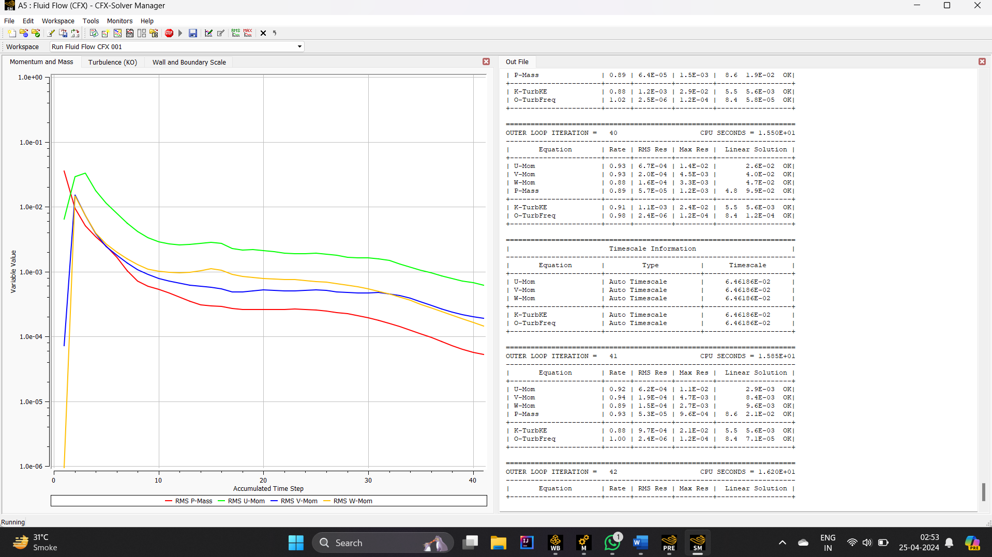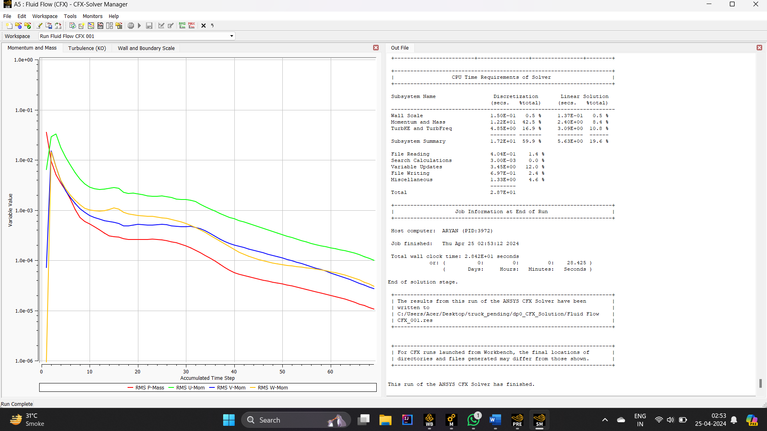

**Convergence Criteria**: Convergence standards decide while the solution is considered converged and the simulation may be stopped. This is commonly based on residuals, which might be measures of the difference between successive iterations of the solution. Convergence criteria specify thresholds for the residuals below which the solution is considered converged. Common convergence standards consist of absolute and relative residuals for variables which include pace, stress, and turbulence quantities.

**Discretization Schemes**: Discretization schemes are used to approximate the differential equations governing fluid waft numerically. These schemes determine how spatial and temporal derivatives are discretized and are important for solution accuracy and stability. Common discretization schemes include finite extent, finite difference, and finite element techniques. Within every scheme, unique schemes can be used for spatial discretization (e.G., primary differencing, upwind differencing) and temporal discretization (e.G., explicit, implicit).

**Solution Methods**: Solution techniques dictate how the discretized equations are solved iteratively to attain the final answer. The desire of solution method depends on elements which include the character of the waft (consistent-nation or transient), the numerical scheme used, and computational sources. Common solution strategies encompass iterative solvers consisting of the Gauss-Seidel method, coupled algebraic multigrid (AMG) solvers, and preconditioned conjugate gradient (PCG) solvers. Solution strategies also can consist of strategies for coping with stiff equations or complex physics, inclusive of segregated or coupled solver techniques.

1. **Explanation of Post-processing the Simulation**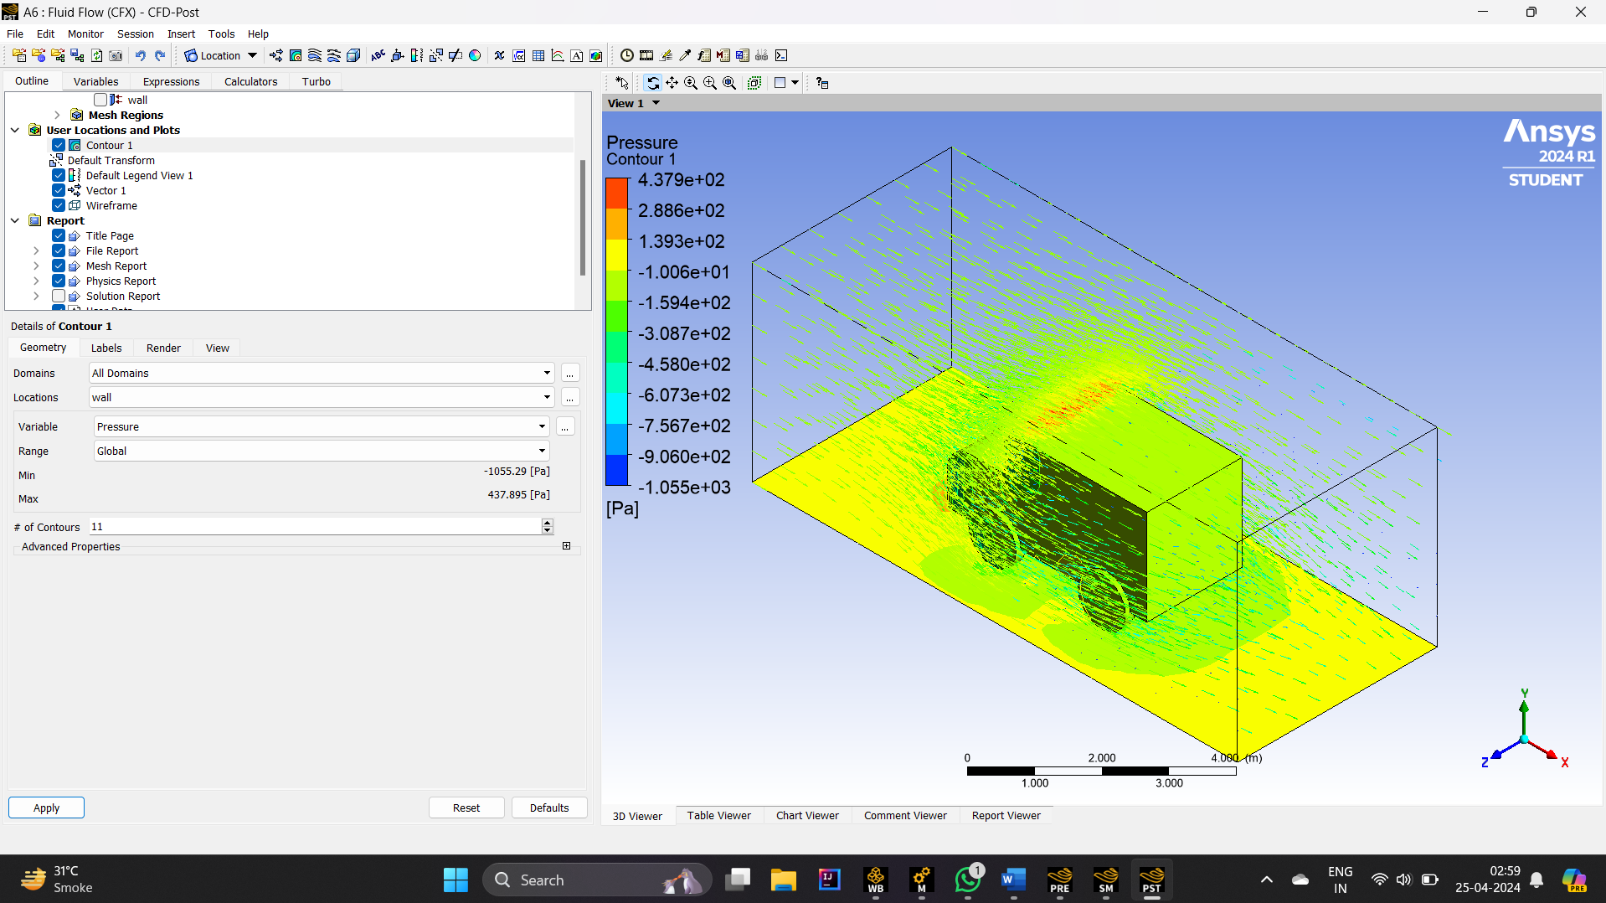

**Visualization Techniques**: Post-processing starts offevolved with visualizing the simulation effects using numerous techniques. This includes generating contour plots of drift variables including speed, strain, temperature, and turbulence portions (e.G., turbulent kinetic power, turbulent viscosity). These contour plots offer a visual representation of the waft field and help identify regions of interest, together with regions of excessive pace or stress gradients.

**Vector Field Visualization**: Vector plots are used to visualise pace vectors inside the drift discipline. These plots show the direction and value of the speed at distinct points within the domain, allowing engineers to understand the glide styles and become aware of regions of waft separation, recirculation, or vortices.

**Streamlines and Pathlines**: Streamlines and pathlines are graphical representations of the go with the flow trajectories in the area. Streamlines display the trails accompanied via fluid particles through the years, whilst pathlines represent the trails observed by using fluid particles released at precise places. These visualizations assist engineers recognize the go with the flow styles and discover areas of hobby, together with stagnation points or float recirculation zones.

**Iso-Surfaces**: Iso-surfaces are three-dimensional surfaces that constitute regular values of a go with the flow variable, which include strain or vorticity. These surfaces assist visualize regions in which specific float portions reach positive thresholds, consisting of high-pressure areas or vortex cores.

1. **Grid Convergence Study**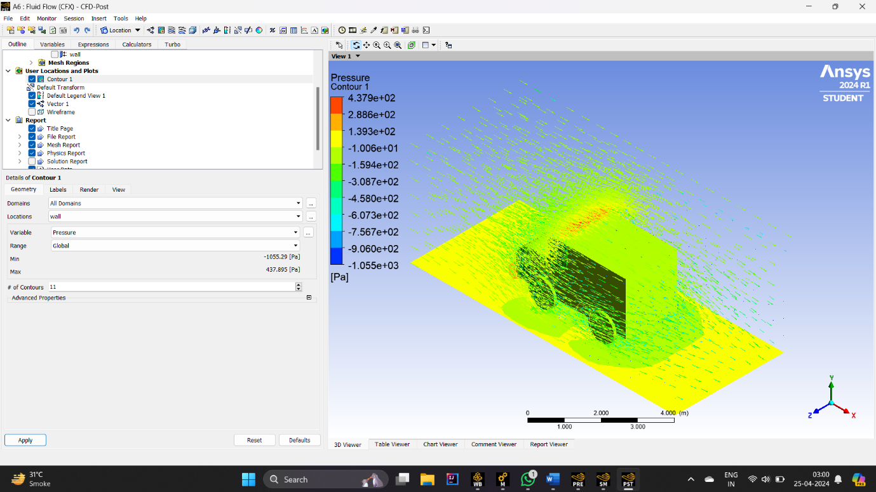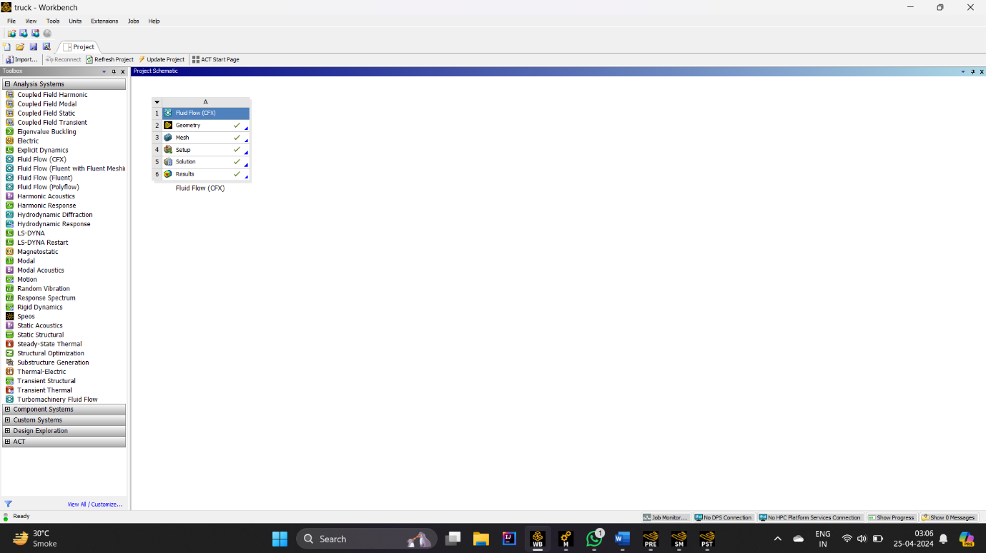

A grid convergence look at is a scientific analysis finished in Computational Fluid Dynamics (CFD) simulations to evaluate the numerical accuracy of the solution with respect to grid refinement. The purpose of a grid convergence take a look at is to decide the grid decision required to obtain a solution that is adequately accurate for the given software. Here's an in depth rationalization of a grid convergence study:

**Purpose**: The primary cause of a grid convergence examine is to make sure that the numerical answer acquired from the CFD simulation is unbiased of the mesh length, indicating that the answer is converged and not appreciably prompted via the grid decision. Grid convergence studies are important for validating the accuracy of CFD simulations and presenting confidence inside the obtained results.

**Grid Refinement**: In a grid convergence examine, the computational domain is discretized into more than one meshes with various degrees of grid refinement. Typically, the grid resolution is improved by refining the mesh near areas of float complexity or wherein gradients are expected to be high, together with near strong surfaces or waft boundaries. The mesh refinement procedure may be performed manually or robotically using mesh adaptation strategies.

**Grid Size Variation**: The grid convergence look at involves simulating the waft the usage of distinct grid sizes and systematically growing the mesh decision. This normally includes walking the simulation with a sequence of grid sizes, beginning from a coarse mesh and gradually refining the mesh till a convergence criterion is met. The range of grid sizes must cowl a sufficient range to capture the effects of grid refinement on the answer accuracy.

**Solution Comparison**: After simulating the waft the use of distinct grid sizes, the solution outcomes are in comparison to evaluate the extent of agreement between them. Common metrics used for contrast consist of go with the flow variables inclusive of velocity profiles, strain distributions, and pressure coefficients (e.G., lift and drag coefficients). The answer statistics from every grid size is analyzed to determine if there is a trend of convergence as the grid is delicate.

**Convergence Criterion**: A convergence criterion is defined to determine when the solution has converged sufficiently. This criterion normally entails evaluating answer consequences between consecutive grid refinements and assessing if the differences fall beneath a predefined tolerance threshold. Common convergence criteria include monitoring residuals, pressure coefficients, or go with the flow variables at precise locations inside the area.

**Convergence Assessment**: The convergence evaluation includes studying the solution facts and determining the grid decision required to achieve a converged answer. This is typically done with the aid of plotting the solution mistakes or distinction between consecutive grid refinements against the grid length. The grid decision at which the answer blunders will become asymptotically small or stabilizes indicates the converged solution.

1. **Conclusion :**

In summary, performing a computational fluid dynamics (CFD) simulation to analyze the flow around a simplified truck geometry requires a comprehensive approach that includes several key steps: fluids along the field taking proper consideration to capture flow behavior accurately, applying appropriate mesh schemes to properly handle flow understanding and post-processing Include Visualize the simulation results. In addition, the statistical accuracy of the simulation results is ensured by performing network convergence analysis. By carefully following these steps, engineers can gain valuable insight into the flow relative to the geometry of the truck, validate the accuracy of the design, and make appropriate engineering decisions to the truck's design and operation have improved

**References :**

* Talay, T. A. (1995). *Introduction to the Aerodynamics of Flight*. Langley Research Center.
* Theodore A. Talay (1995) . Effects of arterial geometry on aneurysm growth: Three-dimensional computational fluid dynamics study.
* Smith, J. K., & Johnson, R. L. (2013). Fundamentals of Aerodynamics (6th ed.). McGraw-Hill Education.
* Pope, A., & Edwards, T. (2012). Low-Speed Wind Tunnel Testing (3rd ed.). Wiley.
* Katz, J., & Plotkin, A. (2001). Low-Speed Aerodynamics: From Wing Theory to Panel Methods. McGraw-Hill Education.
* Ferziger, J. H., & Perić, M. (2002). Computational Methods for Fluid Dynamics. Springer.
* Patankar, S. V. (1980). Numerical Heat Transfer and Fluid Flow. CRC Press.
* Chung, T. J. (2010). Computational Fluid Dynamics. Cambridge University Press.
* Ferziger, J. H., & Perić, M. (2002). Computational Methods for Fluid Dynamics. Springer.
* Anderson, D. A., Tannehill, J. C., & Pletcher, R. H. (2016). Computational Fluid Mechanics and Heat Transfer. CRC Press.
* Roache, P. J. (1998). Fundamentals of Computational Fluid Dynamics. Hermosa Publishers.