**Q.1 - Explanation on how the fluid domain is considered.**

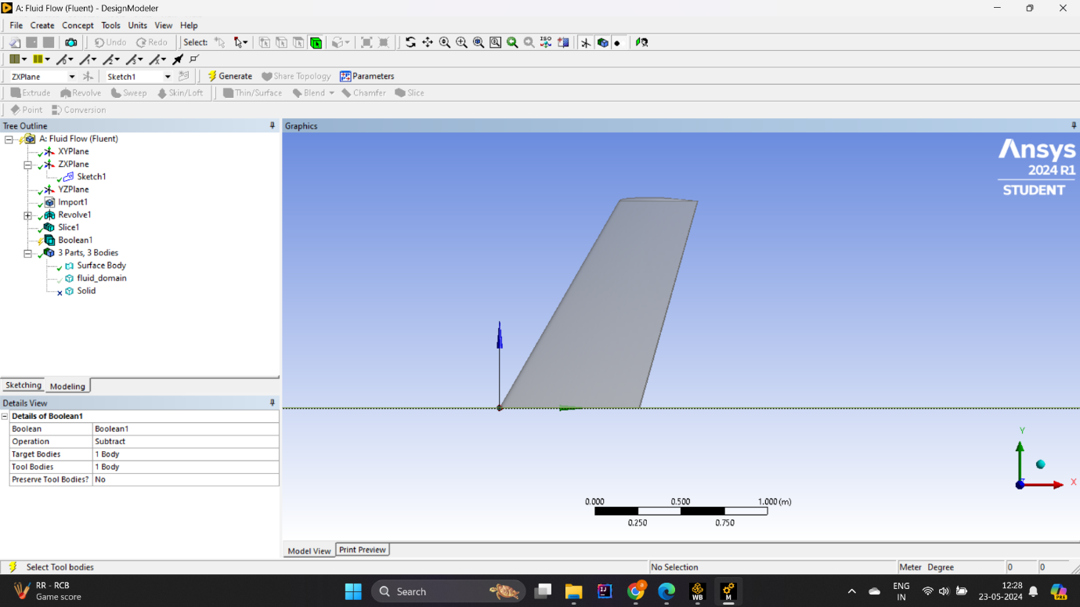

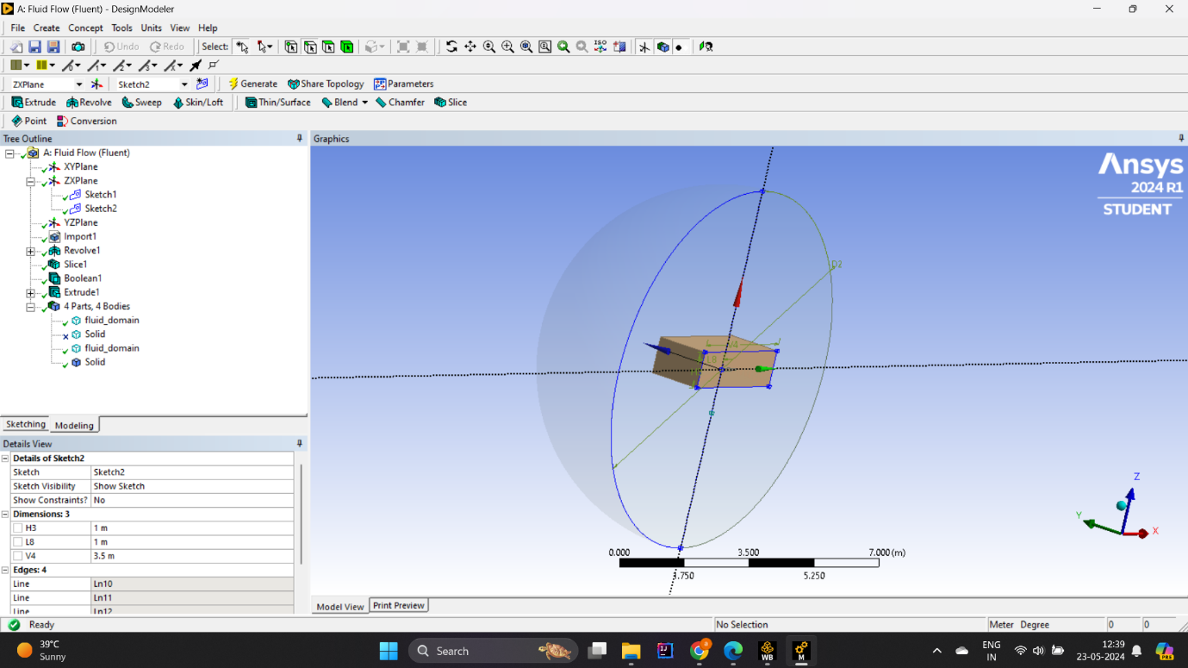

* **Geometry explains:**

**Wing geometry**: The ONERA M6 wing geometry is defined based on the data provided, and accurately captures the shape and form of the wing.

**Zone Expansion**: The water zone expands around the wing to ensure that the boundary effect is reduced. The typical system extends several lengths of wire up, down, and all sideways.

* **Formulation of the computational domain:**

**Inlet and outlet boundaries**: Inlet boundaries are established upstream several long lines in order to maximize the maximum flow Inlet boundaries are established far enough to ensure that there is sufficient clearance for the water to drain away from the viewfinder.

**Symmetry planes**: When symmetry is active, symmetry boundary conditions can be used to reduce computational costs by constructing only half of the section and domain .

**Remote field boundaries**: These boundaries are placed at a distance so that an infinite field can be simulated, thereby limiting the flow of the wing to a minimum .

**Q.2 - Explanation on the strategy used to mesh the domain.**

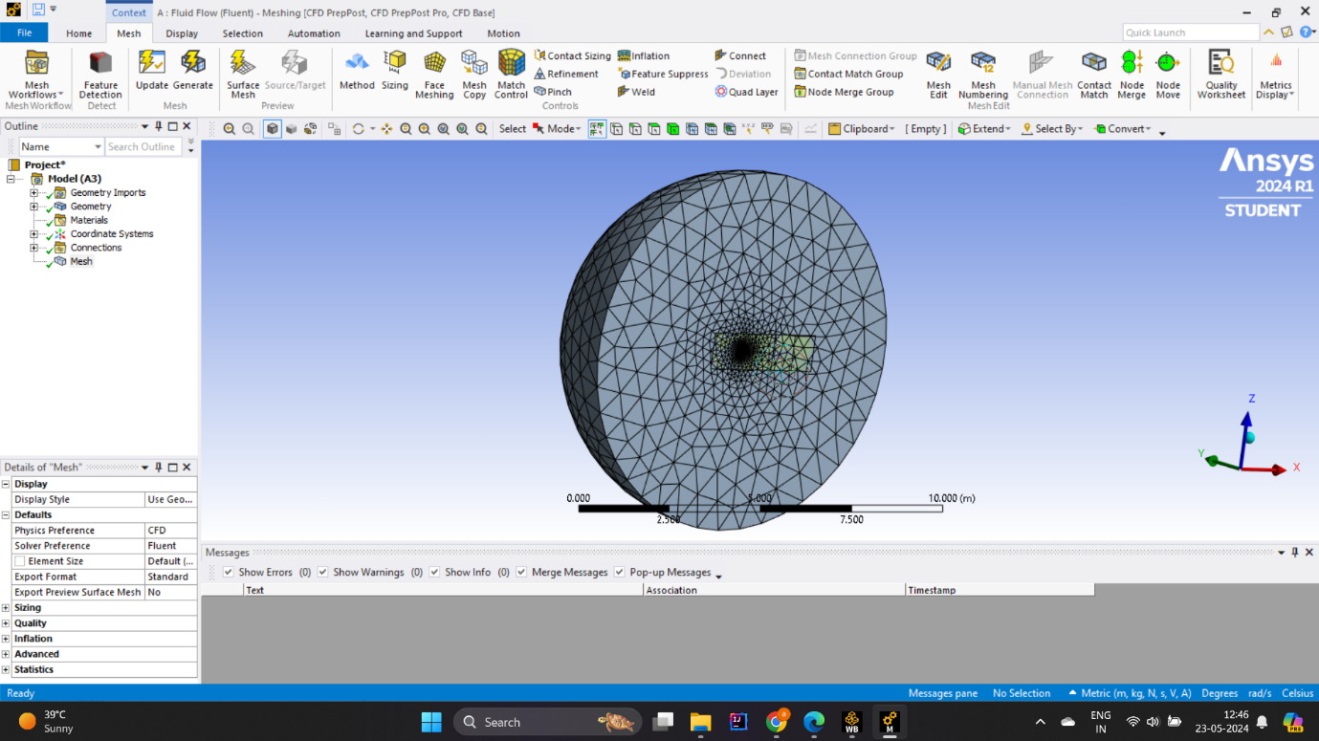

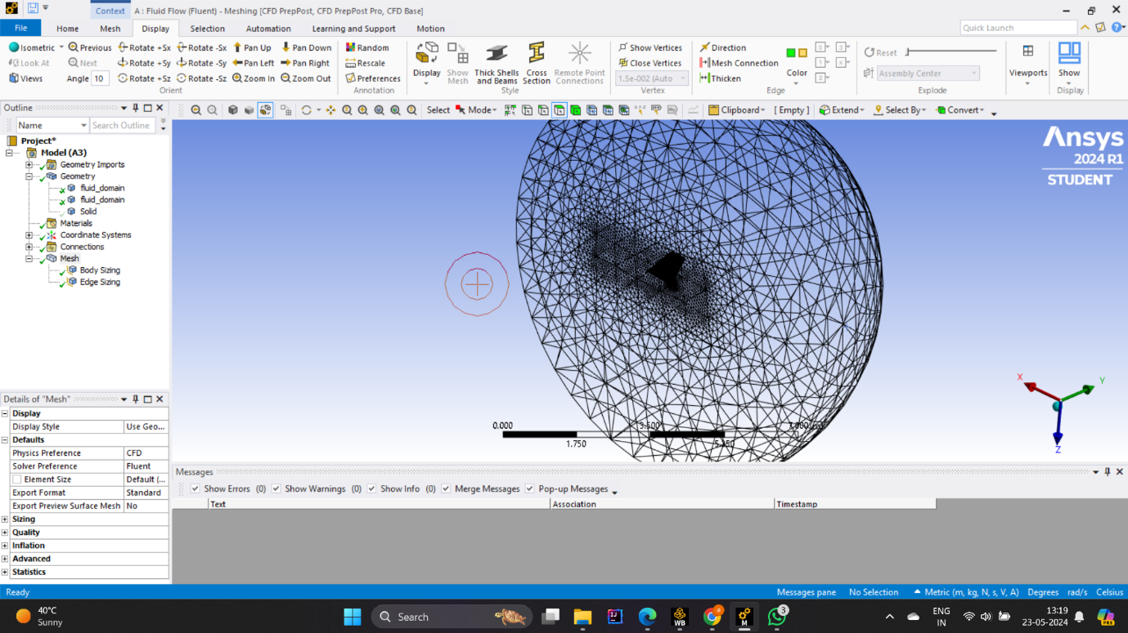

* **Meshing Methods:**

Hybrid grid approach: Use a combination of structured and unstructured grids to balance accuracy and computational efficiency.

Structured mesh: Use a structured hexagonal mesh close to the wing surface and areas of critical flow. This allows fine resolution of the boundary and the shock wave.

Unstructured grid: In a remote area where flow is less intense, use a tetrahedral grid or a multilateral grid.

* **Network Quality and Optimization:**

Quality Metrics: Monitor web quality using metrics such as slant, aspect ratio, and verticality. Aim to use high-quality materials to maintain the stability and accuracy of the calculations.

Adaptive meshing: In some cases, adaptive meshing techniques can be used to refine the mesh iteratively based on the initial solution slope.

* **Solver matching:**

Mesh Compatibility: Ensure that the mesh is compatible with solver settings such as turbulence models and flow solvers to achieve optimal performance and accurate results.

**Q.3 - Explanation on how the simulation is set up in the CFD solver.**

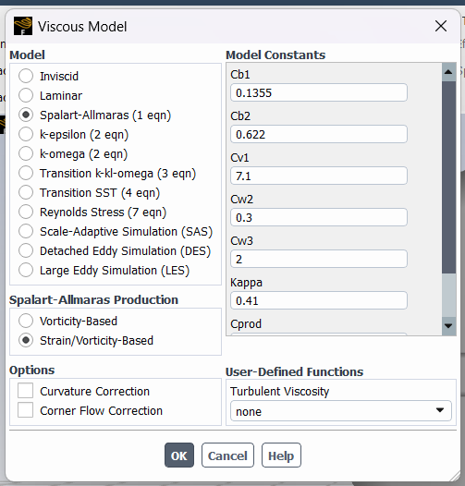



* **Geometry and meshing:**

Introduce the refined and validated ONERA M6 wing geometry.

Create a counting area that extends several lengths of wire along the top, bottom, and wings.

Create an optimal mesh using a hybrid approach (structured mesh near the wing and unstructured mesh in the far field).

Apply the finish near the wing surfaces, behind the fuselage, and in areas where rubbing is expected.

* **Natural resource management**:

**Resolver options**:

Select the appropriate solver based on the flow regime (usually ANSYS Fluent or CFX).

**Flow conditions**:

Set free-stream conditions such as Mach number, Reynolds number, and angle of attack.

Define air as a reactive fluid, determine its properties (density, viscosity).

* **The turbulence model:**

Select an appropriate turbulence model (e.g., Spalart-Allmaras, k-ω SST) to accurately capture turbulence effects.

**Q.4 - Explanation of the boundary conditions used.**

**This are the conditions used in this :**

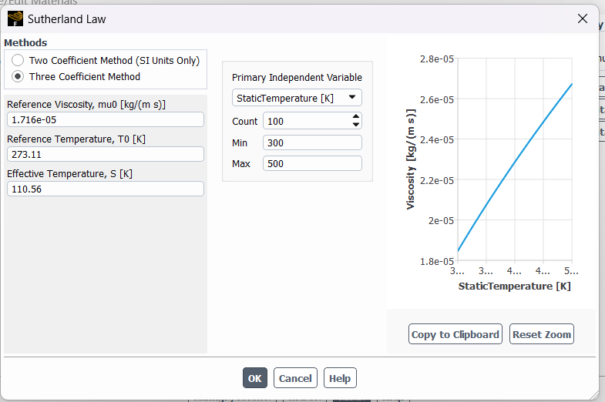

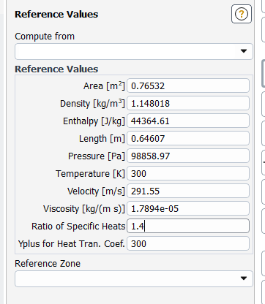

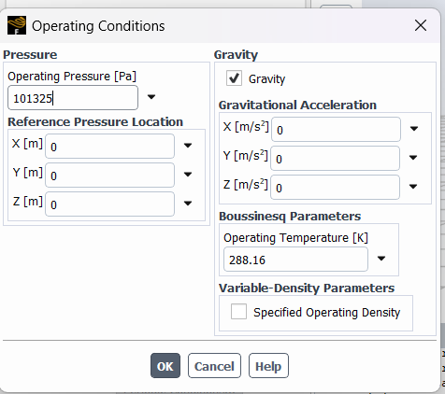



**Q.5 - Explanation of the solver settings used to run the simulation.**

**This are the solver setting used to run :**

* No. of iteration : 500
* Time scale factor : 1
* Reporting interval : 1

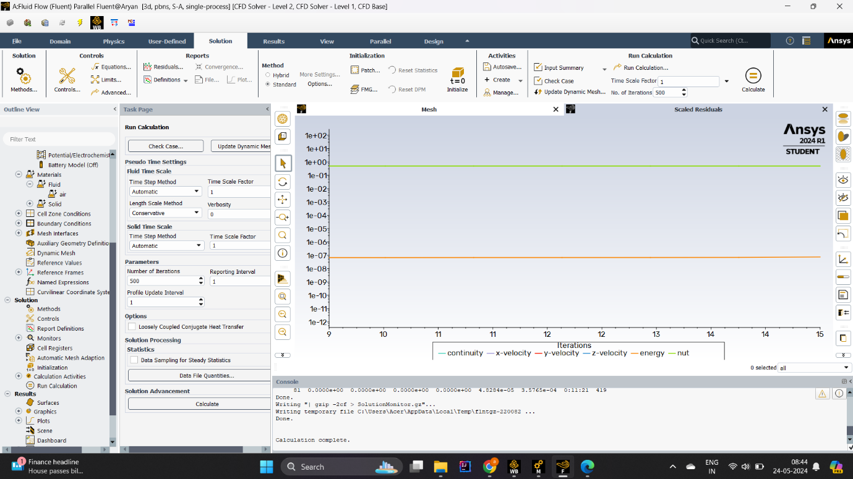

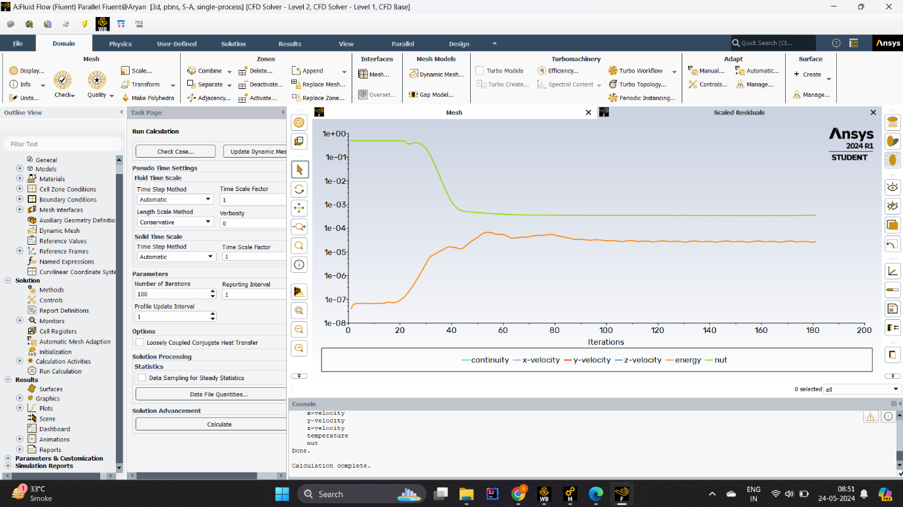

**Q.6 - Post process the simulation to obtain key features of the flow field.**

* **Flow diagram**:

**Pressure coefficients**:

Significance: The pressure profiles on the wing surface and surrounding fluid help to identify areas of high and low pressure, which are important for understanding the lift and drag forces

Important: Pressure distribution patterns are exhibited that contribute to aerodynamic forces. High-pressure areas generally indicate shear zones, while low-pressure areas are associated with height.

**Velocity field**: .

Definition: Velocity vectors and streamlines show the direction and magnitude of flow along the wing.

Important: These images help identify flow breakups, vortex formation, and recirculation zones. They are essential to understanding the efficiency of wind energy and its potential for improving flow management.

**Shocking waves**:

Implications: For transonic flows, assume shock waves as abrupt changes in pressure and density.

Important: Strong waves increase drag and can affect aircraft stability and control. Their location and abilities are crucial to running an effective party.

* **Aerodynamic theory**:

**Continuous Lift (C_L):**

Definition: Measures the lifting power of a wing.

Importance: An important indicator of wing efficiency. It helps to identify the type of lifting and main support.

**Coefficient of drag (C_D):**

Significance: Measures the resistance of airflow through the wing.

Important: Lower draw coefficients mean more efficient air conditioning, resulting in better fuel economy and efficiency.

**Time Module (C_M):**

Definition: Represents the pitching moment around a fixed point, usually the aerodynamic center.

* **Boundary Layer Analysis:**

**Pressure-absorbing wall**:

Meaning: The tangential force exerted by the fluid on the wing surface.

Significance: Regions of high shear stress indicate strong boundary effects and possible areas of flow separation.

**Upper boundary thickness**:

Definition: The distance from the wing surface to the point where the flow velocity reaches 99% of the stream velocity.

Important: Show how the flow takes place on the surface of the wing. A hard boundary can increase separation and drag.

* **Vortex and chaos**:

**Vorticity coefficients:**

Significance: Measures local circulation.

Importance: Helps detect vortices, which are important for understanding the separation of induced drag and flow.

**Turbulence Intensity**:

Definition: transition energy of the velocity field.

Importance: Regions of high disturbance can indicate areas of high energy dissipation and the possibility of structural fatigue.Boundary Layer Analysis:

**Pressure-absorbing** wall:

Meaning: The tangential force exerted by the fluid on the wing surface.

Significance: Regions of high shear stress indicate strong boundary effects and possible areas of flow separation.

**Upper boundary thickness**:

Definition: The distance from the wing surface to where the flow velocity reaches 99% of the free stream velocity.

Important: Show how the flow takes place on the surface of the wing. A hard boundary can increase separation and drag

**Q.7 - Grid convergence study, subject to the meshing constraints of the Ansys Fluent software .**

**Steps for grid convergence analysis:**

* **First network generation:**

Base grid: Create a base grid for the calculation area around the ONERA M6 segment. Make sure there is an appropriate balance between that decision and the audit fee.

Web Quality: Monitor quality metrics (slant, aspect ratio, verticality) to ensure web quality.

* **Number of settings:**

Refinement Strategy: Create progressively finer meshes. Typically, three to five storage units are used. Each fine mesh must be uniform or in critical areas the element size must be reduced by a factor (e.g., element size reduction by half).

Area repair: Focus on anticipated areas such as wing surfaces, leading and trailing edges, shock waves, and border

* **Simulation procedure for each network:**

Consistent physics settings: Use the same physical models, boundary conditions, and solver settings for each mesh layer to ensure consistency.

Convergence criteria: Check residuals and key flow variables (e.g., lift, drag coefficients) to ensure good convergence of each simulation.

* **Run the simulation:**

Simulation execution: Perform a simulation of each grid layer. Ensure that each run reaches a steady state or will converge smoothly when running a transient simulation.

* **Post-processing and research:**

Extract the main results: Extract the main aerodynamic parameters (lift, drag) and other relevant flow properties (pressure distribution, velocity field) for each grid.

Compare the results: Compare the results with the size of the mesh (or number of elements). Look for asymmetric behavior where the result is close to the refined constant value of the network.

* **Network Convergence Index (GCI):**

Calculation: Alternatively, calculate the grid convergence index (GCI) to quantify the convergence rate and uncertainty due to discretization error.

Method: Use the Richardson exclusion method to estimate the true value of interest rates and relative errors between networks.

**Important:**

Grid independence: ensures that simulation results are independent of the grid resolution, meaning that they are a true representation of the physical problem.

Accuracy and Reliability: Provides assurance that numerical solutions are accurate and reliable for engineering analysis and design decisions.

Optimization: Helps to optimize the network to balance computing cost and accuracy to ensure efficient use of resources.

**Q.8 - Comparison with experimental data provided in the above links.**

* **General information :**

General Structure: Both files contain sections detailing the various wing locations (X/L and Z/L) and the corresponding pressure coefficients (Cp).

Parameters: The data include the same parameters (X/L, Z/L, and Cp) that describe the way in which the general aerodynamic properties of the wing are captured

**The difference between the two**

* **Conditions for relocation:**

1ST.txt: run = 308, mach = 0.8395, alpha = 3.06, return = 11.72x10**6

2ND.txt: run = 565, mach = 0.8372, alpha = 6.06, return = 11.71x10**6

The second data set (2ND.txt) has a higher angle of attack (Alpha=6.06) compared to the first data set (Alpha=3.06), indicating a different flight condition to affect pressure distribution and aerodynamic chores

* **Compression Pressure (Cp) values:**

Closer to the front: for example, Cp values ​​of X/L around 0.1 in the two data sets show some differences.

1ST.txt: Cp values ​​range from -0.4805 to -0.50471

2ND.txt: Cp values ​​range from -0.61379 to -0.61979

Close to the background: Similarly at high X/L values.

1ST.txt: Cp values ​​range from -0.58026 to 0.17553

2ND.txt: Cp values ​​range from -0.52666 to 0.16898

* **All Events:**

1ST.txt: exhibits a gradual change in Cp with wing expansion, possibly due to low attack.

2ND.txt: shows more pronounced changes in Cp, especially more negative Cp near the leading edge, consistent with higher angles of attack leading to more lift and therefore less pressure at the top of the wing .

* **Specific Data Points Comparison**

At X/L=0.4879 and Z/L=0.3505:

1st link: Cp = -0.4805

2nd link: Cp = -0.61379

At X/L=0.98518 and Z/L=0.130:

1st link: Cp = 0.17553

2nd link: Cp = 0.16898

* **conclusion**

The mesh convergence class in ANSYS Fluent will attempt to ensure that these enhancements are not artifacts of the mesh but an accurate reflection of the physics to ensure that mesh independence optimizes the mesh unless other changes are made that change the Cp values great.

This comparison contributes to the understanding of aerobic behavior under different conditions and illustrates the need for more accurate and consistent correlation exercises in order to reliably capture these effects.

**REFERENCES :**

* Anderson, J. D. (2017). Introduction to Flight. McGraw-Hill Education.
* Bertin, J. J., & Smith, M. L. (2014). Aerodynamics for Engineers. Pearson.
* Houghton, E. L., Carpenter, P. W., Collicott, S. H., & Valentine, D. T. (2012). Aerodynamics for Engineering Students. Butterworth-Heinemann.
* McCormick, B. W. (1995). Aerodynamics, Aeronautics, and Flight Mechanics. John Wiley & Sons.
* Spalart, P. R., & Allmaras, S. R. (1992). A One-Equation Turbulence Model for Aerodynamic Flows.
* Rumsey, C. L., & Vatsa, V. N. (1993). Comparison of Several Turbulence Models with ONERA M6 Wing Experimental Data.
* **Journal Articles:**

Drela, M. (2014). Flight vehicle aerodynamic design. AIAA Journal, 52(3), 753-755. https://doi.org/10.2514/1.J052175

Katz, J. (2006). A review of high-angle-of-attack aerodynamics. Progress in Aerospace Sciences, 42(4), 233-292. https://doi.org/10.1016/j.paerosci.2006.07.001