Gestures

We used a dataset containing 35387 images for training the model and the dataset was saved with the name “Gesture”. The python file was saved with the name “Test.py” and the csv file was saved with the name “trainLabels”, and the trained model was saved with the name “modelg.h5”

The model was trained over a sample size of 28310 images, and it was validated and tested on sample size of 3537 images each.

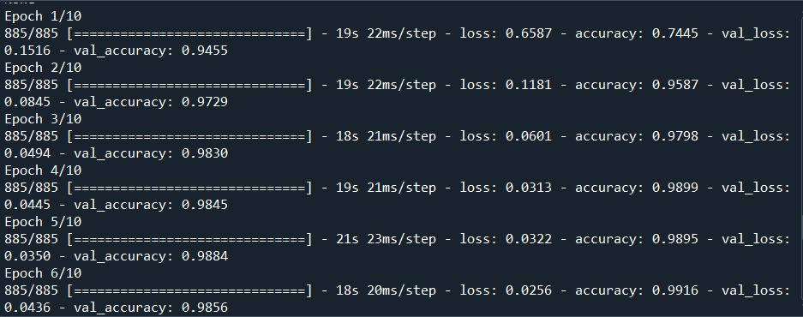

We labelled the classes as:

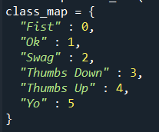

The testing accuracy was 99%.