Numbers

We used a dataset containing 25000 images (5000 for each number) for training the model and the dataset was saved with the name “Num_reduced”. The python file was saved with the name “Test.py” and the csv file was saved with the name “trainLabels” and the trained model was saved with the name “model.h5”

The model was trained over a sample size of 20000 images, and it was validated and tested on sample size of 2500 images each.

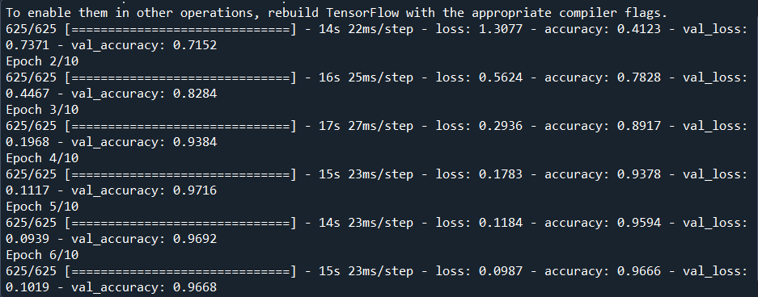

We labelled the classes as:

The testing accuracy was 95%.