Topic- PRABHAT AUTOMOBILES-INVENTORY EMPLOYEE MANAGEMENT SYSTEM



Chapter 4

System Design

**4.1 System Perspective**

The **Inventory Management System** (IMS) is a standalone, centralized software application designed to manage various business processes, including product inventory, employee records, sales transactions, and supplier information. This system is intended to streamline and automate inventory control and sales reporting for the organization. It integrates multiple modules such as **Employee Management**, **Product Management**, **Sales Recording**, and **Supplier Management**, each of which is tailored to the needs of specific user roles like **Admin** and **Employee**.

The system is designed to be scalable and flexible, providing a solid foundation for future enhancements. It can integrate additional features such as **Employee Login**, **Admin Dashboard**, and **Sales Reports**. Additionally, the system offers role-based access, ensuring that the **Admin** can manage all modules, while **Employees** have restricted access to sales-related functions.

**Key Components:**

* **Admin Dashboard**: Provides an overview of inventory, sales, and employee performance.
* **Employee Dashboard**: Allows employees to record sales and view sales-related reports.
* **Product Management**: Enables adding, updating, or removing products from the system.
* **Sales Management**: Facilitates recording sales transactions and generating sales reports.
* **Supplier Management**: Enables managing supplier details and product supply data.

**4.2- Context Diagram**

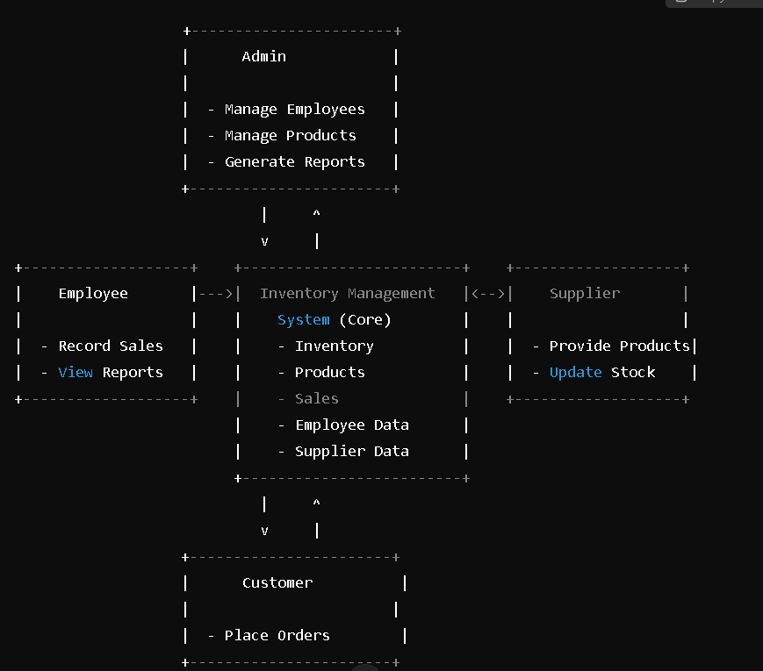

IGNTU B.Voc in Software Development 2024-25

Topic- PRABHAT AUTOMOBILES-INVENTORY EMPLOYEE MANAGEMENT SYSTEM



4.3 Use Case Diagram

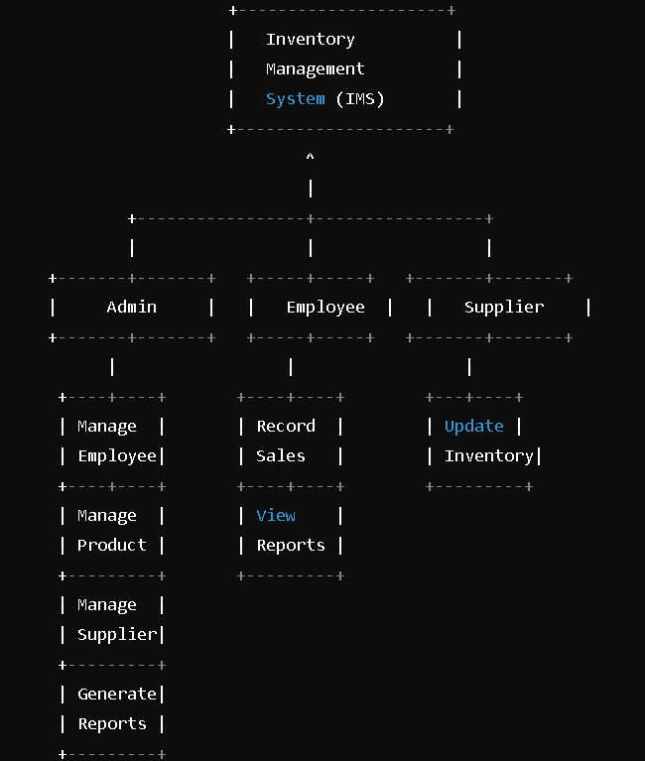



IGNTU B.Voc in Software Development 2024-25

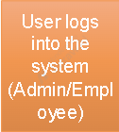Topic- PRABHAT AUTOMOBILES-INVENTORY EMPLOYEE MANAGEMENT SYSTEM **4.4 Activity diagram**















IGNTU B.Voc in Software Development 2024-25

Topic- PRABHAT AUTOMOBILES-INVENTORY EMPLOYEE MANAGEMENT SYSTEM 8



4.7- Database Design(ER)

4.8 Activity diagram

IGNTU B.Voc in Software Development 2024-25