

Minor Project Report on

**PRABHAT AUTOMOBILES-INVENTORY ,EMPLOYEE MANAGEMENT SYSTEM**

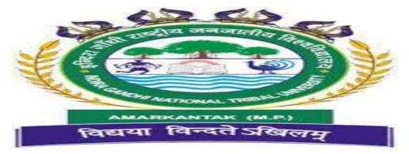

Bachelor of Vocation In

Software Development

Guide:

Dr. Kamlesh kumar Pandey

Submitted By:

Name – Aryan Gupta

Enrollment No - 2201123024

Submitted To:

Department of Vocational Education

Faculty of Technical, Vocational Education and Skill Training

Date of Submission: 03/11/2024



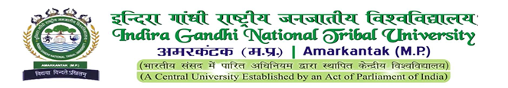

Minor Project Report on

PRABHAT AUTOMOBILES-INVENTORY EMPLOYEE MANAGEMENT SYSTEM

Subject Code: SDL-507

Session: 2024-2025

Submitted By:

Name: Aryan Gupta Signature

Enrolment: 2201123024

B. VOC in Software Development

Under the guidance of:

Mr. Harish Vishwakarma Sir

Assistant Professor Signature

Department of Vocational Education

Prof. Raghavendra Mishra Sir

HoD (Department of Vocation Education) Signature

Department of Vocational Education

Faculty of Technical, Vocational Education and Skill Training

IGNTU B.Voc in Software Development 2024-25





CERTIFICATE OF APPROVAL

This is to Certify that the project the entitled “PRABHAT AUTOMOBILES-INVENTORY EMPLOYEE MANAGEMENT SYSTEM” ,carried out by“Aryan Gupta”, Enrollment No.2201123024 a student of.B.Voc in Software Development 5th semester at Indira Gandhi National Tribal University Amarkantak (M.P.), is hereby approved after proper examination and evaluation as a creditable work for the partial fulfillment of the requirement minor project of Bachelor of Vocation (B.VOC) in Software Development from Indira Gandhi National Tribal University Amarkantak (M.P.).

(Internal Examiner) (External Examiner) Name: Name: Designation: Designation:

Date: Date:

IGNTU B.Voc in Software Development 2024-25

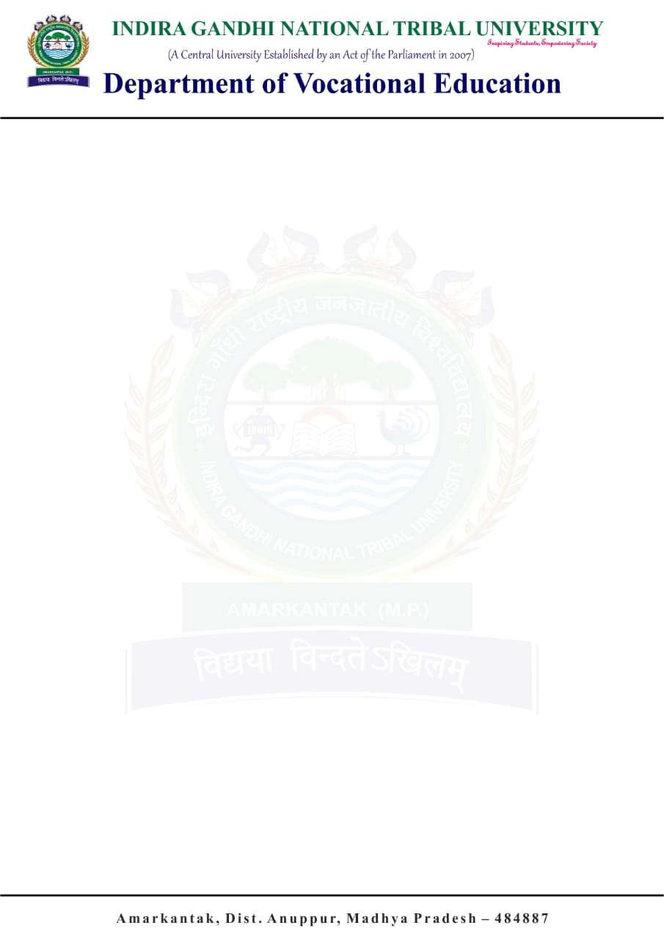

Topic- DAKSHINA2.0 -REC ATTENDANCE APP 4

IGNTU B.Voc in Software Development 2020-2023

CERTIFICATE

This is to Certify that the project entitled “PRABHAT AUTOMOBILES-INVENTORY EMPLOYEE MANAGEMENT SYSTEM”, carried out by “Aryan Gupta, Enrolment No: 2201123024” student of fifth semester, Bachelor of Vocation in Software Development, Department of Vocational Education at Indira Gandhi National Tribal University, Amarkantak (Madhya Pradesh) is hereby approved after proper examination and evaluation as a creditable work for the partial fulfilment of the requirement for awarding the Degree of Bachelor of Vocation in Software Development from Indira Gandhi National Tribal University, Amrkantak (M.P.) For the work carried out during a period from July, 2024 to Nov, 2024 under the guidance of Asst. Professor Mr. Harish Vishwakarma, Department of Vocational Education.

The Minor Project Viva-Voce Examination has been held on 03 Dec, 2024.

Internal Examiner External Examiner

Head

Prof. Raghavendra Mishra

Department of Vocational Education

Indira Gandhi National Tribal University, Amarkantak

(Madhya Pradesh)



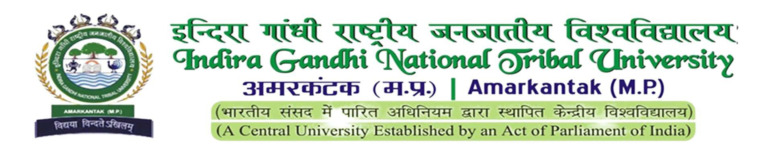

DECLARATION

I hereby declare and certify that, the Minor Research Project entitled “PRABHAT AUTOMOBILES-INVENTORY EMPLOYEE MANAGEMENT SYSTEM the marketing of Micro small and Medium Enterprises and mangment of firms in Anuppur District” is a bonafide record of research work carried out by me during the year2024-25. Further certify that the work presented in the report is original and carried out according to the plan as possible in the proposal and guidelines of the, Department of Vocational Education, IGNTU.

Name – Aryan Gupta

Enrollment No:- 2201123024

IGNTU B.Voc in Software Development 2024-25

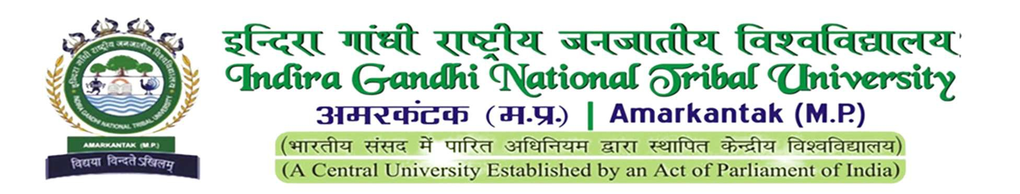



AKNOWLEDGMENT

We have great pleasure in submission of this project report entitled software in python ‘PRABHAT AUTOMOBILES-INVENTORY EMPLOYEE MANAGEMENT SYSTEM ’ for partial fulfillment of the Degree Of Vocational Education in Software Development While submitting Thus project report.

I would like to express my sincere appreciation and gratitude to all those who have contributed to the “PRABHAT AUTOMOBILES-INVENTORY EMPLOYEE MANAGEMENT SYSTEM ” Software in python.

We would like to extreme delight and thank fullness our sir Mr. Harish Vishawakara Sir, Mr. Kamlesh Kumar Pandey sir and Head of the Department Prof. Raghavendra Mishra sir, Prof. Manisha Sharma, Dean, Faculty of Technical, Vocational Education and Skill Training who have provided us the opportunity and organized our project report for us.

Without their active co-operation and guidance. It would have become very difficult to complete task in time. I would also like to thank my all faculty members, my family, and my friends to being a foundation of love and support during the term of my minor project.

Name- Aryan Gupta

Enrollment No.2201123024

IGNTU B.Voc in Software Development 2024-25



Table of Content

Chapter 1- (Introduction)

1.1- Certificate

1.2- Declaration

1.3- Acknowledgement

1.4- Institution profile

1.5- Project Introduction

Chapter 2- (System Study)

2.1- Existing and proposed system

2.2- Feasibility Study

2.3- Tools and Technologies used

2.4 -HARDWARE AND SOFTWARE REQUIREMENT

Chapter 3- (Software Requirements Specification)

3.1- Users

3.2- Functional Requirements

3.3- Non-Functional Requirements

Chapter 4- (System Design)

4.1- System Perspective

4.2- Context Diagram

4.3- Use Case Diagram

4.4- Activity Diagram

4.5- Database Design(ER)

Chapter 5- (Implementation)

5.1.- Screen Shots of the Project Chapter 6-(Software Testing)

Chapter 7-(Conclusion)

Chapter 8- (Future Enhancements)

Appenix- References,

DAILY REPORT

IGNTU B.Voc in Software Development 2024-25

Topic- PRABHAT AUTOMOBILES-INVENTORY EMPLOYEE MANAGEMENT SYSTEM



**Institution profile**

The University –

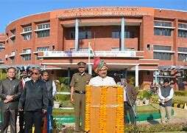

The Indira Gandhi National Tribal University, Amarkantak has been established by an Act of the

Parliament of India. It came into existence by the Indira Gandhi National Tribal University Act,

2007 and came into action on July 2008. The jurisdiction of the University extends to the whole country and it is fully funded by the Central Government through the University Grant Commission. The university caters to the tribes’ long cherished dream of higher education.

Aims and Objectives –

The tribal people are rich in cultural heritage and skill of art and craft but they are still marginalized in respect to higher education as well as in other walks of life. Now in the present age of globalization the world has shrunk into a village as the society has advanced in technology. But the tribes, who are the custodians of Indian culture in real sense, are far behind in this race of advancement. In order to rescue them from the present plight, the university has put before itself the following aims and objectives-

To provide avenues of education, especially higher education and research facilities primarily for the tribal population of India.

To disseminate and advance knowledge by providing instructional and research facilities in tribal art, tradition, culture, language, medicinal systems, customs, forest based economic activities, flora, fauna and advancement in technologies relating to the natural resources of the tribal areas.

To collaborate with national and international universities and organizations, especially for undertaking cultural studies and research on tribal communities.

IGNTU B.Voc in Software Development 2024-25

Topic- PRABHAT AUTOMOBILES-INVENTORY EMPLOYEE MANAGEMENT SYSTEM 10



To formulate tribal centric development models, publish reports and monographs and to organize conferences and seminars on issues relating to tribes and to provide inputs to policy matters in different spheres.

To take appropriate measures for promoting the members of tribal communities capable of managing, administering and looking after their own needs by access to higher education through a university of their own.

To disseminate and advance knowledge by providing instructional and research facilities in such other branches of learning as it may deem fit.

To take appropriate measures for promoting innovations in teaching learning process in inter- disciplinary studies and researches and to pay special attention to the improvement of social, educational and economic conditions and welfare of the scheduled tribes within the Union of India.

In view of the aims and objectives of the university the major thrust will be on providing more opportunity for the tribes. However, the university is open to all.

IGNTU B.Voc in Software Development 2024-25

Topic- PRABHAT AUTOMOBILES-INVENTORY EMPLOYEE MANAGEMENT SYSTEM 11



About the Department

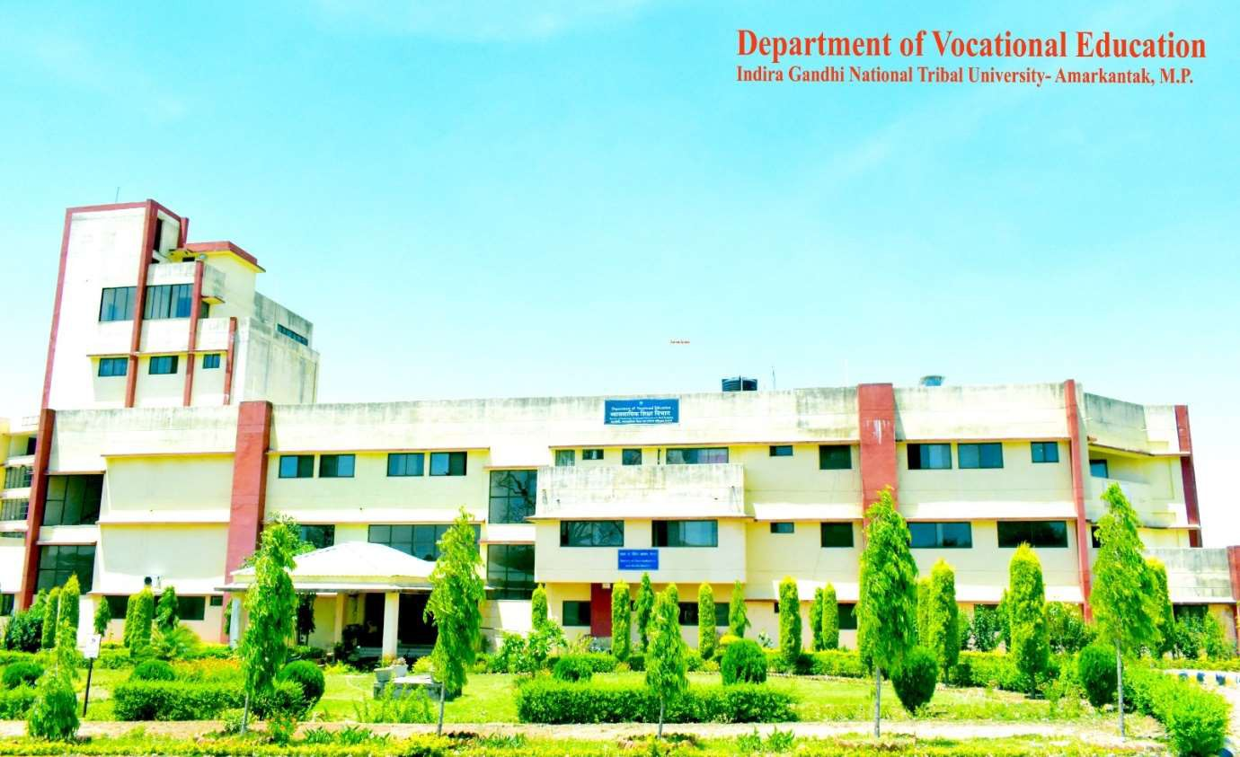

The Indira Gandhi National Tribal University (IGNTU) Bachelor of Vocation (B.Voc) department is an esteemed and dynamic division within the university, aimed at empowering tribal communities and promoting inclusive vocational education. It is committed to providing specialized training and skill development opportunities to students from tribal backgrounds, enabling them to excel in various industries and contribute to the socio-economic development of their communities.

The B.Voc department at IGNTU offers a range of vocational programs that cater to the specific needs and aspirations of tribal students. These programs cover diverse sectors such as agriculture, horticulture, forestry, tourism and hospitality, healthcare, handicrafts,

entrepreneurship, and renewable energy, among others. The curriculum is meticulously designed to integrate theoretical knowledge, practical skills, and hands-on training, ensuring a well- rounded learning experience.

The department strives to bridge the gap between academia and industry by collaborating with leading organizations and experts in respective fields. This collaboration facilitates the development of industry-relevant curriculum, incorporating the latest advancements and best practices. Students benefit from exposure to real-world scenarios, industry visits, internships, and interactions with professionals, enhancing their understanding of industry requirements and cultivating a professional mindset.

IGNTU B.Voc in Software Development 2024-25

Topic- PRABHAT AUTOMOBILES-INVENTORY EMPLOYEE MANAGEMENT SYSTEM 12



IGNTU's B.Voc department places a strong emphasis on the holistic development of students. The faculty members are highly qualified, experienced, and dedicated individuals who provide mentorship and guidance to the students. They employ innovative teaching methodologies, including interactive sessions, practical demonstrations, case studies, and project-based learning, to foster critical thinking, problem-solving abilities, and entrepreneurial skills among the students.

The department also emphasizes the preservation and promotion of tribal culture and traditions. Special attention is given to incorporating indigenous knowledge systems into the curriculum, ensuring that students are connected to their roots while acquiring modern skills. This approach not only empowers tribal communities but also contributes to the preservation and revitalization of indigenous practices and knowledge.

Furthermore, the B.Voc department at IGNTU encourages research and innovation among students. It provides opportunities for students to engage in research projects, collaborate with faculty members, and explore innovative solutions to address societal challenges. This research- driven approach nurtures creativity, intellectual curiosity, and the ability to contribute to knowledge creation and innovation in their chosen fields.

Upon successful completion of their B.Voc programs, graduates from IGNTU's B.Voc department possess a unique blend of theoretical knowledge, practical skills, cultural sensitivity, and entrepreneurial spirit. They are well-equipped to meet the demands of the industry, start their own ventures, or contribute meaningfully to the development of tribal communities and society

at large.

In conclusion, the IGNTU B.Voc department stands as a beacon of empowerment for tribal students, offering industry-oriented vocational programs that combine academic rigor, practical skills, and cultural sensitivity. It not only prepares students for successful careers but also instills in them a sense of pride in their tribal heritage, fostering their holistic development and facilitating the socio-economic progress of tribal communities.

IGNTU B.Voc in Software Development 2024-25



Title of the Project

PRABHAT AUTOMOBILES-INVENTORY EMPLOYEE MANAGEMENT SYSTEM

IGNTU B.Voc in Software Development 2024-25

Topic- PRABHAT AUTOMOBILES-INVENTORY EMPLOYEE MANAGEMENT SYSTEM 14



Chapter – 1

INTRODUCTION



The **Inventory Management System** is a Python-based software solution developed specifically for the client firm, **Prabhat Automobiles**, to handle the complexities of managing their inventory, employees, and sales operations. This system is a comprehensive tool aimed at enhancing the operational efficiency of the organization by automating repetitive tasks, providing accurate data, and simplifying workflows.

The system is designed with two primary user roles: **Admin** and **Employee**, each with dedicated login access and tailored functionalities to meet their respective needs.

1. **Admin Login**:
   * The admin has full access to the system and can oversee all operational aspects.
   * The admin dashboard provides a central hub for managing various entities, such as employees, products, sales, and categories.
   * Key features include:
     + **Employee Management**: The admin can add new employees, update their details, or remove them when necessary.
     + **Product Management**: Products can be categorized, added, updated, or removed, ensuring an organized inventory structure.
     + **Sales Overview**: The admin can view and monitor sales records to analyze trends and make strategic decisions.
     + **Category Management**: Products are systematically categorized, enabling better inventory tracking and reporting.
     + A status display on the home screen shows real-time data, such as the total number of employees, products, and sales figures.
2. **Employee Login**:
   * Employees have restricted access, focusing solely on sales-related tasks.
   * The system enables employees to log sales transactions efficiently and view relevant sales data.
   * This separation of roles ensures secure access control, with employees limited to functionalities directly related to their job responsibilities.

The system utilizes **Tkinter** to provide a graphical user interface (GUI) that is intuitive and easy to navigate. The backend is powered by **SQLite**, offering a lightweight yet robust database solution for storing and retrieving inventory-related data.

The **Inventory Management System** is a practical and scalable solution that addresses the inventory challenges faced by **Prabhat Automobiles**. By integrating features for managing employees, products, sales, and categories, the system empowers the organization to operate more efficiently, reduce manual errors, and focus on core business growth

IGNTU B.Voc in Software Development 2024-

Topic- PRABHAT AUTOMOBILES-INVENTORY EMPLOYEE MANAGEMENT SYSTEM



Chapter 2

System Study

2.1- Existing and proposed system

EXISTING SYSTEM:

• **Manual Operations:** Inventory and sales are managed using paper records or basic tools.

• **Inefficiencies:** Time-consuming processes prone to human errors.

• **Data Management Issues:** Difficult to handle and retrieve growing data.

• **Lack of Reporting:** No system for generating real-time inventory or sales reports.

• **Limited Scalability:** Unable to meet the evolving needs of the business..

PROPOSED SYSTEM:

The system allows one to easily access the relevant information and make necessary operations. Users can have to opton to login by two ways andmake the operations succesfully

Our proposed system has several advantages:

• **Automation:** Streamlines inventory and sales management with an automated system.

• **Role-Based Access:** Admin for full management; Employees for recording sales.

• **Centralized Database:** Unified platform for employees, products, suppliers, and categories.

• **Dashboard:** Real-time updates on inventory, sales, and employee status.

• **Enhanced Efficiency:** Reduces errors, saves time, and improves productivity.

2.2 Feasibility Study:

**Technical Feasibility:**

* Uses Python, Tkinter, and SQLite, which are reliable and widely supported technologies.

**Economic Feasibility:**

* Cost-effective system development with minimal infrastructure requirements.

**Operational Feasibility:**

* Easy-to-use interface for Admin and Employees ensures smooth adoption and operation.

IGNTU B.Voc in Software Development 2024-25

Topic- PRABHAT AUTOMOBILES-INVENTORY EMPLOYEE MANAGEMENT SYSTEM



**Technical Feasibility:**

❖ The technical issue usually raised during the feasibility stage of the investigation includes the following:

❖ Does the necessary technology exist to do what is suggested?

❖ Do the proposed equipment’s have the technical capacity to hold the data required to use the new system?

❖ Will the proposed system provide adequate response to inquiries, regardless of the number or location of users?

❖ Can the system be upgraded if developed?

❖ Are the technical guarantees of accuracy, reliability, ease of access and data security?

**Operational Feasibility:**

❖ User-friendly.

❖ Reliability

❖ Security

❖ Portability

❖ Availability

❖Maintainability : The Inventory Management System is designed with modular components, scalability, comprehensive documentation, and efficient database management to ensure easy updates, debugging, compatibility, and long-term maintenance.

IGNTU B.Voc in Software Development 2024-25

Topic- PRABHAT AUTOMOBILES-INVENTORY EMPLOYEE MANAGEMENT SYSTEM 17



**Economic Feasibility:**

The proposed system automates the entire workflow of the current manual system, ensuring seamless data flow and efficient report generation, including advanced management reports. Being a centralized web-based application with distinct web and database servers, it eliminates the need for multiple localized systems, reducing redundancy and hardware costs.

The centralized database minimizes data inconsistencies and improves operational efficiency, even across different locations. While initial development involves investment in web servers and database infrastructure, it offers significant long-term cost savings by streamlining operations, reducing manual effort, and enabling faster transactions. This ensures high ROI with minimal ongoing maintenance costs.

**2.3- Tools and Technologies used**

**PYTHON**

Python is a versatile and high-level programming language renowned for its simplicity and readability, making it ideal for beginners and professionals alike. It supports multiple programming paradigms, including procedural, object-oriented, and functional programming, and boasts a vast standard library that simplifies complex tasks like file handling, web development, and data analysis. Python is platform-independent, allowing programs to run seamlessly across Windows, macOS, and Linux.

System requirements include a modern operating system (Windows, macOS, or Linux), a minimum of 1 GB RAM (4 GB recommended), and a few hundred megabytes of disk space. Installation involves downloading Python from the official website, setting up the PATH environment variable, and optionally installing an IDE like PyCharm or Visual Studio Code for enhanced development.

Python is widely used in web development (via Django, Flask), data science, artificial intelligence, and automation. Its extensive documentation, active community, and compatibility with numerous frameworks and tools make it a go-to language for a diverse range of applications.

*WHAT ARE ANDROID STUDIO’S KEY FEATURES*

Python is a versatile, high-level programming language known for its simple, readable syntax and cross-platform compatibility. It offers a vast standard library and supports multiple programming paradigms, including object-oriented and functional programming. With dynamic typing and automatic memory management, Python is flexible and efficient. It integrates well with other languages and systems, making it ideal for web development, data analysis, machine learning, and automation. Python’s active community, extensive documentation, and rich ecosystem of third-party libraries like Django, Flask, and TensorFlow contribute to its widespread use and ease of development.

IGNTU B.Voc in Software Development 2024-25

Topic- PRABHAT AUTOMOBILES-INVENTORY EMPLOYEE MANAGEMENT SYSTEM



HOW PYTHON WORKS

Python is an interpreted, high-level programming language that follows a clear execution process:

1. **Writing the Code:**
   * You write Python code using a text editor or an Integrated Development Environment (IDE) like PyCharm or Visual Studio Code.
2. **Interpreter Reads the Code:**
   * Python is an interpreted language, meaning the Python interpreter reads and executes the code line by line. It doesn't need to be compiled before execution.
3. **Bytecode Compilation:**
   * The Python interpreter compiles the source code (.py file) into bytecode (.pyc file). This bytecode is a lower-level representation of the code that is platform-independent.
4. **Execution by Python Virtual Machine (PVM):**
   * The bytecode is sent to the Python Virtual Machine (PVM), which is responsible for executing the instructions. The PVM runs the bytecode on the host machine, translating it into machine code for the specific platform.
5. **Memory Management and Garbage Collection:**
   * Python handles memory management automatically using a built-in garbage collector, which frees up unused memory to optimize resource utilization.

BENEFITS OF PYTHON

Python offers a wide range of benefits that make it a popular choice for developers. Its simple and readable syntax enables easy learning and faster development, even for beginners. Python's cross-platform compatibility allows it to run seamlessly on various operating systems like Windows, macOS, and Linux. The language boasts a rich standard library that supports diverse tasks, from web development to machine learning. Python’s extensive third-party library ecosystem further enhances its capabilities. Its dynamic typing and automatic memory management simplify coding and optimize resource use. With strong community support and active forums, Python remains a top choice for developers across industries.

IGNTU B.Voc in Software Development 2024-25

Topic- PRABHAT AUTOMOBILES-INVENTORY EMPLOYEE MANAGEMENT SYSTEM



HISTORY:

Python was created by **Guido van Rossum** in the late 1980s at **Centrum Wiskunde & Informatica** (CWI) in the Netherlands. The development of Python began in December 1989, with its first release (version 0.9.0) in **February 1991**. Van Rossum aimed to create a language that was easy to understand and use, with a focus on code readability and simplicity. Python was designed to be a successor to the **ABC programming language**, which was developed at CWI but had limitations that Python sought to address.

Python was officially named after the **Monty Python's Flying Circus**, a British comedy series, reflecting van Rossum's intent to make the language fun and approachable, unlike more serious programming languages of the time.

**Key Milestones:**

• **1989:** Python was created by **Guido van Rossum** as a successor to ABC at **CWI**.

• **1991:** First release of Python (**0.9.0**) with core features like exception handling and functions.

• **1994:** Python 1.0 launched, introducing modules and core data types.

• **2000:** **Python 2.0** released with garbage collection and list comprehensions.

• **2001:** **Python Software Foundation (PSF)** formed to oversee development.

• **2008:** **Python 3.0** introduced with major language changes, breaking backward compatibility.

• **2010:** **Python 2.7** was the final release of Python 2.x.

• **2020:** Python 2 reached end-of-life (EOL).

• **2021-2023:** Continuous improvement with Python 3.9 and 3.10, including new features like pattern matching.

• **Present:** Python remains one of the most popular languages, especially in AI, data science, and web development.

IGNTU B.Voc in Software Development 2024-25

Topic- PRABHAT AUTOMOBILES-INVENTORY EMPLOYEE MANAGEMENT SYSTEM



**MySQL:**

**MySQL** is an open-source relational database management system (RDBMS) that uses **Structured Query Language (SQL)** for accessing, managing, and manipulating data stored in tables. MySQL is one of the most widely used database systems, known for its speed, reliability, and ease of use.

Key Features:

atabase management system (RDBMS) that uses **Structured Query Language (SQL)** for accessing, managing, and manipulating data stored in tables. MySQL is one of the most widely used database systems, known for its speed, reliability, and ease of use.

**Key Features of MySQL:**

1. **Open-Source**  
   MySQL is free and open-source, with its source code available for anyone to modify and distribute.
2. **Cross-Platform**  
   It works on various platforms, including Windows, macOS, Linux, and others, making it highly flexible.
3. **Relational Database**  
   Data is stored in tables that can be related to each other using foreign keys, making it ideal for structured data.
4. **ACID Compliant**  
   MySQL provides full support for **ACID** (Atomicity, Consistency, Isolation, Durability) properties, ensuring reliable transaction processing.
5. **Support for Large Databases**  
   MySQL supports large databases, with the ability to scale up for large-scale web applications and enterprises.
6. **Multi-User Access**  
   Multiple users can access the database at the same time with different privileges and access control.
7. **Replication**  
   MySQL supports data replication, allowing databases to be copied across multiple servers for redundancy and backup.
8. **Security**  
   Provides robust security features, such as user authentication, SSL connections, and granular access control.
9. **Full-text Search**  
   It supports full-text indexing and search capabilities, making it useful for applications that require searching through large amounts of text.

IGNTU B.Voc in Software Development 2024-25



Topic- PRABHAT AUTOMOBILES-INVENTORY EMPLOYEE MANAGEMENT SYSTEM 25



**2.4 HARDWARE AND SOFTWARE REQUIREMENT**

The following description shows the minimum and recommended Hardware and Software Minimum:

❖ Windows 7,8,10 server 2012, 64 bits (PC or Mac).

❖ Any CPU (Intel i3/i5/17 recommended).

❖ Any GPU that is compatible with OpenGL 3.2. (Integrated graphics cards InteL iris Xe or above).

❖ Medium projects (between 100 and 500 images at 14 MP): 8 GB RAM, 20 GB HDD Free

Space.

❖ Large projects (between 500 and 2000 images at 14 MP): 16 GB RAM, 40 GB HDD Free

Space.

❖ Very Large projects (over 2000 images at 14 MP): 16 GB RAM, 80 GB HDD Free Space.

IGNTU B.Voc in Software Development 2024-25

Topic- PRABHAT AUTOMOBILES-INVENTORY EMPLOYEE MANAGEMENT SYSTEM



Chapter 3

Software Requirements Specification

**3.1 Users**

The **Inventory Management System** for **Prabhat Automobiles** will have the following types of users:

1. **Admin**:
   * Full access to all features of the system.
   * Responsibilities include managing employees, products, categories, suppliers, and sales reports.
   * Can view and update all data, such as inventory levels, employee information, and sales records.
2. **Employee**:
   * Limited access to system features.
   * Can record sales transactions, view sales performance, and generate reports based on their own activities.
   * No access to employee management, product management, or supplier management functionalities.

**3.2 FunctionalRequirements**

The functional requirements outline the essential actions and operations for the system. These requirements focus on user authentication, role management, and features available to admins and employees.

**User Authentication and Role Management:**

* **Login:** Both admins and employees will log in using a username and password. Admins will have full access to the system, while employees will have restricted access based on their roles.
* **Logout:** Both admins and employees can securely log out of the system.

**Admin Features:**

* **Employee Management:** Admins can add, update, and delete employee records. They can also view a list of employees.

IGNTU B.Voc in Software Development 2024-25

Topic- PRABHAT AUTOMOBILES-INVENTORY EMPLOYEE MANAGEMENT SYSTEM 28

* **Product Management:** Admins can manage the product inventory by adding, updating, and deleting products. They can also check product details and stock levels.
* **Category Management:** Admins have the ability to add and delete product categories.
* **Supplier Management:** Admins can manage supplier details, including adding, updating, and deleting records.
* **Sales Reporting:** Admins can generate comprehensive reports on sales, inventory levels, and employee performance.

**Dashboards:**

* **Admin Dashboard:** Provides an overview of the entire system, showing total employees, products, categories, sales, and inventory status.
* **Employee Dashboard:** Displays the employee’s sales performance, including relevant reports and metrics.

**Security Features:**

* **Password Protection:** All user passwords will be securely stored using encryption techniques.
* **Role-Based Access Control:** Admins have access to all features of the system, while employees are restricted to sales-related functionalities

**3.3 NON FUNCTIONAL REQUIREMENTS:**

In the initial stages of system development, non-functional requirements focus on ensuring the system is secure, scalable, and user-friendly. Performance-wise, pages should load within 3-5 seconds, and the homepage and dashboard should be optimized for quick loading. Scalability should support a small to medium user base, with efficient handling of initial data sets. Availability is key, with a target of 95-98% uptime and basic backup procedures in place. Security features like password encryption and role-based access control will be implemented from the start. The user interface will be simple and intuitive, focusing on usability, while ensuring accessibility on desktop devices. Code will be structured for maintainability, with basic error logging for troubleshooting. Finally, compliance with data protection regulations (e.g., GDPR) will be ensured to protect user privacy. These requirements lay the foundation for a secure, efficient, and scalable system that can grow over time.



IGNTU B.Voc in Software Development 2024-25

Topic- PRABHAT AUTOMOBILES-INVENTORY EMPLOYEE MANAGEMENT SYSTEM



Chapter 4

System Design

**4.1 System Perspective**

The **Inventory Management System** (IMS) is a standalone, centralized software application designed to manage various business processes, including product inventory, employee records, sales transactions, and supplier information. This system is intended to streamline and automate inventory control and sales reporting for the organization. It integrates multiple modules such as **Employee Management**, **Product Management**, **Sales Recording**, and **Supplier Management**, each of which is tailored to the needs of specific user roles like **Admin** and **Employee**.

The system is designed to be scalable and flexible, providing a solid foundation for future enhancements. It can integrate additional features such as **Employee Login**, **Admin Dashboard**, and **Sales Reports**. Additionally, the system offers role-based access, ensuring that the **Admin** can manage all modules, while **Employees** have restricted access to sales-related functions.

**Key Components:**

* **Admin Dashboard**: Provides an overview of inventory, sales, and employee performance.
* **Employee Dashboard**: Allows employees to record sales and view sales-related reports.
* **Product Management**: Enables adding, updating, or removing products from the system.
* **Sales Management**: Facilitates recording sales transactions and generating sales reports.
* **Supplier Management**: Enables managing supplier details and product supply data.

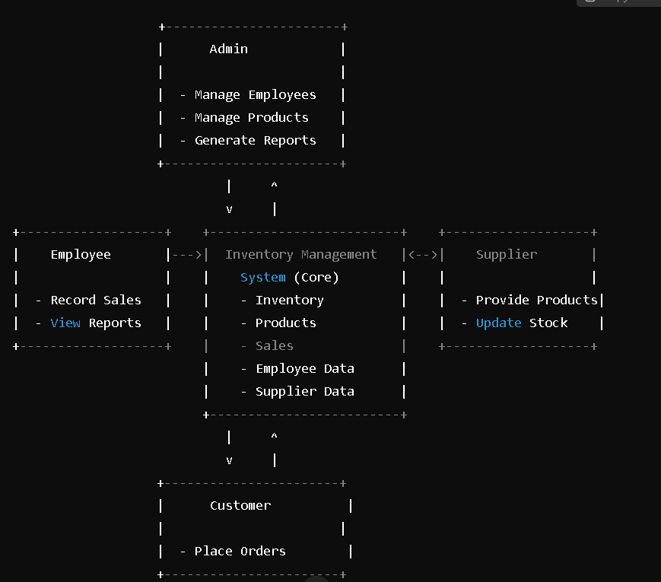**4.2- Context Diagram**

IGNTU B.Voc in Software Development 2024-25

Topic- PRABHAT AUTOMOBILES-INVENTORY EMPLOYEE MANAGEMENT SYSTEM



4.3 Use Case Diagram

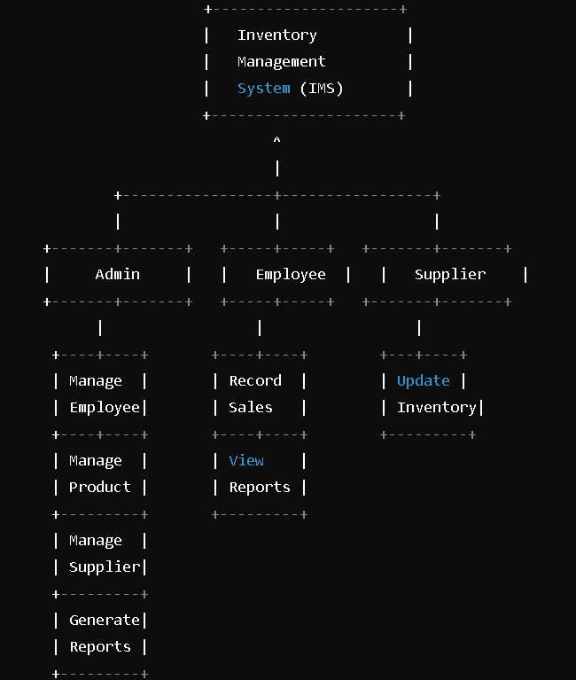



IGNTU B.Voc in Software Development 2024-25

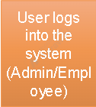Topic- PRABHAT AUTOMOBILES-INVENTORY EMPLOYEE MANAGEMENT SYSTEM **4.4 Activity diagram**



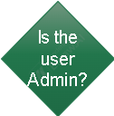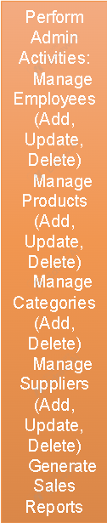











IGNTU B.Voc in Software Development 2024-25

Topic- PRABHAT AUTOMOBILES-INVENTORYEMPLOYEE MANAGEMENT SYSTEM

Chapter 5

Implementation

**5.1- Screen Shots :-**

PRABHAT AUTOMOBILES

* **DASHBOARD SUPPLIER PRODUCTS**
* **EMPLOYEE CATEGORY SALES**

**DASHBOARD.PY**



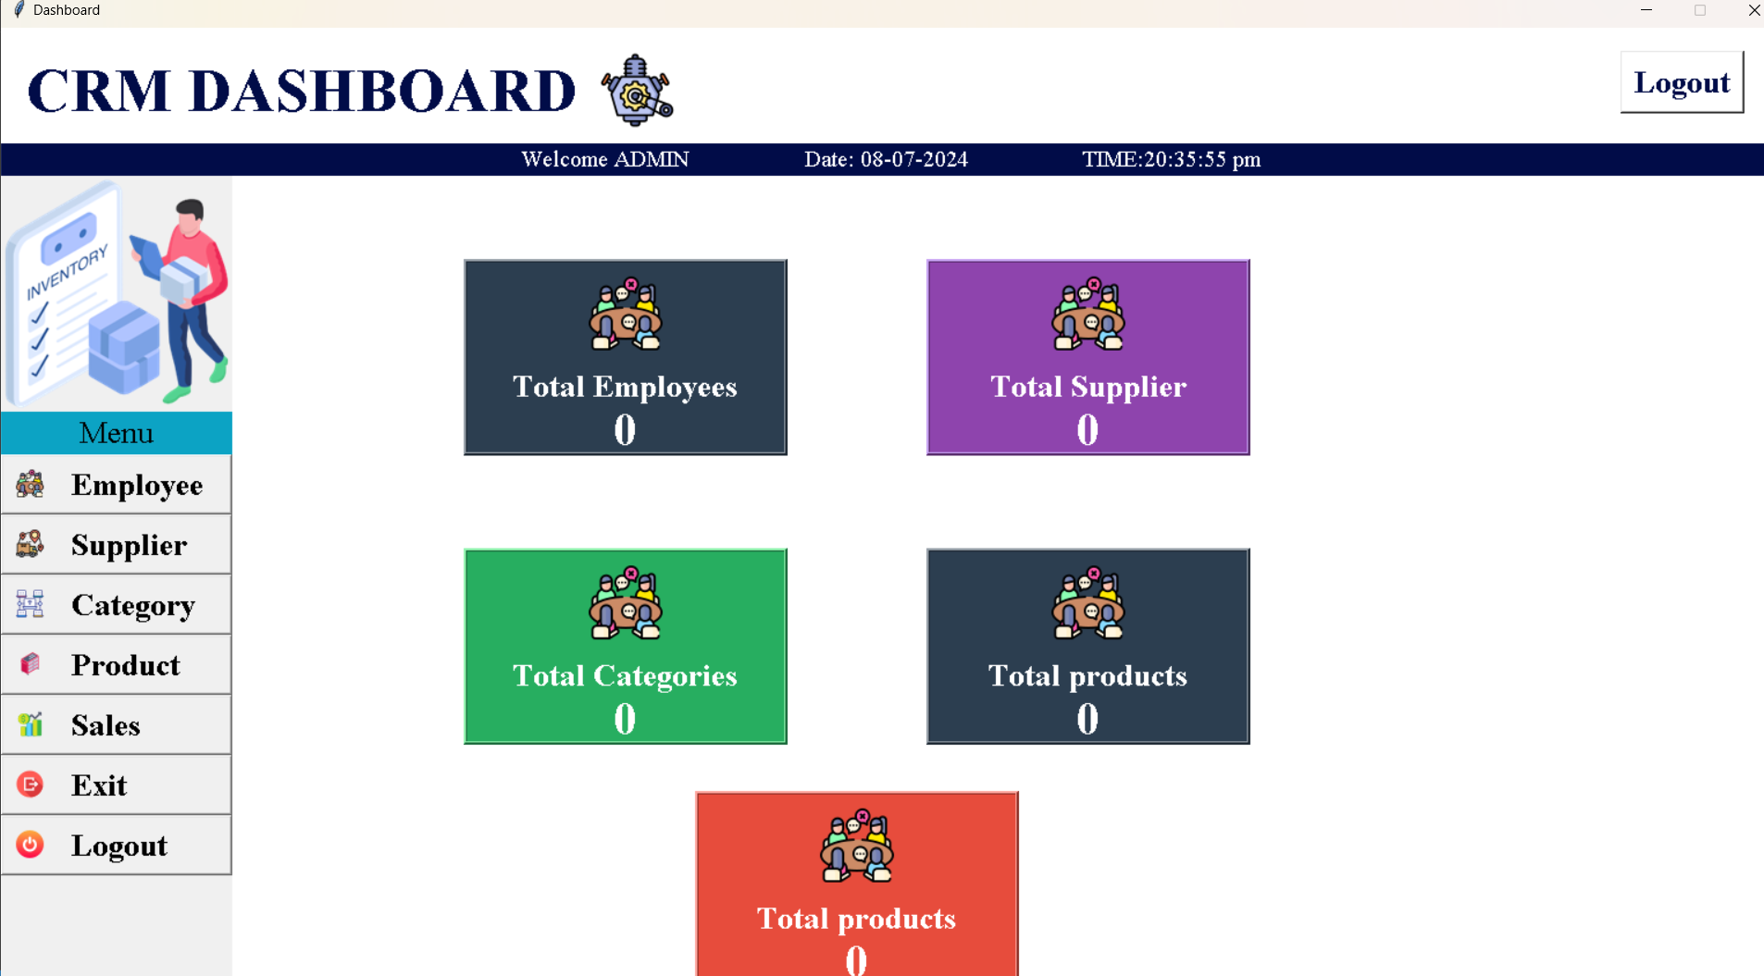

IGNTU B.Voc in Software Development 2024-25

Topic- PRABHAT AUTOMOBILES-INVENTORY EMPLOYEE MANAGEMENT SYSTEM



**EMPLOYEE.PY**

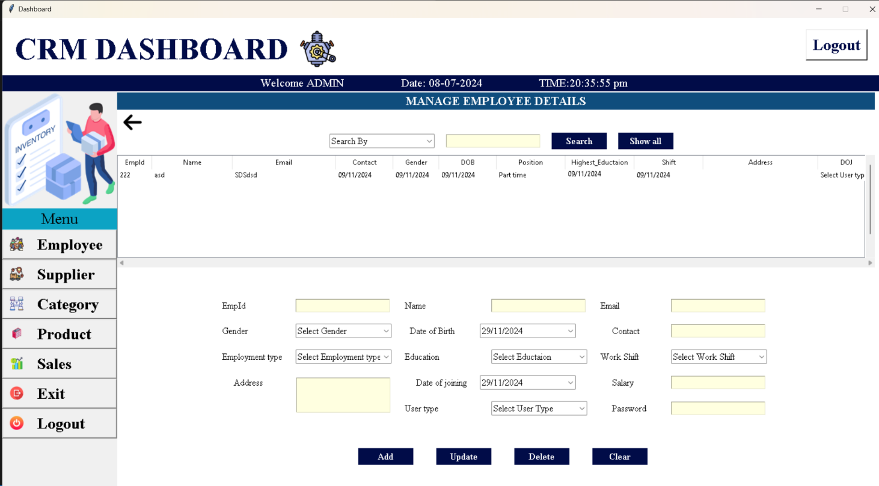

**SUPPLIER.PY**

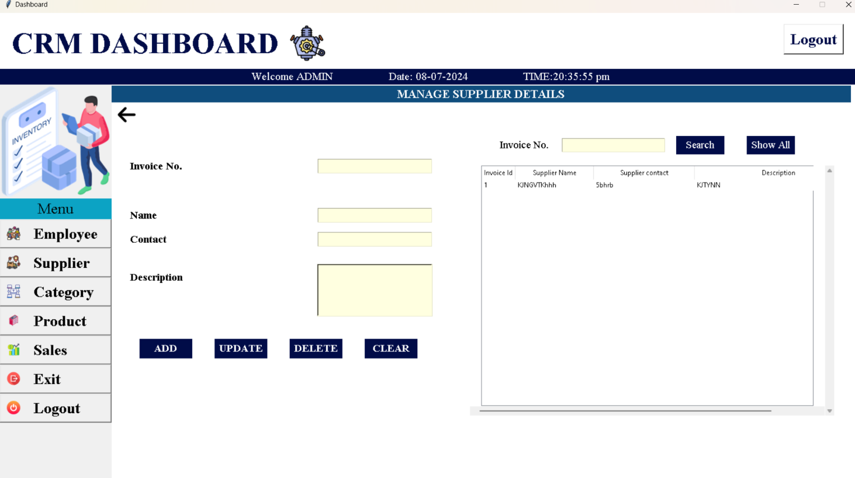

IGNTU B.Voc in Software Development 2024-25

Topic- PRABHAT AUTOMOBILES-INVENTORY EMPLOYEE MANAGEMENT SYSTEM



**CATEGORY.PY**

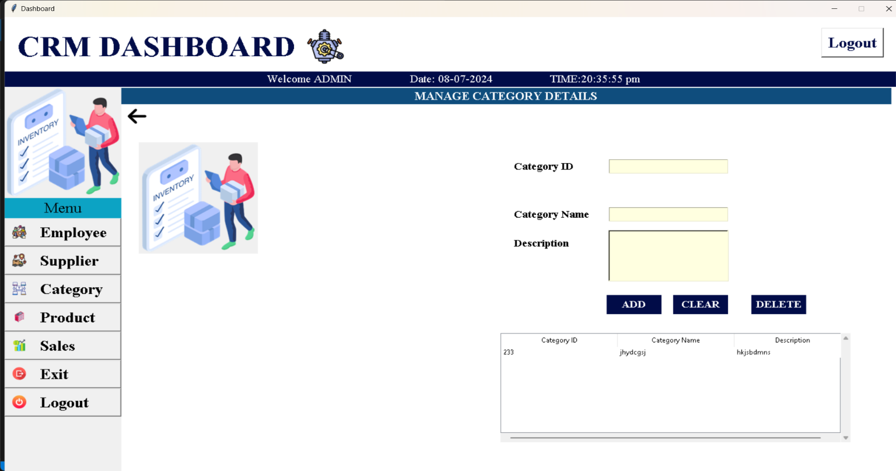

* STUDENTS APP IMAGES

**PRODUCT.PY**

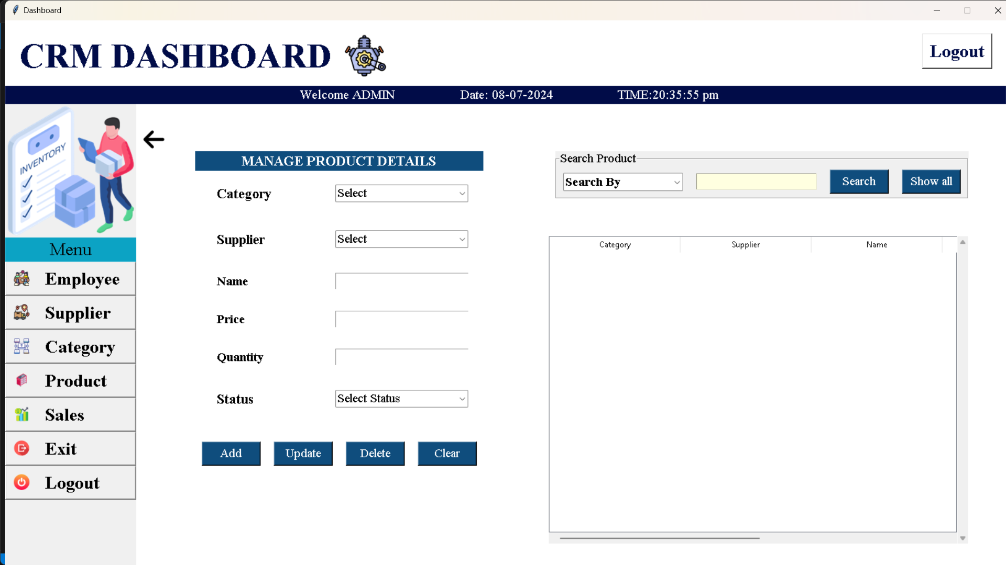

IGNTU B.Voc in Software Development 2024-25

Topic- PRABHAT AUTOMOBILES-INVENTORY EMPLOYEE MANAGEMENT SYSTEM



Chapter 6

Software Testing

**6.1.1 Importance of software Testing**

* Ensures the software meets the specified requirements and performs correctly.
* Detects defects or bugs early, reducing the cost of fixing them.
* Improves software reliability, user satisfaction, and trust.
* Enhances security by identifying vulnerabilities and preventing data breaches.
* Ensures the software is scalable and functions as expected under varying loads.
* Reduces the risk of failure or downtime in production environments.
* Increases software quality, ensuring it is maintainable, user-friendly, and efficient.

**6.1.2 Software Testing Fundamentals**

* **Purpose:** Verifies that software functions as intended and ensures its quality.
* **Types:** Includes functional testing (verifying functionality) and non-functional testing (performance, security, etc.).
* **Levels:** Includes unit testing, integration testing, system testing, and acceptance testing.
* **Approaches:** Can be manual or automated testing depending on the requirements.
* **Test Life Cycle:** Consists of test planning, test case development, test execution, and defect reporting.

*6.1.2.1 Black Box Testing*

• Focuses on testing the functionality of the software without looking at the internal code structure.

• Tests inputs and outputs to ensure the system behaves as expected.

• Does not require knowledge of the software’s internal workings.

• Types of Black Box Testing include functional testing, regression testing, and acceptance testing.

• Ensures that the system meets user requirements and functions correctly from an end-user perspective.

• Useful for validating user interfaces, APIs, and system behavior across different scenarios.

IGNTU B.Voc in Software Development 2024-25

Topic- PRABHAT AUTOMOBILES-INVENTORY EMPLOYEE MANAGEMENT SYSTEM



Chapter 7

Conclusion

Following conclusions can be drawn from our system:-

* **Automation Enhances Efficiency:** The system streamlines operations, reducing manual intervention and increasing productivity.
* **User-Friendly Interface:** Compared to existing systems, the new system offers a more intuitive and visually appealing graphical user interface.
* **Authorized Access:** The system ensures secure, role-based access for users based on their roles and privileges.
* **Improved Communication:** The system eliminates delays in communication, ensuring faster and more efficient information exchange.
* **Security and Reliability:** The system is designed with robust security measures, ensuring data protection and reliable performance.
* **Consistency and Stability:** The system provides consistent performance and meets the reliability expectations of users

Chapter 8

Future Enhancements

* **Mobile Access:** Implement a mobile version of the system for on-the-go access to inventory data.
* **AI Integration:** Use artificial intelligence to predict stock requirements and automate reordering.
* **Cloud Integration:** Migrate to a cloud-based solution for better scalability and remote access.
* **Barcode/RFID Integration:** Introduce barcode scanning and RFID for more efficient inventory tracking.
* **Advanced Analytics:** Add features for detailed sales and inventory analysis to assist in decision-making.

IGNTU B.Voc in Software Development 2024-25

Topic- PRABHAT AUTOMOBILES-INVENTORY EMPLOYEE MANAGEMENT SYSTEM



“Appendix”

References

• **W3Schools - SQL Tutorial**

* Link: https://www.w3schools.com/sql/
* Provides tutorials and examples for SQL, which is essential for managing inventory databases.

• **GitHub - Inventory Management System**

* Link: <https://github.com/>
* Search for various open-source inventory management systems developed using Python, Java, and other technologies.

• **GeeksforGeeks - Building a Basic Inventory Management System in Python**

* Link: https://www.geeksforgeeks.org/python-project-inventory-management-system/
* A guide on how to implement an inventory management system using Python.

• **YouTube - Build an Inventory Management System with Python**

* Link: <https://www.youtube.com/watch?v=5b6QyCo6zyY>
* A video tutorial that demonstrates how to build a simple inventory management system using Python.

**DAILY REPORT:-**

**Phase 1: Requirements Analysis (Days 1-5)**

**Day 1**

* **Project briefing and objective clarification.**
* **Discussed initial system requirements with the team.**

**Day 2**

* **Created project scope and identified key modules:**
  1. **User Authentication & Role Management**
  2. **Employee Management**
  3. **Product Inventory Management**

**Day 3**

* **Prepared system architecture diagram and initial flowchart.**

**Day 4**



* **Defined database schema for users, employees, products, categories, suppliers, and sales.**

**Day 5**

* **Finalized requirements document and obtained approval from the mentor.**

**Phase 2: System Design (Days 6-12)**

**Day 6**

* **Designed wireframes for the login and admin dashboard.**

**Day 7**

* **Created wireframes for the employee dashboard and reporting modules.**

**Day 8**

* **Developed detailed ER diagrams for database relationships.**

**Day 9**

* **Defined API endpoints for communication between frontend and backend.**

**Day 10**

* **Completed UI design for employee management and product inventory modules.**

**Day 11**

* **Finalized designs for supplier and sales reporting modules.**

**Day 12**

* **Reviewed design documents and ensured all components were aligned with the project goals.**

**Phase 3: Development (Days 13-35)**

**Days 13-18: User Authentication & Role Management**

* **Day 13: Implemented user login functionality.**
* **Day 14: Developed role-based access control for admins and employees.**
* **Day 15: Designed secure password encryption using hashing techniques.**
* **Day 16: Tested authentication module with dummy data.**
* **Day 17: Fixed bugs in the authentication module.**
* **Day 18: Completed logout functionality with session handling.**

**Days 19-24: Employee, Product, and Category Management**



* **Day 19: Developed CRUD operations for employee records.**
* **Day 20: Built forms for adding and updating employee details.**
* **Day 21: Implemented product inventory CRUD operations.**
* **Day 22: Added category management functionality.**
* **Day 23: Connected employee and product modules to the database.**
* **Day 24: Completed module integration and tested basic operations.**

**Days 25-30: Supplier Management and Sales Recording**

* **Day 25: Designed supplier management forms and APIs.**
* **Day 26: Implemented CRUD operations for supplier records.**
* **Day 27: Built sales recording form for employees.**
* **Day 28: Connected sales data to the database.**
* **Day 29: Integrated sales recording with real-time reporting.**
* **Day 30: Tested supplier and sales modules.**

**Days 31-35: Dashboards and Reporting**

* **Day 31: Designed admin dashboard to display key metrics.**
* **Day 32: Developed employee dashboard for sales performance tracking.**
* **Day 33: Created reporting functionality for admins.**
* **Day 34: Finalized charts and graphical representations for reports.**
* **Day 35: Conducted module integration testing for dashboards.**

**Phase 4: Testing and Deployment (Days 36-45)**

**Days 36-40: Testing**

* **Day 36: Performed unit testing for all modules.**
* **Day 37: Conducted integration testing across the system.**
* **Day 38: Addressed identified bugs and fixed errors in authentication and CRUD operations.**
* **Day 39: Conducted user acceptance testing with sample users.**
* **Day 40: Completed security testing, ensuring data protection and access restrictions.**

**Days 41-45: Deployment**

* **Day 41: Prepared deployment plan and set up Firebase backend.**
* **Day 42: Deployed frontend components on a hosting platform.**
* **Day 43: Connected the backend to the deployed frontend.**
* **Day 44: Conducted final round of testing post-deployment.**
* **Day 45: Delivered the final system and documented the deployment process.**



**Guidance By**

Dr. Kamlesh Pandey Sir

Department of B.VOC in Software Development

I am taking some ideas/plan/ for this projects with help of some searches on Google. I am watching many website after decide this topic. These are following types-

* GitHub
* GeekforGeeks
* Google

IGNTU B.Voc in Software Development 2024-25