JAVA PRACTICAL LAB

Experiment No.: 02

Name: Aryan Bhoge
PRN No:242141106
Roll No: 29
Division: B
Batch: B2

AIM :
Implement java programs based on control statements.

2.1 if-else statements:
Program 1 : Implement a Java program to take values of length and breadth of a rectangle from user and check if it is square or not. If it is a square, find the area of the square.
Title :
Program to Check Whether a Rectangle is a Square and Find Its Area

Content :
This program takes length and breadth from the user, checks whether the rectangle is a square or not, and displays the result along with the student name in the output.

Theory :
A rectangle is called a square when its length and breadth are equal.
- Condition: length == breadth
- Area of square = side × side
The Scanner class is used to take input from the user at runtime.

Program Code :
import java.util.Scanner; class SquareCheck { public static void main(String[] args) {
Scanner sc = new Scanner(System.in);
System.out.println("Name: Aryan Bhoge"); System.out.print("Enter length: "); int length = sc.nextInt(); System.out.print("Enter breadth: "); int breadth = sc.nextInt(); if (length == breadth) {
System.out.println("Result: It is a Square."); int area = length * breadth;
System.out.println("Area of square = " + area);
} else {
System.out.println("Result: It is not a Square.");
} sc.close();
}
}
Output :

Conclusion :
This program successfully accepts user input for length and breadth, displays the student name in the output, checks whether the rectangle is a square, and calculates the area if the condition is satisfied. This helps in understanding decision-making statements and user input handling in Java.
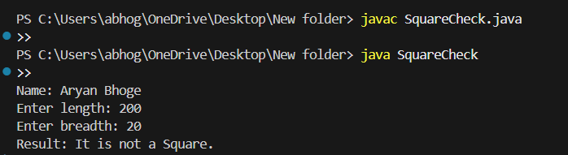

Program 2 :
A company decided to give bonus of 10% (of salary) to employee if his/her year of service is more than 5 years. Implement a Java program to ask user for their salary and year of service and print the net bonus amount and the total salary adding bonus.

Title :
Program to Calculate Employee Bonus Based on Years of Service

Content :
This program accepts the employee’s salary and years of service from the user. If the employee has completed more than 5 years of service, a bonus of 10% of the salary is calculated. The program then displays the bonus amount and the total salary including the bonus along with the student name.
Theory :
Many organizations provide bonuses to employees based on their years of service.
- If years of service > 5, bonus = 10% of salary
- Bonus = salary × 10 / 100
- Total salary = salary + bonus
Java uses if condition to check eligibility and Scanner class to accept user input.

Program Code :

import java.util.Scanner; class BonusCalculation {
public static void main(String[] args) {
Scanner sc = new Scanner(System.in);
System.out.println("Name: Aryan Bhoge");
System.out.print("Enter salary: "); double salary = sc.nextDouble();
System.out.print("Enter years of service: "); int years = sc.nextInt(); double bonus = 0; if (years > 5) { bonus = salary * 0.10;
System.out.println("Employee is eligible for bonus.");
} else {
System.out.println("Employee is not eligible for bonus.");
}
double totalSalary = salary + bonus;
System.out.println("Bonus Amount = " + bonus);
System.out.println("Total Salary (Including Bonus) = " + totalSalary); sc.close();
}
}

Output :
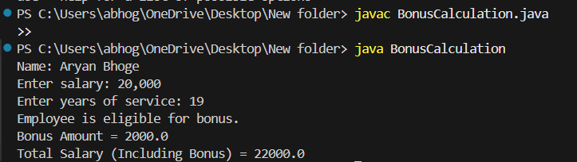

Conclusion :
In this program, employee salary and years of service were accepted from the user. Using conditional statements, the program checked bonus eligibility. If the service period was more than five years, a bonus of 10% was calculated and added to the salary. This experiment helped in understanding decision-making and arithmetic operations in Java.

Program 3 : A school has following rules for grading system:
Below 25 – F, 25 to 45 – E, 45 to 50 – D, 50 to 60 – C, 60 to 80 – B, Above 80 - A Implement a Java program to ask user to enter marks and print the corresponding grade.

Title :
Program to Display Student Grade Based on Marks.

Content :
This program accepts marks from the user and displays the corresponding grade according to the school grading system. The student name is also printed in the output.
Theory :
A grading system is used to evaluate student performance based on marks obtained.
Grading rules used in this program:
- Below 25 → F
- 25 to 45 → E
- 45 to 50 → D
- 50 to 60 → C
- 60 to 80 → B
- Above 80 → A
Java if–else if ladder is used to compare marks with different ranges and print the appropriate grade.

Program Code :

import java.util.Scanner; class GradeSystem { public static void main(String[] args)
{
Scanner sc = new
Scanner(System.in);
System.out.println("Name: Aryan Bhoge");
System.out.print("Enter marks: "); int marks = sc.nextInt(); if (marks < 25) {
System.out.println("Grade: F");
}
else if (marks >= 25 && marks <
45) {
System.out.println("Grade: E");
}
else if (marks >= 45 && marks <
50) {
System.out.println("Grade: D");
}
else if (marks >= 50 && marks <
60) {
System.out.println("Grade: C");
}
else if (marks >= 60 && marks <=
80) {
System.out.println("Grade: B");
}
else if (marks > 80 && marks <=
100) {
System.out.println("Grade: A");
} else {
System.out.println("Invalid marks entered.");
} sc.close();
}
}

Output :
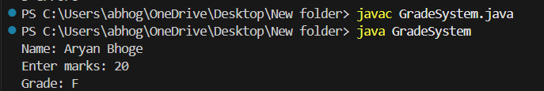

Conclusion :
In this program, marks were accepted from the user and evaluated using conditional statements. Based on the predefined grading system, the correct grade was displayed. This experiment helped in understanding decision-making using if–else-if ladder in Java.
Program 4 : A student will not be allowed to sit in exam if his/her attendance is less than
75%.Implement a Java program to take following input from user: Number of classes held, Number of classes attended and print percentage of class attended and whether student is allowed to sit in exam or not.

Title :

Program to Check Exam Eligibility Based on Attendance Percentage

Content :
This program accepts the number of classes held and the number of classes attended by a student. It calculates the attendance percentage and determines whether the student is allowed to sit in the examination. The student name is also displayed in the output.

Theory :
Attendance plays an important role in academic evaluation. According to the rule:
- If attendance ≥ 75%, the student is allowed to sit in the exam.
- If attendance < 75%, the student is not allowed.
Attendance percentage is calculated using the formula:
Attendance Percentage = (Classes Attended / Classes Held) × 100
Java uses Scanner class for user input and if–else condition for decision making.

import java.util.Scanner;

class AttendanceCheck {
public static void main(String[] args) {
Scanner sc = new Scanner(System.in);

System.out.println("Name: Aryan Bhoge");
System.out.print("Enter number of classes held: ");
int held = sc.nextInt();

System.out.print("Enter number of classes attended: ");
int attended = sc.nextInt();

double percentage = ((double) attended / held) * 100;
System.out.println("Attendance Percentage = " + percentage + "%");

if (percentage >= 75) {
System.out.println("Student is allowed to sit in the exam.");
} else {
System.out.println("Student is NOT allowed to sit in the exam.");
}

sc.close();
}
}

Output :

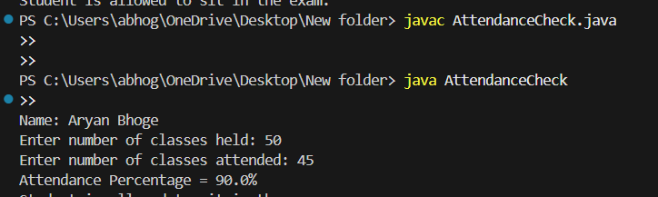

Conclusion :
In this program, the number of classes held and attended were taken as input from the user. The attendance percentage was calculated and compared with the minimum required criteria of 75%. Based on the result, the program displayed whether the student is eligible to appear for the examination. This experiment helped in understanding arithmetic operations and conditional statements in Java.

Program 5 :
Write a Java program to check if a year is leap year or not.
Note for Q.10:
The year is a leap year if it is divisible by 4. The Gregorian calendar stipulates that a year that is evenly divisible by 100 (for example, 1900) is a leap year only if it is also evenly divisible by
400. For this reason, the following years are not leap years: 1700, 1800, 1900, 2100, 2200, 2300,
2500, 2600. This is because they are evenly divisible by 100 but not by 400. The following years are leap years: 1600, 2000, 2400. This is because they are evenly divisible by both 100 and 400.
To determine whether a year is a leap year, follow these steps:
- If the year is evenly divisible by 4, go to step 2. Otherwise, go to step 5.
- If the year is evenly divisible by 100, go to step 3. Otherwise, go to step 4.
- If the year is evenly divisible by 400, go to step 4. Otherwise, go to step 5.
- The year is a leap year (it has 366 days).
- The year is not a leap year (it has 365 days).

Title :
Program to Check Whether a Year Is a Leap Year

Content :
This program accepts a year from the user and checks whether it is a leap year or not using the Gregorian calendar rules. The student name is also displayed in the output.

Theory :
A leap year contains 366 days, while a normal year contains 365 days.
According to the Gregorian calendar rules:
- If the year is divisible by 4, proceed further.
- If the year is divisible by 100, it must also be divisible by 400 to be a leap year.
- If the year is divisible by 400, it is a leap year.
- Otherwise, it is not a leap year.
Examples:
- Leap years: 1600, 2000, 2400
- Not leap years: 1700, 1800, 1900, 2100
Java uses conditional statements to implement these rules logically.

Program Code :
import java.util.Scanner;

class LeapYearCheck {

public static void main(String[] args) {

Scanner sc = new Scanner(System.in);

System.out.println("Name: Aryan Bhoge");

System.out.print("Enter year: "); int year = sc.nextInt();

if (year % 4 == 0) {

if (year % 100 == 0) {

if (year % 400 == 0) {
System.out.println(year + " is a Leap Year.");
} else {
System.out.println(year + " is NOT a Leap Year.");
}

} else {
System.out.println(year + " is a Leap Year.");
}

} else {
System.out.println(year + " is NOT a Leap Year.");
}

sc.close();
}
}

Output :
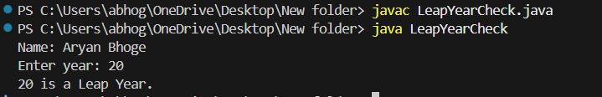

Conclusion :
In this program, the year was taken as input from the user and checked using the Gregorian calendar conditions. Nested if–else statements were used to correctly determine whether the given year is a leap year or not. This experiment helped in understanding logical conditions and decision-making in Java.

2.2 Switch case:
Program 1:
Write a program to Menu driven program using switch statement (Find addition, subtraction, multiplication and division of to integer numbers).

Title :
Menu Driven Program Using Switch Statement for Arithmetic Operations.

Content :
This program is a menu-driven Java application that performs basic arithmetic operations such as addition, subtraction, multiplication, and division on two integer numbers. The user selects the desired operation from the menu. The student name is displayed in the output.

Theory :
A menu-driven program allows the user to choose an option from a list of operations.
The switch statement in Java is used when multiple choices are available. Based on the user’s selection, the corresponding case is executed.
Operations performed:
- Addition
- Subtraction
- Multiplication
- Division
The Scanner class is used to take input from the user.

Program Code :
import java.util.Scanner; class MenuDrivenCalculator {
public static void main(String[] args) {
Scanner sc = new Scanner(System.in);
System.out.println("Name: Aryan Bhoge");
System.out.println("------ Menu ------");
System.out.println("1. Addition");
System.out.println("2. Subtraction");
System.out.println("3. Multiplication");
System.out.println("4. Division"); System.out.print("Enter your choice (1-4): "); int choice = sc.nextInt();
System.out.print("Enter first number: "); int num1 = sc.nextInt();
System.out.print("Enter second number: "); int num2 = sc.nextInt(); switch (choice) {
case 1:
System.out.println("Result = " + (num1 + num2));
break; case 2:
System.out.println("Result = " + (num1 - num2));
break; case 3:
System.out.println("Result = " + (num1 * num2));
break; case 4:
if (num2 != 0) {
System.out.println("Result = " + (num1 / num2));
} else {
System.out.println("Division by zero is not allowed.");
} break; default:
System.out.println("Invalid choice.");
}
sc.close();
}
}

Output :
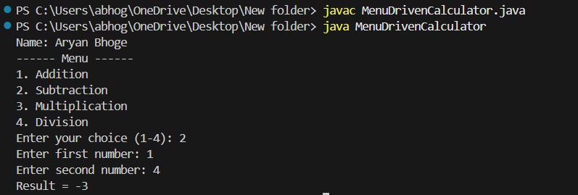
Conclusion :
In this program, a menu-driven system was implemented using the switch statement. Based on the user’s choice, the program successfully performed arithmetic operations on two integers. This experiment helped in understanding switch-case control structures and user-driven program execution in Java.

Program 2:
A school has following rules for grading system:
Below 25 – F, 25 to 45 – E, 45 to 50 – D, 50 to 60 – C, 60 to 80 – B, Above 80 - A Implement a Java program to ask user to enter marks and print the corresponding grade.

Title :
Program to Display Grade According to Marks Obtained

Content :
This program accepts marks from the user and displays the corresponding grade based on the given school grading system. The student name is also printed in the output.

Theory :
A grading system is used to evaluate student performance based on marks.
Grading criteria used in this program:
- Below 25 → F
- 25 to 45 → E
- 45 to 50 → D
- 50 to 60 → C
- 60 to 80 → B
- Above 80 → A
The if–else if ladder is used to check multiple conditions sequentially.

Program Code :
import java.util.Scanner; class GradeSystem {
public static void main(String[] args) {
Scanner sc = new Scanner(System.in);
System.out.println("Name: Aryan Bhoge"); System.out.print("Enter marks: "); int marks = sc.nextInt(); if (marks < 25) {
System.out.println("Grade: F");
}
else if (marks >= 25 && marks < 45) {
System.out.println("Grade: E");
}
else if (marks >= 45 && marks < 50) {
System.out.println("Grade: D");
}
else if (marks >= 50 && marks < 60) {
System.out.println("Grade: C");
}
else if (marks >= 60 && marks <= 80) {
System.out.println("Grade: B");
}
else if (marks > 80 && marks <= 100) {
System.out.println("Grade: A");
} else {
System.out.println("Invalid marks entered.");
}
sc.close();
}
}

Output :
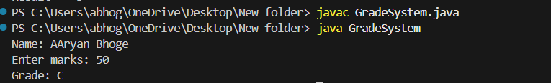

Conclusion :
In this program, marks were taken as input from the user and evaluated using conditional statements. Based on the predefined grading rules, the correct grade was displayed. This experiment helped in understanding the use of if–else-if ladder and logical decision-making in Java.

Program 3:
Write a program to check whether the number is even or odd using switch statement.

Title :
Program to Check Whether a Number Is Even or Odd Using Switch Statement

Content :
This program accepts an integer number from the user and checks whether it is even or odd using a switch statement. The student name is displayed in the output.

Theory :
A number is said to be:
- Even → if it is divisible by 2
- Odd → if it is not divisible by 2
In Java, the switch statement can also be used with expressions. By using number % 2, the remainder will be:
- 0 → Even number
- 1 → Odd number
The Scanner class is used to accept input from the user.

Program Code :
import java.util.Scanner; class EvenOddSwitch {
public static void main(String[] args) {
Scanner sc = new Scanner(System.in);
System.out.println("Name:Aryan Bhoge "); System.out.print("Enter a number: "); int num = sc.nextInt();
switch (num % 2) {
case 0:
System.out.println("The number is Even.");
break; case 1:
System.out.println("The number is Odd.");
break; default:
System.out.println("Invalid input.");
}
sc.close();
}
}

Output :
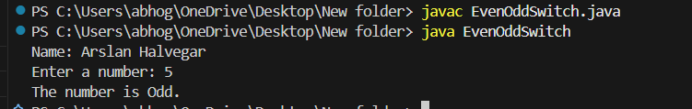

Conclusion :
In this program, an integer number was taken as input from the user. Using the switch statement and modulus operator, the program successfully determined whether the number is even or odd. This experiment helped in understanding switch-case logic and conditional evaluation in Java.

Program 4 :
Take user input for name, roll number, date of birth and address of a student. Ask student to enter a choice between A/B/C/D. If choice is a, then display name of the student with welcome message. If choice is B, then display whether roll number is even or odd. If choice is C, then display age of the student. If choice is D, then display the message ‘You are currently located in’ by mentioning address.

Title :
Menu Driven Program Using Switch Case for Student Information

Content :
This program accepts student details such as name, roll number, date of birth, and address. The user is then asked to select a choice between A, B, C, or D. Based on the selected option, the program displays different information. The student name (Ayub Momin) is displayed in the output.

Theory :
A menu-driven program allows the user to choose an option from multiple choices.
The switch statement is used to execute different blocks of code based on user input.
Functions performed:
- Choice A: Displays student name with a welcome message
- Choice B: Checks whether roll number is even or odd
- Choice C: Calculates age of the student
- Choice D: Displays student address
The Scanner class is used to accept user input from the keyboard.

Program Code :
import java.util.Scanner; import java.time.LocalDate; import java.time.Period; class StudentMenu {
public static void main(String[] args) {
Scanner sc = new Scanner(System.in);
System.out.println("Name: Aryan Bhoge");
System.out.print("Enter student name: ");
String name = sc.nextLine();
System.out.print("Enter roll number: ");
int roll = sc.nextInt(); sc.nextLine(); // clear buffer
System.out.print("Enter date of birth (YYYY-MM-DD): ");
String dobInput = sc.nextLine();
System.out.print("Enter address: ");
String address = sc.nextLine();
System.out.println("\nChoose an option:");
System.out.println("A - Display welcome message");
System.out.println("B - Check roll number even or odd");
System.out.println("C - Display age");
System.out.println("D - Display address"); System.out.print("Enter your choice: "); char choice = sc.next().toUpperCase().charAt(0); switch (choice) {
case 'A':
System.out.println("Welcome " + name + "!");
break; case 'B':
if (roll % 2 == 0)
System.out.println("Roll number is Even.");
else
System.out.println("Roll number is Odd.");
break; case 'C':
LocalDate dob = LocalDate.parse(dobInput); LocalDate today = LocalDate.now(); int age = Period.between(dob, today).getYears(); System.out.println("Student age = " + age + " years");
break; case 'D':
System.out.println("You are currently located in " + address);
break; default:
System.out.println("Invalid choice.");
}
sc.close();
}
}

Output :
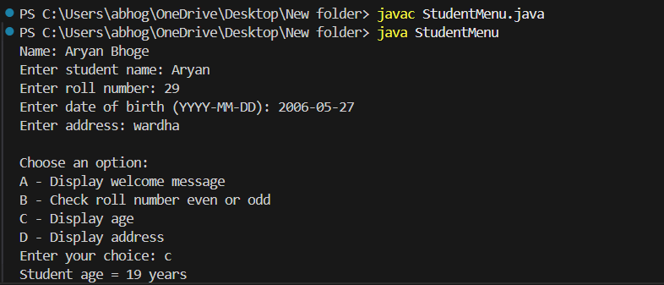

Conclusion :
In this program, student details were taken as input from the user. Using a switch-case menu, different operations such as displaying welcome message, checking roll number parity, calculating age, and showing address were performed. This experiment helped in understanding switch-case statements, user input handling, and basic date operations in Java.

2.3 While loop and do-while loop:
Program 1:
Implement a Java program to show working of while and do-while loop.

Title :
Program to Demonstrate Working of While and Do-While Loop

Content :
This program demonstrates the working of while loop and do-while loop in Java. Both loops are used to print numbers from 1 to 5. The student name is also displayed in the output.

Theory :
Loops are used in Java to execute a block of code repeatedly until a condition becomes false.
While Loop
- Condition is checked before executing the loop body.
- If the condition is false initially, the loop will not execute even once.
Syntax:
while(condition) {
// statements
}
Do-While Loop
- Condition is checked after executing the loop body.
- The loop executes at least once, even if the condition is false.
Syntax: do {
// statements
} while(condition);

Program Code : class WhileDoWhileDemo {
public static void main(String[] args) {
System.out.println("Name: Aryan Bhoge"); System.out.println("\nUsing While Loop:");
int i = 1;
while (i <= 5) { System.out.println(i);
i++;
}
System.out.println("\nUsing Do-While Loop:");
int j = 1; do {
System.out.println(j);
j++;
} while (j <= 5);
}
}

Output :
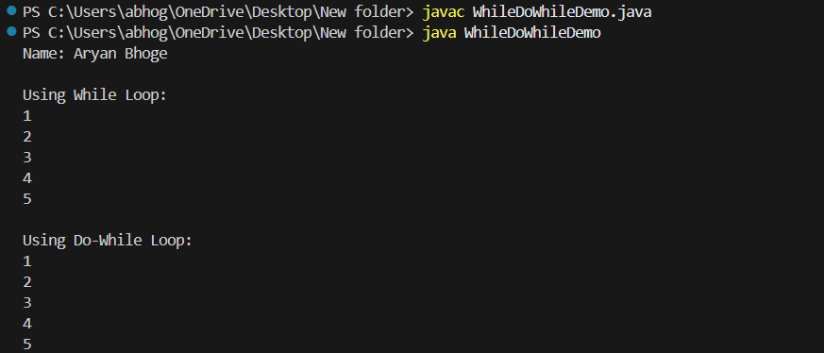

Conclusion :
In this program, the working of while loop and do-while loop was demonstrated. The while loop checks the condition before execution, whereas the do-while loop executes at least once before checking the condition. This experiment helped in understanding looping concepts in Java.

Program 2:
Implement a Java program to count the number of digits in a user entered number.

Title :
Program to Count Number of Digits in a Given Number

Content :
This program accepts an integer number from the user and counts the total number of digits present in the entered number. The student name is displayed in the output.

Theory :
To count digits in a number:
- The number is repeatedly divided by 10
- Each division removes the last digit
- A counter is increased until the number becomes 0
This logic uses a while loop.
Example:
Number = 1234 Digits = 4
The Scanner class is used to accept input from the user.

Program Code :
import java.util.Scanner; class DigitCount { public static void main(String[] args) {
Scanner sc = new Scanner(System.in);
System.out.println("Name: Aryan Bhoge");
System.out.print("Enter a number: ");
long num = sc.nextLong();
int count = 0; // Handle zero case if (num == 0) { count = 1; } else { while (num != 0) { num = num / 10; count++;
}
}
System.out.println("Number of digits = " + count);
sc.close();
}
}

Output :
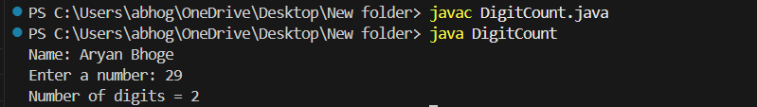

Conclusion :
In this program, a number was taken as input from the user and the total number of digits was calculated using a while loop. This experiment helped in understanding loop control and arithmetic operations in Java.

Program 3:
Implement a Java program to reverse of a user entered number.

Title :
Program to Reverse a User Entered Number

Content :
This program accepts an integer number from the user and displays the reverse of the entered number. The student name is also printed in the output.

Theory :
To reverse a number:
- Extract the last digit using modulus operator (%)
- Multiply the reverse number by 10
- Add the extracted digit
- Remove the last digit by dividing the number by 10
- Repeat until the number becomes 0 This logic is implemented using a while loop.
Example:
Number = 1234 Reverse = 4321

Program Code :
import java.util.Scanner; class ReverseNumber {
public static void main(String[] args) {
Scanner sc = new Scanner(System.in);
System.out.println("Name: Aryan Bhoge");
System.out.print("Enter a number: "); int num = sc.nextInt(); int reverse = 0; while (num != 0) { int digit = num % 10; reverse = reverse * 10 + digit; num = num / 10;
}
System.out.println("Reversed number = " + reverse);
sc.close();
}
}

Output :
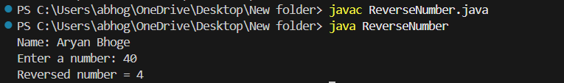

Conclusion :
In this program, a number entered by the user was successfully reversed using a while loop and arithmetic operations. This experiment helped in understanding digit manipulation and loop control in Java.

Program 4:
Implement a Java program to print multiplication table of user entered number.

Title :
Program to Print Multiplication Table of a Given Number

Content :
This program accepts a number from the user and prints its multiplication table from 1 to
10. The student name is also displayed in the output.

Theory :
A multiplication table is generated by multiplying a given number with integers starting from 1 to 10. Formula used: number × i
A for loop is used to repeat the multiplication process multiple times.
The Scanner class is used to accept user input.

Program Code :
import java.util.Scanner; class MultiplicationTable {
public static void main(String[] args) { Scanner sc = new Scanner(System.in);
System.out.println("Name:Aryan Bhoge System.out.print("Enter a number: "); int num = sc.nextInt();
System.out.println("\nMultiplication Table of " + num + ":"); for (int i = 1; i <= 10; i++) {
System.out.println(num + " x " + i + " = " + (num * i));
} sc.close();
}
}

Output :
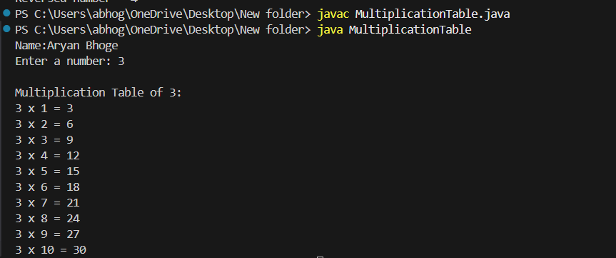

Conclusion :
In this program, a number was taken as input from the user and its multiplication table was printed using a for loop. This experiment helped in understanding looping concepts and arithmetic operations in Java.

Program 5:
Implement a Java program to accept an integer number from user and check whether it is an Armstrong number or not. (Armstrong number: e. g. 153= 1 3 +5 3 +3 3 )

Title :
Program to Check Whether a Number Is an Armstrong Number

Content :
This program accepts an integer number from the user and checks whether it is an Armstrong number or not. The student name is also displayed in the output.

Theory :
An Armstrong number is a number in which the sum of the cubes of its digits is equal to the original number.
Example:
153 = 1³ + 5³ + 3³
153 = 1 + 125 + 27 = 153
Steps used in this program:
- Take the number from the user
- Extract each digit using modulus operator (%)
- Find the cube of each digit
- Add all cubes
- Compare the sum with the original number
A while loop is used to process each digit.

Program Code :
import java.util.Scanner; class ArmstrongNumber { public static void main(String[] args) { Scanner sc = new Scanner(System.in);
System.out.println("Name: Aryan Bhoge
"); System.out.print("Enter a number: "); int num = sc.nextInt(); int original = num; int sum = 0; while (num != 0) { int digit = num % 10; sum = sum + (digit * digit * digit); num = num / 10;
}
if (sum == original) {
System.out.println(original + " is an Armstrong number.");
} else {
System.out.println(original + " is NOT an Armstrong number.");
} sc.close();
}
}

Output :
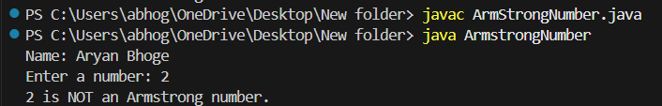

Conclusion :
In this program, an integer number was taken as input from the user and checked whether it is an Armstrong number using digit extraction and arithmetic operations. This experiment helped in understanding loops, modulus operator, and number logic in Java.

Program 6:
Implement a Java program to print all natural numbers in reverse from n to 1.

Title :
Program to Print Natural Numbers in Reverse Order

Content :
This program accepts a natural number n from the user and prints all natural numbers in reverse order from n to 1. The student name is also displayed in the output.

Theory :
Natural numbers are positive numbers starting from 1.
To print numbers in reverse order:
- Start from n
- Decrease the value by 1 in each step
- Continue until 1
A while loop or for loop can be used to achieve this.
In this program, a while loop is used.

Program Code :
import java.util.Scanner; class ReverseNaturalNumbers { public static void main(String[] args) { Scanner sc = new Scanner(System.in);
System.out.println("Name: Aryan Bhoge"); System.out.print("Enter a natural number: "); int n = sc.nextInt();
System.out.println("\nNatural numbers from " + n + " to 1:"); while (n >= 1) {
System.out.println(n); n--; } sc.close();
}
}

Output :
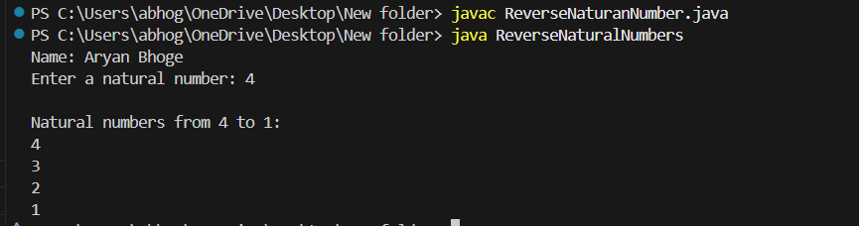

Conclusion :
In this program, a natural number was taken as input from the user and all natural numbers were printed in reverse order using a while loop. This experiment helped in understanding loop control and decrement operations in Java.

2.4 for loop:
Program 1:
Implement a Java program to show working of for loop.

Title :
Program to Demonstrate Working of For Loop

Content :
This program demonstrates the working of the for loop in Java by printing numbers from 1 to 10. The student name is also displayed in the output.

Theory :
A for loop is used when the number of iterations is known in advance.
Syntax of for loop: for(initialization; condition; increment/decrement) {
// statements
}
Working:
- Initialization is executed once
- Condition is checked before each iteration
- Loop body executes if condition is true
- Increment or decrement updates the loop variable

Program Code :
class ForLoopDemo {
public static void main(String[] args) {
System.out.println("Name: Aryan Bhoge");
System.out.println("Using For Loop:");
for (int i = 1; i <= 10; i++) {
System.out.println(i);
}
}
}

Output :
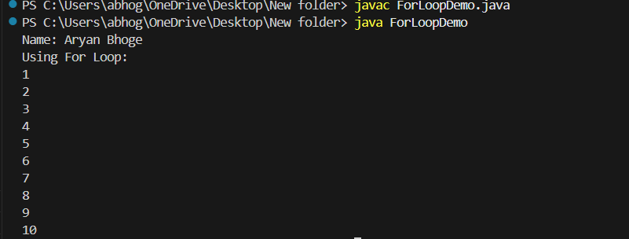

Conclusion :
In this program, the working of the for loop was demonstrated by printing numbers from 1 to 10. This experiment helped in understanding loop structure, iteration control, and repetition of statements in Java.

Program 2:
Implement a Java program to print multiplication table of user entered number.

Title :
Program to Print Multiplication Table of a Given Number

Content :
This program accepts a number from the user and prints its multiplication table from 1 to
10. The student name is also displayed in the output.

Theory :
A multiplication table is generated by multiplying the given number with integers from 1 to
10.
Formula used: number × i
A for loop is used to repeat the multiplication process multiple times.
The Scanner class is used to accept user input from the keyboard.

Program Code :
import java.util.Scanner; class MultiplicationTable {
public static void main(String[] args) { Scanner sc = new Scanner(System.in);
System.out.println("Name: Aryan Bhoge"); System.out.print("Enter a number: "); int num = sc.nextInt();
System.out.println("\nMultiplication Table of " + num + ":"); for (int i = 1; i <= 10; i++) {
System.out.println(num + " x " + i + " = " + (num * i));
} sc.close();
}
}

Output :
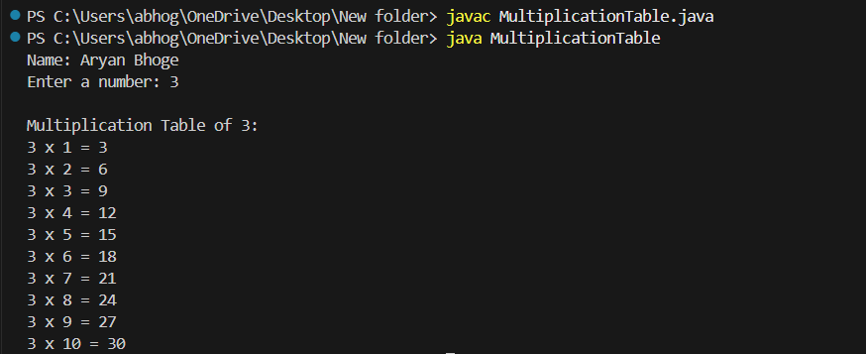

Conclusion :
In this program, a number was taken as input from the user and its multiplication table was printed using a for loop. This experiment helped in understanding looping concepts and arithmetic operations in Java.

Program 3:
Implement a Java program to print all natural numbers from 1 to n.

Title :
Program to Print All Natural Numbers from 1 to n

Content :
This program accepts a natural number n from the user and prints all natural numbers from 1 to n. The student name is also displayed in the output.

Theory :
Natural numbers are positive integers starting from 1.
To print numbers from 1 to n:
- Start from 1
- Increase the value by 1 in each step
- Continue until the value becomes n
A for loop or while loop can be used. In this program, a for loop is used.

Program Code :
import java.util.Scanner; class NaturalNumbers {
public static void main(String[] args) { Scanner sc = new Scanner(System.in);
System.out.println("Name: Aryan Bhoge"); System.out.print("Enter a natural number: "); int n = sc.nextInt();
System.out.println("Natural numbers from 1 to " + n + ":"); for (int i = 1; i <= n; i++) {
System.out.println(i);
} sc.close();
}
}

Output :
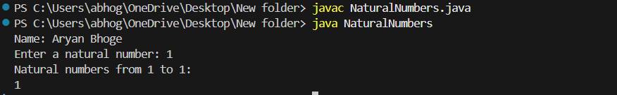

Conclusion :
In this program, a natural number was taken as input from the user and all natural numbers from 1 to n were printed using a for loop. This experiment helped in understanding loop control and sequential execution in Java.

Program 4:
Implement a Java program to print all even numbers between 1 to n.

Title :
Program to Print All Even Numbers Between 1 to n

Content :
This program accepts a number n from the user and prints all even numbers between 1 and n. The student name is also displayed in the output.

Theory :
An even number is a number that is completely divisible by 2.
Condition:
number % 2 == 0
To print even numbers between 1 and n:
- Start from 1
- Check each number
- Print only those numbers that satisfy the even condition
A for loop is used for repetition.

Program Code :
import java.util.Scanner; class EvenNumbers {
public static void main(String[] args) { Scanner sc = new Scanner(System.in);
System.out.println("Name: Aryan Bhoge"); System.out.print("Enter a number: "); int n = sc.nextInt();
System.out.println("Even numbers between 1 and " + n + ":");
for (int i = 1; i <= n; i++) { if (i % 2 == 0) { System.out.println(i);
} } sc.close();
}
}

Output :
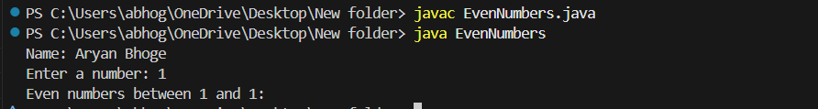

Conclusion :
In this program, a number was taken as input from the user and all even numbers between 1 and n were printed using a for loop and conditional statement. This experiment helped in understanding loops and decision-making in Java.

Program 5:
Implement a Java program to find factorial of a user entered number.

Title :
Program to Find Factorial of a Given Number

Content :
This program accepts a number from the user and calculates its factorial. The student name is also displayed in the output.

Theory :
The factorial of a number (n!) is the product of all positive integers from 1 to n.
Formula: n! = 1 × 2 × 3 × ... × n
Example:
5! = 1 × 2 × 3 × 4 × 5 = 120
A for loop is used to repeatedly multiply numbers.

Program Code :
import java.util.Scanner; class Factorial {
public static void main(String[] args) { Scanner sc = new Scanner(System.in);
System.out.println("Name: Aryan Bhoge"); System.out.print("Enter a number: "); int num = sc.nextInt(); long fact = 1; for (int i = 1; i <= num; i++) { fact = fact * i;
}
System.out.println("Factorial of " + num + " = " + fact); sc.close();
}
}

Output :
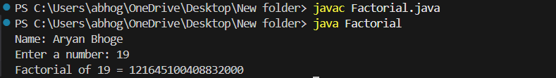

Conclusion :
In this program, a number entered by the user was used to calculate its factorial using a for loop. This experiment helped in understanding loop execution and multiplication logic in Java.

Program 6:
Pattern generation using ‘for’ loop.

Title :
Pattern Generation Using For Loop

Content :
This program demonstrates pattern generation using nested for loops in Java. A simple star (*) pattern is printed. The student name is also displayed in the output.

Theory :
Pattern generation in Java is commonly done using nested for loops.
- The outer loop controls the number of rows
- The inner loop controls the number of columns or symbols printed in each row
Example pattern:
*
- *
- * *
- * * *
- * * * *
Such programs help in understanding loop nesting and control flow.

Program Code :
class PatternDemo {
public static void main(String[] args) {
System.out.println("Name: Aryan Bhoge"); System.out.println("Pattern:\n"); for (int i = 1; i <= 5; i++) {
for (int j = 1; j <= i; j++) {
System.out.print("* ");
}
System.out.println();
}
}
}

Output :
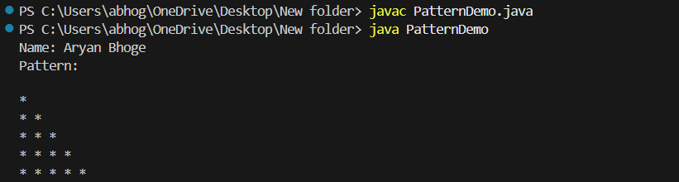

Conclusion :
In this program, a star pattern was generated using nested for loops. This experiment helped in understanding loop nesting, iteration control, and pattern design logic in Java.

