UTILITY BILLING SYSTEM
PROJECT REPORT

A Secure Full-Stack Web Application using ASP.NET Core & Angular
Submitted By:
Aryan Raj
Under the Guidance of:
Mr. Munish Arora
VIT Chennai

TABLE OF CONTENTS
Chapter | Title | Page
1 | Introduction | 1
2 | System Analysis | 2
3 | System Design | 3
4 | Implementation | 5
5 | Testing | 7
6 | Conclusion | 8

CHAPTER 1: INTRODUCTION
1.1 Overview
Utility service providers managing electricity, water, gas, and internet services handle thousands of consumer connections and monthly billing cycles. Many providers still rely on semi-manual systems, leading to incorrect meter readings, billing errors, delayed bill generation, limited visibility into outstanding dues, and poor customer experience. The Utility Billing System is a centralized full-stack web application designed to automate and streamline the entire utility billing lifecycle.
1.2 Problem Statement
Traditional utility billing systems face several challenges:
- Incorrect Billing: Manual meter readings lead to errors and disputes
- Operational Inefficiency: Time-consuming processes for bill generation and payment tracking
- Poor Transparency: Consumers lack visibility into consumption patterns and billing details
- Limited Analytics: Minimal insights into revenue and outstanding dues
- Security Concerns: Inadequate data protection and access control
1.3 Objectives
The primary objectives of this project are:
- Develop a secure full-stack web application using ASP.NET Core Web API (backend) and Angular (frontend)
- Implement JWT-based authentication and role-based authorization for four user roles: Admin, Billing Officer, Account Officer, and Consumer
- Automate meter reading entry, bill generation, and payment processing
- Provide comprehensive dashboards and reports for consumption analytics and revenue tracking
- Apply clean architecture and enterprise best practices with proper separation of concerns
- Demonstrate real-world billing workflows with LINQ-based data querying and calculations
1.4 Scope
In Scope:
- User registration with role-based access control (Admin, Billing Officer, Account Officer, Consumer)
- Consumer and connection management
- Utility type creation with configurable charges
- Billing cycle configuration
- Tariff slab management
- Meter reading entry with validation
- Automated bill generation based on consumption and tariff
- Payment processing (online simulation and offline recording)
- Comprehensive reporting and analytics
- Email notifications for bill generation and due date reminders
Out of Scope:
- Integration with real payment gateways
- Mobile native applications
- SMS gateway integration
- Advanced machine learning analytics
1.5 Technology Stack
Backend:
- ASP.NET Core Web API (.NET 8)
- Entity Framework Core (ORM)
- SQL Server (Database)
- JWT Authentication & Authorization
- LINQ for data querying
- Swagger/OpenAPI (API Documentation)
Frontend:
- Angular (TypeScript)
- Angular Material/Bootstrap (UI Components)
- Reactive Forms
- HTTPClient & Interceptors
Tools:
- Visual Studio 2022 (Backend IDE)
- Visual Studio Code (Frontend IDE)
- SQL Server Management Studio (SSMS)
- Postman (API Testing)
- Git & GitHub (Version Control)

CHAPTER 2: SYSTEM ANALYSIS
2.1 Existing System
Traditional utility billing systems rely heavily on manual processes:
- Manual Meter Reading: Field staff physically visit consumer premises to record readings
- Manual Bill Calculation: Bills calculated using calculators or basic spreadsheets
- Physical Bill Distribution: Printed bills delivered via postal service
- In-Person Payments: Consumers visit payment offices during business hours
- Paper-Based Records: Consumer data maintained in physical registers
Disadvantages:
- High error rate in reading and calculation
- Time-consuming and labor-intensive processes
- Delayed bill delivery and payment processing
- Difficulty in generating reports and analytics
- Risk of data loss and security concerns
- Poor customer experience
2.2 Proposed System
The proposed Utility Billing System addresses all limitations of the existing system through complete automation and digitalization:
Key Features:
- Role-Based Access Control: Four distinct roles (Admin, Billing Officer, Account Officer, Consumer) with specific functionalities
- Automated User Management: Self-registration with admin-controlled role assignment
- Comprehensive Admin Controls: Manage utility types, billing cycles, tariffs, connections, consumers, and staff
- Digital Meter Reading: Billing officers enter readings directly with real-time validation
- Automated Bill Generation: Smart calculation using tariff slabs and consumption data
- Flexible Payment Processing: Online payments for consumers and offline recording by account officers
- Advanced Analytics: Consumption reports, consumer summaries, and payment collection analysis
- Intelligent Notifications: Automated emails for bill generation, due date reminders, payment confirmations, and overdue alerts
- Self-Service Portal: Consumers can view bills, make payments, track consumption, and access payment history 24/7
Advantages:
- Elimination of manual errors through automated validation
- Significant time and cost savings
- Enhanced customer experience with online access
- Real-time visibility into operations
- Comprehensive reporting for data-driven decisions
- Scalable architecture to handle growing user base
- Secure data storage with encrypted passwords and JWT authentication
2.3 Feasibility Analysis
2.3.1 Technical Feasibility
Status: ✓ Feasible
All required technologies (ASP.NET Core, Angular, SQL Server) are mature, well-documented, and appropriate for the problem domain. Development tools are freely available, and the team possesses necessary skills in C#, TypeScript, SQL, and web development.
2.3.2 Operational Feasibility
Status: ✓ Feasible
The system is user-friendly with intuitive interfaces for each role. Minimal training required (2-3 hours per role). High user acceptance expected due to clear benefits: administrators gain better control, officers experience reduced workload, and consumers enjoy 24/7 convenience. Web-based deployment ensures compatibility with existing infrastructure.
2.4 Requirements Specification
2.4.1 Functional Requirements
Admin Module:
- FR-01: Assign roles to registered users
- FR-02: View and manage all consumers and staff
- FR-03: Create, update, and deactivate utility types
- FR-04: Configure billing cycles with start/end dates
- FR-05: Create and delete tariff slabs
- FR-06: Establish connections between consumers and utilities
Billing Officer Module:
- FR-07: View all meter readings
- FR-08: Enter meter readings with validation (current > previous)
- FR-09: Generate bills automatically based on consumption
Account Officer Module:
- FR-10: View all payments and outstanding balances
- FR-11: Record offline payments (cash/cheque)
- FR-12: Generate consumption and consumer summary reports
Consumer Module:
- FR-13: View profile and connection details
- FR-14: Make online payments
- FR-15: View payment history and download receipts
- FR-16: Access consumption reports
System Module:
- FR-17: Send email notifications for bill generation, due dates, and payments
- FR-18: Calculate bills using tariff slabs
- FR-19: Track bill lifecycle (Generated → Due → Paid → Overdue)
2.4.2 Non-Functional Requirements
- NFR-01: RESTful API design with proper HTTP methods
- NFR-02: JWT-based authentication and role-based authorization
- NFR-03: Responsive UI compatible with desktop, tablet, and mobile
- NFR-04: Page load time under 3 seconds
- NFR-05: Secure password storage using encryption
- NFR-06: Input validation on both client and server side
- NFR-07: Centralized exception handling
- NFR-08: Clean architecture with DTO usage
- NFR-09: LINQ for data querying and aggregations
- NFR-10: Maintainable and scalable codebase

CHAPTER 3: SYSTEM DESIGN
3.1 System Architecture
The application follows a three-tier architecture with clear separation of concerns:
Presentation Layer (Angular Frontend):
- Component-based UI with Angular Material
- Reactive forms for user input
- HTTP interceptors for JWT token handling
- Route guards for role-based navigation
Business Logic Layer (ASP.NET Core Web API):
- RESTful API controllers
- Service layer for business logic
- Repository pattern for data access
- DTO (Data Transfer Objects) for data exchange
- JWT authentication middleware
- Global exception handling
Data Layer (SQL Server Database):
- Normalized database schema
- Entity Framework Core for ORM
- LINQ for data queries
- Foreign key constraints for referential integrity
Communication: Angular frontend communicates with backend API using HTTP/HTTPS, sending JWT tokens in Authorization headers for authenticated requests.
3.2 Database Design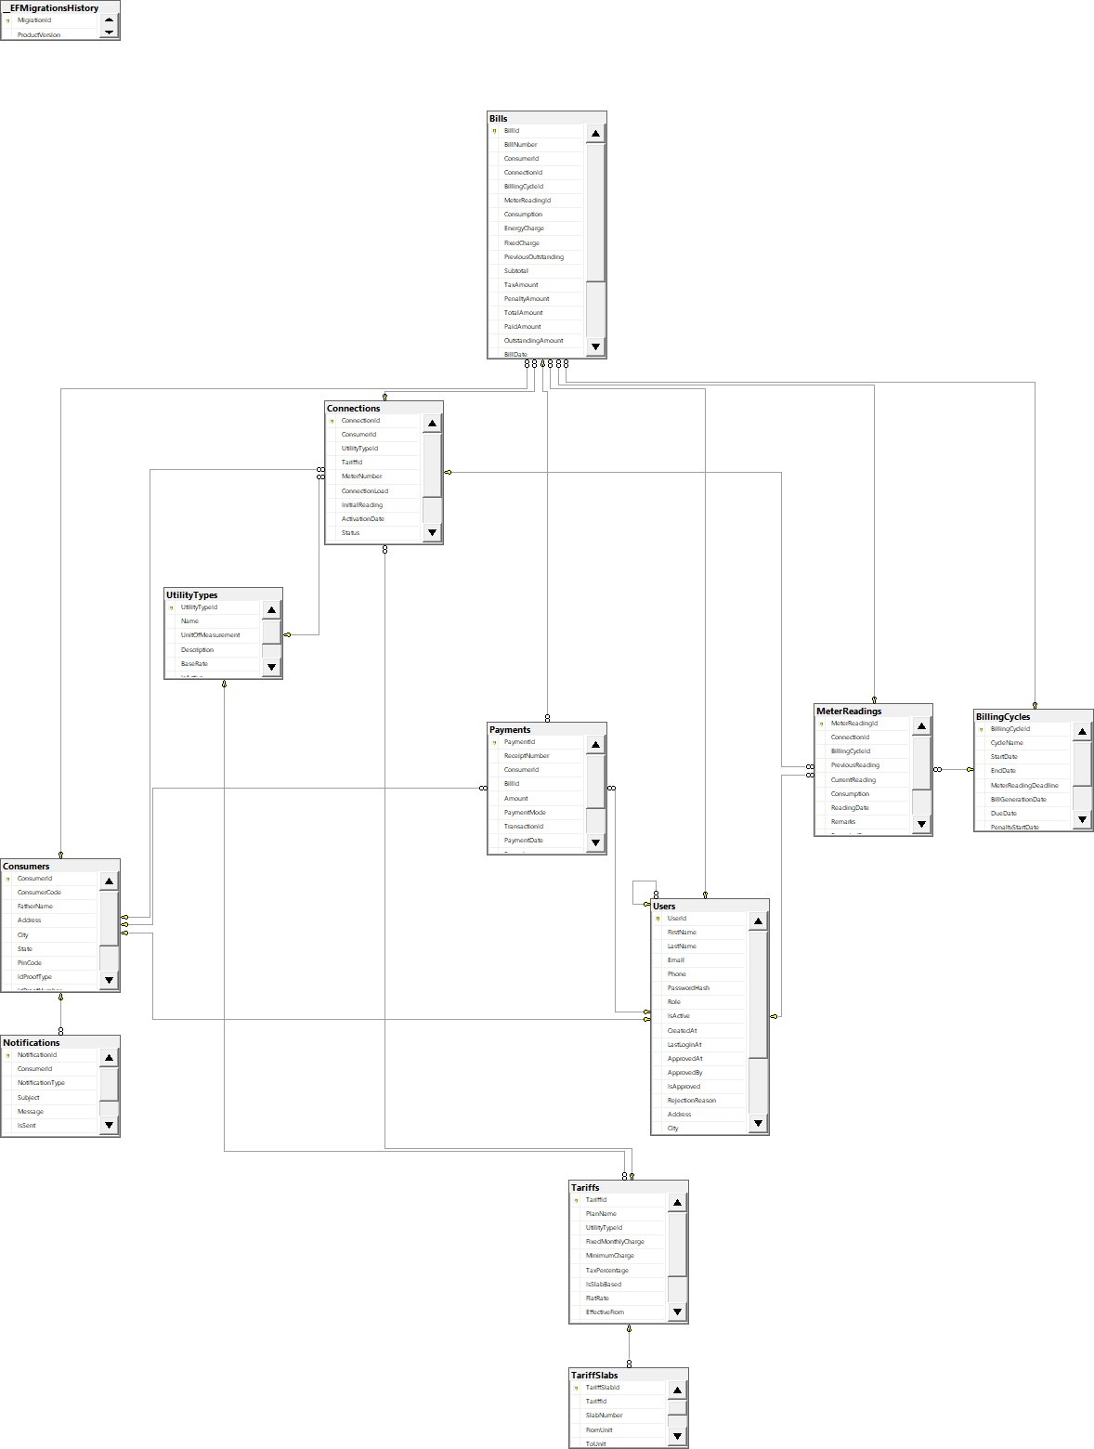

3.3 Use Case Diagrams
Admin Use Cases:
- Assign roles to users
- Manage consumers and staff
- Create/deactivate utility types
- Configure billing cycles
- Manage tariff slabs
- Create connections
Billing Officer Use Cases:
- Login to system
- View meter readings
- Enter new meter readings
- Generate bills
Account Officer Use Cases:
- Login to system
- View payments and outstanding dues
- Record offline payments
- Generate consumption reports
- Generate consumer summary reports
Consumer Use Cases:
- Login to system
- View profile
- View connections
- View bills
- Make online payment
- View payment history
- View consumption report
3.4 API Endpoints Design
Authentication:
- POST /api/auth/register - User registration
- POST /api/auth/login - User login (returns JWT token)
Admin Endpoints:
- PUT /api/users/{id}/assign-role - Assign role to user
- GET /api/consumers - Get all consumers
- POST /api/utilitytypes - Create utility type
- PUT /api/utilitytypes/{id}/deactivate - Deactivate utility
- POST /api/billingcycles - Create billing cycle
- POST /api/tariffs - Create tariff slab
- POST /api/connections - Create connection
Billing Officer Endpoints:
- GET /api/meterreadings - Get all meter readings
- POST /api/meterreadings - Enter meter reading
- POST /api/bills/generate - Generate bill
Account Officer Endpoints:
- GET /api/payments - Get all payments
- GET /api/payments/outstanding - Get outstanding payments
- POST /api/payments - Record payment
- GET /api/reports/consumption - Get consumption report
- GET /api/reports/consumer-summary - Get consumer summary
Consumer Endpoints:
- GET /api/consumers/profile - Get consumer profile
- GET /api/consumers/{id}/connections - Get connections
- GET /api/consumers/{id}/bills - Get bills
- POST /api/payments/online - Make online payment
- GET /api/consumers/{id}/payment-history - Get payment history
- GET /api/consumers/{id}/consumption - Get consumption report

CHAPTER 4: IMPLEMENTATION
4.1 Technologies Used
Backend Implementation:
- ASP.NET Core 8.0 Web API: RESTful API development
- Entity Framework Core: ORM for database operations
- SQL Server: Relational database
- JWT (JSON Web Tokens): Stateless authentication
- BCrypt: Password hashing
- Swagger: API documentation
- LINQ: Data querying and aggregations
Frontend Implementation:
- Angular 16: Single-page application framework
- TypeScript: Type-safe JavaScript
- Angular Material: UI component library
- RxJS: Reactive programming
- Angular Forms: Reactive forms for user input
- HTTP Interceptors: Automatic JWT token attachment
4.2 Backend Architecture
4.2.1 Layered Architecture
Controllers Layer:
[ApiController]
[Route("api/[controller]")]
public class BillsController : ControllerBase
{
private readonly IBillService _billService;

[HttpPost("generate")]
[Authorize(Roles = "BillingOfficer")]
public async Task<IActionResult> GenerateBill([FromBody] GenerateBillDto dto)
{
var result = await _billService.GenerateBillAsync(dto);
return Ok(result);
}
}
Service Layer:
public class BillService : IBillService
{
private readonly IUnitOfWork _unitOfWork;

public async Task<BillDto> GenerateBillAsync(GenerateBillDto dto)
{
// Get meter reading
var reading = await _unitOfWork.MeterReadings.GetByIdAsync(dto.ReadingId);

// Get connection and tariff
var connection = await _unitOfWork.Connections.GetByIdAsync(reading.ConnectionId);
var tariffs = await _unitOfWork.Tariffs
.GetTariffsByUtilityTypeAsync(connection.UtilityTypeId);

// Calculate bill amount using LINQ
decimal amount = CalculateBillAmount(reading.UnitsConsumed, tariffs);

// Create bill
var bill = new Bill
{
ConnectionId = connection.ConnectionId,
ReadingId = reading.ReadingId,
BillDate = DateTime.Now,
DueDate = DateTime.Now.AddDays(15),
UnitsConsumed = reading.UnitsConsumed,
Amount = amount,
Status = "Unpaid"
};

await _unitOfWork.Bills.AddAsync(bill);
await _unitOfWork.SaveAsync();

return MapToDto(bill);
}
}
Repository Layer:
public class BillRepository : Repository<Bill>, IBillRepository
{
public async Task<IEnumerable<Bill>> GetOutstandingBillsAsync()
{
return await _context.Bills
.Where(b => b.Status == "Unpaid" || b.Status == "Overdue")
.Include(b => b.Connection)
.ThenInclude(c => c.Consumer)
.ToListAsync();
}
}
4.2.2 LINQ Usage Examples
Monthly Revenue Calculation:
var monthlyRevenue = await _context.Bills
.Where(b => b.BillDate.Month == month && b.BillDate.Year == year && b.Status == "Paid")
.GroupBy(b => new { b.BillDate.Month, b.BillDate.Year })
.Select(g => new
{
Month = g.Key.Month,
Year = g.Key.Year,
TotalRevenue = g.Sum(b => b.Amount)
})
.FirstOrDefaultAsync();
Outstanding Dues Report:
var outstandingDues = await _context.Bills
.Where(b => b.Status != "Paid")
.GroupBy(b => b.Connection.Consumer)
.Select(g => new
{
ConsumerName = g.Key.FirstName + " " + g.Key.LastName,
TotalOutstanding = g.Sum(b => b.Amount),
BillCount = g.Count()
})
.OrderByDescending(x => x.TotalOutstanding)
.ToListAsync();
Average Consumption:
var avgConsumption = await _context.MeterReadings
.Where(m => m.Connection.UtilityTypeId == utilityTypeId)
.GroupBy(m => m.Connection.ConsumerId)
.Select(g => new
{
ConsumerId = g.Key,
AverageConsumption = g.Average(m => m.UnitsConsumed)
})
.ToListAsync();
4.2.3 JWT Authentication
public class AuthService : IAuthService
{
public async Task<AuthResponseDto> LoginAsync(LoginDto loginDto)
{
var user = await _userRepository.GetByEmailAsync(loginDto.Email);

if (user == null || !BCrypt.Verify(loginDto.Password, user.PasswordHash))
throw new UnauthorizedException("Invalid credentials");

var token = GenerateJwtToken(user);

return new AuthResponseDto
{
Token = token,
Email = user.Email,
Role = user.Role
};
}

private string GenerateJwtToken(User user)
{
var claims = new[]
{
new Claim(ClaimTypes.NameIdentifier, user.UserId.ToString()),
new Claim(ClaimTypes.Email, user.Email),
new Claim(ClaimTypes.Role, user.Role)
};

var key = new SymmetricSecurityKey(Encoding.UTF8.GetBytes(_configuration["Jwt:Key"]));
var credentials = new SigningCredentials(key, SecurityAlgorithms.HmacSha256);

var token = new JwtSecurityToken(
issuer: _configuration["Jwt:Issuer"],
audience: _configuration["Jwt:Audience"],
claims: claims,
expires: DateTime.Now.AddHours(24),
signingCredentials: credentials
);

return new JwtSecurityTokenHandler().WriteToken(token);
}
}
4.3 Frontend Architecture
4.3.1 Module Structure
Core Module:
- Authentication service
- HTTP interceptor
- Route guards
- Token management
Shared Module:
- Reusable components (header, footer, sidebar)
- Common pipes and directives
Feature Modules:
- Admin Module
- Billing Officer Module
- Account Officer Module
- Consumer Module
4.4 Key Features Implementation
4.4.1 Role Assignment (Admin)
Admin can assign roles to registered users after reviewing their details. This ensures proper access control.
4.4.2 Bill Calculation Algorithm
Bills are calculated using tariff slabs:
For units consumed = 350
Slab 1: 0-100 units @ $0.50 = $50
Slab 2: 101-200 units @ $0.75 = $75
Slab 3: 201-350 units @ $1.00 = $150
Total Amount = $275
4.4.3 Notification System
Automated email notifications sent using SMTP:
- Bill generated: Sent immediately after bill creation
- Due date reminder: Scheduled job runs daily, sends 3 days before due date
- Payment confirmation: Sent after successful payment
- Overdue alert: Sent when bill passes due date

CHAPTER 5: TESTING
5.1 Testing Strategy
The application was tested at multiple levels to ensure functionality, security, and reliability:
1. Unit Testing (xUnit):
- Service layer methods
- Repository layer data access
- Business logic validation
- LINQ query correctness
2. Integration Testing:
- API endpoint testing
- Database operations
- Authentication and authorization flows
3. API Testing (Postman):
- All API endpoints tested with various scenarios
- JWT token validation
- Role-based authorization verification
- Request/response validation5.2 Test Cases Summary

CHAPTER 6: CONCLUSION AND FUTURE SCOPE
6.1 Conclusion
The Utility Billing System successfully addresses the challenges faced by utility service providers through comprehensive automation and digitalization. The project demonstrates the practical application of full-stack development using ASP.NET Core and Angular to solve real-world business problems.
Key Achievements:
- Functional Completeness: All core modules (User Management, Consumer Management, Meter Reading, Bill Generation, Payment Processing, Reporting, Notifications) implemented and working as expected.
- Security: Robust JWT-based authentication and role-based authorization ensure only authorized users can access specific functionalities. Passwords encrypted using BCrypt for secure storage.
- Clean Architecture: Application follows separation of concerns with distinct layers (Controllers, Services, Repositories) making it maintainable and scalable.
- LINQ Utilization: Extensive use of LINQ for data querying, filtering, aggregations (revenue calculations, outstanding dues, average consumption) demonstrating efficient data handling.
- User Experience: Role-specific interfaces (Admin, Billing Officer, Account Officer, Consumer) provide intuitive and efficient workflows. Responsive design ensures accessibility across devices.
- Automation: Automated bill calculation, validation rules, and notification system significantly reduce manual effort and errors.
Learning Outcomes:
- Hands-on experience with modern web technologies (ASP.NET Core, Angular, Entity Framework Core)
- Understanding of RESTful API design principles
- Implementation of secure authentication and authorization mechanisms
- Database design and relationship management
- Frontend-backend integration
- Version control using Git and GitHub
- Testing methodologies (unit testing, API testing)
- Real-world problem-solving through software engineering
Impact:
The system can significantly improve operational efficiency for utility providers by:
- Reducing billing cycle time by 60-70%
- Eliminating billing errors through automated validation
- Improving customer satisfaction through 24/7 online access
- Providing data-driven insights for business decisions
- Reducing operational costs (printing, distribution, manual labor)
6.2 Future Enhancements
While the current system meets all project objectives, several enhancements can further improve its capabilities:
1. Payment Gateway Integration:
- Integrate with real payment gateways (Stripe, PayPal, Razorpay)
- Support multiple payment methods (Credit Card, Debit Card, UPI, Net Banking)
- Automated payment reconciliation
2. Mobile Applications:
- Native Android and iOS applications
- Push notifications for bill alerts
- Mobile-optimized payment interface
3. Advanced Analytics:
- Machine learning for consumption prediction
- Anomaly detection for unusual consumption patterns
- Fraud detection algorithms
4. Additional Features:
- SMS gateway integration for multi-channel notifications
- Customer complaint management system
- Field service management for meter maintenance
- Multi-language support for wider accessibility
- PDF invoice generation with QR codes
- Automated late payment penalty calculation
5. Integration Capabilities:
- Integration with CRM systems
- ERP system connectivity
- Third-party accounting software integration
- IoT meter integration for automatic readings
6. Scalability Improvements:
- Microservices architecture for better scalability
- Containerization using Docker
- Kubernetes orchestration for cloud deployment
- Caching mechanisms (Redis) for improved performance
- Message queuing (RabbitMQ) for asynchronous processing
7. Enhanced Security:
- Two-factor authentication (2FA)
- Biometric authentication for mobile apps
- Advanced encryption for sensitive data
- Regular security audits and penetration testing

REFERENCES
- Microsoft Documentation - ASP.NET Core Web API
https://docs.microsoft.com/en-us/aspnet/core/web-api
- Angular Documentation
https://angular.io/docs
- Entity Framework Core Documentation
https://docs.microsoft.com/en-us/ef/core
- Stack Overflow - Developer Community
https://stackoverflow.com
- GitHub - Code Repository and Version Control
https://github.com

APPENDIX
A. GitHub Repository
URL: https://github.com/aryan2882/Capstone_Project
B. Default Login Credentials
Admin:
- Email: admin@utilitybilling.com
- Password: Admin@123

Document Information:
- Version: 1.0
- Date: January 4, 2026
- Total Pages: 20
- Prepared By: Aryan Raj
- Project: Utility Billing System - Capstone Project

