**SYNOPSIS**

1. **Title of the Project:**

Voice enabled user interface for geospatial map-based web-applications.

1. **Name of the College:**

D. Y. PATIL Technical Campus, Faculty of Engineering & Faculty of Management, Talsande.

1. **Name of Department:**

Computer Science and Engineering.

1. **Name of Students:**
2. BAMANE ARYAN ABHIJIT
3. KHAMKAR ATHARVA ARUN.
4. PATIL ABHISHEK.SAMBHAJI
5. DESAI HRITUJA SAMBHAJI
6. **Name of Guide:**

MR. BS. JADHAV

1. **Relevance:**

This project is relevant in the context of enhancing user interaction with geospatial applications. As the use of web-based GIS tools grows, the need for more intuitive, voice-driven interfaces becomes increasingly important. This work aims to bridge the gap between traditional point-and-click methods and modern voice command capabilities, thereby making geospatial data more accessible to a broader audience, including those with physical limitations or less technical expertise.

1. **Literature Review:**

With the advent of technologies such as voice recognition and natural language processing (NLP), new developments are being introduced into everyday tools, impacting various fields. One such field is Cartography and Geoinformatics, where these advances are integral to the evolution of map and geospatial visualisation. Online mapping applications and open geospatial data have democratised spatial information, enabling public participation in its creation [1]. Integrating speech recognition technology into these applications can improve efficiency, user experience and accessibility while reducing the need for specialised skills and knowledge in dealing with geospatial data [2]. Blanco [3] highlighted the lack of infrastructure and practical experience in implementing speech recognition in GIS interfaces, a challenge the present study aims to address. Integrating speech recognition and NLP in geospatial applications has been a topic of considerable interest in previous research [4]. For example, Lai and Degbelo [5] presented a webmapprototype that skilfully fuses text and speech for efficient metadata retrieval. Gilbert’s [6] VocalGeo serves as a testament to the potential of speech recognition in promoting geospatial education. Similarly, Cal‘ı and Condorelli [7] have highlighted the tangible benefits of incorporating NLP and speech recognition into conventional GIS through their iTour initiative. Furthermore, progress has been made in improving user GIS communication, as evidenced by Wang, Cai, and MacEachren’s [8] PlanGraph and GeoDialogue.

1. **Problem identification:**

* Accessibility: Traditional geospatial interfaces are challenging for users with disabilities, requiring more inclusive solutions.
* Command Complexity: Interpreting and executing complex geospatial commands accurately through voice recognition.
* Integration Challenges: Ensuring seamless integration of voice-enabled features with existing geospatial mapping platforms.

1. 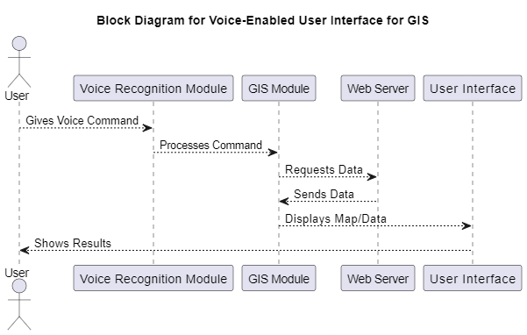**Block Diagram: (if any):**
2. **Experimental Setup: (if any)**

Browser with good internet connection and a working mic.

1. **Objective and Scope of Project:**

**Objective:**

* Enhance accessibility for users with disabilities by developing a voice-enabled interface for geospatial mapping applications.
* Improve user experience and efficiency by enabling intuitive voice commands for complex geospatial tasks.
* Ensure accurate interpretation and execution of voice commands using advanced speech recognition and NLP technologies.

**Scope:**

* Implement core geospatial functions (zoom, pan, query) through voice commands.
* Integrate with popular geospatial mapping platforms and databases.
* Design an intuitive user interface with visual and auditory feedback.
* Focus on accessibility, adhering to relevant standards and guidelines.
* Provide user guides, tutorials, and ongoing support based on user feedback.

1. **Proposed Work:**

**Phase 1: Research and Planning**

* Conduct user research to identify needs and preferences.
* Evaluate and select suitable speech recognition and natural language processing (NLP) technologies.
* Identify compatible geospatial mapping platforms and databases for integration.

**Phase 2: Development and Integration**

* Implement core geospatial operations such as zooming, panning, and querying using voice commands.
* Integrate advanced geospatial tasks like data analysis and layer management.
* Develop APIs and middleware to support interoperability with various systems.

**Phase 3: Testing, Deployment, and User Training**

* Perform usability testing with a diverse group of users to validate accessibility and user experience.
* Deploy the voice-enabled interface in a live environment.
* Offer ongoing support and updates based on user feedback and technological advancements.

1. **Motivation for work:**

* Make geospatial mapping applications more accessible to users with visual impairments or limited mobility through voice commands.
* Simplify complex geospatial tasks, making interactions more intuitive and efficient.
* Utilize speech recognition and natural language processing to create intelligent, user-friendly interfaces.
* Improve efficiency in industries reliant on geospatial data, such as urban planning and emergency response, with hands-free operation.

1. **Expected Outcome:**

The expected outcome is a fully functional voice-enabled user interface for web-based GIS applications that enhances accessibility, improves user experience, and can be adapted for various use cases. Additionally, the project will deliver comprehensive documentation and a demonstration of the prototype.

1. **Expected Date of Completion:**
2. **Approximate Expenditure:**

As the project primarily involves software development using open-source tools and libraries, the expenditure is expected to be minimal, covering mainly potential hosting and development environment costs.

1. **References:**

* Article: Development of a Voice Virtual Assistant for the Geospatial Data Visualization Application on the Web by Homeyra Mahmoudi 1, Silvana Camboim, and Maria Antonia Brovelli :[https://www.researchgate.net/publication/372201565_Development_of_a_Voice_Virtual_Assistant_for_the_Geospatial_Data_Visualization_Application_on_the_Web]
* Article: First Steps toward Voice User Interfaces for Web-Based Navigation of Geographic Information: A Spanish Terms Study by Teresa Blanco, Sergio Martín-Segura, Juan López de Larrinzar, Rubén Béjar and Francisco Javier Zarazaga-Soria.: [https://www.researchgate.net/publication/368320105_First_Steps_toward_Voice_User_Interfaces_for_Web-Based_Navigation_of_Geographic_Information_A_Spanish_Terms_Study]

**Place:**

**Date:**

|  |  |  |
| --- | --- | --- |
| **Roll No.** | **Name of Student** | **Signature** |
| **4041** | **BAMANE ARYAN ABHIJIT** |  |
| **4042** | **KHAMKHAR ATHARVA ARUN** |  |
| **4043** | **PATIL ABHISHEK SAMBHAJI** |  |
| **4044** | **DESAI HRITUJA SAMBHAJI** |  |