How to get Exact

Search Results On Google

Introduction: "Hey there! Ever felt lost while searching on Google? Don't worry, we've got your back! In this video, we'll show you some cool tricks to make you a Google search whiz. From finding exact phrases to filtering out unwanted stuff, we've got all the tips you need to search like a pro. So, if you're ready to make your Google searches smoother and faster, stick around and let's dive in!"

1) Using a Quotation Marks:

- Put phrases in quotation marks to find web pages with those exact words in that specific order.

- Quotation marks help to focus your search and avoid getting results with individual words scattered around.

- Researchers often use this to locate exact terms or phrases in academic papers or technical documents.



2) Using a Dashes:

- Dashes help in removing specific words or phrases from your search results, making them more relevant to what you need.

- When you're overwhelmed with unrelated results, dashes help you refine your search quickly.

- Dashes assist in making your search queries more accurate by filtering out irrelevant terms.



3) Using a Tilde:

- Using a tilde (~) alongside your search term helps to find similar words or phrases, expanding your search to related terms.

- Google's tilde feature helps understand what you're looking for by considering synonyms and related words.

- You'll get broader search results, covering different aspects of a topic when using the tilde operator.

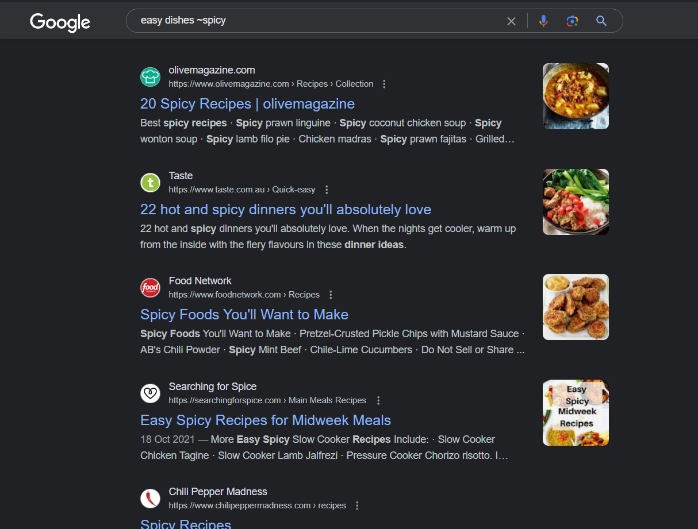

4) Using a Site Operator:

- By using "site:", you can search for information within a particular website or domain.

- This helps to find information from reliable sources or websites you trust.

- It saves time by directly searching within a specific website, avoiding unrelated search results.

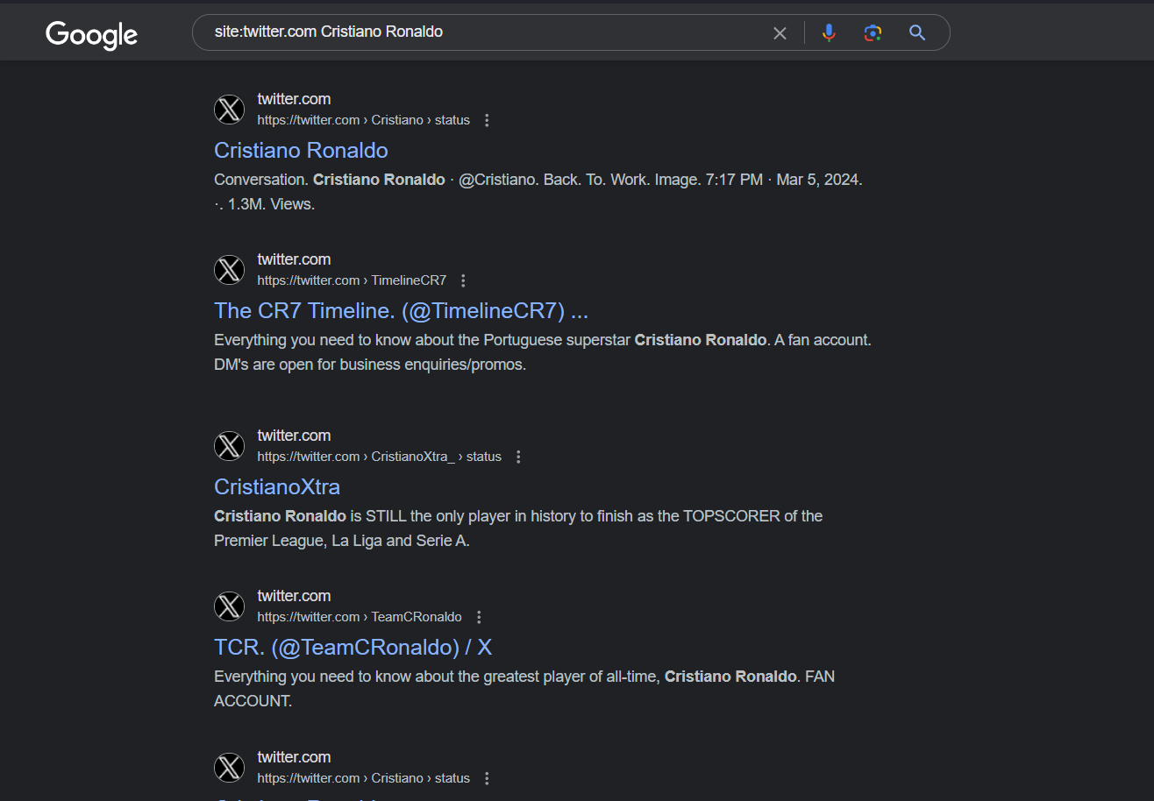

5) Using a Vertical Bar:

- The vertical bar (|) lets you combine multiple search terms or phrases to get results related to any of them.

- You can explore different angles of a topic simultaneously by using the vertical bar.

- This feature lets you tailor your search to include various perspectives or topics of interest.



6) Using a Specific Range with Two Periods:

- Including two periods (..) helps to specify a range of numbers, useful for searching within a specific numerical range.

- It makes it easier to find data or information within a certain timeframe or numeric range.

- You can quickly filter search results to focus on relevant data points within your specified range.

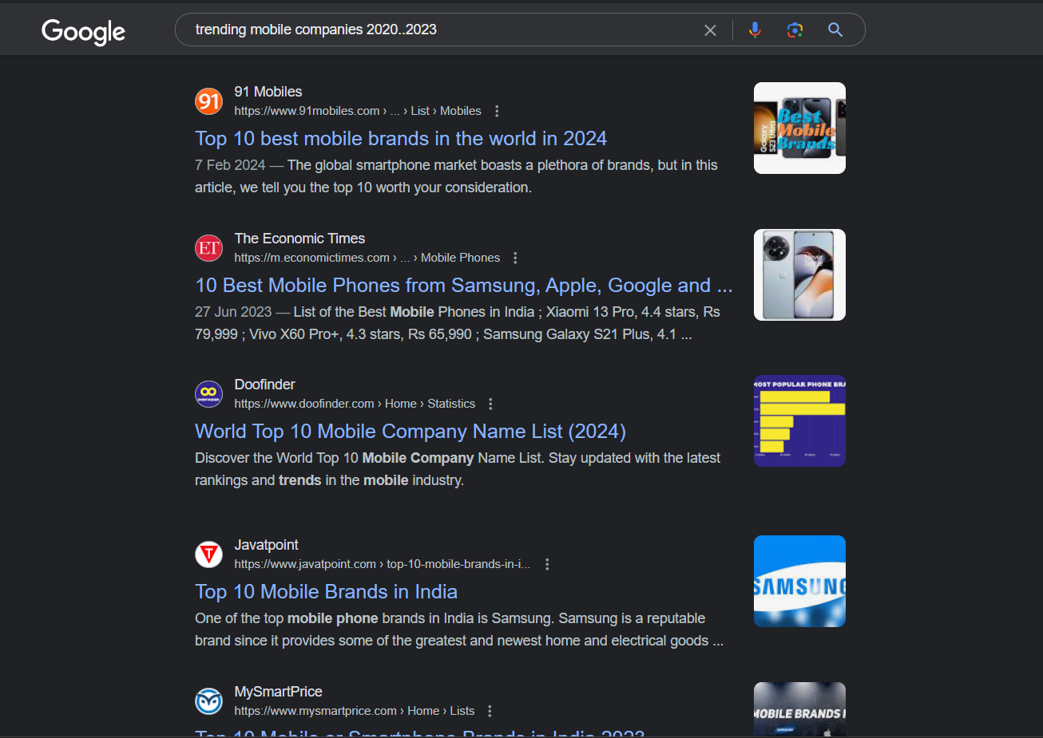

7) Using a FileType Operator:

- The "filetype:" operator allows you to search for specific types of files, like documents or presentations.

- This helps to find files in the format you need, saving time by excluding irrelevant file types.

- It assists in organizing and accessing files in the preferred format for your projects or presentations.

