unsloth/Llama-3.2-3B-Instruct
Accuracy : 0.7416
Precision : 0.7414
Recall : 0.7416
F1 Score : 0.7407
ROC-AUC : 0.8785
--- Classification Report ---
precision recall f1-score support

Other 0.733 0.736 0.734 473
Negative 0.753 0.809 0.780 346
Positive 0.742 0.675 0.707 311

accuracy 0.742 1130
macro avg 0.742 0.740 0.740 1130
weighted avg 0.741 0.742 0.741 1130

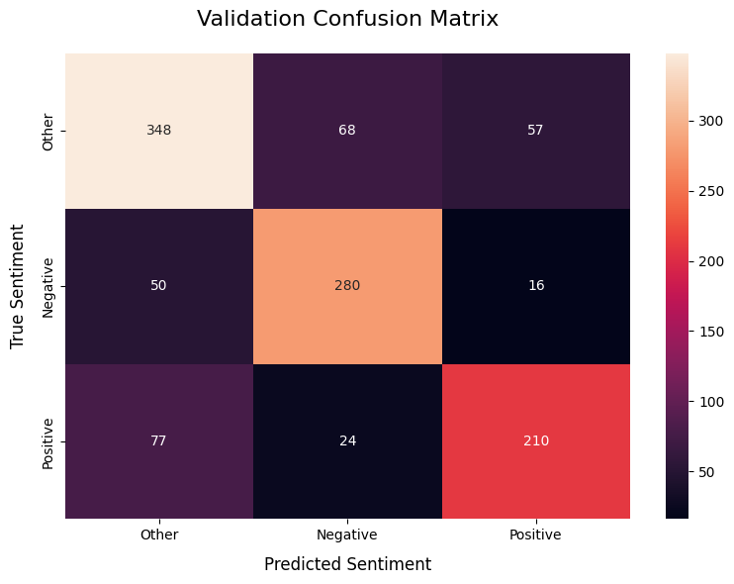

google/gemma-2b-it
Accuracy : 0.7097
Precision : 0.7141
Recall : 0.7097
F1 Score : 0.7097
ROC-AUC : 0.8653

--- Classification Report ---
precision recall f1-score support

Other 0.669 0.729 0.698 473
Negative 0.724 0.743 0.733 346
Positive 0.772 0.643 0.702 311

accuracy 0.710 1130
macro avg 0.722 0.705 0.711 1130
weighted avg 0.714 0.710 0.710 1130

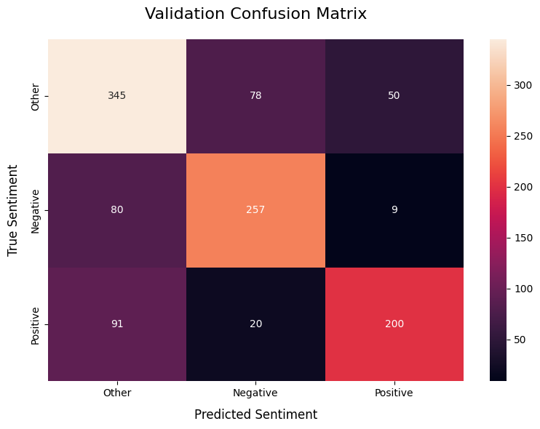

unsloth/Qwen3-1.7B

Accuracy : 0.7000
Precision : 0.7003
Recall : 0.7000
F1 Score : 0.6998
ROC-AUC : 0.8527

--- Classification Report ---
precision recall f1-score support

Other 0.678 0.691 0.685 473
Negative 0.717 0.740 0.728 346
Positive 0.715 0.669 0.691 311

accuracy 0.700 1130
macro avg 0.703 0.700 0.701 1130
weighted avg 0.700 0.700 0.700 1130

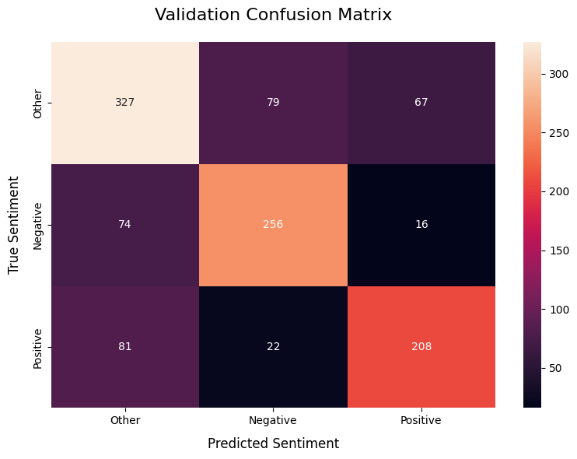
Baseline Scores :

Accuracy: 0.6442
Precision: 0.6475
Recall: 0.6442
F1 Score: 0.6439
AUROC: 0.8195

Classification Report:

precision recall f1-score support

Negative 0.66 0.60 0.63 473
Neutral 0.68 0.66 0.67 346
Positive 0.60 0.70 0.65 311

accuracy 0.64 1130
macro avg 0.64 0.65 0.65 1130
weighted avg 0.65 0.64 0.64 1130

