Name: - Aryan Patel

SIN: - 301226774

**Assignment 3-1 Advanced Database concept**

**Question 1:-**

CREATE OR REPLACE

FUNCTION ttlsp

(in_shopid IN number)

RETURN NUMBER

IS

totalSp NUMBER(5,2) :=0 ;

BEGIN

Select sum(subtotal) INTO totalSp from bb_basket where IDSHOPPER = in_shopid;

IF totalSp IS NULL THEN

RAISE NO_DATA_FOUND;

END IF;

RETURN totalSp;

END;

/

DECLARE

ttl_sp NUMBER(5,2) := 0;

sh_id NUMBER(5,2) := 22;

BEGIN

ttl_sp := ttlsp(sh_id);

DBMS_OUTPUT.PUT_LINE('Total Spending of shpper id '||sh_id ||' is '|| ttl_sp);

EXCEPTION

WHEN NO_DATA_FOUND THEN

DBMS_OUTPUT.PUT_LINE('No Data Found');

END;

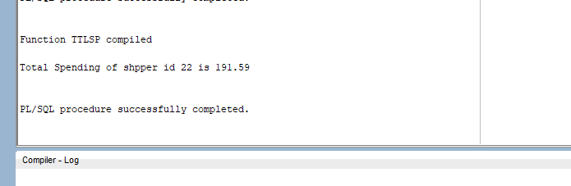

**Question 2:-**

create or replace procedure up_status

(basket_id in bb_basketstatus.idbasket%type,

dt_stage in bb_basketstatus.dtstage%type,

b_sh in bb_basketstatus.shipper%type,

b_tr in bb_basketstatus.shippingnum%type)

IS

BEGIN

INSERT INTO bb_basketstatus

(idstatus, idbasket, idstage, dtstage, shipper, shippingnum)

values (bb_status_seq.nextval, basket_id, 4, dt_stage, b_sh, b_tr);

commit;

end;

/

DECLARE

BEGIN

up_status(5, '2-FEB-12', 'UPS', 'ZW45325567D3246J55');

END;

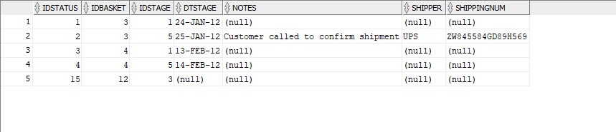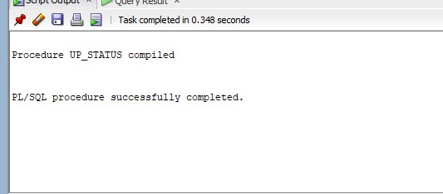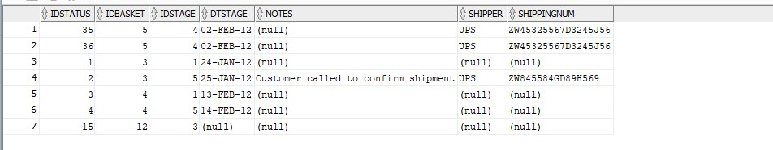

**Question 3: -**

CREATE OR REPLACE FUNCTION int_prd(id_bas IN NUMBER, id_prd IN NUMBER, unt_prc IN NUMBER, qnt IN NUMBER)

RETURN VARCHAR2

IS

prtorder bb_basketitem.idbasketitem%TYPE;

msg VARCHAR2(100);

basitem bb_basketitem.idbasketitem%TYPE;

BEGIN

basitem := BB_IDBASKETITEM_SEQ.NEXTval;

INSERT INTO bb_basketitem(idbasketitem, idproduct, price, quantity, idbasket)

VALUES(basitem, id_prd, unt_prc, qnt, id_bas);

SELECT idbasketitem INTO prtorder

FROM bb_basketitem

WHERE idbasketitem = basitem;

IF(prtorder = basitem) THEN

msg:= 'Order updated.';

ELSE

msg:= 'Order not updated';

END IF;

RETURN msg;

END;

/

SET SERVEROUTPUT ON

DECLARE

out_msg varchar2(50);

BEGIN

out_msg:= int_prd(3, 8, 30.5, 7);

DBMS_OUTPUT.PUT_LINE(out_msg);

END;

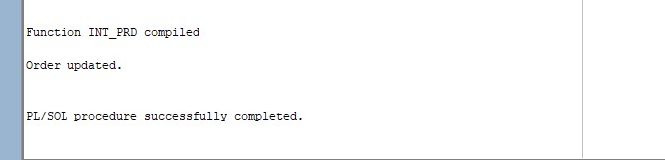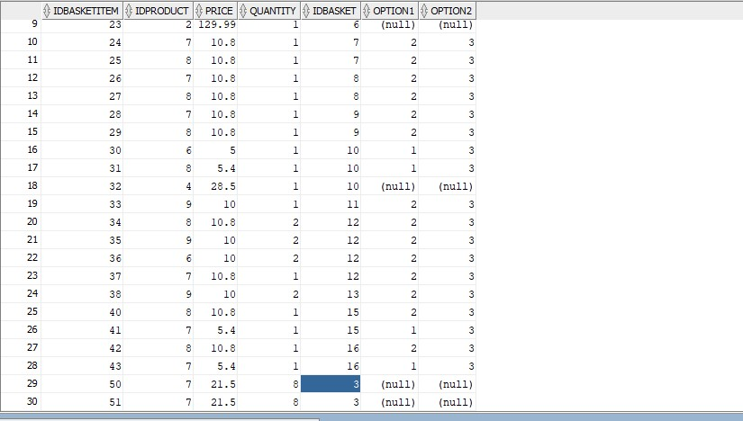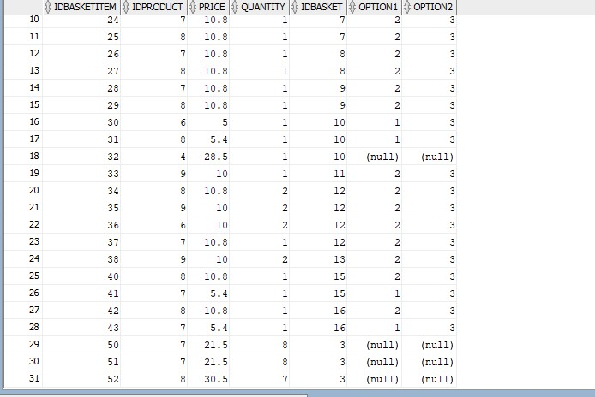

**Question 5: -**

create or replace PROCEDURE product_add

(pName IN BB_PRODUCT.PRODUCTNAME%TYPE,

pDescription IN BB_PRODUCT.DESCRIPTION%TYPE,

pImage IN BB_PRODUCT.PRODUCTIMAGE%TYPE,

pPrice IN BB_PRODUCT.PRICE%TYPE,

pSalesstart IN BB_PRODUCT.SALESTART%TYPE,

pSaleend IN BB_PRODUCT.SALEEND%TYPE,

pSaleprice IN BB_PRODUCT.SALEPRICE%TYPE,

pActive IN BB_PRODUCT.ACTIVE%TYPE,

pFeatured IN BB_PRODUCT.FEATURED%TYPE,

pFeaturestart IN BB_PRODUCT.FEATURESTART%TYPE,

pFeatureend IN BB_PRODUCT.FEATUREEND%TYPE,

pTyp IN BB_PRODUCT.TYPE%TYPE,

pIddepartment IN BB_PRODUCT.IDDEPARTMENT%TYPE,

pStock IN BB_PRODUCT.STOCK%TYPE,

pOrdered IN BB_PRODUCT.ORDERED%TYPE,

pReorder IN BB_PRODUCT.REORDER%TYPE)

IS

id_bas bb_basketstatus.idbasket%type;

BEGIN

INSERT INTO BB_PRODUCT (IDPRODUCT, PRODUCTNAME, DESCRIPTION, PRODUCTIMAGE, PRICE, SALESTART, SALEEND, SALEPRICE, ACTIVE, FEATURED, FEATURESTART, FEATUREEND, TYPE, IDDEPARTMENT, STOCK, ORDERED, REORDER)

VALUES (BB_PRODID_SEQ.NEXTVAL, pName, pDescription, pImage, pPrice, pSalesstart, pSaleend, pSaleprice, pActive, pFeatured, pFeaturestart, pFeatureend, pTyp, pIddepartment, pStock, pOrdered, pReorder);

COMMIT;

END;

/

DECLARE

BEGIN

product_add('Black Tea', 'Made from tea leaves.', 'blacktea.jpg', 10, '2-AUG-12', '20-AUG-12', 7, 1, null, null, null, 'D', 3, 90, 20, 30);

END;

