Name: Aryan Patel

SN: 301226774

1. Check that node/npm are installed

node -v

npm -v

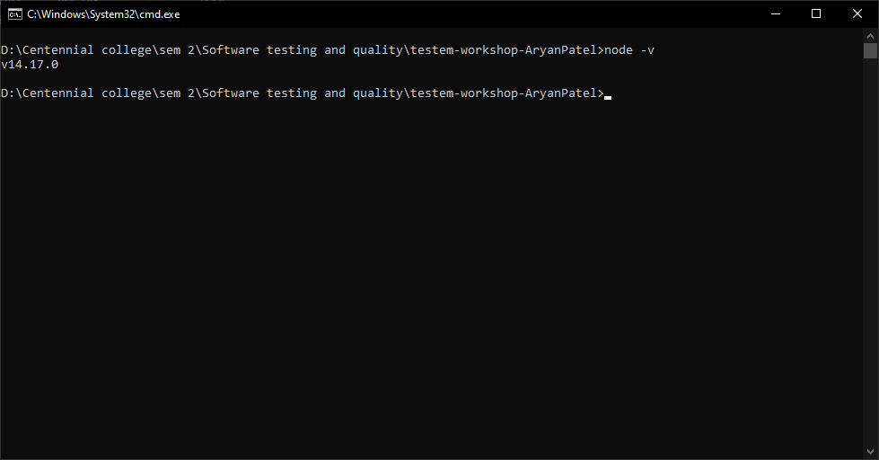

2. make a working directory for the workshop

mkdir testem-workshop-yourname

3. change the current directory to go to the above directory

cd testem-workshop-yourname

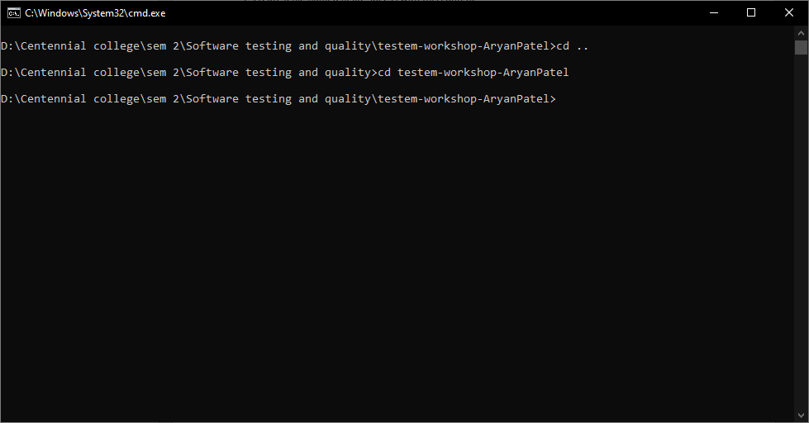

4. check whether testem is installed

testem --help

4. install testem (if it is not installed)

npm install testem

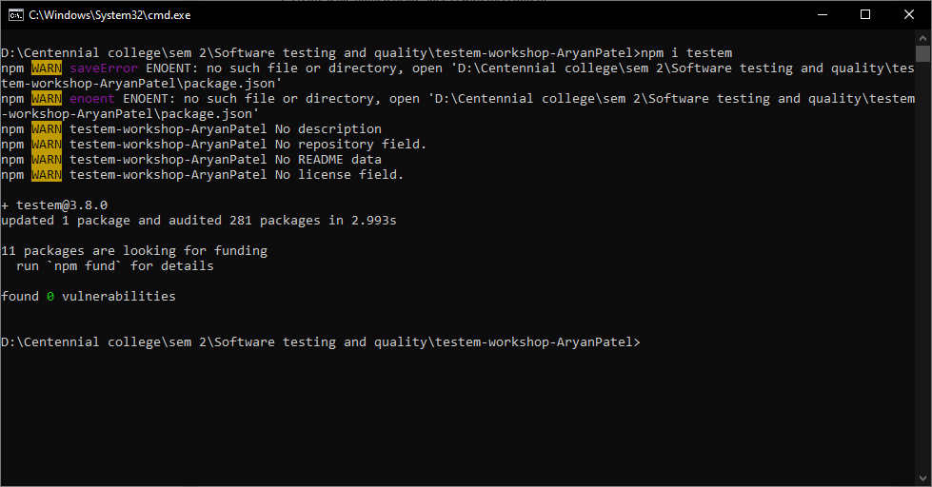

5. execute testem

testem-workshop-yourname\node_modules\.bin\testem

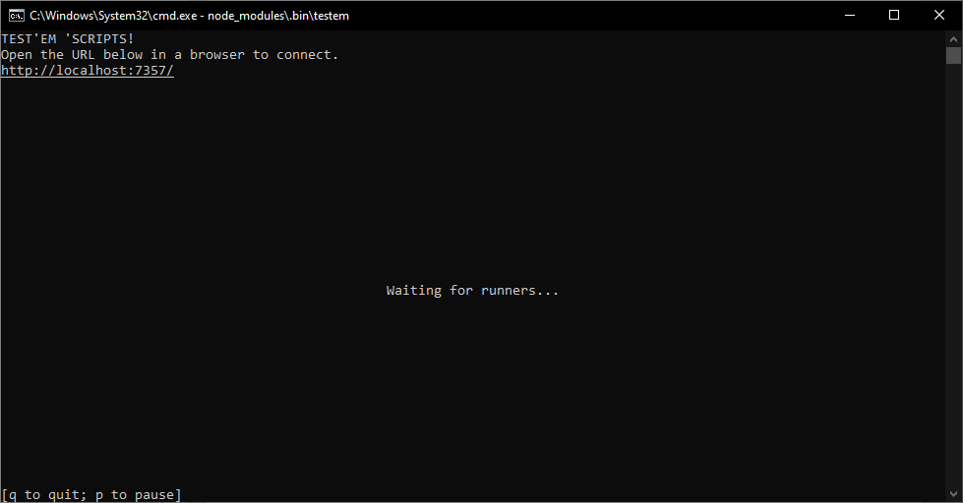

6. open in browser the address given by testem:

localhost:7357

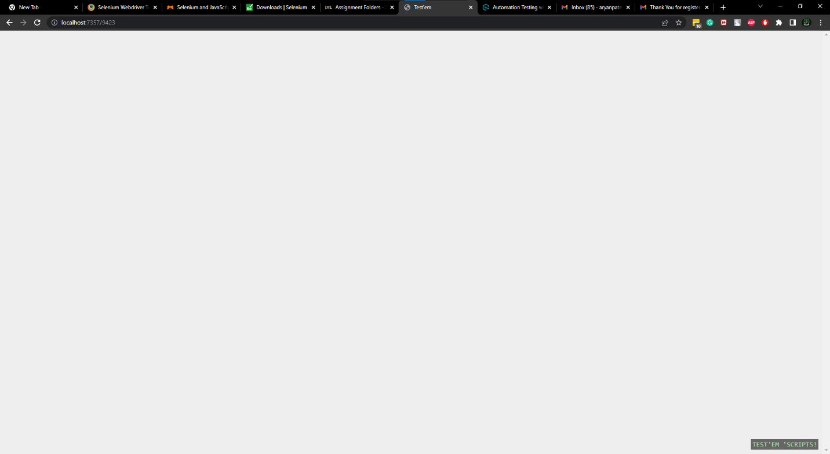

7. create a file named hello_spec.js with this content:

describe('hello', function(){

it('should say hello', function(){

expect(hello()).toBe('hello world');

});

});

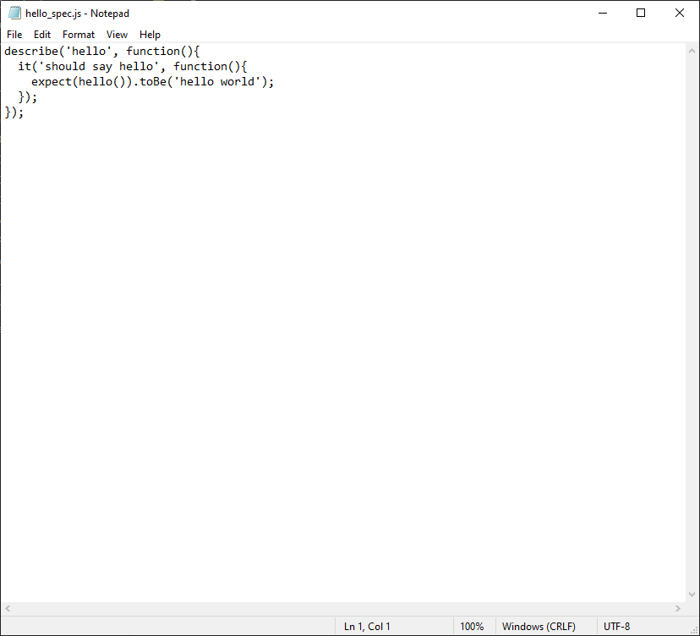

8. implement hello in a file hello.js

function hello(){

return "hello world";

}

