Linux commands with examples:

Pwd 🡪 To print the current (working) directory.



vi 🡪 It is a **vi**sual text editor.



Touch 🡪 The touch command is the easiest way to create new, empty files. It is also used to change the timestamps.

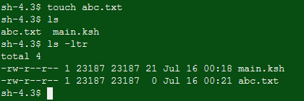

Mkdir 🡪 The mkdir command is is used to create new directories.

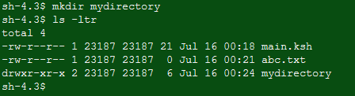

Rm 🡪 The **rm** (i.e., remove) **command** is used to delete files and directories on Linux.

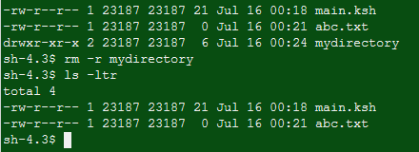

Ls 🡪 List information about the FILEs (the current directory by default).



Echo 🡪 The **echo Command** **echo** is a built-in **command** in the bash and C shells that writes its arguments to standard output.



Cat 🡪 Displays contents of file/files



Who 🡪 Displays who is logged on to the system.

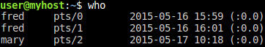

Cd 🡪 The **cd command**, also known as chdir (**change directory**), is a **command**-line OS shell **command** used to change the current working directory in operating systems such as Unix, DOS, OS/2, AmigaOS (where if a bare path is given, **cd** is implied), Windows, and **Linux**.

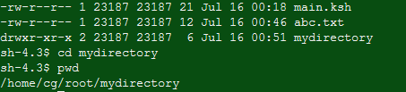

Date 🡪 Date command is helpful to display date in several formats.

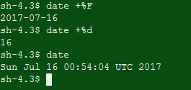

Cal 🡪 Display a conveniently-formatted calendar from the command line.

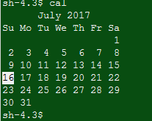

Mv 🡪 The mv command is used to move or rename files.

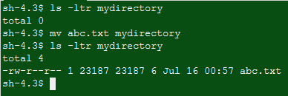

Cp 🡪 The cp command is used to make copies of files and directories.

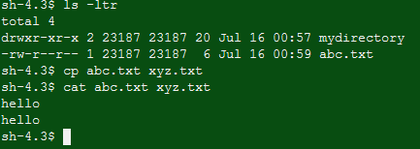

Which 🡪 The Linux which command is used to find the location of a program.

