

import java.io.*;

**public** **class** Acad

{

**public** **static** **void** main(String args[])

{

**int** x = 50;

**int** y = 70;

**int** z = x + y;

{

System.***out***.println("Sum of two numbers: " + z);

}

}

}



**import** java.util.Scanner;

import java.io.*;

**public** **class** Acad

{

**public** **static** **void** main(String args[])

{

Scanner in = **new** Scanner(System.***in***);

System.***out***.println("Enter value of x: ");

**int** x = in.nextInt();

System.***out***.println("Enter value of y: ");

**int** y = in.nextInt();

**int** z = x + y;

System.***out***.println("Sum of two numbers: " + z);

}

}



**import** java.util.Scanner

import java.io.*;

**public** **class** Sum

{

**public** **static** **int** add(**int** x,**int** y)

{

**return** x + y;

}

**public** **static** **void** main(String args[])

{

Scanner in = **new** Scanner(System.***in***);

System.***out***.println("First number is: ");

**int** a = in.nextInt();

System.***out***.println("Second number is: ");

**int** b = in.nextInt();

System.***out***.println("Sum is: " + *add*(a,b));

}

}



**import** java.util.Scanner;

**import** java.io.*;

**public** **class** Oddeven

{

**public** **static** **void** main(String args[])

{

Scanner in = **new** Scanner(System.***in***);

System.***out***.println("Enter first number: ");

**int** a = in.nextInt();

System.***out***.println("Enter the second number: ");

**int** b = in.nextInt();

**for**(**int** i = a; i <= b; i ++)

{

**if** (i%2 == 0)

System.***out***.println("Even Number " + i);

**else**

System.***out***.println("Odd Number " + i);

}

}

}

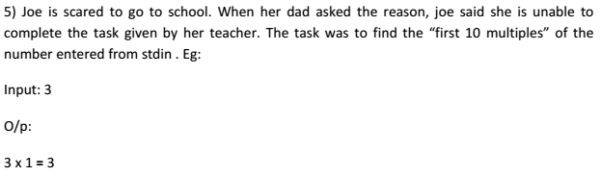

**import** java.util.Scanner;

**import** java.io.*;

**public** **class** Multiply

{

**public** **static** **void** main(String args[])

{

Scanner in = **new** Scanner(System.***in***);

System.***out***.println("Enter a number : ");

**int** a = in.nextInt();

**int** x = 1;

**while** (x < 11)

{

System.***out***.println(a + " multiplied by " + x + " is " +(x*a));

x++;

}

}

}



**import** java.io.*;

**import** java.util.Scanner;

**public** **class** Overload

{

**static** **int** add(**int** a,**int** b){**return** a+b;}

**static** **int** add(**int** a,**int** b,**int** c){**return** a+b+c;}

**public** **static** **void** main(String[] args)

{

System.***out***.println(*add*(11,11));

System.***out***.println(*add*(11,11,11));

}

}



Answer is 6 is an example of over loading a method with same return type.



import java.util.Scanner;

public class Descending_Order

{

public static void main(String[] args)

{

int n, temp;

Scanner s = new Scanner(System.in);

System.out.print("Enter no. of elements you want in array:");

n = s.nextInt();

int a[] = new int[n];

System.out.println("Enter all the elements:");

for (int i = 0; i < n; i++)

{

a[i] = s.nextInt();

}

for (int i = 0; i < n; i++)

{

for (int j = i + 1; j < n; j++)

{

if (a[i] < a[j])

{

temp = a[i];

a[i] = a[j];

a[j] = temp;

}

}

}

System.out.print("Descending Order:");

for (int i = 0; i < n - 1; i++)

{

System.out.print(a[i] + ",");

}

System.out.print(a[n - 1]);

}

}