SQL Project | Uber Rides Data Analysis
Tools Used : PostgreSQL / MySQL, SQL
Domain : Ride-Hailing & Transportation Analytics
Company Context : Uber

Project Summary
This project analysis Uber ride booking data to understand revenue performance, cancellations, customer behavior, vehicle efficiency, and location demand.
The goal is to simulate how a real ride-hailing company uses data to make business decisions and reduce revenue loss.

Project Overview

Trip Information
- BookingID
- TripDate
- TripTime
- BookingStatus

Customer & Driver Information
- CustomerID
- CustomerCancelledRides
- CustomerCancelReason
- DriverCancelledRides
- DriverCancelReason

Vehicle & Location
- VehicleType
- PickupLocation
- DropLocation

Financial & Ratings
- Amount
- RideDistanceKM
- PaymentMethod
- DriverRating
- CustomerRating

Incomplete Rides
- IncompleteRides
- IncompleteReason

Key Business KPIs
- Total Bookings
- Completed vs Cancelled vs Incomplete Rides
- Total & Average Revenue
- Total & Average Ride Distance
- Average Customer & Driver Ratings

Create Table:-
CREATE TABLE Uber (
BookingID VARCHAR(20) PRIMARY KEY,
TripDate DATE,
TripTime TIME,
BookingStatus VARCHAR(30),
CustomerID VARCHAR(20),
VehicleType VARCHAR(15),
PickupLocation VARCHAR(100),
DropLocation VARCHAR(100),
CustomerCancelledRides INT,
CustomerCancelReason VARCHAR(100),
DriverCancelledRides INT,
DriverCancelReason VARCHAR(100),
IncompleteRides INT,
IncompleteReason VARCHAR(100),
Amount DECIMAL(10,2),
RideDistanceKM DECIMAL(8,2),
DriverRating DECIMAL(2,1),
CustomerRating DECIMAL(2,1),
PaymentMethod VARCHAR(20)
);

Overall Business Performance (Key Business KPIs)
select
count(*) as Total_Booking,
sum(case when BookingStatus = 'Completed' then 1 else 0 end ) as Complete_Booking,
sum(case when BookingStatus like 'Canc%' then 1 else 0 end ) as Cancelled_Booking,
to_char(sum(amount), '"RS "999,999,999.00') as Total_Revenue,
to_char(avg(amount), '"RS"999,999,999.00') as Avg_Revenue,
concat(round(sum(ridedistanceKM),2),' Km') as Total_Distance,
concat(round(avg(ridedistanceKM),2),' Km') as Avg_Distance
from uber;

Result:-
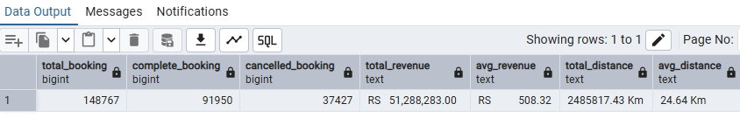

1.Business Performance
How many total rides were booked and how much revenue was generated?
Select
count(*) as Total_Rides,
to_char(sum(amount), '"RS "999,999,999.00') as Total_Revenue
From uber;
Result:-
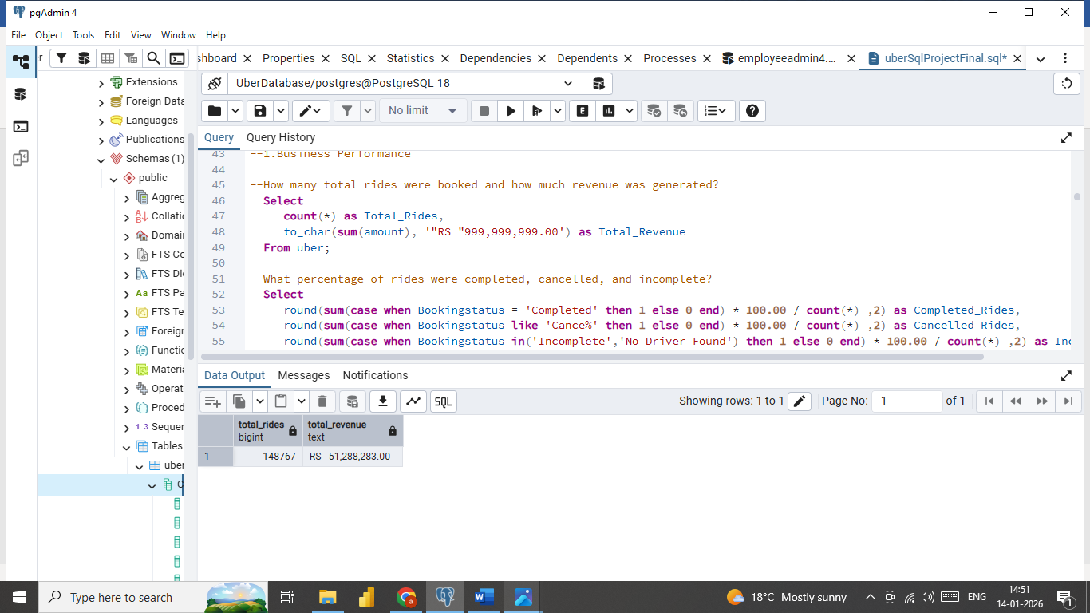
What percentage of rides were completed, cancelled, and incomplete?
Select
Concat(round(sum(case when Bookingstatus = 'Completed' then 1 else 0 end) * 100.00 / count(*) ,2),' %') as Completed_Rides,
Concat(round(sum(case when Bookingstatus like 'Cance%' then 1 else 0 end) * 100.00 / count(*) ,2),' %') as Cancelled_Rides,
Concat(round(sum(case when Bookingstatus in('Incomplete','No Driver Found') then 1 else 0 end) * 100.00 / count(*) ,2),' %') as Incomplete_Rides
from uber;
Result:-
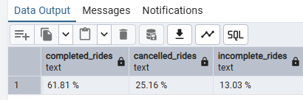
What percentage of rides were completed, cancelled by Customer & Driver,noDriver Found and incomplete?
Select
Bookingstatus,Count(*) as TotalRides,
Concat(Round(count(*) * 100 / Sum(count(*)) over(),2),' %') as Percentage
From uber
Group by Bookingstatus
Order by totalRides Desc;
Result:-
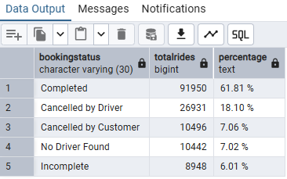
--What is the average fare and average distance per ride?
select
concat('Rs ',round(avg(amount),2)) as Average_Fare ,
concat(round(Avg(RideDistanceKM),2),' Km') as Average_Distance
from uber
where bookingStatus='Completed';
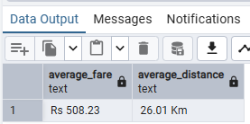
Result:-

What are the average driver and customer ratings?
Select
round(AVG(DriverRating),2) AS Average_Driver_Rating,
round(AVG(CustomerRating),2) AS Avgerage_Customer_Rating
FROM Uber;
Result:-
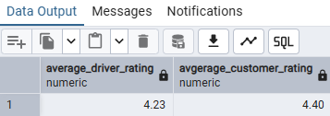
2.Time Analysis
What are the peak booking hours?
select
to_char(triptime, 'hh12 AM')as PeakHour,
count(*) as bookingCount
From uber
group by PeakHour
order by BookingCount Desc,peakhour;
Result:-
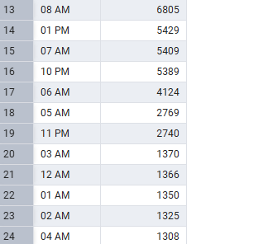
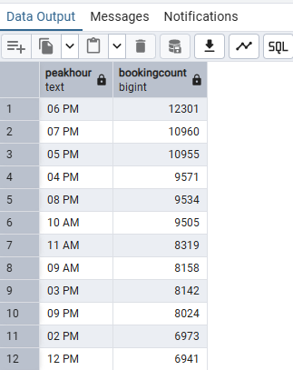

Which time slot (Morning, Afternoon, Evening, Night) generates the most rides?
select
case
when extract(Hour from Triptime) between 5 and 8 then 'Early Morning 5 AM - 8 AM'
when extract(Hour from Triptime) between 9 and 11 then 'Late Morning 9 AM - 11 AM'
when extract(Hour from Triptime) between 12 and 16 then 'Afternoon 12 PM - 4 PM'
when extract(Hour from Triptime) between 17 and 20 then 'Evening 5 PM - 8 PM'
else 'Night 9 PM - 4 AM' End as TimeSlot,
Count(*) as Booking_Count
From uber
group by Timeslot
Order by Booking_Count Desc;
Result:-
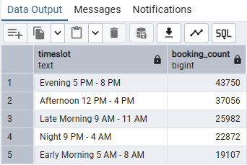
3.Vehicle Performance
Which vehicle type is most used?
select
vehicleType,
Count(*) as Total_Rides
From uber
group by vehicletype
order by total_rides desc;
Result:-
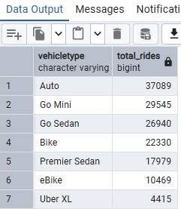

Which vehicle type generates the highest revenue and what % of total revenue does it contribute?
select
vehicletype,
round(sum(amount),2) as Revenue,
Concat(round(100.00 * sum(amount) / sum(sum(amount)) over(),2),' %') as percentage
from uber
where bookingStatus ='Completed'
Group by vehicletype
order by Revenue Desc;
Result:-
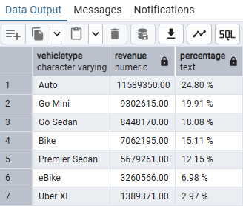

What is the average revenue per km by vehicle type?
Select
Vehicletype,
concat('Rs ',round(sum(amount)/ sum(RidedistanceKM),2) ) as Avg_Revenue_per_KM
from uber
where bookingstatus = 'Completed'
group by vehicletype;
Result:-
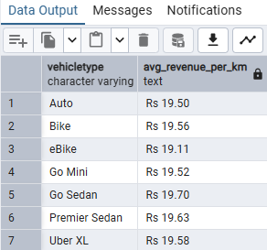
4.Customer Behavior
What percentage of customers have cancelled at least one ride?
select
count(distinct customerID) as Total_Customer,
count(distinct CustomerID) filter(where CustomerCancelledRides = 1) as Customer_Cancelled_Rides,
concat(Round(count(distinct CustomerID)
filter(where CustomerCancelledRides = 1) * 100.00 / count(distinct customerID),2),' %') as CancelationRate
from uber;
Result:-
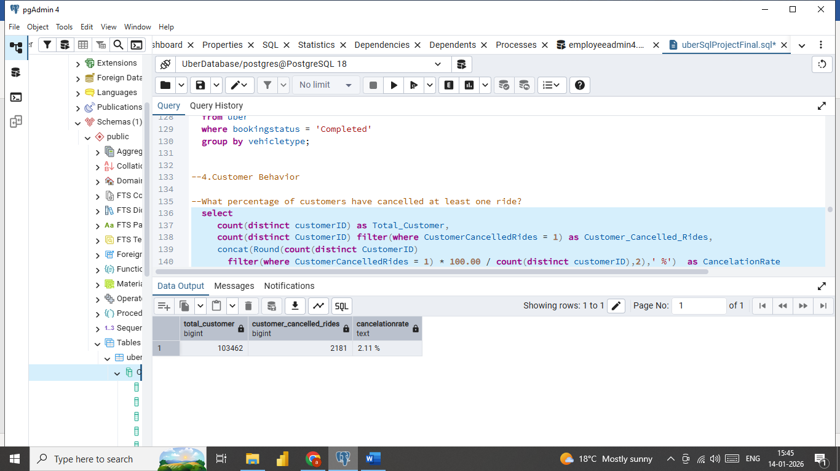

Who are the top 10 highest-spending customers?
Select
CustomerID,to_char(sum(Amount),'"Rs"999,999,999.00') as revenue
from uber
where Bookingstatus = 'Completed'
group by CustomerId
order by revenue Desc limit 10 ;
Result:-
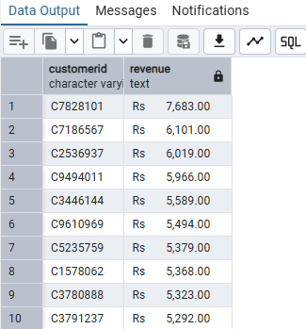

5.Driver Reliability

What are the top driver cancellation reasons?
select
DrivercancelReason as Driver_cancel_Reason,Count(*) AS Total_Cancellations
from uber
where drivercancelledRides = 1
group by DrivercancelReason
order by Total_Cancellations desc;
Result:-
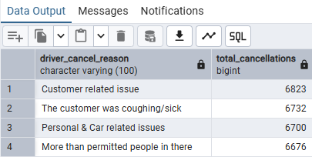

6.Location Intelligence
Which pickup locations generate the most completed rides?
select
pickuplocation,
sum(case when bookingstatus = 'Completed' then 1 else 0 end ) as Complete_rides
from uber
group by pickuplocation
order by Complete_rides desc;
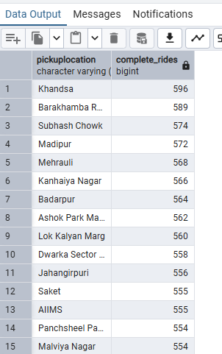
Result:-

Which pickup-drop pairs generate the highest average fare?
select
pickuplocation,droplocation,
round(avg(amount),2) as avg_trip_amount
from uber
where bookingStatus = 'Completed'
group by pickuplocation,droplocation
order by avg_trip_amount Desc;
Result:-
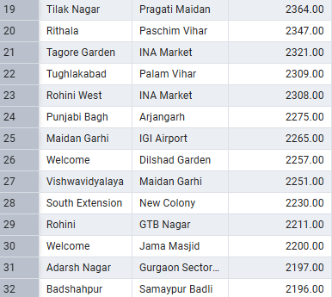
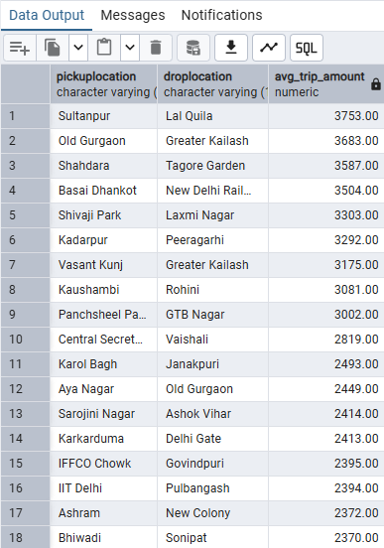

7.Revenue & Payments
How is revenue distributed across payment methods?
Select
paymentMethod,
to_char(sum(Amount),'"Rs "999,999,999.00') as Revenue
From uber
where bookingStatus = 'Completed'
group by paymentmethod
order by revenue Desc;
Result:-
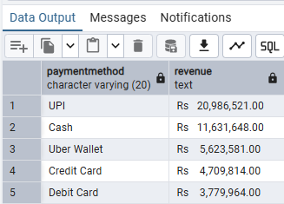

8.Risk & Loss Analysis

What are the main reasons for incomplete rides and their percentages?
select
incompleteReason, count(*) as total_Reason,
concat(round(count(*) * 100.00 / sum(count(*)) over() ,2),' %') as Percentage
from uber
where incompleterides = 1
group by incompleteReason ;
Result:-
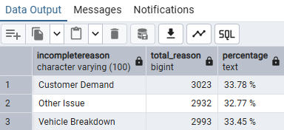

Analysis Sections Covered
- Business Performance Analysis
- Time-Based Demand Analysis
- Vehicle Performance & Revenue Contribution
- Customer Behavior & Spending Patterns
- Driver Reliability & Cancellations
- Location Intelligence
- Revenue & Payment Method Analysis
- Risk & Loss Analysis

Key Insights
- A significant percentage of revenue loss comes from customer and driver cancellations
- Peak demand occurs during evening and night hours
- Certain vehicle types contribute disproportionately higher revenue
- Top pickup-drop pairs have significantly higher average fares
- Incomplete rides highlight operational gaps such as driver unavailability

Conclusion
This project demonstrates the ability to apply SQL for real-world business problem solving, convert raw ride data into actionable insights, and communicate findings in a structured analytical format.
It reflects skills required for Data Analyst / Business Analyst roles in transportation, logistics, and marketplace companies.

