CA-3 PROJECT REPORT
InternAgent
Agentic AI Internship Matching & Eligibility Assistant

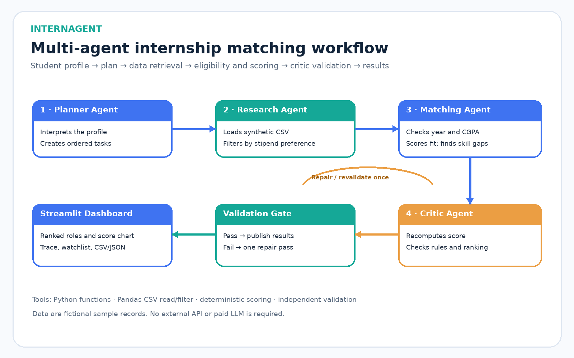
Submitted by: Aryan Gawande
PRN: 24070126223
Domain: Education & Career Development
Technology: Python · Streamlit · Pandas · Plotly
Date: 19 October 2026

1. Executive Summary
InternAgent is a working proof of concept for an explainable, multi-stage agentic workflow. It takes a student profile, retrieves candidate opportunities from a synthetic CSV dataset, applies academic eligibility rules, ranks eligible roles, exposes skill gaps, and validates recommendations before presentation. The app deliberately avoids paid APIs so the decision process remains transparent and reproducible.

2. Problem Statement and Domain Justification
Students often compare internship listings manually, interpret different academic requirements, and attempt to map personal skills to job requirements. This is repetitive, and a recommendation without an eligibility explanation or validation evidence may be difficult to trust. Education and career development is a suitable domain because the task naturally separates into planning, data retrieval, rule-based decision-making and output verification.

3. Existing Challenge
- Manually scanning several listings consumes time.
- Academic-year and CGPA constraints can be overlooked.
- An unranked list does not help students prioritize opportunities.
- Students need actionable information about missing required skills.
- A plain chatbot response does not prove that tool execution and validation occurred.

4. Proposed Solution
The Streamlit UI accepts academic year, CGPA, skills, interests, preferred location, work mode, minimum stipend and desired result count. The orchestrator invokes four functional agents and returns ranked results only after validation.
Agent | Responsibility | Output
Planner Agent | Decomposes the goal into ordered tasks. | Execution plan
Research Agent | Loads the synthetic CSV and applies the stipend preference. | Candidate records
Matching & Eligibility Agent | Applies year/CGPA gates, computes scores and identifies skill gaps. | Assessed and ranked opportunities
Critic / Validation Agent | Recomputes scores and checks IDs, eligibility, score bounds, order and top-k count. | Validation report

5. Architecture and Data Flow
The orchestrator first creates a plan, then filters the source records, assesses eligibility and fit, and asks the Critic to validate the result. If a validation check fails, it allows one repair/revalidation pass. The Streamlit UI displays the ranked shortlist, execution trace and excluded roles.

6. Match Scoring and Eligibility
Eligibility is a hard rule: the student's academic year must be within the internship's year range and CGPA must be at least the minimum. Skill matching is a ranking signal rather than a hard gate, making skill gaps visible without silently excluding every opportunity that requires growth.
Score component | Weight | Interpretation
Required skill overlap | 55% | Share of required skills currently listed in the student profile
Domain interest | 20% | Higher score when the listing domain is one of the student's interests
Location/work-mode fit | 10% | Preference fit for location and work arrangement
CGPA buffer | 15% | Bounded reward for CGPA above the minimum requirement

The total is clamped to the 0–100 range and sorted descending. The score is a transparent fit heuristic—not a probability of interview or hiring success.

7. Technology Stack
Technology | Purpose
Python | Workflow orchestration and rule functions
Streamlit | Interactive student profile and results dashboard
Pandas / CSV | Synthetic dataset loading and filtering
Plotly | Match-score visualization
unittest | Repeatable validation and regression tests
GitHub Actions | Runs tests on repository pushes and pull requests

8. Output Validation and Testing
The Critic independently recomputes the weighted score without calling the matching helper. It checks uniqueness of internship IDs, eligibility of recommendations, score bounds and reproducibility, descending score order, and the top-k result-count policy.
Evidence | Result
Synthetic dataset records | 12 fictional internship listings
Automated unit tests | 6 tests passed in the authoring environment
Default demo shortlist | Up to 3 ranked recommendations
Critic checks | 5 of 5 passed for the sample profile

9. Results and Demonstration Plan
For the live demo, keep the sample profile (Year 2, CGPA 7.5, Python, Machine Learning, Pandas, Scikit-learn and SQL). Click Run agent workflow. Show the score chart, expand one role to review score components and missing skills, open the execution trace, inspect the eligibility watchlist and demonstrate CSV/JSON export.

10. Limitations
- The 12 listings and organization names are synthetic, not live internships.
- Skill match uses exact normalized labels and does not measure skill depth or semantic equivalence.
- Eligibility constraints are simplified and cannot represent every employer policy.
- The system does not submit applications or contact employers.
- The independent Critic improves reliability but cannot prove that every possible defect is absent.

11. Future Scope
- Connect to a trusted, regularly refreshed source of internship postings.
- Add semantic skill matching and an optional local model for plain-language explanations.
- Represent agent state transitions explicitly with LangGraph.
- Add consent-based profile persistence, application tracking and feedback.
- Expand evaluation with adversarial profiles, rank-quality metrics and human review.

12. Conclusion
InternAgent demonstrates a useful agentic pattern: a planner decomposes the task, a research stage uses a data tool, a matching stage makes rule-based decisions, and a Critic independently validates the result. The project emphasizes explainability and a real workflow over unnecessary complexity or a chatbot-only interface.

Reproducibility
Install the packages in requirements.txt, run streamlit run app.py, and run the automated tests with python -m unittest discover -s tests -v. All included data are synthetic and local.

