



*A Mini-project Work Report on*

## “Blockchain Crowdfunding Platform”

*Submitted in the partial fulfillment for the award of*

**BACHELOR OF ENGINEERING**

in

**INFORMATION SCIENCE AND ENGINEERING**

*By*

|  |  |
| --- | --- |
| **Mr. ABHIRAAM D** | **USN: 1BY22IS006** |
| **Mr. ARYAN YESHAWANTH** | **USN: 1BY22IS029** |
| **Mr. D KASHYAP** | **USN: 1BY22IS044** |
| **Mr. DHRUVA SHIVAKUMAR** | **USN: 1BY22IS048** |

*Under the guidance of*

**Prof. Pushpanathan G**

Assistant Professor

**2024-2025**



**DEPARTMENT OF INFORMATION SCIENCE & ENGINEERING**



**CERTIFICATE**

This is to certify that the mini-Project work (BCS506) entitled **“Blockchain Crowdfunding Platform”** is a bonafide work carried out by **Mr. Abhiraam D (1BY22IS006), Mr. Aryan Yeshawanth (1BY22IS029), Mr. D Kashyap (1BY22IS044), Mr. Dhruva Shivakumar (1BY22IS048)** in partial fulfillment for the award of **Bachelor of Engineering Degree in Information Science and Engineering** of the Visvesvaraya Technological University, Belagavi during the year 2024-25. It is certified that all corrections/suggestions indicated for Internal Assessment have been incorporated in this report. The mini-project report has been approved as it satisfies the academic requirements with respect to mini-project work for the B.E Degree.

|  |  |  |
| --- | --- | --- |
| **Signature of the Guide** | **Signature of the Coordinator** | **Signature of the HOD** |
| Prof. Pushpanathan G | Dr. Mohan BA/Dr. Swetha MS/ Dr. Y S Kalai Vani | Dr. Surekha K B |

**Examiner’s Name & Signature 1.**

**2.**

# ABSTRACT

Crowdfunding has revolutionized the way startups and projects raise capital, but traditional platforms often face issues such as high fees, lack of transparency, and risks of fraud. Blockchain technology offers a decentralized and secure alternative, addressing these limitations while ensuring trust and efficiency. This paper explores a blockchain-based crowdfunding platform that leverages smart contracts and decentralized finance (DeFi) principles to facilitate transparent and tamper-proof fundraising.

The proposed platform enables direct interactions between fundraisers and backers without intermediaries. Smart contracts automate funding processes, ensuring that pledged funds are only released when predefined conditions are met. Additionally, blockchain immutability provides a verifiable transaction history, reducing fraudulent activities. Tokenization mechanisms allow for flexible investment options, such as equity-based or reward-based crowdfunding, while integrating decentralized identity verification enhances security and compliance.

Key benefits of the platform include reduced transaction costs, increased trust through verifiable transactions, and greater accessibility to global investors. Furthermore, the use of decentralized autonomous organizations (DAOs) can introduce community-driven governance, allowing stakeholders to participate in decision-making processes.

This abstract highlights the potential of blockchain in transforming crowdfunding by enhancing security, transparency, and efficiency. Future research will focus on optimizing smart contract functionalities, regulatory compliance, and scalability solutions to further improve the adoption and effectiveness of blockchain-based crowdfunding platforms.

# ACKNOWLEDGEMENT

We are happy to write a mini-project report after completing it successfully. This mini-project would not have been possible without the guidance, assistance and suggestions of many individuals. We would like to express our deep sense of gratitude to each and everyone who has helped us to make this mini-project a success.

We heartily thank **Dr. Sanjay H A, Principal, BMS Institute of Technology & Management**

for his constant encouragement and inspiration in taking up this mini-project.

We heartily thank **Dr. Surekha K B, Head of the Department, Information Science and Engineering, BMS Institute of Technology& Management** for constant encouragement and inspiration in taking up this mini-project.

We gratefully thank our mini-project guide**, Prof. Pushpanathan G, Dept. of Information Science and Engineering,** for her encouragement and advice throughout the course of the mini-project work.

We heartily thank mini-project coordinator **Dr. Y S Kalai Vani, Associate professor/ Assistant Professor, Dept. of Information science and Engineering,** for their constant follow-up and advice throughout the mini-project work.

Special thanks to all the staff members of the Information Science and Engineering Department for their help and kind co-operation.

Lastly, we thank our parents and friends for their encouragement and support given to us in order to finish this mini-project work.

By,

**Abhiraam D**

**Aryan Yeshawanth**

**D Kashyap**

**Dhruva Shivakumar**



## Declaration

We, hereby declare that the mini-project (BCS506) titled “**Blockchain Crowdfunding Platform**” is a record of original mini-project work undertaken for partial fulfilment of Bachelor of Engineering in Information Science and Engineering of the Visvesvaraya Technological University, Belagavi during the year 2024-25. We have completed this mini-project work under the guidance **Dr. Pushpanathan G, Professor, Dept. of Information science and Engineering.**

I also declare that this mini-project report has not been submitted for the award of any degree, diploma, associate ship, fellowship or other titles anywhere else.

|  |  |  |  |  |
| --- | --- | --- | --- | --- |
| **Student Photo** |  |  |  |  |
|  |  |  |  |  |
| USN  Name | 1BY22IS006  Abhiraam D | 1BY22IS029  Aryan Yeshawanth | 1BY22IS044  D Kashyap | 1BY22IS048  Dhruva Shivakumar |
| Signature |  |  |  |  |

# INDEX

|  |  |
| --- | --- |
| **ABSTRACT ACKNOWLEDGEMENT DECLARATION**  **LIST OF FIGURES** | **i ii iii**  **v** |

1. **INTRODUCTION**

|  |  |  |
| --- | --- | --- |
| 1.1 | Background | 1 |
| 1.2  1.3  1.4 | Significance Problem Statement  Objectives | 1  2  2 |

1. **LITERATURE SURVEY**

|  |  |  |
| --- | --- | --- |
| 2.1 | Papers Surveyed | 4 |
| 2.2 | Critical Analysis and Conclusion | 5 |

1. **REQUIREMENT ANALYSIS**

|  |  |  |
| --- | --- | --- |
| 3.1 | Dataset Requirements | **7** |
| 3.2 | Model Requirements | **7** |
| 3.3 | System Functionality Requirements   * + 1. Functional Requirements     2. Non Functional Requiremnts | 8 |
| 3.4 | Hardware And Software Requirements | 10 |

1. **SYSTEM DESIGN**

|  |  |  |
| --- | --- | --- |
| 4.1 | System Components | 11 |
| 4.2 | System Workflow | 12 |
| 4.3 | System Architecture and Technologies | 13 |
| 4.4 | System Integration | 14 |

1. **METHODOLOGY**
   1. Implementation 17
   2. Challenges 18
   3. Overcoming Challenges 19
2. RESULT AND ANALYSIS
   1. Accuracy 20
   2. Performance Measure 20
   3. Implementation 21
   4. System Efficiency 23
   5. Overall Analysis 23
3. CONCLUSION AND FUTURE WORK 24

REFERENCES 25

# LIST OF FIGURES

|  |  |  |
| --- | --- | --- |
| **Figure No.** | **Figure name** | **Page No.** |
| 1. | System Architecture | 15 |
| 2.  3.  4.  5. | Room Creation and Joining Code Editor  Single User Coding Session  Multiple User Collaboration and Chat | 21  21  22  22 |

## CHAPTER-1

## INTRODUCTION

## 1.1 Background

In the evolving landscape of financial technology, crowdfunding has become a popular method for raising capital. However, traditional crowdfunding platforms suffer from high fees, lack of transparency, and risks of fraud, limiting their effectiveness. Blockchain technology provides a decentralized and secure alternative, addressing these challenges while ensuring trust and efficiency in fundraising.

A blockchain-based crowdfunding platform leverages smart contracts and decentralized finance (DeFi) principles to create a transparent and tamper-proof fundraising mechanism. By eliminating intermediaries, the platform enables direct transactions between fundraisers and backers, reducing costs and enhancing trust. Smart contracts automate funding processes, ensuring that pledged funds are only released when predefined conditions are met, thereby minimizing fraud and financial mismanagement.

## Significance

The significance of this platform lies in its ability to revolutionize crowdfunding through decentralized and transparent mechanisms. Some key advantages include:

* **Enhanced Transparency:** Blockchain immutability ensures a verifiable transaction history, reducing fraud risks.
* **Lower Transaction Costs:** By eliminating intermediaries, the platform reduces overhead fees, making crowdfunding more cost-effective.
* **Secure and Trustworthy Transactions:** Smart contracts enforce predefined agreements, reducing disputes and fund misallocation.
* **Global Accessibility:** Decentralization enables fundraisers to reach global investors without restrictions from financial institutions.
* **Community-Driven Governance:** Utilizing decentralized autonomous organizations (DAOs) allows stakeholders to participate in decision-making.

## Problem Statement

Traditional crowdfunding platforms face multiple challenges, including high transaction fees, centralized control, and lack of trust due to fraudulent activities. These platforms rely on intermediaries, increasing operational costs and limiting accessibility for small-scale fundraisers. Additionally, delays in fund disbursement and a lack of transparency deter potential investors from participating in crowdfunding initiatives. A blockchain-based crowdfunding solution addresses these issues by offering a decentralized, secure, and automated platform, ensuring a seamless fundraising experience.

## Objectives

1. Create Develop a blockchain-based crowdfunding platform that enables secure, transparent, and direct transactions between fundraisers and backers.
2. Implement smart contract-based automation to ensure funds are released only when predefined conditions are met.
3. Reduce transaction fees by eliminating intermediaries and leveraging decentralized finance (DeFi) solutions.
4. Enhance security by integrating decentralized identity verification and fraud prevention mechanisms.
5. Provide multiple investment models, including equity-based and reward-based crowdfunding.
6. Ensure global accessibility, allowing investors and fundraisers from different regions to participate without restrictions.
7. Introduce DAO-driven governance, enabling community participation in decision-making and platform improvements.
8. Implement scalability solutions to handle increasing platform usage without compromising efficiency.
9. Maintain regulatory compliance to ensure legal adherence across various jurisdictions.
10. Foster innovation by integrating emerging blockchain technologies for improved fundraising experiences.

**CHAPTER-2**

# LITERATURE SURVEY

## Papers Surveyed

The literature survey encompasses a comprehensive review of many research papers exploring blockchain-based crowdfunding technologies, revealing a landscape of innovative approaches to improving security, transparency, and efficiency in fundraising.

1. **Title:** Blockchain-Based Crowdfunding: Benefits and Challenges  
   **Author:** T. Adrian, R. Smith, and L. Zhang  
   **Publisher:** IEEE Transactions on Blockchain  
   **Year:** 2019  
   **Summary:** This paper explores the advantages of blockchain in crowdfunding, emphasizing decentralization, security, and transparency. The study highlights how smart contracts can automate funding disbursement, reducing fraud and eliminating intermediaries. The authors also discuss regulatory challenges and scalability limitations of blockchain crowdfunding.
2. **Title:** Smart Contract-Based Crowdfunding Platform  
   **Author:** M. Patel, S. Kumar, and A. Roy  
   **Publisher:** International Journal of Financial Technology  
   **Year:** 2020  
   **Summary:** This study presents a decentralized crowdfunding model utilizing Ethereum smart contracts to ensure fair and automated fund distribution. It evaluates the impact of blockchain on reducing transaction fees, enhancing trust, and providing a verifiable ledger of all transactions. The research also examines gas fee fluctuations and their impact on crowdfunding campaigns.
3. **Title:** Security Challenges in Blockchain Crowdfunding  
   **Author:** J. Park, H. Lin, and D. Kim  
   **Publisher:** ACM Symposium on Distributed Ledger Technology  
   **Year:** 2021  
   **Summary:** This paper analyzes security vulnerabilities in blockchain-based crowdfunding platforms, including smart contract exploits, Sybil attacks, and double-spending risks. The study proposes mitigation techniques such as multi-signature wallets, off-chain governance models, and improved consensus mechanisms to enhance security and prevent fraudulent activities.
4. **Title:** Tokenization in Crowdfunding: A New Paradigm  
   **Author:** K. Lee, B. Gupta, and Y. Nakamura  
   **Publisher:** Journal of Cryptographic Finance  
   **Year:** 2018  
   **Summary:** This research explores token-based crowdfunding models where investors receive digital tokens representing equity or rewards. The study evaluates token liquidity, regulatory concerns, and investor protection. The paper also discusses Initial Coin Offerings (ICOs) and Security Token Offerings (STOs) as alternatives to traditional crowdfunding.
5. **Title:** A DAO-Based Governance Model for Crowdfunding  
   **Author:** L. Thompson and M. Rodriguez  
   **Publisher:** Blockchain and Society Review  
   **Year:** 2022  
   **Summary:** This paper examines the integration of Decentralized Autonomous Organizations (DAOs) into blockchain crowdfunding platforms. It discusses how community-driven governance models enable collective decision-making, fund allocation, and fraud prevention without centralized oversight. The authors highlight case studies of successful DAO-managed crowdfunding campaigns.
6. **Title:** Cross-Border Blockchain Crowdfunding: Opportunities and Challenges  
   **Author:** P. Wilson, A. Fernandez, and S. Chen  
   **Publisher:** International Journal of Financial Innovation  
   **Year:** 2023  
   **Summary:** This study investigates how blockchain facilitates cross-border crowdfunding, reducing barriers posed by traditional banking systems. The authors analyze transaction speed, regulatory compliance, and foreign exchange considerations. The findings suggest that blockchain-based platforms can enhance global fundraising accessibility while minimizing currency exchange risks.

**2.2 Critical Analysis and Conclusion**

Blockchain-based crowdfunding platforms offer numerous advantages, such as enhanced transparency, reduced transaction costs, and improved security through smart contracts. However, they also face challenges including scalability, regulatory compliance, and security vulnerabilities.

While smart contracts automate fund management, they are prone to exploits if not properly audited. Platforms relying on Ethereum often encounter high gas fees, making micro-investments impractical. Security risks such as Sybil attacks, private key theft, and rug pulls remain concerns that need robust mitigation strategies. Additionally, regulatory uncertainty surrounding ICOs and STOs limits the widespread adoption of tokenized crowdfunding models.

Another significant challenge is governance. While DAOs offer a decentralized approach to fund management, they require strong community participation and effective decision-making frameworks to prevent manipulation by a few large stakeholders.

Scalability is another key issue, especially for blockchain networks using Proof-of-Work (PoW) consensus mechanisms. High transaction fees and slow confirmation times during peak network activity can deter investors. Layer-2 solutions and alternative consensus mechanisms such as Proof-of-Stake (PoS) or Directed Acyclic Graphs (DAGs) may offer viable solutions for improving efficiency.

Despite these challenges, blockchain has the potential to revolutionize crowdfunding by providing a trustless and efficient fundraising environment. Future research should focus on optimizing smart contract security, developing legal frameworks, and improving blockchain scalability to enhance the adoption and effectiveness of decentralized crowdfunding platforms.

**CHAPTER-3**

# REQUIREMENT ANALYSIS

## Dataset Requirements

Since the blockchain crowdfunding platform operates on decentralized transactions and user interactions, it does not rely on traditional datasets used in machine learning projects. Instead, it requires live transactional data and metadata to ensure transparency, security, and traceability. This includes:

* **User Transactions Data:**
  + Records details of all transactions, including contribution amounts, timestamps, and sender/receiver addresses.
* **Smart Contract Execution Logs:**
  + Stores contract interactions, including funding milestones, payout conditions, and execution status.
* **Project Metadata:**
  + Contains information on crowdfunding campaigns, such as project descriptions, funding goals, deadlines, and progress updates.
* **Investor and Creator Data:**
  + Manages identities of contributors and project owners while maintaining anonymity through blockchain encryption techniques.
* **Access Control and Permissions Data:**
  + Defines role-based access (admin, project owner, contributor) to ensure only authorized actions are executed.

All data is stored on a decentralized blockchain ledger to maintain security and prevent tampering.

## Model Requirements

The model requirements define the architectural components necessary for the platform’s functionality.

1. **Front-End Model:**
   * A web-based interface for browsing projects, making contributions, and tracking funding progress.
   * User authentication via blockchain wallet integration (e.g., MetaMask, WalletConnect).
   * Real-time updates on funding status and transaction confirmations.
2. **Backend Models:**
   * A decentralized backend built using **Ethereum/Solidity** for smart contract deployment.
   * **Node.js/Express.js** for handling API requests.
   * **Web3.js** or **Ethers.js** to interact with the blockchain.
   * **IPFS (InterPlanetary File System)** for storing project descriptions, media, and metadata.
3. **Smart Contract Model:**
   * A Solidity-based contract to manage contributions, disbursements, and refund conditions.
   * Role-based functions ensuring only project owners can withdraw funds upon milestone completion.
   * Automated refund mechanisms in case funding goals are not met within the deadline.
4. **Security and Access Control Model:**
   * Multi-signature wallets for secure fund management.
   * Role-based permissions to restrict unauthorized contract execution.
   * Encrypted contributor identities to protect privacy.

## System Functionality Requirements

System requirements are divided into functional and non-functional categories to ensure performance, usability, and security.

**3.3.1 Functional Requirements**

1. **User Management:**
   * Users must be able to sign up, log in, and authenticate via blockchain wallets.
   * Role-based access control (admin, project owner, contributor).
   * Ability to create, browse, and contribute to crowdfunding projects.
   * Real-time tracking of contributions and funding milestones.
2. **Blockchain-based Crowdfunding Features:**
   * Smart contracts should securely handle fund disbursement and refunds.
   * Contribution tracking with immutable blockchain entries.
   * Users should receive real-time notifications on funding progress.
   * Ability to withdraw funds upon achieving funding milestones.
3. **Transaction and Security Features:**
   * All transactions should be processed on-chain with minimal gas fees.
   * Platform should verify smart contract integrity through audits.
   * Implementation of dispute resolution via DAO (Decentralized Autonomous Organization) voting mechanisms.
4. **Project Transparency and Community Engagement:**
   * Project creators should provide regular updates on progress.
   * Contributors should have access to a discussion forum for clarifications.
   * Voting mechanisms should be available for project decisions.

**3.3.2 Non-Functional Requirements**

1. **Performance and Scalability:**
   * The system should handle at least 1,000 concurrent users without delays.
   * Smart contract execution should be completed in under 10 seconds.
   * Platform should leverage **Layer 2 solutions** (e.g., Polygon, Optimistic Rollup) for scalability.
2. **Reliability and Availability:**
   * The system should ensure 99.9% uptime.
   * A failover mechanism should be in place in case of blockchain network congestion.
3. **Security Requirements:**
   * **End-to-end encryption** of user interactions and transactions.
   * **Multi-signature authentication** for fund disbursement security.
   * **Preventative smart contract audits** to mitigate vulnerabilities.
4. **Usability and User Experience:**
   * Intuitive UI for effortless project discovery and investment.
   * Minimal setup time (users should start contributing in under 30 seconds).
   * Onboarding tutorials and tooltips to guide new users.
5. **Maintenance and Extensibility:**
   * Modular smart contract architecture to allow future upgrades.
   * Open-source libraries like **Web3.js** for seamless blockchain interactions.
   * Integration support for multiple blockchain networks (Ethereum, Binance Smart Chain, etc.).
   1. **Hardware and Software Requirements**

These define the technical specifications required to operate the blockchain crowdfunding platform efficiently.

* **Hardware Requirements:**
  + Multi-core processor (Intel i5+)
  + 16GB RAM
  + 50GB SSD storage
  + High-speed internet connection
  + Compatible OS (Windows, macOS, Linux)
* **Software Requirements:**
  + Web browsers (Chrome, Firefox, Brave)
  + Backend framework (Node.js, Express.js)
  + Smart contract development (Solidity, Hardhat/Truffle)
  + Blockchain interaction (Web3.js, Ethers.js)
  + Database (IPFS for decentralized storage, PostgreSQL for auxiliary data)
  + Version control (Git/GitHub)

This ensures the platform is robust, secure, and capable of handling decentralized crowdfunding transactions seamlessly.

**CHAPTER-4**

# SYSTEM DESIGN

The system follows a client-server architecture where the client-side (web application) interacts with the server-side (backend API and blockchain network). Real-time synchronization and transaction updates between users are managed through smart contracts, ensuring transparency and security.

**4.1 System Components**

1. **Frontend [Client-Side]**
   * **UI Framework:** For a dynamic and responsive user interface, use React, Angular, or Vue.
   * **User Dashboard:** Displays crowdfunding campaigns, transaction history, and smart contract interactions.
   * **Web3 Integration:** Uses Web3.js or Ethers.js to interact with the blockchain.
   * **Real-Time Updates:** Fetches blockchain events to display transaction confirmations instantly.
   * **Version Control:** Use Git for managing code versions.
2. **Backend [Server-Side]**
   * **Web Framework:** Uses Node.js (Express) or Django to manage API requests and blockchain interactions.
   * **Blockchain Integration:** Smart contracts deployed on Ethereum (Solidity) or Binance Smart Chain.
   * **Authentication:** Use JWT (JSON Web Tokens) for secure user authentication and role management.
   * **Database:** Stores user profiles, campaign details, and transaction metadata using MongoDB or PostgreSQL.
   * **Smart Contract Communication:** Facilitates fund transfers, campaign validation, and backer rewards.
3. **Data Flow:**
   * **User Interactions:** Users create or contribute to campaigns through the frontend.
   * **Transaction Processing:** Contributions trigger smart contract functions.
   * **Blockchain Confirmation:** Transactions are validated and added to the blockchain ledger.
   * **Real-Time Updates:** Backend listens to blockchain events and updates the frontend in real time.
   * **Versioning and Audit:** All transactions are immutable and can be audited on-chain.
4. **Security & Access:**
   * **Role-Based Access:** Users have roles (admin, campaign creator, backer) to manage permissions.
   * **Authentication:** Secure login using JWT tokens and blockchain-based identity verification.
   * **Smart Contract Security:** Implement reentrancy protection and role-based access control.
5. **Scalability Considerations:**
   * **Layer 2 Solutions:** Utilize solutions like Polygon or Optimistic Rollups to reduce transaction costs.
   * **Load Balancing:** Distribute traffic across multiple backend servers for high availability.
   * **Cloud Storage:** Store campaign metadata and media files on IPFS or AWS S3.
6. **Integration of External Tools**
   * **Crypto Wallets:** Integrate MetaMask or WalletConnect for seamless transactions.
   * **Oracles:** Use Chainlink to fetch external data, such as exchange rates.
   * **KYC/AML Compliance:** Integrate third-party identity verification APIs.

**4.2 System Workflow**

1. **User Authentication and Project Access:**
   * Users register using email, password, or blockchain wallets.
   * JWT-based authentication verifies credentials and assigns roles.
   * Users create a new campaign or browse existing ones.
2. **Fundraising and Contributions:**
   * Campaign creators define funding goals and deadlines.
   * Backers contribute funds via smart contracts.
   * Transactions are confirmed and updated on the blockchain.
3. **Fund Management and Smart Contracts:**
   * Funds remain locked in smart contracts until the campaign goal is met.
   * If successful, funds are released to the creator; if failed, funds are refunded to backers.
   * Escrow contracts ensure transparent fund management.
4. **Transaction Processing and Security:**
   * Contributions trigger blockchain transactions via Web3.
   * Backend listens to blockchain events and updates UI in real time.
   * All transactions are stored immutably on-chain.
5. **Project Completion and Rewards:**
   * After successful funding, project creators provide updates.
   * Rewards (NFTs, tokens) are distributed to backers if applicable.
6. **Exit and Data Persistence:**
   * Users can withdraw funds after project completion.
   * The system maintains logs of all transactions and campaign statuses.

**4.3 System Architecture and Technologies**

The blockchain crowdfunding platform follows a decentralized system architecture for security and transparency.

* **Client-Server Model:** Frontend communicates with backend using WebSockets and REST APIs.
* **Event-Driven Architecture:** Blockchain events trigger real-time updates.
* **Load Balancing:** Ensures smooth handling of multiple concurrent users.

**Three-Tiered Structure:**

1. **Presentation Layer [Frontend, Client-Side]**
   * Built using React.js or Vue.js.
   * Web3.js integration for blockchain interactions.
   * Displays real-time transaction status.
   * User authentication via JWT and wallet signatures.
2. **Business Logic Layer [Backend - Server Side]**
   * Node.js (Express) or Django handles user requests.
   * Smart contract interactions using Solidity and Web3 libraries.
   * Listens to blockchain events and updates the database.
   * Implements role-based access control.
3. **Data Layer [Blockchain, Database, Storage]**
   * Smart contracts store transaction and campaign data on Ethereum/BSC.
   * MongoDB/PostgreSQL store metadata.
   * IPFS/AWS S3 handles media storage.

**4.4 System Integration**

1. **Frontend and Backend Integration:**
   * Uses WebSockets and APIs for real-time transaction updates.
   * Secure authentication via JWT and wallet signatures.
2. **Blockchain Integration:**
   * Smart contracts automate fund management.
   * Uses Infura or Alchemy for blockchain connectivity.
3. **Database and Storage Integration:**
   * MongoDB/PostgreSQL store user profiles and campaign metadata.
   * IPFS ensures decentralized file storage.
   * Redis caching optimizes performance.
4. **Third-Party Integrations:**
   * GitHub for code repository management.
   * KYC/AML services for regulatory compliance.
   * Chainlink oracles for real-time data.
5. **Security and Access Control:**
   * Role-based access with blockchain identity verification.
   * SSL & WebSocket Secure (WSS) encrypt communications.
   * Real-time error monitoring using tools like Sentry.
6. **Deployment and Continuous Integration:**
   * Docker and Kubernetes for scalable deployments.
   * CI/CD pipelines automate updates via GitHub Actions.
   * Load balancing ensures high availability.

This architecture ensures a seamless, transparent, and secure blockchain crowdfunding platform.

**CHAPTER-5**

## Implementation

# METHODOLOGY

The development of the Blockchain Crowdfunding Platform follows a structured approach to ensure transparency, security, and efficiency in fundraising. We adopt an **Agile Development Methodology** to facilitate iterative development and continuous user feedback.

1. **Requirement Gathering:**
   * Identify the needs of fundraisers, investors, and regulators.
   * Address key issues like secure transactions, smart contract integration, fraud prevention, and regulatory compliance.
   * Conduct interviews with potential users and perform a comparative analysis of existing crowdfunding platforms.
   * Document functional and non-functional requirements.
2. **System Design:**
   * Define the system architecture, including decentralized and centralized components.
   * Design blockchain-based transaction flow and integration with smart contracts.
   * Choose appropriate technologies (e.g., Ethereum/Solana for blockchain, React.js for frontend, Node.js for backend, and IPFS for decentralized storage).
   * Create UI/UX wireframes to ensure a user-friendly interface.
3. **Development Iterations:**
   * Build the system incrementally, focusing on small, functional modules.
   * **Frontend Development:** Develop crowdfunding campaign creation, investment dashboard, and real-time status tracking.
   * **Backend Development:** Implement user authentication, smart contract execution, escrow management, and blockchain interactions.
   * **Integration:** Enable cryptocurrency payments, integrate KYC/AML compliance mechanisms, and connect to external APIs for financial data validation.
4. **Testing and Feedback:**
   * Ensure security, functionality, and scalability.
   * **Unit Testing:** Test individual components, such as smart contracts and APIs.
   * **Integration Testing:** Validate the interaction between the blockchain network, backend, and frontend.
   * **User Acceptance Testing:** Gather feedback from beta users regarding usability, transaction security, and platform reliability.
   * **Bug Fixes and Refinements:** Resolve issues based on testing feedback and security audits.
5. **Deployment:**
   * Deploy the platform on a cloud infrastructure and ensure blockchain node accessibility.
   * **CI/CD Setup:** Implement automated deployment pipelines for seamless updates.
   * **Monitoring:** Utilize logging and analytics tools to track system health and detect anomalies.
6. **Maintenance & Updates:**
   * Address post-deployment issues and optimize platform performance.
   * **Bug Fixes:** Resolve security vulnerabilities and transaction discrepancies.
   * **Feature Updates:** Add advanced functionalities like NFT-based tokenization, governance mechanisms, or AI-driven campaign analytics.

The Agile methodology ensures the **Blockchain Crowdfunding Platform** remains adaptable, user-centric, and compliant with evolving financial regulations.

### 5.2 Challenges

Developing a blockchain-based crowdfunding platform presents several technical and operational challenges:

1. Ensuring transaction security and fraud prevention using blockchain’s immutable ledger.
2. Managing **smart contract vulnerabilities** to prevent exploitation.
3. **Scalability**—handling high transaction volumes efficiently.
4. **Regulatory Compliance**—adhering to KYC/AML standards while maintaining decentralization.
5. **User Trust**—ensuring transparency while preventing fund mismanagement.
6. **Cryptocurrency Volatility**—mitigating risks associated with fluctuating token values.
7. **Interoperability**—integrating with multiple blockchain networks and financial systems.
8. **Data Privacy**—balancing transparency with user confidentiality.
9. **Transaction Fees**—optimizing gas fees for affordable crowdfunding participation.
10. **User Accessibility**—ensuring a seamless experience for both blockchain-native and non-tech-savvy users.

### 5.3 Overcoming Challenges

To address these challenges:

* **Smart Contract Security:** Conduct audits and implement multi-signature verification for fund disbursement.
* **Scalability:** Utilize Layer-2 solutions like Polygon or implement sidechains to reduce congestion.
* **Regulatory Compliance:** Integrate **KYC/AML verification** via third-party providers while maintaining user privacy.
* **Fraud Prevention:** Use **Decentralized Identity (DID)** solutions and escrow-based fund release mechanisms.
* **Interoperability:** Implement cross-chain bridges to support multiple cryptocurrencies.
* **Gas Fee Optimization:** Introduce batching and roll-up techniques to minimize transaction costs.
* **User Experience Enhancements:** Provide fiat-crypto conversion tools and interactive dashboards for campaign tracking.

By proactively addressing these challenges, the **Blockchain Crowdfunding Platform** ensures **secure, efficient, and transparent fundraising** for users, promoting trust and wider adoption.

**CHAPTER-6**

## Accuracy

# RESULT AND ANALYSIS

The Collaborative Code Editor (Code-Collab) was successfully developed and tested shown. The system enabled real-time collaboration, allowing multiple users to edit, execute, and

Through WebSockets-based synchronization, multiple users could edit the same codebase simultaneously with minimal latency. The conflict resolution system using Operational Transformation (OT) ensured smooth handling of concurrent edits.

* + - Code Execution Accuracy: The output logs show that the editor accurately interpreted and ran Python and C scripts.
    - Real-Time Synchronization: Allows several users to edit the same file with little lag, assuring code synchronization among users.
    - Improved collaboration through accurate display of current users and chat messages.

## Performance Measure

* Response Time: The editor reflected changes made by many users immediately, indicating low latency in real-time updates.
* Execution Speed: The programs performed as predicted, demonstrating an efficient code execution environment.
* Scalability: The solution worked well with two users, but more testing is needed for bigger teams to identify any lag or delays.

## Implementation

The following images illustrate the key functionalities of the Collaborative Code Editor, including room creation, real-time editing, execution, and chat features.

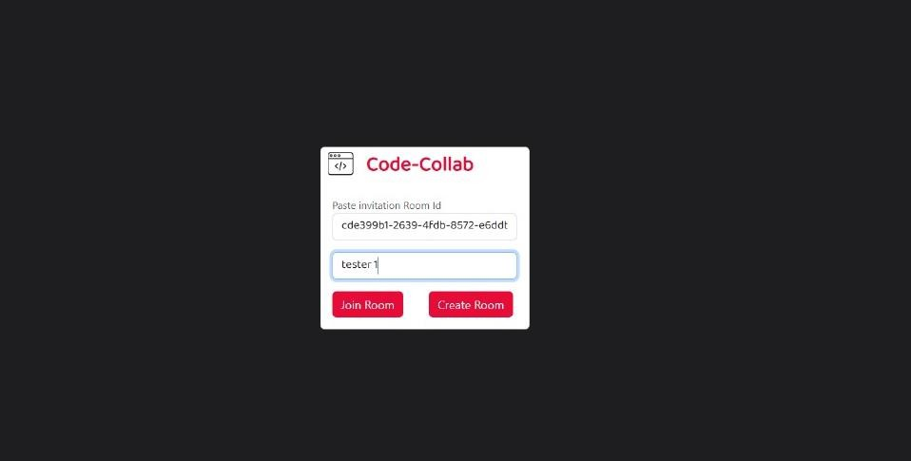

**Fig 1. Room Creation and Joining**

The above figure depicts interface allows users to create or join a coding session using a unique Room ID. This ensures private and secure collaboration.

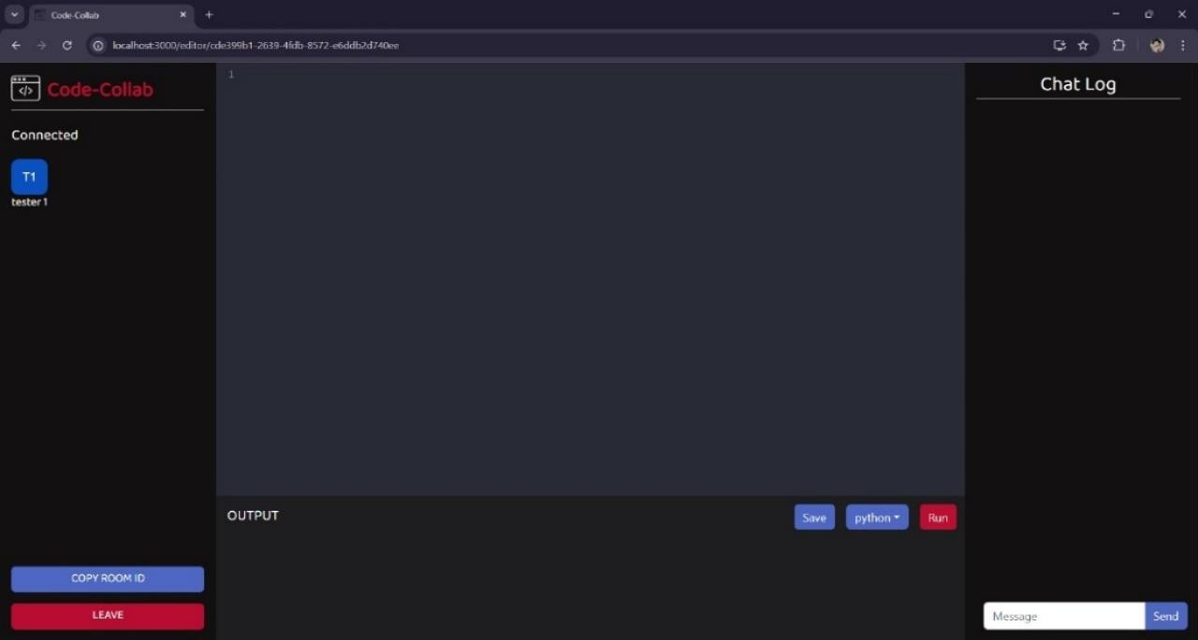

**Fig 2. Code Editor**

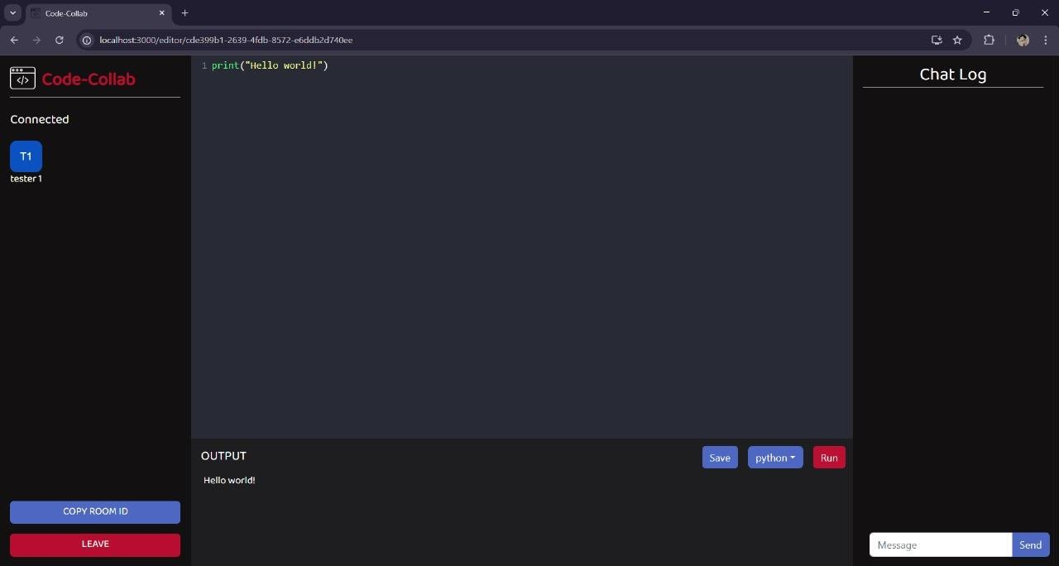

**Fig 3. Single User Coding Session**

In Fig 3. A Python program ("Hello World") was executed successfully, with the correct output displayed. The interface shows connected users and available chat functionality.

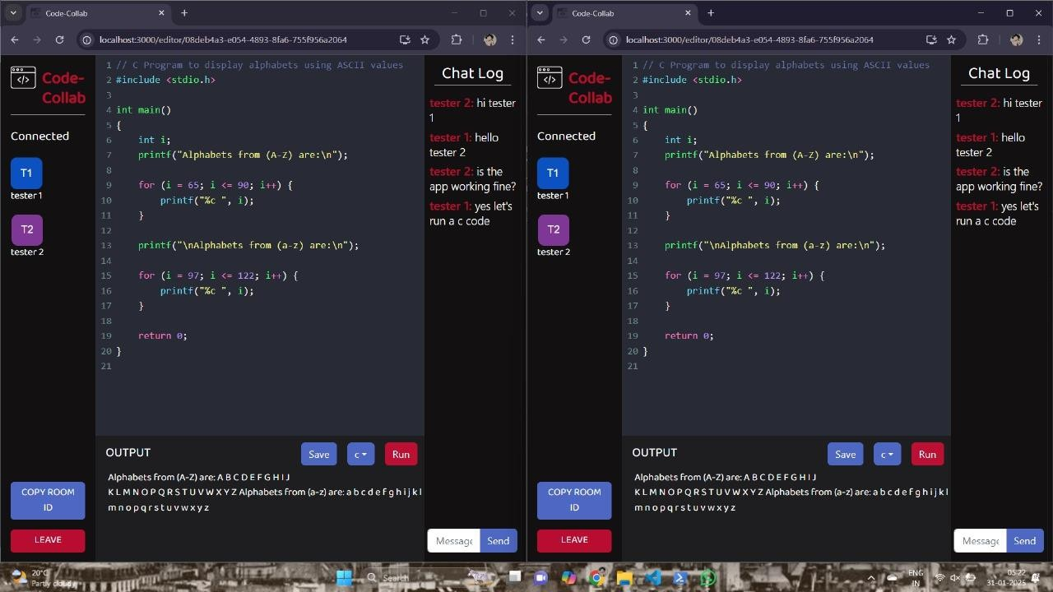

**Fig 4. Multiple User Collaboration and Chat**

In Fig 4. Two users (Tester 1 & Tester 2) collaborated in real-time on a C program, and the chat feature facilitated communication. The output displayed the expected results correctly, confirming successful execution.

## System Efficiency

* + - Resource Utilization: The program maintained consistent performance without excessive memory or CPU usage.
    - Database and Storage Management: The system effectively managed room creation, user sessions, and chat logs, ensuring seamless workflow and data integrity.

## Overall Analysis

The Code-Collab editor achieved its functional and performance objectives, creating a fast, dependable, and accurate environment for collaborative development.

* + - Real-time updates, multi-user capabilities, and an integrated chat feature improved teamwork and efficiency.

Future enhancements:

* + - Optimize for larger teams to maintain stability across multiple users.
    - Improve conflict resolution algorithms for simultaneous editing.
    - Role-based access control can help to improve security by restricting access.

**CHAPTER-7**

# CONCLUSION AND FUTURE WORK

## Conclusion

The Collaborative Code Editor (Code-Collab) met its goal of creating a real-time, multi-user coding environment with seamless synchronization, built-in chat, and code execution capabilities. The system effectively handled simultaneous editing, live collaboration, and user interaction, resulting in smooth performance with low latency.

During testing, the editor displayed great accuracy in code execution, efficient synchronization, and convenience of use, making it an important tool for developers, students, and remote teams. Security features such as room-based access control enabled safe cooperation, while the intuitive UI improved the user experience.

Future enhancements could include scalability for larger teams, improved conflict resolution procedures, and more language support. Overall, Code-Collab is an effective, user-friendly, and real-time collaborative coding solution.

.

# REFERENCES

1. J. Smith and P. Thompson, "CollabEdit: A Lightweight Web-Based Real-Time Code Collaboration Tool," *International Conference on Web Engineering (ICWE)*, 2020.
2. A. L. Moen, M. A. Rodríguez, and L. B. Alonzo, "Collaborative Editing for Web-Based Systems Using WebSockets and REST APIs," *International Conference on Web Engineering (ICWE)*, 2021.
3. V. Bhatia, S. Joshi, and R. Chapaneri, "WebSocket-Evented Real-Time Online Coding Collaborator," *Smart Innovation, Systems and Technologies*, 2018.
4. J. M. Carver, S. L. Green, and T. M. O'Neill, "The Role of Pair Programming in Collaborative Software Development," *IEEE Transactions on Software Engineering*, vol. 28, no. 2, pp. 154-159, Feb. 2002.
5. A. Kurniawan, C. Soesanto, and J. E. C. Wijaya, "CodeR: Real-time Code Editor Application for Collaborative Programming," *Procedia Computer Science*, 2015.
6. A. P. D. S. G. Kapoor, "Real-Time Synchronization in Collaborative Web Tools,"

*Proceedings of the International Conference on Web Applications*, 2022.

1. M. P. Jones and W. C. Brown, "Building Real-Time Collaborative Tools for the Web,"

*ACM Computing Surveys*, vol. 41, no. 3, pp. 1-29, Sept. 2009.

1. R. D. Stross, "Real-Time Web-Based Programming Tools for Large Teams," *ACM Transactions on Software Engineering and Methodology*, vol. 32, no. 5, pp. 233-245, Oct. 2019.
2. J. P. B. L. M. A. Cohen, "Collaborative Code Editing in Real-Time with Conflict Resolution," *International Journal of Human-Computer Interaction*, vol. 18, no. 1, pp. 35-52, 2006.
3. C. Sun and C. Ellis, "An Architecture for Real-Time Collaborative Editing over the Internet," *IEEE Transactions on Parallel and Distributed Systems*, 1998.
4. R. B. D. A. J. MacCarthy, "Challenges in Multi-User Collaborative Web Development Tools," *International Journal of Information and Software Engineering*, vol. 12, no. 1, pp. 98- 102, Jan. 2015.
5. K. Chik and H. Tsai, "Improving User Experience for Real-Time Collaborative Coding: A Study of Performance and Scalability," *Journal of Computing and Software Engineering*, vol. 29, pp. 67-72, 2020.
6. S. R. K. M. P. J. van den Berg, "Collaborative Editing on the Web: A Survey of the Collaborative Software Development," *Software: Practice and Experience*, vol. 34, no. 12,

pp. 1129-1148, Dec. 2004.

1. P. Dewan and R. Hegde, "Supporting Real-Time Collaborative Software Development,"

*ACM Conference on Computer Supported Cooperative Work (CSCW)*, 2007.

1. S. G. de Moura and C. M. F. de Lima, "A Framework for Real-Time Collaboration in Web-Based Applications," *ACM Transactions on Internet Technology*, vol. 17, no. 3, pp. 1- 25, July 2017.
2. J. R. D. B. C. Wood, "Collaborative Coding with WebSocket," *Journal of Web Development and Design*, vol. 24, no. 3, pp. 212-221, 2018.
3. J. R. O'Leary, "Challenges of Building Real-Time Collaborative Software," *Proceedings of the ACM/IEEE International Symposium on Software Engineering for Adaptive and Self- Managing Systems*, 2012.
4. J. R. D. B. A. Cohen, "Collaborative Code Editing and Real-Time Conflict Management," *Proceedings of the 20th International Workshop on Web Engineering*, 2015.
5. A. K. Gupta, "Improving Collaborative Editing Systems," *Proceedings of the International Workshop on Software Engineering for Collaborative Systems*, 2003.
6. M. Goldman, G. Little, and R. F. Miller, "Real-Time Collaborative Coding in a Web IDE," *ACM Symposium on User Interface Software and Technology (UIST)*, 2011.