WEEK 1 DATA ANALYTICS PROJECT
Data Exploration and Problem Definition
Dataset: Sample Superstore Sales Dataset
Prepared using Python, Pandas, NumPy and Matplotlib
Submission Report
Date: 17 September 2026

1. Executive Summary
This report documents the Week 1 data analytics task: dataset selection, data exploration, identification of important variables, initial quality checks, basic visualization, problem definition, hypotheses, and a proposed analysis strategy. The analysis uses the Sample Superstore sales dataset, a transactional retail dataset containing order, customer, product, geographic, sales, discount and profit information.
The dataset contains 9,994 records and 21 columns. The initial exploration shows that the data can support questions around sales growth, product and category performance, regional performance, customer segments, discounting, and profitability. The main analytical challenge is to understand not only where sales are high, but also where sales translate into sustainable profit.

2. Dataset Selection
Selected dataset: Sample Superstore. It is a commonly used public educational/business analytics dataset representing retail orders. It was selected because it contains a mixture of numerical, categorical and date variables and therefore allows practice with realistic exploratory data analysis.
Aspect | Description
Dataset | Sample Superstore Sales Dataset
Domain | Retail / E-commerce / Business Sales
Unit of analysis | Order line / transaction record
Main outcomes | Sales and Profit
Key dimensions | Product, Category, Customer, Segment, Region, State, City, Ship Mode, Order Date
Tools | Python, Pandas, NumPy, Matplotlib
Purpose | Explore patterns and define a business-focused analytics problem

3. Dataset Structure and Variables
The dataset combines identifiers, dates, categorical dimensions and numerical measures.
Variable | Type | Business meaning
Row ID | Identifier | Unique row identifier
Order ID | Identifier | Order-level identifier
Order Date | Date | Date the order was placed
Ship Date | Date | Date the order was shipped
Ship Mode | Categorical | Shipping method
Customer ID / Name | Categorical | Customer identifiers and names
Segment | Categorical | Customer segment
Country / Region / State / City | Categorical | Geographic dimensions
Postal Code | Numeric / identifier | Postal code; should be treated as categorical in many analyses
Product ID / Name | Categorical | Product identifiers and names
Category / Sub-Category | Categorical | Product hierarchy
Sales | Numeric | Revenue value per record
Quantity | Numeric | Units sold
Discount | Numeric | Discount rate
Profit | Numeric | Profit associated with the record

4. Python-Based Data Exploration
The following workflow was used to inspect the data:
- Imported the CSV file with Pandas.
- Standardized column names by removing accidental surrounding whitespace.
- Converted Order Date and Ship Date into datetime format.
- Checked dataset dimensions and data types.
- Calculated missing-value counts and duplicate rows.
- Computed descriptive statistics for numerical variables.
- Grouped sales and profit by important categorical dimensions.
- Resampled sales by month to inspect the time trend.
- Visualized sales by month, category, region and profit by sub-category.

5. Dataset Size and Data Quality
Metric | Result
Number of rows | 9,994
Number of columns | 21
Total missing cells | 0
Duplicate rows | 0
Numeric variables | 6
Categorical/date variables | 15
Rows with negative profit | 1,871
Missing-value profile:
No missing values were detected in the loaded dataset.
Quality observations: identifiers should not be used as continuous numerical measures; dates should be analyzed as dates; Postal Code is better interpreted as a geographic identifier than a numeric quantity; and negative profit records should be retained because they may represent genuine loss-making transactions rather than data errors.

6. Descriptive Statistics and Initial Findings
Measure | Value
Total Sales | 2,297,200.86
Total Profit | 286,397.02
Total Quantity | 37,873
Average record Sales | 229.86
Median record Sales | 54.49
Overall Profit Margin | 12.47%
Negative-profit records | 1,871

7. Distribution and Trend Visualizations
The following visualizations provide a first-level understanding of the dataset.
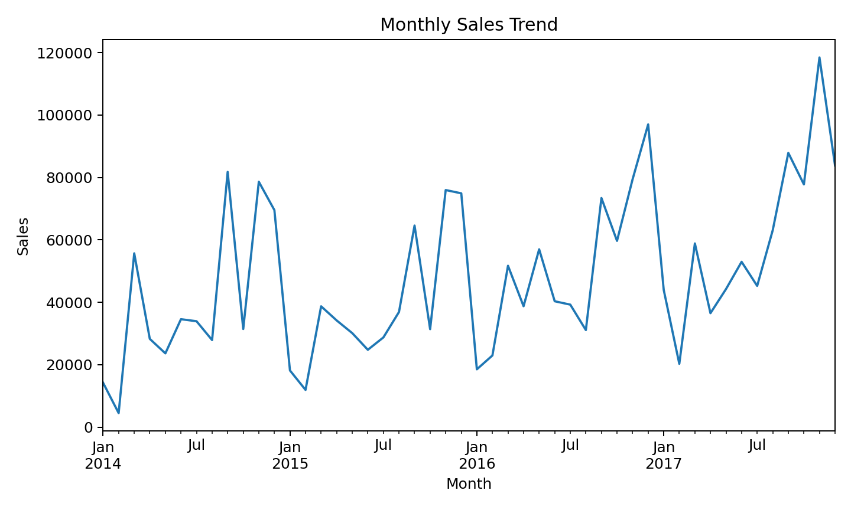
Figure 1. Monthly sales trend.
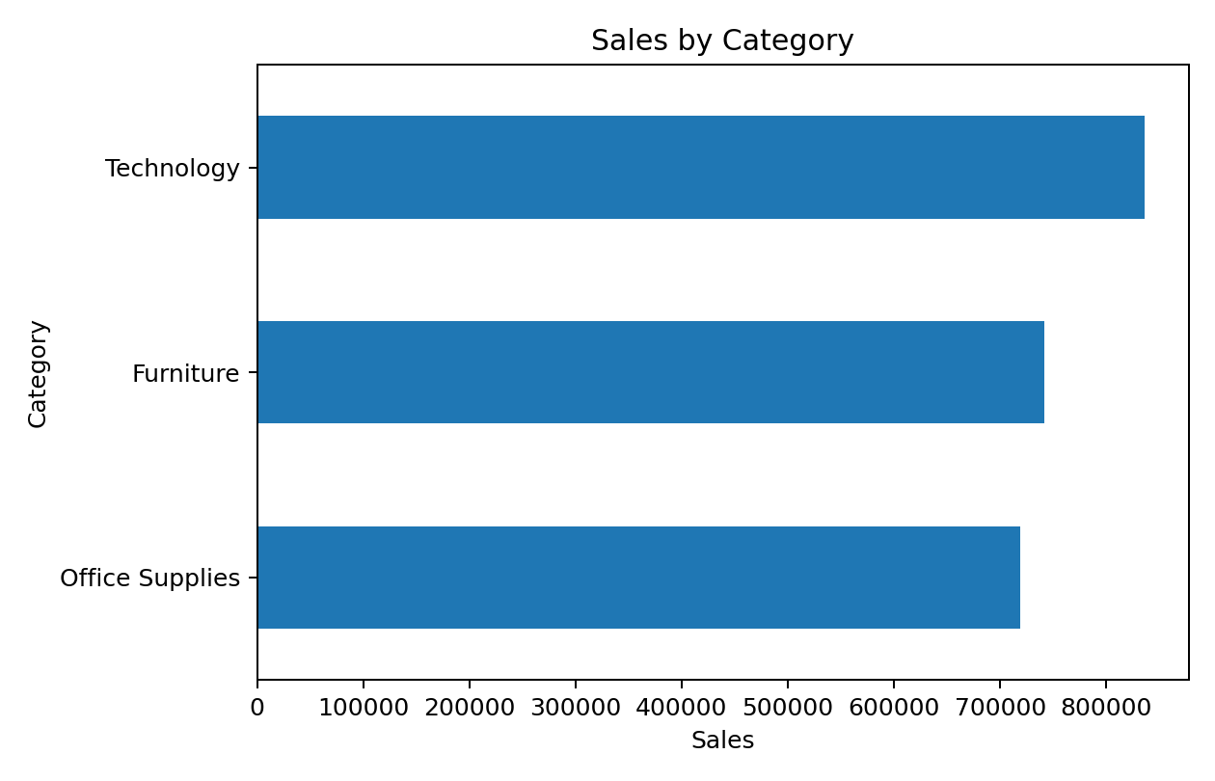
Figure 2. Sales by product category.
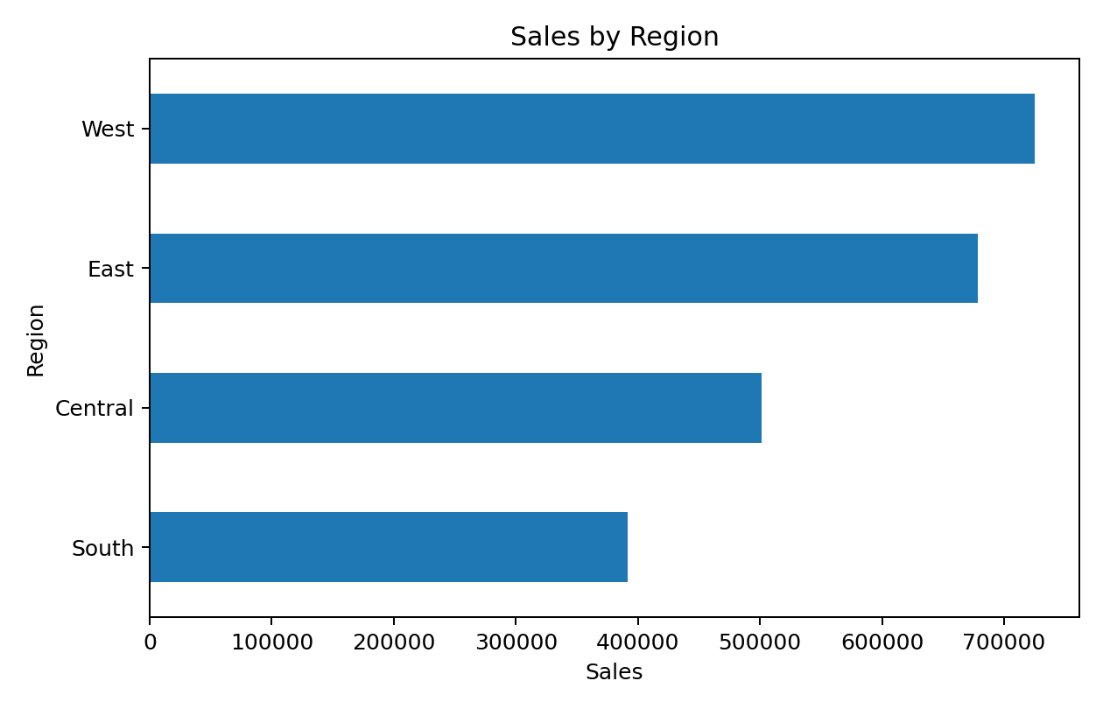
Figure 3. Sales by region.
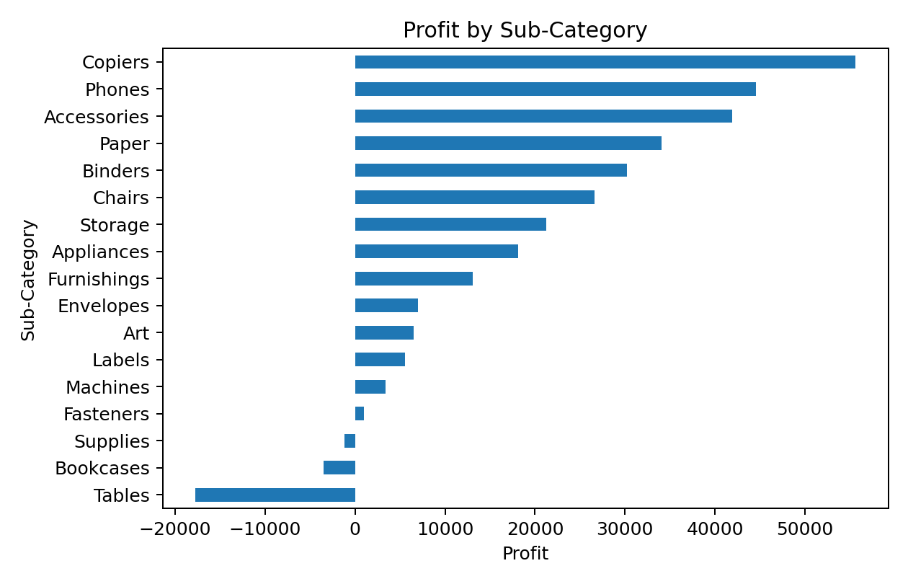
Figure 4. Profit by sub-category.

8. Category, Region and Segment Exploration
Sales concentration:
Category | Sales | Profit
Technology | 836,154.03 | 145,454.95
Furniture | 741,999.80 | 18,451.27
Office Supplies | 719,047.03 | 122,490.80
Regional sales:
Region | Sales
West | 725,457.82
East | 678,781.24
Central | 501,239.89
South | 391,721.91
Customer-segment sales:
Segment | Sales
Consumer | 1,161,401.34
Corporate | 706,146.37
Home Office | 429,653.15

9. Product-Level Exploration
Top 10 products by sales:
Rank | Product | Sales
1 | Canon imageCLASS 2200 Advanced Copier | 61,599.82
2 | Fellowes PB500 Electric Punch Plastic Comb Binding Machine with Manual Bind | 27,453.38
3 | Cisco TelePresence System EX90 Videoconferencing Unit | 22,638.48
4 | HON 5400 Series Task Chairs for Big and Tall | 21,870.58
5 | GBC DocuBind TL300 Electric Binding System | 19,823.48
6 | GBC Ibimaster 500 Manual ProClick Binding System | 19,024.50
7 | Hewlett Packard LaserJet 3310 Copier | 18,839.69
8 | HP Designjet T520 Inkjet Large Format Printer - 24" Color | 18,374.90
9 | GBC DocuBind P400 Electric Binding System | 17,965.07
10 | High Speed Automatic Electric Letter Opener | 17,030.31
Bottom 10 products by profit:
Rank | Product | Profit
1 | Cubify CubeX 3D Printer Double Head Print | -8,879.97
2 | Lexmark MX611dhe Monochrome Laser Printer | -4,589.97
3 | Cubify CubeX 3D Printer Triple Head Print | -3,839.99
4 | Chromcraft Bull-Nose Wood Oval Conference Tables & Bases | -2,876.12
5 | Bush Advantage Collection Racetrack Conference Table | -1,934.40
6 | GBC DocuBind P400 Electric Binding System | -1,878.17
7 | Cisco TelePresence System EX90 Videoconferencing Unit | -1,811.08
8 | Martin Yale Chadless Opener Electric Letter Opener | -1,299.18
9 | Balt Solid Wood Round Tables | -1,201.06
10 | BoxOffice By Design Rectangular and Half-Moon Meeting Room Tables | -1,148.44

10. Key Initial Insights
- Sales total approximately 2,297,201, while total profit is approximately 286,397, indicating that revenue and profitability should be analyzed together.
- The overall calculated profit margin is approximately 12.47%, providing a useful baseline for later comparisons.
- 1,871 records have negative profit. These records are analytically important because they may identify products, discounts, customers or regions where revenue does not translate into profit.
- West has the highest total sales among the four regions in this dataset.
- Technology is the largest category by total sales.
- The monthly series provides a basis for studying seasonality, growth, peaks and unusual periods in later tasks.
- Product-level analysis can reveal a difference between high-volume/high-revenue products and products that are actually profitable.

11. Problem Definition
Business Problem Statement: The business needs to understand the factors associated with sales and profitability across products, categories, regions, customer segments and time. The analysis should identify areas generating strong revenue, areas generating weak or negative profit, and relationships between discounting, quantity, sales and profit.
Primary analytical question: Which products, categories, regions, customer segments and discount levels contribute most to revenue and profit, and where are there opportunities to improve profitability without unnecessarily reducing sales?
Secondary questions:
- How do sales and profit change over time?
- Which categories and sub-categories generate the most sales and profit?
- Which products generate high sales but relatively low or negative profit?
- Does a higher discount level appear to be associated with lower profit?
- Which regions and customer segments contribute the most revenue and profit?
- Are there geographic areas with consistently weak profitability?
- How does shipping mode relate to order value and profitability?

12. Hypotheses
ID | Hypothesis | Proposed method
H1 | Higher discount levels are associated with lower profit margins. | Correlation / grouped comparison / regression
H2 | Sales and profit vary materially across product categories and sub-categories. | ANOVA or non-parametric group comparison
H3 | Some high-sales products are not necessarily high-profit products. | Sales-profit quadrant analysis
H4 | Regional performance differs in both revenue and profitability. | Grouped comparison and statistical testing
H5 | Sales exhibit time-based patterns or seasonality. | Time-series aggregation and visualization

13. Proposed Analysis Strategy
Stage | Purpose | Methods/tools
1. Data preparation | Validate dates, identifiers, missing values, duplicates, data types and outliers. | Pandas, NumPy
2. Univariate EDA | Study distributions of Sales, Profit, Quantity and Discount. | Pandas, Matplotlib
3. Bivariate analysis | Analyze Sales vs Profit, Discount vs Profit, Quantity vs Sales. | Scatter plots, correlation
4. Time analysis | Calculate monthly/quarterly sales and profit and identify peaks/trends. | Datetime, resampling, line charts
5. Category analysis | Compare categories and sub-categories by sales, profit and margin. | Groupby, bar charts
6. Geographic analysis | Compare regions, states and cities. | Groupby, maps/heatmaps if available
7. Customer analysis | Compare segments and customer-level contribution. | Groupby, Pareto analysis
8. Statistical testing | Test whether observed group differences are statistically meaningful. | t-test/ANOVA/Mann-Whitney as appropriate
9. Business recommendations | Translate analytical results into measurable business actions. | Dashboard/report

14. Tools and Technologies
- Python — primary programming language.
- Pandas — data loading, cleaning, transformation and aggregation.
- NumPy — numerical operations and descriptive calculations.
- Matplotlib — exploratory charts and trend visualization.
- Jupyter Notebook / Google Colab — interactive analysis environment.
- Excel or Power BI — optional later-stage dashboarding and stakeholder presentation.

15. Potential Limitations
- The dataset is a sample/educational retail dataset and may not represent a specific real company's complete operations.
- The dataset is observational, so correlations should not automatically be interpreted as causal relationships.
- Discount may be associated with other commercial decisions, so a simple correlation may hide confounding factors.
- Customer behavior and profitability can be affected by variables not present in the dataset, such as acquisition cost, inventory cost, returns and advertising spend.
- Some conclusions may be sensitive to the selected aggregation level (order, product, customer, city or region).
- Negative profit values should be investigated rather than automatically removed as anomalies.

16. Future Improvements
- Add return/cancellation data if available.
- Add product cost, inventory and marketing-spend variables.
- Build a Power BI or Excel dashboard with interactive filters.
- Develop a customer segmentation analysis.
- Perform statistical significance testing on the major hypotheses.
- Build a simple predictive model for sales or profit after completing the descriptive and diagnostic analysis.
- Create a repeatable data-cleaning pipeline so future datasets can be processed automatically.

17. Conclusion
The Week 1 exploration establishes a clear foundation for deeper analytics. The Superstore dataset contains sufficient information to investigate revenue, profitability, product performance, customer segments, geography, shipping and time patterns. The central problem is to understand the relationship between sales and profitable growth rather than focusing on revenue alone. The next stages should therefore combine descriptive EDA with diagnostic analysis, statistical testing and business-focused visualization.

18. Reproducibility: Core Python Code
import pandas as pd
import numpy as np
import matplotlib.pyplot as plt
df = pd.read_csv("Sample - Superstore.csv", encoding="latin1")
df["Order Date"] = pd.to_datetime(df["Order Date"])
df["Ship Date"] = pd.to_datetime(df["Ship Date"])
print(df.shape)
print(df.info())
print(df.isna().sum())
print(df.describe())
# Sales and profit by category
category_summary = (
df.groupby("Category")[["Sales", "Profit"]]
.sum()
.sort_values("Sales", ascending=False)
)
# Monthly sales
monthly_sales = (
df.set_index("Order Date")["Sales"]
.resample("MS")
.sum()
)
monthly_sales.plot(kind="line", figsize=(10,5))
plt.title("Monthly Sales Trend")
plt.xlabel("Month")
plt.ylabel("Sales")
plt.show()

19. Submission Checklist
- ☐ Dataset selected and documented.
- ☐ Dataset structure and variable types explored.
- ☐ Summary statistics calculated.
- ☐ Missing and duplicate values checked.
- ☐ Anomalous/negative-profit records identified for investigation.
- ☐ Basic distributions and trends visualized.
- ☐ Problem statement clearly defined.
- ☐ Key analytical questions documented.
- ☐ Hypotheses documented.
- ☐ Analysis methods and tools proposed.
- ☐ Limitations and future improvements included.
- ☐ Report prepared in DOCX format.

