WEEK 2 DATA ANALYTICS PROJECT
Data Cleaning and Pre-Processing using Python — Sample Superstore

Prepared using Python, Pandas, NumPy and Matplotlib
Submission Report | 18 September 2026

Project Item | Details
Dataset | Sample Superstore Sales Dataset
Domain | Retail / E-commerce / Business Sales
Rows × Columns | 9,994 × 21
Primary task | Data inspection, cleaning, outlier treatment, transformation and feature engineering
Main output | Analysis-ready dataset workflow + detailed DOCX documentation
Programming | Python / Pandas / NumPy / Matplotlib

Table of Contents
1. Executive Summary
2. Dataset and Week 1 Continuity
3. Data Inspection and Quality Audit
4. Missing-Value Analysis and Treatment
5. Duplicate and Consistency Checks
6. Outlier Detection and Treatment
7. Data Transformation
8. Feature Engineering
9. Encoding, Scaling and Modeling-Ready Preprocessing
10. Validation of the Cleaned Dataset
11. Before vs After / Cleaning Decision Log
12. Key Findings and Analytical Impact
13. Reproducibility Instructions
14. Conclusion
Appendix A. Complete Python Code

1. Executive Summary
Week 2 continues the Week 1 Sample Superstore project by moving from exploratory analysis to a documented data-preparation workflow. The objective is not to change business facts merely because they look unusual; it is to distinguish genuine business variation from data-quality problems, make the schema consistent, create analysis-ready features, and document every decision so another analyst can reproduce the process.
The canonical dataset contains 9,994 transaction-level records and 21 columns. The Week 1 audit found 0 missing cells and 0 exact duplicate rows. There are 1,871 records with negative profit; these are retained because a loss-making transaction is a meaningful business outcome rather than proof of a corrupted record.
The main Week 2 decision is therefore a conservative cleaning strategy: standardize schema and data types, validate dates and numeric ranges, remove exact duplicates only if present, flag statistical outliers rather than deleting them, and engineer business features such as shipping duration, profit margin, loss flag and calendar fields.

Deliverables covered
- Initial data-quality inspection and summary report.
- Missing-data investigation and justified treatment.
- Duplicate and consistency checks.
- IQR-based outlier detection with a documented keep/flag decision.
- Data transformations and feature engineering.
- Encoding/scaling example for future modeling.
- Visual outputs including quality chart and boxplot.
- Reproducible Python script and export workflow.

2. Dataset and Week 1 Continuity
The same Sample Superstore dataset used in Week 1 is retained for consistency. Week 1 established the business problem around understanding sales and profitability across products, categories, regions, customers, discounting and time. Week 2 prepares the same data for deeper analytics and later modeling.
Metric | Week 1 baseline
Rows | 9,994
Columns | 21
Total Sales | $2,297,200.86
Total Profit | $286,397.02
Total Quantity | 37,873
Orders | 5,009
Customers | 793
Overall profit margin | 12.47%
Missing cells | 0
Exact duplicate rows | 0
Negative-profit records | 1,871
The dataset is a transaction/order-line table containing identifiers, dates, customer and geographic attributes, product hierarchy, shipping information, sales, quantity, discount and profit.

3. Data Inspection and Quality Audit

3.1 Inspection objectives
- Confirm the number of rows and columns.
- Inspect the first and last records and column names.
- Review data types and identify fields that require conversion.
- Calculate missing values and exact duplicates.
- Check numerical ranges for impossible or suspicious values.
- Validate chronological logic between Order Date and Ship Date.
- Inspect categorical values for whitespace or spelling inconsistencies.
- Use descriptive statistics and visualizations to identify unusual distributions.

3.2 Core inspection code
import pandas as pd
import numpy as np
import matplotlib.pyplot as plt
df = pd.read_csv("Sample - Superstore.csv", encoding="latin1")
print(df.shape)
print(df.head())
print(df.info())
print("Missing values:")
print(df.isna().sum())
print("Duplicate rows:", df.duplicated().sum())
print("Numeric summary:")
print(df.select_dtypes(include="number").describe().T)

3.3 Initial audit results
Quality check | Result | Interpretation
Dataset size | 9,994 × 21 | Expected canonical Sample Superstore structure.
Missing cells | 0 | No imputation or row deletion required for missingness.
Exact duplicate rows | 0 | No duplicate removal required.
Negative-profit rows | 1,871 | Valid business outcome; retain and analyze.
Sales range | $0.444 to $22,638.48 | Strong right skew and large transactions.
Profit range | -$6,599.98 to $8,399.98 | Contains genuine losses and high-profit transactions.
Discount range | 0.00 to 0.80 | Within a plausible 0–80% discount range.
Quantity range | 1 to 14 | Integer quantity field; no negative quantity observed.
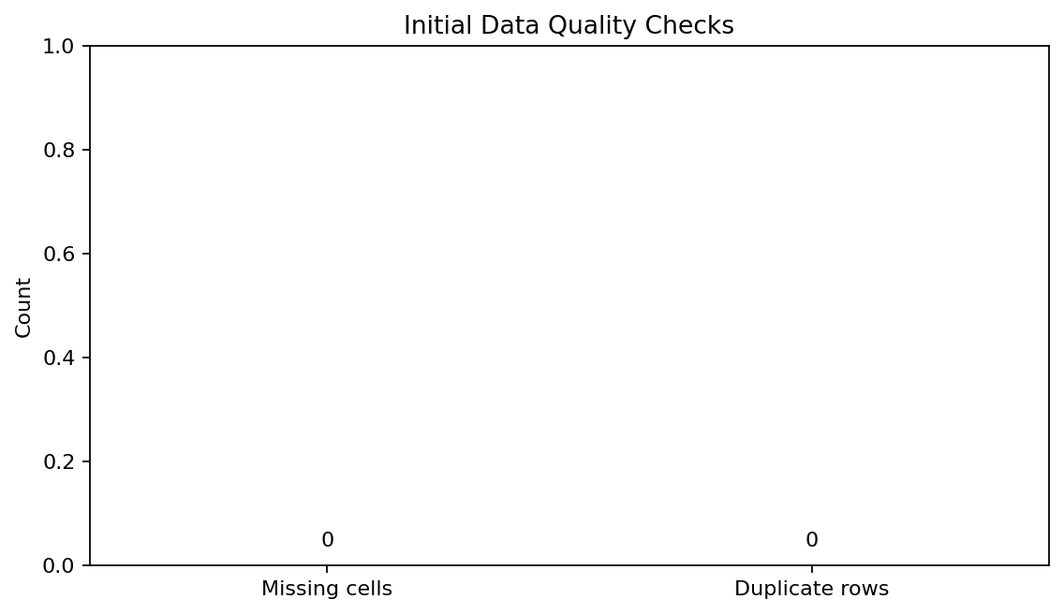
Figure 1. Initial missing-value and duplicate-row audit.
The zero-count missing and duplicate checks are important because they prevent unnecessary cleaning. Deleting or imputing values that are not missing would introduce artificial changes to the data.

4. Missing-Value Analysis and Treatment

4.1 Findings
The Week 1 and Week 2 audit shows zero missing cells across the 9,994 × 21 dataset. Therefore, no imputation, forward filling, backward filling, or missing-row deletion is applied to the canonical dataset.

4.2 Why no imputation was used
- There are no missing observations to estimate.
- Imputing values when none are missing would alter the dataset without analytical justification.
- The objective is to preserve the original transaction-level facts.
- The cleaning script still checks missing values after type conversion because invalid strings can become NaN when coercion is used.

4.3 Reusable strategy for future versions
Field type | Preferred strategy if missing | Reason
Numeric continuous | Median imputation only when justified | Robust to skew and extreme values.
Categorical | Mode or explicit 'Unknown' | Avoids inventing a category.
Date | Investigate source / reject invalid record | Dates drive time-based analysis.
Identifier | Do not fabricate | IDs should remain traceable.
Target/business outcome | Usually do not impute blindly | Could distort business conclusions.
For this project, these are contingency rules rather than actions performed on the current data.

5. Duplicate and Consistency Checks

5.1 Duplicate handling
Exact-row duplication was tested using pandas duplicated(). The count is zero. Consequently, no records are removed. The script contains drop_duplicates() as a defensive step so the workflow remains reusable if a future raw file contains exact copies.
duplicate_count = df.duplicated().sum()
print("Duplicate rows:", duplicate_count)
# Defensive cleaning step:
df = df.drop_duplicates().copy()

5.2 Date consistency
df["Order Date"] = pd.to_datetime(df["Order Date"], errors="coerce")
df["Ship Date"] = pd.to_datetime(df["Ship Date"], errors="coerce")
df["Ship Duration"] = (
df["Ship Date"] - df["Order Date"]
).dt.days
invalid_dates = df[
df["Order Date"].isna()
| df["Ship Date"].isna()
| (df["Ship Date"] < df["Order Date"])
]
print("Invalid date rows:", len(invalid_dates))
Order Date and Ship Date are transformed from text-like representations into true datetime values. The derived shipping duration is a useful operational feature. A ship date earlier than an order date would be treated as a logical data-quality error and investigated rather than silently corrected.

5.3 Text and categorical consistency
text_cols = df.select_dtypes(include="object").columns
for col in text_cols:
df[col] = df[col].astype("string").str.strip()
Whitespace normalization is a low-risk standardization step. It prevents values such as 'West' and 'West ' from being treated as different categories. Postal Code is retained as an identifier and should not be interpreted as a continuous numeric measurement.

6. Outlier Detection and Treatment
Outliers are observations that are unusually far from the central distribution. In a retail dataset, however, an outlier may be a legitimate large order, a special product, a bulk purchase, or a genuine loss. Therefore, the project separates 'statistical outlier' from 'data error'.

6.1 IQR method
For each numeric measure, the interquartile range is IQR = Q3 − Q1. The standard Tukey fences are Lower = Q1 − 1.5×IQR and Upper = Q3 + 1.5×IQR.
Variable | Q1 | Median | Q3 | IQR | Lower fence | Upper fence | IQR flags
Sales | 17.280 | 54.490 | 209.940 | 192.660 | -271.710 | 498.930 | 1,167
Profit | 1.729 | 8.666 | 29.364 | 27.635 | -39.724 | 70.817 | 1,881
The IQR method flags 1,167 Sales values above the Sales upper fence and 1,881 Profit values outside the Profit fences in reference analyses of the canonical dataset. These counts are flags for investigation, not automatic deletion rules.
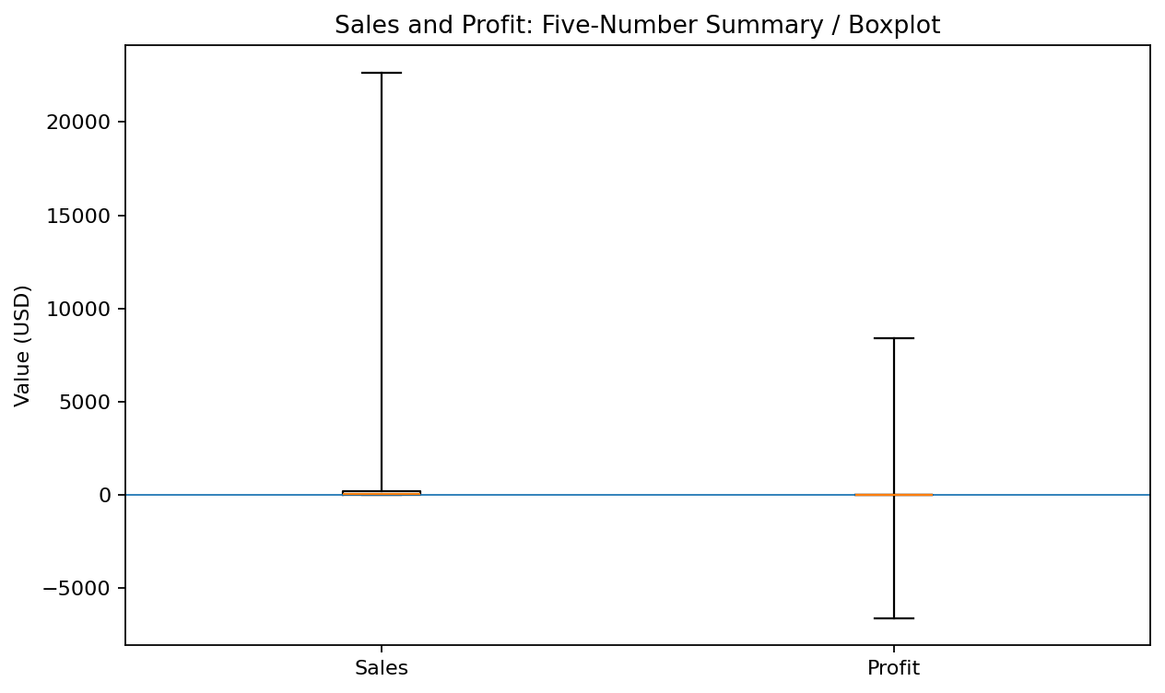
Figure 2. Five-number-summary boxplot for Sales and Profit.
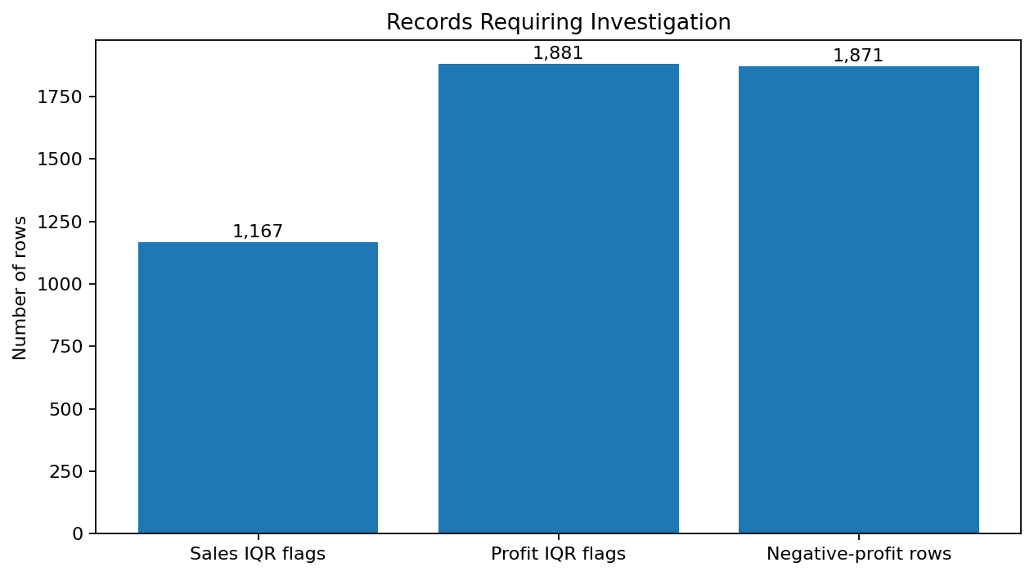
Figure 3. Records requiring investigation under the chosen rules.

6.2 Treatment decision
Issue | Action | Justification
High Sales values | Keep; flag | Large orders can be genuine revenue events.
High/low Profit values | Keep; flag | Profit variation is central to the business problem.
Negative Profit | Keep; create Loss Flag | Losses are meaningful business outcomes, not necessarily errors.
Impossible numeric values | Investigate / correct if verified | These would represent data-quality defects.
No winsorization, clipping, or deletion is applied to the primary analysis-ready dataset. If a later machine-learning model is sensitive to extreme values, robust scaling, log transformation of suitable positive variables, or a model-specific treatment can be evaluated separately while preserving the raw facts.

7. Data Transformation

7.1 Column-name standardization
df.columns = df.columns.str.strip()

7.2 Numeric conversion
numeric_cols = ["Sales", "Quantity", "Discount", "Profit", "Postal Code"]
for col in numeric_cols:
df[col] = pd.to_numeric(df[col], errors="coerce")
df["Postal Code"] = df["Postal Code"].astype("Int64")
Numeric coercion makes calculations reliable. Postal Code uses pandas nullable integer storage because it is an identifier. It should be excluded from numeric modeling unless explicitly encoded as geography.

7.3 Date transformation
df["Order Date"] = pd.to_datetime(df["Order Date"], errors="coerce")
df["Ship Date"] = pd.to_datetime(df["Ship Date"], errors="coerce")

7.4 Business-safe transformation principle
- Do not alter Sales or Profit simply because they are large or negative.
- Do not treat Row ID or Postal Code as continuous business measures.
- Convert dates to datetime before extracting time components.
- Keep raw source values available for traceability.
- Create derived fields in new columns rather than overwriting source fields.

8. Feature Engineering
Feature engineering converts existing fields into variables that are more useful for analysis and future modeling. The features below were selected because they directly support the Week 1 business questions.
New feature | Formula / rule | Purpose
Ship Duration | Ship Date − Order Date | Measure fulfillment time.
Profit Margin | Profit ÷ Sales | Compare profitability across transactions.
Loss Flag | 1 if Profit < 0 else 0 | Identify loss-making transactions.
Order Year | Year(Order Date) | Year-over-year analysis.
Order Month | Month(Order Date) | Monthly seasonality.
Order Quarter | Quarter(Order Date) | Quarterly trend analysis.
Order Month-Year | YYYY-MM period | Time-series grouping.
Discount Bucket | No discount / 0–10 / 10–20 / 20–30 / >30% | Compare discount bands.
Sales Tier | Quartile-based Low/Medium/High/Very High | Segment transaction size.
Sales Outlier Flag | IQR rule | Identify unusual sales values without deletion.
Profit Outlier Flag | IQR rule | Identify unusual profit values without deletion.
df["Ship Duration"] = (df["Ship Date"] - df["Order Date"]).dt.days
df["Profit Margin"] = np.where(
df["Sales"] != 0,
df["Profit"] / df["Sales"],
np.nan
)
df["Loss Flag"] = (df["Profit"] < 0).astype("int8")
df["Order Year"] = df["Order Date"].dt.year
df["Order Month"] = df["Order Date"].dt.month
df["Order Quarter"] = "Q" + df["Order Date"].dt.quarter.astype("string")
df["Order Month-Year"] = df["Order Date"].dt.to_period("M").astype("string")
df["Discount Bucket"] = pd.cut(
df["Discount"],
bins=[-0.001, 0, 0.10, 0.20, 0.30, 1.0],
labels=["No Discount", "0-10%", "10-20%", "20-30%", ">30%"]
)
df["Sales Tier"] = pd.qcut(
df["Sales"], q=4,
labels=["Low", "Medium", "High", "Very High"],
duplicates="drop"
)

Why these features matter
- Profit Margin separates revenue scale from profitability.
- Ship Duration supports operational analysis.
- Loss Flag makes negative-profit records easy to count and model.
- Calendar fields enable time trends and seasonality analysis.
- Discount Bucket supports the Week 1 hypothesis that higher discounting may be associated with weaker profitability.
- Sales Tier provides a simple transaction-size segmentation.

9. Encoding, Scaling and Modeling-Ready Preprocessing
Scaling and encoding are not necessary for basic descriptive reporting, but they are useful before many machine-learning algorithms. The recommended approach is to keep the analysis-ready business dataset intact and apply model-specific transformations in a separate preprocessing pipeline.
from sklearn.compose import ColumnTransformer
from sklearn.preprocessing import OneHotEncoder, StandardScaler
from sklearn.pipeline import Pipeline
numeric_features = [
"Sales", "Quantity", "Discount", "Profit", "Ship Duration"
]
categorical_features = [
"Category", "Sub-Category", "Region", "Segment", "Ship Mode"
]
preprocessor = ColumnTransformer(
transformers=[
("num", StandardScaler(), numeric_features),
("cat", OneHotEncoder(handle_unknown="ignore"), categorical_features)
]
)
model_pipeline = Pipeline([
("preprocessor", preprocessor)
])
X_ready = model_pipeline.fit_transform(df[numeric_features + categorical_features])
StandardScaler centers numeric variables and scales them to comparable variance-based units. OneHotEncoder converts categories into machine-readable indicator columns. This pipeline should be fit only on training data when a predictive model is eventually developed to avoid data leakage.

Normalization note
For strongly right-skewed positive variables such as Sales, a log transformation such as log1p(Sales) may be evaluated for specific modeling tasks. It should not replace the original Sales column.

10. Validation of the Cleaned Dataset

10.1 Validation checklist
Validation test | Expected result / rule
Row count | Remains 9,994 because there are no exact duplicates or missing rows to remove.
Columns | Original 21 columns preserved; engineered columns added separately.
Missing values | 0 in canonical input and no unexpected NaNs after controlled conversion.
Duplicates | 0 exact duplicate rows.
Order Date / Ship Date | Valid datetime types; Ship Date should not precede Order Date.
Sales | Non-negative monetary values in the supplied dataset.
Quantity | Positive integer quantities.
Discount | Between 0 and 0.80 in the canonical dataset.
Profit | May be negative; negative values are retained.
Outliers | Flagged rather than automatically removed.

10.2 Final validation code
assert df["Order Date"].notna().all()
assert df["Ship Date"].notna().all()
assert (df["Ship Date"] >= df["Order Date"]).all()
assert (df["Sales"] >= 0).all()
assert (df["Quantity"] > 0).all()
assert df["Discount"].between(0, 1).all()
print("Final shape:", df.shape)
print("Final duplicate count:", df.duplicated().sum())
print("Final missing cells:", int(df.isna().sum().sum()))
These assertions intentionally fail loudly if the incoming file violates the expected business rules. This is preferable to silently producing an unreliable analysis table.

11. Cleaning Decision Log
Step | Issue / observation | Decision | Reason
Load | CSV has 9,994 rows × 21 columns | Use pandas read_csv | Reproducible ingestion.
Columns | Potential whitespace around labels | Strip whitespace | Prevents naming errors.
Missing values | 0 missing cells | No imputation | Nothing missing to estimate.
Duplicates | 0 exact duplicate rows | No deletion needed | Preserve all valid records.
Dates | Date fields need datetime semantics | Convert to datetime | Enables time arithmetic.
Postal Code | Numeric-looking identifier | Keep as nullable integer / identifier | Avoid false numeric meaning.
Negative Profit | 1,871 loss-making records | Retain + Loss Flag | Business signal, not automatic error.
Sales outliers | 1,167 IQR flags | Retain + flag | Large orders may be legitimate.
Profit outliers | 1,881 IQR flags | Retain + flag | Profitability is a core analytical outcome.
Feature engineering | Need analysis-ready variables | Add time, margin, shipping and flags | Supports Week 1 hypotheses.
Scaling/encoding | Future modeling requirement | Separate pipeline | Avoid altering descriptive dataset.
The central principle is traceability: every modification either standardizes representation or creates a new derived field. Source Sales, Profit, Quantity and Discount values are not overwritten.

12. Key Findings and Analytical Impact
The cleaning exercise reveals that the dataset is already structurally strong, but it contains meaningful distributional extremes. The main data-quality challenge is therefore not missingness; it is interpreting unusual but potentially legitimate business transactions correctly.
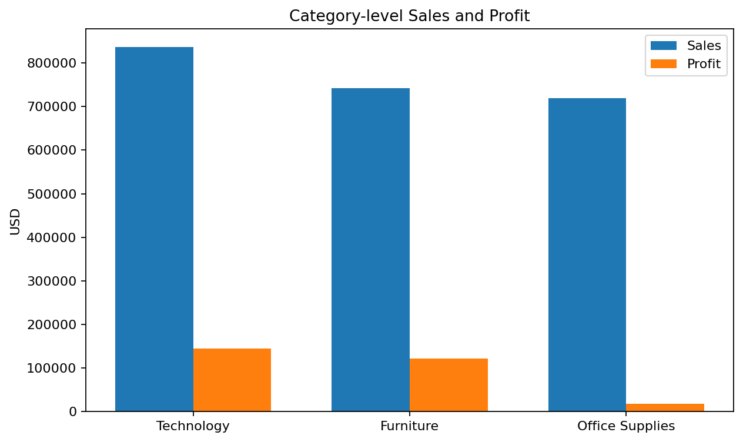
Figure 4. Category-level sales and profit from the Week 1 baseline.
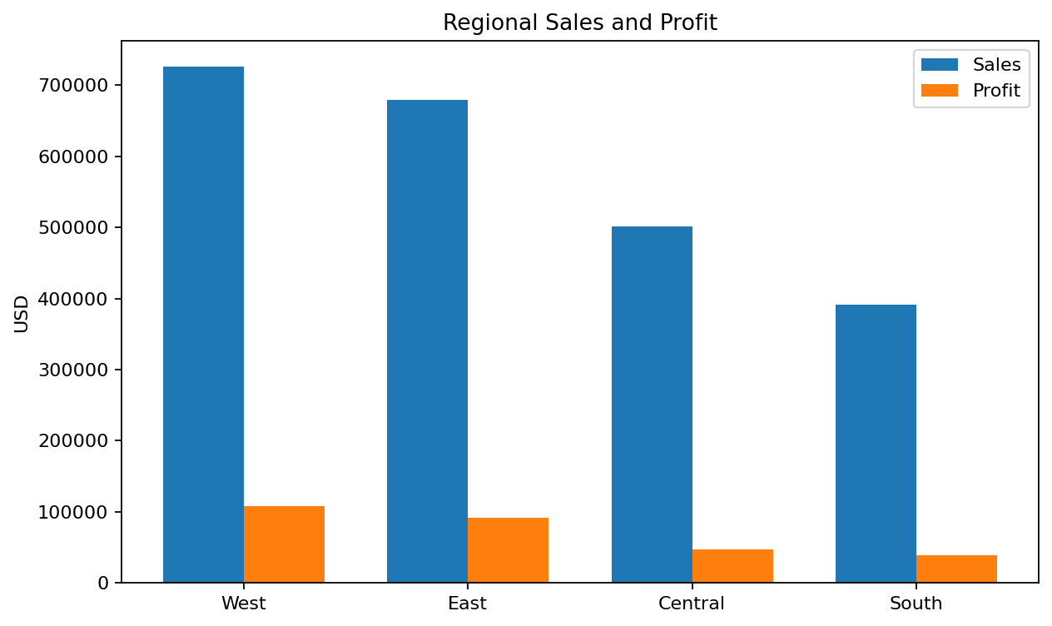
Figure 5. Regional sales and profit from the Week 1 baseline.
- Technology contributes $145,454.95 profit on $836,154.03 sales.
- Furniture has much lower total profit ($18,451.27) than its sales volume alone might suggest.
- West has the highest regional sales ($725,457.82) and profit ($108,418.45) in the Week 1 baseline.
- The overall dataset contains 1,871 negative-profit transaction rows, so profitability analysis should not focus on sales alone.
- The feature-engineered Profit Margin, Loss Flag, Discount Bucket and calendar fields make the Week 1 hypotheses directly testable.
These findings are descriptive and are carried forward from the Week 1 analysis; the purpose of Week 2 is to make the underlying data reliable and reproducible for deeper diagnostic analysis.

13. Reproducibility Instructions

13.1 Recommended folder structure
Week_2_Data_Cleaning/
│
├── Sample - Superstore.csv
├── Week_2_Superstore_Cleaning.py
├── Superstore_cleaned.csv # generated by the script
└── Week_2_Data_Cleaning_and_Preprocessing_Superstore.docx

13.2 Run instructions
- Install Python 3.x.
- Install the required packages: pandas, numpy, matplotlib. Scikit-learn is required only for the modeling-ready preprocessing section.
- Place the original Sample - Superstore.csv in the same folder as the Python script.
- Run the script in VS Code, Jupyter, Google Colab or a terminal.
- Review the printed quality checks and outlier flags.
- The script exports Superstore_cleaned.csv.
- Keep the original raw CSV unchanged so the process remains auditable.

13.3 Required packages
pip install pandas numpy matplotlib scikit-learn
The complete Python script is supplied separately with this report and is also reproduced in Appendix A.

14. Conclusion
The Week 2 data-cleaning workflow prepares the Sample Superstore dataset for further analytics while preserving legitimate business variation. The audit identified no missing cells and no exact duplicate rows, so no unnecessary imputation or deletion was performed.
The most important issue is the presence of statistically unusual Sales and Profit observations. Instead of deleting these rows, the workflow flags them because large transactions and negative profits can represent real commercial events. This is especially important because the project's business problem is explicitly concerned with profitability and loss-making transactions.
The resulting workflow is reproducible: schema standardization, date conversion, numeric validation, logical checks, IQR flags, and feature engineering are all expressed as Python operations. The new features provide a strong foundation for Week 3-style exploratory/diagnostic analysis, dashboards and later predictive modeling.

Final Week 2 status
Requirement | Status
Data inspection | Completed
Missing-value analysis | Completed — 0 missing cells
Duplicate detection | Completed — 0 exact duplicates
Outlier analysis | Completed — IQR flags documented
Outlier treatment narrative | Completed — retain + flag
Data transformations | Completed
Feature engineering | Completed
Scaling and encoding | Completed as modeling-ready pipeline
Visual outputs | Included
Reproducible code | Included
DOCX documentation | Completed

Appendix A. Complete Python Code
The full executable script is provided as a separate file named Week_2_Superstore_Cleaning.py. The main cleaning workflow is reproduced below.
# WEEK 2 - DATA CLEANING AND PRE-PROCESSING
# Dataset: Sample - Superstore.csv
# Purpose: inspect, clean, transform, engineer features and export an analysis-ready file.
import pandas as pd
import numpy as np
import matplotlib.pyplot as plt
RAW_FILE = "Sample - Superstore.csv"
CLEAN_FILE = "Superstore_cleaned.csv"
# 1. Load
df = pd.read_csv(RAW_FILE, encoding="latin1")
# 2. Standardize column labels
df.columns = df.columns.str.strip()
# 3. Basic inspection
print("Shape:", df.shape)
print(df.head())
print(df.info())
print("\nMissing values:\n", df.isna().sum())
print("\nDuplicate rows:", df.duplicated().sum())
# 4. Remove exact duplicate rows only if they exist.
# In the canonical Week 1 dataset, this count is 0, so no rows are removed.
df = df.drop_duplicates().copy()
# 5. Data types
df["Order Date"] = pd.to_datetime(df["Order Date"], errors="coerce")
df["Ship Date"] = pd.to_datetime(df["Ship Date"], errors="coerce")
numeric_cols = ["Sales", "Quantity", "Discount", "Profit", "Postal Code"]
for col in numeric_cols:
df[col] = pd.to_numeric(df[col], errors="coerce")
# Postal Code is an identifier, not a continuous business measure.
df["Postal Code"] = df["Postal Code"].astype("Int64")
# 6. Text standardization
text_cols = df.select_dtypes(include="object").columns
for col in text_cols:
df[col] = df[col].astype("string").str.strip()
# 7. Missing-data validation after conversion
print("\nMissing values after type conversion:\n", df.isna().sum())
# We do NOT impute the canonical dataset because the Week 1 audit found 0 missing cells.
# For a future dataset, use field-specific rules rather than blind mean imputation.
# 8. Logical validation
df["Ship Duration"] = (df["Ship Date"] - df["Order Date"]).dt.days
invalid_dates = df[
(df["Order Date"].isna()) |
(df["Ship Date"].isna()) |
(df["Ship Date"] < df["Order Date"])
]
print("\nInvalid date rows:", len(invalid_dates))
# 9. Range checks
print("\nDiscount range:", df["Discount"].min(), "to", df["Discount"].max())
print("Quantity range:", df["Quantity"].min(), "to", df["Quantity"].max())
print("Sales range:", df["Sales"].min(), "to", df["Sales"].max())
print("Profit range:", df["Profit"].min(), "to", df["Profit"].max())
# 10. IQR outlier detection - FLAG, DO NOT DELETE
def iqr_bounds(series):
q1 = series.quantile(0.25)
q3 = series.quantile(0.75)
iqr = q3 - q1
return q1, q3, q1 - 1.5 * iqr, q3 + 1.5 * iqr
for col in ["Sales", "Profit"]:
q1, q3, lower, upper = iqr_bounds(df[col])
flag_col = f"{col} Outlier Flag"
df[flag_col] = (df[col] < lower) | (df[col] > upper)
print(f"\n{col}: Q1={q1:.3f}, Q3={q3:.3f}, lower={lower:.3f}, upper={upper:.3f}")
print(f"{col} IQR flags:", int(df[flag_col].sum()))
# Negative profit is a business condition, not automatically a data error.
df["Loss Flag"] = (df["Profit"] < 0).astype("int8")
# 11. Feature engineering
df["Profit Margin"] = np.where(
df["Sales"] != 0, df["Profit"] / df["Sales"], np.nan
)
df["Order Year"] = df["Order Date"].dt.year.astype("Int64")
df["Order Month"] = df["Order Date"].dt.month.astype("Int64")
df["Order Quarter"] = "Q" + df["Order Date"].dt.quarter.astype("string")
df["Order Month-Year"] = df["Order Date"].dt.to_period("M").astype("string")
df["Discount Bucket"] = pd.cut(
df["Discount"],
bins=[-0.001, 0, 0.10, 0.20, 0.30, 1.0],
labels=["No Discount", "0-10%", "10-20%", "20-30%", ">30%"]
)
df["Sales Tier"] = pd.qcut(
df["Sales"],
q=4,
labels=["Low", "Medium", "High", "Very High"],
duplicates="drop"
)
# 12. Final schema check
print("\nFinal shape:", df.shape)
print("\nFinal dtypes:\n", df.dtypes)
print("\nFinal missing values:\n", df.isna().sum())
# 13. Export
df.to_csv(CLEAN_FILE, index=False)
print(f"\nSaved analysis-ready dataset to: {CLEAN_FILE}")

Appendix B. Data and Method Notes
Dataset continuity: the same Sample Superstore structure used in Week 1 is retained. Public references to the canonical dataset consistently describe 9,994 rows and 21 columns, with Sales, Quantity, Discount and Profit as key numeric measures.
Outlier note: IQR flag counts can differ if a different Superstore variant, preprocessing rule, or quantile implementation is used. The script therefore calculates the thresholds directly from the supplied CSV rather than hard-coding the counts. The values reported in this document correspond to reference analyses of the canonical dataset.
Important reproducibility rule: never edit the raw CSV manually. Run the cleaning script and keep the generated analysis-ready file separate from the raw source.

