WEEK 3 DATA ANALYTICS PROJECT
Data Visualization and Reporting using Python
Dataset: Sample Superstore Sales Dataset
Prepared using Python, Pandas, NumPy and Matplotlib
Based on the uploaded Sample - Superstore(1).csv
Submission Report | 19 September 2026
Project Item | Actual Result
Rows × Columns | 9,994 × 21
Total Sales | $2,297,200.86
Total Profit | $286,397.02
Total Quantity | 37,873
Unique Orders | 5,009
Unique Customers | 793
Overall Profit Margin | 12.47%
Missing cells before cleaning | 0
Exact duplicates before cleaning | 0
Negative-profit records | 1,871

1. Executive Summary
Week 3 continues the same Sample Superstore analytics project from Weeks 1 and 2. The uploaded CSV was directly loaded and analyzed to produce the required visualizations. The purpose of this stage is to transform numerical findings into clear visual narratives that communicate comparisons, trends, relationships and region-category patterns.
The uploaded file contains 9,994 rows and 21 columns. It contains $2,297,200.86 in total sales and $286,397.02 in total profit, giving an overall profit margin of 12.47%. The data contains 1,871 negative-profit transaction rows, which are retained because negative profit is a business outcome that should be investigated rather than automatically treated as a data error.

2. Visualization Strategy
The visualization strategy was built around the analytical questions established in Weeks 1 and 2. Different chart types were selected according to the type of comparison being made.
Visualization | Question | Reason
Bar chart | How do sales and profit compare by category? | Best for direct categorical comparison.
Line chart | How does sales change over time? | Makes direction and changes in a time series visible.
Scatter plot | How are regional sales and profit related? | Shows paired numerical values and exceptions.
Heatmap | Which region-category combinations generate profit or loss? | Shows a two-dimensional pattern compactly.

3. Data Preparation
- Loaded the uploaded CSV using pandas. Initial shape: 9,994 rows × 21 columns.
- Standardized column names by stripping surrounding whitespace.
- Converted Order Date and Ship Date to datetime.
- Converted Sales, Quantity, Discount, Profit and Postal Code to numeric values.
- Checked missing cells: 0 before visualization.
- Checked exact duplicates: 0 before visualization.
- Removed exact duplicates defensively; no valid business records were expected to be lost when the duplicate count is zero.
- Created Profit Margin and calendar fields for analytical grouping.
- Detected 1,167 Sales and 1,881 Profit IQR outlier flags; these are retained rather than deleted.

4. Visualization 1 — Bar Chart
Question: How do sales and profit compare across product categories?
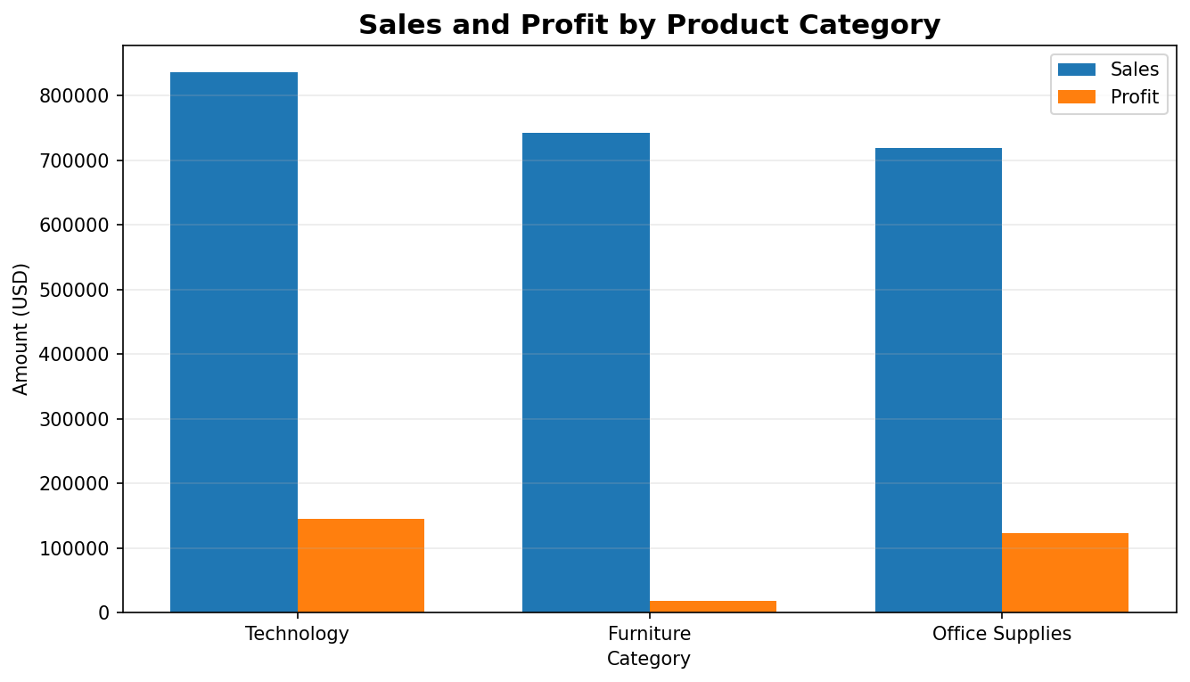
Figure 1. Sales and profit by product category, generated from the uploaded CSV.
- Technology: sales $836,154.03; profit $145,454.95.
- Furniture: sales $741,999.80; profit $18,451.27.
- Office Supplies: sales $719,047.03; profit $122,490.80.
The category with the largest sales total is Technology, at $836,154.03. The category with the largest profit total is Technology, at $145,454.95. The chart demonstrates that sales volume and profitability are different measures and should be considered together.

5. Visualization 2 — Line Chart
Question: How did annual sales change during the observed period?
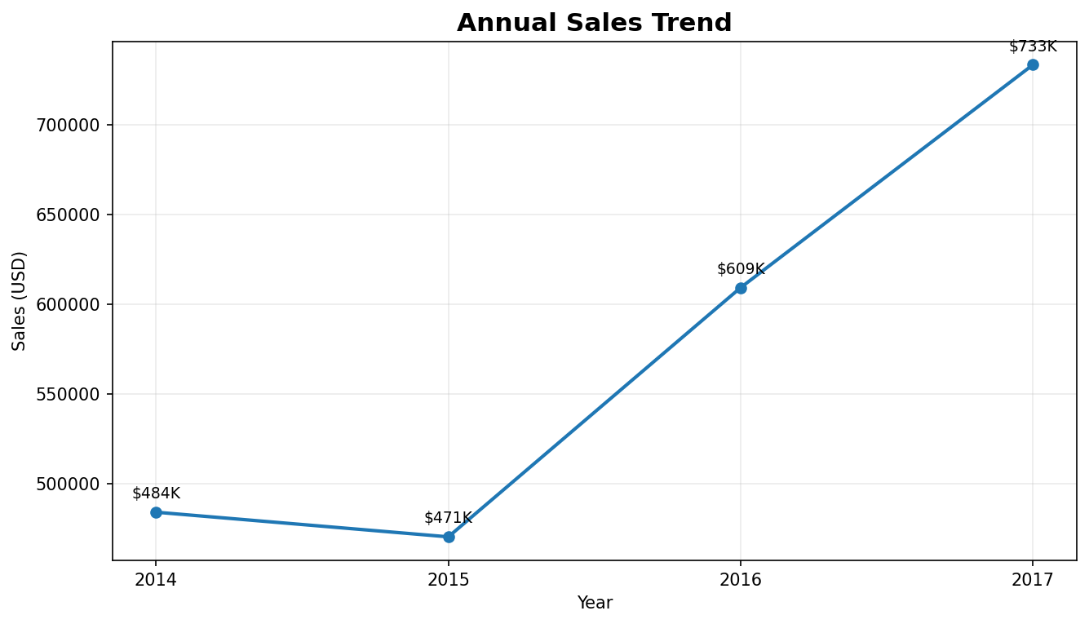
Figure 2. Annual sales trend generated from the uploaded CSV.
The line chart aggregates Sales by Order Year. It provides a compact view of year-to-year movement and makes increases or decreases easier to identify than a raw transaction table.
- 2014: $484,247.50
- 2015: $470,532.51
- 2016: $609,205.60
- 2017: $733,215.26

6. Visualization 3 — Scatter Plot
Question: What pattern is visible between aggregate regional sales and profit?
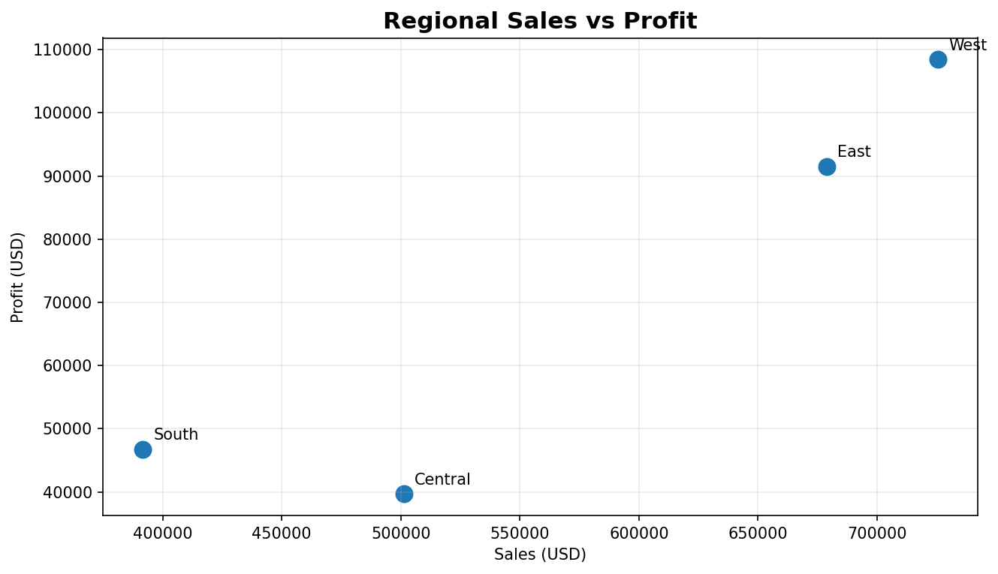
Figure 3. Regional sales versus profit generated from the uploaded CSV.
- West: sales $725,457.82; profit $108,418.45.
- East: sales $678,781.24; profit $91,522.78.
- Central: sales $501,239.89; profit $39,706.36.
- South: sales $391,721.91; profit $46,749.43.
The points provide a descriptive comparison of regions. Regions with higher sales generally also have higher total profit in this dataset, but the chart also shows that sales alone do not completely determine the relative profitability of a region. Because only four regional aggregates are plotted, this should not be interpreted as a strong statistical or causal test.

7. Visualization 4 — Heatmap
Question: How does profit vary across region and product category?
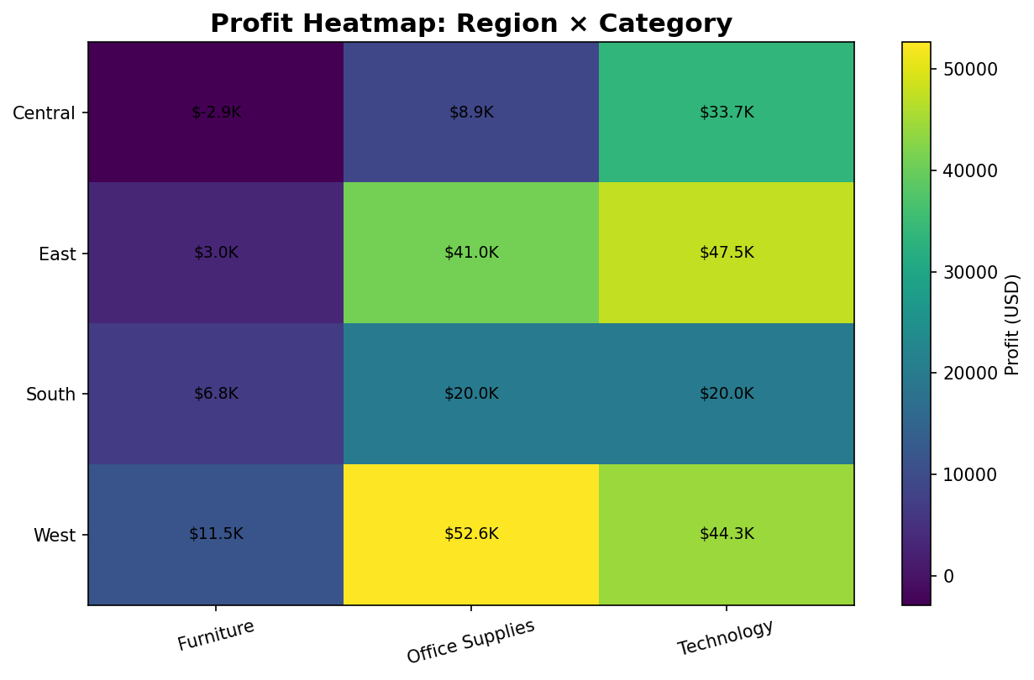
Figure 4. Region × Category profit heatmap generated from the uploaded CSV.
The heatmap combines geography and category into one visual. Positive and negative cells can be compared without scanning multiple tables. In particular, the visualization helps identify category-region combinations where profitability is weaker even when the overall region or category total may look healthy.

8. Additional Visualization — Sub-Category Profit
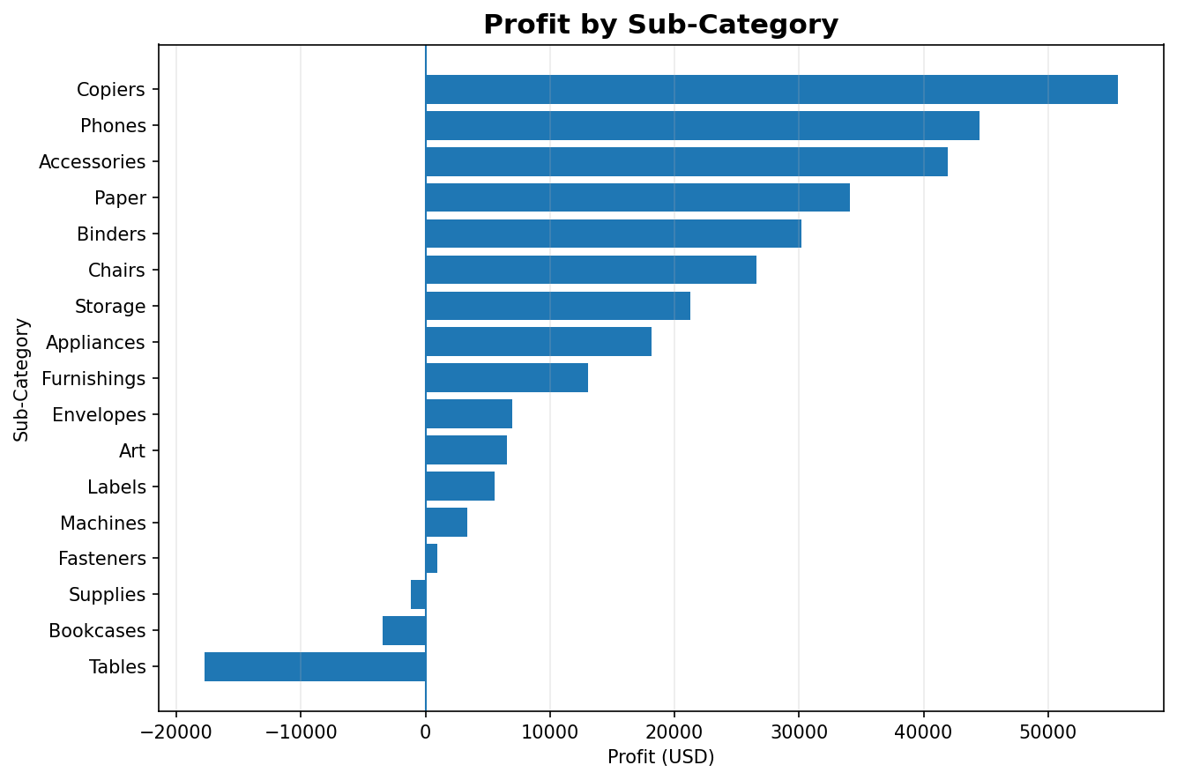
Figure 5. Profit by sub-category.
The uploaded data contains 3 sub-categories with negative aggregate profit. These should be investigated for pricing, discounting, product mix and cost-related explanations rather than automatically removed from the analysis.

9. Additional Visualization — Discount vs Profit
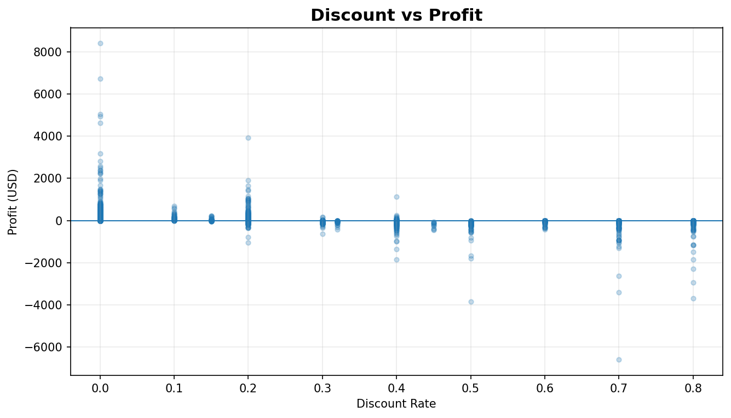
Figure 6. Discount versus profit.
The transaction-level Discount–Profit Pearson correlation in the uploaded data is -0.219. This is a descriptive linear association, not evidence that discounting by itself causes a change in profit. Customer segment, product category, region, order size and other factors may also affect the observed relationship.

10. Key Visual Insights
- Total sales in the uploaded dataset are $2,297,200.86, compared with total profit of $286,397.02.
- The overall profit margin is 12.47%.
- Technology has the largest category sales total.
- Technology has the largest category profit total.
- West has the largest regional sales total.
- West has the largest regional profit total.
- There are 1,871 negative-profit transaction records, making profitability analysis important in addition to revenue analysis.
- The region-category heatmap provides a more detailed view than region totals alone.

11. Visualization Design Best Practices
- Every chart has a clear, descriptive title.
- X- and Y-axes are labeled with meaningful business terms and units.
- Legends are included where multiple measures appear in the same chart.
- Annotations are used selectively to make important values readable.
- Gridlines are light and secondary to the data.
- The heatmap includes a labeled color scale.
- The scatter plot directly labels regions to reduce legend lookup.
- Figures are exported at high resolution for the final report.

12. Python Implementation
The accompanying Week_3_Superstore_Visualization.py script is fully dataset-driven. It reads the CSV from the project folder and regenerates all six visual outputs. This means the charts do not depend on manually entered aggregate values.
df = pd.read_csv(INPUT_FILE, encoding="latin1")
df["Order Date"] = pd.to_datetime(df["Order Date"], errors="coerce")
category_summary = (
df.groupby("Category")[["Sales", "Profit"]].sum()
)
region_summary = (
df.groupby("Region")[["Sales", "Profit"]].sum()
)
heatmap_data = df.pivot_table(
index="Region",
columns="Category",
values="Profit",
aggfunc="sum"
)

13. Limitations
- Sample Superstore is a public/educational retail dataset and may not represent a specific company's complete operations.
- The regional scatter plot contains only four aggregate observations, so it is descriptive.
- Correlation does not establish causation.
- Profitability may depend on business costs and variables not present in the dataset.
- Aggregating transactions can hide product- or customer-level variation.
- The annual line chart does not show monthly seasonality; the code can be extended to a monthly trend.

14. Reproducibility and Folder Structure
Week_3_Data_Visualization/
├── Sample - Superstore.csv
├── Week_3_Superstore_Visualization.py
├── charts/
│ ├── 01_category_sales_profit_bar.png
│ ├── 02_annual_sales_line.png
│ ├── 03_regional_sales_profit_scatter.png
│ ├── 04_profit_region_category_heatmap.png
│ ├── 05_subcategory_profit.png
│ └── 06_discount_vs_profit_scatter.png
└── Week_3_Data_Visualization_and_Reporting_Superstore.docx
- Install Python 3.x.
- Install packages: pip install pandas numpy matplotlib.
- Place Sample - Superstore.csv in the same folder as the Python script.
- Run: python Week_3_Superstore_Visualization.py.
- Open the generated charts and DOCX report.

15. Evaluation Checklist
Requirement | Status
Visualization strategy | Completed
Bar chart | Completed
Line chart | Completed
Scatter plot | Completed
Heatmap | Completed
Axes, titles and legends | Completed
Detailed narrative explanations | Completed
Python implementation | Completed
Visual outputs embedded in DOCX | Completed
Limitations documented | Completed
Reproducibility instructions | Completed

16. Conclusion
Week 3 converts the cleaned Sample Superstore data into a structured visual narrative. The four required visualization types answer complementary questions: category comparison, time trend, regional relationship and region-category interaction. Additional sub-category and discount-profit visuals extend the analysis. The report emphasizes that visualization is most useful when each chart is tied to a specific analytical question and accompanied by an explanation of what the pattern means and what it cannot prove.

Appendix A — Full Python Script
"""
WEEK 3 - DATA VISUALIZATION AND REPORTING
Dataset: Sample - Superstore.csv
Required visuals:
1. Bar chart
2. Line chart
3. Scatter plot
4. Heatmap
Additional:
5. Sub-category profit
6. Discount vs profit
"""
from pathlib import Path
import pandas as pd
import numpy as np
import matplotlib.pyplot as plt
BASE_DIR = Path(__file__).resolve().parent
INPUT_FILE = BASE_DIR / "Sample - Superstore.csv"
OUTPUT_DIR = BASE_DIR / "charts"
OUTPUT_DIR.mkdir(exist_ok=True)
if not INPUT_FILE.exists():
raise FileNotFoundError(
f"Dataset not found: {INPUT_FILE}\n"
"Place 'Sample - Superstore.csv' in the same folder as this script."
)
df = pd.read_csv(INPUT_FILE, encoding="latin1")
df.columns = df.columns.str.strip()
for col in ["Order Date", "Ship Date"]:
df[col] = pd.to_datetime(df[col], errors="coerce")
for col in ["Sales", "Quantity", "Discount", "Profit", "Postal Code"]:
df[col] = pd.to_numeric(df[col], errors="coerce")
df = df.drop_duplicates().copy()
df["Profit Margin"] = np.where(df["Sales"] != 0, df["Profit"] / df["Sales"], np.nan)
df["Order Year"] = df["Order Date"].dt.year
print("Shape:", df.shape)
print("Missing cells:", int(df.isna().sum().sum()))
print("Duplicate rows:", int(df.duplicated().sum()))
print("Total sales:", round(df["Sales"].sum(), 2))
print("Total profit:", round(df["Profit"].sum(), 2))
# 1. Bar chart
category_summary = (
df.groupby("Category")[["Sales", "Profit"]]
.sum()
.sort_values("Sales", ascending=False)
)
ax = category_summary.plot(kind="bar", figsize=(9, 5.2))
ax.set_title("Sales and Profit by Product Category")
ax.set_xlabel("Category")
ax.set_ylabel("Amount (USD)")
ax.grid(axis="y", alpha=0.25)
ax.legend(title="")
plt.xticks(rotation=0)
plt.tight_layout()
plt.savefig(OUTPUT_DIR / "01_category_sales_profit_bar.png", dpi=180, bbox_inches="tight")
plt.close()
# 2. Line chart
annual_sales = df.groupby("Order Year")["Sales"].sum()
fig, ax = plt.subplots(figsize=(9, 5.2))
ax.plot(annual_sales.index, annual_sales.values, marker="o", linewidth=2)
for year, sales in annual_sales.items():
ax.annotate(f"${sales/1000:.0f}K", (year, sales),
textcoords="offset points", xytext=(0, 8), ha="center")
ax.set_title("Annual Sales Trend")
ax.set_xlabel("Year")
ax.set_ylabel("Sales (USD)")
ax.grid(True, alpha=0.25)
plt.tight_layout()
plt.savefig(OUTPUT_DIR / "02_annual_sales_line.png", dpi=180, bbox_inches="tight")
plt.close()
# 3. Scatter plot
region_summary = df.groupby("Region")[["Sales", "Profit"]].sum()
fig, ax = plt.subplots(figsize=(9, 5.2))
ax.scatter(region_summary["Sales"], region_summary["Profit"], s=120)
for region, row in region_summary.iterrows():
ax.annotate(region, (row["Sales"], row["Profit"]),
textcoords="offset points", xytext=(7, 6))
ax.set_title("Regional Sales vs Profit")
ax.set_xlabel("Sales (USD)")
ax.set_ylabel("Profit (USD)")
ax.grid(True, alpha=0.25)
plt.tight_layout()
plt.savefig(OUTPUT_DIR / "03_regional_sales_profit_scatter.png", dpi=180, bbox_inches="tight")
plt.close()
# 4. Heatmap
heatmap_data = df.pivot_table(
index="Region",
columns="Category",
values="Profit",
aggfunc="sum"
)
fig, ax = plt.subplots(figsize=(8.5, 5.5))
im = ax.imshow(heatmap_data.values, aspect="auto")
ax.set_title("Profit Heatmap: Region × Category")
ax.set_xticks(np.arange(heatmap_data.shape[1]))
ax.set_xticklabels(heatmap_data.columns, rotation=15)
ax.set_yticks(np.arange(heatmap_data.shape[0]))
ax.set_yticklabels(heatmap_data.index)
for i in range(heatmap_data.shape[0]):
for j in range(heatmap_data.shape[1]):
ax.text(j, i, f"${heatmap_data.iloc[i,j]/1000:.1f}K",
ha="center", va="center", fontsize=9)
fig.colorbar(im, ax=ax, label="Profit (USD)")
plt.tight_layout()
plt.savefig(OUTPUT_DIR / "04_profit_region_category_heatmap.png", dpi=180, bbox_inches="tight")
plt.close()
# 5. Additional: sub-category profit
subcat_summary = df.groupby("Sub-Category")["Profit"].sum().sort_values()
fig, ax = plt.subplots(figsize=(9, 6))
ax.barh(subcat_summary.index, subcat_summary.values)
ax.axvline(0, linewidth=1)
ax.set_title("Profit by Sub-Category")
ax.set_xlabel("Profit (USD)")
ax.set_ylabel("Sub-Category")
ax.grid(axis="x", alpha=0.25)
plt.tight_layout()
plt.savefig(OUTPUT_DIR / "05_subcategory_profit.png", dpi=180, bbox_inches="tight")
plt.close()
# 6. Additional: discount vs profit
fig, ax = plt.subplots(figsize=(9, 5.2))
ax.scatter(df["Discount"], df["Profit"], alpha=0.25, s=16)
ax.axhline(0, linewidth=1)
ax.set_title("Discount vs Profit")
ax.set_xlabel("Discount Rate")
ax.set_ylabel("Profit (USD)")
ax.grid(True, alpha=0.25)
plt.tight_layout()
plt.savefig(OUTPUT_DIR / "06_discount_vs_profit_scatter.png", dpi=180, bbox_inches="tight")
plt.close()
print("All Week 3 visualizations generated successfully.")

