WEEK 5
Implementing Machine Learning Algorithms and Model Evaluation
Yuva Intern – Data Analytics Internship
Machine Learning / Predictive Analytics Project

Dataset | Sample - Superstore.csv
Dataset Size | 9,994 rows × 21 columns
Target Variable | Sales
Task Type | Regression

1. Introduction
This report documents the Week 5 machine learning task undertaken as part of the Yuva Intern Data Analytics internship. The work extends the analysis performed in earlier weeks by moving from descriptive, exploratory, visualization, and statistical analysis toward predictive analytics. The objective was to train regression models capable of predicting Sales from selected order, customer, product, regional, quantity, discount, and time-related attributes.

2. Objective
The main objective was to implement machine learning algorithms in Python, compare baseline and ensemble regression approaches, perform cross-validation, tune model hyperparameters using GridSearchCV, and evaluate the resulting models using appropriate regression metrics.
- Select a suitable machine learning approach based on the problem definition.
- Prepare categorical and numerical features for machine learning.
- Train Linear Regression and Random Forest Regression models.
- Perform 5-fold cross-validation.
- Optimize Random Forest hyperparameters using GridSearchCV.
- Evaluate models using MAE, MSE, RMSE, and R².
- Generate visual outputs for model evaluation and comparison.
- Document limitations and possible future improvements.

3. Dataset Description
The analysis used the Sample - Superstore dataset used in the previous internship tasks. The dataset contains 9,994 transaction records and 21 columns covering orders, customers, products, geography, sales, quantity, discount, and profit.
Important columns include:
- Order Date – transaction date used to derive year and month features.
- Ship Mode – shipping method.
- Segment – customer segment.
- Region – geographic region.
- Category and Sub-Category – product classification.
- Quantity – units ordered.
- Discount – discount applied to the transaction.
- Sales – target variable for regression.
The executed preprocessing check reported zero missing values across all 21 columns.

4. Problem Statement
The predictive problem was formulated as a regression task: predict the Sales value of a transaction using selected categorical, numerical, and date-derived features. Sales is continuous, so regression algorithms and regression-specific evaluation metrics were appropriate.

5. Feature Selection and Preprocessing
The following features were selected:
- Ship Mode
- Segment
- Region
- Category
- Sub-Category
- Quantity
- Discount
- Order_Year
- Order_Month
Order Date was converted to datetime and transformed into Order_Year and Order_Month. The target column was Sales. The data was split into 80% training and 20% testing data using random_state=42, resulting in 7,995 training observations and 1,999 testing observations.
A ColumnTransformer-based preprocessing pipeline was used. Numerical features were imputed using the median strategy, while categorical features were imputed using the most frequent value and then one-hot encoded. handle_unknown='ignore' was used to make the pipeline robust to unseen categories in the test data.

6. Algorithm Selection

6.1 Linear Regression
Linear Regression was selected as a baseline model because it is simple, interpretable, computationally efficient, and provides a useful reference point for determining whether a more complex model provides additional predictive value.

6.2 Random Forest Regressor
Random Forest Regression was selected as a second model because transaction-level sales relationships may be nonlinear and may involve interactions among quantity, discount, product category, region, and other variables. A tree-based ensemble can model nonlinear patterns without requiring a linear relationship between every feature and the target.

7. Model Training
Both models were trained through scikit-learn pipelines so that preprocessing and model fitting were handled consistently. The test set was kept separate for final evaluation.

8. Cross-Validation
A 5-fold shuffled K-Fold cross-validation procedure with random_state=42 was applied to the Random Forest pipeline on the training data using R² as the scoring metric.
Observed fold R² scores:
0.0807, 0.2784, 0.0232, -0.1833, 0.1368
Mean cross-validation R²: 0.0671
The fold-to-fold variation indicates that model performance was not uniform across the folds. This variability is relevant when interpreting generalization performance and suggests that additional feature engineering and/or a revised predictive formulation may be useful.

9. Hyperparameter Tuning
GridSearchCV was used to tune the Random Forest model. The search tested 24 parameter combinations with 3-fold cross-validation, resulting in 72 model fits. The optimization objective was negative root mean squared error, so lower RMSE corresponds to better performance.
Parameter | Best Value | Purpose
n_estimators | 200 | Number of trees in the forest
max_depth | 10 | Maximum depth of each tree
min_samples_split | 5 | Minimum samples required to split a node
min_samples_leaf | 2 | Minimum samples required at a leaf
Best cross-validation RMSE reported by GridSearchCV: 527.4981

10. Model Evaluation Metrics
- MAE (Mean Absolute Error): measures the average absolute difference between actual and predicted Sales.
- MSE (Mean Squared Error): squares prediction errors, giving larger errors greater influence.
- RMSE (Root Mean Squared Error): the square root of MSE and is expressed in the same units as Sales.
- R² (coefficient of determination): indicates the proportion of target variation explained by the model on the evaluated data.

11. Model Evaluation Results
Model | MAE | RMSE | R²
Linear Regression | 226.36 | 693.34 | 0.1862
Random Forest | 215.65 | 684.43 | 0.2070
Tuned Random Forest | 196.74 | 667.62 | 0.2454
On the held-out test set, the tuned Random Forest produced the lowest MAE (196.74) and RMSE (667.62) and the highest R² (0.2454) among the three evaluated models. The untuned Random Forest also improved on the Linear Regression baseline on all three reported test metrics. These results describe performance for this particular train/test split and feature set; they should not be interpreted as evidence that the model explains all important drivers of Sales.
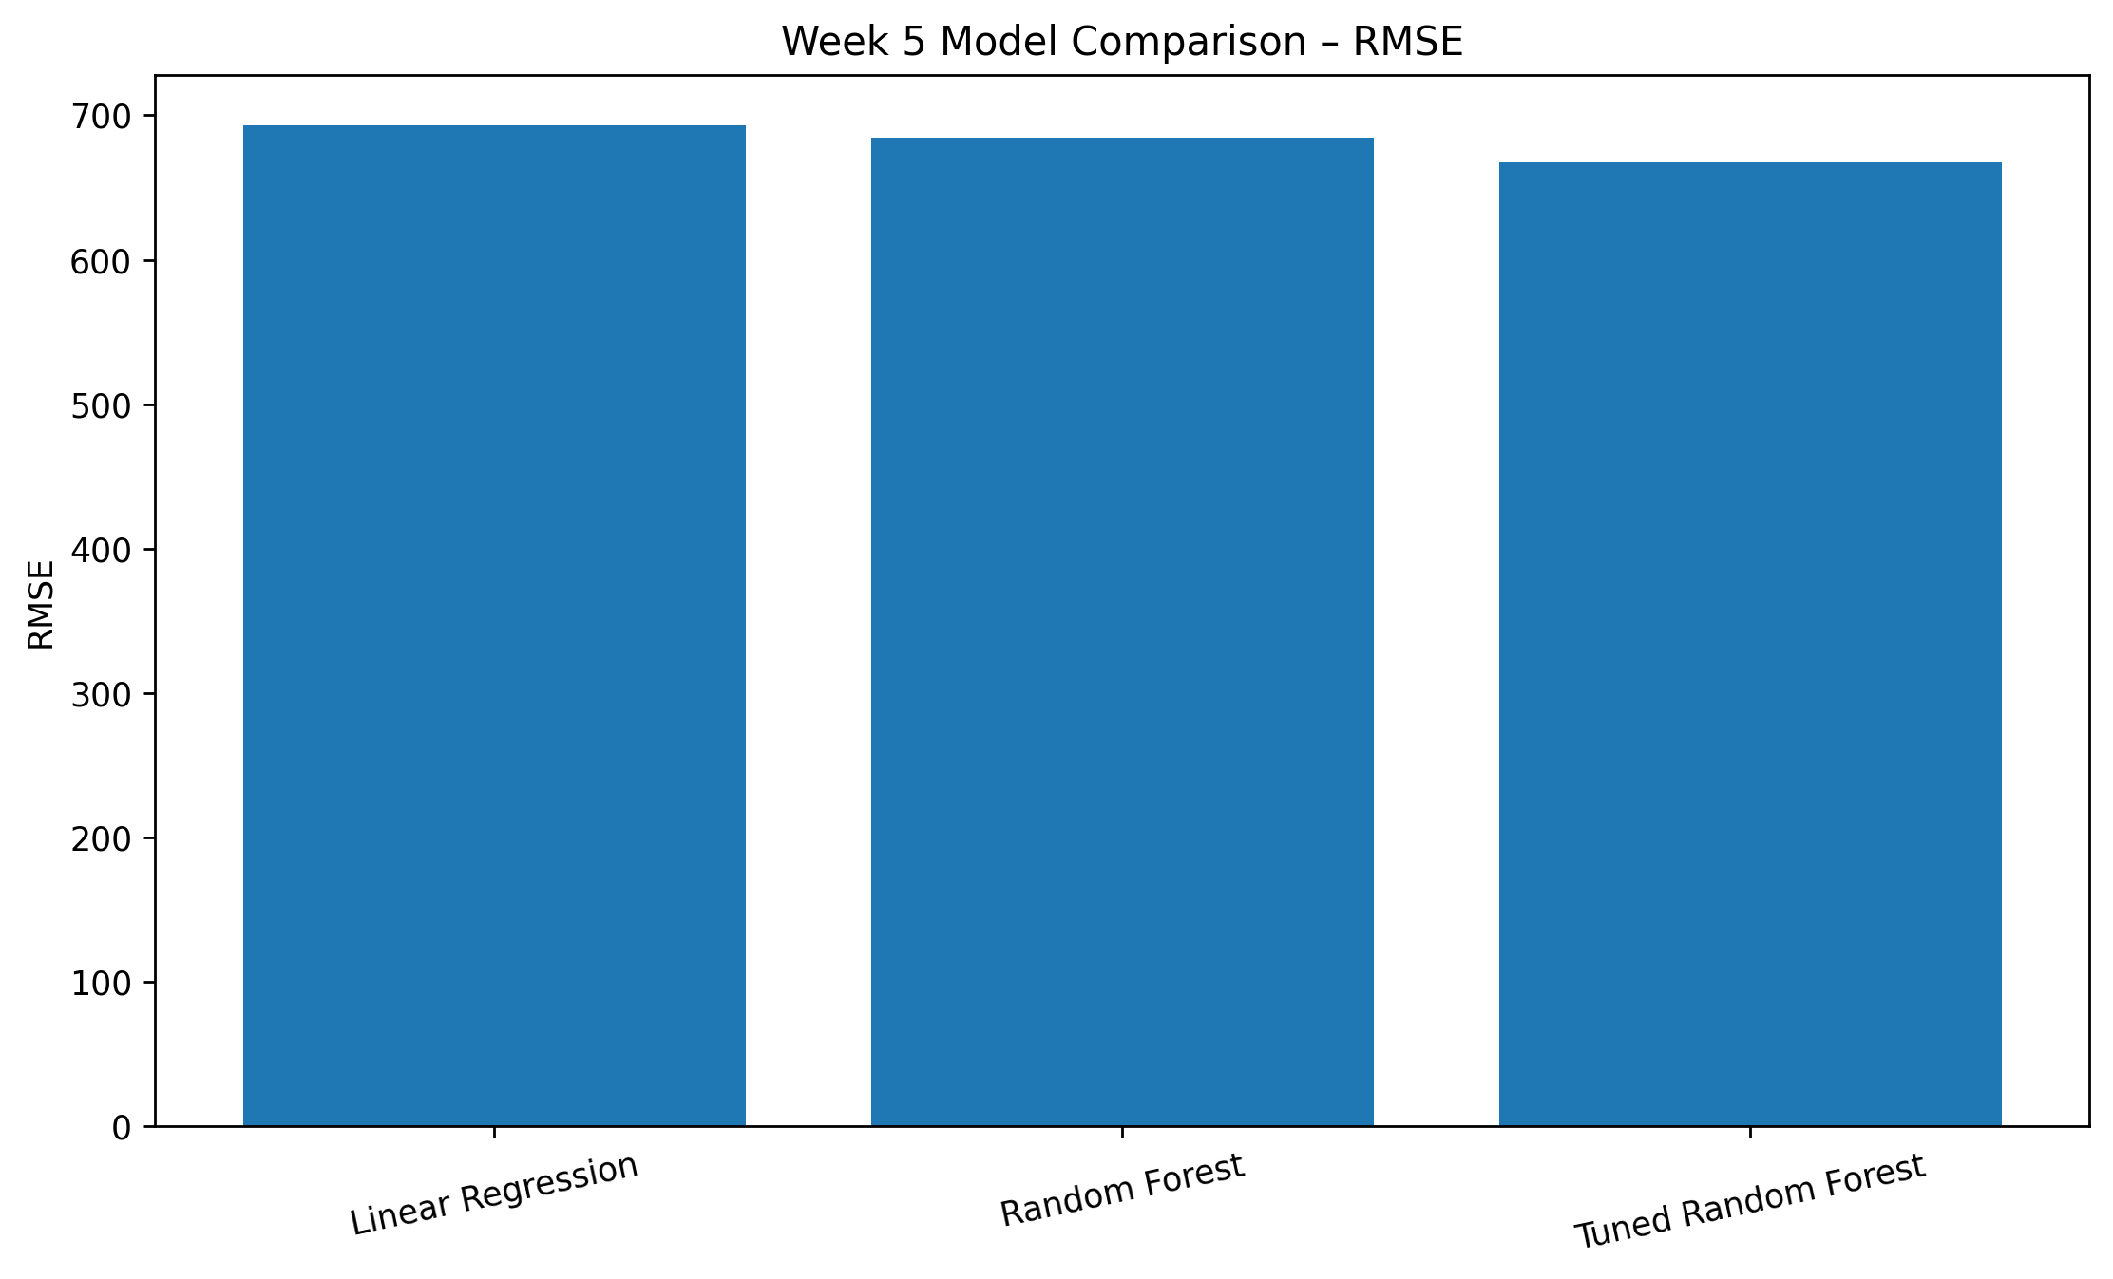
Figure 1. RMSE comparison based on the executed test-set results.

12. Visual Model Evaluation
The Python workflow also generated the following visual outputs in the project's output folder:
- actual_vs_predicted.png – compares observed Sales with model predictions.
- residual_plot.png – visualizes prediction residuals against predicted Sales.
- model_comparison.png – compares model RMSE values.
- model_comparison.csv – tabulates MAE, RMSE, and R² for the three models.
- predictions.csv – stores actual and predicted Sales for the test observations.
- tuning_results.csv – stores GridSearchCV results for the tested parameter combinations.
The actual-vs-predicted and residual plots should be retained with the GitHub submission as supporting evidence of model evaluation. They were generated directly by the executed machine learning script.

13. Interpretation of Results
The baseline Linear Regression model achieved an R² of 0.1862 on the test set. The untuned Random Forest increased test-set R² to 0.2070 and reduced RMSE from 693.34 to 684.43. After hyperparameter tuning, the Random Forest achieved a test-set R² of 0.2454 and RMSE of 667.62, with MAE decreasing to 196.74.
The improvement after tuning suggests that restricting tree depth and adjusting the minimum samples required for splits and leaves produced a better-performing configuration for this feature set. However, the 5-fold cross-validation mean R² of 0.0671 and the variation between folds show that performance can be sensitive to the subset of data used for validation.

14. Limitations
- The feature set is relatively compact and does not include all potentially informative transaction attributes.
- The target Sales may depend strongly on product-level and customer-level characteristics that were not encoded in the selected features.
- The cross-validation R² scores varied substantially between folds, indicating instability across validation subsets.
- The analysis uses a single train/test split for the final reported test metrics.
- The current model should be treated as an internship-level predictive experiment rather than a production forecasting system.
- The model predicts transaction-level Sales rather than future aggregated sales by month, customer, or product.

15. Future Improvements
- Add stronger date features such as day of week, quarter, days since first order, and shipping duration.
- Experiment with product, customer, city/state, and interaction features using leakage-safe encoding strategies.
- Evaluate additional models such as Gradient Boosting, HistGradientBoosting, Random Forest variants, or other suitable regressors.
- Use repeated cross-validation or time-aware validation if the objective is future sales prediction.
- Perform feature importance and permutation-importance analysis to understand drivers of prediction.
- Consider reframing the task as time-series or aggregated forecasting if the business question is future-period sales forecasting.
- Evaluate whether a log transformation of Sales or robust treatment of extreme sales values improves error behavior.

16. Conclusion
Week 5 successfully implemented an end-to-end machine learning workflow for Sales prediction using Python and scikit-learn. The workflow covered preprocessing, train-test splitting, baseline modeling, ensemble modeling, 5-fold cross-validation, hyperparameter optimization with GridSearchCV, and quantitative model evaluation. The tuned Random Forest achieved the strongest held-out test metrics among the evaluated models, while cross-validation revealed meaningful variability that should be considered in future iterations. The project therefore demonstrates the complete transition from earlier analytical work toward predictive machine learning, while also documenting the limitations that remain before the approach could be considered a robust production forecasting solution.

17. Tools and Technologies
- Python
- Pandas
- NumPy
- Matplotlib
- Seaborn
- Scikit-learn
- GridSearchCV
- K-Fold Cross-Validation

18. Reproducibility and Project Outputs
The machine learning workflow is implemented in src/machine_learning.py. Running the script produces the evaluation and visualization files in the output directory. The project also includes a requirements.txt file listing the main Python dependencies.
Recommended repository structure:
YuvaIntern_Task_05/
├── dataset/Sample - Superstore.csv
├── src/machine_learning.py
├── output/
├── report/Week_5_Machine_Learning_Report.docx
├── requirements.txt
├── README.md
└── .gitignore

19. Appendix – Key Code Snippets
Train-test split:
X_train, X_test, y_train, y_test = train_test_split(
X, y, test_size=0.20, random_state=42
)
Grid Search:
grid_search = GridSearchCV(
rf_model, param_grid, cv=3,
scoring="neg_root_mean_squared_error",
n_jobs=-1
)
Final evaluation:
tuned_mae = mean_absolute_error(y_test, tuned_predictions)
tuned_rmse = np.sqrt(mean_squared_error(y_test, tuned_predictions))
tuned_r2 = r2_score(y_test, tuned_predictions)

