1

Wireframe Documentation

Analysing Google App Store

Aryan Varshney

30.04.2025

# Contents

1. Key Insights............................................................................................................................................... 3
   1. KPI & Slicer.......................................................................................................... 4
   2. Total Installs by App (Top 5)…………………………….. ………………….. 4
   3. Top 5 Genres by ……………………………………………………………….. 5
   4. Top Apps by Reviews……………………………………………………………5
   5. Top 5 Android Versions by Installs…………………………………………..….6
   6. Top 5 Categories by Installs………………………………………………..…….6 1.7 Total Reviews by App……………………………………………………………7

1. Category-wise Performance Analysis ------- 8
   1. Installations by Category………………………………………………………….. 8
   2. App Type Distribution & Installs by Content Rating…………………………... 8
   3. Average Rating by Category……………………………………………………… 9
   4. Count of Apps by Category and Type……………………………………………. 9
   5. Count of Apps by Year…………………………………………………………… 10
   6. Total Installs by App Category…………………………………………………… 10

# 1. Key Insights

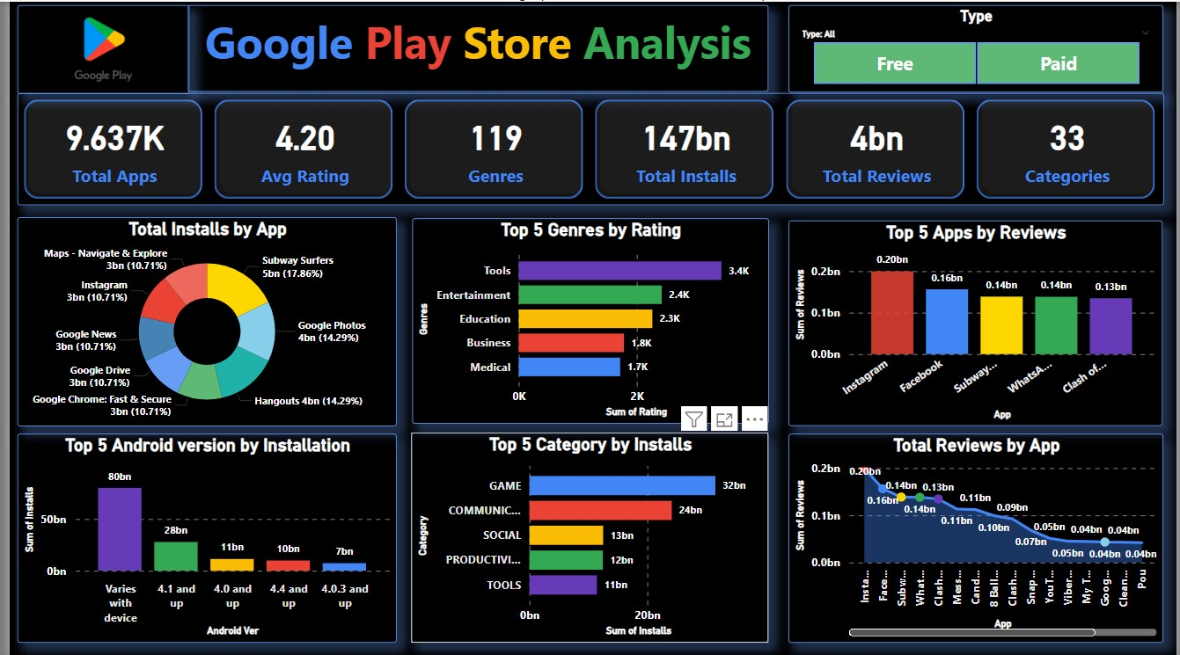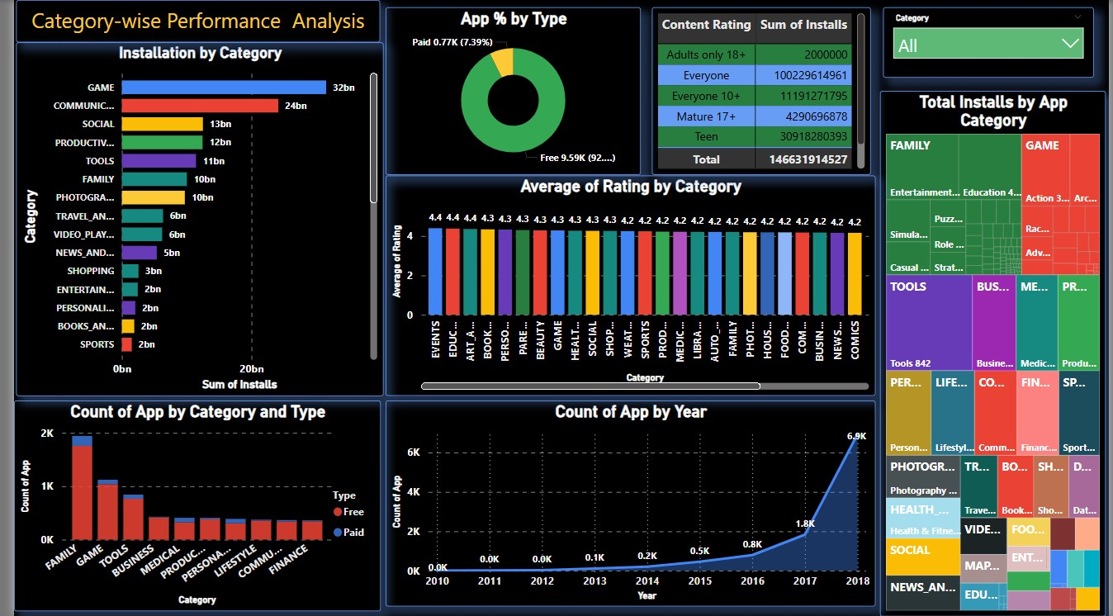

## 1.1 KPI & Slicer

* **The slicers for Type (FREE and PAID), Category**

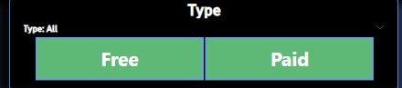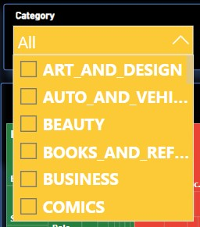

* **KPI are Total App, Average Rating, Genres, Total Installs, Total Reviews , Categories**

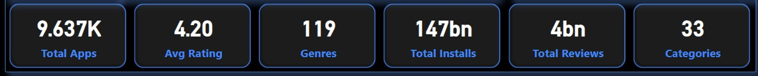

## 1.2 Total Installs by App (Top 5)

• **Type:** Donut Chart • **Description:**

This Donut chart displays the top 5 apps with the highest number of total installs. It provides a quick visual comparison of which apps dominate in terms of user downloads on the Play Store.

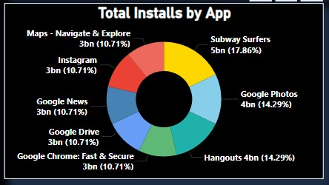

## 1.3 Top 5 Genres by Rating

• **Type:** Stacked Bar Chart • **Description:**

This stacked bar chart displays the top 5 genres based on the sum of app ratings. The X-axis represents the total ratings, while the Y-axis lists the genres. It helps identify which genres receive the most user appreciation in terms of ratings.

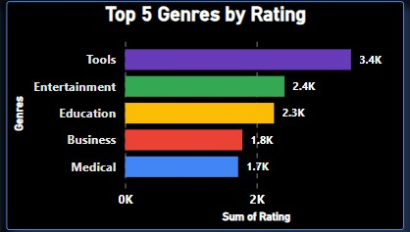

## 1.4 Top Apps by Reviews

• **Type:** Stacked Column Chart • **Description:**

This stacked column chart displays the top apps based on the total number of user reviews. The X-axis shows the app names, while the Y-axis represents the total reviews received. This visual highlights the most actively engaged apps by users on the Play Store.

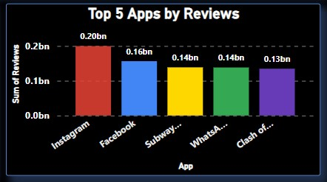

## 1.5 Top 5 Android Versions by Installs

• **Type:** Stacked Column Chart • **Description:**

This stacked column chart shows the top 5 Android versions that support the most installed apps. The X-axis represents the Android versions, and the Y-axis displays the total number of installs. It helps identify which Android versions are most common among highly downloaded apps.

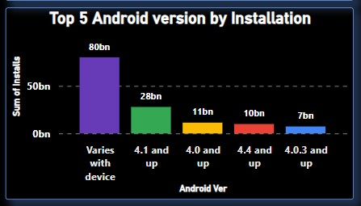

## 1.6 Top 5 Categories by Installs

• **Type:** Clustered Bar Chart • **Description:**

This clustered bar chart highlights the top 5 app categories based on the total number of installs. The X-axis shows the total installs, while the Y-axis lists the categories. This chart helps in understanding which app categories are most popular among users.

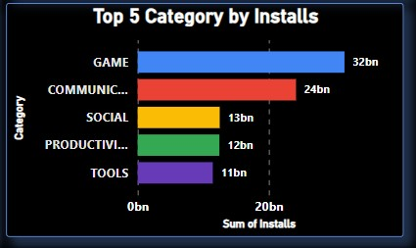

## 1.7 Total Reviews by App

• **Type:** Area Chart • **Description:**

This area chart shows the total number of user reviews for each app. The X-axis represents the app names, and the Y-axis shows the sum of reviews. It provides a visual trend of how reviews are distributed across different apps, helping to spot highly engaged apps.

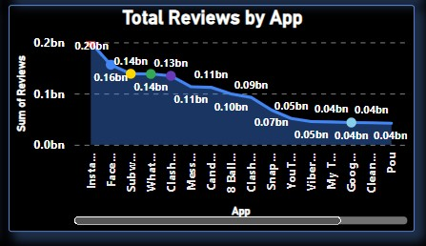

|  |  |  |
| --- | --- | --- |
| 8 | | |
| 2. | Category-wise Performance Analysis |  |

## 2.1 Installations by Category

• **Type:** Stacked Bar Chart • **Description:**

This stacked bar chart displays the total number of installs across different app categories. The X-axis shows the sum of installs, and the Y-axis lists the categories. It helps to understand which app categories attract the most user downloads.

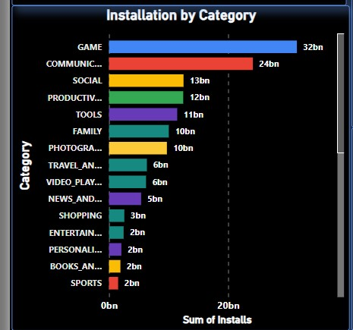

## 2.2 App Type Distribution & Installs by Content Rating

• **Type:** Donut Chart + Matrix Table • **Description:**

The donut chart displays the percentage distribution of apps by type—Free or Paid—offering a quick view of monetization strategy on the Play Store.

Alongside, the matrix table shows the total number of installs grouped by content rating (such as Everyone, Teen, Mature, etc.), helping to analyze which audience segments drive the most downloads.

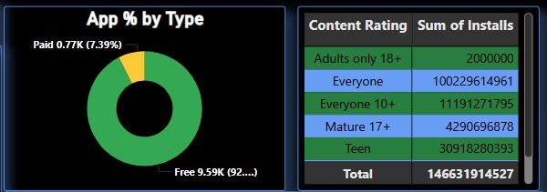

## 2.3 Average Rating by Category

• **Type:** Clustered Column Chart • **Description:**

This chart displays the average user rating for each app category. The X-axis represents the categories, and the Yaxis shows the average rating. It helps identify which categories receive the most positive user feedback on average.

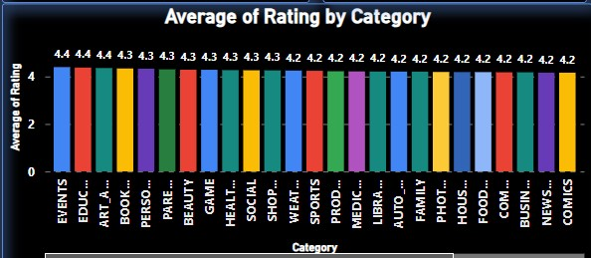

## 2.4 Count of Apps by Category and Type

• **Type:** Stacked Column Chart • **Description:**

This stacked column chart shows the count of apps in each category, broken down by app type (Free or Paid). The X-axis represents the app categories, and the Y-axis shows the total count of apps. It provides insight into the distribution of app types across different categories.

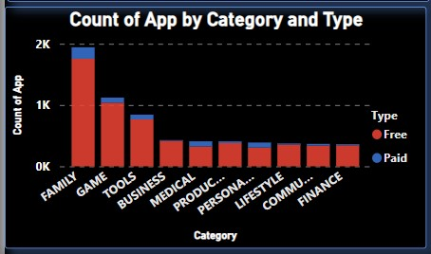

10

## 2.5 Count of Apps by Year

• **Type:** Area Chart • **Description:**

This area chart shows the count of apps released each year, with the X-axis representing the years and the Y-axis displaying the number of apps. It provides a visual trend of app growth over the years, highlighting changes in the number of new apps published annually.

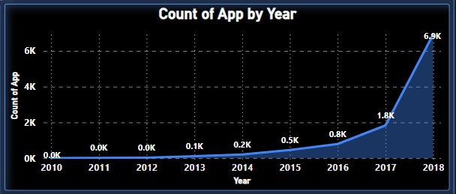

## 2.6 Total Installs by App Category

• **Type:** Tree Map • **Description:**

This tree map displays the total number of installs across different app categories. Each category is represented as a block, with the size of the block corresponding to the total installs. It provides a clear, hierarchical view of how installs are distributed across categories.

