“Campus Connect: Lost & Found System”
A Project Report
Submitted towards final evaluation of
Field Project
in
INFORMATION TECHNOLOGY
by
Alok Rahmatkar(2024BIT017)
Aryan Kale(2024BIT020)

Under the Valuable Guidance of
Dr.



DEPARTMENT OF INFORMATION TECHNOLOGY
SHRI GURU GOBIND SINGHJI INSTITUTE OF
ENGINEERING AND TECHNOLOGY , NANDED -431606
MAHARASHTRA , INDIA .

SHRI GURU GOBIND SINGHJI INSTITUTE OF
ENGINEERING AND TECHNOLOGY
NANDED

Department of Information and Technology
CERTIFICATE
This is to certify that the project report entitled “Campus Connect: Lost & Found System” submitted by Aryan Kale (Reg. No. 2024BIT020) and Siddhant Vedpathak(Reg. No. 2024BIT025) of the Department of Information Technology has been carried out under our guidance and supervision.
This project is submitted in partial fulfilment of the requirements for the final evaluation of the Field Project of Semester - III of Bachelor of Technology in Information Technology.
The results contained in this Seminar report have not been submitted to another university or institute Guide,
……………………………………………..
……………………………………
Dr. C. P. Navdeti
HOD Department of IT
SGGS IE&T, NANDED

Forwarded by,
……………………… …………………………

__________________ ____________________

Department of IT Department of IT
SGGSIE&T, NANDED SGGSIE&T , NANDED

Date:
Place: SGGSIE&T, NANDED

APPROVAL SHEET

The Seminar entitled “Campus Connect: Lost & Found System” submitted by Aryan Kale (Reg. No. 2024BIT020) and Siddhant Vedpathak(Reg. No. 2024BIT025)is approved for partial fulfilment of the requirements for the final evaluation of the Field Project of Semester – III of Bachelor of Technology in Information Technology.

Guide:
……………………………………. …………………………………….

Dr. C. P. Navdeti
HOD Department of IT
SGGSIE&T, NANDED

Examiner(s):

- Sign ………………………..

Name………………………

- Sign ………………………….
Name ………………………

Date:
Place: SGGSIE&T, NANDED

DECLARATION

I hereby declare that the project report entitled “Campus Connect: Lost & Found System”, being submitted for the Final Evaluation of Field Project in Information Technology at Shri Guru Gobind Singhji Institute of Engineering and Technology, Nanded, Maharashtra, is my original and independent work carried out under proper guidance and supervision.

Acknowledgement

I would like to express my sincere gratitude to all those who supported me throughout the completion of this project titled “Campus Connect: Lost & Found System.”
I am deeply thankful to my project co-guides, Mr. Prem Agrawal ,Mr. Madhav Padampalle, Mr. Sainath Narwane, and Mrs. Rupali Jakapure, for their valuable guidance, encouragement, and continuous support during the development of this project. Their insightful suggestions and constructive feedback greatly helped me enhance the quality of my work.
I would like to express my gratitude towards Dr. C. P. Navdeti Head of Information and
Technology Department, SGGS Institute of Engineering and Technology for his kind co-operation and encouragement, which helped me during the completion of the report.

I am very privileged to thank the entire faculty of the Information and Technology for their
help and constant encouragement. I feel very happy and want to thank my parents for always giving
me their blessings and supporting me in everything I do.

Finally, I would like to express my sincere appreciation to my project partner for constant motivation, teamwork, and cooperation throughout the project.

Abstract

Title of Project: Campus Connect: Lost & Found System

Datasets:
The system uses a structured dataset that stores details of lost and found items, including the item name, category, description, location, date, and status. A separate user dataset keeps information like user ID, name, and contact details for verification.

The data model links users with their reports, allowing easy search, matching, and tracking of items to ensure smooth and efficient management of lost-and-found records.

The Campus Connect: Lost & Found System is a web-based platform developed to simplify the process of reporting and recovering lost belongings within a campus environment. The system provides users with an easy way to submit details about lost or found items—such as name, category, description, location, and date—while administrators verify and manage these reports.
The platform utilizes a structured MySQL database to store and organize user and item information efficiently, allowing quick searches and accurate matching between lost and found records. It ensures transparency, reduces manual effort, and provides real-time status tracking for users.
Designed using HTML, CSS, JavaScript, PHP, and XAMPP (for local hosting), the system delivers a user-friendly interface and reliable performance. By digitizing the entire process, it enhances communication, saves time, and ensures efficient management of lost and found cases across the campus.

Table of Contents

Sr No. | Name | Page No.
1 | Introduction | 8
2 | Objectives | 9
3 | System Overview | 10
4 | Scope of the Project | 11-12
5 | System Requirements | 13
6 | System Design | 14
7 | User-Case Diagram | 15
8 | Flow Chart | 16
9 | Implementation Details | 17
10 | Database Design | 18-20
11 | System Testing | 21
12 | Output Screens | 22-26
13 | Limitations of the system | 28
14 | Future Scope | 29

INTRODUCTION

The Campus Connect: Lost & Found System is a web-based application developed to help users report and recover lost items easily within a campus or organization. In the existing manual process, lost items are often difficult to track, and there is no proper record or communication between the person who lost an item and the one who found it. This system provides an efficient and organized digital solution to overcome these problems.

The two main users involved in this system are:
- User (i.e., Students or Staff)
- Admin

In this software, a user can register and log in using a valid email ID and password. After logging in, users can submit a report about a lost or found item by entering details such as the item name, category, description, location, and date. The admin verifies these reports, manages user submissions, and ensures that matching lost and found records are correctly updated.

This system helps save time, increases transparency, and makes the process of finding lost items faster and more reliable.

OBJECTIVES

The primary objectives of the Campus Connect: Lost & Found System are outlined below:

- To develop a centralized online platform that enables students and staff to report and manage lost and found items efficiently within the campus premises.
- To simplify the reporting process by allowing users to provide complete item details such as name, category, description, location, and date of loss or discovery.
- To ensure data authenticity and transparency by allowing administrators to verify and approve each lost or found report before it becomes publicly visible.
- To maintain a structured and searchable database that links users and item records for faster retrieval and accurate matching of lost and found items.
- To implement an automated notification system that updates users regarding the current status of their reports, such as verification, found, or returned.
- To enhance accountability by maintaining digital records and ensuring secure data storage with proper access control and user verification.
- To design a user-friendly and responsive interface using technologies like HTML, CSS, PHP, and MySQL for smooth interaction and easy accessibility.
- To reduce manual work and improve operational efficiency by replacing traditional paper-based tracking with a faster, reliable, and organized digital system

System Overview

The Campus Connect: Lost & Found System is a web-based platform designed to simplify and automate the process of reporting and retrieving lost items within a campus environment. It offers a structured and user-friendly interface where individuals can record details of lost or found belongings, while administrators can verify and manage the corresponding reports efficiently.
The system operates under two primary user roles — User (Student/Staff) and Administrator — each assigned distinct functions and responsibilities.
Users can create an account, log in, and submit reports containing key details such as the item name, category, description, location, date, and contact information. They can also track the progress of their reports and receive notifications when a possible match for their lost or found item is identified.
The Administrator oversees the platform’s operations by verifying report authenticity, managing user information, and maintaining the central database. Admins can add, modify, or remove item records to ensure that all entries are valid and correctly matched.
All data is securely stored in a MySQL database, enabling fast and reliable data search, retrieval, and management. The system enhances transparency, reduces manual effort, and offers an efficient digital solution for handling lost and found cases within the campus community.

Scope of the Project

The proposed system is designed to serve two main user groups — Admin and User (Student/Staff). Its primary goal is to automate and modernize the campus lost and found process, enabling users to report, track, and manage items seamlessly. By using a PHP-based web application integrated with a MySQL database, the system ensures that all reports are securely handled, improves response time, and enhances overall transparency.
The application emphasizes user verification, data accuracy, security, and ease of navigation, offering a smooth and reliable experience for both administrators and users.

Modules of the System

1. Admin Module
The admin oversees the system’s operations, manages user accounts, and handles report verification and maintenance.
Main Features:
- Dashboard: Displays statistics such as total users, lost items, found items, and pending verifications.
- Manage Reports: Add, edit, validate, or delete lost and found item records.
- Manage Users: View, monitor, or remove registered users and track their activity.
- Notifications: Send alerts or updates related to item reports.
- Search Function: Quickly locate records using item ID, name, or user details.
- Profile Settings: Update profile details, reset passwords, or recover account access.

2. User Module (Registered Users – Students/Staff)
Registered users can log into the system to report missing or found items and check the progress of their submissions.
Main Features:
- Dashboard: View personal reports along with their current status (Pending, Found, or Returned).
- Report Lost Item: Submit details such as item name, category, location, date, and description.
- Report Found Item: Provide information about discovered items and optionally upload supporting images.
- View Matches: Check if similar items have already been reported or found.
- Profile Settings: Edit personal information, update passwords, or recover accounts.

3. Guest User (Non-Registered User)
Guest users can browse general information about the system without registration.
Main Features:
- Home Page: Provides an overview of system features and purpose.
- About Page: Explains the objectives and benefits of the Lost and Found System.
- Contact Page: Displays admin or support contact details.

4. Security and Authentication Module
This module protects system data and restricts access to authorized users only.
Key Features:
- Session-based Login and Logout System for secure user access.
- Password Hashing and Encryption to safeguard credentials.
- Email Verification and Password Recovery for account security.
- Role-based Access Control separating Admin and User privileges.
- Data Integrity Protection against unauthorized modifications.

System Requirements

The Campus Connect: Lost & Found System requires both hardware and software components to function efficiently. The following are the requirements for developing and running the system:

1. Hardware Requirements
- System: Intel i3 Processor or higher
- Processor Speed: 2.0 GHz or higher
- Hard Disk: Minimum 100 GB
- RAM: Minimum 4 GB

2. Software Requirements
- Operating System: Windows / Linux
- Server Package: XAMPP (includes Apache, PHP, and MySQL)
- Backend Language: PHP
- Frontend Technologies: HTML, CSS, JavaScript
- Database: MySQL
- Browser: Google Chrome / Mozilla Firefox / Edge

System Design

The System Design of the Campus Connect: Lost & Found System defines how various modules, users, and components interact to manage lost and found items effectively within the campus. It explains the overall architecture, data flow, and relationships between different entities of the system.

1. System Architecture
The system is based on a three-tier architecture, ensuring clear separation between the user interface, application logic, and database management.
a) Presentation Layer:
Developed using HTML, CSS, and JavaScript, this layer provides an interactive and user-friendly interface for all users (Students, Faculty, and Admin). It allows users to post lost or found items, browse listings, and communicate securely through the platform.
b) Application Layer:
Implemented using PHP, this layer handles the main business logic of the system — such as managing item reports, verifying user inputs, filtering search results, updating item status (lost, found, returned), and handling notifications between users.
c) Database Layer:
Managed with MySQL, it stores important data such as user profiles, item details, timestamps, and communication records. It ensures secure data storage and quick retrieval for all operations.

2. Use Case Diagram
The system involves three main actors:
Student/Faculty: Can post lost or found item details, search for items, and contact other users to claim or return items.
Administrator: Manages user accounts, verifies item reports, removes inappropriate posts, and maintains overall system integrity.
Guest User (Optional): Can view public listings but must log in to post items or contact other users.
The Use Case Diagram represents the interaction between these users and the main system processes such as Report Lost Item, Report Found Item, Search Items, Mark as Returned, and Manage Posts.

User-Case Diagram:

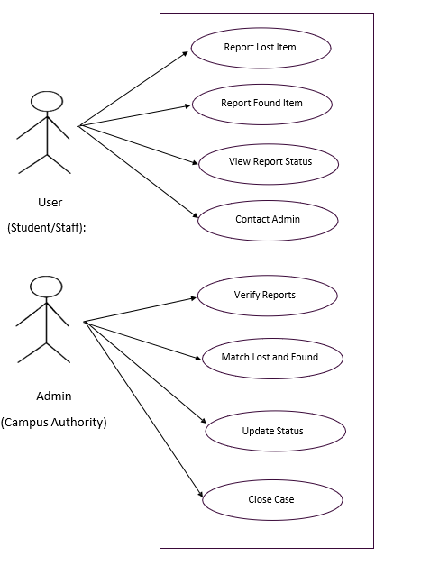

Flow Chart:

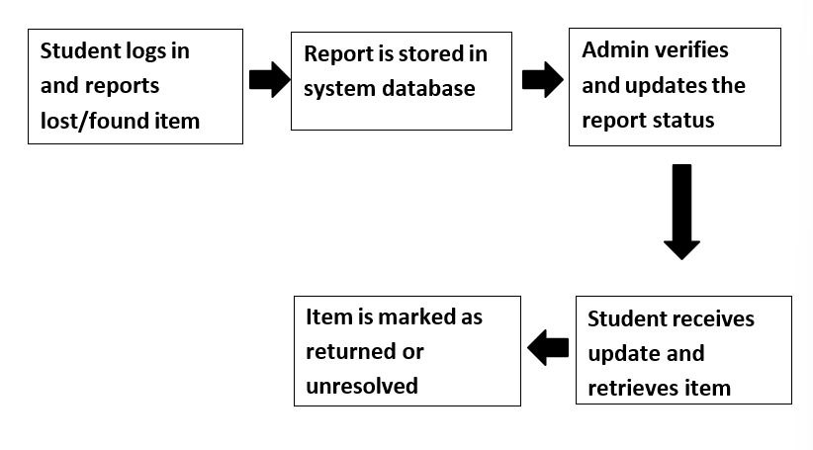

Description:
The above flowchart illustrates the workflow of the Campus Connect: Lost and Found System. The process starts when a student logs into the portal and submits a report regarding a lost or found item. The system securely stores the report details in its central database.
Next, the administrator reviews and verifies the submitted information, updating the report status based on the verification results. Once the verification is complete, the student receives a notification regarding the status of their report. If the lost item is successfully located, the student can collect it from the designated area.
Finally, the record is updated in the system as either “Returned” or “Unresolved,” depending on the outcome.
This workflow ensures effective communication between students and administrators, promoting an organized, transparent, and efficient process for managing lost and found items within the campus.

Implementation Details

The Campus Connect: Lost & Found System was designed and tested locally using the XAMPP server environment, which integrates Apache, PHP, and MySQL into a single package. Hosting the application on localhost enabled smooth communication between the frontend components (HTML, CSS, and JavaScript) and the backend modules (PHP and MySQL).
The XAMPP setup provided a reliable and user-friendly platform for database connectivity, debugging, and module testing before deployment. This local environment simplified configuration, enhanced performance, and supported comprehensive testing of all system functionalities.
Users of the system can easily track the status of their lost or found reports and receive notifications when a potential match is identified. The Administrator plays a key role in managing the platform — verifying reports, handling user data, and maintaining the integrity of the database. Admins can add, modify, or remove item records to ensure that all entries are accurate and properly matched.
All information is securely stored in a MySQL database, ensuring efficient searching, retrieval, and monitoring of reports. The system enhances transparency, minimizes manual efforts, and provides a dependable digital solution for managing lost and found activities within the campus.

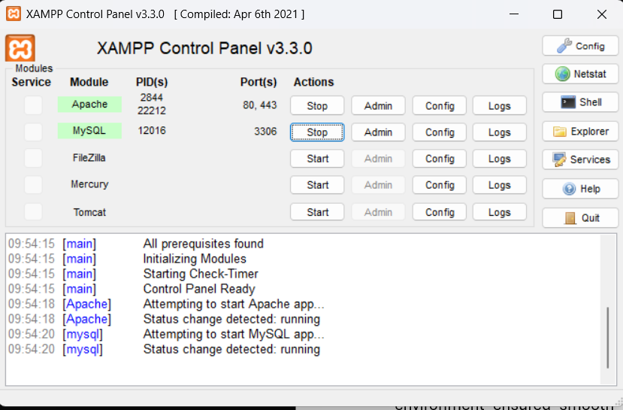

Database Design

The data in the Campus Connect: Lost & Found System is stored and managed through a well-structured MySQL database, allowing smooth data storage and quick retrieval. Designing the database is an essential part of the system design process. During the analysis phase, important data elements and structures were identified and organized efficiently to ensure consistency and easy access.
A database is a collection of related data stored with minimal redundancy to serve multiple users efficiently. The main goal is to make data access fast, reliable, and flexible. Relationships are established between different entities, and redundant data is eliminated through normalization, ensuring accuracy and reducing storage needs. This helps maintain data consistency and improves system performance.
The Campus Connect: Lost & Found System database consists of the following main tables:
- users – Stores details of all registered users, including their name, email, contact information, and login credentials.
- items – Contains information about both lost and found items such as item name, description, category, location, date, and status.
- notifications – Manages alerts and notifications related to item updates or matches between lost and found reports.
These tables are interrelated and together support all the core functionalities of the system, ensuring efficient tracking and management of lost and found items.
They are as follows:

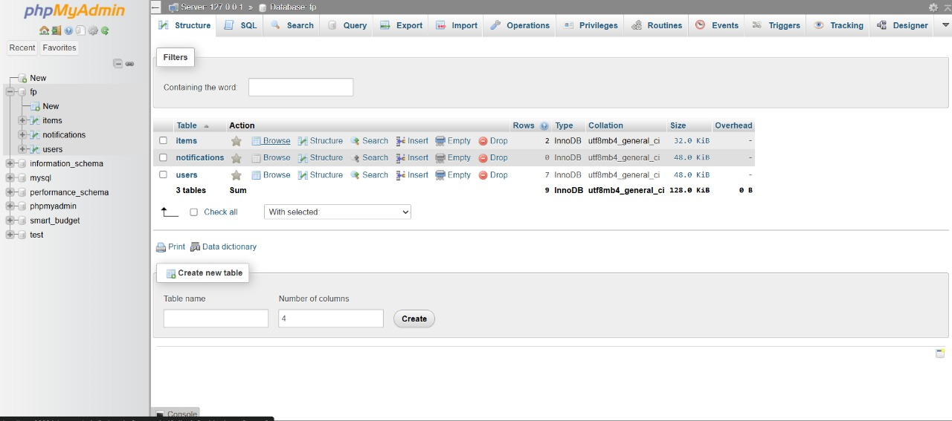

User Table:
This table stores user information including username, email, password hash, and role. It helps manage authentication, authorization, and account creation within the system.
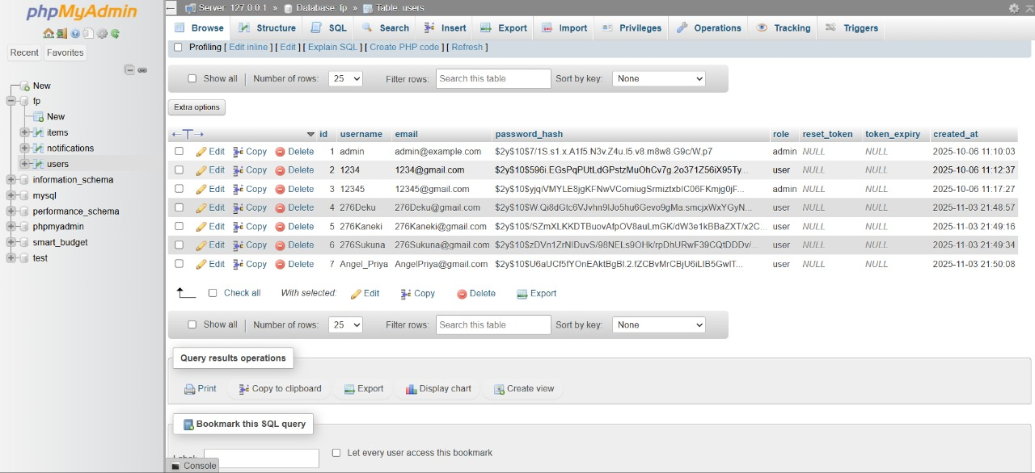

Item Table:
The items table records details of lost and found items such as type, category, color, location, and contact. It enables efficient tracking and management of item reports.
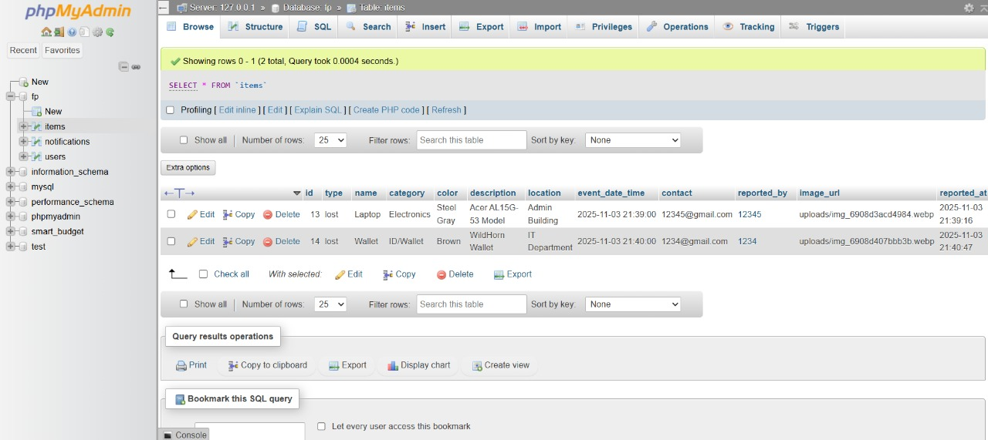

Notification Table:
This table maintains system-generated messages and alerts for users. It helps notify users about updates or matches related to their lost or found items.

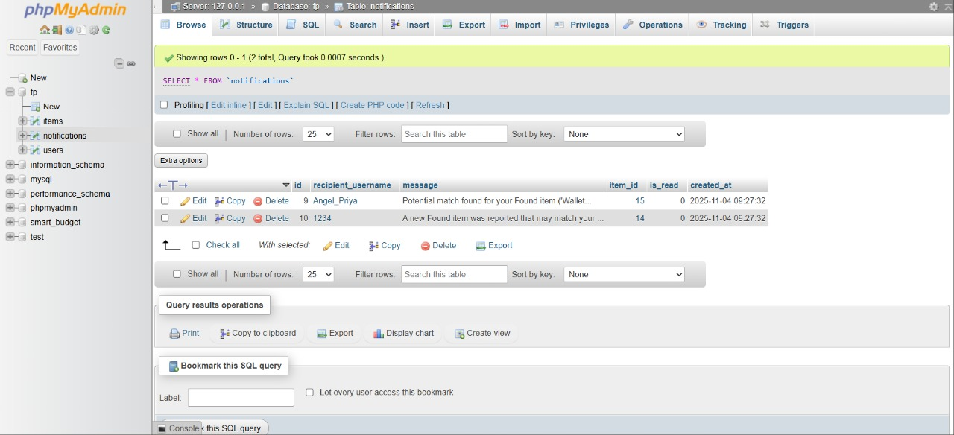

System Testing

Software Testing Techniques:
Software testing is a critical element of software quality assurance and represents the ultimate review of specification, design, and coding. For the Campus Connect: Lost & Found System, testing ensures that the system operates reliably, efficiently, and meets the requirements of its users.
Testing Objectives:
- Testing is the process of executing a program with the intent of finding errors in the system.
- A good test case design is one that has a high probability of finding previously undiscovered errors.
- A successful test is one that uncovers as yet undiscovered errors.
These objectives imply a shift in perspective: testing cannot guarantee the absence of defects, but it can confirm that software errors are present and can be addressed.
Types of Testing Strategies for Campus Connect:
1.Unit Testing:Unit testing focuses on verifying the smallest units or modules of the system. In Campus Connect, this includes testing individual components such as the user registration module, lost item submission form, and notification system. Unit tests check module interfaces, examine local data structures, test boundary conditions, verify all independent paths, and validate error-handling mechanisms. Unit testing is typically white-box oriented.
2.Integration Testing:Integration testing examines how different modules of Campus Connect interact with each other. For example, it tests the seamless connection between the lost item reporting module and the database, or the interface between the notification system and the admin dashboard. Both top-down and bottom-up testing approaches are used to uncover errors associated with module interfacing and ensure that data flows correctly throughout the system.
3.Performance Testing:Performance testing evaluates the efficiency of the system. In Campus Connect, this includes measuring response times for submitting a lost item report, retrieving search results, and sending notifications. The objective is to ensure that all system functions operate within acceptable timeframes and that the system can handle multiple simultaneous users without performance degradation.

Output Screen of Project

Home Page:

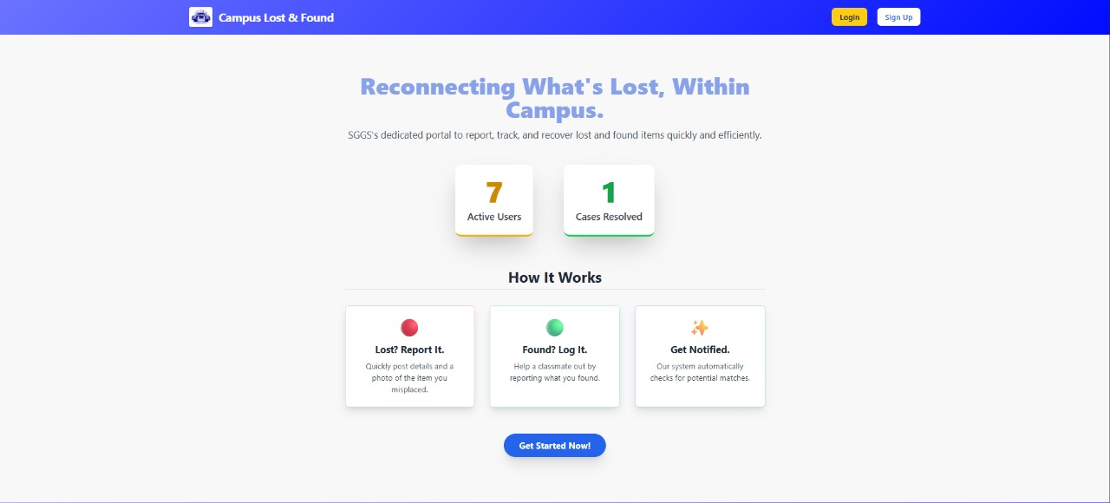

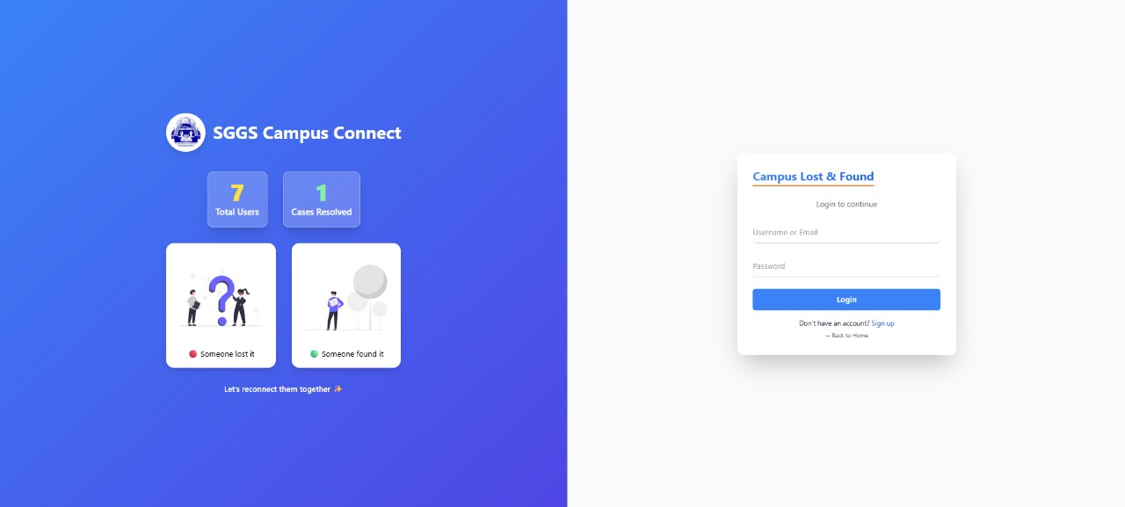
Login Page:

Register Page:
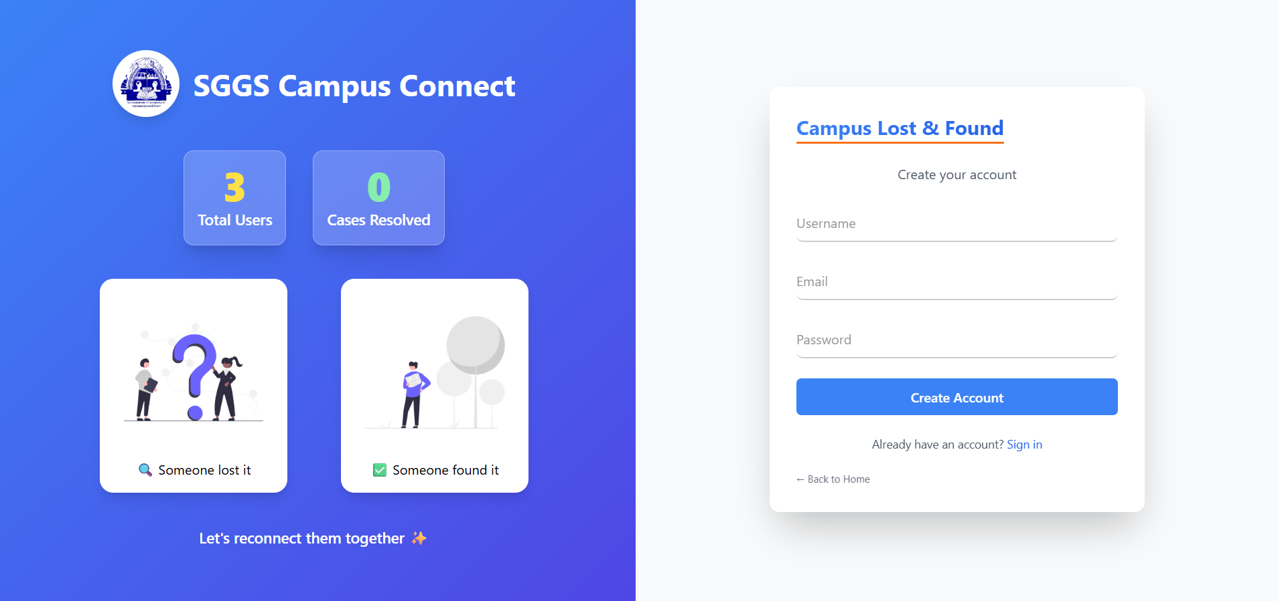

User Dashboard:

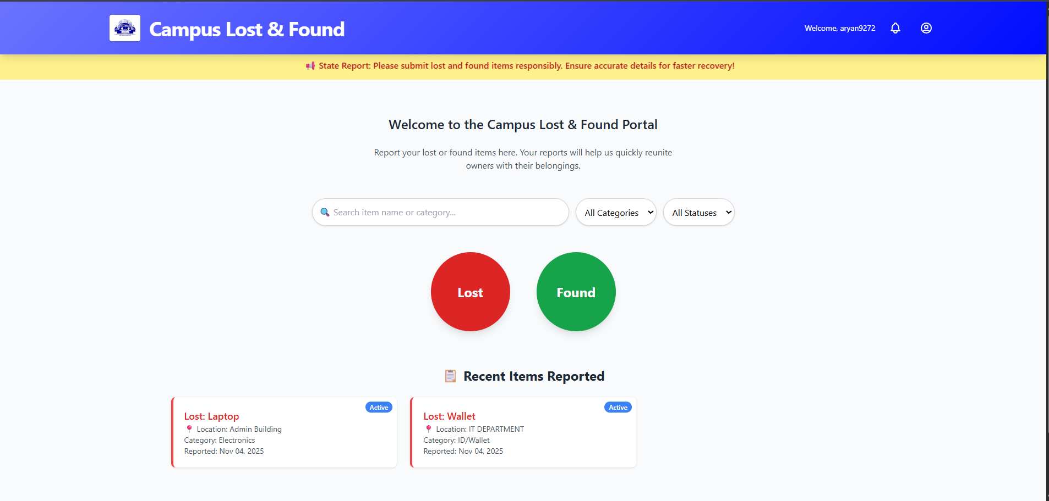

Profile:
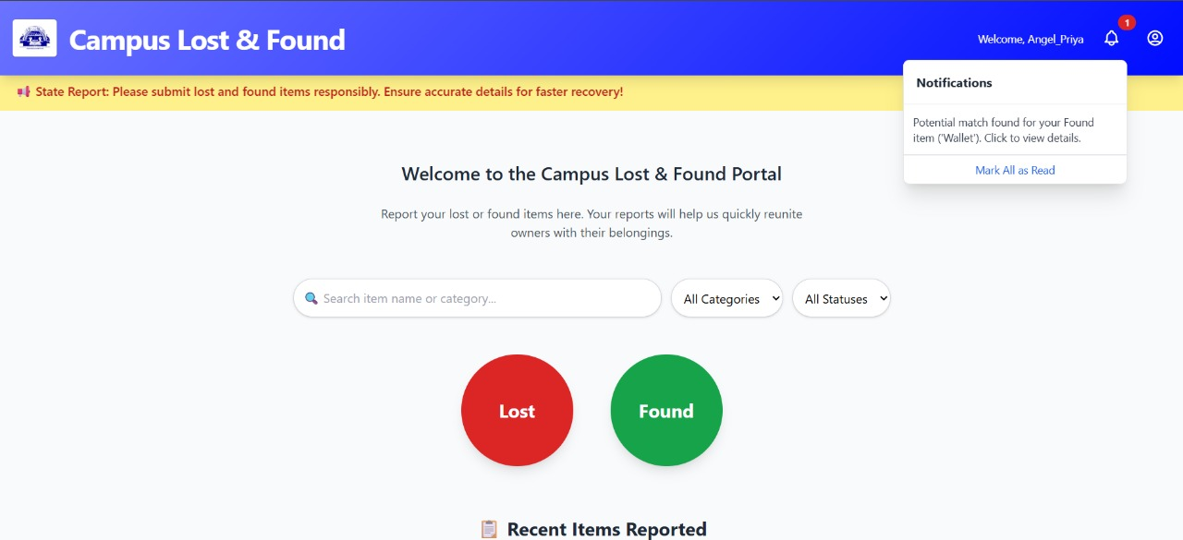
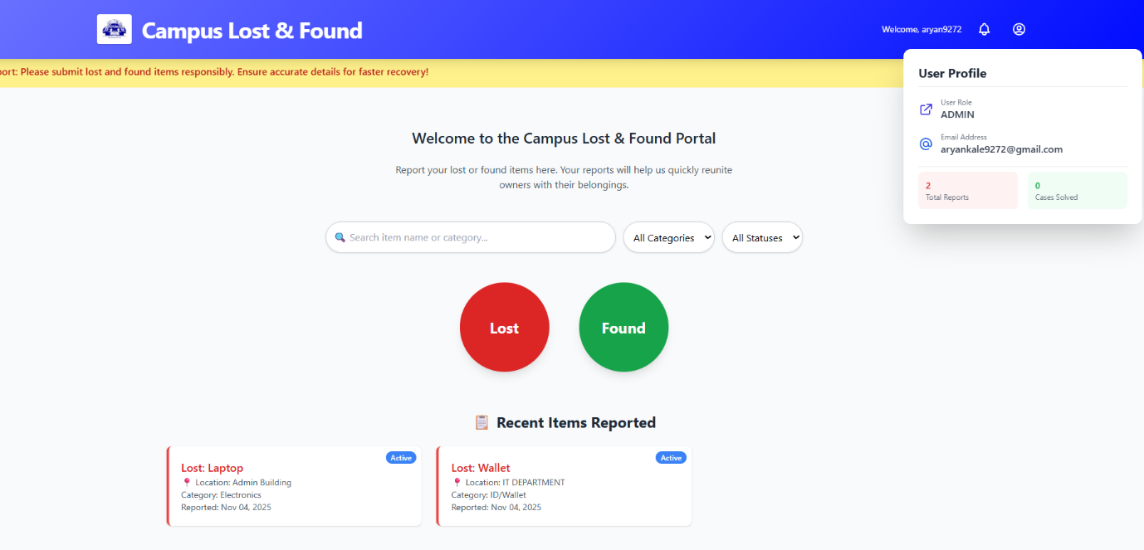

Notification:
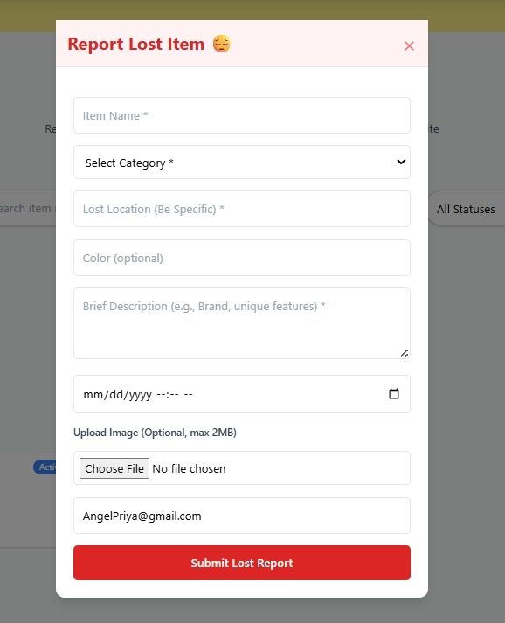
Report Lost Item: Report Found Item:
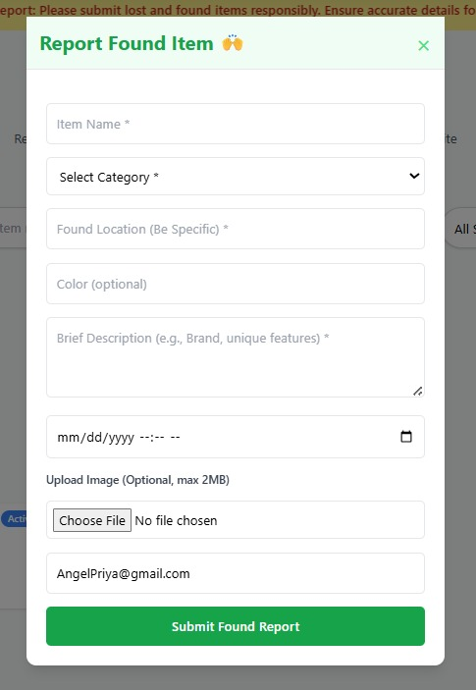
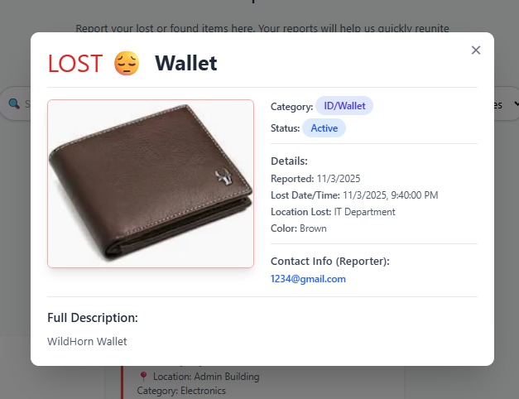
Report Status:
Admin Dashboard:

The Admin Dashboard provides administrators with centralized control to manage users, item reports, and notifications efficiently. It allows the admin to verify entries, update statuses, and maintain the overall database integrity of the Lost & Found System.
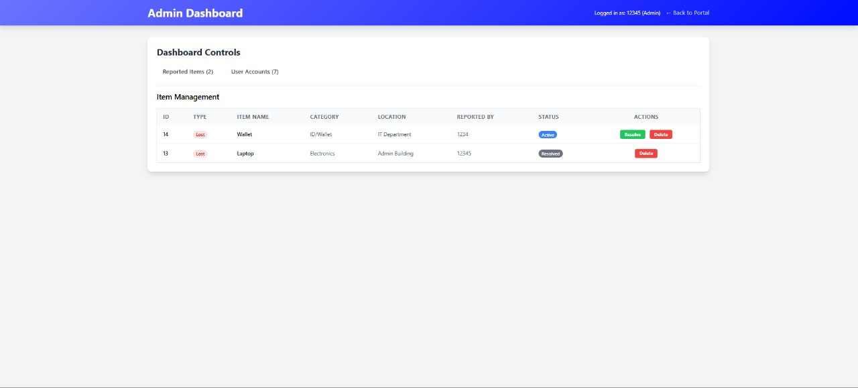

Conclusion

The Campus Connect: Lost & Found System is a web-based application designed to efficiently manage and streamline the process of reporting, tracking, and recovering lost items within a campus. Developed using HTML, CSS, PHP, and MySQL, the system ensures stable performance, smooth functionality, and ease of use for both students and administrators.
A comprehensive feasibility study confirmed that the project is technically, economically, and operationally feasible, while extensive testing validated the system’s functionality, integration, and performance.
The system automates the entire lost and found process, significantly reducing manual work and enhancing accountability across the campus. Through real-time notifications and updates, it improves communication between users and administrators. The centralized MySQL database secures all records, ensuring that information is well-organized, easily accessible, and error-free, unlike traditional manual systems.
Its modular and scalable design allows for future advancements such as mobile app integration, AI-powered item matching, and cloud-based deployment. Overall, the Campus Connect system offers a reliable, transparent, and efficient digital solution to address lost-and-found management challenges while improving the overall user experience.

Limitations of the System

While the Campus Connect: Lost & Found System successfully achieves its intended objectives, certain limitations remain that can be improved in future versions:
- The system is currently hosted on a local environment (XAMPP) and not accessible online, which restricts its use to a single network or device.
- It does not include a mobile application, which limits convenience for users who prefer accessing services through smartphones.
- Automated matching between lost and found items is not implemented; users must manually check for possible matches.
- Image recognition and comparison features are not available, so item identification relies entirely on textual descriptions.
- The system presently supports only one campus and does not allow integration across multiple institutions or departments.
- Real-time notifications via email or SMS are not yet included, which could otherwise improve communication speed.

Future Scope

The Campus Connect: Lost & Found System provides a strong foundation for efficient lost-and-found management on campuses. In the future, the system can be enhanced in the following ways:
- Mobile Application: Developing an Android and iOS app would allow students and staff to report and track lost or found items on the go, increasing accessibility and convenience.
- Automated Item Matching: Integrating AI or machine learning algorithms can help automatically match lost and found items based on descriptions, images, or keywords, reducing manual verification effort.
- Notification Enhancements: Adding email, SMS, or push notifications will ensure users receive instant alerts when their lost item is found or verified.
- Multi-Campus Support: Expanding the system to handle multiple campuses or organizations will centralize lost-and-found data, making it scalable for larger institutions.
- Item Image Upload & Recognition: Allowing users to upload images of lost or found items, combined with image recognition technology, will improve identification accuracy.
- Integration with ID Cards / QR Codes: Linking items to student/staff ID cards or using QR codes/NFC tags can simplify tracking and recovery.
- Advanced Reporting & Analytics: Adding dashboards with reports on lost/found items trends, frequently lost items, and recovery rates can help administrators make data-driven decisions.
Overall, these enhancements will improve the usability, efficiency, and scalability of the system, making it an even more robust solution for campus lost-and-found management.

Refrences

• W3Schools–HTML,CSS,PHP,and MySQL Tutorials
https://www.w3schools.com
•PHP Manual – Official Documentation for PHP Functions and Database Integration
https://www.php.net/manual/en/
•MySQL Documentation – Database Design and SQL Query Reference
https://dev.mysql.com/doc/
•XAMPP Apache Friends – Localhost Server Setup and Configuration
https://www.apachefriends.org
•GeeksforGeeks – Web Development Tutorials and PHP Projects
https://www.geeksforgeeks.org
•Research Paper:Smart Lost and Found System Using Web and Mobile Technologies,
International Journal of Computer Applications (IJCA), 2023.
•YouTube/SimplyLearn Tutorials – Building Web Applications using PHP and MySQL.

