K R MANGALAM UNIVERSITY
B.Tech – Artificial Intelligence & Machine Learning
SMART UTILITY TOOLKIT
LAB ASSIGNMENT REPORT
Submitted By: Aryan Porwal
Roll no. = 2501730261
Course: Web Dev III (Node.js & Express Backend)
Assignment: Lab Assignment 1
Unit: Unit 1

Table of Contents
1. Introduction
2. Objectives
3. Technologies Used
4. Project Structure
5. Implementation and Output
5.1 CLI-Based Calculator
5.2 Custom Module
5.3 HTTP Server
5.4 File Manager
5.5 Random Dice Generator
6. Conclusion

1. Introduction
Smart Utility Toolkit is a Node.js practical project developed using built-in Node.js modules. The project demonstrates command-line programming, custom modules, HTTP server development, file operations, and random number generation.

2. Objectives
- Use process.argv to accept command-line input.
- Create and reuse a custom module.
- Build a basic HTTP server with multiple routes.
- Perform create, read, update, and delete operations on files.
- Generate random dice values using the crypto module.

3. Technologies Used
- Node.js
- JavaScript (ES6)
- Terminal / Command Prompt
- Node.js Core Modules: process, http, fs, crypto

4. Project Structure
Insert a screenshot showing your complete project folder and files.
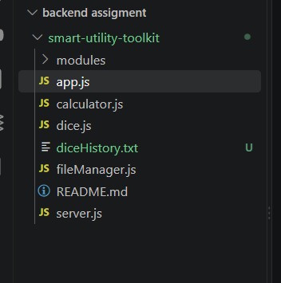

5. Implementation and Output

5.1 CLI-Based Calculator
The calculator uses process.argv to receive the operation and numbers from the terminal and then displays the calculated result.

5.1.1. Addition
Command: node calculator.js add 10 5
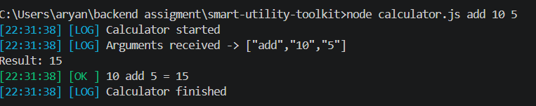
Figure 5.1.1: Addition

5.1.2. Subtraction
Command: node calculator.js sub 10 5
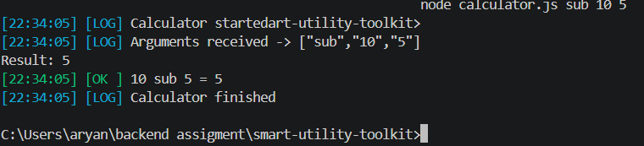
Figure 5.1.2: Subtraction

5.1.3. Multiplication
Command: node calculator.js mul 10 5
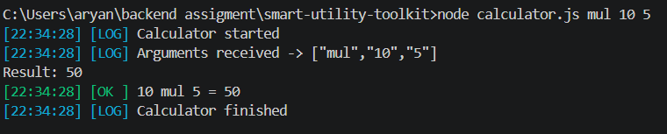
Figure 5.1.3: Multiplication

5.1.4. Division
Command: node calculator.js div 10 5
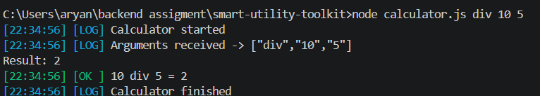
Figure 5.1.4: Division
5.2 Custom Module
This section demonstrates the creation and reuse of a custom Node.js module using module.exports and require().

5.2.1. Custom Module Output
Insert a screenshot showing your custom module working successfully.
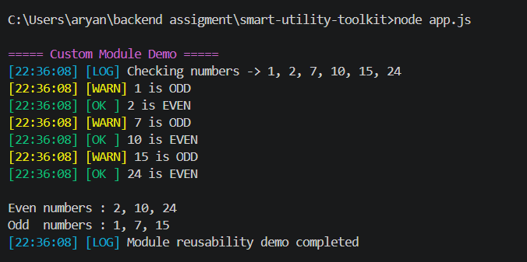
Figure 5.2.1: Custom Module Output

5.3 HTTP Server
The HTTP server is created using the built-in http module and returns different responses for different routes.

5.3.1. Server Running
Insert terminal screenshot showing the server running.
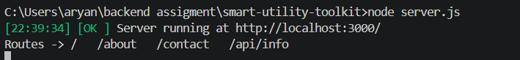
Figure 5.3.1: Server Running

5.3.2. Home Route (/)
Insert browser or Postman screenshot.
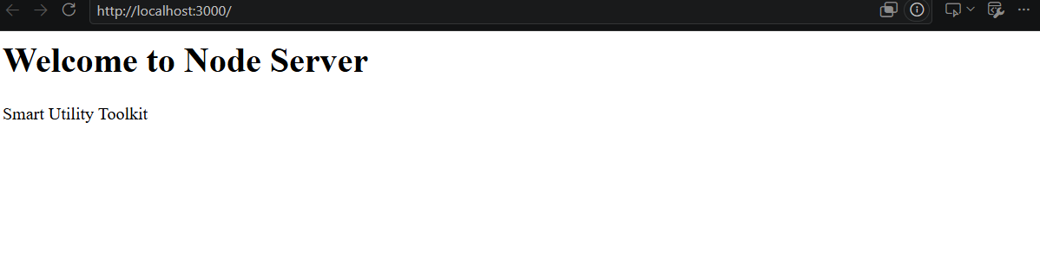
Figure 5.3.2: Home Route (/)

5.3.3. About Route (/about)
Insert browser or Postman screenshot.
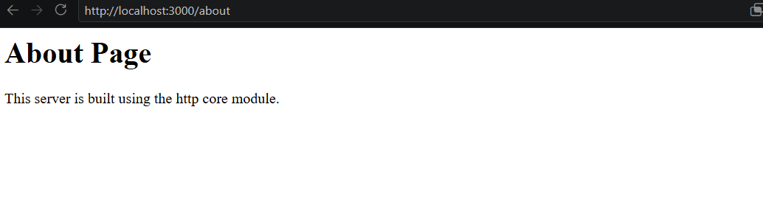
Figure 5.3.3: About Route (/about)

5.3.4. Contact Route (/contact)
Insert browser or Postman screenshot.
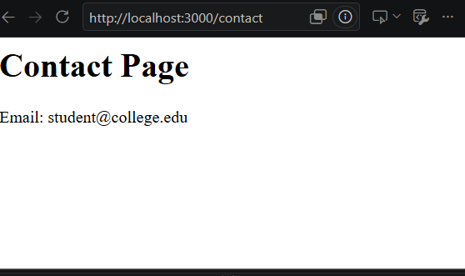
Figure 5.3.4: Contact Route (/contact)

5.3.5. Invalid Route – 404
Insert screenshot showing the 404 response.
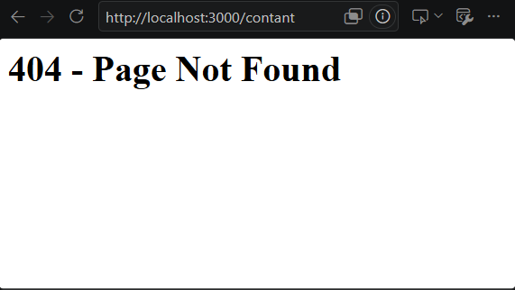
Figure 5.3.5: Invalid Route – 404

5.4 File Manager using FS Module
The file manager demonstrates CRUD operations using Node.js fs module.

5.4.1. Create File
Insert terminal screenshot showing successful create file operation.
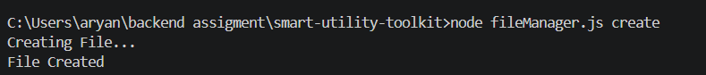
Figure 5.4.1: Create File

5.4.2. Read File
Insert terminal screenshot showing successful read file operation.
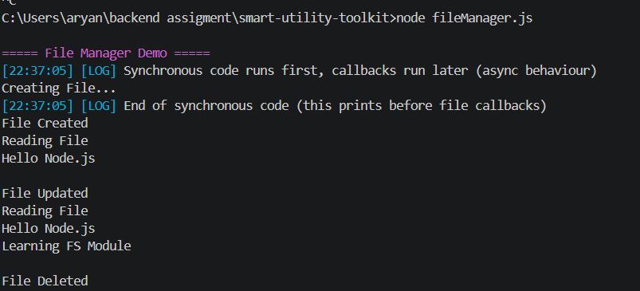
Figure 5.4.2: Read File

5.4.3. Update File
Insert terminal screenshot showing successful update file operation.
Figure 5.4.3: Update File

5.4.4. Delete File
Insert terminal screenshot showing successful delete file operation.
Figure 5.4.4: Delete File

5.5 Random Dice Generator
The dice generator uses the crypto module to generate random values from 1 to 6.

5.5.1. Dice Generator Output
Command: node dice.js
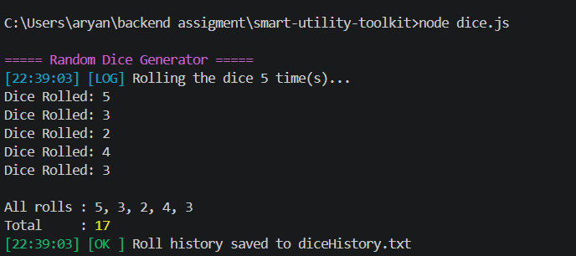
Figure 5.5.1: Dice Generator Output
6. Conclusion
This assignment provided practical experience with the fundamental concepts of backend development using Node.js. The project demonstrates command-line input handling, reusable modules, HTTP routing, file CRUD operations, and random value generation using Node.js core modules.

Screenshot Checklist
☐ Project folder structure
☐ Calculator addition, subtraction, multiplication and division
☐ Custom module output
☐ HTTP server running
☐ Home, About, Contact and 404 routes
☐ File create, read, update and delete operations
☐ Random dice generator output

