Galaxy Type Classification With Sub-categorization Using Deep Learning Framework
Aryan Kamat  Department of Electronics and Communications  KLE Technological University  Huballi, India  aryankamat03@gmail.com | Nitish Kumar Pathak  Department of Electronics and Communications  KLE Technological University  Huballi, India  4nitishkr@gmail.com | Aditya Phatak  Department of Electronics and Communications  KLE Technological University  Huballi, India  adiphatak21@gmail.com
Akash Kulkarni  Department of Electronics and Communications  KLE Technological University  Huballi, India  akash.kulkarni@kletech.ac.in | Kaushik Mallibhat  Department of Electronics and Communications  KLE Technological University  Huballi, India  kaushik@kletech.ac.in

Abstract— This paper presents a robust approach to galaxy categorization utilizing machine learning and image processing techniques, emphasizing Galaxy Zoo and Galaxy10 datasets. The MobileNetV2 architecture is used for feature extraction on a training dataset of 4100 labeled photos. At the same time, image pre-processing procedures ensure dataset standardization. After 20 epochs, the model reaches an overall accuracy of 91%, indicating its usefulness in categorizing galaxies into Elliptical, Spiral, and Irregular types, as well as detailed subclassifications such as E0, E3, E7 for elliptical galaxies and Normal Spiral, Barred Spiral for spiral galaxies. The subclassification models use image processing to extract morphological traits, demonstrating the possibility for automated study of astronomical information and contributing to advances in astrophysics research.
Keywords—Galaxy, IEEE, Morphology, Subclassification, image processing, Deep learning, Machine Learning, MobileNetV2.

Introduction
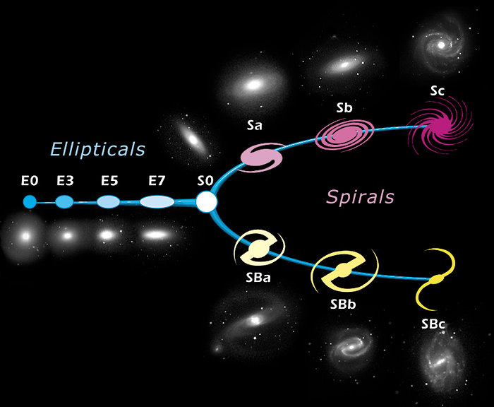
Gravity holds billions of stars and their solar systems together within a huge collection of gas, dust, and other cosmic matter called a galaxy. Galaxies must be categorized morphologically in order to comprehend the accretion history of the galaxy. Astronomers cluster galaxies according to their visual characteristics using a method called the morphological type of galaxies. Because it sheds light on the universe's origins and evolution, studying the types and characteristics of galaxies is extremely important. Understanding the universe and examining the formation process of galaxies depend heavily on the classification of galaxies. Grouping galaxies according to their visual traits is known as galaxy morphological classification. Large-scale databases of data are used for this classification, which helps astrophysicists test theories and come to fresh insights about the nature of the universe, star formation, and underlying galaxies.

According to the Galaxy Classification System, astronomers can better organize galaxies based on their visual forms. One of the most well-known is the Hubble sequence. Edwin Hubble developed the widely accepted Hubble sequence, sometimes called the "Hubble tuning fork," in 1926. This system categorizes galaxies into several main types based on their visual appearance. These include elliptical galaxies (labeled E), which are smooth and nearly featureless. These are further classified into E0, E1, E2, and so on till E7, based on how elongated they appear. Spiral galaxies (labeled S) can be further classified into Normal and Barred spirals. The normal spirals range from ‘Sa’ to ‘Sc' depending on how loosely or tightly bound the arms are from the central bulge. The Barred spirals contain a bar at the center instead of a bulge, with spiral arms starting from the end of the bar instead of the central bulge, lenticular galaxies (labeled S0) that combine characteristics of spiral and elliptical galaxies, and irregular galaxies (designated Irr) with chaotic, asymmetrical structures that may contain odd or interacting galaxies are further divided into disturbed and merging galaxies. Merged, as the name suggests, is 2 or more galaxies combining to form a galaxy, and disturbed galaxies are galaxies that do not have definite shapes or structures. Elliptical galaxies are essentially elliptical in shape and appear considerably smoother.
Astronomers can benefit significantly from categorizing these galaxies. A deeper understanding of the mechanisms that formed these patterns can be obtained by examining the similarities between the structures of galaxies in the same category. Various galaxy types correspond to distinct phases of their formation and development.

Recent developments in algorithms and computer tools have made it possible to analyze galaxy morphology automatically. The classification of galaxy images has been improved using machine learning techniques, crucial for handling the massive volumes of data produced by contemporary astronomical surveys and observatories. Our ability to research has been greatly enhanced by the combination of sophisticated computer approaches and traditional morphological classification. Classifying galaxies into their respective classes is daunting and tedious as there is too much data to classify manually. By using machine learning methods, we can automate this task much faster and more efficiently. Using machine learning, it would be possible to identify patterns in the galaxies that might not be distinguishable to the human eye. The model will also bring consistency and standardization to the classification process, allowing it to produce reliable results several times.

Literature survey
This section explores various approaches for classifying galaxies, focusing on the transformative impact of convolutional neural networks (CNNs). While machine learning and algorithms have been limited to categorizing galaxy types, researchers, including students and faculty, have been at the forefront of pioneering innovative techniques, such as CNNs, in galaxy classification. These dedicated individuals have harnessed the power of CNNs, an advanced neural network architecture known for its exceptional image recognition capabilities.
For galaxy morphologies, the feature set typically comprises photometric parameters describing the physical structure of galaxies. CNNs, designed to analyze visual data, are well-suited for this task. During the training phase, CNNs process a dataset with known categories and aim to segregate the data into groups by learning intricate patterns and features in galaxy images. Unlike traditional methods, CNNs don't rely on predefined rules or hand-crafted features but autonomously discover relevant patterns. While Support Vector Machines (SVMs) have also been used for galaxy classification, the emphasis here is on the innovative use of CNNs, which have significantly enriched the field by providing a more powerful and flexible approach to analyzing and classifying galaxies.
In 2013 the authors of [8], this research dives into the realistic classification of galaxy morphologies. Separating galaxies into three groups—spiral, elliptical, and irregular—is essential. This research uses Support Vector Machines (SVMs) to power a multi-classification system with a tiered structure. Using a typical binary SVM classifier, a three-category sample is first separated in this tiered structure. The SVM is trained to separate objects into "everything else" or one of the three categories as part of this "one against all" classification technique. A second binary classifier differentiates between the final two classes once the first category has been selected and divided. This classifier assigns predictions to each object previously classified as "everything else" after being trained on these two classes. This hierarchical method, which uses SVMs, offers a robust framework for realistic and accurate classification of galaxy shapes.
For instance, in 2019, the authors in [1] utilized Convolutional Neural Networks (CNNs) to classify galaxy images sourced from the Galaxy Zoo 2 dataset. Similarly, the authors of [3] delved into this subject in 2015. The research efforts of the authors of [4] in 2010 , the authors of [5] in 2004, the authors of [14] in 2013, the authors of [6] in 2022, and the authors of [18] in 2020 collectively enrich our understanding of galaxy classification methods. Each of these studies adds a unique piece to the puzzle of classifying galaxies in our vast universe.
The following findings have been made by earlier researchers. Based on machine learning and image analysis, the authors of [5] carried out automatic morphological galaxy categorization. They rely on a feed-forward neural network and the locally weighted regression technique for classification. The accuracy attained was almost 91%. Using Random Forest and naive base classifiers, [6] classified morphological galaxies in 2013. About 91% of the Random Forest classifiers and 79% of the Naive base classifiers attained accuracy. The authors of [7] presented a technique for processing photos of galaxies in the Zsolt frei Catalog that uses a supervised machine learning system based on nonnegative matrix factorization. An approximate accuracy of 93% was obtained. Using the Nonnegative Matrix Factorization technique as its foundation, [17] presented a novel automatic machine-supervised learning astronomical categorization scheme in 2016. This system had a 92% accuracy rate.
Indeed, several research papers explore diverse methodologies for classifying galaxies. These approaches range from Hybrid Ensemble Learning to unsupervised learning techniques and even innovative Capsule networks. In this context, various studies have shed light on these alternative methods.
For instance, the authors of [10] in 2015, the authors of [15] in 2019, and the authors of [11] in 2017 have delved into the world of galaxy classification using different techniques. The authors of [2] in 2022, while the authors [9] in 2020 made their contribution in 2019. The authors of [12] in 2018 also contributed to this body of research. Collectively, these papers showcase diverse approaches to tackle the challenging task of classifying galaxies.
There needs to be a more significant classification of galaxies into categories within spiral and elliptical and an accurate distinction between them due to their visual similarities. This suggests the need for further research to improve the classification of such galaxies. Many papers focus on shape-based classification, but it needs to address the full spectrum of galaxy morphology. There is a gap in exploring more detailed morphological features beyond basic shapes.
Our main objective is to design a machine learning model capable of classifying galaxies into three major types: Elliptical, spiral, and irregular, and further sub-classify elliptical galaxies into E0, E3, E7, and spiral galaxies into a typical spiral, and barred spiral.
Table 1 Comparative Methods for Galaxy Classifications
Related Works | Year | Methodology Used
[16] | 2019 | Unsupervised graph-clustering algorithm.
[17] | 2016 | Non-negative Matrix Factorization.
[8] | 2013 | The SVM algorithm
[5] | 2003 | The Image Analysis Module (IAM), The Data Compression Module (DCM), and the Machine Learning Module (MLM).
[13] | 2021 | Automated Machine Learning.

Methodology
This section uses the Galaxy Zoo and Galaxy10 datasets to build a galaxy categorization model. The proposed pipeline as shown in fig 4 describes data collection using labeled photos of elliptical, spiral, and irregular galaxies. The data pre-processing phase standardizes photos, and our approach comprises extracting morphological features with the MobileNetV2 architecture. The following sections dig into the specifics of dataset curation, pre-processing methods, and the architecture's use in attaining accurate galaxy classification.

Data collection
To demonstrate the performance of our galaxy classification model, we use Galaxy Zoo and galaxy10 data sets, which consist of spiral, elliptical, and irregular images in JPEG and PNG formats. This section briefly describes the labeled dataset we generate from the Galaxy Zoo and Galaxy 10 DECaLS datasets. For the training dataset, we used around 1500 images for elliptical galaxies, which consist of 500 images of E0, 500 images of E3 and, 500 of E7 elliptical galaxies, respectively, 1500 images of a spiral galaxy, which have 750 images of a typical spiral galaxy, and 750 images of the barred spiral galaxy, and 1000 images of irregular galaxy. We used 400 images of each spiral galaxy, elliptical galaxy, and irregular galaxy labeled dataset for testing purposes.

Data Pre-Processing
In this part, raw images are resized to a standardized dimension. Pixel values of image rescaled within a specific range. Images get rotated for the augmentation of data. Images are centered to ensure consistency in the position of features.

Implementation
The implementation part extracts morphological features from pre-processed images to capture needed patterns. This is essential for the reduction of the dimensionality of data. With this architecture, the hierarchical properties of the dataset are captured, resulting in a more accurate image reconstruction. Nonnegative constraints have been proposed for the MobilenetV2 architecture to obtain a parts-based representation.

MobilenetV2
Convolutional neural network architectures like the MobileNetV2 are mostly used for multiclass classification applications. A classifier head is located on the right side of the design, and a contracting path is located on the left. Following a traditional convolutional network architecture, the contracting path consists of two successive 3x3 convolutions with ReLU activation.
A 2x2 max-pooling operation with a stride of 2 is used instead to achieve downsampling. This technique is done iteratively for effective feature augmentation.
The architecture consists of three blocks, or phases, repeated iteratively. These phases use convolutional layers with filters applied to the data to compute locally weighted sums, or "feature maps." During training, the effectiveness of feature extraction is improved by repeating these steps. In the classifier step, the network ends with fully linked layers.
Subsampling of non-overlapping areas in feature maps takes place at the pooling layer, which makes it easier to aggregate local features to spot intricate patterns. The number of feature channels doubles at each step of the down-sampling process. While average pooling may also be taken into consideration, max pooling includes choosing the largest element from the rectified feature map.
The feature map matrix is vectorized after down sampling in the last block of the MobileNetV2 stage and sent into the classifier stage, a fully connected layer that resembles a neural network. We combined all stages to make the model for classifying into elliptical, spiral, and irregular.

Subclassification of Elliptical
Once the primary model predicts an image to be elliptical, we then pass it through the subclassification model, where we use techniques of image processing, edge and contour detection to further subclassify whether the elliptical galaxy belongs to E0, E3 or E7.
This code segment is dedicated to classifying images of elliptical galaxies. Upon predicting the label 'elliptical,' the algorithm undertakes image processing and contour analysis steps to further categorize the elliptical galaxies into subtypes based on their morphological characteristics. The classification involves calculating ellipticity values. Once the main model detects the image to be elliptical, the code loads the image and processes it through various stages. Initially, it converts the image to grayscale, allowing a focus on intensity variations. Pixel values are then normalized to the range [0, 1]. The Sobel operator is applied in both x and y directions to compute the gradient magnitude, emphasizing edges in the image. Subsequently, a Gaussian blur is employed for additional smoothing, enhancing the overall image features. Contours are extracted from the smoothed edges, and the algorithm identifies the contour with the most significant area. An ellipse is fitted to this contour, and its semi-major and semi-minor axes' lengths are calculated. The ellipticity, representing the deviation from a perfect circle, is determined based on these axes. The ellipticity is then utilized for sub-classifying the elliptical galaxies into different types. The classification scheme is dependent on the calculated ellipticity values. If the ellipticity is less than 0.1, the galaxy is labeled an "E0 Elliptical Galaxy." For ellipticity values between 0.1 and 0.5, the galaxy is classified as an "E3 Elliptical Galaxy." Elliptical galaxies with ellipticity exceeding 0.5 are categorized as "E7 Elliptical Galaxy."
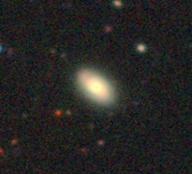
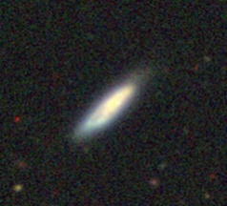
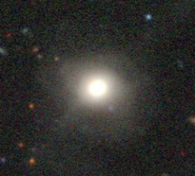

Subclassification for Spiral
The functionality depends on a predicted label of 'spiral' for the given image. The process involves image processing, contour analysis, and ellipticity calculations to determine whether the spiral galaxy is of a specific subtype, such as a "Barred Spiral Galaxy" or a "Normal Spiral Galaxy". “Upon detecting the image as a spiral, the algorithm initiates by utilizing OpenCV to load the target image, followed by its conversion to grayscale. A thresholding technique is employed to enhance the brightest areas in the image. Contours are extracted from the thresholded image to pinpoint the central bulge of the spiral galaxy. The most prominent contour, representing the bulge, is then fitted with an ellipse, and this information is visually depicted in the original image.
Following this, lower brightness regions (arms) connected to the bulge are identified through a defined threshold. These arm contours are overlaid on the original image in red. Subsequently, a third level of lower brightness regions (spiral arms) is identified, and their contours are also superimposed on the original image with the same red color. The code calculates the ellipticity of the bulge and the third-level contours separately. If the difference in ellipticity exceeds a predefined threshold, the galaxy is classified as a "Barred Spiral Galaxy." If not, the code checks the ellipticity of the second-level contours (arms). If the ellipticity of the arms exceeds a specified threshold, the galaxy is again classified as a "Barred Spiral Galaxy." Otherwise, it is labeled as a "Normal Spiral Galaxy."
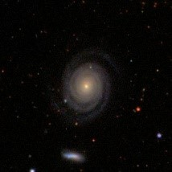
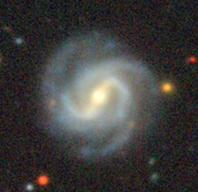

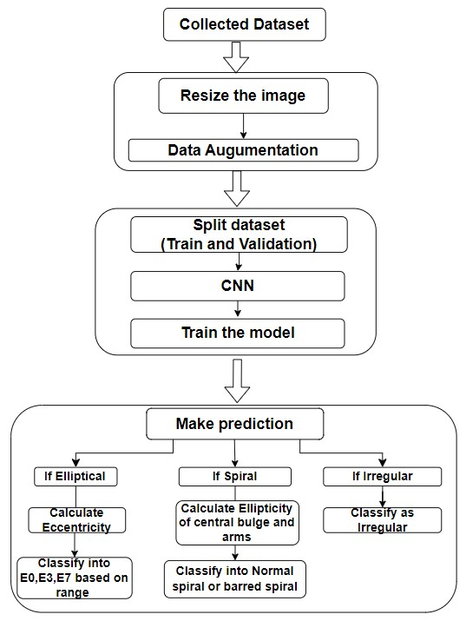

Results

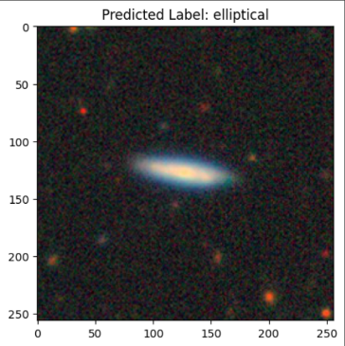
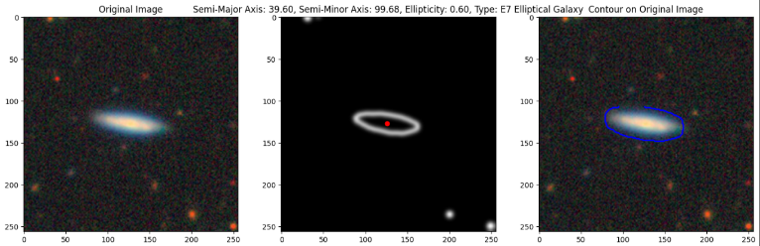
We implemented Convolutional Neural networks for classifying the given image of a galaxy into 3 categories: Elliptical, spiral, and irregular, with their subcategories like elliptical (E0, E3, E7) and spiral (Normal spiral, Barred spiral). We used MobileNetV2 architecture and image processing to enhance and extract the features of the images. We used the GalaxyZoo dataset from Kaggle and the irregular class images from the Galaxy10decals dataset. The total images for training data were 4,100, and the total for testing data was 800. All the images were of size 256x256. We set a batch size of 32 and applied data augmentation to diversify and expand the dataset by rescaling, rotating, and flipping the images to create variation. Then, we split the training and testing data and trained the model for 20 epochs with 50 steps per epoch. After running for 20 epochs, we obtained an accuracy of 91%, with each epoch taking around 40 seconds to complete.
Upon running the model, we obtained the results as depicted below. Fig 5 and Fig 6 represent the results for elliptical galaxies and their subclassification into E0, E3, and E7. Fig 7 represents the results obtained for the Spiral galaxy and its subclasses, Normal spiral, and barred spiral, and Fig 8 represents the result for the irregular galaxy.

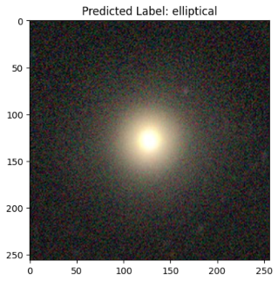
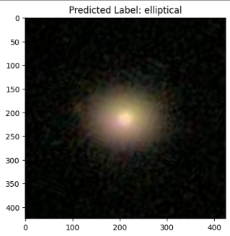
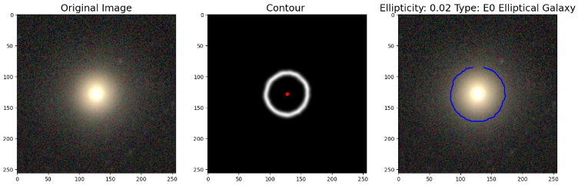
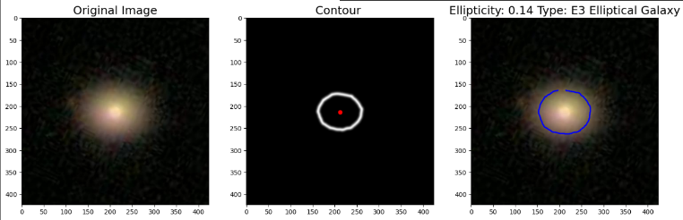

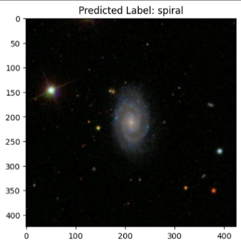
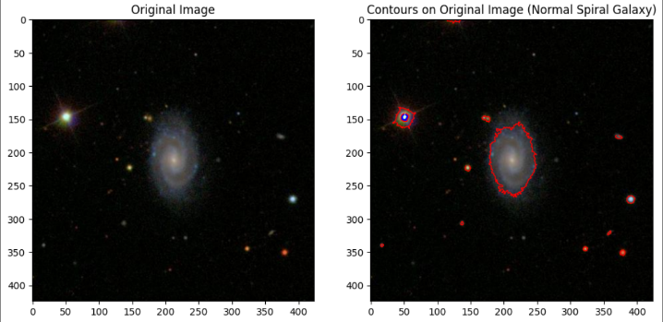
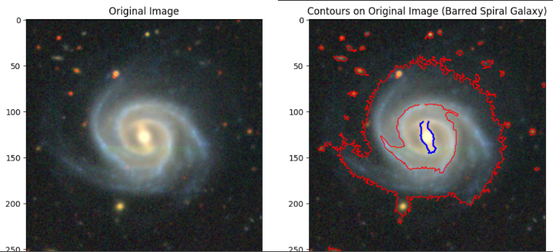
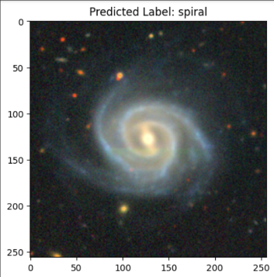

Conclusion

We have shown encouraging results in successfully classifying galaxy photos into multiple categories and subcategories using our implementation of Convolutional Neural Networks utilizing the MobileNetV2 architecture. With the help of the GalaxyZoo dataset and Galaxy10decals, our model was able to train with impressive accuracy of 91% on the testing dataset. To improve the features of our model, we applied image processing and data augmentation techniques. However, an important limitation was that the irregular class's predictions were skewed in favor of the spiral class when a combination of merged and distorted galaxy images were used. In order to provide reliable and objective model performance, this emphasizes the significance of dataset creation and the necessity of giving differences within particular classes significant thought.

Acknowledgement

We would like to express our appreciation to the Galaxy Zoo project and the AstroNN website for providing the dataset which was significant in building and refining the model.

References

- Xiao-Pan Zhu,Jia-Ming Dai1,Chun-Jiang Bian,Yu Chen,Shi Chen, Chen Hu,et.al in 2019 Galaxy morphology classification with deep convolutional neural networks.
- Ganesh Srinivasa Shetty,Dr.Raghu N., et al in 2022: The classification of satellite galaxies using Convolution neural networks Machine Learning.
- A. Schutter, L. Shamir, Galaxy morphology et.al in 2015: An unsupervised machine learning approach.
- Manda Banerji, Ofer Lahav, Chris J. Lintott, Filipe B. Abdalla, et.al. in 2010: Galaxy Zoo: reproducing galaxy morphologies via machine learning.
- Jorge de la Calleja, Olac Fuentes et al. in 2003: Machine learning and image analysis for morphological galaxy classification.
- Aleksandra Ciprijanovi , Diana Kafkes, Gregory Snyder et. al in 2022: Semi-Supervised Domain Adaptation for Cross-Survey Galaxy Morphology Classification and Anomaly Detection.
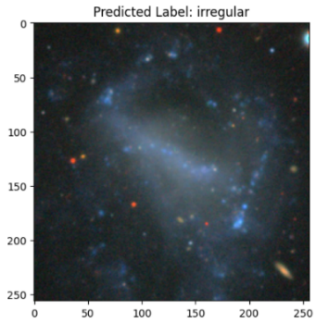
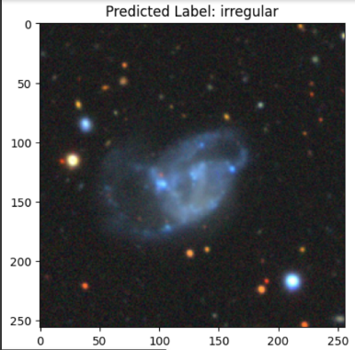
- Edward J. Kim, Robert J. Brunner and Matias Carrasco Kind: A hybrid ensemble learning approach to star–galaxy classification, in 2015.
- Matthew Freed, and Jeonghwa Lee, et al. in 2013: Application of Support Vector Machines to the Classification of Galaxy Morphologies.
- Reza Katebi, Yadi Zhou, Ryan Chornock, Razvan Bunescu et al. in 2013: Galaxy morphology prediction using Capsule Networks.
- Edward J. Kim, Robert J. Brunner et al in 2015:Star–galaxy classification using deep convolutional neural networks.
- Kyle W. Willett, Chris J. Lintott, Steven P. Bamford, Karen L. Masters, et al. in 2017: Galaxy Zoo DECaLS: Detailed visual morphology measurements from volunteers and deep learning for 314 000 galaxies.
- Alex Hocking, James E. Geach, Yi Sun, Neil Davey et al. in2020: An automatic taxonomy of galaxy morphology using unsupervised machine learning.
- Moonzarin Reza et al. in 2021: Galaxy morphology classification using automated machine learning.
- Nour Eldeen M. Khalifa, Mohamed Hamed N. Taha, Aboul Ella Hassanien, I. M. Selim et al. in 2013: Deep Galaxy: Classification of Galaxies based on Deep Convolutional Neural Networks.
- Mohamed Abd Elfattah, Nashwa Elbendary, Hamdy K. Elminir, Mohamed A. Abu El-Soud, Aboul Ella Hassanien et al. in 2019: Galaxies image classification using empirical mode decomposition and machine learning techniques.
- G. Martin , S. Kaviraj , A. Hocking et al. in 2019: Galaxy morphological classification in deep-wide surveys via unsupervised machine learning.
- I.M.Selim, Arabi E. Keshk, Bassant M.El Shourbugy et al. in 2016: Galaxy Image Classification using Non-Negative Matrix Factorization.
- M. Z Variawa; T. L van Zyl; M. Woolway et al. in 2020 : A rules-based and Transfer Learning approach for deriving the Hubble type of a galaxy from the Galaxy Zoo data.

