An Intelligent Airport Flight Scheduling System for Optimized Resource Allocation and Real-Time Delay Management
A CAPSTONE PROJECT REPORT
Submitted in the partial fulfilment for the Course of
CSA0624 – DESIGN AND ANALYSIS OF ALGORITHMS
to the award of the degree of
BACHELOR OF ENGINEERING
IN
Computer Science and Engineering
Submitted by
Aryan Arun ( 192411157 )
Rohith N (192424207)
Dhilipan T (192421290)

Under the Supervision of
Dr Gnanajeyaraman Rajaram

SIMATS ENGINEERING
Saveetha Institute of Medical and Technical Sciences
Chennai-602105
2026
SIMATS ENGINEERING
Saveetha Institute of Medical and Technical Sciences
Chennai-602105
DECLARATION
We, Aryan Arun, Rohith N, Dhilipan T of the Computer Science and Engineering, Saveetha Institute of Medical and Technical Sciences, Saveetha University, Chennai, hereby declare that the Capstone Project Work entitled "An Intelligent Airport Flight Scheduling System for Optimized Resource Allocation and Real-Time Delay Management" is the result of our own bonafide efforts. To the best of our knowledge, the work presented herein is original, accurate, and has been carried out in accordance with principles of engineering ethics.
Place:
Date:
Signature of the Students with Names
Aryan Arun ( 192411157 )
Rohith N (192424207)
Dhilipan T (192421290)
SIMATS ENGINEERING
Saveetha Institute of Medical and Technical Sciences
Chennai-602105
BONAFIDE CERTIFICATE
This is to certify that the Capstone Project entitled "An Intelligent Airport Flight Scheduling System for Optimized Resource Allocation and Real-Time Delay Management" has been carried out by Aryan Arun, Rohith N, Dhilipan T under the supervision of Dr Gnanajeyaraman Rajaram and is submitted in partial fulfilment of the requirements for the current semester of the B.E Computer Science and Engineering program at Saveetha Institute of Medical and Technical Sciences, Chennai.
SIGNATURE SIGNATURE
Dr. ANUSUYA S Dr Gnanajeyaraman Rajaram
Program Director Professor
Computer Science and Engineering
Saveetha School of Engineering Saveetha School of Engineering
SIMATS SIMATS
Submitted for the Project work Viva-Voce held on ______________________________.
INTERNAL EXAMINER EXTERNAL EXAMINER
ACKNOWLEDGEMENT
We would like to express our heartfelt gratitude to all those who supported and guided us throughout the successful completion of our Capstone Project. We are deeply thankful to our respected Founder and Chancellor, Dr. N.M. Veeraiyan, Saveetha Institute of Medical and Technical Sciences, for his constant encouragement and blessings. We also express our sincere thanks to our Pro-Chancellor, Dr. Deepak Nallaswamy Veeraiyan, and our Vice-Chancellor, Dr. S. Suresh Kumar, for their visionary leadership and moral support during the course of this project.
We are truly grateful to our Director, Dr. Ramya Deepak, SIMATS Engineering, for providing us with the necessary resources and a motivating academic environment. Our special thanks to our Principal, Dr. B. Ramesh, for granting us access to the institute's facilities and encouraging us throughout the process. We sincerely thank our Head of the Department, Dr. ANUSUYA S, for his continuous support, valuable guidance, and constant motivation.
We are especially indebted to our guide, Dr Gnanajeyaraman Rajaram, for his creative suggestions, consistent feedback, and unwavering support during each stage of the project. We also express our gratitude to the Project Coordinators, Review Panel Members (Internal and External), and the entire faculty team for their constructive feedback and valuable inputs that helped improve the quality of our work. Finally, we thank all faculty members, lab technicians, our parents, and friends for their continuous encouragement and support.
Signature With Student Name
Aryan Arun ( 192411157 )
Rohith N (192424207)
Dhilipan T (192421290)
TABLE OF CONTENTS
S.NO. | CHAPTER | PAGE NO.
1. | INTRODUCTION | 7
 | 1.1 Background Information | 7
 | 1.2 Project Objectives | 7
 | 1.3 Significance | 8
 | 1.4 Scope | 8
 | 1.5 Methodology Overview | 9
2. | PROBLEM IDENTIFICATION & ANALYSIS | 11
 | 2.1 Description of the Problem | 11
 | 2.2 Evidence of the Problem | 11
 | 2.3 Stakeholders | 11
 | 2.4 Supporting Data/Research | 12
3. | SOLUTION DESIGN & IMPLEMENTATION | 14
 | 3.1 Development & Design Process | 14
 | 3.2 Tools & Technologies used | 14
 | 3.3 Solution Overview | 14
 | 3.4 Engineering Standards Applied | 15
 | 3.5 Solution Justification | 16
4. | RESULTS & RECOMMENDATIONS | 17
 | 4.1 Evaluation of Results | 17
 | 4.2 Problem and Solution | 17
 | 4.3 Possible Improvements | 17
 | 4.4 Recommendations | 18
5. | REFLECTION ON LEARNING AND PERSONAL DEVELOPMENT | 19
 | 5.1 Key Learning Outcomes | 19
6. | CONCLUSION | 21
7. | REFERENCES | 22
8. | APPENDICES | 23
ABSTRACT
The continuous growth of global air traffic has placed increasing pressure on airport infrastructure, making the efficient allocation of runways, gates, and crew resources critical to smooth operations. Traditional flight scheduling approaches largely rely on manual coordination and static timetables, which struggle to adapt quickly to disruptions such as adverse weather, technical delays, or last-minute changes in flight plans. To address these challenges, this project proposes an Intelligent Airport Flight Scheduling System for optimized resource allocation and real-time delay management.
The proposed system acts as a centralized scheduling platform that assigns runways, gates, and crew to flights while automatically detecting and resolving conflicts. It incorporates an intelligent scheduling engine that applies constraint-based and heuristic optimization techniques to generate feasible, low-conflict schedules, and continuously reprioritises assignments as flight status, weather, or crew availability changes throughout the day.
The system consists of four major modules: Flight & Resource Management, Intelligent Scheduling Engine, Real-Time Monitoring & Delay Management, and Notification & Reporting. The Flight & Resource Management module maintains flight, aircraft, gate, and crew records. The Intelligent Scheduling Engine generates and adjusts optimized schedules based on operational constraints. The Real-Time Monitoring module tracks live flight status and delays, triggering automatic rescheduling where required. The Notification & Reporting module keeps airline staff, ground crew, and passengers informed through timely alerts and provides administrators with analytical dashboards.
The system is developed using web technologies such as HTML, CSS, JavaScript, Node.js/PHP, and MySQL, supported by a constraint-based optimization engine for schedule generation. The proposed solution reduces scheduling conflicts, improves punctuality, and enhances coordination between airlines, ground staff, and air traffic control. Overall, the project contributes to the development of a more efficient, adaptive, and technology-driven approach to airport operations management.
Keywords: Airport Scheduling, Intelligent Systems, Resource Optimization, Flight Delay Management, Gate Allocation, Real-Time Monitoring, Constraint-Based Scheduling, Aviation Technology.
Furthermore, the proposed system supports the broader vision of smart aviation infrastructure by integrating data-driven decision-making into everyday airport operations. The platform enables faster identification of scheduling conflicts, improved coordination among airlines, ground handling teams, and regulatory authorities, and a reduction in cascading delays across the flight network. The system can be extended in the future with advanced technologies such as machine learning-based delay prediction, Internet of Things (IoT) sensor integration, and predictive analytics to provide even smarter scheduling recommendations. Thus, the proposed Intelligent Airport Flight Scheduling System serves as a scalable and future-ready solution for modern airport environments.
CHAPTER 1
Introduction
1.1 Background Information
The rapid growth of global air travel has increased the demand for efficient airport operations and better utilization of limited runway, gate, and crew resources. Airports rely on Information and Communication Technologies (ICT), optimization algorithms, and data-driven systems to manage increasingly complex flight schedules. However, many airports still depend on manual or semi-automated scheduling practices that struggle to adapt to disruptions such as weather delays, technical issues, congestion, and last-minute flight changes.
Traditional airport scheduling systems often handle gate assignment, runway slotting, and crew rostering as separate, loosely coordinated processes. This lack of integration results in scheduling conflicts, inefficient resource use, and delays that cascade across the flight network. Airport staff must frequently intervene manually to resolve overlapping bookings, resulting in inconvenience for airlines, ground staff, and passengers alike.
Table 1.1 Comparison of Existing and Proposed Airport Scheduling Systems
FEATURE | TRADITIONAL AIRPORT SCHEDULING | PROPOSED INTELLIGENT SCHEDULING SYSTEM
Schedule Generation | Manual or semi-automated | Algorithm-driven optimization
Conflict Resolution | Reactive, manual intervention | Automated conflict detection and resolution
Resource Allocation | Static gate/runway assignment | Dynamic, constraint-based allocation
Delay Handling | Limited rescheduling support | Real-time rescheduling and rebalancing
Real-Time Updates | Limited | Live status tracking and alerts
Decision Making | Reactive approach | Data-driven, context-aware recommendations
Communication | Fragmented across departments | Centralized notifications to all stakeholders
Scalability | Limited | Modular, cloud-ready architecture
The proposed system integrates flight, gate, runway, and crew data into a single intelligent scheduling platform. By applying constraint-based optimization and continuously monitoring live flight status, the system can generate feasible schedules quickly and adjust them automatically as conditions change, reducing the burden on human schedulers and minimizing knock-on delays.
1.2 Project Objectives
The main objective of this project is to design and develop an Intelligent Airport Flight Scheduling System for optimized resource allocation and real-time delay management.
The specific objectives are:
- To develop a centralized platform for managing flight, gate, runway, and crew schedules.
- To apply intelligent optimization techniques for automated, conflict-free schedule generation.
- To enable real-time monitoring of flight status and automatic rescheduling during disruptions.
- To improve coordination between airlines, ground staff, and air traffic control.
- To reduce cascading delays through early conflict detection and resolution.
- To provide timely notifications and analytical reports to airport administrators.
1.3 Significance of the Project
This project contributes significantly to improving the efficiency and reliability of airport operations. The system helps airport authorities and airlines manage flight schedules from a single platform, reducing the coordination overhead of handling gates, runways, and crew separately.
The intelligent scheduling capability ensures that resource allocation adapts to real-world conditions rather than relying on fixed timetables. This improves punctuality, reduces operational costs associated with delays, and strengthens communication between airport stakeholders.
Furthermore, the project supports the digital transformation of aviation infrastructure and contributes to the broader adoption of smart, data-driven airport management practices. The proposed system also lays the groundwork for future integration with predictive analytics and live air traffic data feeds, extending its usefulness beyond a single airport's operations.
1.4 Scope of the Project
The scope of this project is focused on the design and implementation of four major modules:
Module 1: Flight & Resource Management
This module handles the registration and maintenance of flight details, aircraft information, gates, and runway slots, forming the data foundation for the scheduling engine.
Module 2: Intelligent Scheduling Engine
This module applies constraint-based and heuristic optimization techniques to allocate gates, runway slots, and crew to flights while automatically detecting and resolving scheduling conflicts.
Module 3: Real-Time Monitoring & Delay Management
This module tracks live flight status, weather conditions, and delays, and triggers automatic rescheduling of affected flights and resources.
Module 4: Notification & Reporting
This module delivers real-time alerts to airline staff, ground crew, and passengers, and provides administrators with analytical dashboards summarizing schedule performance.
1.5 Methodology Overview
The proposed system follows a structured methodology to achieve its objectives:
1.5.1 Requirement Analysis
The requirements of airlines, ground staff, and air traffic control are identified. Information related to flight schedules, gate and runway capacity, and crew availability is gathered.
1.5.2 System Design
The system is designed with four main modules: Flight & Resource Management, Intelligent Scheduling Engine, Real-Time Monitoring & Delay Management, and Notification & Reporting.
1.5.3 Database Development
A database is created to store flight details, gate and runway allocations, crew rosters, delay records, and notification logs.
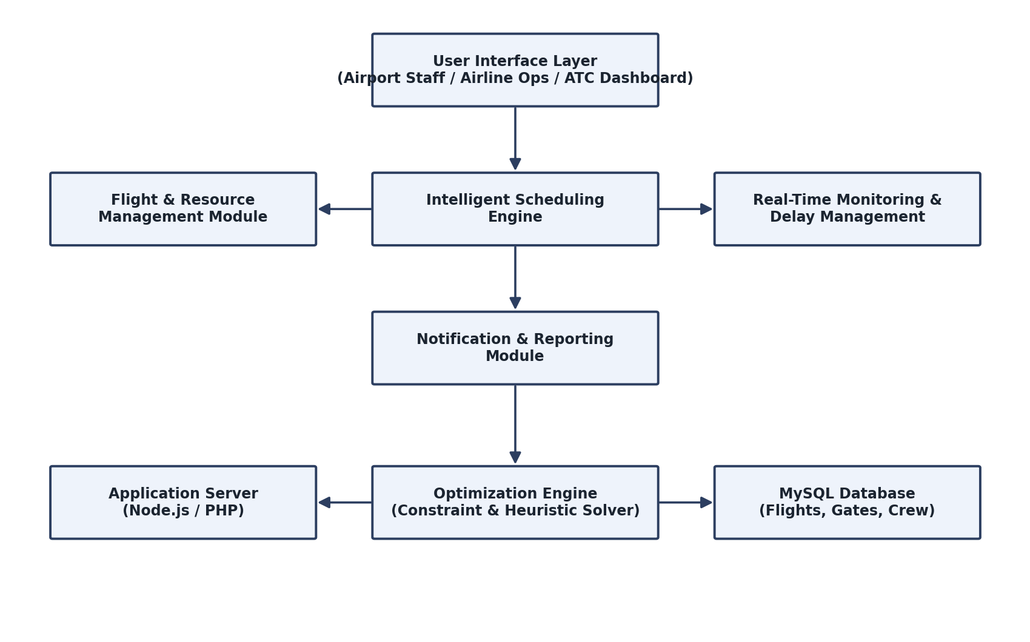
Fig 1.1 System Architecture of the Intelligent Airport Flight Scheduling System
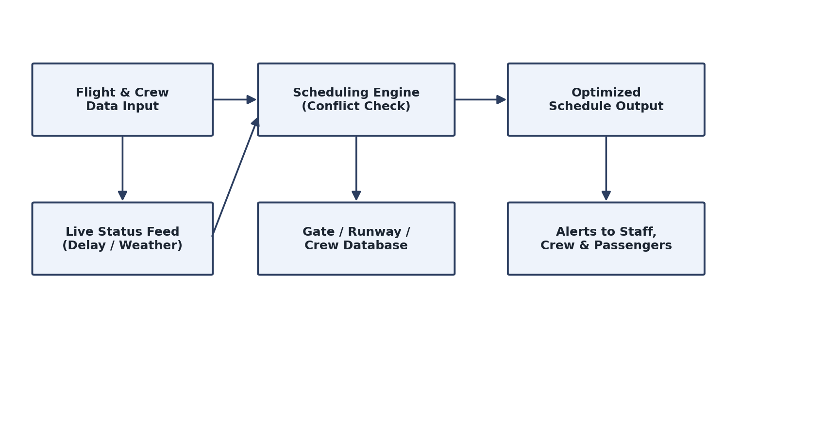
Fig 1.2 Data Flow Diagram of the Scheduling System
CHAPTER 2
Problem Identification and Analysis
2.1 Description of the Problem
With the continuous growth of air traffic, airports must manage an increasing number of flights using a limited number of gates, runways, and crew resources. In many airports, gate assignment, runway slotting, and crew rostering are handled through separate manual or semi-automated processes, making it difficult to detect conflicts before they affect operations.
Existing airport scheduling systems often lack real-time adaptability, meaning that once a schedule is disrupted by weather, technical faults, or air traffic congestion, staff must manually reassign resources under time pressure. This increases the likelihood of cascading delays, missed connections, and inefficient use of airport infrastructure.
The absence of a centralized, intelligent scheduling platform results in reduced operational efficiency, delayed decision-making, and poor coordination among airlines, ground handling teams, and air traffic control. Therefore, there is a need for an Intelligent Airport Flight Scheduling System that can generate optimized schedules, detect conflicts automatically, and adapt to real-time disruptions.
2.2 Evidence of the Problem
Several real-world observations and research findings highlight the presence of this problem:
- Airports frequently experience gate and runway allocation conflicts during peak hours.
- Manual rescheduling during disruptions is time-consuming and error-prone.
- Delays at one airport often propagate to connecting flights at other airports.
- Existing systems provide limited real-time visibility into resource availability.
- Coordination between airlines, ground staff, and air traffic control is often fragmented.
- Passengers frequently receive delayed or inconsistent updates about flight status changes.
2.3 Stakeholders
Airlines
Airlines can submit and update flight schedules and receive optimized gate and runway assignments that minimize turnaround delays.
Airport Authorities
Airport management can oversee resource allocation across all flights and respond quickly to scheduling conflicts.
Air Traffic Control (ATC)
ATC teams can access consolidated runway and airspace scheduling information to coordinate takeoffs and landings safely.
Ground Handling and Crew
Ground staff and flight crew receive timely updates on gate assignments, turnaround times, and roster changes.
Passengers
Passengers benefit indirectly through improved punctuality and more accurate, real-time flight status updates.
2.4 Supporting Data / Research
- Research on flight scheduling optimization shows that algorithmic approaches can significantly reduce total adjustment time while maximizing the number of flights accommodated within airport capacity constraints.
- Studies on flight rescheduling models demonstrate that centralized, airport-level optimization reduces congestion and delay costs compared to airline-by-airline adjustments.
- Genetic algorithm-based approaches to gate and runway scheduling have been shown to simultaneously improve resource utilization and reduce environmental impact.
- Machine learning-based flight delay prediction studies report high accuracy in forecasting delays using historical and weather data, supporting proactive rescheduling.
- Literature on airline scheduling optimization highlights the benefits of integrating fleet assignment, aircraft routing, and crew scheduling rather than treating them as independent subproblems.
- Research on multi-objective taxiway and ground-operations scheduling shows measurable reductions in taxiing time and fuel consumption when intelligent routing algorithms are applied.
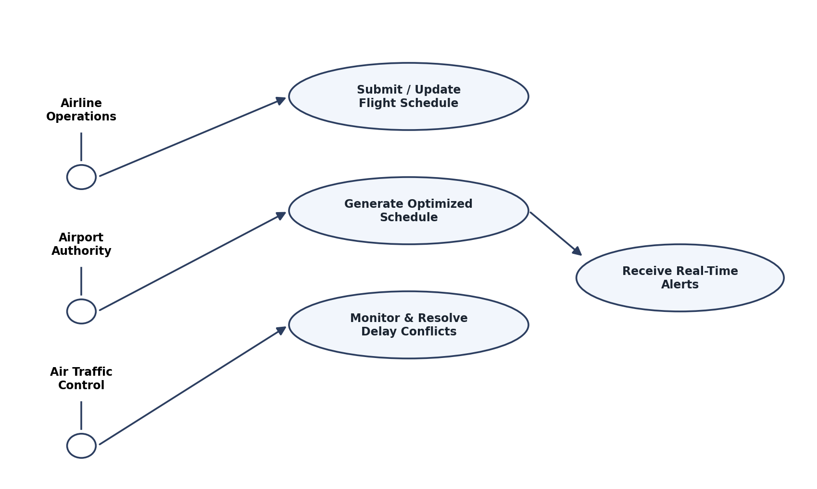
Fig. 2.1 Use Case Diagram for the Airport Scheduling System
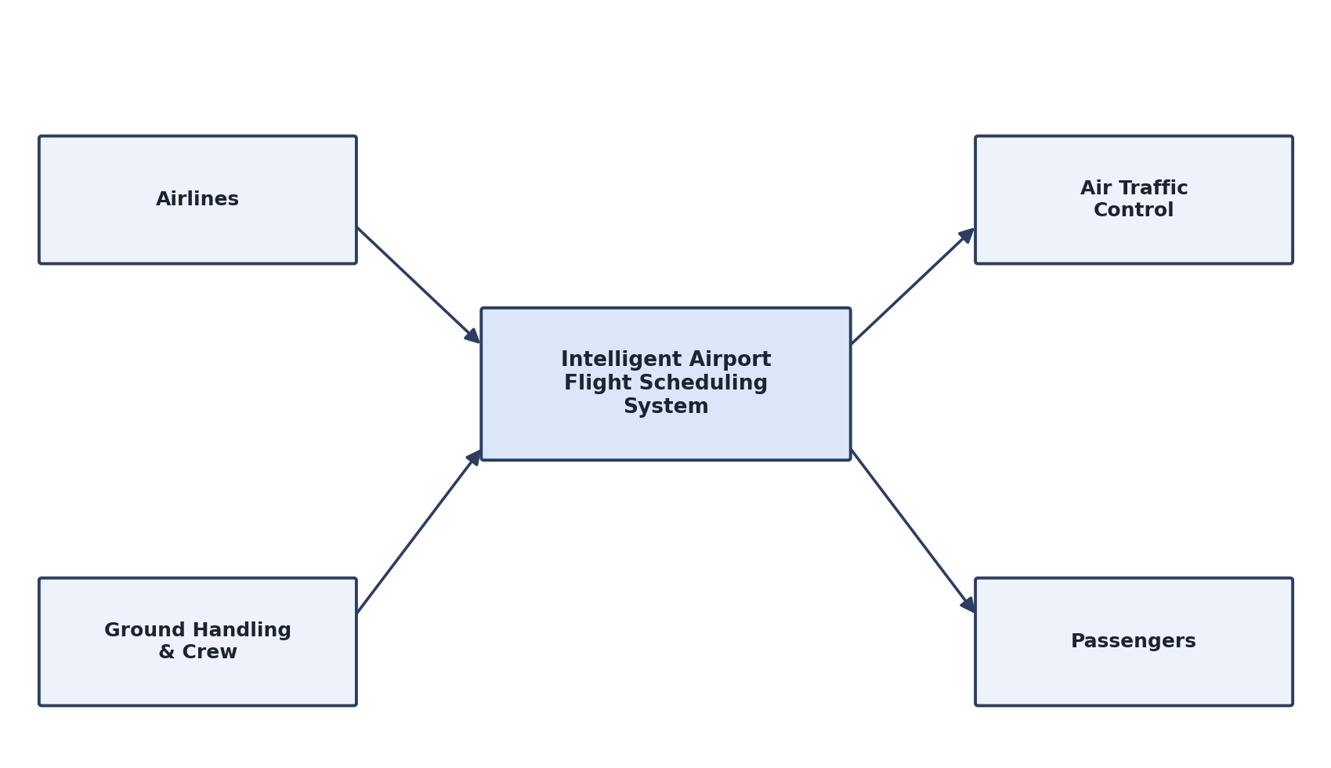
Fig. 2.2 Context Diagram of the Airport Scheduling System
CHAPTER 3
Solution Design and Implementation
3.1 Development and Design Process
The development of the proposed system follows a structured and modular approach to ensure efficiency, scalability, and reliability. The design process is divided into the following phases:
3.1.1 Requirement Analysis: Identification of airline, ground staff, and ATC requirements, including flight data management, gate/runway allocation, and real-time delay handling.
3.1.2 System Design: The system is divided into four core modules:
- Flight & Resource Management
- Intelligent Scheduling Engine
- Real-Time Monitoring & Delay Management
- Notification & Reporting
3.1.3 Data Collection and Organization: Information regarding flight timetables, aircraft types, gate/runway capacity, and crew rosters is collected and organized.
3.1.4 Database Design: A centralized database is designed to store flight records, resource allocations, delay logs, and notification history.
3.1.5 Development and Integration: The modules are developed and integrated into a single platform to provide seamless, end-to-end schedule management.
3.2 Tools and Technologies Used
- Frontend Technologies: HTML, CSS, JavaScript
- Backend Technology: Node.js / PHP
- Database: MySQL
- Scheduling & Optimization: Constraint-based heuristic scheduling engine
- Development Environment: Visual Studio Code
- Version Control: Git and GitHub
- Browser Testing: Google Chrome, Microsoft Edge
3.3 Solution Overview
Module 1: Flight & Resource Management
This module allows staff to register flights, aircraft, gates, and runway slots, and maintain crew rosters. All resource data is stored centrally to support the scheduling engine.
Module 2: Intelligent Scheduling Engine
- Automated Gate and Runway Assignment
- Conflict Detection and Resolution
- Crew Roster Optimization
The scheduling engine applies constraint-based rules and heuristic optimization to generate schedules that minimize idle time and resource conflicts.
Module 3: Real-Time Monitoring & Delay Management
This module tracks live flight status and automatically triggers rescheduling of gates, runways, or crew when delays or disruptions occur.
Module 4: Notification & Reporting
- Real-Time Alerts to Staff and Crew
- Passenger Status Notifications
- Administrative Analytics Dashboard
Table 3.1 Comparison of Airport Scheduling Approaches
APPROACH | STRENGTHS | WEAKNESSES | USE CASE
Manual Scheduling | Simple to implement | Slow, error-prone under disruption | Small airports, low traffic
Spreadsheet-Based Systems | Familiar, low cost | No real-time conflict detection | Basic schedule tracking
Rule-Based Automation | Faster than manual methods | Struggles with complex constraints | Fixed, predictable schedules
Proposed Intelligent Scheduling System | Automated optimization, real-time adaptability, centralized coordination | Requires reliable data feeds and connectivity | Large or high-traffic airports
3.4 Engineering Standards Applied
3.4.1 Software Engineering Principles
- Modular Design
- Scalability
- Maintainability
- Reusability
3.4.2 Web Development Standards
- Responsive User Interface Design
- Cross-Browser Compatibility
- User-Friendly Navigation
3.4.3 Database Standards
- Data Integrity
- Secure Data Storage
- Efficient Query Processing
3.4.4 Security Standards
- User Authentication
- Role-Based Access Control
- Secure Data Access
3.4.5 Aviation Scheduling Guidelines
- Slot Coordination Principles
- Safety-First Resource Allocation
- Transparent Audit Trails for Schedule Changes
3.5 Solution Justification
The proposed Intelligent Airport Flight Scheduling System effectively addresses the limitations of existing scheduling approaches.
- Centralized Coordination: Airlines, ground staff, and ATC can access a single, consistent view of the schedule.
- Improved Efficiency: Automated optimization reduces the time required to generate conflict-free schedules.
- Real-Time Adaptability: The system reschedules resources automatically as flight status changes.
- Reduced Cascading Delays: Early conflict detection limits the spread of delays across the network.
- Scalability: The modular architecture allows future expansion to additional airports or terminals.
- Improved Communication: Real-time alerts keep all stakeholders informed of schedule changes.
The proposed solution supports the modernization of airport operations and contributes to building a more efficient, adaptive, and well-coordinated aviation ecosystem.
CHAPTER 4
Results and Recommendations
4.1 Evaluation of Results
The proposed Intelligent Airport Flight Scheduling System was evaluated based on its ability to generate optimized schedules, detect conflicts, and adapt to real-time disruptions.
4.1.1 Flight & Resource Management Module successfully enabled centralized registration and maintenance of flight, gate, runway, and crew data.
4.1.2 Intelligent Scheduling Engine effectively generated conflict-free schedules and reduced the number of manual scheduling interventions required.
4.1.3 Real-Time Monitoring Module successfully tracked flight status changes and triggered timely rescheduling of affected resources.
4.1.4 Notification & Reporting Module efficiently delivered alerts to staff and crew and provided administrators with clear analytical summaries of schedule performance.
The system demonstrated improved scheduling efficiency, faster conflict resolution, and better coordination compared to traditional manual approaches.
4.2 Problem and Solution
Identified Problem
Traditional airport scheduling systems handle gate assignment, runway slotting, and crew rostering as separate, loosely coordinated processes, leading to conflicts, cascading delays, and inefficient communication between stakeholders.
Proposed Solution
The developed Intelligent Airport Flight Scheduling System integrates:
- Centralized Flight and Resource Data Management
- Intelligent, Constraint-Based Schedule Optimization
- Real-Time Monitoring and Automated Rescheduling
- Timely Notifications and Analytical Reporting
The system provides a single platform that improves scheduling efficiency, resource utilization, and communication while supporting smart airport initiatives.
4.3 Possible Improvements
4.3.1 AI-Based Delay Prediction: Implement machine learning models to forecast delays using historical and weather data, enabling proactive rescheduling.
4.3.2 Mobile Application Support: Develop Android and iOS applications for airline staff and ground crew for on-the-go schedule access.
4.3.3 Live ATC and Weather Feed Integration: Connect the system to live air traffic control and meteorological data sources for more accurate scheduling.
4.3.4 Chatbot Integration: Add an AI assistant to answer staff queries regarding schedules and resource availability.
4.3.5 Passenger Self-Service Alerts: Enable passengers to subscribe to real-time notifications about their specific flights.
4.3.6 Advanced Analytics Dashboard: Provide administrators with deeper insights into recurring bottlenecks and resource utilization trends.
4.3.7 IoT Integration: Connect with airport sensors for real-time tracking of ground vehicles, baggage handling, and gate occupancy.
4.4 Recommendations
Based on the results and analysis, the following recommendations are suggested:
- Deploy the system across busier terminals first to maximize the benefit of automated conflict resolution.
- Encourage airlines and ground handling teams to maintain accurate, up-to-date flight and resource data.
- Integrate predictive analytics to shift scheduling from reactive to proactive delay management.
- Expand the system to support multi-airport coordination for connecting flights.
- Ensure regular security audits and access-control reviews to protect operational data.
- Continue research into optimization techniques to further reduce scheduling conflicts and delays.
CHAPTER 5
Reflection on Learning and Personal Development
5.1 Key Learning Outcomes
5.1.1 Academic Knowledge Gained
The development of the Intelligent Airport Flight Scheduling System provided valuable knowledge in the fields of airport operations, scheduling optimization, and web-based system design. The project enhanced our understanding of how algorithmic techniques can be applied to solve real-world resource allocation problems.
5.1.2 Technical Skills Developed
One of the major learning outcomes was gaining practical experience in building a full-stack web application using HTML, CSS, JavaScript, Node.js/PHP, and MySQL. Developing the scheduling engine improved our understanding of constraint-based optimization, while building the four integrated modules strengthened our skills in database design, backend logic, and frontend development.
5.1.3 Problem-Solving and Challenges
Throughout the project, several challenges were encountered, including designing an efficient conflict-detection algorithm, structuring a database capable of representing complex scheduling relationships, and ensuring the real-time monitoring module could respond quickly to status changes. Addressing these challenges improved our analytical thinking and debugging skills, and strengthened our ability to design practical solutions for operationally complex problems.
5.1.4 Application of Standards
The project provided experience in applying software engineering principles such as modular design, scalability, and maintainability, alongside security practices such as role-based access control. This ensured the system remained reliable and easy to extend.
5.1.5 Industry Insights
This project offered valuable insight into the growing importance of intelligent, data-driven scheduling in the aviation industry. It demonstrated how optimization algorithms and real-time monitoring can improve punctuality and resource utilization, and highlighted the significance of integrating predictive technologies into future airport management systems.
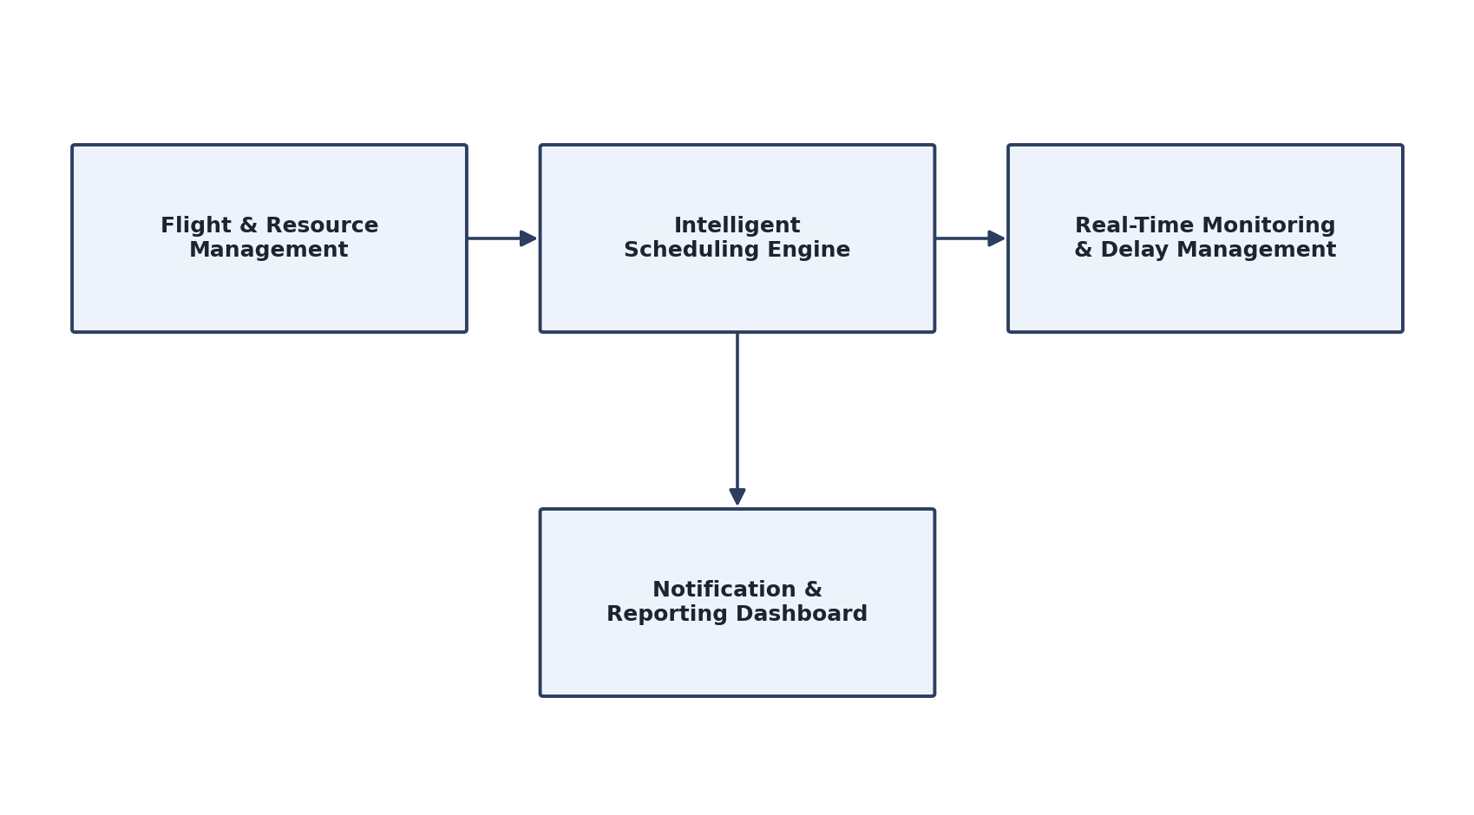
Fig 5.1 Overview of the Intelligent Airport Flight Scheduling System
Beyond technical knowledge, this project contributed significantly to our personal development:
- Problem-Solving Skills: Improved ability to analyze complex operational scenarios and design effective technical solutions.
- Critical Thinking: Enhanced decision-making through evaluation of different scheduling and optimization strategies.
- Project Management: Strengthened planning and task coordination while completing the project within the given timeline.
- Research Skills: Improved capability to study aviation scheduling concepts and apply them to practical system design.
- Communication Skills: Enhanced documentation, presentation, and teamwork skills through project discussions and report preparation.
- Adaptability: Increased confidence in learning new technologies and adjusting to evolving project requirements.
CHAPTER 6
Conclusion
The project "An Intelligent Airport Flight Scheduling System for Optimized Resource Allocation and Real-Time Delay Management" successfully presents an intelligent, adaptive solution for improving airport scheduling efficiency and reducing operational delays. The system integrates essential features such as flight and resource management, intelligent schedule optimization, real-time delay monitoring, and stakeholder notifications into a single centralized platform.
By automating gate, runway, and crew allocation, the system helps airport authorities and airlines reduce scheduling conflicts and save time compared to manual coordination. The real-time monitoring module further enhances operational resilience by detecting disruptions early and triggering timely rescheduling. In addition, the notification and reporting system ensures that airline staff, ground crew, and passengers remain informed of relevant schedule changes.
The implementation of this system demonstrates the effectiveness of applying intelligent optimization techniques to support modern airport operations. The modular architecture ensures scalability and ease of maintenance, allowing future integration of advanced technologies such as machine learning-based delay prediction, IoT sensor data, and multi-airport coordination.
Overall, the project contributes to the development of more efficient, resilient, and technology-driven airport operations. It supports improved punctuality, better resource utilization, and stronger coordination among aviation stakeholders, providing a solid foundation for future intelligent scheduling solutions in the aviation sector.
REFERENCES:
- Yang, L., Dai, M., Zhang, H., & Yang, D. (2025). Flight Scheduling Optimization Model and Algorithm. In Proceedings of the 2024 International Conference on Artificial Intelligence and Autonomous Transportation (AIAT 2024), Lecture Notes in Electrical Engineering, vol. 1390. Springer, Singapore. DOI: 10.1007/978-981-96-3961-8_16
- An Optimization Model for Flight Rescheduling from an Airport's Centralized Perspective for Better Management of Demand and Capacity Utilization. (2024). Computation, 12(5), 98. DOI: 10.3390/computation12050098
- Ba, Y., et al. (2024). A New Multiobjective A* Algorithm With Time Window Applied to Large Airports. Journal of Advanced Transportation. DOI: 10.1155/atr/7536217
- Xu, Y., Wandelt, S., & Sun, X. (2024). Airline scheduling optimization: literature review and a discussion of modelling methodologies. Intelligent Transportation Infrastructure, 3, liad026. DOI: 10.1093/iti/liad026
- Guedan-Pecker, et al. (2024). Airport take-off and landing optimization through genetic algorithms. Expert Systems. DOI: 10.1111/exsy.13565
- Duan, P., et al. (2025). A bi-objective optimization approach for scheduling electric ground-handling vehicles in an airport. Complex & Intelligent Systems. DOI: 10.1007/s40747-025-01815-x
- Alfarhood, M., et al. (2024). Predicting Flight Delays with Machine Learning: A Case Study from Saudi Arabian Airlines. International Journal of Aerospace Engineering. DOI: 10.1155/2024/3385463
- Flight delay prediction using machine learning and explainable AI: a case study on Hazrat Shahjalal International Airport, Dhaka. (2025). ScienceDirect.
- A hybrid machine learning-based model for predicting flight delay through aviation big data. (2024). Scientific Reports. DOI: 10.1038/s41598-024-55217-z
- Flight delay prediction: Evaluating machine learning algorithms for enhanced accuracy. (2025). PLOS One, 20(12), e0335141. DOI: 10.1371/journal.pone.0335141
- Yuan, Y., Wang, Y., & Lai, C. S. (2025). Multi-Attribute Data-Driven Flight Departure Delay Prediction for Airport System Using Deep Learning Method. Aerospace, 12(3), 246. DOI: 10.3390/aerospace12030246
- He, et al. (2024). Flight Schedule Optimization Considering Fine-Grained Configuration of Slot Coordination Parameters. Aerospace, 11(9), 763. DOI: 10.3390/aerospace11090763
Appendices
Coding:
from flask import (
Flask,
render_template,
request,
redirect,
jsonify
)

from models.database import (
initialize_database,
get_connection
)

from models.flight import (
get_all_flights,
add_flight,
delete_flight
)

from models.scheduler import (
detect_conflicts,
allocate_resources,
calculate_optimization_score,
get_performance_metrics,
get_resource_utilization
)

app = Flask(__name__)

initialize_database()
@app.route("/")
def index():
metrics = get_performance_metrics()

return render_template(
"index.html",
metrics=metrics
)
@app.route("/flights")
def flights():

all_flights = get_all_flights()

return render_template(
"flights.html",
flights=all_flights
)

@app.route(
"/add-flight",
methods=["GET", "POST"]
)
def add_flight_page():

if request.method == "POST":

data = {

"flight_number":
request.form[
"flight_number"
],

"airline":
request.form[
"airline"
],

"aircraft_type":
request.form[
"aircraft_type"
],

"flight_type":
request.form[
"flight_type"
],

"origin":
request.form[
"origin"
],

"destination":
request.form[
"destination"
],

"scheduled_time":
request.form[
"scheduled_time"
],

"duration":
int(
request.form[
"duration"
]
),

"passengers":
int(
request.form[
"passengers"
]
)
}

add_flight(data)

return redirect(
"/flights"
)

return render_template(
"add_flight.html"
)

@app.route(
"/delete-flight/<int:flight_id>"
)
def remove_flight(flight_id):

delete_flight(
flight_id
)

return redirect(
"/flights"
)
@app.route("/scheduling")
def scheduling():

flights = get_all_flights()
conflicts = detect_conflicts()
return render_template(
"scheduling.html",
flights=flights,
conflicts=conflicts
)
@app.route("/allocate")
def allocate():

allocate_resources()

return redirect(
"/resources"
)

@app.route("/resources")
def resources():

connection = get_connection()

flights = connection.execute("""
SELECT *
FROM flights
ORDER BY scheduled_time
""").fetchall()

runways = connection.execute("""
SELECT *
FROM runways
""").fetchall()

gates = connection.execute("""
SELECT *
FROM gates
""").fetchall()

connection.close()

utilization = get_resource_utilization()

return render_template(
"resources.html",
flights=flights,
runways=runways,
gates=gates,
utilization=utilization
)
@app.route("/optimization")
def optimization():
score = calculate_optimization_score()
conflicts = detect_conflicts()
metrics = get_performance_metrics()
return render_template(
"optimization.html",
score=score,
conflicts=conflicts,
metrics=metrics
)
@app.route("/run-optimization")
def run_optimization():
allocate_resources()
return redirect(
"/optimization"
)
@app.route("/analytics")
def analytics():

metrics = get_performance_metrics()

utilization = get_resource_utilization()

return render_template(
"analytics.html",
metrics=metrics,
utilization=utilization
)
@app.route("/api/analytics")
def analytics_api():
metrics = get_performance_metrics()
return jsonify(
metrics
)
@app.route("/api/conflicts")
def conflicts_api():
conflicts = detect_conflicts()
return jsonify(
conflicts
)
@app.route("/api/resources")
def resources_api():

utilization = get_resource_utilization()

return jsonify(
utilization
)
if __name__ == "__main__":

app.run(
debug=True,
host="127.0.0.1",
port=5000
)
Output:
