Aryan Aziz

**CS-352 HW #1**

**Software Selected:** Charles Web Debugging Proxy (<http://www.charlesproxy.com/>)

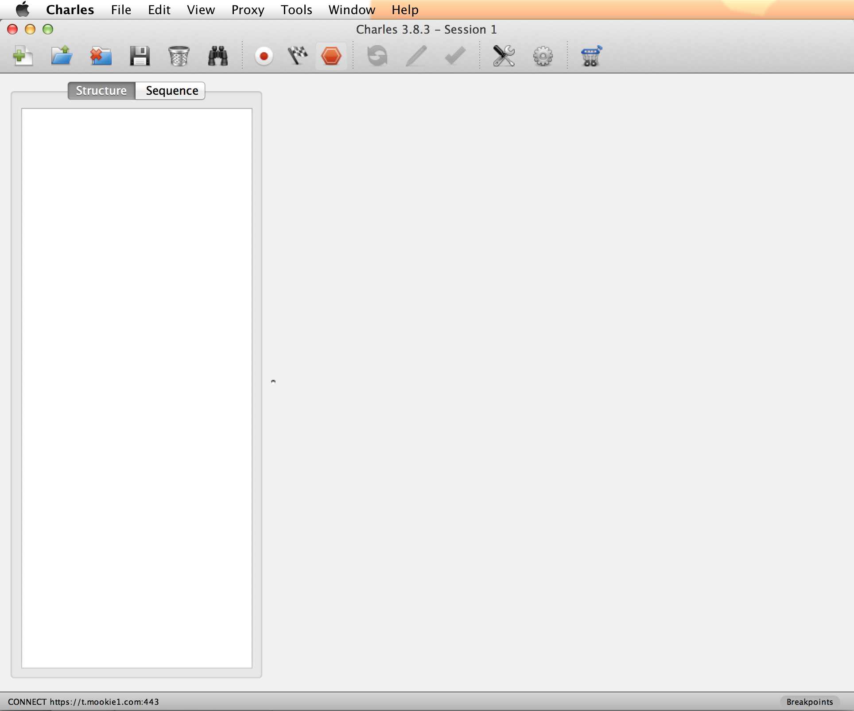

**Visibility:**

* **Support:** An easy example to show the visibility is the menu bar at the top with the icons laid for all of the various main functions (to save a file/open, start recording, etc etc)



* **Violate:** Charles has a LOT of other features that are only available if you right click on certain menus or use the main Mac task bar menu items.

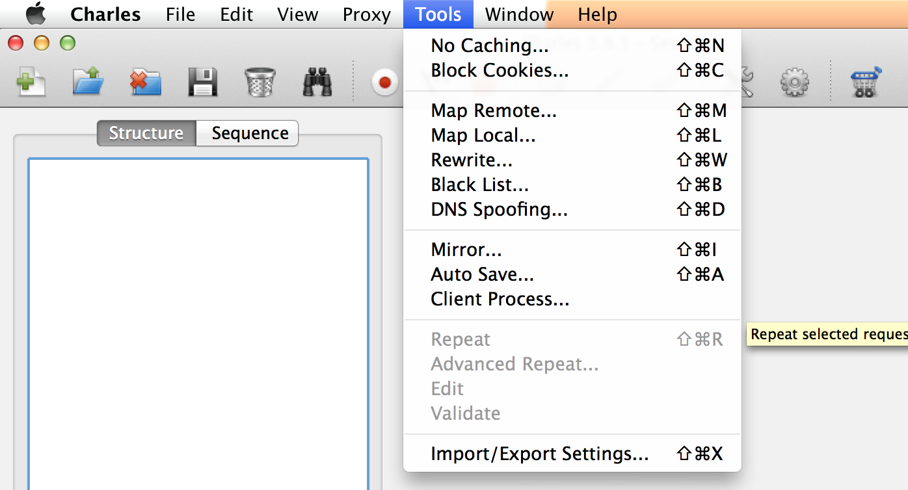

**Feedback:**

* **Support:** With all of its normal menu bar items (I am going to ignore the default mac task bar) Charles displays a lit box around the item you have selected. (This can be seen with the 7th icon below)





* **Violate:** In some instances, Charles will create a new session tab without your knowledge. When this occurs, it leaves the original tab as the active one, leading you to think your action did not happen/is not working.

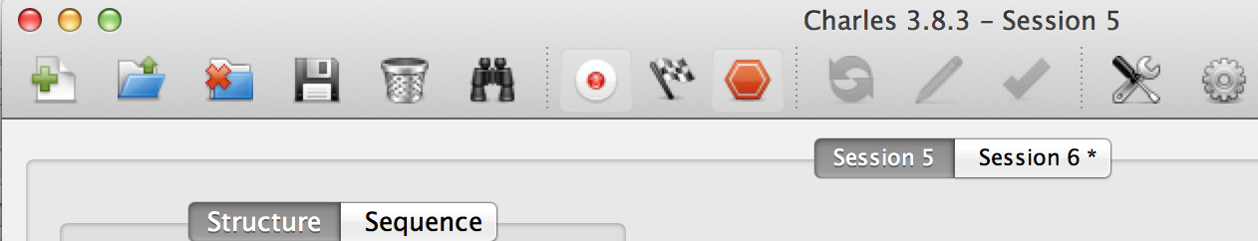

**Constraints:**

* **Support:** Most menus are hardcoded and only allow the user to select a specific feature, preventing typographical errors (Please see the screenshot for Visibility violation above).
* **Violate:** When using some of the extra features that are spoken of in Visibility violation, it allows the user to enter any type of values they want (varchar) allowing for possible typographical errors (IE entering in an incorrect ip or entering a url without http)

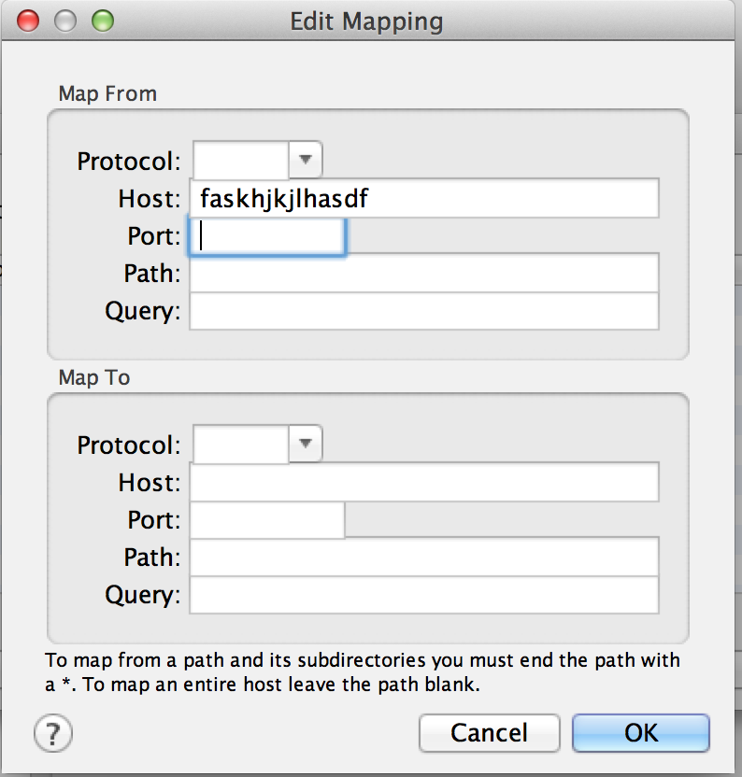

**Consistency:**

* **Support:** Charles shows good support of consistency across the board as pretty much all processes are done the same way no matter which window you are in. If you want to create a new session you will always use the new session button at the top. To blacklist a URL you can always right click on it and select it.
* **Violate:** There are some instances when you want to select a url or a piece of code and it will not let you copy it, whereas in other situations it will. In the screen shot, there are 2 items that are highlighted (one in grey and one in blue). The item in grey can be right clicked and copy url, whereas the one in blue must be double clicked which opens a new box and then the text must be highlighted and copied.

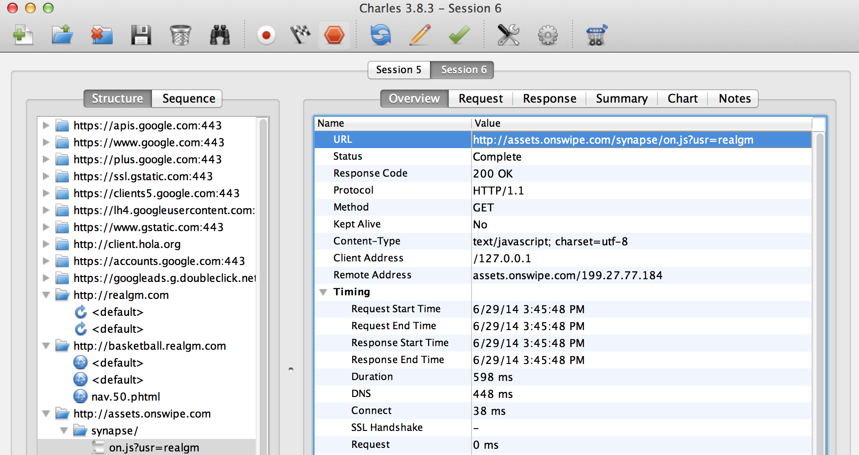

**Affordance:**

* **Support:** A good example of affordance is the usage of all of the buttons and dropdown arrows, showing you that you can click on these and expand/switch menus. The screenshot directly above this displays this with the folders on the left hand side and the arrows next to them.
* **Violate:** This can also be seen on the example above, but all of the items on the right hand side don’t really give you any information on how to use them/what you can do. You can highlight on them by clicking but most people won’t know that double clicking will pop up a text document that allows you to copy the information.