Howard University
College of Engineering and Architecture
Department of Electrical Engineering & Computer Science

Large Scale Programming
Fall 2024

Midterm Exam – Part I
October 17, 2024

Part I: 50 pts. (essay questions)

Instructions:
- Submit completed exam to your github repository under package org.howard.edu.lsp.midterm

Verify that the commit(s) completed successfully

- OPEN BOOK, OPEN NOTES. THERE IS NO COLLABORATION ON THIS EXAM
- Site any and ALL references for anything obtained off the internet.

Question 1. (10 pts.)

You are reviewing the following class in a Fitness Tracking System. The class is intended to manage various aspects of a user’s fitness activities.

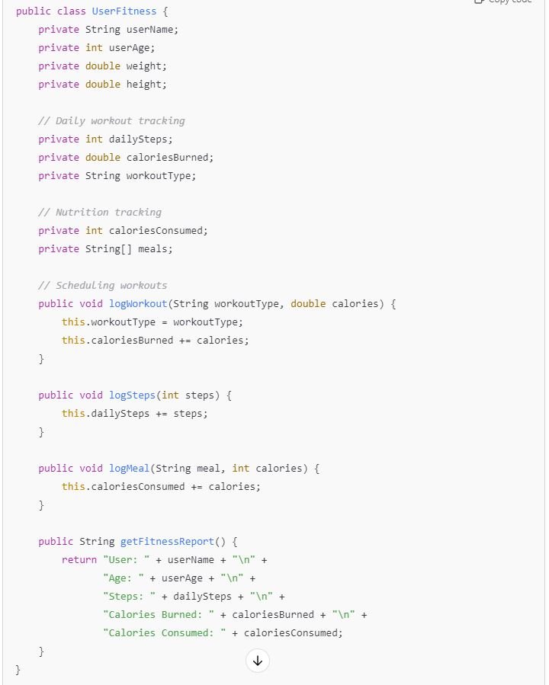

Tasks:
- Analyze the UserFitness class. Explain why this class has low cohesion. (5 pts.)

The UserFitness class lacks cohesion because it tries to manage multiple unrelated tasks within a single class. These tasks include storing personal information (such as the user's name, age, weight, and height), tracking workout activities (such as steps taken and calories burned), monitoring nutrition (e.g., meals and calories consumed), and producing fitness reports that summarize the user's fitness data.

Each of these tasks relates to a different area—personal details, workout tracking, nutrition management, and reporting—and should not be combined into the same class. The principle of cohesion states that a class should be focused on a single, well-defined goal. In this case, trying to cover multiple unrelated topics in one class makes it more difficult to maintain, update, and test. When changes are required for one aspect (e.g., nutrition tracking), they may unintentionally affect other aspects (e.g., workout tracking or report generation). The end result is a class that is excessively complex and difficult to work with.

- Describe, in general, how you would split the UserFitness class into more cohesive classes. Your answer should not be a complete design. (5 pts.)

To improve cohesion in the UserFitness class, the responsibilities should be divided into smaller, more specialized classes, each focusing on a specific domain. Here's a general suggestion for breaking down the class:
1. User Class: This class manages users' personal information, including name, age, weight, and height. By separating personal information into a separate class, the user's data is better encapsulated and managed.
Fields: String userName, int userAge, double weight, and double height.

2. WorkoutTracker Class: This class tracks workout data, including types, steps, and calories burned. This separation ensures that workout tracking is managed independently of other fitness aspects.
Fields: int dailySteps, double caloriesBurned, and String workoutType.
Methods: logWorkout() and logSteps().

3. NutritionTracker Class: This class would focus on tracking nutritional data, such as meals and calories consumed. Separating nutrition tracking ensures that the system is modular, making it easier to update and manage nutrition-related features.
Fields: int caloriesConsumed and String[] meals.
Method: logMeal().

4. FitnessReport Class: This class generates reports summarizing users' fitness activities using data from WorkoutTracker and NutritionTracker classes. By separating report generation and data collection, the system becomes more adaptable and easy to change without affecting other areas.
Method: generateReport().
By dividing the original class into smaller, more cohesive classes, each class can concentrate on a single responsibility. This design enhances maintainability and extensibility by allowing future changes or enhancements to specific areas (such as workout tracking or reporting) without affecting the rest of the system.

Question 2. (5 pts.)
Given the following, answer the below questions.

A university manages its students using a program that has a class Student with subclasses FirstYear, SecondYear, and ThirdYear for year-specific state and behaviors. The program has a List that contains all Students.

Should Student be a class, an abstract class or an interface? Explain your answer

- At the end of each year, the third-year students graduate and must be removed. This is done by passing the list to the following method:

void removeThirdYears(List<Students> students) {
for (Student student : students) {
try {
ThirdYear = (ThirdYear) student;
students.remove(thirdyear);
}
}
}

The Student class should be an abstract class because it represents a general concept that includes shared attributes and behaviors like name and studentID, which all students have in common. By making it abstract, we can define these shared features once and allow subclasses like FirstYear, SecondYear, and ThirdYear to inherit them, while still giving each subclass the flexibility to add specific behaviors relevant to their year.

Using an interface wouldn't work well in this case because interfaces can't store data (like fields), so every subclass would have to redefine those common properties. A concrete class isn't suitable either since the Student class is meant to serve as a foundation for more specialized types of students, not something we want to create directly.

Why is the above method flawed? Hint: Another Arthur Riel heuristic (5 pts.)

The current method has two major drawbacks. First, it will throw a ConcurrentModificationException because the list is being modified while being iterated over with a for-each loop. To address this issue, an Iterator should be used, which allows for the safe removal of elements during iteration. Second, the line ThirdYear = (ThirdYear) student; assumes that every student is a ThirdYear, which will result in a ClassCastException if a student does not match that type. The correct solution is to use the instanceof keyword to check the student's type before casting, removing only ThirdYear instances.

Question 3. (5 pts.)
Given the following, answer the below questions.

public class BankAccount {
public String accountHolderName;
public String accountNumber;
public double balance;
public double interestRate;

public BankAccount(
String accountHolderName,
String accountNumber,
double initialDeposit,
double interestRate) {
this.accountHolderName = accountHolderName;
this.accountNumber = accountNumber;
this.balance = initialDeposit;
this.interestRate = interestRate;
}

// Exposed implementation for adding interest
public void addInterest() {
double interest = balance * (interestRate / 100);
balance += interest;
}

// Exposed implementation for deposits
public void deposit(double amount) {
balance += amount;
}

// Exposed implementation for withdrawals
public void withdraw(double amount) {
balance -= amount;
}
}

- Is BankAccount well-encapsulated? Why or why not? If so, describe what changes you would make to the class. Otherwise, state nothing. (5 pts.)

No, the BankAccount class is not correctly encapsulated. The fields accountHolderName, accountNumber, balance, and interestRate are declared public, exposing the class's internal state for direct access and modification. This violates the principle of encapsulation, which states that an object's internal state should be concealed and only accessible via controlled mechanisms.
To improve encapsulation, mark these fields as private. Public getter and setter methods can then be provided as needed to allow for controlled access and modification. Using setters also allows for validation, which ensures that values such as deposit amounts or interest rates are checked before any changes are made, thereby maintaining data integrity.

Question 4. (10 pts.)
Given the following, answer the below questions.

Given:
A car manufacturer uses Java software to track current vehicles being built. The UML diagram below shows an excerpt of the current software structure. You should assume the presence of other appropriate fields and methods

Car
getTrimLevel()
Engine
accelerate()
getFuelLevel()
Base
Sports
Luxury
Electric
Petrol

Each car can be built to one of three trim levels: Base, Luxury or Sport. They can also be configured with an electric or petrol engine. At various points in the manufacturing process the customer can choose to change the trim level.

Task:
- Explain in detail why the current structure does not support this. (5 pts.)

The current structure most likely treats trim levels (Base, Sports, and Luxury) as subclasses of the Car class. This hierarchical setup has limitations because it prevents the trim level from being changed dynamically during runtime. If you need to switch from one trim level (e.g., Base) to another (e.g., Luxury), you must create a new object of the appropriate subclass, which is inefficient. Furthermore, this design assumes that the trim level is fixed when the object is instantiated and does not include a mechanism for updating it later. As a result, the system lacks the ability to change the trim level of a vehicle after it has been created.

- Describe how to refactor the structure to allow trim-level change for a car to dynamically change. Hint: How would you modify Car to use composition to solve the problem? (5 pts.)

To make the trim level configurable at runtime, the design should use composition rather than inheritance. One solution is to create a TrimLevel interface with concrete implementations such as BaseTrim, SportTrim, and LuxuryTrim. The Car class would then have a reference to a TrimLevel object, and you could add a method called setTrimLevel(TrimLevel newTrim) to change the trim dynamically. This method allows the same Car object to change its trim level without having to create a new instance, increasing flexibility and improving system efficiency.

Question 5. (5 pts.)
Suppose you are about to code a particular class and find that you have written another class with nearly the functionality that you now are developing. This means that the two classes in large parts contain the same code, but in smaller parts have different code. Explain in detail why this may be a problem and how to solve it. Give your answer in terms of Arthur Riel’s design heuristics.

If two classes have similar functionality but differ in minor details, it can cause several problems. According to Arthur Riel's design heuristics, here are the potential problems and solutions:
Problems:
1. Code duplication: This violates the DRY (Don't Repeat Yourself) principle, making the codebase more difficult to maintain and prone to errors.
2. Increased Maintenance: Changes will need to be made in several locations, increasing the likelihood of inconsistencies and errors.
3. Poor Organization: Spreading similar logic across multiple classes makes it more difficult to understand, debug, and modify the code.

Solutions:
1. Use Inheritance: If two classes have a "is-a" relationship, move their shared code to a common base class.
2. Favor Composition over Inheritance. If inheritance is not appropriate, move the shared code to a separate class and use composition to reuse it across both classes.
3. Abstract Classes or Interfaces: These can provide a shared structure, ensuring consistent behavior among related classes.
4. Apply Design patterns: Use patterns such as the Template Method, can help you manage common and varying logic more efficiently.
Finally, duplicating code introduces unnecessary complexity and risks. Using Riel's heuristics, such as inheritance, composition, or design patterns, can help ensure that your codebase is clean, maintainable, and flexible.

Question 6. (5 pts.)
Suppose we need to store instances of the classes Car and BankAccount in a database. To obtain low coupling it may seem as if the functionality to save an instance should be in precisely those classes, since they have the information that shall be saved. Why is it unwise to place the database calls there?

Placing database calls within the Car and BankAccount classes is unwise for several reasons:
1. Separation of Concerns: These classes should focus on their core logic rather than how data is stored or retrieved.
2. Single Responsibility Principle (SRP): It is violated because combining domain logic with persistence logic requires changes to both the database and the domain class.
3. Tight Coupling: Embedding database code reduces flexibility, making it difficult to switch to a different storage solution later.
4. Test Difficulties: When database code is tightly integrated with business logic, unit testing becomes more difficult, requiring complex mocks or database setups.
5. Poor Maintainability: Mixing responsibilities complicates code maintenance and updates.

Solution:
Use a repository or DAO (Data Access Object) pattern to manage database interactions separately. This enables the Car and BankAccount classes to concentrate on their primary responsibilities, while the repository handles data storage. This approach encourages modularity, flexibility, and easier testing.

Question 7. (5 pts.)
Given a set of requirements, what conditions must be met to make it appropriate to create a new class hierarchy using inheritance? Neither superclass nor subclass exist before, the question is about designing a new class hierarchy.

To justify the creation of a new class hierarchy through inheritance, the following conditions must be met:
Common Features: To avoid redundancy, the classes should share attributes or behaviors that can be abstracted into a single parent class.
"Is-a" Relationship: The subclass should logically fall under the parent class. For example, a Car is a type of Vehicle that reflects a natural hierarchy.
Polymorphism: This requires the ability to use different subclasses interchangeably, with the parent class defining behavior that can be overridden or extended in each subclass.
Scalability: If more subclasses are likely to be added in the future, inheritance makes it easier to extend the system.

Code Reusability: Shared functionality should be placed in the parent class rather than being redefined in each subclass.
Specialization: Subclasses should add or modify parent class behaviors to reflect their specific role.
Logical Structure: The hierarchy should be clear and intuitive, allowing you to easily understand the relationships between classes.

Question 8. (2.5 pts.)
Describe the difference between inheritance and composition why would you choose one over the other.

In object-oriented programming, there are two methods for managing class relationships: inheritance and composition. Inheritance establishes a "is-a" relationship, in which a subclass inherits properties and behavior from its superclass. This is useful when multiple classes have similar functionality and a hierarchy is required to extend or override behaviors. It also supports polymorphism, which lets the same method behave differently depending on the subclass. For example, a car is a type of vehicle.
Composition, on the other hand, creates a "has-a" relationship in which one class contains instances of other classes in order to utilize their functionality. For example, a car has an engine. Composition provides greater flexibility because components can be swapped or reused without adhering to a specific class hierarchy. It encourages loose coupling, which makes the code easier to maintain and extend.
When there is a clear hierarchy and the need to extend shared behavior, inheritance is the preferred method. Composition is a better option for increased flexibility, modularity, and ease of maintenance because it avoids the potential pitfalls of tightly coupling classes through inheritance.

Question 9. (2.5 pts.)
Explain the meaning of cohesion and describe whether low or high cohesion is better.

Cohesion measures how closely related and focused the responsibilities of a class or module are. High cohesion means that a class has a single, well-defined purpose, with all of its methods and attributes contributing toward that goal. Low cohesion occurs when a class handles multiple, unrelated tasks, which makes it harder to understand, maintain, and test.

High cohesion is preferred because it leads to cleaner, more organized code. Classes with high cohesion are easier to maintain and less prone to errors, as changes in one area are unlikely to affect other parts of the system. They are also more reusable, since focused classes are easier to adapt for different contexts.

Low cohesion, on the other hand, can produce complex, difficult-to-manage code that combines unrelated responsibilities. This raises the possibility of bugs and makes maintenance and testing more difficult. As a result, code with high cohesion is more likely to be maintainable, robust, and flexible.

