Hosho Digital Sales Management System
Solution Document for Orbit Sales OS
Prepared on 22 May 2026
This document accompanies the working CRM application, ERD source, screenshots, and Power BI-ready dataset assets.
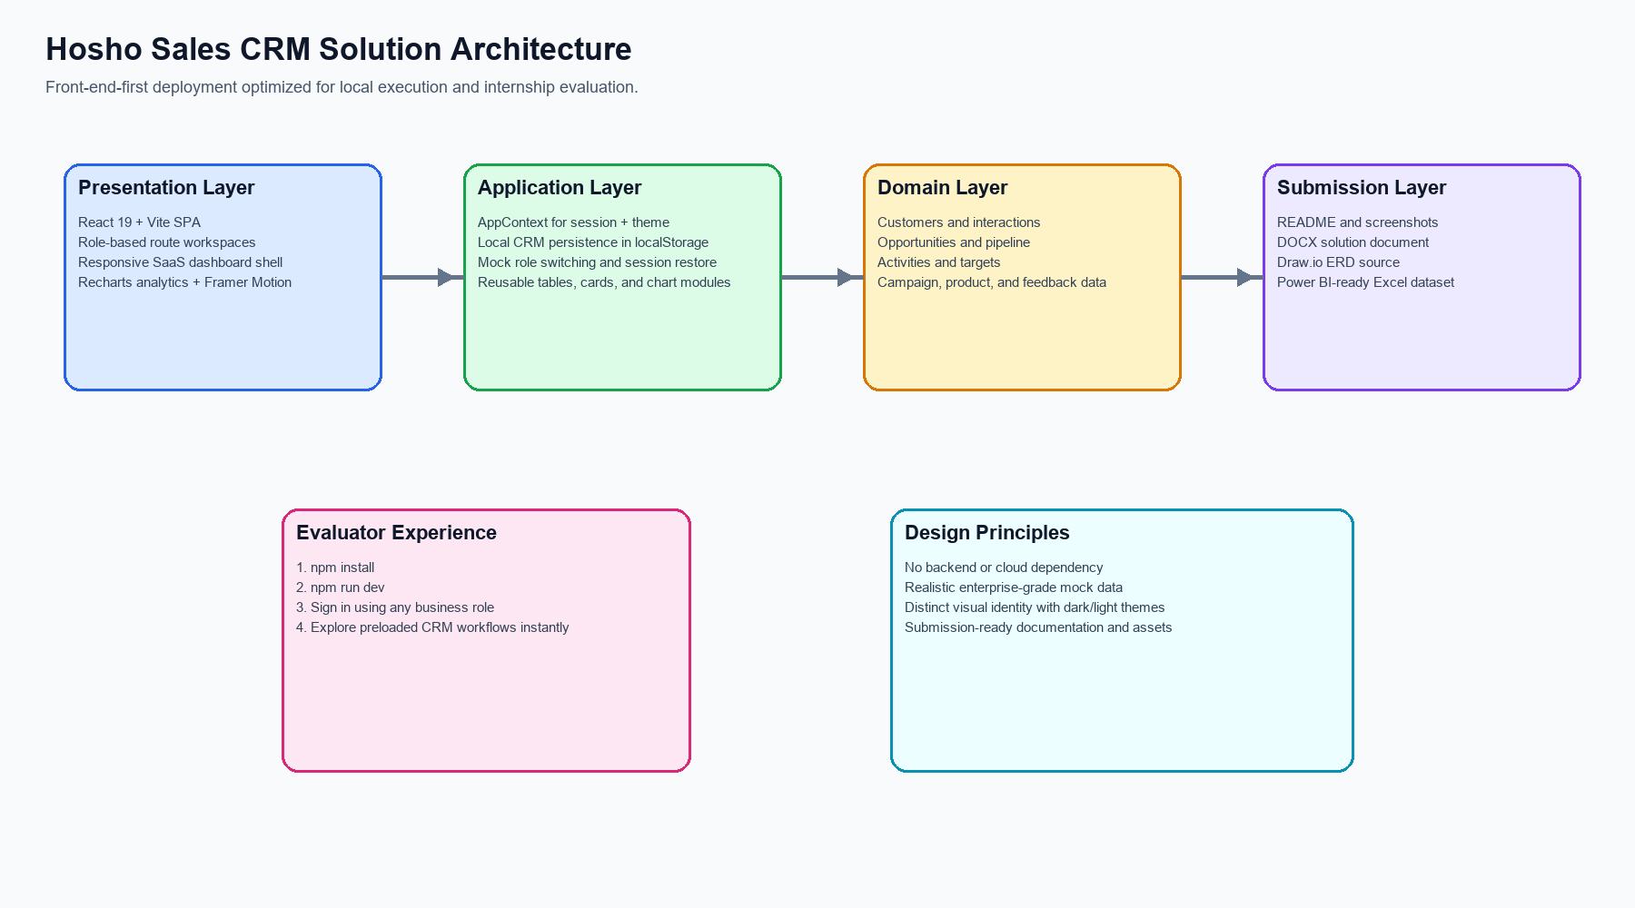

1. Background
The assignment requires a complete Sales Management website backed by user stories that span sales representatives, sales managers, account managers, marketing, product management, and executive leadership. The solution needed to feel polished and business-ready while remaining extremely easy to run in a local evaluation environment.
Orbit Sales OS was designed as a front-end-first CRM operating workspace that emphasizes usability, visual quality, realistic demo data, and maintainable modular code. The result is intentionally enterprise-styled without depending on external infrastructure or manual database setup.

2. Requirement Overview
- Professional login experience with role selection and session persistence.
- Dashboard with KPI cards, charts, pipeline summary, revenue insights, conversion metrics, and forecasts.
- Customer management with CRUD actions, customer profile pages, and interaction history.
- Sales opportunities and pipeline tracking with deal values, stages, and ownership.
- Activities management covering calls, meetings, notes, and follow-ups.
- Team performance views for quotas, territories, leaderboard ranking, and discount approvals.
- Reports and analytics for forecasting, revenue, win/loss, and regional performance.
- Marketing features for campaign tracking, ROI, segmentation, and lead sharing.
- Product features for updates, feature requests, feedback capture, and documentation support.
- Executive analytics for strategic KPI monitoring and high-level business signals.
- Submission artifacts including ERD, screenshots, solution document, and Power BI-ready Excel data.

3. Solution Approach
A single-page React application was selected to reduce setup complexity while still delivering a premium SaaS user experience. Instead of introducing a backend and database that would slow evaluation, the application uses realistic preloaded data and local persistence through browser storage. This keeps startup friction low and allows the evaluator to interact with the product immediately after installation.
- Use a route-based CRM shell so each business area feels like a distinct operational workspace.
- Centralize state, role session, and local persistence in a single application context.
- Use reusable analytics and card components to maintain a consistent visual system.
- Support all user stories with focused page modules rather than a monolithic dashboard.
- Package the assignment with documentation, diagrams, screenshots, and Excel data to create a complete submission set.

4. Solution Architecture
The architecture is intentionally simple, modular, and local-first. Presentation, application state, and domain data are separated so the evaluator can understand and extend the codebase quickly.

Architecture summary: React and Vite power the presentation layer, AppContext manages role session and local persistence, reusable page modules implement business workflows, and submission assets live alongside the source for easy review.

5. Technical Details
- React 19 and Vite provide fast local startup and a clean modern development workflow.
- React Router organizes the product into customer, pipeline, activities, team, reports, marketing, product, and executive pages.
- Tailwind CSS plus custom design tokens provide a distinct CRM visual identity with dark and light themes.
- Recharts is used for revenue trends, regional performance, funnel views, and win/loss visuals.
- Framer Motion adds subtle motion and hover feedback to make the UI feel premium.
- Vitest is used for utility-level verification of KPI calculations.
- Browser localStorage is used for data persistence so user changes survive refreshes without external setup.
- Power BI support is delivered through an import-ready Excel workbook with multiple normalized sheets.

6. Benefits of the Solution
- Very low evaluator setup cost.
- Broad role coverage without authentication overhead.
- Professional and unique visual presentation rather than a generic student layout.
- Simple modular codebase that is easy to explain during review.
- Submission package covers both product implementation and communication assets.

7. Alternate Approach
An alternate approach would be a full-stack implementation using a Node API and SQLite or PostgreSQL database with real authentication and persisted relational records. That approach would be more production-like for long-term deployment, but it would increase local setup complexity, introduce migration concerns, and create more failure points for a short internship evaluation.
The chosen approach deliberately prioritizes immediate usability, strong visual execution, and clarity of submission over backend complexity. For this assignment context, that tradeoff provides a better evaluator experience.

8. Assumptions
- Mock role switching is acceptable in place of enterprise authentication.
- Local persistence is acceptable for assignment evaluation.
- Power BI support can be satisfied through high-quality import-ready Excel data and dashboard guidance.
- Realistic mock data is sufficient as long as the workflows feel coherent and interactive.
- The app should optimize for localhost execution rather than cloud deployment.

9. ERD Diagram
The draw.io source file is included in the repository as `Hosho_Sales_CRM_ERD.drawio`. A preview is embedded below for convenience.
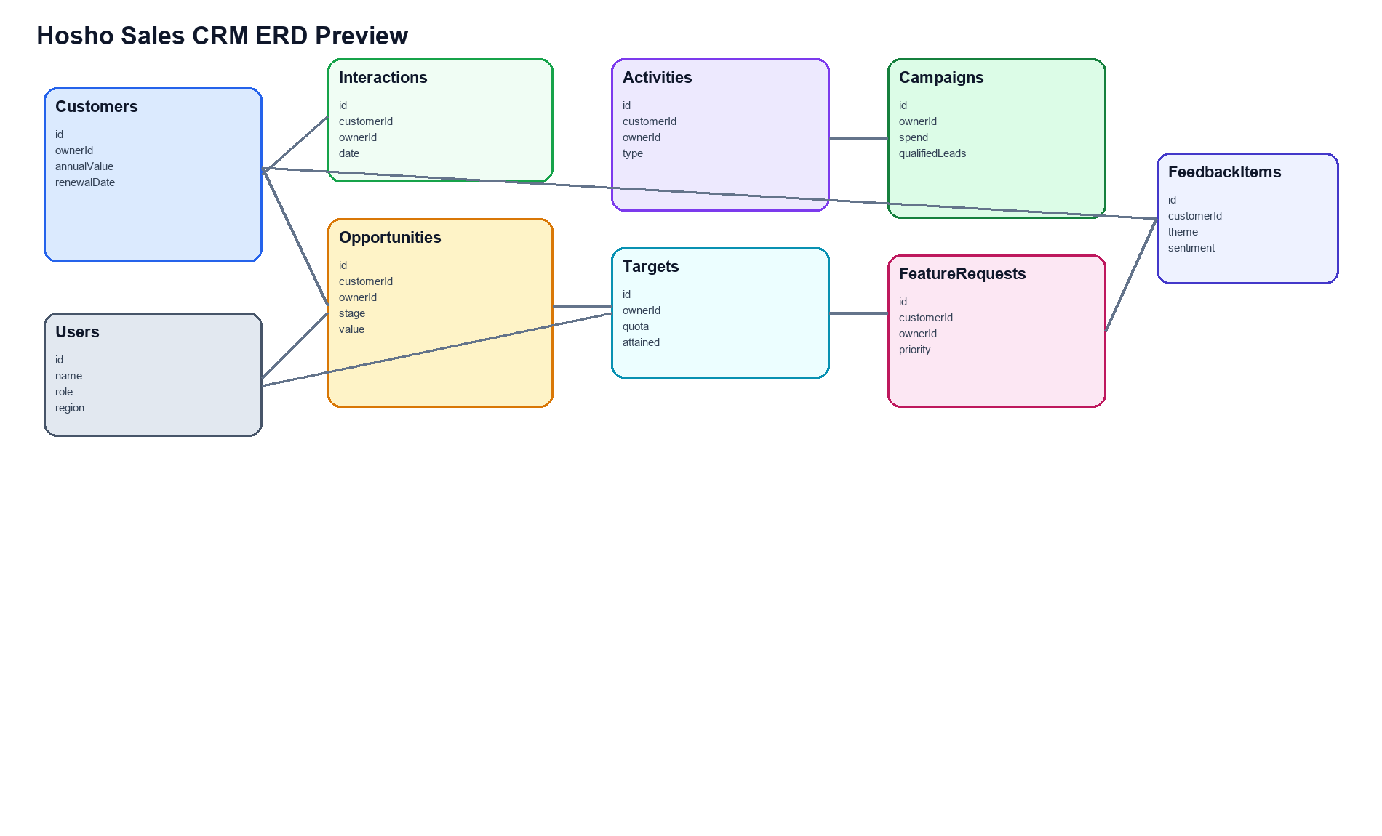

10. Application Screenshots

Dashboard and analytics cockpit
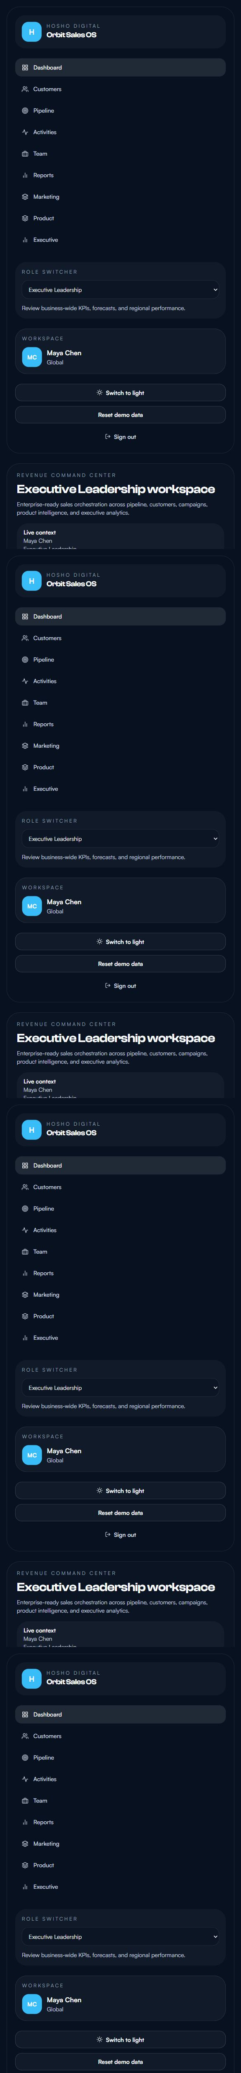

Customer management workspace
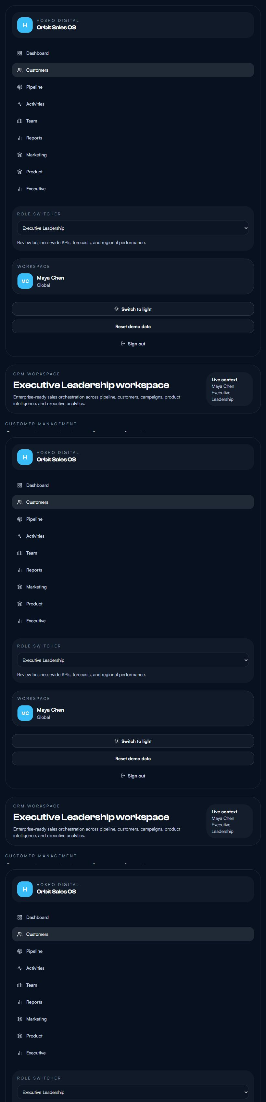

Pipeline management board
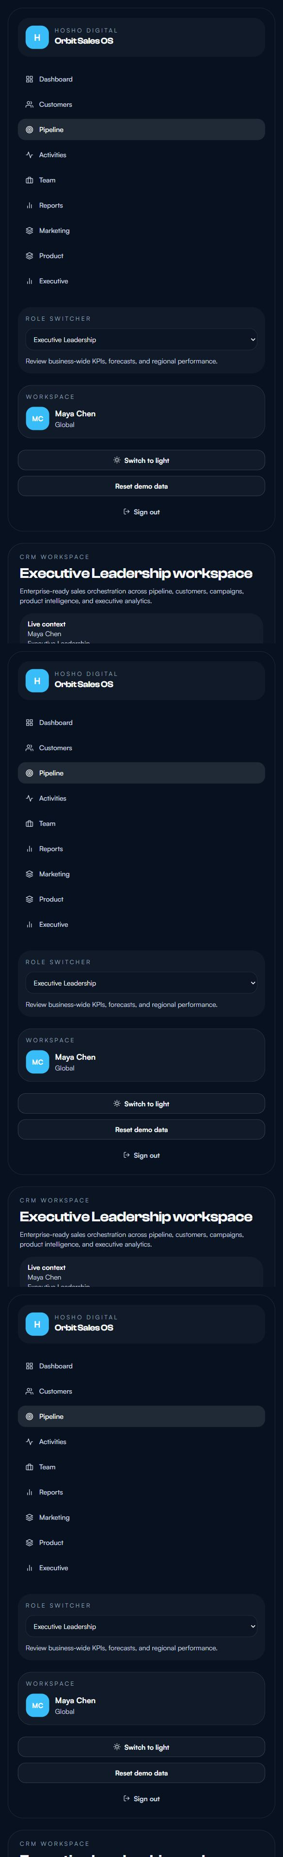

Reports and forecasting workspace
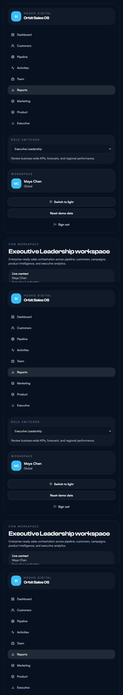

Marketing performance workspace
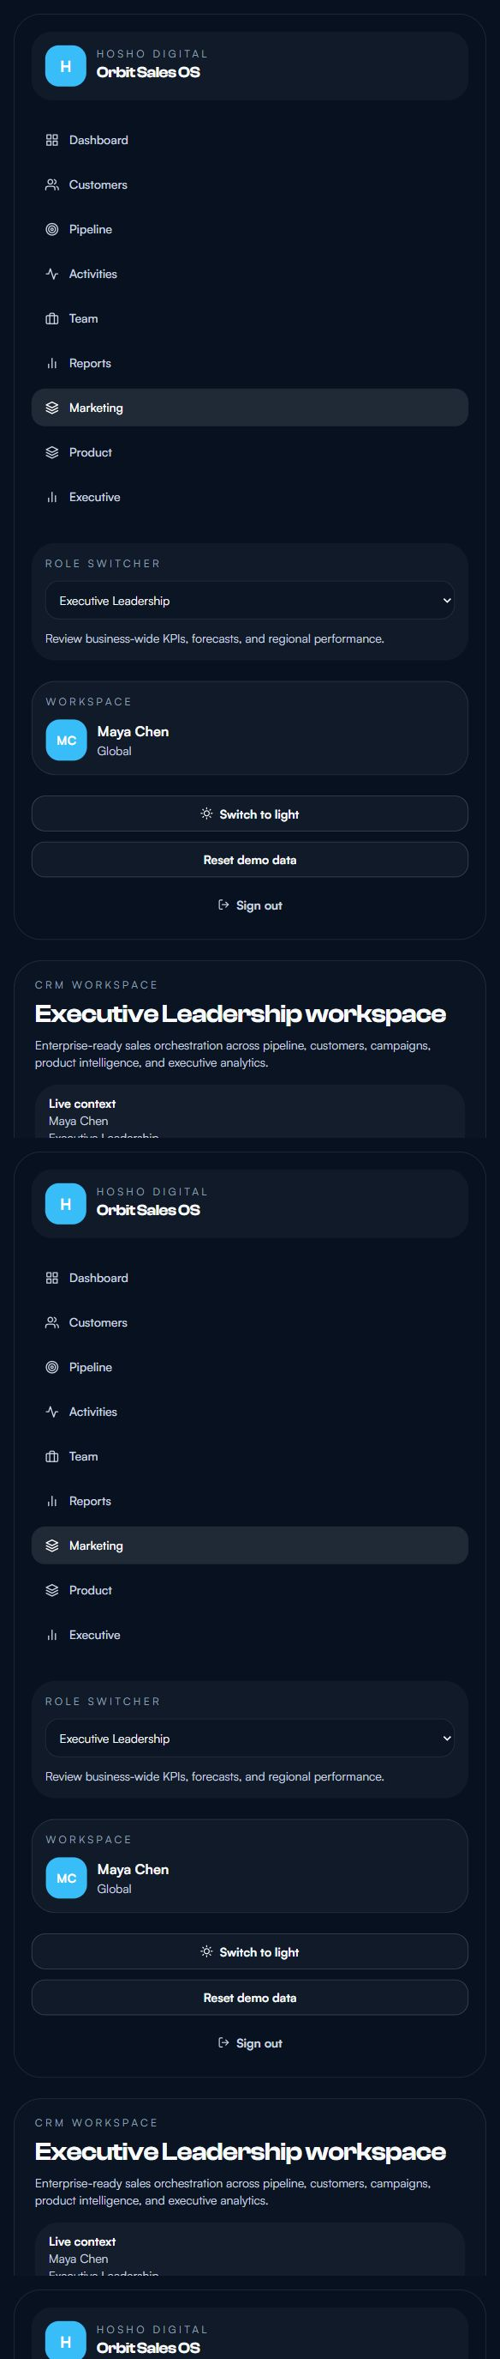

Executive analytics workspace
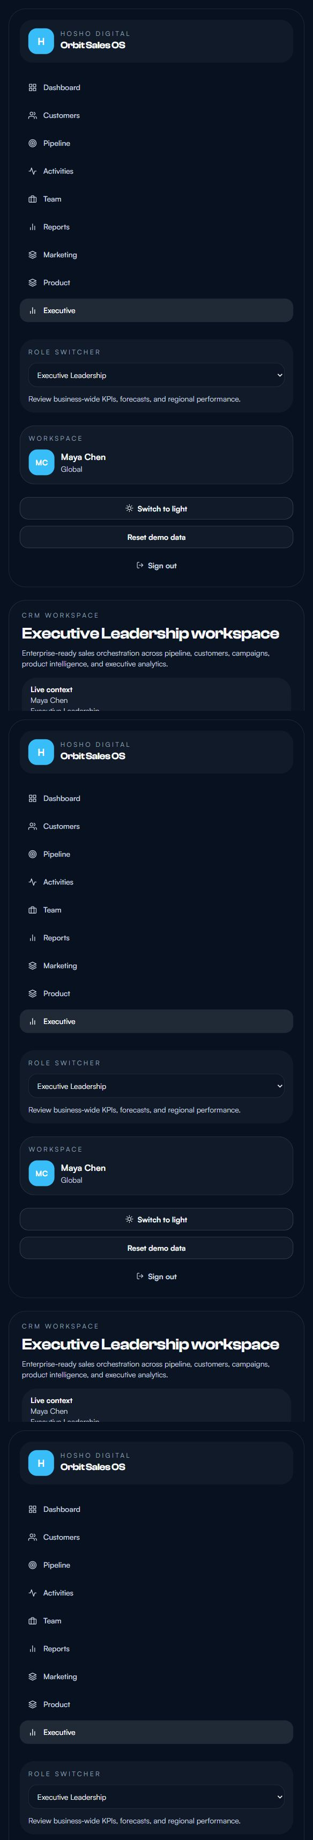

Role-based login experience
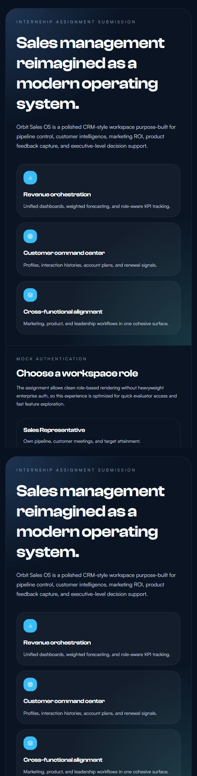

11. Conclusion
Orbit Sales OS satisfies the role-based user stories from the assignment while staying easy to run, easy to review, and visually impressive. The solution is intentionally balanced: it is complete enough to feel enterprise-oriented, but simple enough to be started locally in minutes without database or cloud dependencies.

