C Programming Project Report
Password Strength Checker


- Course: Programming in C (B.Tech 1st Semester)
- Course Code:
- Submitted By: Aryan Batham, 590021614
- Submitted To: Mohsin Furkh Dar, SoCS
- Date of Submission: 04/12/2025

Problem Statement

Password security is an essential part of digital safety. Many users create weak passwords, making their accounts vulnerable to attacks. The goal of this project is to create a terminal-based Password Strength Checker using basic C programming concepts taught in the first semester.
The program analyzes a password entered by the user and checks for length, uppercase letters, lowercase letters, digits, and special characters. It then calculates a score and displays whether the password is weak, medium, or strong. The program also provides suggestions for improvement and allows users to re-enter stronger passwords.

Objective of the Project

The primary objectives of the Password Strength Checker project are:
1. To design an interactive terminal-based password checking tool using C.
2. To analyze password strength based on multiple criteria.
3. To apply string handling and character classification functions.
4. To reinforce decision-making concepts using conditions.
5. To display user-friendly feedback and improvements.
6. To implement modular programming by splitting code into multiple files.
7. To allow repeated testing of passwords through loops.
8. To ensure proper input handling using fgets().

Software Used

Programming Language: C
Compiler: GCC
IDE: Visual Studio Code / CodeBlocks
Operating System: Windows / Linux
Header Files Used: stdio.h, string.h, ctype.h
Additional Tools: Terminal / Command Prompt
Folder Structure: src/, include/, assets/

Algorithm
1. Start Program
• Ask user to enter a password.
• Read password using fgets().
2. Evaluate Password Strength
• Count length.
• Check for uppercase, lowercase, digits, and special characters.
• Assign score based on criteria.
• Display analysis.
3. Suggest Improvements
• If strength < 5, display tips for creating stronger passwords.
4. Ask User If They Want to Try Again
• If yes → read new password and repeat process.
• If no → exit program.
5. End Program.

Flowchart / Pseudocode

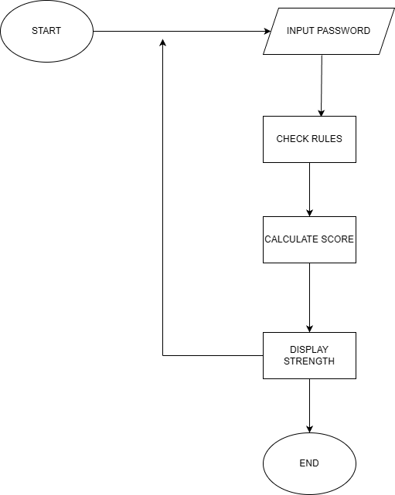

Screenshots of Output

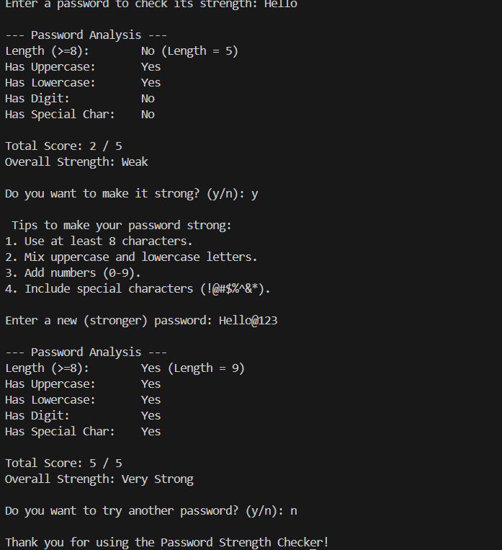

Conclusion & Future Enhancements

This project successfully demonstrates the use of fundamental C programming concepts to build a practical password strength checker. The program integrates string handling, character analysis, conditional statements, loops, and modular programming.
The project improved understanding of program structure, code organization using header files, and user interaction. Future enhancements may include adding GUI support, encryption-based analysis, or checking against common leaked passwords.

