LINUX BASICS

Introduction to Linux:-

(http://www.javatpoint.com/linux-distributions , https://www.digitalocean.com/community/tutorials/an-introduction-to-linux-basics )

- What is linux?

- LINUX is one of the popular version of UNIX OS.
- It is open source as its source code is freely available.
- It is free to use.
- It was designed considering UNIX compatibility.

- Explain the History of LINUX?

- LINUX began in 1991 with the commencement of a personal project by Finnish student Linus Torvalds to create a new free Operating System Kernel.

- What are the benefits of LINUX over other Operating System?

- Portable- Free to use and distribute
- Free Support- through helpsite, blogs and forums
- Reliable
- Live CD/USB- run without installing it directly from CD/USB
- Develop Free Open Source OS
- Security
- Flexibility
- Resistant to malware such as spyware,adware and viruses.
- Multiuser
- Multitasking
- Hierarchical File system
- Shell

- What is a terminal?

- It is an interface in which we can type and execute text based commands.

- Explain the structure of Linux OS?

- An OS is a collection of software, each designed for a specific reason or function.
- LINUX basically has the following components:-
  - Kernel
  - System Libraries
  - System Tools
  - Development Tools
  - End User Tools

- What is a Kernel?

- Kernel is the core of the operating system. It establishes the communication between devices and software. Moreover, it manages the system resources. Its responsibilities are:-
  - Device Management
  - Memory Management
  - Process Management
  - Handling System Calls

- What are System Libraries?

- System Libraries are special programs that helps in accessing the kernel's features.

- Explain Linux Distributions?

- Other Operating Systems like Microsoft combine each bit of code internally & release it as a single package. We have to choose from the version they offer.

But LINUX is different from them, Different part of LINUX are developed by different organizations.https://www.digitalocean.com/community/tutorials/an-introduction-to-linux-basics

LINUX distributors list include Ubuntu, LINUX MINT, Debian, Red Hat Enterprise/Cent OS, Fedora etc.

- How to choose a LINUX Distributor?

- Ubuntu- works like MAC OS and easy to use.
- LINUX Mint- works like Windows & should be use by new corners.
- Desbian- provide stability but not recommended to a new user.
- Fedora- if we want to use RedHat & latest software
- RedHat- to be used commercially
- CentOS- RedHAt without trademark
- OpenSUSE- work same as Fedora but slightly older & more stable
- Arch LINUX- not for beginners beacuase every package has to bes installed by ourself.

- What is LINUX Licensing?

- Linus Torvalds has given license to GNU General Public License (GPL) version 2. It make sure that any software source code licencensed under it have to make originating source code open and freely available to all its users. Here, Freely available means code can be distributed and modified.

LINUX Directories

- What are commands?

- It is instruction given to our computer by us to do whatever we want. In Mac OS & Linux, it is called terminal whereas In Windows, it is called command prompt.

- They are executed by typing in at command line followed by pressing Enter Key. It then passes to the shell which reads the command and execute it.

- It then passes to the shell which reads the command & execute it.

- Shell is a method for the user to interact with the system. The default shell in LINUX is bash( Bourne-Again Shell)

- There are two types of commands:-
  - Built-in
  - External/Linux commands

- What are the various LINUX directory commands?

- CTRL+ALT+ T – to open LINUX terminal

- pwd - stands for print working directory. It is used to show which directory we are presently working in.
eg.

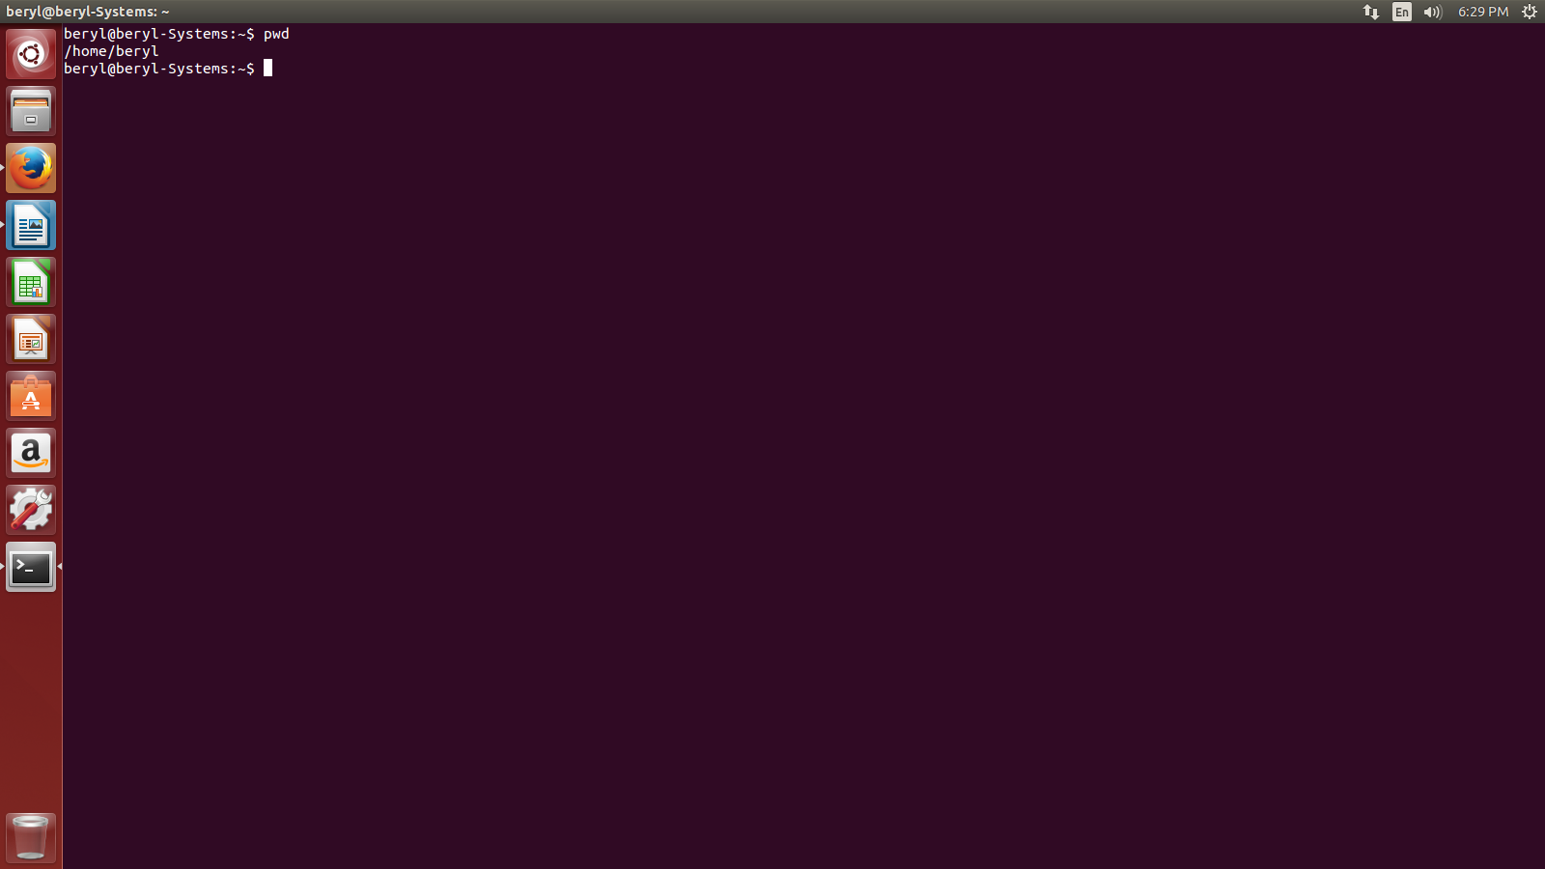

- ls – is used to show the list of folder or to see the files & directories in our current working directory.
eg.

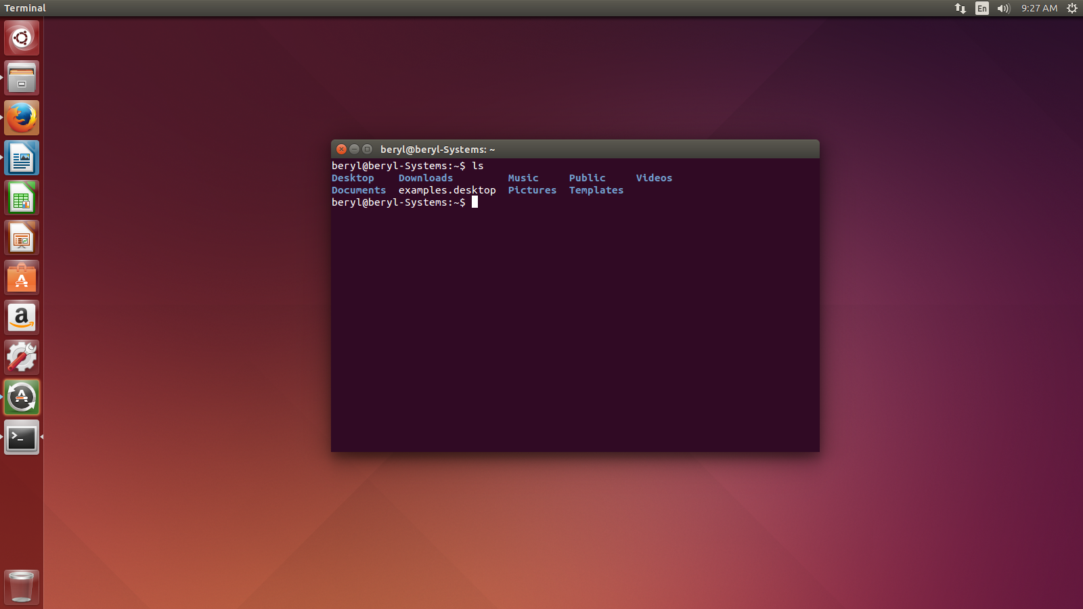

- cd – is used to change the present working directory.
eg.
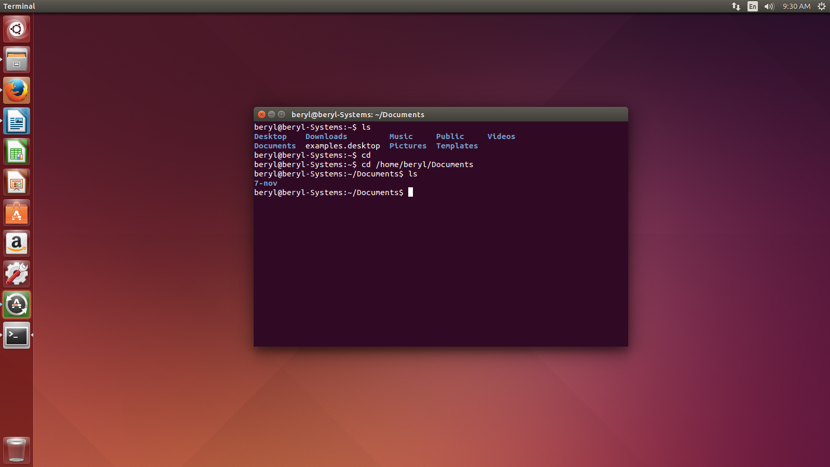
LINUX Basics

LINUX Directories:-

- What are the various directory commands?

- mkdir – stands for make directory. It is used to create our own specified directory
eg.

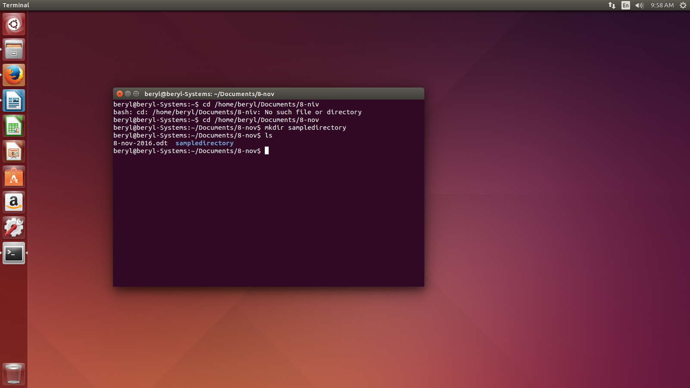
- rmdir – stands for removing directory. It is used to remove the empty directories.
eg.

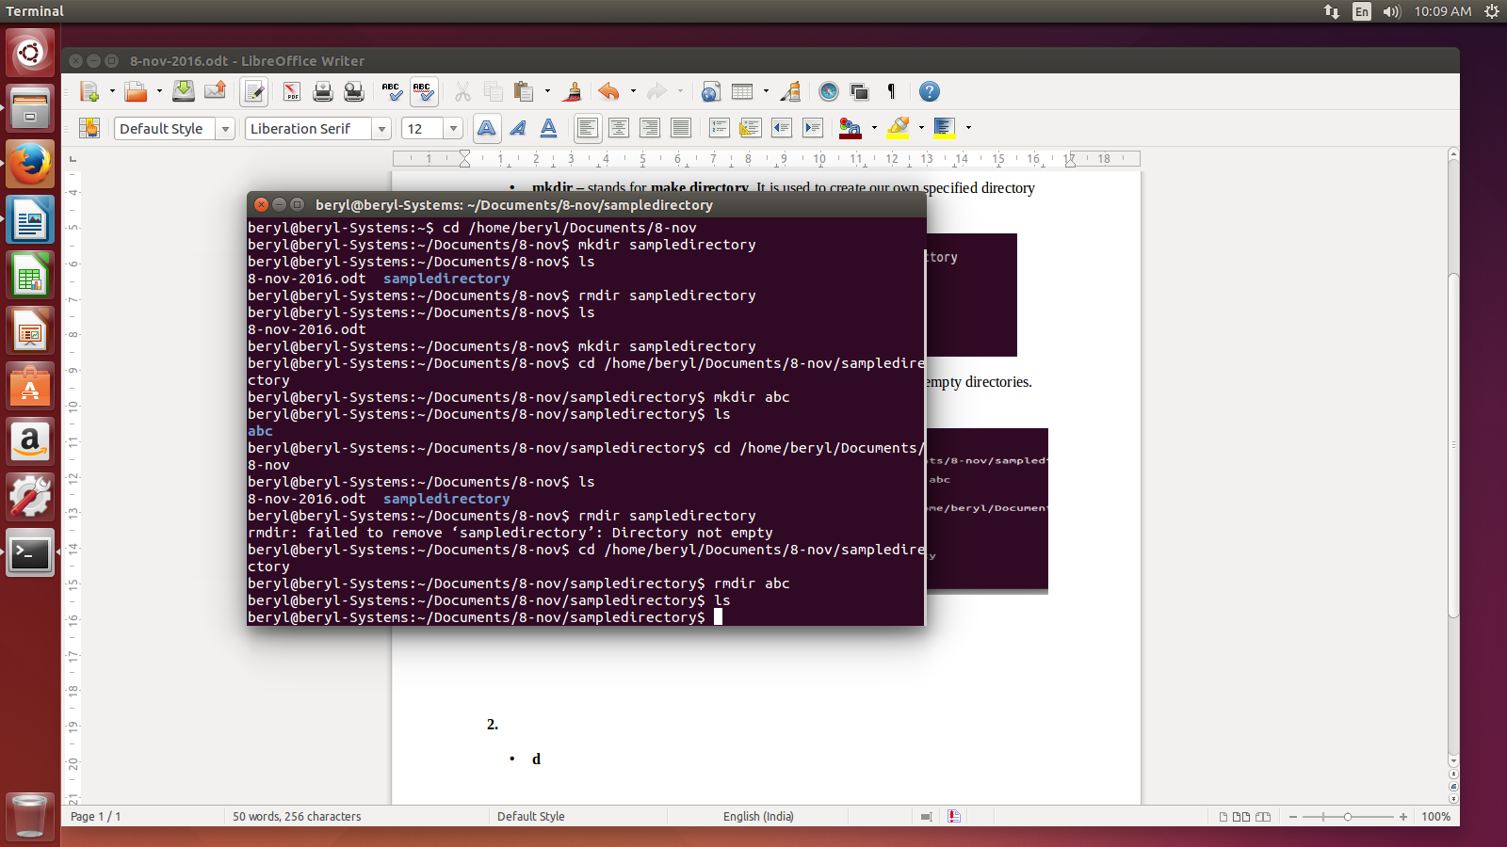

- What are the various options to use cd commands?

- The various options to use cd commands are:-

  - cd ~ - brings us to the home directory. eg.

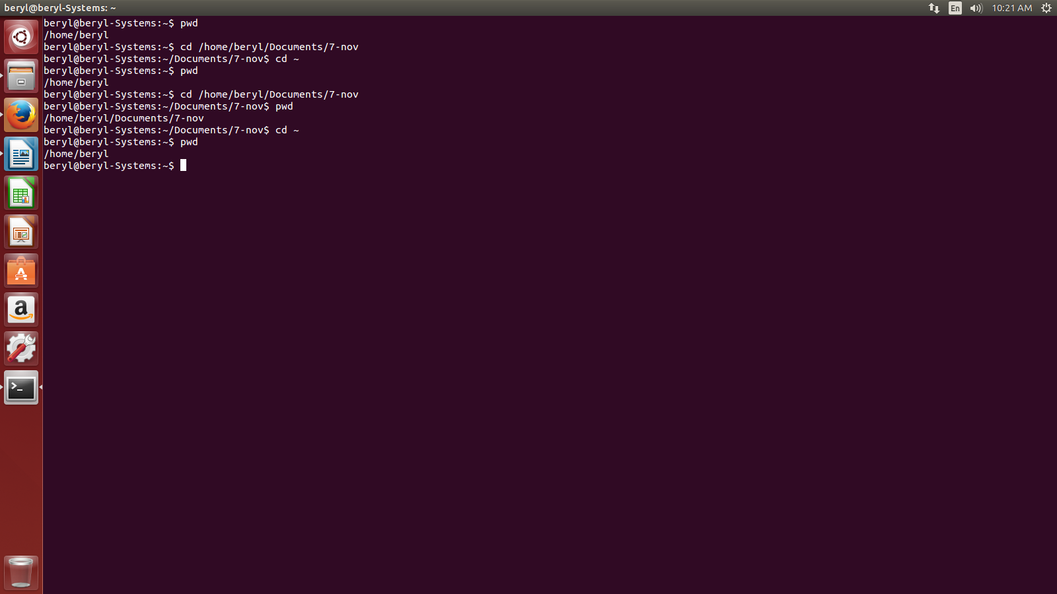

  - cd - - brings us to the previous directory of the current directory. eg.

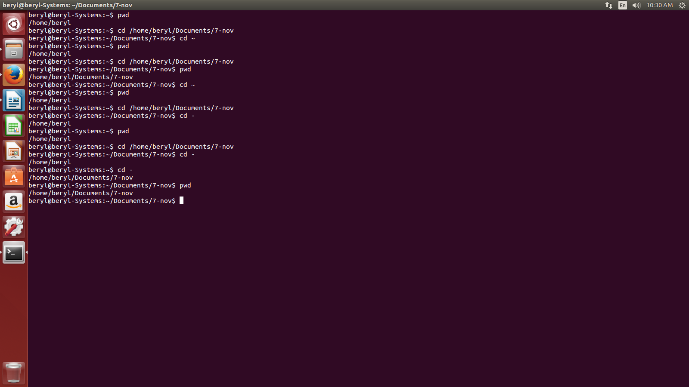

  - cd .. - brings us to the home directory of the current directory.eg.

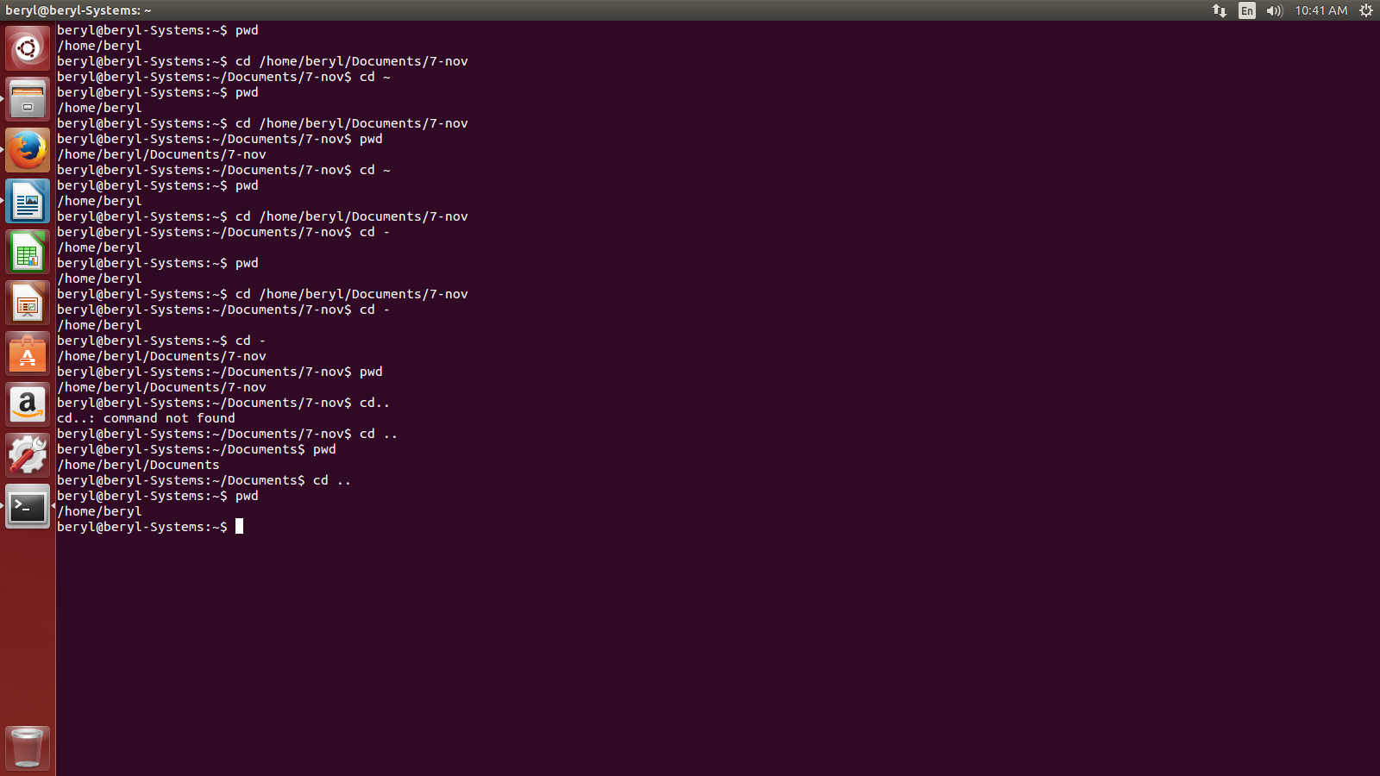
  - cd / - takes us to the entire system root directory. eg.,

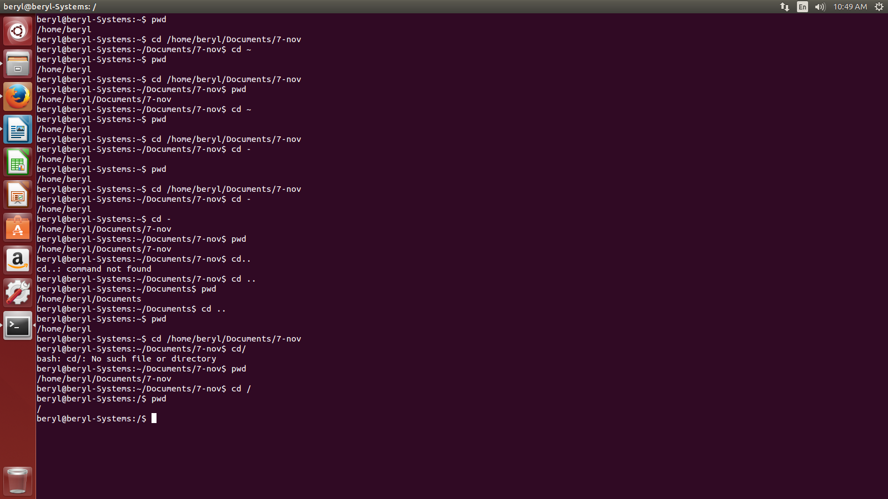

- What is ls command and what are the different options of using ls command?

- ls command is the list command in Linux that show list or content of a directory. The various options to use ls command are:-

  - ls -a – show the list of all the files including the hidden files as well. eg.,
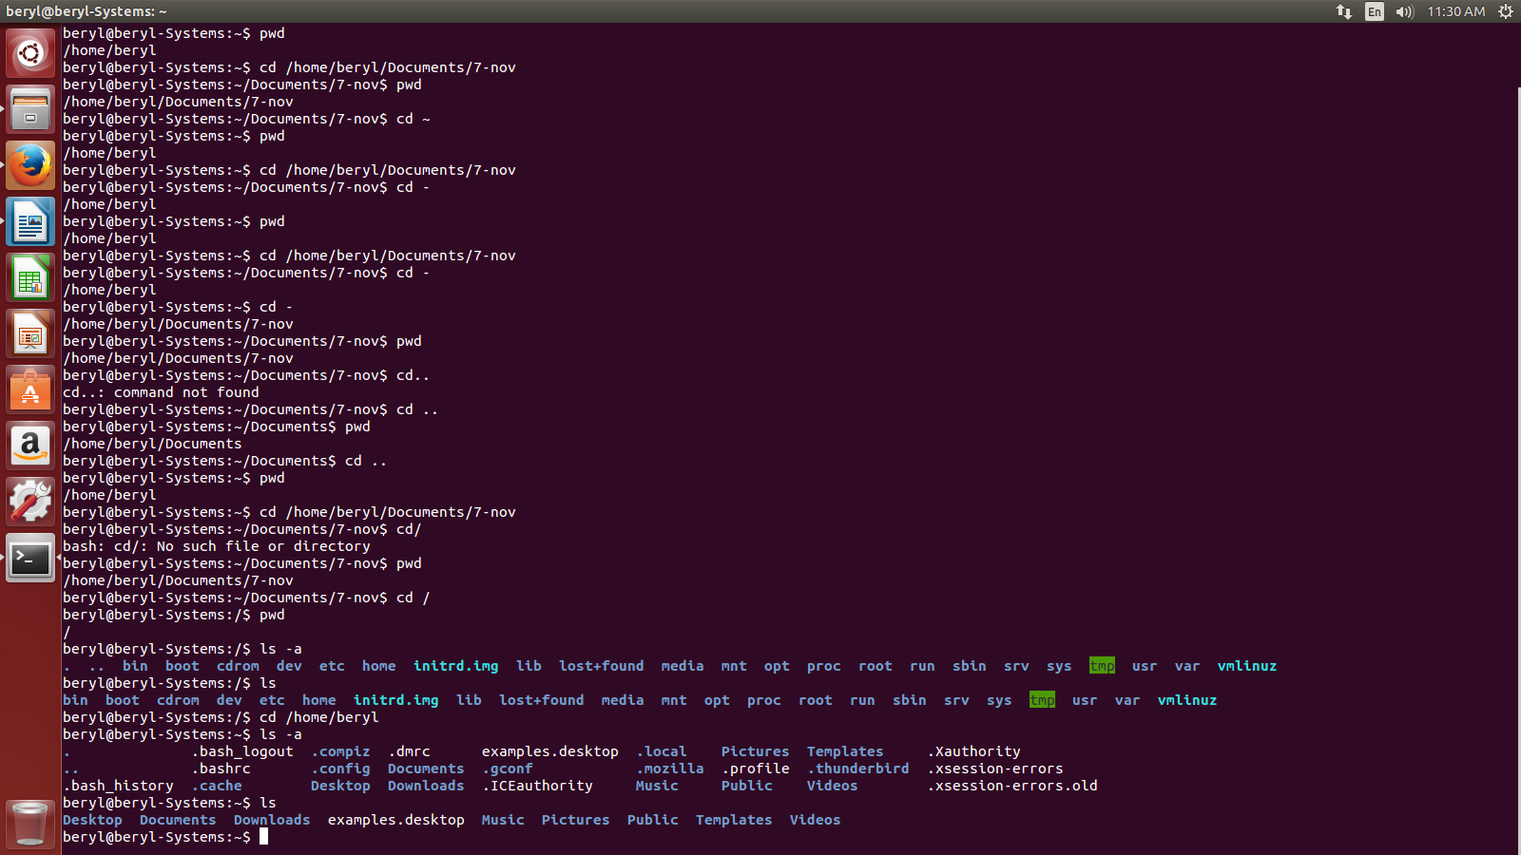
  - ls -l – shows the detailed list of the files in a folder. eg.

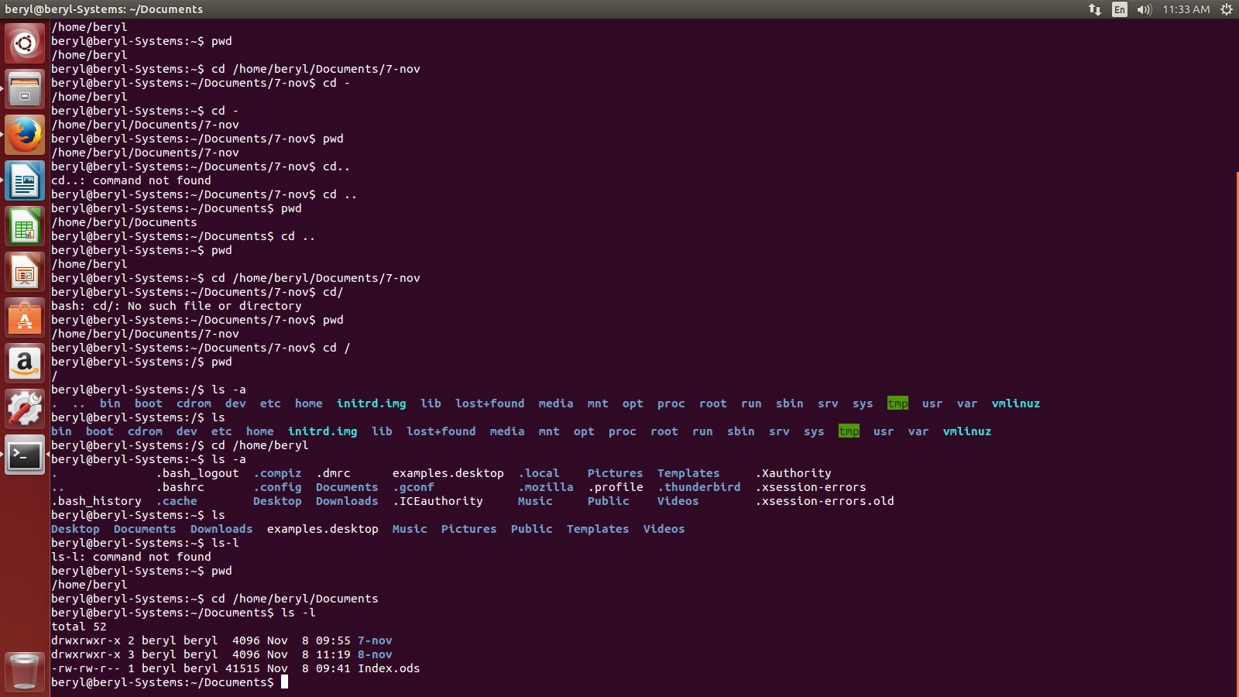
  - ls -lh – show the detailed list of the files in a human readable format. eg.,

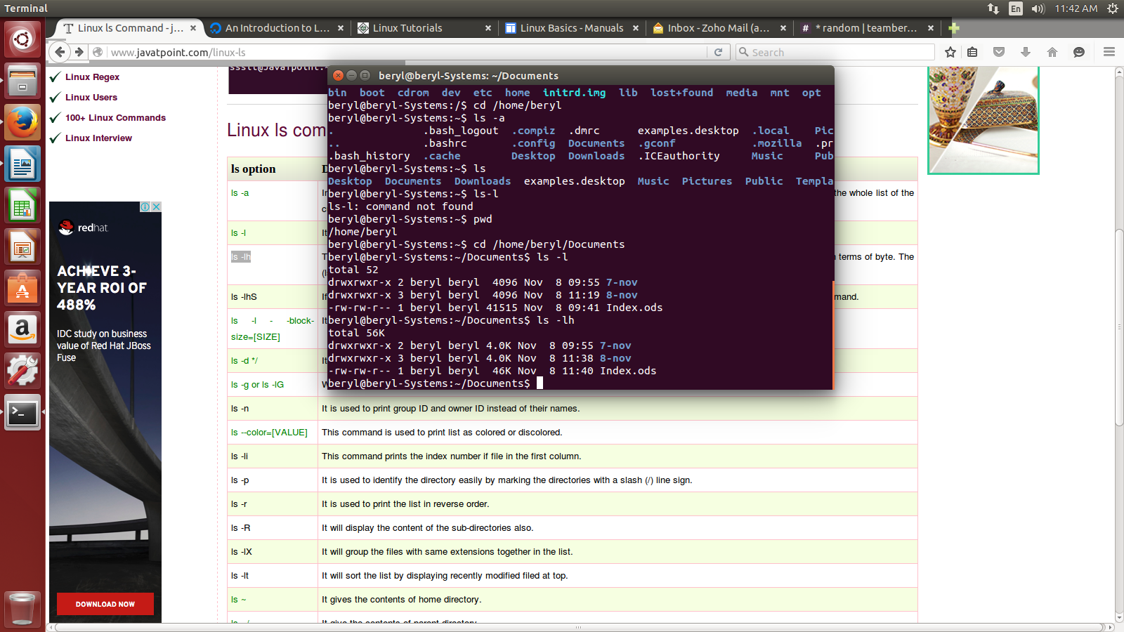

    - ls -lhS and ls -lS – show the detailed list of files according to size in descending order.

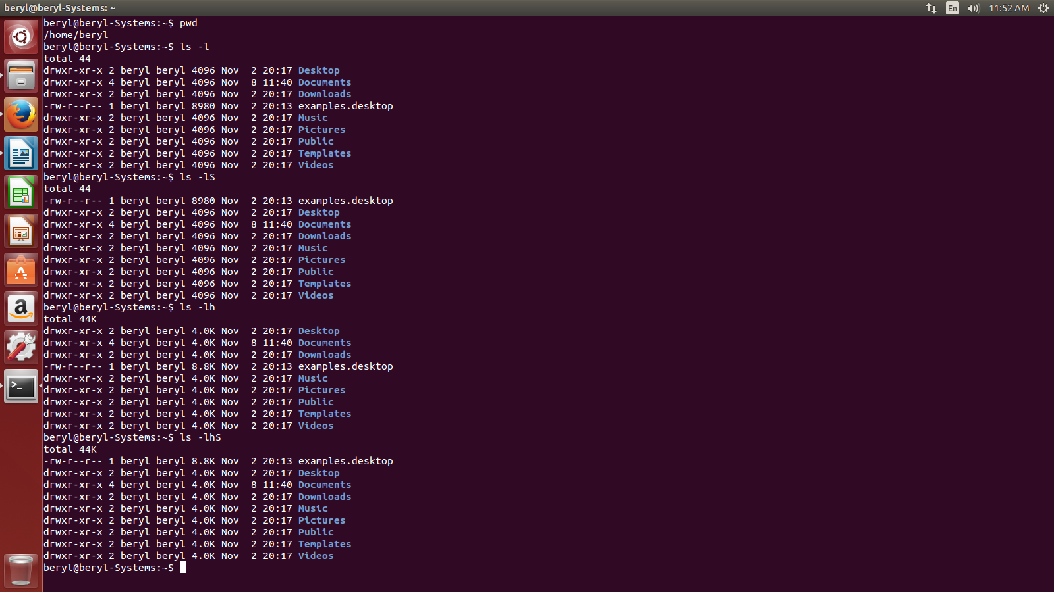

    - ls -d */ - is used to display the subdirectories of a directory.
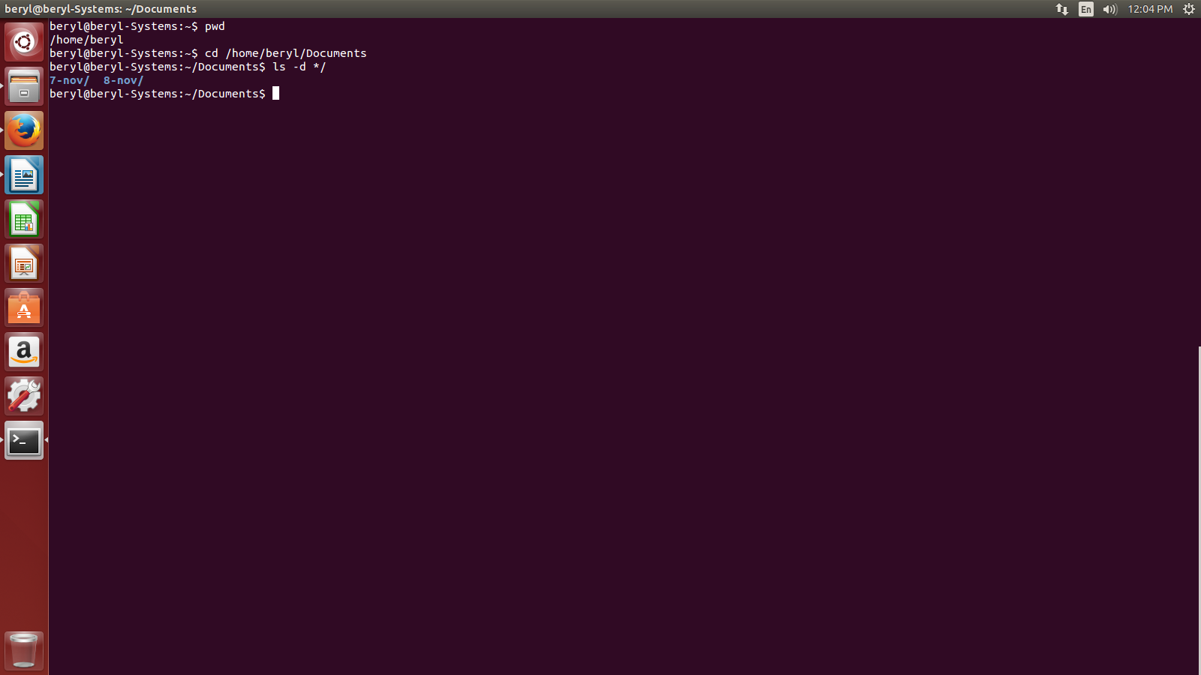

    - ls -g – is used to exclude the column of group information and owner.
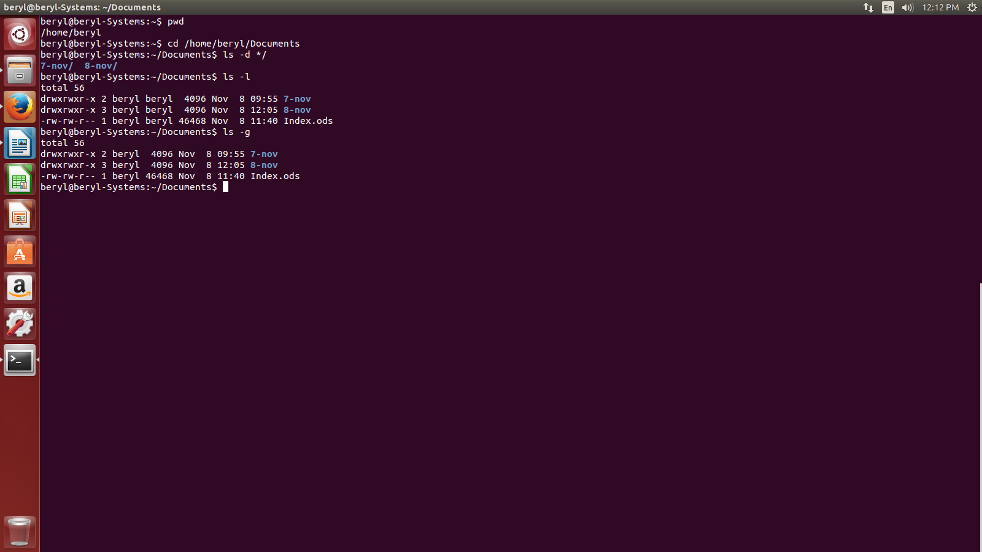

    - ls -n – is used to print the list of files in detail but here it would list the id of owner and groups rather than their names.

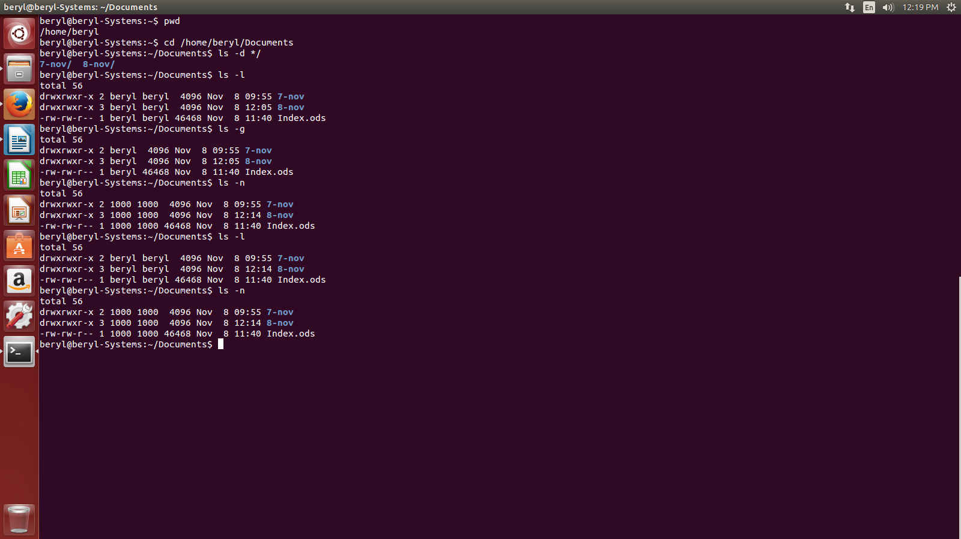

    - ls –color=[value] – is used to the change the color of the font. The value can be never, auto etc.

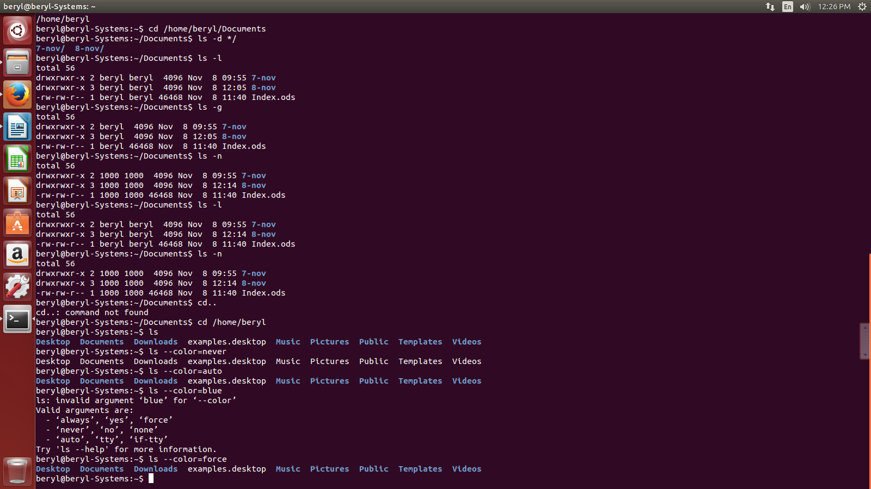
    - ls -li – is used to show the detailed list of files with an index number.eg.,
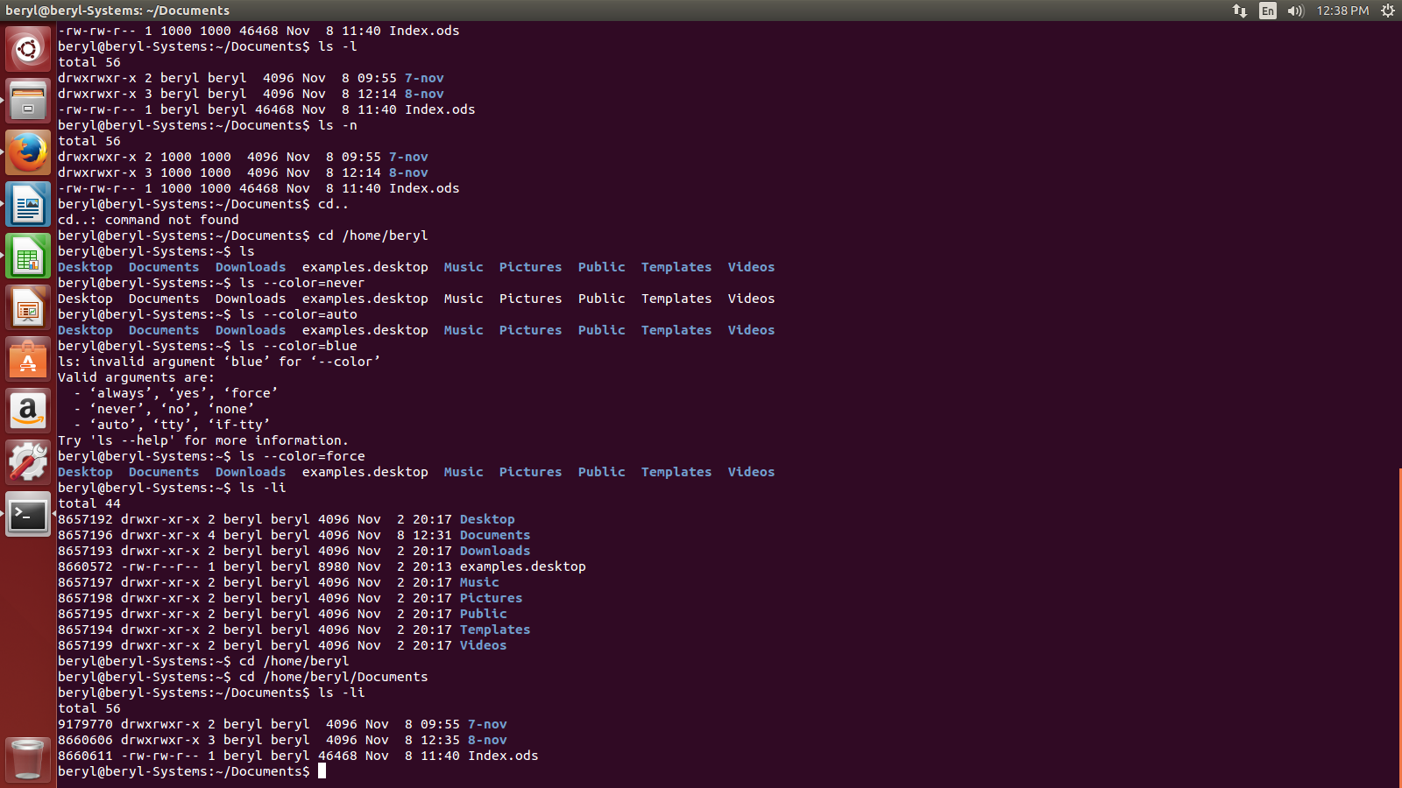
    - ls -r – is used to print the list in reverse order.

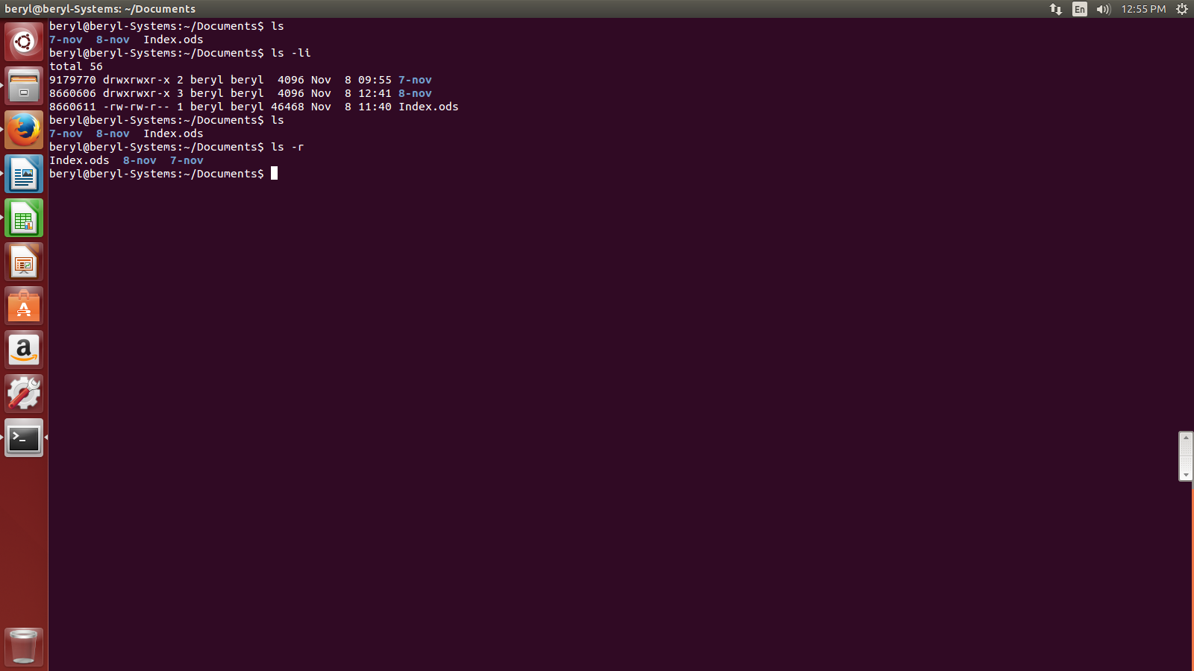

    - ls -R – is used to show the contents of subdirectories as well.eg.,

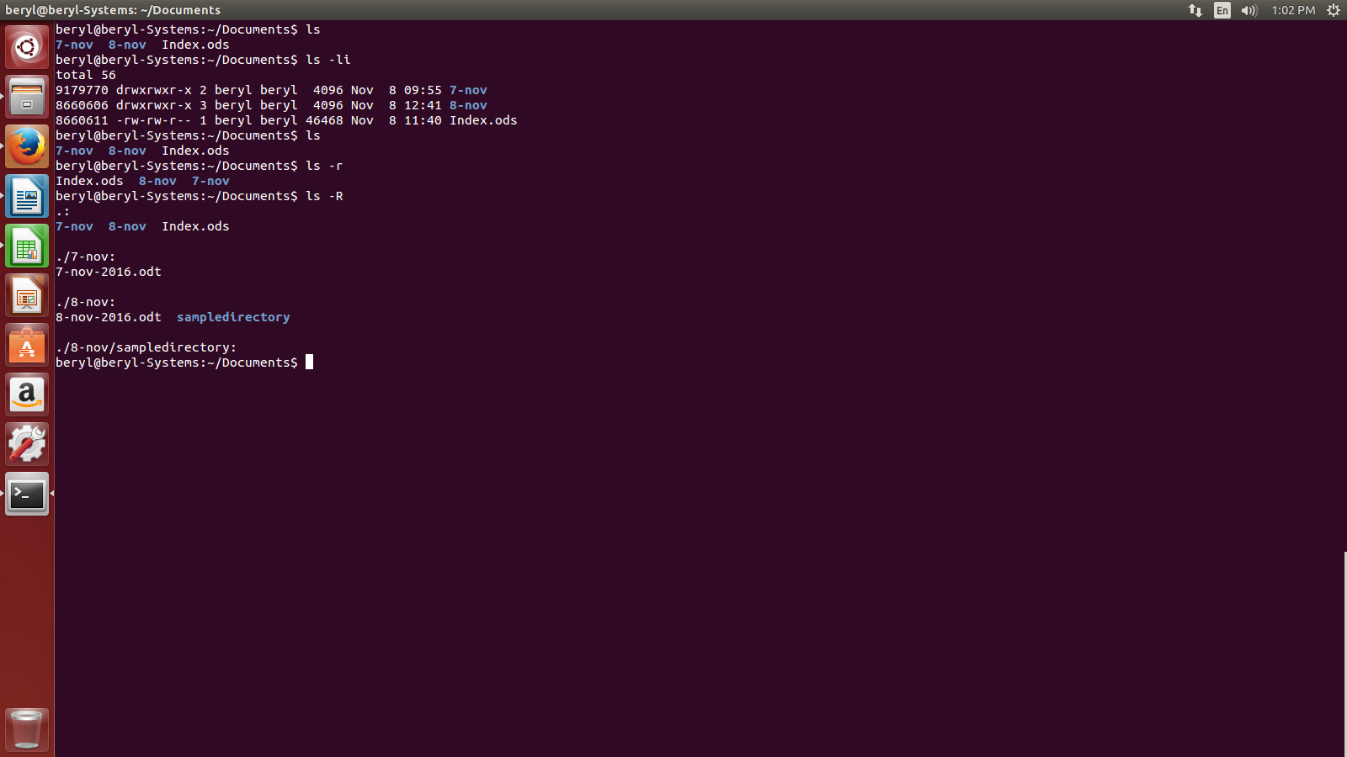

    - ls -lX – is used to show the detailed list of file by putiing the file with same extensions together.

Add directory including its sub directory.

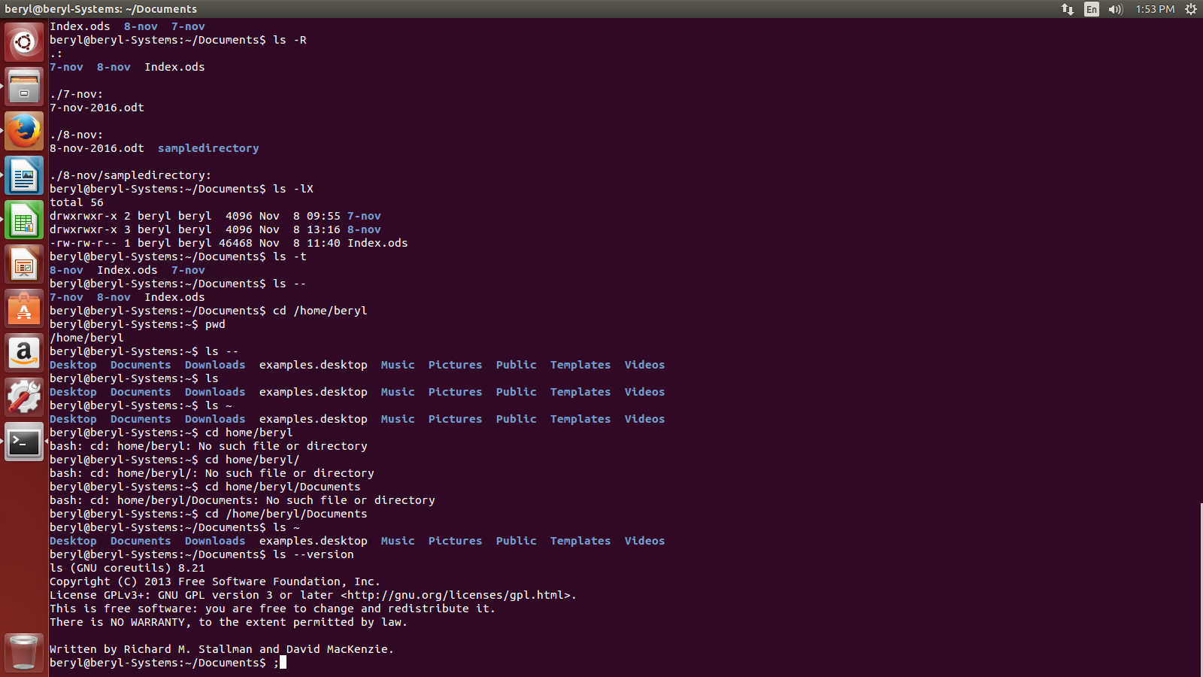
    - ls -lt – is used to show the detailed list of file in the order of recently used apps on the top.

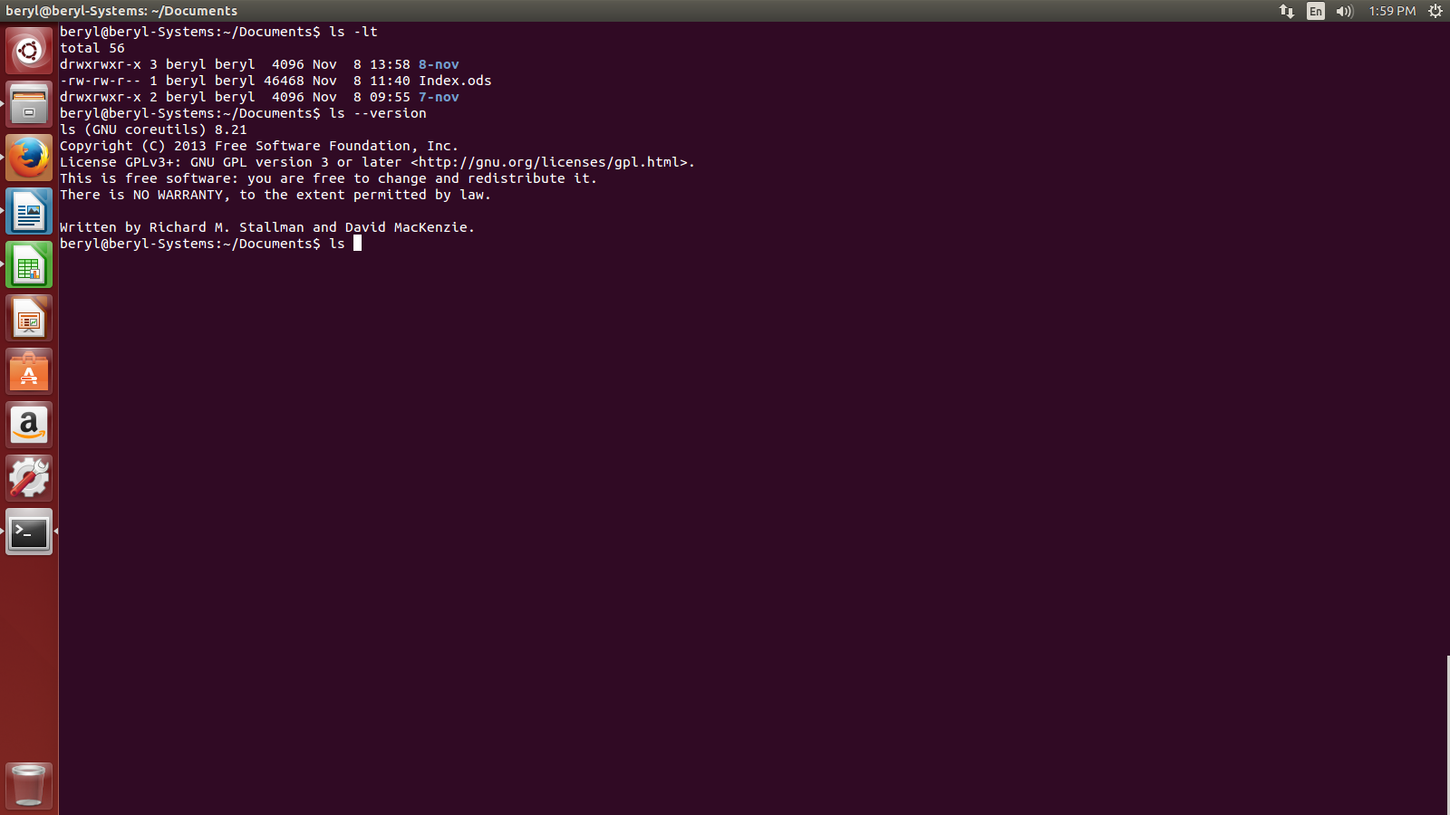
    - ls –version – is used to see the version of the ls command.

- What are the different options of using mkdir command?

- mkdir command is used to create directory.

Syntax :- mkdir <dir name>

The various options of mkdir are:-

- mkdir <dirname1> <dirname2> <dirname3>... - is used to create multiple directories.
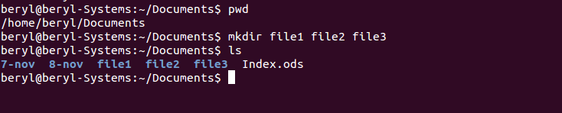

- mkdir -p - is used to create directory inside a directory. eg.,

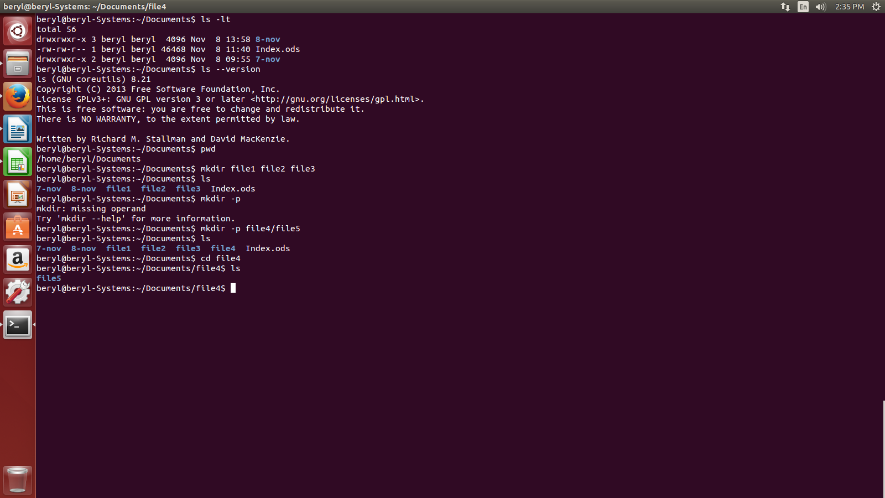

- mkdir -v – is used to create multiple directories with a message of directory creation. If it wont be able to create the directories it will print an error message. We can also use both -p and and -v together as -pv or -vp. eg.,

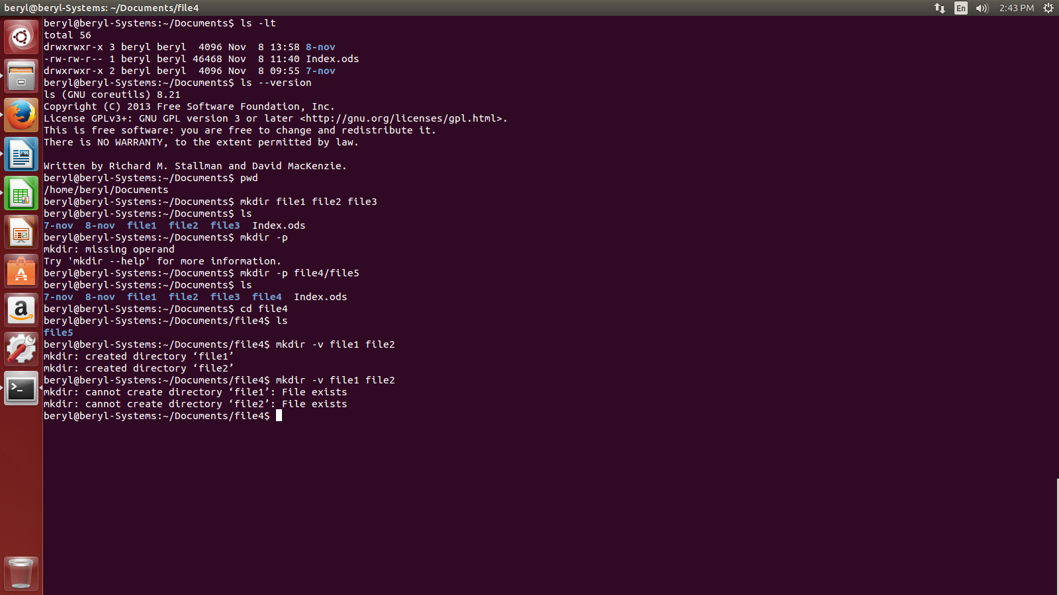

- What are the different options of using rmdir command?

- rmdir command is used to delete directory.

Syntax :- rmdir <dir name>

The various options of rmdir are:-

- rmdir -p – is used to remove directory along with its subdrirectory.

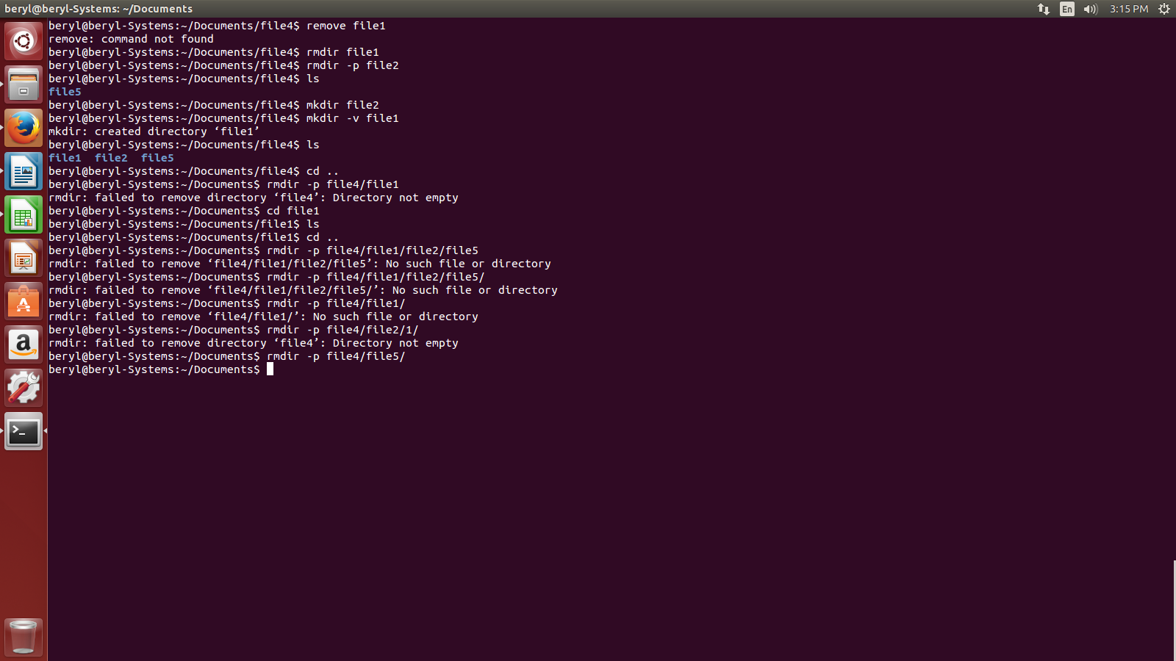

LINUX Files:-

- What are files in LINUX and their types?

- In LINUX, everything is a file. If in case, it is not a file then it is a process. A file doesnt include only text files, images and compiled programs but also include partitons, hardware device drives and directories.

- There are basicsally 3 types of files in LINUX. They are:-
- Regular files (-) - contains programs , text files and executable files.
- Directory files (d) – contains the list of files and is shown in blue color.
- Special files -
  - Block file (b)
  - Character file (c)
  - Named pipe file (p)
  - Symbolic link file (l)
  - Socket file (s)

- What are the various LINUX file commands?

- The various LINUX file commands are:-

- file - determine file type
- touch – used to create a file
- rm – used to remove a file
- cp – used to copy a file
- mv – used to move a file
- rename – used to rename a file

- What is a file command and what are its various options?

- file command is used to see the file type.
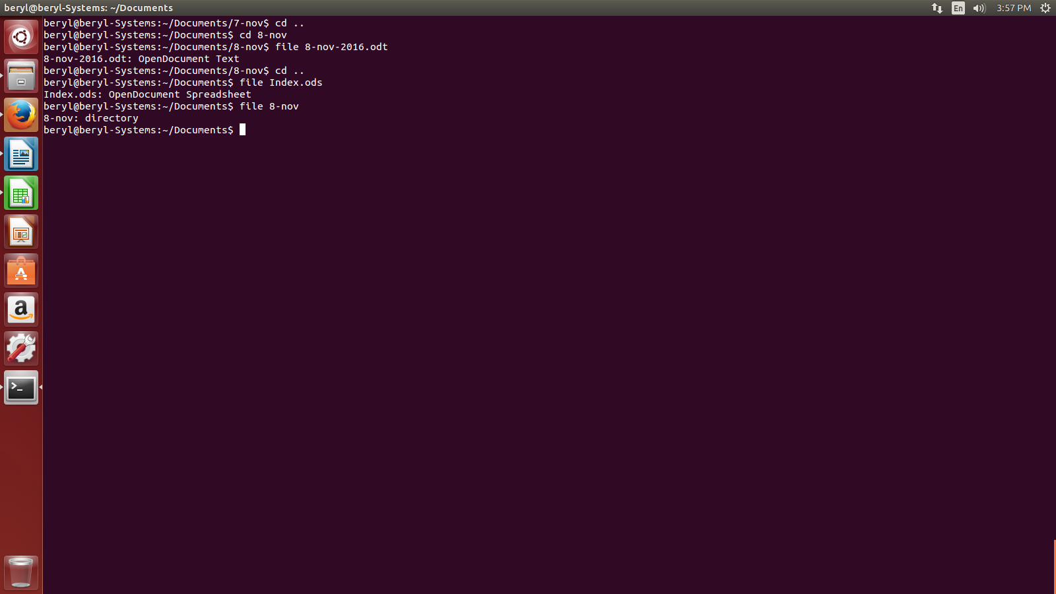

The various options of file command are:-

- file * - is used to see the type of all files in the present working directory. eg.,

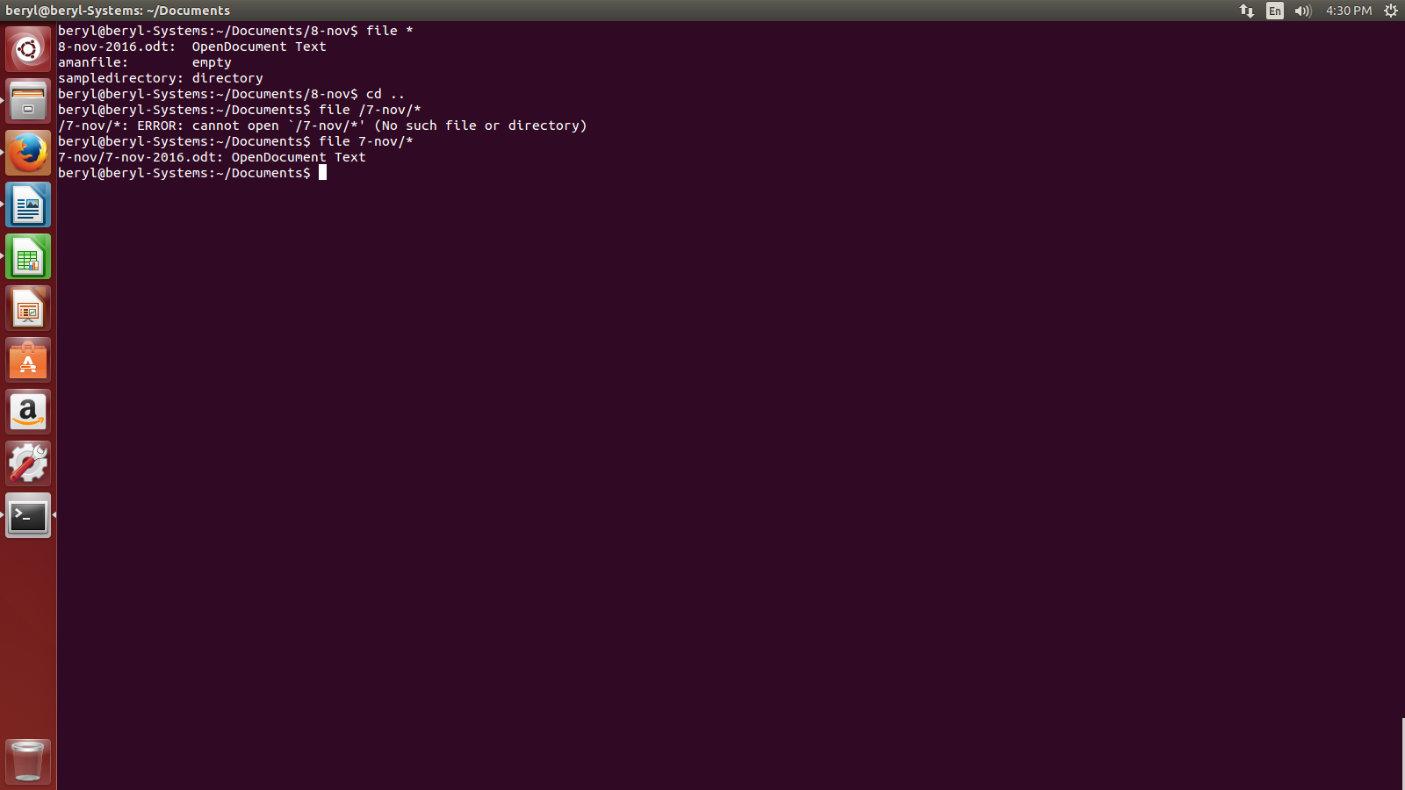
- file /directoryname/* - is used to see the types of file in a particular directory. eg.,

- file [range] – is used to find the types of all the files within a particular alpabhet range. eg.,

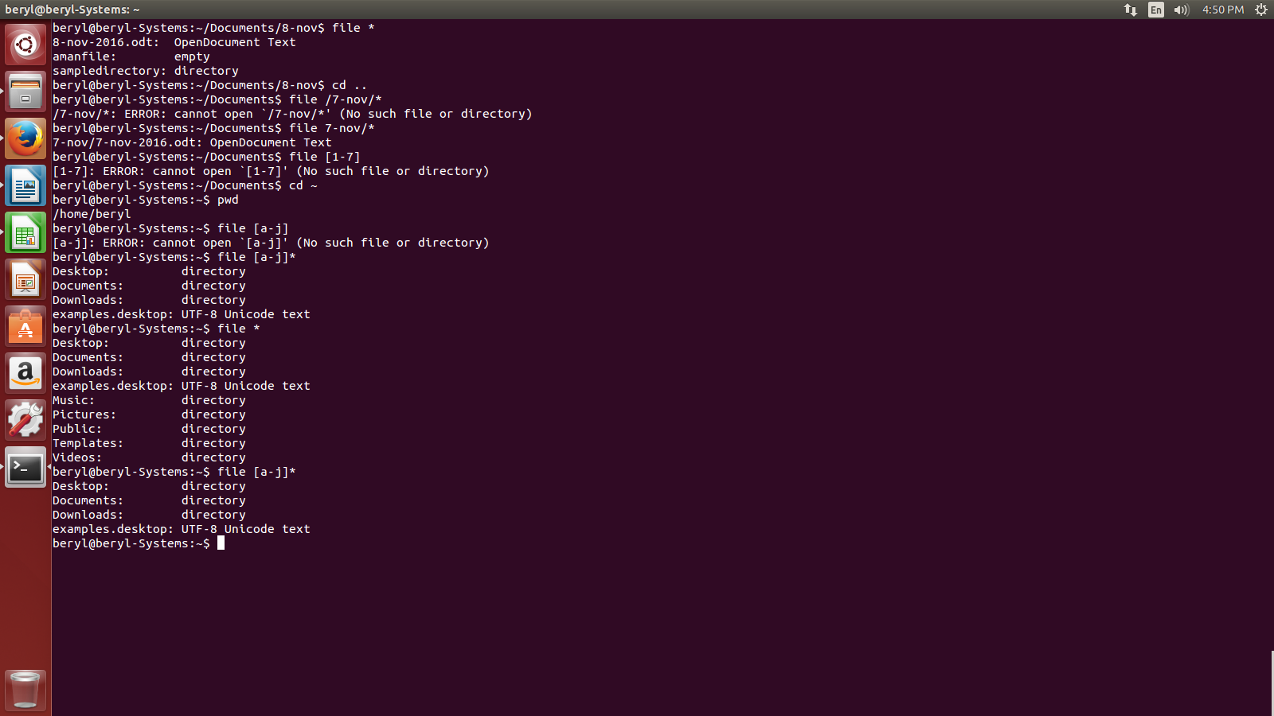
- What is touch command what are its various options?

- Touch command is used to create an empty file. e.g.,
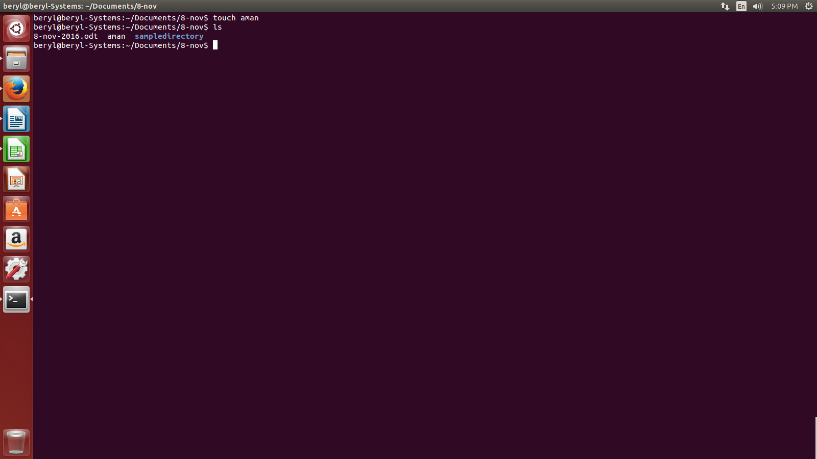
The various options of touch command are:-

    - stat – is used to see the status of a particular file.e.g,
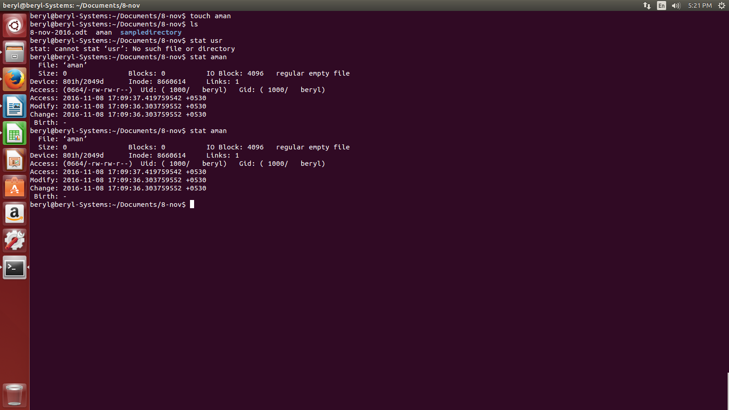

    - touch -a – is used to update the access and change time of a file. eg.,

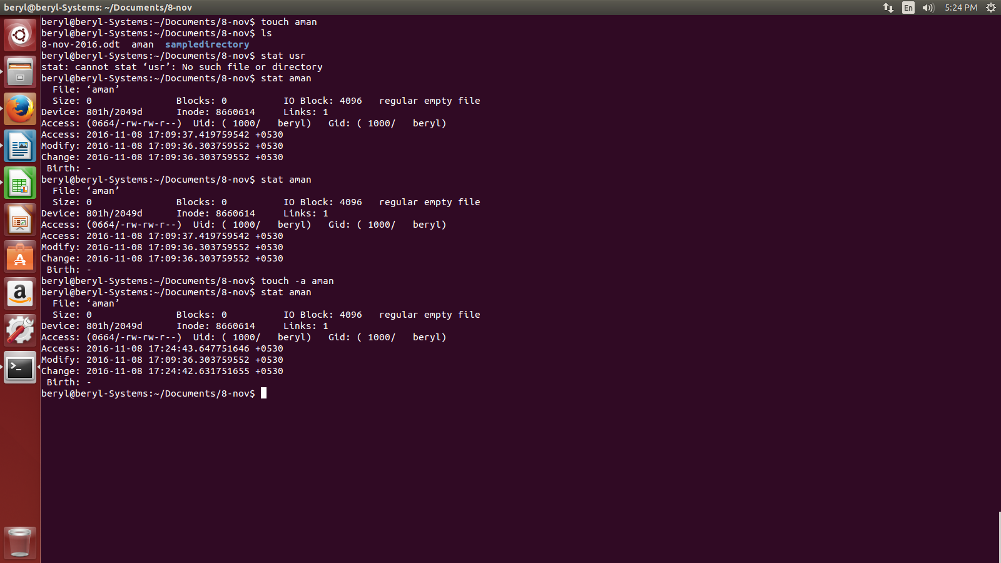
    - touch -m – is used to update only the access time of a file. e.g.,

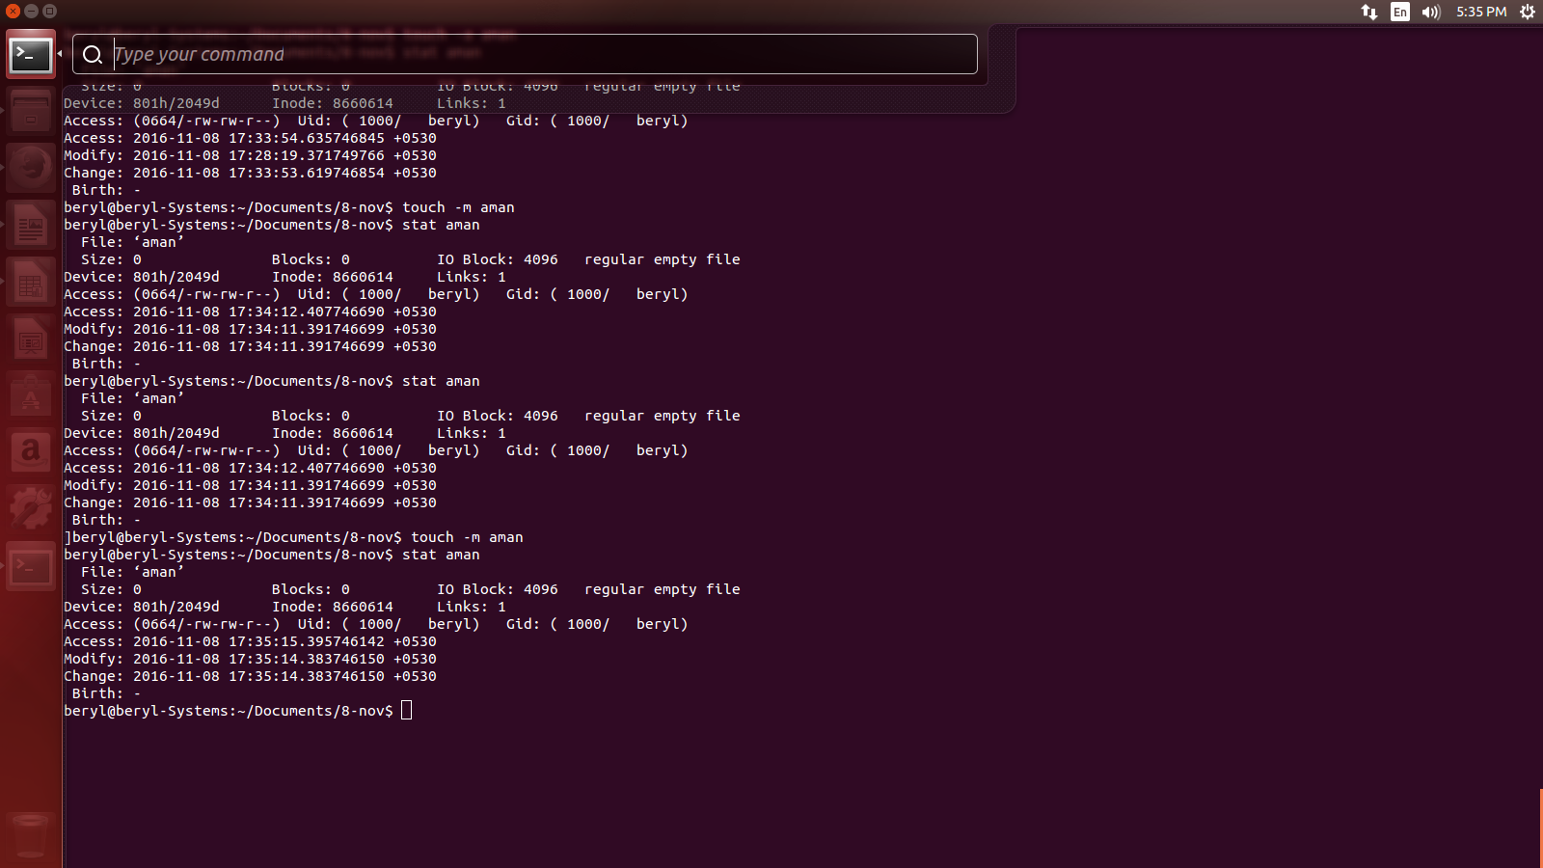
    - touch -t – is used to update the time as specified. e.g.,
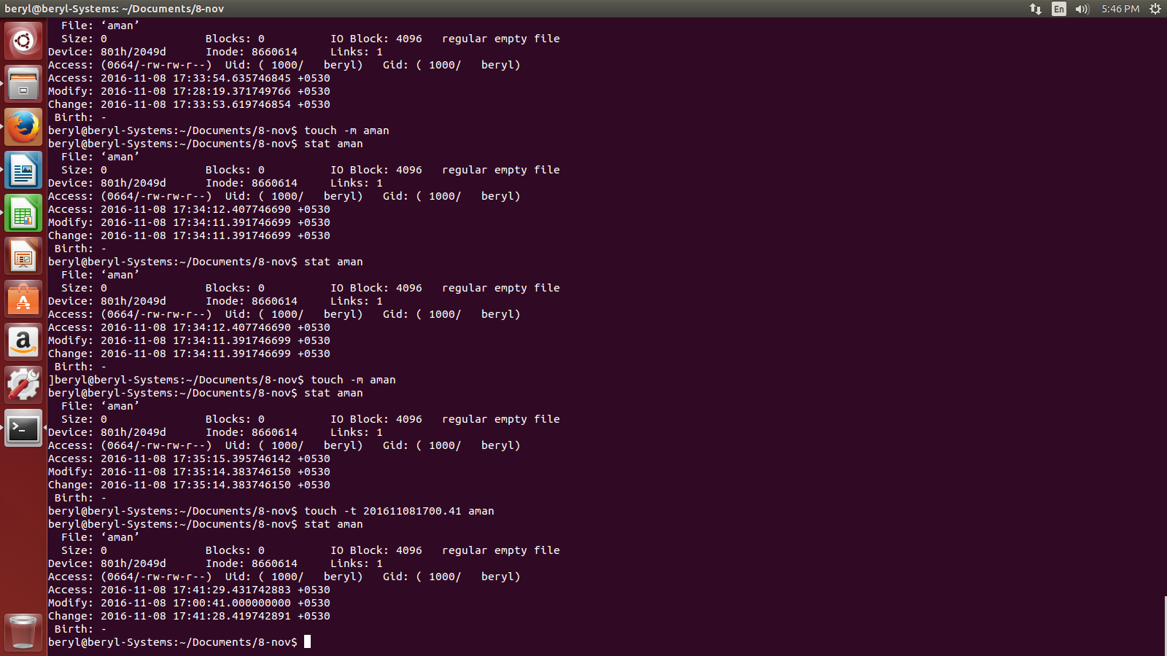

    - touch -c – will not create an empty file if the file already exists with us. e.g.,

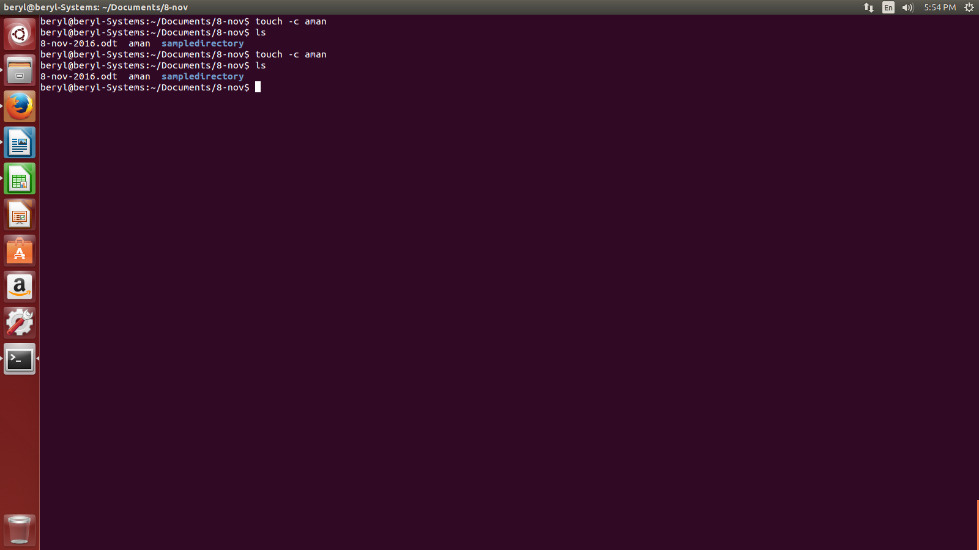
- What is rm command in linux?

- rm command is used to remove a file. Linux does'nt have any recycle bin or trash like other O.S. so be very careful before using this command. e.g.,

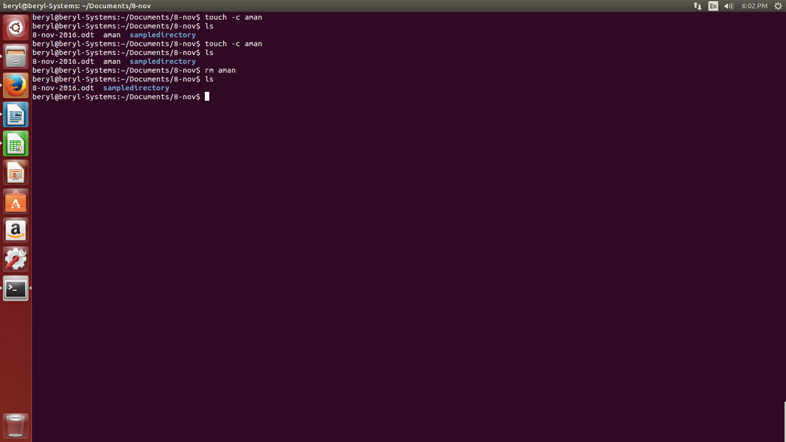
- What is cp file in Linux and what are its various options?

- cp command is used to copy a file.

- What is the current version of ubuntu?


