

School of Computer Science Engineering and Information Systems

Fall Semester 2026-2027

Department of Computer Applications

PMCA698J – Dissertation -I / Internship -1

Review -1

Date: 14.8.2026
TAIS: A Telemetry Assessment and Integrity System for AIS-140 Vehicle Tracking

25MCA0022 – ARYAN BHAGAT
Under the Guidance of
Dr. SATHIYAMOORTHY E
Professor Grade 2
SCORE

Guide Signature with date
Dr. SATHIYAMOORTHY E

Internal Examiner -1 Internal Examiner-2
Signature Signature
ABSTRACT:

India's AIS-140 standard mandates GPS/NavIC-based Vehicle Location Tracking Devices (VLTDs) on all commercial vehicles, and this same telemetry infrastructure now underpins the country's transition to GNSS-based satellite tolling — where a vehicle's continuously reported GPS position determines the toll charged. While AIS-140 devices include physical tamper detection (enclosure breach, power disconnection), no existing mechanism verifies whether the telemetry data itself — the position, speed, and heading actually reported — is internally consistent or kinematically plausible. This project presents TAIS (Telemetry Assessment and Integrity System), a server-side system that assesses the integrity of AIS-140 telemetry by computing a weighted Trust Score (0–100) with an explained confidence level. TAIS operates exclusively on the fields already mandated and transmitted under AIS-140, requiring no modifications to vehicle-side hardware. The system employs a five-stage pipeline: simulated telemetry generation, deliberate anomaly injection, rule-based trust scoring across four consistency dimensions (motion, trajectory, signal quality, temporal), human-readable explanation generation, and dashboard visualization with tiered response actions (Normal/Flagged/Escalate). A simulation-first methodology is adopted, with quantitative evaluation planned using precision, recall, F1-score, and false-positive rate against labelled ground truth.

Keywords: AIS-140, GNSS integrity, telemetry trust scoring, vehicle tracking, spoofing detection, satellite tolling, anomaly detection, kinematic plausibility

- INTRODUCTION:
The Automotive Industry Standard 140 (AIS-140), mandated by the Ministry of Road Transport and Highways (MoRTH) and certified by the Automotive Research Association of India (ARAI), requires all commercial and public-service vehicles in India to be equipped with Vehicle Location Tracking Devices (VLTDs). These devices continuously transmit GPS/NavIC-fused telemetry — including position, speed, heading, and signal quality indicators — to state-level backend monitoring servers. Enforcement has been strict since 2018 and was further tightened via Amendment 2 in 2023.
The operational significance of this telemetry is about to escalate dramatically. India's Ministry of Road Transport and Highways has publicly announced the rollout of GNSS-based satellite tolling, where a vehicle's continuously reported GPS location — not a fixed toll-booth transaction — will determine the toll amount charged. Pilot programs have already been conducted on national highway stretches including the Bengaluru–Mysore (NH-275) and Panipat–Hisar (NH-709) sections.
This shift transforms AIS-140 telemetry from a compliance-monitoring input into a direct financial-decision input. A vehicle reporting manipulated, corrupted, or inconsistent trajectory data could be undercharged, overcharged, or have its trip disputed — with no existing mechanism to flag the data as suspicious before it reaches a billing decision. The physical tamper detection built into AIS-140 devices provides no protection against data-level manipulation, where the device hardware is intact but the reported telemetry values are fabricated or replayed.
TAIS (Telemetry Assessment and Integrity System) addresses this specific gap. It is a server-side system designed to assess the integrity of incoming AIS-140 telemetry by computing a Trust Score with an explained confidence level, enabling transport authorities and toll operators to flag kinematically implausible data before it influences a billing or compliance decision.

- PROBLEM STATEMENT:
Every AIS-140 device ships with mandatory tamper detection, but this detection is exclusively physical — it flags enclosure breach, power disconnection, or SIM removal. Nothing in the current system checks whether the telemetry data itself — the position, speed, and heading actually being reported — is internally consistent or physically plausible.
This gap was tolerable when AIS-140 data was used mainly for compliance monitoring and after-the-fact investigation. It becomes a direct financial integrity problem once that same data stream determines a real-time bank charge under GNSS-based satellite tolling. A vehicle reporting an inconsistent, corrupted, or manipulated trajectory could be undercharged, overcharged, or have its trip data disputed — with no existing mechanism to flag the telemetry as suspicious before it reaches a billing decision.
Existing systems fail to address this gap: physical tamper detection says nothing about data integrity; aviation RAIM requires raw pseudoranges unavailable at backend servers; commercial telematics score driver behavior rather than data authenticity; and ML trajectory models operate as uninterpretable black boxes.
Research Question: Can a server-side system, using only the telemetry fields already mandated and transmitted under AIS-140, reliably distinguish physically plausible vehicle telemetry from kinematically implausible telemetry — and communicate that distinction with enough explanation to support a real billing/compliance decision?

- OBJECTIVES:
1. Characterize the available data: Precisely document what telemetry fields are actually available at the AIS-140 backend, distinguishing confirmed fields from assumed or unavailable data (completed in Week 1).
2. Build a scenario-driven telemetry simulator: Generate labelled, realistic telemetry sequences conforming to the AIS-140 field set, covering highway, city, and degraded-signal scenarios — standing in for real device output.
3. Design and implement a rule-based Trust-Scoring Engine: Develop a system that flags kinematically inconsistent telemetry using four sub-scores (motion, trajectory, signal quality, temporal), producing a human-readable explanation and confidence level per decision.
4. Demonstrate end-to-end via a dashboard: Build a demonstration interface visualizing scores over time, per-flag explanations, and tiered response actions (Normal / Flagged / Escalate).
5. Evaluate quantitatively: Measure system performance using precision, recall, F1-score, detection latency, and false-positive rate against labelled simulator ground truth.

- SCOPE OF THE PROJECT:
• Telemetry-level consistency assessment using only currently-mandated AIS-140 fields
• Simulated telemetry data generation for three driving scenarios (highway, city, degraded signal)
• Six categories of deliberately injected anomalies (position jump, drift, speed injection, heading change, replay, GPS freeze)
• Rule-based trust scoring with four sub-dimensions and weighted composite score
• Human-readable explanation generation with confidence levels
• Dashboard visualization with tiered response (Normal / Flagged / Escalate)
• Quantitative evaluation against labelled ground truth
- Out of Scope (Deliberately)
• No RF signal transmission of any kind (illegal and unnecessary)
• No live integration with government/NHAI billing servers
• No claim to detect anomaly cause (spoofing vs. tunnel) — TAIS flags implausibility, not intent
• No real-world field data collection (simulation-first scope decision)
• No modifications to vehicle-side AIS-140 hardware or firmware

- PROPOSED SYSTEM:
TAIS is a server-side telemetry assessment system built as a five-stage pipeline:
Stage 1 — Telemetry Simulator: Generates labelled, scenario-driven telemetry sequences conforming to the locked Telemetry Record schema. Three scenarios are implemented: Highway, City, and Degraded Signal.

Stage 2 — Anomaly Injector: Takes genuine simulated sequences and produces deliberately anomalous variants in software across six anomaly types: Position Jump, Drift, Speed Injection, Heading Change, Replay, and GPS Freeze.

Stage 3 — Trust-Scoring Engine: Computes four sub-scores per telemetry window: Motion Consistency, Trajectory Consistency, Signal Quality, and Temporal Consistency. Combined into a weighted Trust Score (0-100).

Stage 4 — Explanation Layer: Every Trust Score includes a Confidence level (High/Medium/Low) and a list of specific triggered reasons, providing auditability for billing dispute resolution.

Stage 5 — Dashboard: Demonstration interface visualizing scores over time, per-flag explanations, and tiered response actions (Normal / Flagged for review / Escalate).

- LITERATURE SURVEY:

S.NO | TITLE | MERITS | DEMERITS
1 | Huang et al. (2025)  "A survey of GNSS receiver autonomous integrity monitoring: Research status and opportunities" | Comprehensive taxonomy of RAIM techniques; highlights machine-learning integrity monitoring. | Identifies critical real-world gap: over-relies on aviation/simulated data and lacks realistic automotive datasets.
2 | Martin (2020)  "Advanced receiver autonomous integrity monitoring in tightly integrated GNSS/Inertial systems" | Demonstrates tightly-coupled GNSS/IMU integration for robust integrity monitoring. | Requires receiver-level raw pseudorange and continuous IMU access unavailable at AIS-140 backends.
3 | Psiaki & Humphreys (2016)  "GNSS spoofing and detection" | Foundational overview of GNSS spoofing attack mechanics and signal-level countermeasure families. | Focuses on RF signal-level and receiver-level detection rather than backend telemetry checks.
4 | Wu et al. (2020)  "Spoofing and anti-spoofing technologies of Global Navigation Satellite System: A survey" | Comprehensive catalogue of anti-spoofing techniques across GNSS architecture. | Does not cover standardized post-receiver vehicle telemetry validation in regulatory contexts.
5 | Thombre et al. (2020)  "GNSS threat monitoring and reporting: Past, present, and a proposed future" | Catalogues intentional (spoofing/jamming) and unintentional (multipath, ionospheric) threats. | Focuses on threat reporting frameworks rather than automated real-time backend telemetry scoring.
6 | Zidan et al. (2020)  "GNSS vulnerabilities and existing solutions: A review of the literature" | Systematic review of vulnerabilities across signal, receiver, and system layers. | Confirms absence of protection mechanisms at the post-transmission backend telemetry stage.
7 | Bhatti & Humphreys (2017)  "Hostile control of ships via false GPS signals: Demonstration and detection" | Provides real-world empirical proof of vehicle spoofing feasibility. | Demonstration limited to maritime receivers; does not address automotive telemetry standards.
8 | Dasgupta et al. (2022)  "A sensor fusion-based GNSS spoofing attack detection framework for autonomous vehicles" | Proposes Kalman-filter GPS/IMU sensor fusion specifically for vehicular spoofing detection. | Assumes raw continuous IMU stream availability, whereas AIS-140 only provides discrete boolean flags.
9 | Fakharian et al. (2011)  "Adaptive Kalman filtering based navigation: An IMU/GPS integration approach" | Demonstrates adaptive Kalman filtering for GPS/IMU navigation accuracy. | Designed for accuracy during signal loss (tunnels) rather than adversarial telemetry manipulation.
10 | Zhang et al. (2005)  "Navigation with IMU/GPS/digital compass with unscented Kalman filter" | Applies Unscented Kalman Filter for non-linear multi-sensor navigation fusion. | Operates as an on-board navigation filter rather than a server-side audit mechanism.
11 | Shen et al. (2019)  "Integrated navigation accuracy improvement algorithm based on multi-sensor fusion" | Validates multi-sensor fusion for vehicular navigation accuracy. | Targeted at hardware-level sensor integration rather than standardized cloud telemetry.
12 | Dhongade & Khandekar (2019)  "GPS and IMU integration on an autonomous vehicle using Kalman filter" | Practical LabVIEW implementation of GPS/IMU vehicle trajectory tracking. | Lacks automated anomaly scoring or auditable explanation generation.
13 | Liu et al. (2020)  "Online anomalous trajectory detection with deep generative sequence modeling" | Uses VAE-RNN sequence modeling to detect anomalous GPS trajectories online. | Black-box classification lacking per-decision explanations required for billing dispute resolution.
14 | Song et al. (2018)  "Anomalous trajectory detection using recurrent neural network" | Applies RNNs for temporal sequence-based trajectory anomaly detection. | Requires large historical training corpora and lacks domain-specific AIS-140 field constraints.
15 | Cao et al. (2024)  "Anomaly detection for in-vehicle network using self-supervised learning" | Advanced self-supervised vehicle-cloud anomaly detection for connected vehicles. | Targets in-vehicle CAN bus network traffic rather than AIS-140 backend telemetry packets.
16 | Semanjski et al. (2020)  "Detecting GNSS spoofing using supervised machine learning" | Evaluates ML classifiers (RF, SVM, NN) achieving >95% spoofing detection accuracy. | Relies on receiver-internal signal features (C/N0) not transmitted in AIS-140 packets.

[6.1] FINDINGS IN LITERATURE SURVEY:
1. GNSS integrity monitoring is mature but operates at the wrong level. Existing systems (RAIM, sensor fusion) require receiver-internal data (raw pseudoranges, continuous IMU streams) that standard AIS-140 devices do not transmit to backend servers.

2. No published system operates at the telemetry-reporting level. Protections are concentrated at signal and receiver stages. The specific gap between what AIS-140 devices transmit and what is actually verified about that data has not been addressed.

3. Trajectory-level anomaly detection exists but lacks interpretability. ML-based approaches (Liu et al., 2020; Song et al., 2018) detect anomalous trajectories but produce black-box classifications unsuitable for billing/regulatory dispute resolution.

4. Real-world automotive GNSS integrity datasets are scarce. Huang et al. (2025) explicitly flag this gap, motivating TAIS's simulation-based evaluation approach.
TAIS's Contribution: A telemetry-level (not receiver-level) trust-scoring system with interpretable, explained outputs, targeting the specific AIS-140 regulatory context in India.
[7.] METHEDOLOGY:
TAIS implements a five-stage pipeline (Simulator → Anomaly Injector → Trust-Scoring Engine → Explanation Layer → Dashboard).

Trust Score Computation:
Trust Score = w1(Motion) + w2(Trajectory) + w3(Signal Quality) + w4(Temporal)

Threat Model: Attacker can manipulate telemetry prior to transmission or replay old data. System assumes backend server and communication channel authenticity are trusted.
Evaluation Methodology: Labelled simulated sequences stand in as ground truth. Evaluation metrics include Precision, Recall, F1-Score, Detection Latency, and False Positive Rate on degraded-signal baseline scenarios.
[8.] SOFTWARE REQUIREMENTS:
Functional Requirements:
FR-01: Generate simulated AIS-140 telemetry for highway, city, and degraded signal scenarios.
FR-02: Inject 6 anomaly categories (position jump, drift, speed injection, heading change, replay, GPS freeze).
FR-03: Compute composite Trust Score (0-100) across 4 consistency sub-dimensions.
FR-04: Generate human-readable explanations with confidence levels (High/Medium/Low).
FR-05: Classify decisions into tiered actions (Normal / Flagged for review / Escalate).
FR-06: Provide web dashboard for real-time visualization and report export.
Non-Functional Requirements:
NFR-01 (Performance): Trust Score computation within 100ms per window.
NFR-02 (Scalability): Support concurrent streams from at least 10 simulated devices.
NFR-03 (Auditability): 100% of scoring decisions accompanied by structured reason lists.
NFR-04 (Maintainability): Schema-locked architecture (src/schema.py) strictly enforced across all modules.

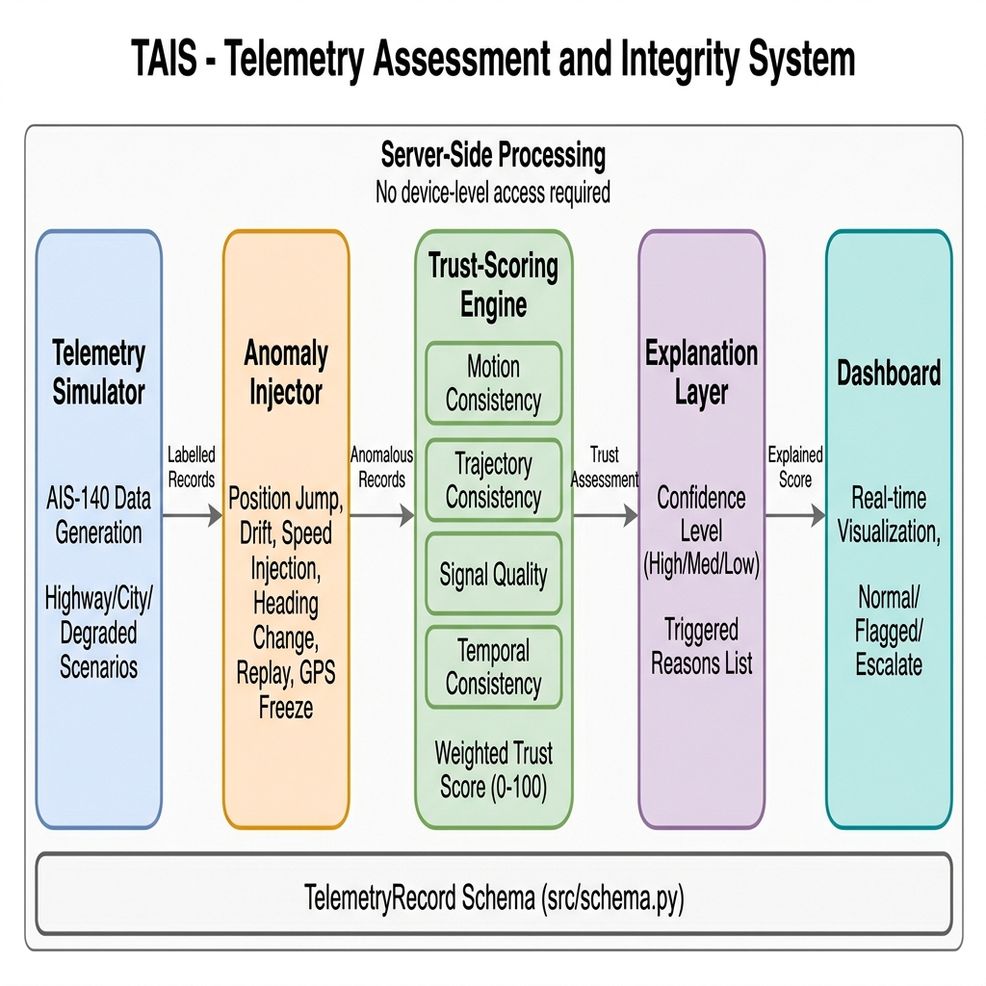
[9.] SYSTEM ARCHITECTURE

Fig. 9.1 System Architecture

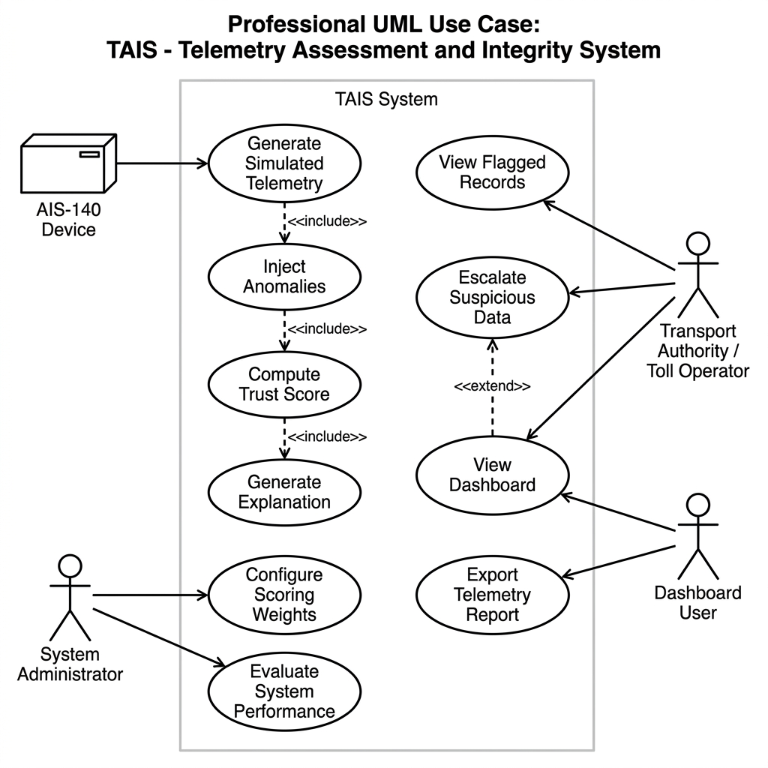
[10]. UML DIAGRAMS:

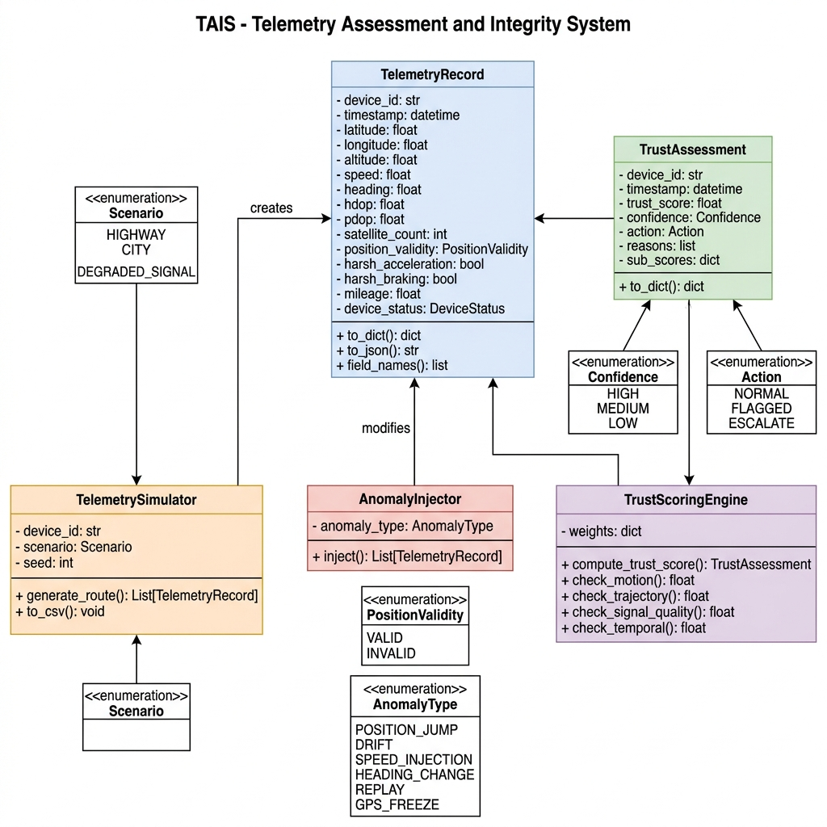
Fig. 10.1 Use Case Diagram

Fig. 10.2 Class Diagram
[11] SUMMARY:

This Review-1 deliverable presents the complete architectural and theoretical groundwork for TAIS. The project addresses a timely operational challenge in Indian transport infrastructure: ensuring telemetry integrity for GNSS-based tolling using mandated AIS-140 hardware. By establishing a simulation-first methodology, a locked schema contract, a 5-stage processing pipeline, and an auditable rule-based trust scoring engine, TAIS establishes a robust framework for detecting kinematically implausible vehicle data.

REFERENCES:

- Bhatti, J., & Humphreys, T. E. (2017). Hostile control of ships via false GPS signals: Demonstration and detection. Navigation, 64(1), 51–66.

- Cao, J., Di, X., Liu, X., Li, J., Li, Z., & Zhao, L. (2024). Anomaly detection for in-vehicle network using self-supervised learning with vehicle-cloud collaboration update. IEEE Transactions on Intelligent Transportation Systems, 25(7), 7454–7466.

- Dasgupta, S., Rahman, M., Islam, M., & Chowdhury, M. (2022). A sensor fusion-based GNSS spoofing attack detection framework for autonomous vehicles. IEEE Transactions on Intelligent Transportation Systems, 23(12), 23559–23572.

- Dhongade, A. P., & Khandekar, M. A. (2019). GPS and IMU integration on an autonomous vehicle using Kalman filter (LabView tool). In 2019 International Conference on Intelligent Computing and Control Systems (ICCS) (pp. 1135–1139). IEEE.

- Fakharian, A., Gustafsson, T., & Mehrfam, M. (2011). Adaptive Kalman filtering based navigation: An IMU/GPS integration approach. In Proceedings of the IEEE International Conference on Networking, Sensing and Control (ICNSC) (pp. 181–185). IEEE.

- Huang, Z., Mou, W., Wang, R., Li, P., Lyu, Z., & Ou, G. (2025). A survey of GNSS receiver autonomous integrity monitoring: Research status and opportunities. Frontiers in Physics, 13, Article 1567301.

- Liu, Y., Zhao, K., Cong, G., & Bao, Z. (2020). Online anomalous trajectory detection with deep generative sequence modeling. In Proceedings of the IEEE 36th International Conference on Data Engineering (ICDE) (pp. 949–960). IEEE.

- Martin, T. (2020). Advanced receiver autonomous integrity monitoring in tightly integrated GNSS/Inertial systems. In 2020 DGON Inertial Sensors and Systems (ISS) (pp. 1–20). IEEE.

- Psiaki, M. L., & Humphreys, T. E. (2016). GNSS spoofing and detection. Proceedings of the IEEE, 104(6), 1258–1270.

- Semanjski, I., Mucelli Rezende Oliveira, A., De Wit, A., & Gautama, S. (2020). Detecting GNSS spoofing using supervised machine learning. Sensors, 20(22), Article 6657.

- Shen, C., Huang, C., Liu, J., Chen, X., Weijinya, U., & Shi, G. (2019). Integrated navigation accuracy improvement algorithm based on multi-sensor fusion. In 2019 IEEE 2nd International Conference on Micro/Nano Sensors for AI, Healthcare, and Robotics (NSENS) (pp. 1–5). IEEE.

- Song, L., Wang, R., Xiao, D., Han, X., Cai, Y., & Shi, C. (2018). Anomalous trajectory detection using recurrent neural network. In Advanced Computational Methods in Energy, Power, Electric Vehicles, and Their Integration (pp. 263–271). Springer.

- Thombre, S., Bhuiyan, M. Z. H., Eliardsson, P., Gabrielsson, B., Pattinson, M., Giordano, M., Borio, D., Closas, P., & Fernández-Hernández, I. (2020). GNSS threat monitoring and reporting: Past, present, and a proposed future. The Journal of Navigation, 73(6), 1213–1231.

- Wu, Z., Zhang, Y., Yang, Y., Liang, C., & Liu, R. (2020). Spoofing and anti-spoofing technologies of Global Navigation Satellite System: A survey. IEEE Access, 8, 165444–165496.

- Zhang, P., Gu, J., Milios, E., & Huynh, P. (2005). Navigation with IMU/GPS/digital compass with unscented Kalman filter. In Proceedings of the IEEE International Conference on Mechatronics and Automation (Vol. 3, pp. 1497–1502). IEEE.

- Zidan, J., Adegoke, E. I., Kampert, E., Birrell, S. A., Ford, C. R., & Sherlock, M. D. (2020). GNSS vulnerabilities and existing solutions: A review of the literature. IEEE Access, 8, 5848–5868.

