Assignment

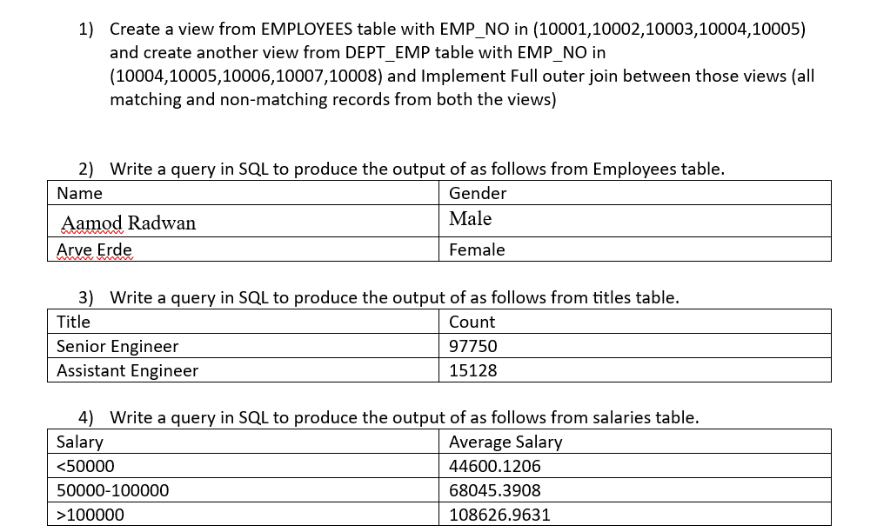

**Assignment 1:**

DROP VIEW IF EXISTS employee_view;

CREATE VIEW employee_view AS SELECT * FROM employees WHERE emp_no IN (10001, 10002, 10003, 10004, 10005);

DROP VIEW IF EXISTS dept_emp_view;

CREATE VIEW dept_emp_view AS SELECT * FROM dept_emp WHERE emp_no IN (10004, 10005, 10006, 10007, 10008);

SELECT e.emp_no, e.birth_date, e.first_name, e.last_name, e.gender, e.hire_date, d.dept_no, d.from_date, d.to_date FROM  employee_view e LEFT JOIN dept_emp_view d ON e.emp_no = d.emp_no

UNION

SELECT d.emp_no, e.birth_date, e.first_name, e.last_name, e.gender, e.hire_date, d.dept_no, d.from_date, d.to_date FROM employee_view e RIGHT JOIN dept_emp_view d ON e.emp_no = d.emp_no;

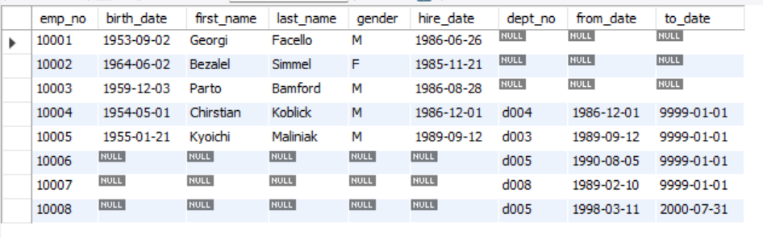

**Assignment 2:**

SELECT concat(first_name,' ',last_name) as Name , gender as Gender from employees WHERE (first_name = 'Aamod' AND last_name = 'Radwan') OR (first_name = 'Arve' AND last_name = 'Erde') limit 2;

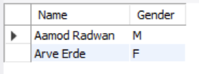

**Assignment 3:**

SELECT title as Title , COUNT(emp_no) as Count from titles where title in ('Senior Engineer' , 'Assistant Engineer') group by title;

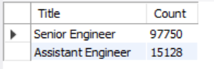

**Assignment 4:**

SELECT CASE WHEN salary < 50000 THEN '<50000'

WHEN salary BETWEEN 50000 AND 100000 THEN '50000-100000'

ELSE '>100000'

END AS SalaryRange,

AVG(salary) AS AverageSalary FROM salaries GROUP BY SalaryRange;

