**Assignment 3**

1. Write a query to display all the details from employee table with department, title and latest salary.
2. Write a procedure which accepts the parameters (emp_no,birth_date, first_name, last_name, gender, hire_date) and to update the table if emp_no already exists in the table or insert a new record if emp_no does not exists in table.
3. Write a function to return the experience of an employee by passing the emp_no.

Queries Below:

1.

SELECT e.emp_no,e.birth_date,e.first_name,e.last_name,e.gender,e.hire_date,d.dept_name,t.title,s.salary

FROM

    employees e

JOIN

    dept_emp de ON e.emp_no = de.emp_no

JOIN

    departments d ON de.dept_no = d.dept_no

JOIN

    titles t ON e.emp_no = t.emp_no

JOIN

    (SELECT emp_no, MAX(salary) AS salary

     FROM salaries

     GROUP BY emp_no) s ON e.emp_no = s.emp_no

WHERE

    de.to_date = '9999-01-01'

    AND t.to_date = '9999-01-01';

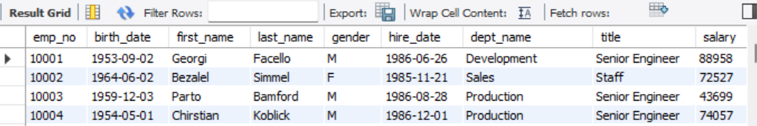

2.

DELIMITER //

CREATE PROCEDURE upsert_employee(

    IN p_emp_no INT,

    IN p_birth_date DATE,

    IN p_first_name VARCHAR(50),

    IN p_last_name VARCHAR(50),

    IN p_gender CHAR(1),

    IN p_hire_date DATE

)

BEGIN

    DECLARE emp_count INT;

    SELECT COUNT(*) INTO emp_count

    FROM employees

    WHERE emp_no = p_emp_no;

    IF emp_count > 0 THEN

        UPDATE employees

        SET birth_date = p_birth_date,

            first_name = p_first_name,

            last_name = p_last_name,

            gender = p_gender,

            hire_date = p_hire_date

        WHERE emp_no = p_emp_no;

    ELSE

        INSERT INTO employees (emp_no, birth_date, first_name, last_name, gender, hire_date)

        VALUES (p_emp_no, p_birth_date, p_first_name, p_last_name, p_gender, p_hire_date);

    END IF;

END //

DELIMITER ;

3.

DELIMITER //

CREATE FUNCTION get_experience(p_emp_no INT)

RETURNS INT

DETERMINISTIC

BEGIN

    DECLARE experience INT;

    SELECT TIMESTAMPDIFF(YEAR, hire_date, CURDATE())

    INTO experience

    FROM employees

    WHERE emp_no = p_emp_no;

    RETURN experience;

END //

DELIMITER ;

SELECT get_experience(10001) AS experience;

