**Assignment 31 July 2024**

**Assignment1** : Refer <https://dev.mysql.com/doc/employee/en/employees-installation.html> and install employee sample database in MySql server.  
**Assignment2** : Write a query to display the employees whose firstname starts with 'Y' and ends with 'n' from employees table  
**Assignment3** : Write a query to display the emp_no and salary increased by 30% from salaries table.  
**Assignment4** : Write a query to display unique titles from titles table.

**Below are the Query and the Output**

**Assignment 1:** Done

**Assignment 2:**

-- Query:

SELECT * FROM employees

WHERE employees.first_name LIKE 'Y%n';

**Output:**

**Assignment 3:**

-- Query

SELECT emp_no, salary * 1.30 AS increased_salary

FROM salaries;

**Output:**

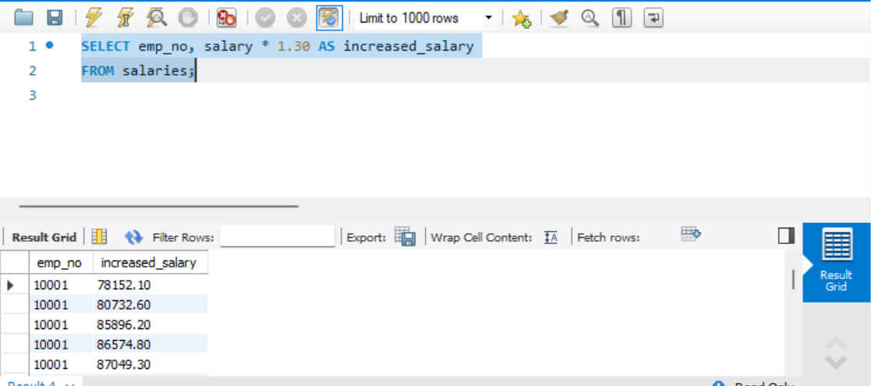

**Assignment 4:**

--Query

SELECT DISTINCT title FROM titles;

**Output:**

