Diabetes Prediction using Classical Machine Learning Approaches
Methodology
We are using the diabetes dataset provided for predicting whether a patient can have diabetes or not based on certain parameters such as pregnancy, glucose, age, blood-pressure etc. We have used simple machine learning models such as logistic regression and linear discriminant analysis for the prediction. Before setting up the model, we preprocess the data by checking for any null rows and then replacing them with mean values if required.
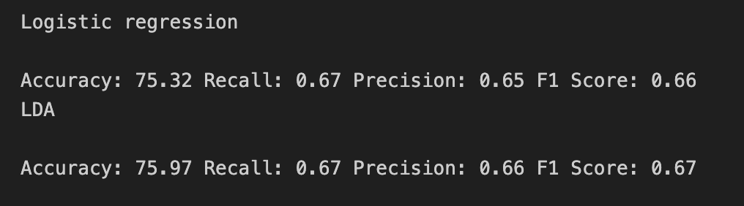
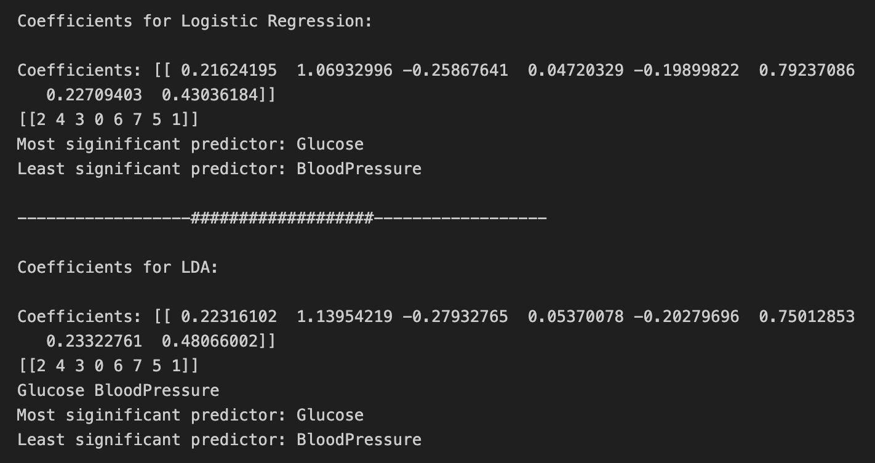
We divide the dataset into features and the target variable and then splitting the dataset between training and testing. Next step was to fit the data on both the models and calculate the metrics to compare both of them. At last we have plotted the ROC curve for both the models and have listed the most significant and the least significant predictor of diabetes.
Results
As we can see there is not much difference between the models with LDA being very slightly better. Both the models predicted Glucose as the most significant predictor of diabetes while Blood Pressure as the least significant one.

Conclusions
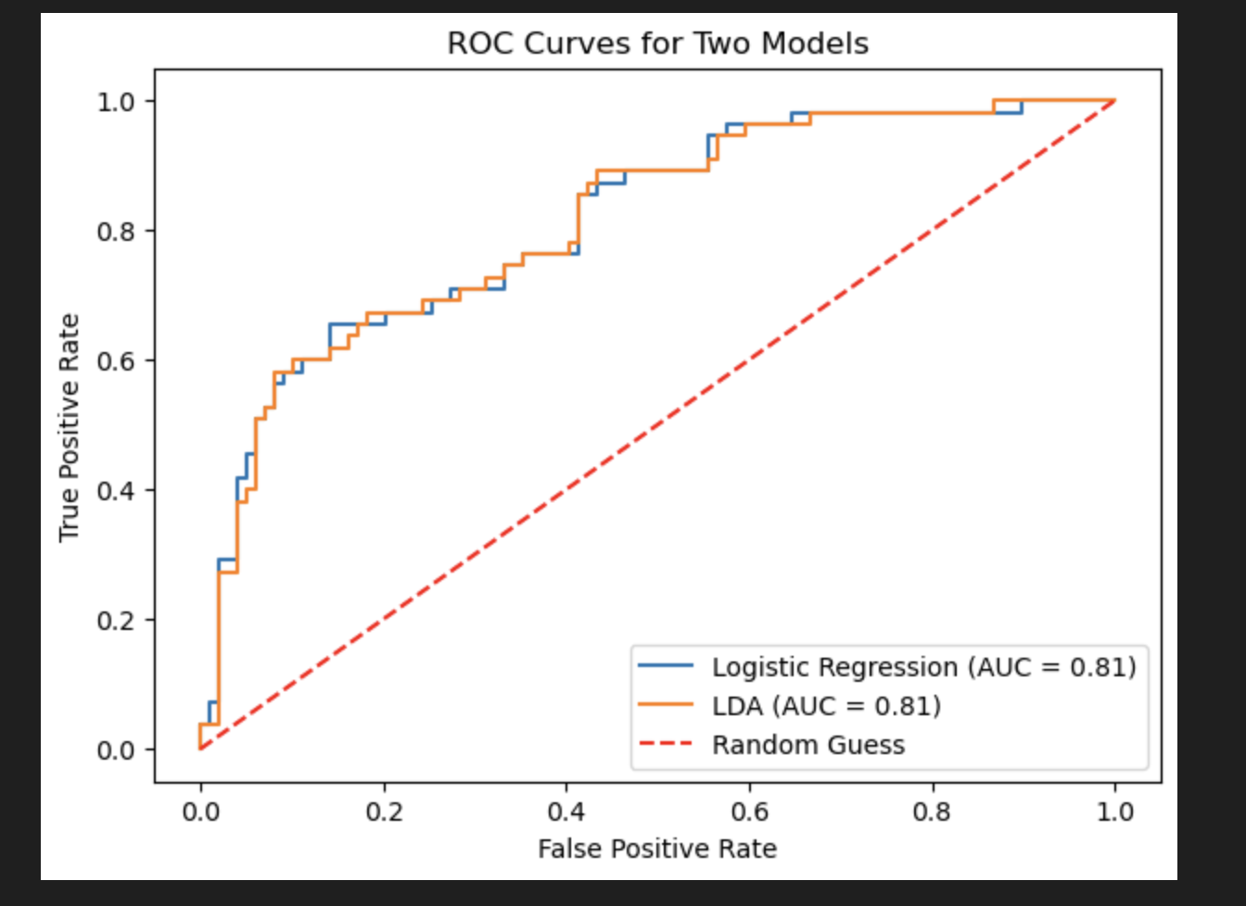
We can conclude the LDA performs better in binary classification problem than the logistic regression as seen above. ROC curve and ROC score is same for both the models indicating that there is a very slight difference.

