MES ABASAHEB GARWARE COLLEGE
(AUTONOMOUS), PUNE
B.Sc. Data Science — Semester III
Database Management System
MINI PROJECT REPORT
TRAINPRO
Training Institute Management & Analytics System
Technology: MySQL 8.0+
Academic Year: 2026–2027
Prepared by: Aryan Bochare
Course: B.Sc. Data Science

1. Project Overview
TRAINPRO is a relational database management system designed for a training institute. The system manages students, trainers, courses, batches, enrollments, attendance and assessment results. It also provides analytical queries for enrollment trends, attendance monitoring, student performance, course comparison and ranking.
The project follows the scope of Assignment No. 12 in the Database Management System workbook, which requires database planning, table relationships, primary and foreign keys, realistic sample data, business queries, analysis, an ER diagram, a MySQL script and a short project report.

2. Objective
To develop a basic MySQL Training Institute Management System that demonstrates database planning, table relationships, query writing, business analysis and presentation of findings.

3. Problem Statement
Training institutes manage information about students, trainers, courses, batches, enrollments, attendance and assessment results. If these activities are maintained separately, it becomes difficult to maintain consistency and generate useful reports. TRAINPRO organizes these activities into related tables so that the institute can retrieve reliable information and perform analysis using SQL.

4. Users of the System
User | Main Use
Administrator | Manage master data, enrollments and database records.
Trainer | Monitor assigned batches, attendance and assessment performance.
Institute Coordinator | Review enrollments, attendance, performance and management reports.

5. Functional Requirements
- Store and manage student details.
- Store trainer details and specializations.
- Maintain course information including duration, fees and level.
- Create batches and assign courses and trainers.
- Record student enrollments in batches.
- Maintain attendance records for each enrollment.
- Maintain assessment results for enrolled students.
- Generate student-wise progress reports.
- Analyze course enrollment and student performance.
- Rank students using assessment results.

6. Database Design
The database contains seven core relational tables. Each table has a primary key and dependent tables use foreign keys to preserve referential integrity. The design avoids repeated student, trainer, course and batch information.
Table | Primary Key | Purpose
Student | StudentID | Stores student personal and registration details.
Trainer | TrainerID | Stores trainer details, specialization and experience.
Course | CourseID | Stores course name, duration, fees and level.
Batch | BatchID | Stores course batch, trainer assignment, dates and mode.
Enrollment | EnrollmentID | Connects students with batches.
Attendance | AttendanceID | Stores attendance status for an enrollment.
AssessmentResult | ResultID | Stores assessment-wise marks for an enrollment.

7. Table Relationships
Parent | Related Table | Relationship | Purpose
Course | Batch | One-to-Many | One course can be conducted through multiple batches.
Trainer | Batch | One-to-Many | One trainer can handle multiple batches.
Student | Enrollment | One-to-Many | One student can have multiple enrollments.
Batch | Enrollment | One-to-Many | One batch can contain multiple student enrollments.
Enrollment | Attendance | One-to-Many | One enrollment can have multiple attendance records.
Enrollment | AssessmentResult | One-to-Many | One enrolled student can receive multiple assessment results.

8. ER Diagram
The ER diagram was generated in MySQL Workbench using Reverse Engineer. It shows the seven tables, their keys and the relationships established through foreign keys.
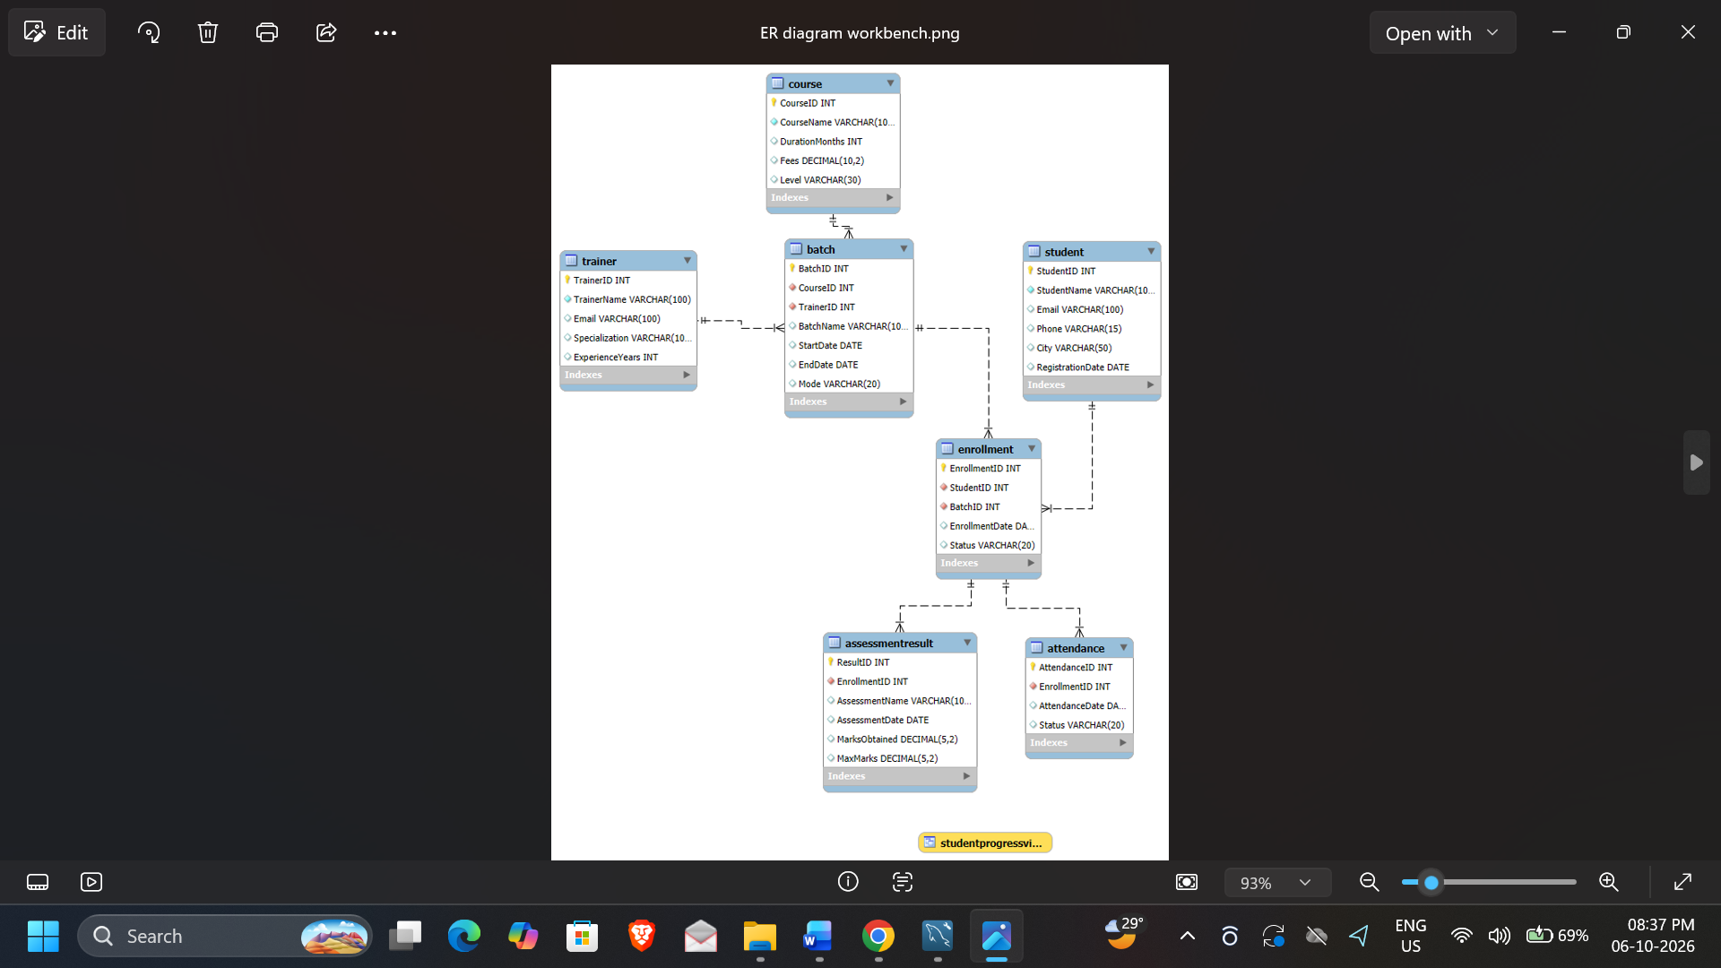
Figure 1: Final TRAINPRO ER diagram exported from MySQL Workbench

9. Database Implementation
The database was implemented in MySQL using primary keys, foreign keys, NOT NULL constraints and UNIQUE constraints where appropriate. Sample data was inserted into every table. Attendance and assessment records were generated so that the database supports meaningful analytical queries.

10. Data Volume
Entity | Records
Students | 20
Trainers | 6
Courses | 6
Batches | 8
Enrollments | 20
Attendance | 200
Assessment Results | 80

The sample dataset contains multiple courses, trainers, batches, students, attendance records and assessment results, allowing the business questions specified in the workbook to be analyzed.

11. SQL Concepts Demonstrated
- CREATE DATABASE and CREATE TABLE
- PRIMARY KEY and FOREIGN KEY constraints
- NOT NULL and UNIQUE constraints
- INSERT and SELECT statements
- INNER JOIN across related tables
- GROUP BY and aggregate functions such as COUNT, AVG, MIN and MAX
- HAVING and ORDER BY for analytical filtering
- Subquery for student performance ranking
- View for the reusable student progress report
- Window function RANK() for analytical ranking

12. Key Business Queries
Business Question | SQL Technique
Display students enrolled in each batch | JOIN
Display course and trainer for every batch | Multiple JOINs
Find total students in each course | COUNT + GROUP BY
Find students below required attendance | CASE + aggregate + HAVING
Find average assessment performance | AVG + GROUP BY
Identify top performers | ORDER BY + LIMIT
Compare course-wise performance | JOIN + AVG/MIN/MAX
Rank students | RANK() window function
Generate student-wise progress | VIEW

13. Analysis and Findings

13.1 Course Enrollment
Data Science has the highest enrollment in the implemented sample dataset, with 7 students. Cyber Security has 4 students, Python Programming has 3 students, and Web Development, Machine Learning and SQL & Database Management have 2 students each.

13.2 Attendance Monitoring
The student-wise attendance query identifies students below the 75% threshold. In the sample data, Om Deshmukh, Kunal Patil and Mansi Chavan fall below this threshold, with 40% attendance each. These records demonstrate how the system can identify students requiring attendance follow-up.

13.3 Student Performance
Student | Course | Average Score
Aarav Kulkarni | Data Science | 88.50
Isha Mehta | Cyber Security | 88.50
Riya Sharma | Data Science | 86.00
Vedant More | Python Programming | 80.50
Ananya Shah | Python Programming | 79.50

The ranking query uses RANK() to order students according to average assessment score. This demonstrates the use of window functions for analytical reporting.

13.4 Course-wise Performance
Course | Students | Average Score | Highest | Lowest
Python Programming | 3 | 75.83 | 80.50 | 67.50
Web Development | 2 | 74.25 | 77.00 | 71.50
Machine Learning | 2 | 73.00 | 73.50 | 72.50
Data Science | 7 | 72.71 | 88.50 | 48.50
Cyber Security | 4 | 68.88 | 88.50 | 52.50
SQL & Database Management | 2 | 58.75 | 69.00 | 48.50

14. Management Insights
- Data Science has the largest student enrollment and therefore represents the strongest enrollment demand in the sample.
- Students below 75% attendance can be identified automatically for counseling or follow-up.
- The progress view combines attendance and assessment performance into one reusable report.
- Course-wise performance comparison helps management identify courses that may require additional academic support.
- Student ranking makes it easier to recognize high performers and identify students who may need intervention.
- The relational design keeps master data separate from transactional records, reducing unnecessary repetition.

15. How the Institute Can Improve Training
- Follow up with students whose attendance falls below the required percentage.
- Provide additional academic support to consistently low-performing students.
- Recognize high-performing students through certificates, mentoring or advanced learning opportunities.
- Review course-wise performance regularly to identify subjects or batches needing improvement.
- Use the progress view as a recurring management report.

16. Conclusion
TRAINPRO successfully implements a basic Training Institute Management System in MySQL. The project connects students, trainers, courses, batches, enrollments, attendance and assessment results using primary and foreign keys. The database supports meaningful business analysis through joins, aggregate functions, subqueries, views and window functions.
The system demonstrates how a properly designed relational database can convert operational records into useful management information. The final SQL script, ER diagram, analytical queries and project report together satisfy the main deliverables specified for the mini project.

17. Future Scope
- Add fee payment and installment management.
- Add automated certificate generation.
- Add login and role-based access control.
- Add a web-based dashboard for management.
- Add course feedback and trainer evaluation.
- Add automated attendance alerts and performance notifications.

18. Project Deliverables
Deliverable | File / Evidence
MySQL database | TrainProDB
Final SQL script | TrainProDB_Final.sql
ER diagram | TrainPro_ER_Diagram.png
Project report | TRAINPRO_Project_Report.docx
Query outputs | Screenshots folder
Presentation | TRAINPRO_Presentation.pptx

19. References
Primary academic source: Database Management System Workbook, B.Sc. Data Science, Semester III, MES Abasaheb Garware College (Autonomous), Academic Year 2026–2027, Assignment No. 12: Mini Project – Training Institute Management System.

