1)Write a program to display the array element.

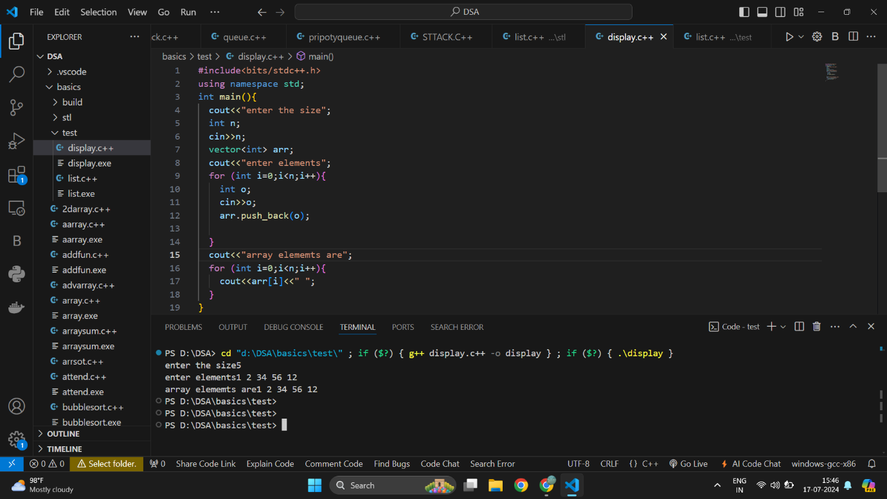

2)write a progam to find the max element from the list

Leet code

[**1. Two Sum**](https://leetcode.com/problems/two-sum/)

Solved

Easy

Topics

Companies

Hint

Given an array of integers nums and an integer target, return *indices of the two numbers such that they add up to target*.

You may assume that each input would have ***exactly* one solution**, and you may not use the *same* element twice.

You can return the answer in any order.

[**20. Valid Parentheses**](https://leetcode.com/problems/valid-parentheses/)

Solved

Easy

Topics

Companies

Hint

Given a string s containing just the characters '(', ')', '{', '}', '[' and ']', determine if the input string is valid.

An input string is valid if:

1. Open brackets must be closed by the same type of brackets.
2. Open brackets must be closed in the correct order.
3. Every close bracket has a corresponding open bracket of the same type.

