1)Write a program to display the array element.

#include<bits/stdc++.h>

using namespace std;

int main(){

  cout<<"enter the size";

  int n;

  cin>>n;

  vector<int> arr;

  cout<<"enter elements";

  for (int i=0;i<n;i++){

    int o;

    cin>>o;

    arr.push_back(o);

  }

  cout<<"array elememts are";

  for (int i=0;i<n;i++){

    cout<<arr[i]<<" ";

  }

}

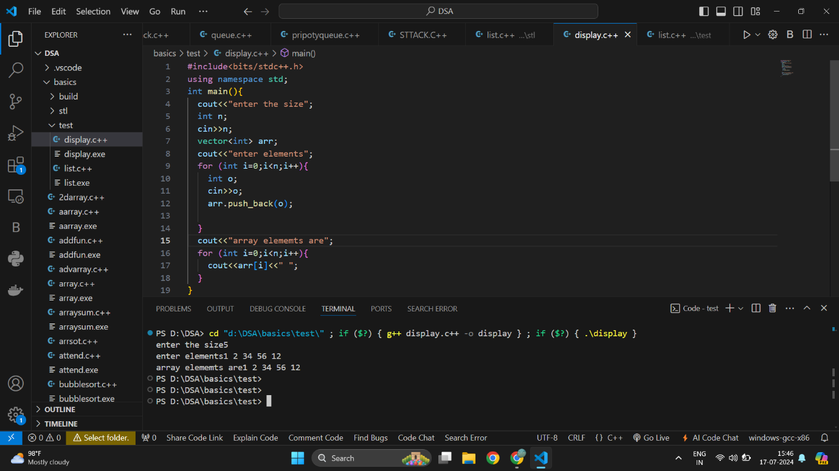

2)write a progam to find the max element from the list.

#include<iostream>

#include<list>

using namespace std;

int main()

{

    list<int> l;

    l.push_back(2);

    l.push_back(4);

    l.push_back(1);

    l.push_back(3);

    int maxi=l.front();

    for(int i: l)

    {

        if(maxi<i)

            maxi=i;

    }

    cout<<maxi;

}

Leet code

[**1. Two Sum**](https://leetcode.com/problems/two-sum/)

Solved

Easy

Topics

Companies

Hint

Given an array of integers nums and an integer target, return *indices of the two numbers such that they add up to target*.

You may assume that each input would have ***exactly* one solution**, and you may not use the *same* element twice.

You can return the answer in any order.

[**20. Valid Parentheses**](https://leetcode.com/problems/valid-parentheses/)

Solved

Easy

Topics

Companies

Hint

Given a string s containing just the characters '(', ')', '{', '}', '[' and ']', determine if the input string is valid.

An input string is valid if:

1. Open brackets must be closed by the same type of brackets.
2. Open brackets must be closed in the correct order.
3. Every close bracket has a corresponding open bracket of the same type.

