Faym.co — Product Management Intern Shortlisting Assignment
Submitted by Aryan
August 2, 2026

Part A — Wallet Transactions Data Case Study
Dataset: 501 wallet transactions from January to July 2020, across 10 users, five settlement rails (IMPS, IFT, NEFT, UPI, RTGS) and two transaction types (CREDIT, DEBIT). All queries below are written against a table transactions("Transaction Time", "User Id", "Transaction Amt", Narration, "Transaction Type", Txn_id, Month) and were validated by executing them against the actual dataset in SQLite, not written blind.

Q1. 7th Highest Debit Amount Through IMPS
SELECT "Transaction Amt" AS debit_amount, "User Id", Txn_id, "Transaction Time"
FROM transactions
WHERE Narration = 'IMPS' AND "Transaction Type" = 'DEBIT'
ORDER BY "Transaction Amt" DESC
LIMIT 1 OFFSET 6;
Answer: ₹9,525 — User 8, Txn ID 64B08A24, dated 16-Jan-2020.
For transparency, the top 10 IMPS debit transactions:
Rank | Amount (₹) | User Id | Txn Id | Date
1 | 9,987 | 9 | 613AFBB8 | 08-Apr-2020
2 | 9,887 | 10 | EE06FC09 | 09-Jul-2020
3 | 9,872 | 3 | 7641EB77 | 24-Feb-2020
4 | 9,863 | 5 | 834C909F | 14-Jul-2020
5 | 9,743 | 4 | 53258869 | 16-May-2020
6 | 9,566 | 3 | 8D2D3F20 | 28-May-2020
7 | 9,525 | 8 | 64B08A24 | 16-Jan-2020
8 | 9,450 | 1 | BDF20BCA | 28-Jan-2020
9 | 9,434 | 7 | B0EEB2E7 | 17-Apr-2020
10 | 9,337 | 4 | 47625EBE | 11-Jun-2020

Q2. Number of Transactions, Category-wise
SELECT Narration AS Category, COUNT(*) AS Num_Txns
FROM transactions
GROUP BY Narration
ORDER BY Num_Txns DESC;
The dataset also contains an IFT (Internal Fund Transfer) rail alongside the four named in the brief; included below for completeness.
Category | Num_Txns | % of Total
IMPS | 272 | 54.3%
IFT | 89 | 17.8%
UPI | 86 | 17.2%
NEFT | 33 | 6.6%
RTGS | 21 | 4.2%
Total | 501 | 100%

Q3. Bell Curve, Box Plot & Statistical Summary — Load Amount
The brief says "load amount" but the dataset has only one amount column, Transaction Amt. Two defensible interpretations — both are shown so the read is not sensitive to which one the interviewer had in mind:
- All transactions (n=501) — treating the amount column at face value.
- CREDIT-only / wallet loads (n=352) — treating "load" strictly as money loaded into the wallet.
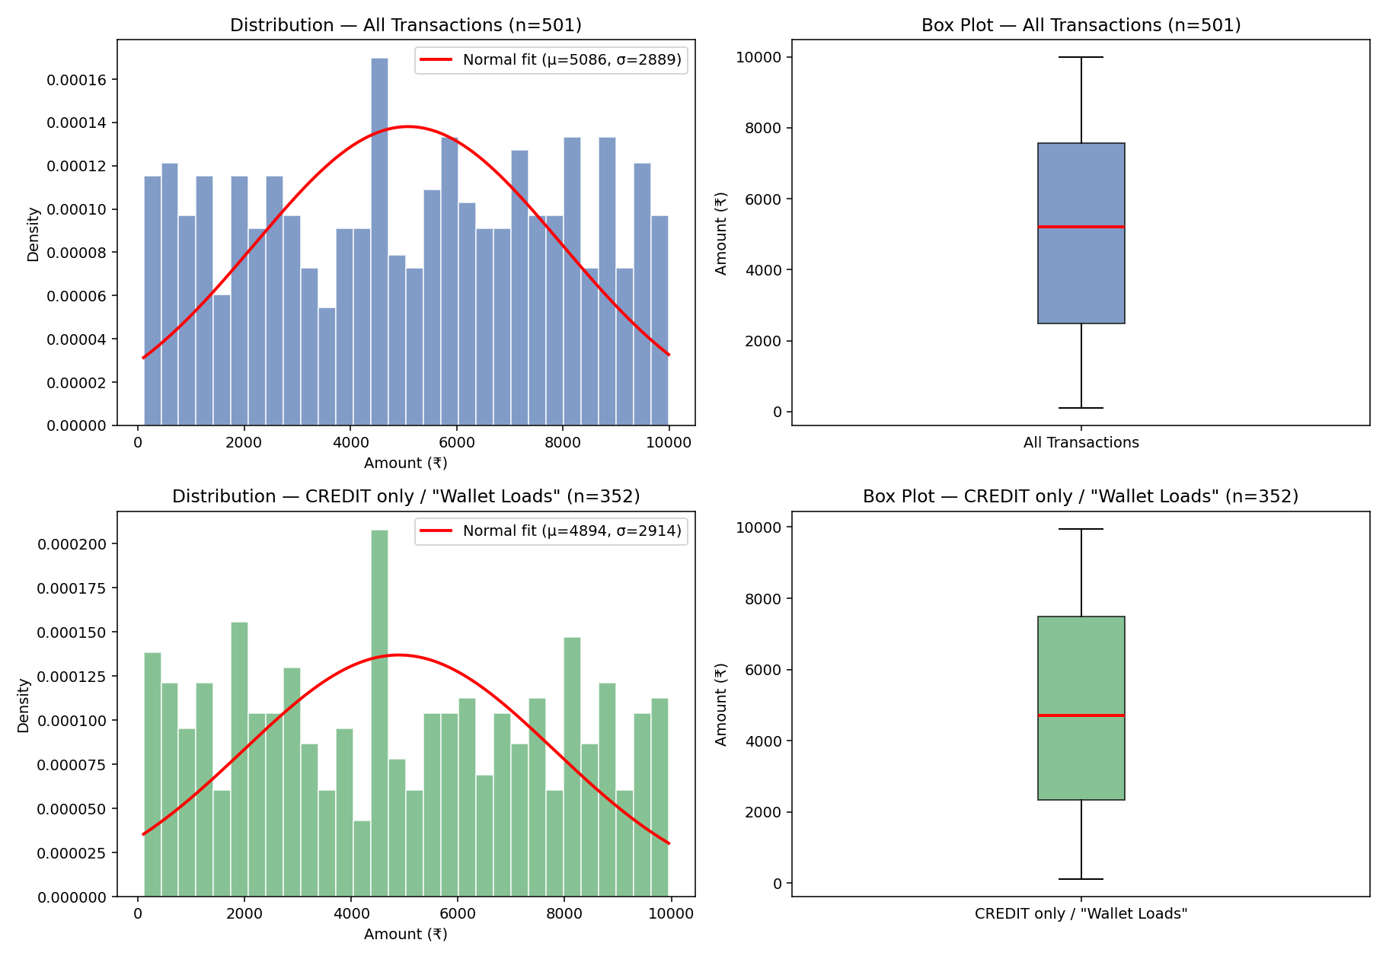
Figure 1: Distribution and box plot of transaction amount under both interpretations.
Statistic | All Transactions (n=501) | CREDIT-only / Loads (n=352)
Count | 501 | 352
Mean | ₹5,085.53 | ₹4,894.26
Median | ₹5,206.00 | ₹4,707.50
Std Deviation | ₹2,889.16 | ₹2,914.07
Min | ₹108.00 | ₹108.00
Q1 (25th pct) | ₹2,480.00 | ₹2,329.00
Q3 (75th pct) | ₹7,571.00 | ₹7,492.00
Max | ₹9,987.00 | ₹9,950.00
IQR | ₹5,091.00 | ₹5,163.00
Skewness | -0.055 (~symmetric) | +0.049 (~symmetric)
Kurtosis (excess) | -1.20 (platykurtic) | -1.24 (platykurtic)
Outliers (1.5×IQR) | 0 | 0
Interpretation: under either definition the distribution is close to symmetric (|skew| < 0.06) and flatter than a true normal curve (negative excess kurtosis) — amounts are fairly evenly spread across the full range rather than clustering tightly around the mean, consistent with a synthetically generated / near-uniform amount field. Neither variant contains outliers under the standard 1.5×IQR rule.

Q4. Monthly Cohort View — Active Users (DEBIT Transactions)
Cohort definition: each user's cohort month = the calendar month of their first-ever DEBIT transaction. "Active" in a given month = the user made at least one DEBIT transaction in that month.
WITH debit_txns AS (
SELECT "User Id", Month FROM transactions WHERE "Transaction Type" = 'DEBIT'
),
first_month AS (
SELECT "User Id", MIN(Month) AS cohort_month FROM debit_txns GROUP BY "User Id"
)
SELECT f.cohort_month, d.Month AS activity_month,
COUNT(DISTINCT d."User Id") AS active_users
FROM debit_txns d JOIN first_month f ON f."User Id" = d."User Id"
GROUP BY f.cohort_month, d.Month
ORDER BY f.cohort_month, d.Month;
Pivoted in the shape of the brief's template. Rows = cohort/first-appearance month; columns = calendar month; cell = number of that cohort's users who did a DEBIT in that month. Blank = zero.
Cohort \ Month | 2020-01 | 2020-02 | 2020-03 | 2020-04 | 2020-05 | 2020-06 | 2020-07
2020-01 (n=8) | 8 | 5 | 8 | 7 | 7 | 7 | 8
2020-02 (n=1) |  | 1 |  | 1 | 1 |  | 1
2020-03 (n=1) |  |  | 1 | 1 | 1 | 1 | 1
2020-04 (n=0)
2020-05 (n=0)
2020-06 (n=0)
2020-07 (n=0)
Reading (cohort = first DEBIT month): of the 10 users, 8 had their first DEBIT in January, 1 in February, 1 in March. The Jan cohort shows near-full retention (5–8 of 8 active each month). Cohorts 4–7 are empty because no user's first debit falls after March.
Alternate cohort definition (standard cohort methodology: cohort = user's first month of ANY transaction; active = did a DEBIT that month). Provided so the read isn't sensitive to which definition the interviewer had in mind:
Cohort \ Month | 2020-01 | 2020-02 | 2020-03 | 2020-04 | 2020-05 | 2020-06 | 2020-07
2020-01 (n=10) | 8 | 6 | 9 | 9 | 9 | 8 | 10
2020-02 (n=0)
2020-03 (n=0)
2020-04 (n=0)
2020-05 (n=0)
2020-06 (n=0)
2020-07 (n=0)
Under this definition every user shows up in the January cohort (all 10 users had at least one transaction in January), and 8–10 of them stay DEBIT-active every subsequent month — a very sticky user base.

Q5. Top 10 Percentile Users by Net Amount (DEBIT − CREDIT)
WITH user_net AS (
SELECT "User Id",
SUM(CASE WHEN "Transaction Type"='DEBIT' THEN "Transaction Amt" ELSE 0 END) -
SUM(CASE WHEN "Transaction Type"='CREDIT' THEN "Transaction Amt" ELSE 0 END) AS net_amount
FROM transactions GROUP BY "User Id"
),
ranked AS (
SELECT "User Id", net_amount,
PERCENT_RANK() OVER (ORDER BY net_amount DESC) AS pct_rank
FROM user_net
)
SELECT "User Id", net_amount FROM ranked
WHERE pct_rank <= 0.10
ORDER BY net_amount DESC;
Full ranking for context. Every user's net amount is negative because, across all 10 users, wallet CREDIT volume exceeds DEBIT volume (typical of a load-heavy wallet product). "Highest" net amount therefore means least negative:
Rank | User Id | Net Amount (₹) = Debit − Credit
1 | 8 | -35,804
2 | 1 | -37,313
3 | 3 | -39,640
4 | 10 | -58,427
5 | 4 | -88,041
6 | 7 | -113,196
7 | 6 | -117,389
8 | 9 | -127,790
9 | 2 | -132,453
10 | 5 | -147,655
Top 10th-percentile result (User Id, net amount): (8, -35,804).

Part B — Product Spec: Browser Agent for Automated Multi-Item Returns
This section reframes the provided engineering brief as a product requirements document (PRD), adding the goals, success metrics, state model, and risk analysis a PM would attach before this goes into a sprint.

1. Problem & Background
Faym's ops/support team currently files e-commerce returns (Amazon, Flipkart) manually, line item by line item. A single order can bundle multiple SKUs, each with its own return window and return ID, and each platform exposes a different return flow (Amazon supports both a batch flow covering a whole order and a sequential per-item flow; Flipkart is sequential-only). Manual filing is slow, error-prone at the line-item level (partial-order returns are easy to mis-track), and doesn't scale. We want a browser automation agent that reads a queue of pending returns from Excel, executes the correct return flow per platform, and writes the outcome back per line item — without getting the account flagged as a bot.

2. Goals & Non-Goals
Goals:
- Automate return initiation for Amazon and Flipkart, at 1 line item = 1 tracked outcome, regardless of whether the platform's UI groups items into one order-level flow or forces one pass per item.
- Excel remains the single source of truth for input (task queue) and output (results) — no separate database in v1.
- Handle partial-order success gracefully: never let one ineligible item block the rest of the order.
- Operate within normal human session patterns to minimize bot-detection risk.
Non-goals (v1):
- No support for platforms beyond Amazon/Flipkart.
- No automated dispute/escalation flow if a platform rejects a return outright — that path is a human hand-off.
- No unattended handling of CAPTCHA/OTP challenges — these fall back to human-in-the-loop.

3. Users
- Primary: Ops/CX associate who owns the returns queue in Excel and reviews flagged items.
- Secondary: Ops lead who monitors throughput/SLA and refund accuracy.

4. End-to-End Workflow
The agent runs a loop over pending rows in Excel:
- Read the next task where Task status = "To Do"/"Pending".
- Group tasks by (Order ID + Platform), and detect the return model for that platform: Batch (one flow can close out every line item in the order — e.g. Amazon in some order types) vs Sequential (one micro-flow per line item — Flipkart always; Amazon sometimes).
- Open a browser session for that platform (persistent, logged-in profile — see Section 8).
- For a Batch-eligible order: run one return flow, select all eligible items in that single flow, and map the platform's per-item confirmation back to each row.
- For a Sequential order: repeat the return micro-flow once per line item — select return reason, refund/pickup option, confirm.
- Capture Return ID, Return status, and Refund amount as shown by the platform for each item.
- Write the result back to the corresponding Excel row immediately (not batched at the end), so partial progress is never lost if the run is interrupted.
- Set Task status = Done for completed items, or Needs human review for anything that failed, was out of window, or hit an unexpected UI state.
- Only mark the parent Order ID fully Done once every one of its line items has a terminal state.

5. Return-Model Detection Logic
Before acting, the agent inspects the order page for the platform:
- If the platform's return UI presents a multi-select / "select items to return" screen for the order → Batch flow: process all eligible line items for that order in one pass.
- If the UI only ever lets you initiate a return against one SKU at a time → Sequential flow: loop the micro-flow per line item, re-opening the order page between items if the platform kicks you back to the order view after each confirmation.
- Detection result and the reasoning (e.g. "multi-item selector present") is logged per order for auditability, since this determines the whole execution path.

6. Data Model — Excel Schema
One row = one line item (SKU) within an order, never one row per order:
Field | Written by | Notes
Platform | Input | Amazon / Flipkart
Order ID | Input | Locates the parent order
Product / SKU | Input | Identifies the specific line item
Return window | Input / verified | Agent verifies eligibility before acting
Return ID | Agent | Captured post-confirmation from the platform
Return status | Agent | Placed / Failed / Out of window
Refund amount | Agent | As shown by the platform
Task status | Agent | Done / Needs human review
Timestamp / log | Agent | When the action ran; error detail if any
Attempt count | Agent (added) | Retries so far — caps automatic retry loops
Return model used | Agent (added) | Batch / Sequential — for audit and debugging

7. Partial-Success Handling
- Every line item is processed and recorded independently — never a single order-level pass/fail flag.
- An ineligible item (e.g. past its return window) is logged with status "Out of window" and the loop continues to the next item; it never aborts the order.
- Eligible items in the same order (A, B) are completed even if another item (C) fails or is ineligible.
- Failed/skipped items are explicitly flagged "Needs human review" — never silently dropped or left blank.
- The parent order is only rolled up to fully Done once every one of its line items carries a terminal recorded state (Done or Needs human review).

8. Bot-Detection Avoidance
Because this drives real consumer-facing sites, the agent needs to look like a normal logged-in shopper, not a script:
- Persistent, warmed-up browser profile/cookies per account rather than a fresh headless session every run, so each run looks like a continuation of a normal session rather than a new anonymous client.
- Run non-headless (or a stealth-patched headless build) and mask common automation fingerprints (navigator.webdriver, headless UA strings, missing plugins/canvas noise).
- Randomized, human-scale pacing between actions (variable delays, not fixed sleep(1s)), plus incremental mouse movement/scroll before clicks rather than teleporting the cursor to coordinates.
- Rate-limit actions per account per hour to stay well under anything that would look like bulk automation; stagger multiple accounts rather than running them in lockstep.
- Graceful fallback on a CAPTCHA/OTP/unexpected verification screen: pause that task, flag for human-in-the-loop, and do not hammer retries against a challenge screen (repeated failed attempts is itself a strong bot signal).
- Treat OTP-based logins (as specified for the Flipkart test account) as a supervised step — the agent requests the OTP and a human/notification channel supplies it, rather than trying to intercept SMS automatically.

9. Success Metrics
- % of line items auto-completed without human review (north-star metric for automation coverage).
- Median time from "To Do" to terminal state, per line item.
- Refund-amount accuracy vs platform-shown amount (should be 100% — this is a capture, not a decision, field).
- Bot-flag/CAPTCHA-challenge rate per 100 runs, tracked over time as a leading indicator of detection risk.

10. Risks & Mitigations
Risk | Mitigation
Platform UI changes break selectors | Selector abstraction per platform adapter; nightly smoke test against a known test order; alert on failure-rate spike rather than failing silently.
Account gets flagged / rate-limited | Pacing + fingerprint masking (Section 8); circuit-breaker that pauses all automation on that account after N consecutive anomalies.
Partial order state gets lost mid-run | Write-back happens per item immediately, not batched at the end (Section 4, step 7).
OTP/CAPTCHA blocks unattended runs | Human-in-the-loop fallback with task flagged, not retried blindly.
Excel is edited concurrently by a human | Row-level refresh check before write-back; last-write timestamp comparison.

11. Rollout Plan
- Pilot on Flipkart Test Orders using the provided test credentials (9205359199 / OTP) — sequential flow only, low volume, human reviewing every write-back.
- Once return-ID capture and refund-amount accuracy are verified against manual filing for ~20–30 test returns, extend to Amazon and enable batch-flow detection.
- Graduate from "human reviews every row" to "human reviews only flagged rows" once the flagged-rate stabilizes below an agreed threshold (e.g. <5%) over two consecutive weeks.

12. Open Questions
- What refund/pickup option should the agent default to when the platform offers a choice (e.g. instant refund to source vs wallet credit) — is there a house policy?
- Priority ordering across platforms/orders was left "To be set" in the brief — should SLA-at-risk (return window closing soonest) drive queue priority?
- Should the agent notify ops proactively (Slack/email) when an item is flagged, or is polling the Excel sheet sufficient for v1?

