REPORT
OF
NGO / SOCIAL INTERNSHIP
AT
CJ DARCL LOGISTICS LTD.
UNDER CSR/NGO INITIATIVE “SHIKSHALAYA”
Submitted
To
School of Computer Science and Engineering
IILM University, Greater Noida, U.P.
In partial fulfilment of the requirement of degree of
B.Tech CSE
By
Name of Student: ARYAN CHHAWRA
Roll Number of Student: ____________________
Batch: 2026-27

CANDIDATE’S DECLARATION
I, ARYAN CHHAWRA, do hereby declare that the internship report titled “NGO / Social Internship at CJ Darcl Logistics Ltd. under CSR/NGO Initiative Shikshalaya” has been completed by me to fulfil the requirement for the award of the degree of Bachelor of Technology in CSE. The report presents my internship experience based on the activities and responsibilities undertaken during the internship period. All references used in preparing this report have been acknowledged, and I affirm that this report is my own work and has not been submitted to any other institute for any degree or diploma requirement. I shall be solely responsible for any kind of copyright violation in this regard.

Student Name: ARYAN CHHAWRA
Roll No.: _______25SCS1003003666_______________________

ACKNOWLEDGEMENT
I take this opportunity to express my sincere gratitude to everyone who supported me throughout my NGO / Social Internship with CJ Darcl Logistics Ltd. under its CSR/NGO initiative “Shikshalaya”. The internship provided me with an opportunity to participate in social welfare activities, community outreach, awareness programmes, and other assigned responsibilities.
I am thankful to the organisation for providing me with the opportunity to learn through practical participation and for the guidance and support extended during the internship period. I also express my gratitude to the School of Computer Science and Engineering, IILM University, Greater Noida, for providing the academic framework and support required for completing this internship.
Finally, I express my gratitude to my parents for their blessings, encouragement, and continuous support.

Signature: ______________________________
Student Name: ARYAN CHHAWRA
Roll No.: ______________________________

INTERNSHIP COMPLETION CERTIFICATE
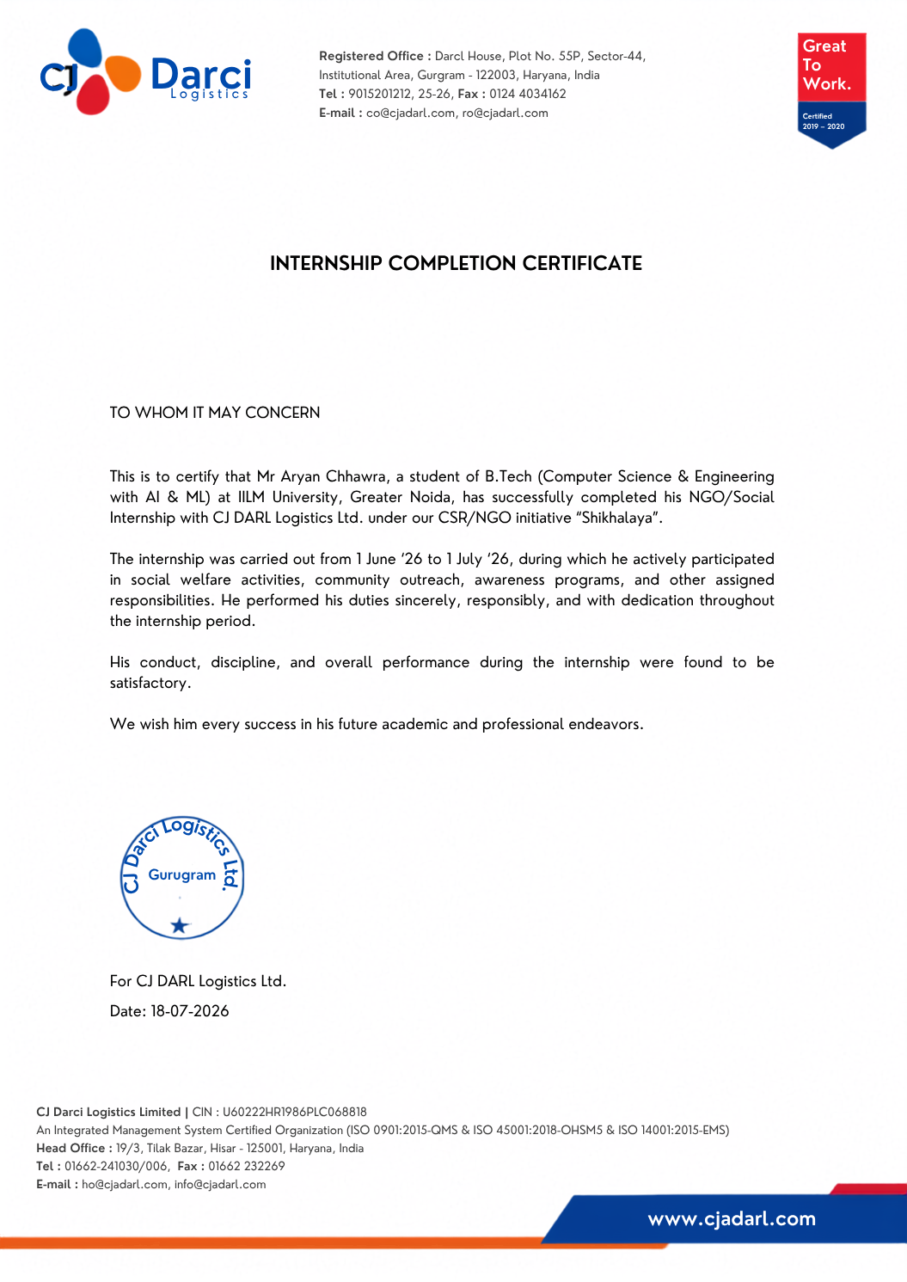

TABLE OF CONTENTS
Chapter Name | Page Nos.
Cover Page | —
1. Candidate’s Declaration | i
2. Acknowledgement | ii
3. Internship Completion Certificate | —
4. Project Description | iii
4.1 Introduction | iii
4.2 Organization Profile | iv
4.3 Problem Statement | iv
4.4 Project Objectives | v
4.5 Scope of the Project | v
4.6 Technologies and Tools Used | vi
4.7 System Architecture | vi
4.8 Methodology | vii
4.9 Expected Outcomes | viii
4.10 Certificates of Completion and Other Communication Mail Proof | ix
5. Bibliography / References | x

Note: Page numbers are indicative and may shift slightly depending on the final printing/layout settings.

4. PROJECT DESCRIPTION

4.1 Introduction
The internship was an NGO / Social Internship completed with CJ Darcl Logistics Ltd. under the organisation’s CSR/NGO initiative “Shikshalaya”. According to the internship completion certificate, the internship was carried out from 1 June 2026 to 1 July 2026. During this period, the intern actively participated in social welfare activities, community outreach, awareness programmes, and other assigned responsibilities.
The internship was therefore focused on practical participation in social and community-oriented activities rather than on the development of a software product. It provided an opportunity to understand how organised social initiatives require participation, responsibility, communication, discipline, and consistent execution.
The certificate records that the duties were performed sincerely, responsibly, and with dedication throughout the internship period. It also states that the intern’s conduct, discipline, and overall performance were found to be satisfactory.

4.2 Organization Profile
CJ Darcl Logistics Ltd. is the organisation with which the internship was completed. The certificate identifies the organisation as CJ Darcl Logistics Ltd. and states that the internship was undertaken under its CSR/NGO initiative “Shikshalaya”. The certificate carries the organisation’s registered-office details and identifies the registered office as Darcl House, Plot No. 55P, Sector-44, Institutional Area, Gurugram – 122003, Haryana, India.
The certificate also indicates that the organisation operates with an Integrated Management System and lists ISO 9001:2015-QMS, ISO 45001:2018-OHSMS and ISO 14001:2015-EMS certifications. It further displays a Great Place To Work certification. These details provide an indication of the organisation’s formal management and workplace practices.
For the purpose of this internship report, the relevant organisational context is its CSR/NGO initiative “Shikshalaya”, through which the internship activities were carried out. The certificate does not provide a detailed description of the initiative’s internal structure or specific programmes; therefore, no additional organisational claims are made in this report.

4.3 Problem Statement
Social welfare and community outreach activities require organised participation, awareness-building, communication, and responsible execution. The internship context reflects the need to support such activities through active participation in social welfare work, community outreach, awareness programmes, and assigned responsibilities.
The internship therefore addressed a practical participation-oriented problem: how a student can contribute responsibly to organised social initiatives while developing discipline, communication, awareness, teamwork, and a sense of social responsibility.

4.4 Project Objectives
• To participate actively in social welfare activities conducted under the Shikshalaya initiative.
• To contribute to community outreach and awareness programmes assigned during the internship.
• To carry out assigned responsibilities sincerely, responsibly, and with dedication.
• To develop practical understanding of participation in organised social initiatives.
• To strengthen professional qualities such as discipline, responsibility, communication, cooperation, and accountability.
• To understand the importance of social responsibility alongside academic and professional development.

4.5 Scope of the Project
The scope of the internship was centred on social and community-oriented participation. Based on the completion certificate, the scope included social welfare activities, community outreach, awareness programmes, and other responsibilities assigned during the internship period.
The internship scope can be understood through the following areas:
• Social welfare participation: supporting activities intended to contribute to social welfare.
• Community outreach: participating in activities involving interaction and engagement with the community.
• Awareness programmes: contributing to programmes intended to spread awareness on relevant social issues.
• Assigned responsibilities: completing responsibilities allocated during the internship period with sincerity and accountability.
• Professional conduct: maintaining discipline, responsibility, and dedication throughout the internship.
No software-development deliverable, programming task, database system, or technical product is specified in the internship completion certificate. Accordingly, this report does not claim any such technical deliverable.

4.6 Technologies and Tools Used
The internship completion certificate does not specify a particular software technology stack or specialised technical tools. Since the internship was an NGO / Social Internship, the principal working resources were activity-oriented rather than software-development-oriented.
Area | Relevance to Internship
Communication | Interaction and coordination required for community outreach and assigned responsibilities.
Documentation | Recording and organising internship-related information and report material.
Awareness & Outreach Materials | Use of relevant communication material in awareness-oriented activities, where applicable.
Team/Activity Coordination | Coordination with people involved in assigned social welfare and outreach activities.

4.7 System Architecture
Because this internship was social and community-oriented rather than a software-development project, a conventional technical system architecture is not applicable. For reporting purposes, the internship workflow can be represented as a functional activity flow:
Organisation / CSR-NGO Initiative (Shikshalaya)
↓
Internship Orientation and Assigned Responsibilities
↓
Social Welfare Activities + Community Outreach + Awareness Programmes
↓
Participation, Coordination and Responsibility
↓
Completion of Assigned Activities
↓
Internship Completion and Evaluation

4.8 Methodology
The methodology followed during the internship was activity-based and participation-oriented. The internship period extended from 1 June 2026 to 1 July 2026. The process can be described in the following stages:
Stage | Description
1. Orientation and Understanding | Understanding the nature of the NGO / Social Internship and the responsibilities assigned under the Shikshalaya initiative.
2. Participation in Activities | Taking part in social welfare activities, community outreach, and awareness programmes as assigned.
3. Execution of Responsibilities | Carrying out assigned duties sincerely, responsibly, and with dedication during the internship period.
4. Coordination and Conduct | Maintaining appropriate discipline, responsibility, and cooperation while participating in internship activities.
5. Completion and Evaluation | Completing the internship period and receiving an internship completion certificate recording satisfactory conduct, discipline, and overall performance.
The methodology was not based on a software development life cycle. Instead, it followed a practical cycle of understanding assigned responsibilities, participating in activities, carrying out duties, maintaining discipline and responsibility, and completing the internship successfully.

4.9 Expected Outcomes
• Improved understanding of social welfare and community-oriented activities.
• Greater awareness of the role of responsible participation in social initiatives.
• Development of discipline and accountability through completion of assigned responsibilities.
• Improvement in communication and coordination in community outreach settings.
• Development of a stronger sense of social responsibility.
• Practical exposure to working within an organised CSR/NGO initiative.
The completion certificate confirms that the internship was successfully completed and records the intern’s conduct, discipline, and overall performance as satisfactory.

4.10 Certificates of Completion and Other Communication Mail Proof
The Internship Completion Certificate issued by CJ Darcl Logistics Ltd. is attached in this report as documentary proof of completion. The certificate states that ARYAN CHHAWRA, a student of B.Tech (Computer Science & Engineering with AI & ML) at IILM University, Greater Noida, successfully completed his NGO/Social Internship with CJ DARL Logistics Ltd. under the CSR/NGO initiative “Shikshalaya”.
The certificate records the internship period as 1 June 2026 to 1 July 2026 and is dated 18 July 2026. It further states that the intern participated in social welfare activities, community outreach, awareness programmes, and other assigned responsibilities.
No separate communication email proof was provided with the materials used to prepare this report. Therefore, no email communication has been reproduced or claimed here. If required by the university, the relevant communication mail proof may be appended to this section before final submission.

5. BIBLIOGRAPHY / REFERENCES
1. CJ Darcl Logistics Ltd. (2026). Internship Completion Certificate issued to Aryan Chhawra for NGO/Social Internship under CSR/NGO initiative “Shikshalaya”, dated 18 July 2026.
2. IILM University, School of Computer Science and Engineering. Internship Report Format, Batch 2026–27.

Source note: The factual details of the internship, organisation, dates, initiative, activities, and performance statements in this report are based on the Internship Completion Certificate provided for this report. Details not specified in that certificate have been kept general rather than presented as verified facts.

