CASE STUDY EVALUATION • CA-II
DevOps Transformation Case Studies
Netflix | Amazon
Microservices • Chaos Engineering • Two-Pizza Teams • Continuous Delivery
Name | Anshul Ravindra Mandekar
Class | DevOps L1
PRN | 23070122033
Faculty | Arijit Dutta
Project | Case Study Evaluation
GitHub Repository | github.com/AnshulMandekar/AnshulMandekar-devops-case-study-main
Marking scheme: 5 marks per question (any two)
Contents
Question 1: Netflix — From a Fragile Monolith to Resilient, Chaos-Tested Microservices 3
1.1 Introduction and Background 3
1.2 Challenges Exposed by the 2008 Database Corruption 3
1.3 The DevOps Solution 4
1.4 Impact on Resilience and Scalability 7
1.5 Critical Analysis 8
1.6 Conclusion 8
Question 2: Amazon — Two-Pizza Teams, Microservices and a Culture of Continuous Innovation 9
2.1 Introduction and Background 9
2.2 Challenges of the Monolithic System 9
2.3 Amazon’s Solution 10
2.4 How the Shift Directly Solved the Monolith’s Problems 12
2.5 Fostering a Culture of Continuous Innovation (Deploying Every 11.7 Seconds) 12
2.6 Critical Analysis 14
2.7 Conclusion 14
Comparative Summary 15
Overall Conclusion 15
Practical Implementation (GitHub Repository) 16
References 17

Question 1: Netflix — From a Fragile Monolith to Resilient, Chaos-Tested Microservices
Question 1 (5 marks)
Challenge: In 2008, a major database corruption halted DVD shipments for three days, highlighting the fragility of their monolithic architecture and the need for a more resilient and scalable system.
Brainstorm: What specific challenges, highlighted by the 2008 database corruption, did Netflix face with its monolithic architecture? How did their adoption of DevOps principles, including the migration to a microservices architecture and the pioneering of “Chaos Engineering,” provide a solution to these problems and impact their service’s resilience and scalability?

1.1 Introduction and Background
In 2008 Netflix was still mainly a DVD-by-mail subscription company, with a young streaming service that had launched in January 2007. Its systems ran in Netflix’s own data centres as a large, monolithic Java application backed by a single, vertically scaled Oracle relational database. Almost every business function — member accounts, billing, the DVD queue, warehouse shipping, the catalogue and recommendations — lived inside this one application and depended on this one database.
In August 2008 a major database corruption struck. For three days Netflix could not ship DVDs to its members. For a business whose promise was “your next disc arrives in a day or two”, this was a direct hit to customer trust and revenue. Netflix’s engineers concluded that the problem was not one faulty disk but the architecture itself: the company had to move away from vertically scaled single points of failure towards highly reliable, horizontally scalable, distributed systems in the cloud. This decision started a seven-year journey that made Netflix one of the most influential DevOps case studies in the industry.

1.2 Challenges Exposed by the 2008 Database Corruption
The incident acted as an unplanned stress test. It revealed the following structural weaknesses of the monolithic architecture:
- Single point of failure (SPOF). Every function depended on one central database. When it was corrupted, everything stopped together; unaffected features had no way to keep working on their own.
- Tight coupling and a large “blast radius”. Modules shared code, memory and one database schema, so a fault in one area could cascade into the entire system. There was no failure isolation.
- Vertical scaling limits. The only way to grow was to buy bigger and more expensive servers and storage (scale-up). Streaming traffic was growing much faster than hardware could be procured, and there is a hard ceiling on how large a single machine can be.
- Slow recovery (high MTTR). Repairing a huge, corrupted relational database took days because there was no independent, healthy replica that could take over instantly. Mean Time To Recovery was measured in days, not minutes.
- Slow and risky releases. The whole application was built, tested and deployed as one unit. Each release needed coordination across many teams, and a bug in one feature could block or break all the others, so releases were infrequent and stressful.
- Data-centre capacity planning. Hardware had to be ordered months in advance for peak demand, leaving capacity idle most of the time yet still insufficient for unexpected spikes.
- Organisational bottlenecks. As the engineering team grew, many developers working on one codebase caused merge conflicts and a dependency on a central operations team, slowing innovation.
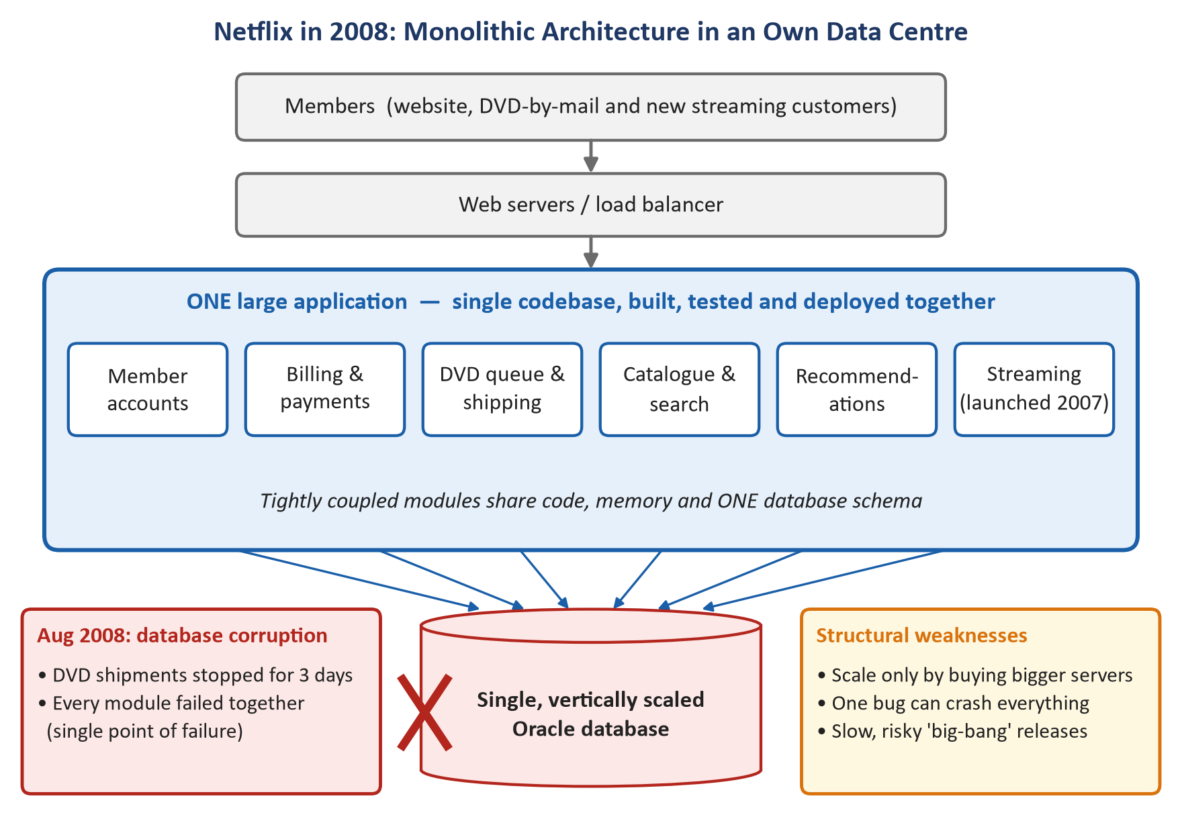
Figure 1.1: Netflix’s 2008 monolithic architecture: every module depended on one vertically scaled database, so one corruption stopped the whole business.

1.3 The DevOps Solution

1.3.1 Re-architecting for the Cloud: Monolith to Microservices
Netflix chose Amazon Web Services (AWS) as its cloud platform but, crucially, did not simply “lift and shift” the monolith onto rented servers. Moving the same fragile design to the cloud would have moved the same problems. Instead Netflix took a cloud-native approach and rebuilt almost all of its technology. Non-customer-facing workloads such as video encoding moved first (2009); customer-facing systems followed from 2010; and the migration was completed in January 2016, when the last data-centre components were shut down. The main design changes were:
- Decomposition into microservices: the monolith was split into hundreds of small, independently deployable services (sign-up, billing, catalogue, search, playback, recommendations, etc.), each owned by one team and each focused on one business capability.
- Database-per-service and distributed data: instead of one Oracle database, data was spread across horizontally scalable NoSQL stores such as Apache Cassandra and the EVCache caching layer, replicated across multiple Availability Zones. There is no longer one database whose corruption can halt the company.
- Stateless services and horizontal scaling: service instances keep no critical local state, so any instance can be killed and replaced, and auto-scaling adds or removes instances in minutes as demand changes.
- Redundancy across zones and regions: services run in several Availability Zones and in an active–active multi-region set-up, so even the loss of an entire AWS region can be handled by moving traffic elsewhere.
- Resilience patterns in code (Netflix OSS): Eureka for service discovery, Zuul as the edge API gateway, Ribbon for client-side load balancing and Hystrix for circuit breakers. With Hystrix, if the personalised-recommendations service fails, the user sees a generic list of popular titles instead of an error page — graceful degradation instead of total failure.
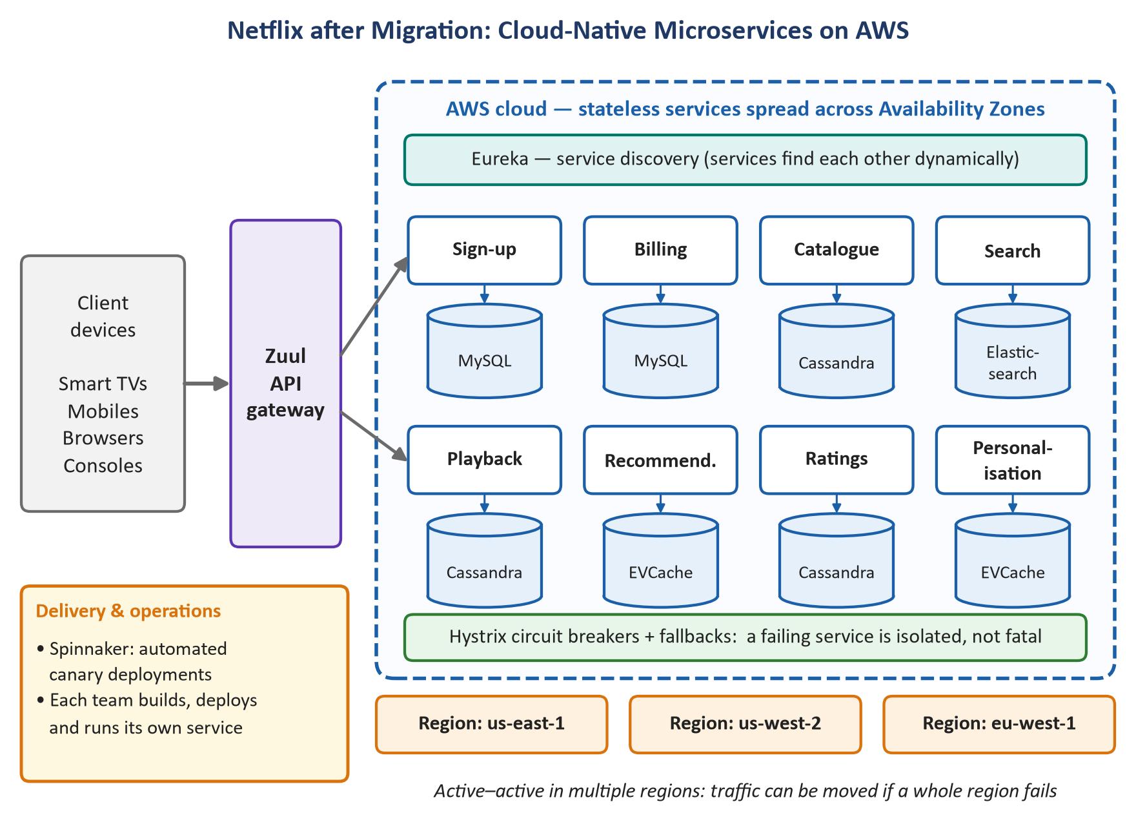
Figure 1.2: Cloud-native microservices on AWS: independent services, separate data stores, circuit breakers and multi-region redundancy.

1.3.2 DevOps Culture and Continuous Delivery
Architecture alone was not enough; Netflix paired it with a strong DevOps culture:
- “Freedom and Responsibility” and “You build it, you run it”: each team owns its service end-to-end — design, coding, testing, deployment and on-call support. There is no separate operations team to “throw code over the wall” to, so developers feel the consequences of their design choices and build for reliability.
- Continuous delivery with Spinnaker: Netflix built (and open-sourced in 2015) Spinnaker, a deployment platform supporting automated pipelines, red/black (blue–green) deployments, automated canary analysis (a new version first receives a small share of traffic and is compared with the old version) and one-click rollback.
- The “paved road”: central platform teams provide well-supported tools and templates so that the safe, resilient way is also the easiest way for product teams.
- Observability and blameless learning: real-time telemetry (e.g., the Atlas monitoring system) and blameless post-incident reviews turn every failure into an improvement.

1.3.3 Pioneering Chaos Engineering
With thousands of cloud instances, failures are not a question of if but when. Netflix’s insight was that the best way to avoid being surprised by failure at 3 a.m. is to cause failure deliberately, during working hours, when engineers are present to observe and fix weaknesses. This became the discipline of Chaos Engineering: running controlled experiments on a production system to build confidence that it can withstand turbulent, real-world conditions.
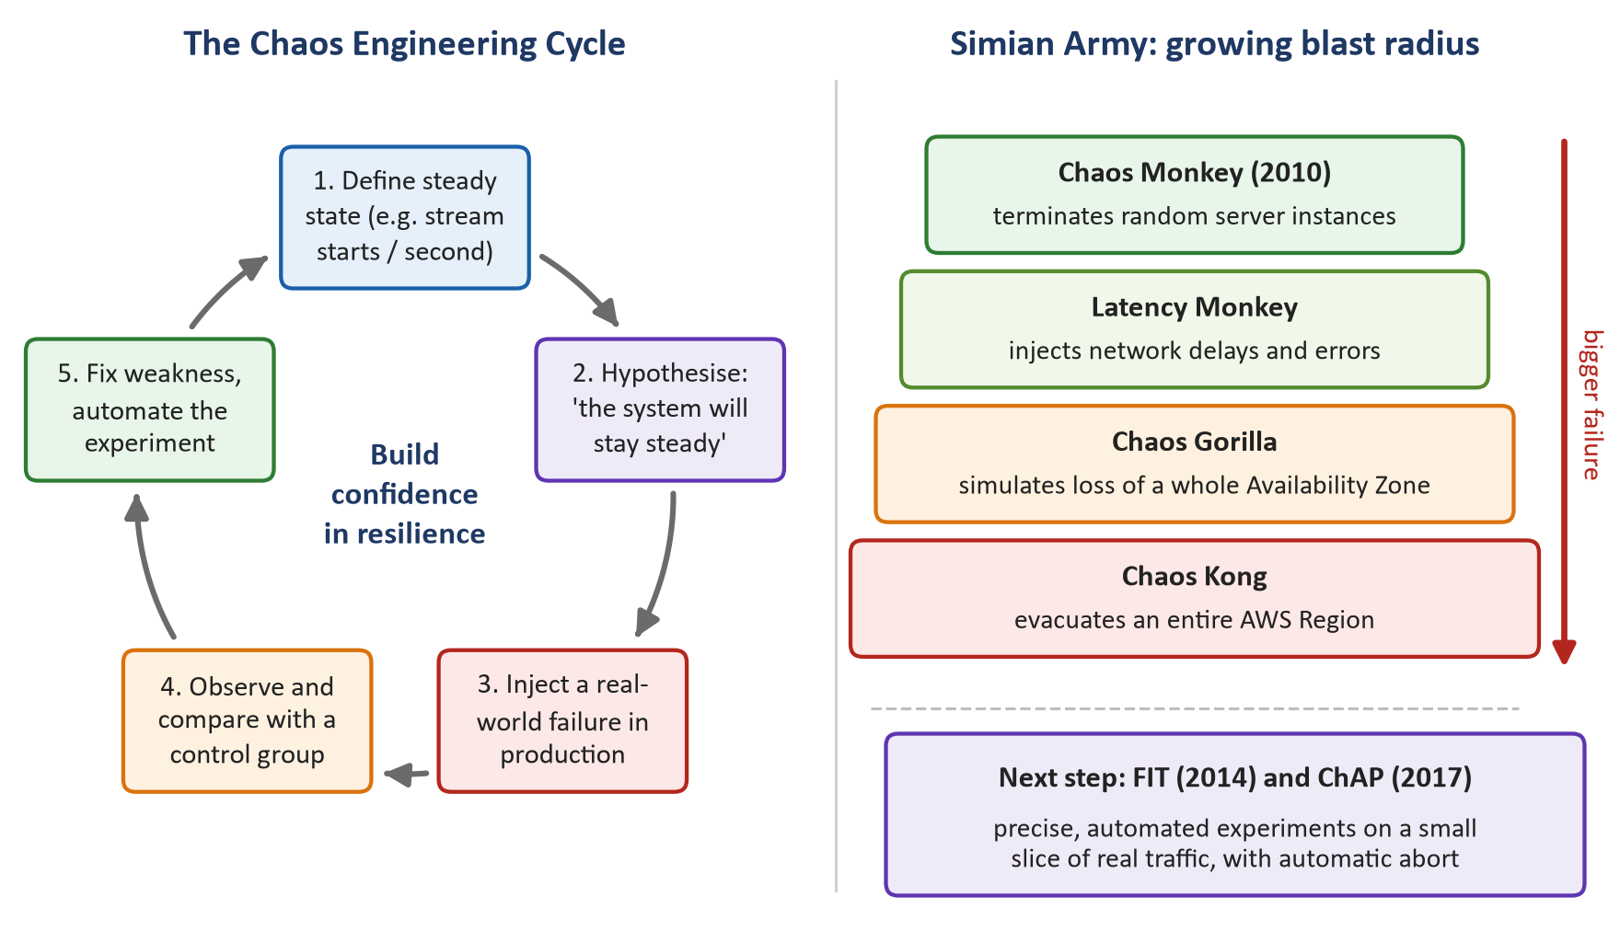
Figure 1.3: The Chaos Engineering experiment cycle (left) and the Simian Army’s progressively larger failure scenarios (right).
- Chaos Monkey (2010): randomly terminates virtual-machine instances in production during business hours. It forced every team to design services that survive the loss of any single server.
- The Simian Army (2011): a family of tools extending the idea — Latency Monkey (injects delays and errors between services), Conformity Monkey and Security Monkey (find instances that break best-practice or security rules), Janitor Monkey (removes unused resources), Chaos Gorilla (simulates the loss of a whole Availability Zone) and Chaos Kong (evacuates an entire AWS region).
- FIT (2014) and ChAP (2017): Failure Injection Testing and the Chaos Automation Platform allow precise experiments on a small slice of real traffic, comparing an experiment group with a control group and automatically aborting if key metrics such as stream starts per second (SPS) deviate.
- Principles of Chaos Engineering: (1) define a measurable steady state; (2) hypothesise that it will continue; (3) introduce real-world events such as server crashes or network latency; (4) run experiments in production; (5) automate them to run continuously; and (6) minimise the blast radius.

1.4 Impact on Resilience and Scalability
Table 1.1: Netflix before and after the DevOps transformation
Dimension | Monolith in own data centre (2008) | Cloud microservices + Chaos Engineering
Failure impact | One database corruption stopped all DVD shipments for 3 days | Failures are isolated to one service; fallbacks keep core streaming working
Scalability | Vertical: buy bigger hardware, months of procurement | Horizontal and elastic: auto-scaling in minutes, global reach
Recovery time | Days (manual database repair) | Minutes; automated failover across zones and regions
Release process | Infrequent, coordinated “big-bang” releases | Each team deploys independently and frequently through automated pipelines
Resilience assurance | Assumed, untested until a real outage | Continuously verified by chaos experiments in production
Culture | Central operations, fear of change | Ownership, “you build it, you run it”, learning from failure

The results of this transformation were significant:
- Scalability: by the time the migration finished in 2016, Netflix had roughly eight times as many members as in 2008, and monthly streaming hours had grown about one-thousand-fold since late 2007 — growth that would have been very hard to support with vertically scaled data-centre hardware.
- Global expansion: in January 2016 Netflix launched in 130 new countries at once, made possible by elastic cloud capacity.
- Availability: Netflix reported steadily rising service availability, approaching its goal of “four nines” (99.99%).
- Surviving real outages: during the major AWS US-East outage of April 2011, Netflix kept streaming while many other AWS-hosted sites went down, which Netflix attributed to its design-for-failure approach. Region-evacuation drills with Chaos Kong also helped Netflix recover quickly from a later AWS regional disruption in 2015.
- Cost efficiency: Netflix noted that its cloud cost per streaming start ended up being a fraction of the data-centre cost.
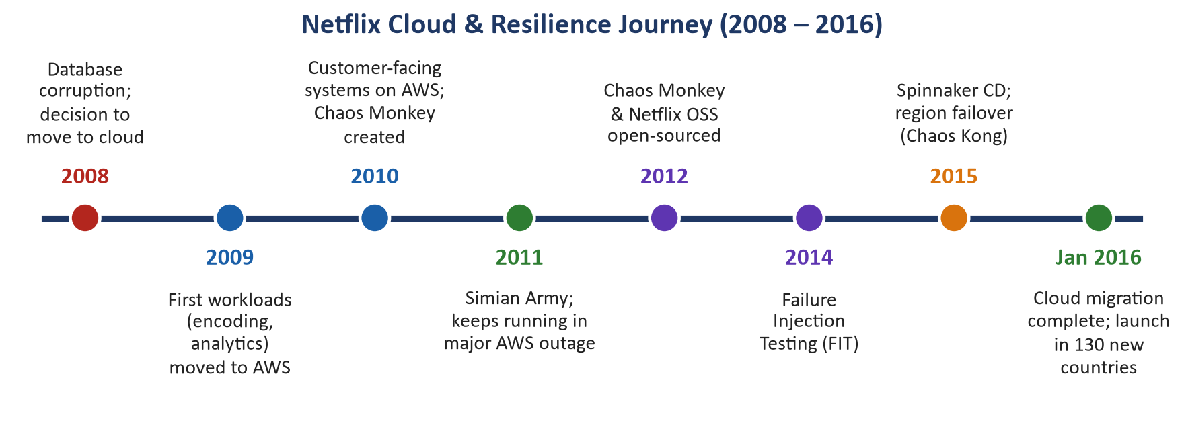
Figure 1.4: Key milestones in Netflix’s cloud migration and resilience journey.

1.5 Critical Analysis
- Microservices add complexity. Network calls can fail or slow down, data becomes eventually consistent, and debugging a request that crosses dozens of services is hard. Netflix had to invest heavily in tooling (service discovery, tracing, monitoring, CI/CD) to manage this.
- Chaos Engineering needs maturity first. Injecting failure is only safe when an organisation already has good monitoring, automated rollback and a blameless culture. Netflix limited risk by running experiments in business hours, on small traffic slices and with automatic abort conditions.
- Context matters. Netflix’s scale justified this investment; smaller organisations may be better served by a well-structured “modular monolith” before adopting full microservices.

Key takeaway
The 2008 outage taught Netflix that resilience cannot be bought as hardware. It must be designed in (microservices, redundancy, circuit breakers), operated by owners (DevOps culture) and continuously proven (Chaos Engineering). Together these turned a three-day outage into a system that expects failure and keeps streaming anyway.

1.6 Conclusion
The 2008 database corruption exposed the core weaknesses of Netflix’s monolith: a single point of failure, tight coupling, vertical scaling limits, slow recovery and slow releases. By adopting DevOps principles — rebuilding as cloud-native microservices on AWS, giving teams end-to-end ownership, automating delivery, and pioneering Chaos Engineering — Netflix replaced fragility with resilience and rigid capacity with elastic, global scalability. Its practices and open-source tools have since become a reference model for the entire industry.

Question 2: Amazon — Two-Pizza Teams, Microservices and a Culture of Continuous Innovation
Question 2 (5 marks)
Challenge: In the early 2000s, Amazon’s rapid growth was hampered by a monolithic architecture that led to frequent outages and slow feature releases, directly impacting customer satisfaction and revenue.
Brainstorm: How did Amazon’s adoption of ‘two-pizza teams’ and a microservices architecture directly address the challenges of their monolithic system, such as frequent outages and slow feature releases? How might this cultural and architectural shift have fostered the ‘culture of continuous innovation’ that allowed them to deploy code, on average, every 11.7 seconds?

2.1 Introduction and Background
By the early 2000s Amazon.com had grown from an online bookstore into a fast-expanding “everything store”. The website ran on a large monolithic application, internally known as “Obidos”, connected to large shared back-end databases. As traffic, product categories and the number of engineers grew rapidly, this architecture became the main obstacle to growth. For an e-commerce company, the impact is immediate: every minute the site is down is lost sales, and every month a feature is delayed is a month competitors can catch up.

2.2 Challenges of the Monolithic System
- Frequent outages and a large blast radius: all features were deployed as a single unit, so one faulty change, memory leak or overloaded component could take down the entire website, not just one feature.
- Shared database bottleneck: many modules read and wrote the same tables. The central database became a performance hotspot and a single point of failure, and changing a table could break code owned by other teams.
- Slow feature releases: every team’s changes had to be merged, built, regression-tested and released together. A small change in one area waited for the next coordinated release, and long build and test cycles slowed everyone down.
- Coordination overhead: teams constantly had to negotiate with each other to change shared code, so more engineers did not mean proportionally more output.
- Inefficient scaling: the whole application had to be scaled together even when only one part (for example, search during the holiday season) needed more capacity.
- Unclear ownership: developers wrote the code but a separate operations group ran it, which slowed feedback and encouraged blame rather than fixes.
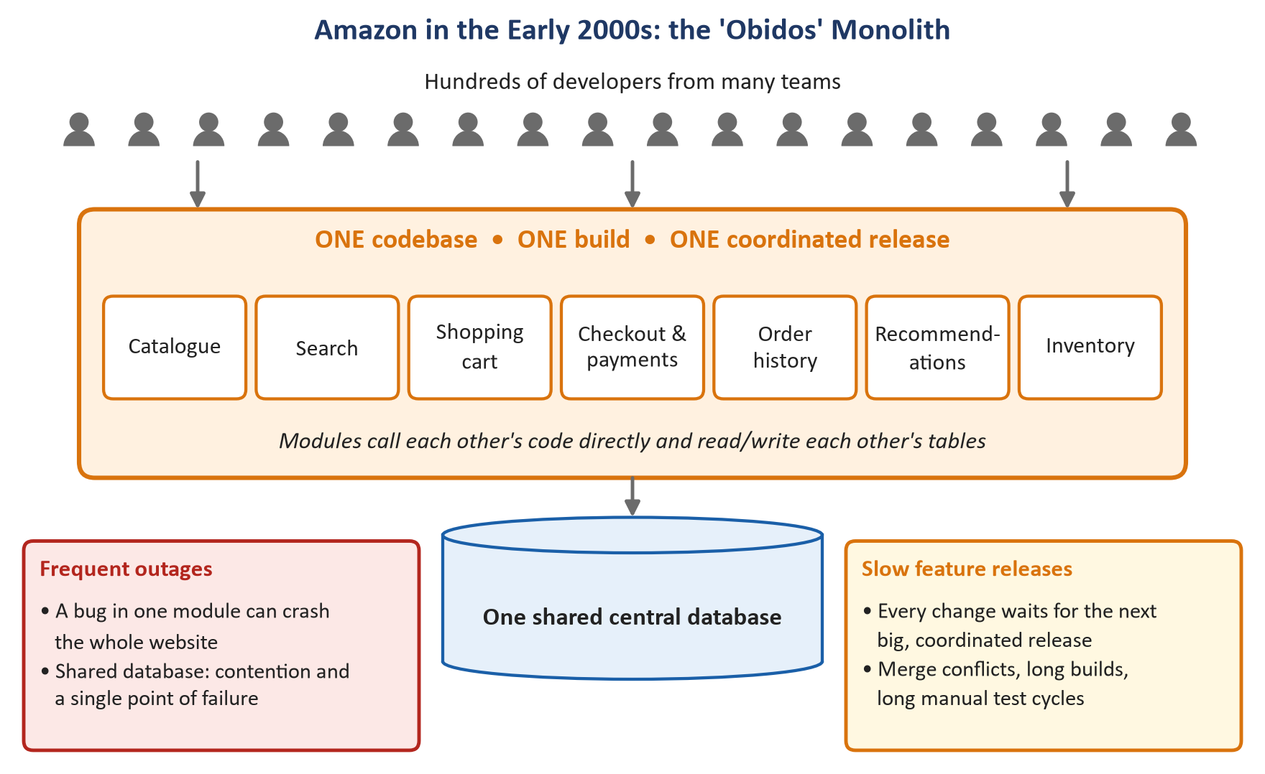
Figure 2.1: Amazon’s early-2000s monolith: one codebase, one build, one release and one shared database for hundreds of developers.
The coordination problem can be explained with simple mathematics. In a group of n people the number of possible communication paths is n(n − 1) / 2, so communication overhead grows much faster than team size:
Table 2.1: Communication paths grow quadratically with team size
Team size (n) | Communication paths n(n−1)/2 | Implication
6 | 15 | Everyone can stay aligned informally
10 | 45 | Upper limit of a “two-pizza team”
50 | 1,225 | Heavy meetings and coordination needed
100 | 4,950 | Coordination dominates; delivery slows sharply

2.3 Amazon’s Solution

2.3.1 Service-Oriented Architecture / Microservices and the “API Mandate”
Around 2002 Jeff Bezos issued a now-famous internal directive (later made public through Steve Yegge’s 2011 memo). In summary, it required that:
- all teams expose their data and functionality only through service interfaces (APIs);
- teams communicate with each other only through these interfaces — no direct reads of another team’s database, no shared memory and no back doors;
- the technology behind a service does not matter, as long as it honours its interface; and
- every interface is designed as if it could be exposed to outside developers.
Over the following years the monolith was gradually broken into hundreds and later thousands of independent services, each owning its own data. Werner Vogels, Amazon’s CTO, explained in 2006 that rendering a single Amazon.com page could involve calls to more than a hundred such services.

2.3.2 Two-Pizza Teams
To match the new architecture, Amazon reorganised its people into two-pizza teams — teams small enough to be fed by two pizzas, typically around 6–10 people. These teams are:
- Autonomous and cross-functional: they include the skills needed to design, build, test, deploy and operate their service without waiting for other departments.
- Single-threaded owners: each team owns one service (or a small set) end-to-end and is measured on clear, customer-focused metrics.
- “You build it, you run it”: in Vogels’ words from 2006, developers are responsible for running their software in production, including being on call. This puts developers in direct contact with operational reality and customers, which improves quality.
- An intentional use of Conway’s Law: Melvin Conway observed in 1968 that system designs mirror the communication structure of the organisation that builds them. By creating small, independent teams, Amazon naturally produced small, independent services (sometimes called the “inverse Conway manoeuvre”).
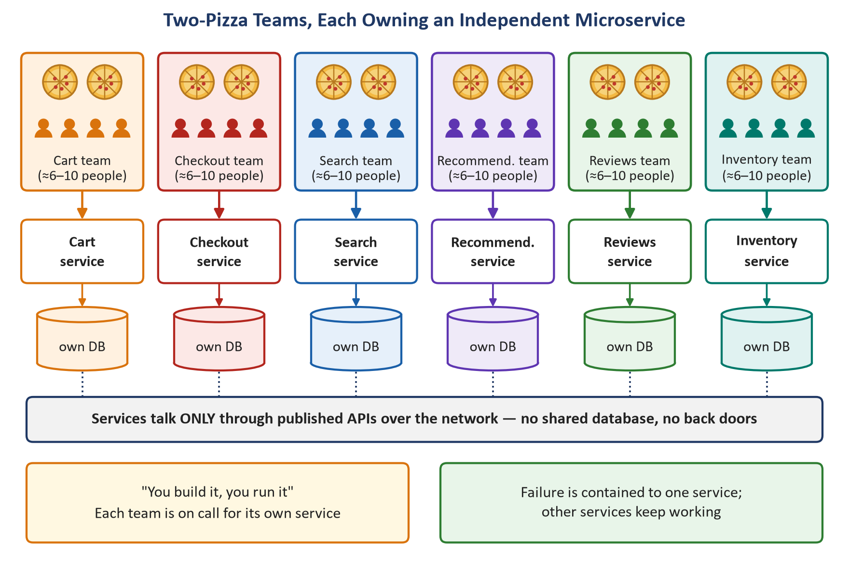
Figure 2.2: Two-pizza teams: each small, autonomous team owns one microservice and its data, and services interact only through APIs.

2.3.3 Automation: Continuous Delivery at Scale
Independent teams can only move fast if releasing software is cheap and safe. Amazon therefore built internal deployment tooling (the “Apollo” deployment system and automated pipelines) so that each service has its own pipeline: code is built and tested automatically, deployed first to a single host (canary), then to one Availability Zone, then region by region, with health metrics monitored at every step and automatic rollback if alarms fire. The internal infrastructure platforms built during this period later became the foundation of Amazon Web Services (AWS), launched publicly in 2006.
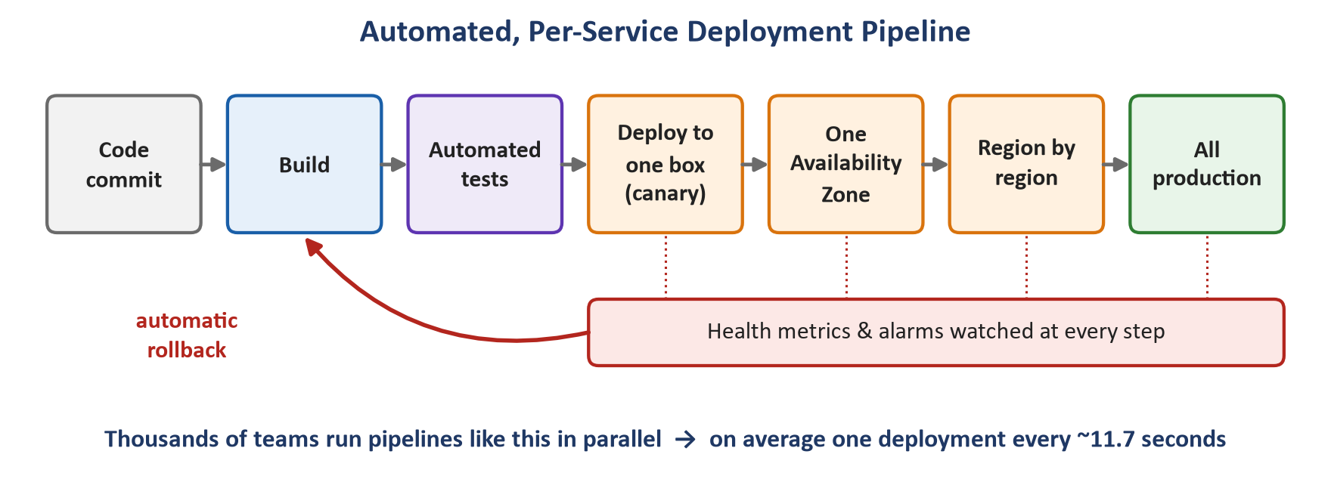
Figure 2.3: A per-service automated deployment pipeline with staged rollout and automatic rollback.

2.4 How the Shift Directly Solved the Monolith’s Problems
Table 2.2: Mapping each monolith challenge to the DevOps response
Monolith challenge | Two-pizza teams + microservices response | Result
Frequent site-wide outages | Each service runs and fails independently; callers degrade gracefully | A fault affects one feature, not the whole website
Shared database bottleneck | Database per service; data accessed only through APIs | No single database is a point of failure for everything
Slow feature releases | Each team deploys its own service whenever it is ready | Lead time drops from weeks or months to hours or minutes
Coordination overhead | Teams interact through stable API contracts, not meetings | Teams change internals freely without negotiating
Inefficient scaling | Each service is scaled independently | Capacity is added only where needed (e.g., peak sales events)
Unclear ownership | “You build it, you run it” with on-call ownership | Faster incident response and higher code quality

2.5 Fostering a Culture of Continuous Innovation (Deploying Every 11.7 Seconds)
At the O’Reilly Velocity conference in 2011, Amazon’s Jon Jenkins reported that on weekdays Amazon was deploying code on average every ~11.7 seconds (often quoted as 11.6 s), with up to about 1,079 deployments in a single hour and deployments reaching around 10,000 hosts at a time. That is roughly 86,400 ÷ 11.7 ≈ 7,400 deployments per day.
This number is not the result of one team working frantically. It is the aggregate of thousands of small, autonomous teams each shipping small changes through automated pipelines whenever they are ready. The cultural and architectural shift fostered continuous innovation in several connected ways:
- Autonomy removes waiting. Teams do not need permission or a shared release date to ship, so ideas reach customers quickly.
- Ownership drives quality. Teams that are on call for their own service have a strong incentive to write reliable, well-tested code and to automate operations.
- Small batches lower risk. Small changes are easy to test, review and roll back. Jenkins also reported large reductions in deployment-caused outages and outage minutes since 2006, with only a tiny fraction of deployments causing an outage. When failure is cheap and reversible, teams are willing to experiment.
- Experimentation becomes routine. Amazon’s A/B-testing platform (Weblab) lets teams test ideas on real customers and let data, not opinions, decide. Bezos has repeatedly argued that Amazon’s success depends on how many experiments it runs.
- Fast “two-way door” decisions. In his 2015 shareholder letter Bezos distinguished irreversible “one-way door” decisions from reversible “two-way door” decisions. With automated rollback, most software changes become two-way doors that small teams can make quickly without escalation.
- Customer obsession and “Working Backwards”. Teams start from a mock press release and FAQ for the customer, keeping innovation focused on real customer value.
- Blameless learning. Amazon’s “Correction of Errors” (COE) process analyses incidents with techniques such as the “5 Whys” and focuses on fixing mechanisms rather than blaming people.
- Reusable platforms. Because every capability is a service with an API, new products can be built by combining existing services — and Amazon’s internal infrastructure itself became AWS, a major new business.
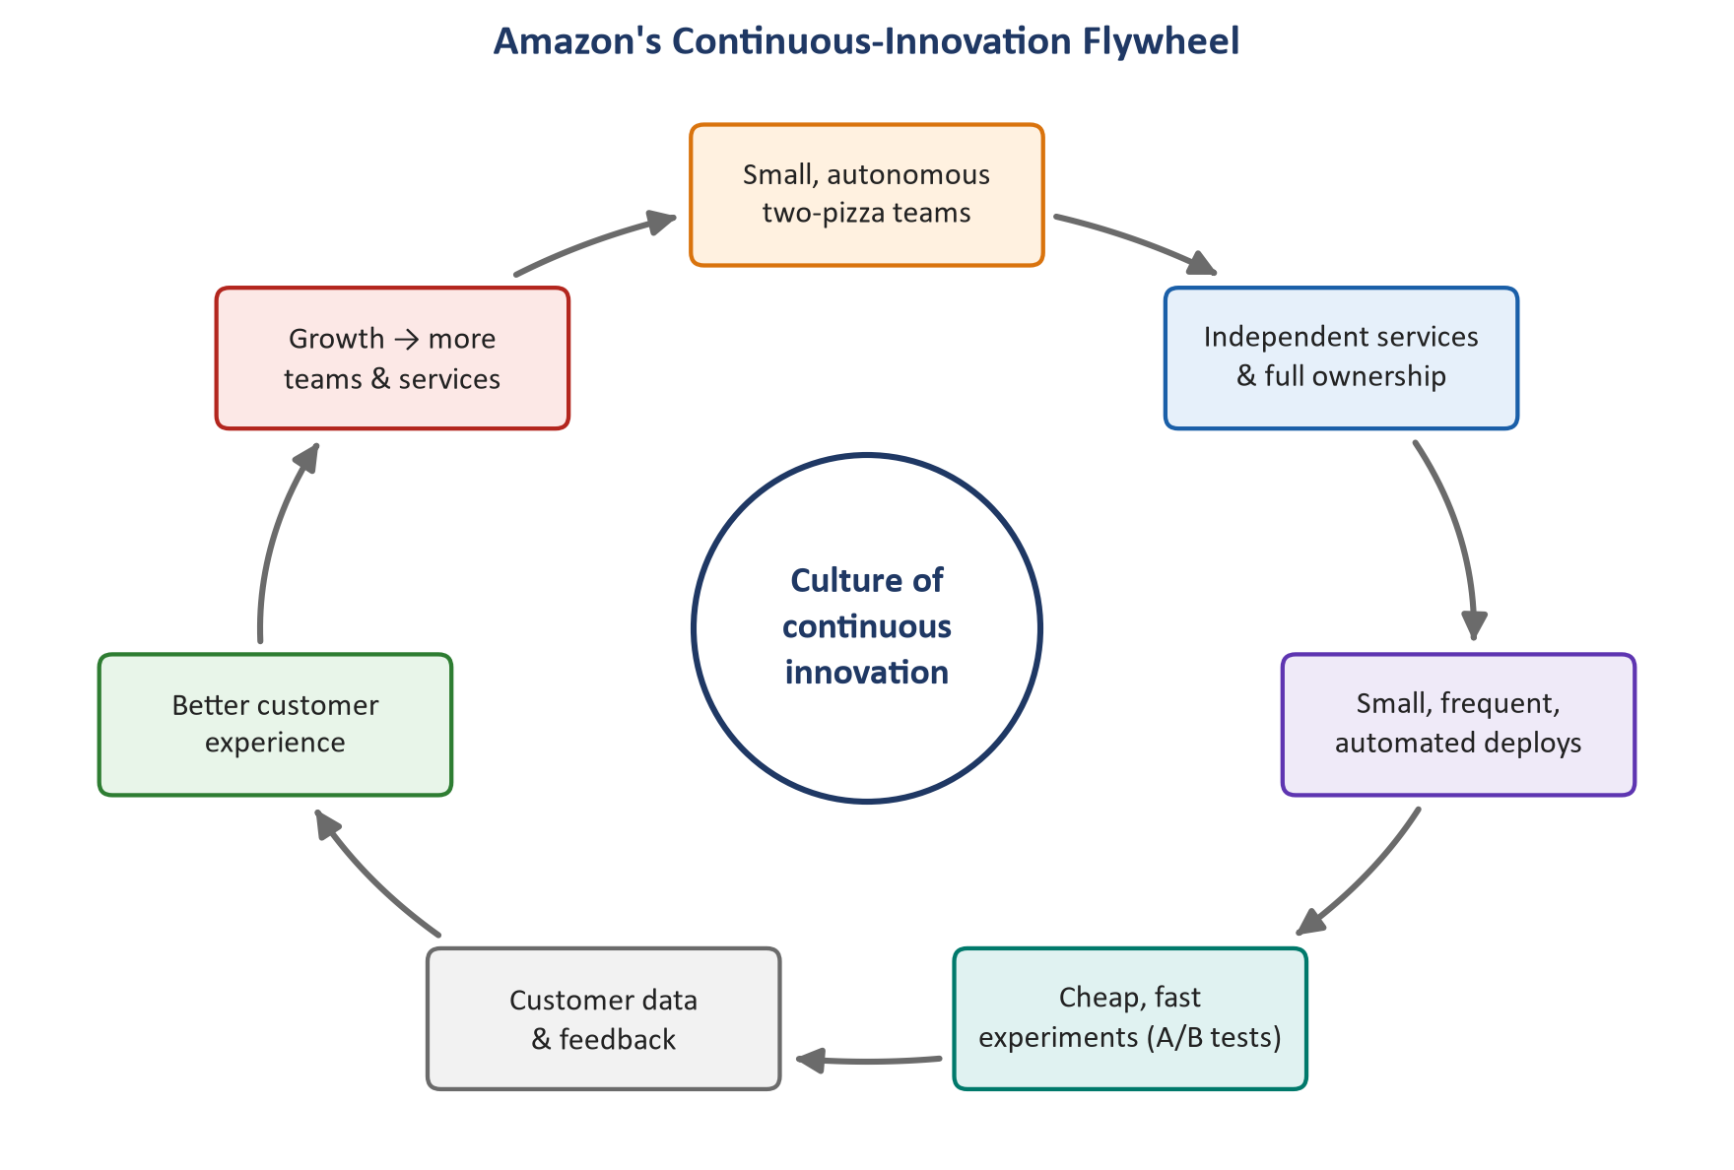
Figure 2.4: The continuous-innovation flywheel created by two-pizza teams and microservices.

Key takeaway
Two-pizza teams and microservices reinforce each other: small teams create small, independent services, and independent services let small teams move without waiting for anyone. Add automated, low-risk deployment and a culture of ownership and experimentation, and “a deployment every 11.7 seconds” becomes the natural outcome rather than a target.

2.6 Critical Analysis
- Operational complexity: thousands of services require strong monitoring, distributed tracing, service discovery and API version management; without this platform investment, microservices can become a “distributed monolith”.
- Duplication and consistency: autonomous teams may duplicate effort or make inconsistent technology choices, and end-to-end testing across services is harder.
- Architecture must fit the problem: in 2023 Amazon’s own Prime Video team moved one audio/video monitoring component from distributed serverless services back into a single process and reported about a 90% infrastructure cost reduction. The lesson is not that microservices are wrong, but that each architectural choice should be driven by context.

2.7 Conclusion
Amazon’s monolith caused frequent outages and slow releases because everything was coupled — code, data, releases and people. By adopting a service-oriented / microservices architecture and reorganising into two-pizza teams that own their services end-to-end, Amazon decoupled all four. Combined with automated deployment pipelines and a culture of ownership, experimentation and blameless learning, this shift created a self-reinforcing flywheel of continuous innovation — the foundation that made deployments every ~11.7 seconds possible and, ultimately, gave birth to AWS.

Comparative Summary
Although Netflix and Amazon faced different problems at different times, their DevOps journeys share a common pattern: a painful limitation of the old monolithic way of working led to changes in architecture, organisation and automation, producing delivery that is both faster and more reliable.
Table 3.1: The two case studies at a glance
 | Netflix | Amazon
Core problem | Fragile monolith with a single-point-of-failure database (2008) | Monolith causing frequent outages and slow releases (early 2000s)
Key architecture change | Cloud-native microservices on AWS, multi-region | Service-oriented architecture / microservices, API mandate
Key organisational change | Freedom & Responsibility; you build it, you run it | Two-pizza teams; single-threaded ownership
Signature practice | Chaos Engineering (Chaos Monkey, Simian Army) | Automated per-service deployment and experimentation
Main outcome | Resilient, globally scalable streaming | Deployments every ~11.7 s; continuous innovation; AWS

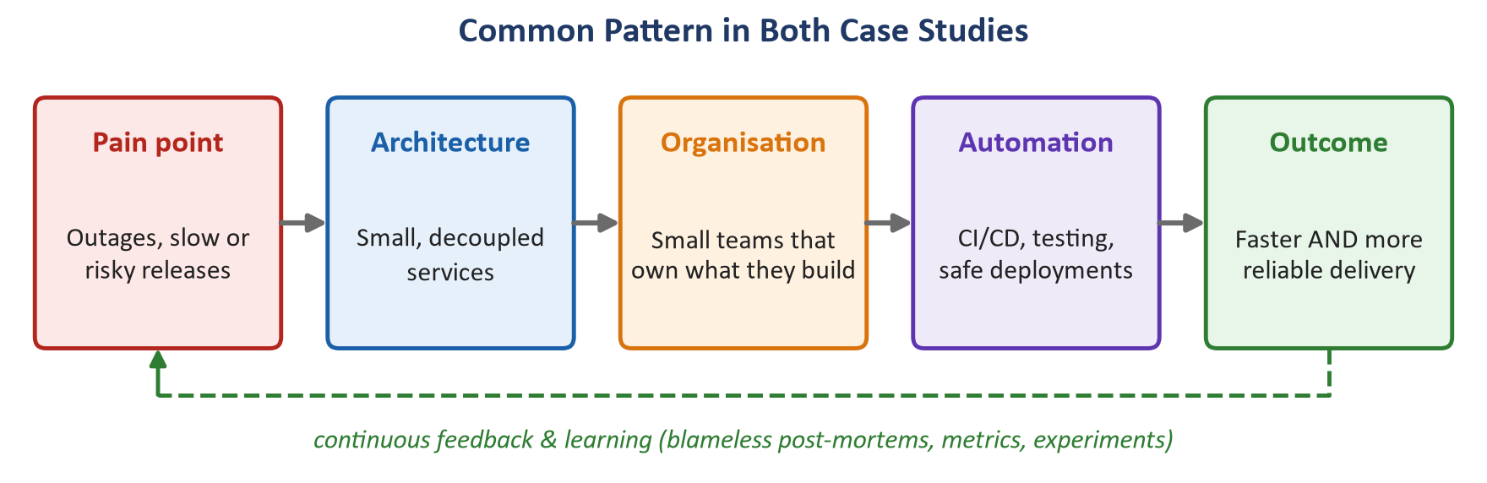
Figure 3.1: The common DevOps pattern in the Netflix and Amazon case studies.

Overall Conclusion
These case studies show that DevOps is not a single tool but a combination of architecture (small, decoupled services), organisation (small teams that own what they build), automation (CI/CD, testing and safe deployment pipelines) and culture (learning from failure, experimentation and shared responsibility). Netflix used it to achieve resilience, and Amazon to achieve speed of innovation. In both cases, the old assumption that speed and stability are opposites turned out to be false: when done well, each reinforces the other.

Practical Implementation (GitHub Repository)
The hands-on part of this evaluation is implemented in a public GitHub repository: https://github.com/AnshulMandekar/AnshulMandekar-devops-case-study-main
The repository applies the DevOps practices discussed in the two case studies to a microservice taken from my B.Tech PBL project, FinVeritas (an explainable financial-analysis system). Its financial-ratio engine is packaged as an independent service and then built, tested, deployed, configured and monitored with a complete DevOps toolchain. The CI/CD pipeline runs automatically on every push to the main branch.
Table 4.1: Practical tasks and where they are implemented in the repository
Task | Implementation in the repository
1 – Deployment strategy | GitHub Actions CI/CD pipeline (.github/workflows/ci-cd.yml): lint and unit tests, security scan, Docker build and push to GitHub Container Registry, then a rolling deployment to Kubernetes with smoke tests
2 – Configuration management | Ansible playbook and inventory (ansible/) that install packages, create users, manage files and run the service with systemd
3 – Containerization & orchestration | Dockerfile and Kubernetes Deployment/Service manifests (k8s/) with rolling-update and rollback commands
4 – Monitoring & logging | Prometheus and Grafana (monitoring/) with a dashboard for uptime, latency and error rate, plus alert rules
5 – Reflection & report | Architecture, pipeline flow, challenges and lessons learned documented in README.md

Link to the case studies: the service is deployed independently through its own pipeline, as in Amazon's microservices and two-pizza-team model (Q2), and it runs as several replicas with health probes, rolling updates and chaos-engineering switches for fault and latency injection, applying Netflix's design-for-failure approach (Q1).

References
- Izrailevskiy, Y. (2016, February 11). Completing the Netflix cloud migration. Netflix Newsroom.
- Netflix Technology Blog. (2011). The Netflix Simian Army. netflixtechblog.com.
- Netflix Technology Blog. (2011). Lessons Netflix learned from the AWS outage. netflixtechblog.com.
- Basiri, A., Behnam, N., de Rooij, R., Hochstein, L., Kosewski, L., Reynolds, J., & Rosenthal, C. (2016). Chaos engineering. IEEE Software, 33(3), 35–41.
- Principles of Chaos Engineering. (n.d.). principlesofchaos.org.
- Rosenthal, C., & Jones, N. (2020). Chaos Engineering: System Resiliency in Practice. O’Reilly Media.
- Gray, J. (2006). A conversation with Werner Vogels. ACM Queue, 4(4).
- Jenkins, J. (2011). Velocity culture (the unmet challenge in Ops). O’Reilly Velocity Conference.
- Yegge, S. (2011). Stevey’s Google platforms rant (describing Amazon’s API mandate).
- Bezos, J. (2016). 2015 Letter to Amazon Shareholders. Amazon.com, Inc.
- Kolny, M. (2023). Scaling up the Prime Video audio/video monitoring service and reducing costs by 90%. Prime Video Tech Blog.
- Conway, M. E. (1968). How do committees invent? Datamation, 14(4), 28–31.
- Kim, G., Humble, J., Debois, P., & Willis, J. (2016). The DevOps Handbook. IT Revolution Press.

