Indian Institute of Information Technology Bhopal



Digital Image Processing
Level 2: Edge Detection

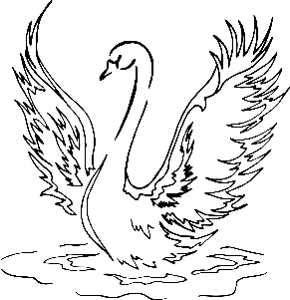
विद्या ददाति विनयं
Submitted by: | Guided by:
Aryan Chouhan and Yuvraj Singh | Dr. Supriya Agrawal
23U03121 and 23U03086 | Prof IIIT Bhopal

L2 Project: Edge Detection using Gradient and Laplacian Algorithm

AIM
To implement and compare edge detection techniques using First Order Gradient (Sobel/Prewitt) and Second Order Laplacian operators. The goal is to detect edges and boundaries of objects in an image based on intensity variations.

THEORY
1. Edge Detection Overview
Edge detection is a fundamental step in image processing used to identify object boundaries. It detects regions in an image where the intensity changes abruptly. Edges are useful for object recognition, image segmentation, and computer vision tasks.
2. Gradient-Based Edge Detection (First Order Derivative)
The gradient measures the rate of change of pixel intensity. The Sobel and Prewitt operators are commonly used gradient-based filters. They approximate the first derivative of the image in both horizontal (Gx) and vertical (Gy) directions.
Mathematically:
Gx = dI/dx, Gy = dI/dy
Gradient Magnitude = sqrt(Gx² + Gy²)
Gradient Direction = arctan(Gy / Gx)
3. Laplacian Edge Detection (Second Order Derivative)
The Laplacian operator detects edges by measuring the second derivative of intensity. It responds to regions of rapid intensity change in all directions and is often applied after Gaussian smoothing to reduce noise.
Mathematically:
∇²I = d²I/dx² + d²I/dy²

CODE
import cv2 as cv
import numpy as np
import matplotlib.pyplot as plt
# --- Read input image ---
img = cv.imread('input.jpg', cv.IMREAD_GRAYSCALE)
# --- Gradient (Sobel) Edge Detection ---
Gx = cv.Sobel(img, cv.CV_64F, 1, 0, ksize=3)
Gy = cv.Sobel(img, cv.CV_64F, 0, 1, ksize=3)
gradient_magnitude = cv.magnitude(Gx, Gy)
gradient_magnitude = np.uint8(np.clip(gradient_magnitude, 0, 255))
# --- Laplacian Edge Detection ---
laplacian = cv.Laplacian(img, cv.CV_64F, ksize=3)
laplacian = np.uint8(np.clip(np.abs(laplacian), 0, 255))
# --- Display Results ---
plt.figure(figsize=(12,5))
plt.subplot(1,3,1); plt.imshow(img, cmap='gray'); plt.title('Original Image'); plt.axis('off')
plt.subplot(1,3,2); plt.imshow(gradient_magnitude, cmap='gray'); plt.title('Gradient (Sobel) Edges'); plt.axis('off')
plt.subplot(1,3,3); plt.imshow(laplacian, cmap='gray'); plt.title('Laplacian Edges'); plt.axis('off')
plt.tight_layout(); plt.show()

Input Image:

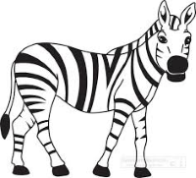

Output Image:

- Gradient Edge Detection(sobel3x3)
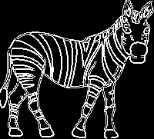
- Laplacian Edge Detection
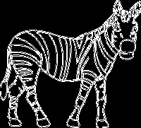

RESULT
1. The Gradient-based method (Sobel) successfully detected strong edges in both horizontal and vertical directions.
2. The Laplacian operator provided edge details in all directions simultaneously.
3. Gradient edges appeared thicker due to directional gradients, while Laplacian produced sharper, finer edge details.
4. Applying Gaussian smoothing before Laplacian filtering can help reduce noise and false edges.

LEARNINGS
• Learned how edge detection works using first and second-order derivatives.
• Understood how Sobel filters compute gradient magnitude and direction.
• Implemented Laplacian filtering to capture second-order edge information.
• Observed the effect of noise and how smoothing impacts edge detection quality.
• Gained hands-on experience with OpenCV and image processing concepts.

