Indian Institute of Information Technology Bhopal



Digital Image Processing
Level 3: Document Scanner

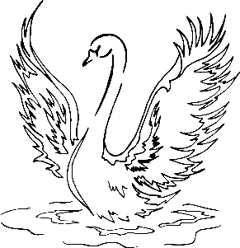
विद्या ददाति विनयं
Submitted by: | Guided by:
Aryan Chouhan and Yuvraj Singh | Dr. Supriya Agrawal
23U03121 and 23U03086 | Prof IIIT Bhopal

L3 Project: Document Scanner using OpenCV

AIM
To design and implement a Document Scanner using Python and OpenCV that automatically detects, crops, and enhances documents from captured or uploaded images, simulating the functionality of mobile scanning apps.

THEORY
1. Overview
Document scanning involves detecting the boundaries of a document within an image, applying perspective transformation, and enhancing the output to achieve a clear, flat, and readable scanned copy. The process uses fundamental computer vision techniques like edge detection, contour approximation, and perspective correction.
2. Steps Involved in Document Scanning
a) **Preprocessing:** Convert the image to grayscale and apply Gaussian blur to remove noise.
b) **Edge Detection:** Use Canny Edge Detection to identify document boundaries.
c) **Contour Detection:** Find the largest contour approximated to four corners representing the document edges.
d) **Perspective Transformation:** Apply a perspective warp to obtain a top-down view of the document.
e) **Contrast Enhancement:** Improve brightness and contrast for better readability.
3. Mathematical Concept: Perspective Transform
Perspective transformation maps the four corner points of a document to a rectangle in a new coordinate system.
If the document corners are A, B, C, D in the input image and A', B', C', D' are in the output image, the transformation matrix 'M' satisfies:
[x', y', 1]^T = M * [x, y, 1]^T
CODE
import cv2 as cv
import numpy as np
def four_corners_document(img: np.ndarray, processing_height_in_px: int = 800):
# Resize image for processing
ratio = img.shape[0] / processing_height_in_px
resized = cv.resize(img, (int(img.shape[1] / ratio), processing_height_in_px))
gray = cv.cvtColor(resized, cv.COLOR_BGR2GRAY)
blurred = cv.GaussianBlur(gray, (5, 5), 0)
edges = cv.Canny(blurred, 75, 200)
# Find contours and get the largest one
contours, _ = cv.findContours(edges.copy(), cv.RETR_LIST, cv.CHAIN_APPROX_SIMPLE)
contours = sorted(contours, key=cv.contourArea, reverse=True)[:5]
for c in contours:
peri = cv.arcLength(c, True)
approx = cv.approxPolyDP(c, 0.02 * peri, True)
if len(approx) == 4:
doc_cnt = approx
break
return doc_cnt.reshape(4, 2) * ratio
def order_points(pts):
rect = np.zeros((4, 2), dtype="float32")
s = pts.sum(axis=1)
rect[0] = pts[np.argmin(s)]
rect[2] = pts[np.argmax(s)]
diff = np.diff(pts, axis=1)
rect[1] = pts[np.argmin(diff)]
rect[3] = pts[np.argmax(diff)]
return rect
def scan_document(image_path):
img = cv.imread(image_path)
pts = four_corners_document(img)
rect = order_points(pts)
(tl, tr, br, bl) = rect
widthA = np.linalg.norm(br - bl)
widthB = np.linalg.norm(tr - tl)
heightA = np.linalg.norm(tr - br)
heightB = np.linalg.norm(tl - bl)
maxWidth = int(max(widthA, widthB))
maxHeight = int(max(heightA, heightB))
dst = np.array([[0, 0], [maxWidth - 1, 0],
[maxWidth - 1, maxHeight - 1], [0, maxHeight - 1]], dtype="float32")
M = cv.getPerspectiveTransform(rect, dst)
warped = cv.warpPerspective(img, M, (maxWidth, maxHeight))
# Convert to grayscale and enhance
gray_warped = cv.cvtColor(warped, cv.COLOR_BGR2GRAY)
scanned = cv.adaptiveThreshold(gray_warped, 255, cv.ADAPTIVE_THRESH_GAUSSIAN_C,
cv.THRESH_BINARY, 11, 2)
return scanned

Input Images:

- Input1
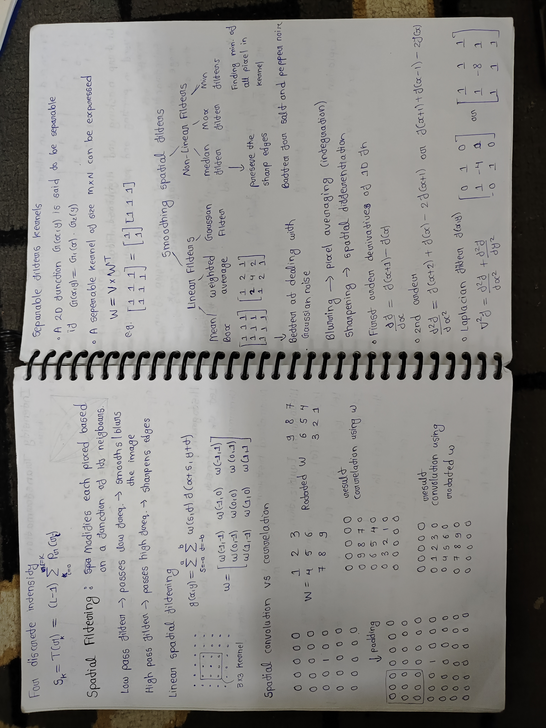

- Input2
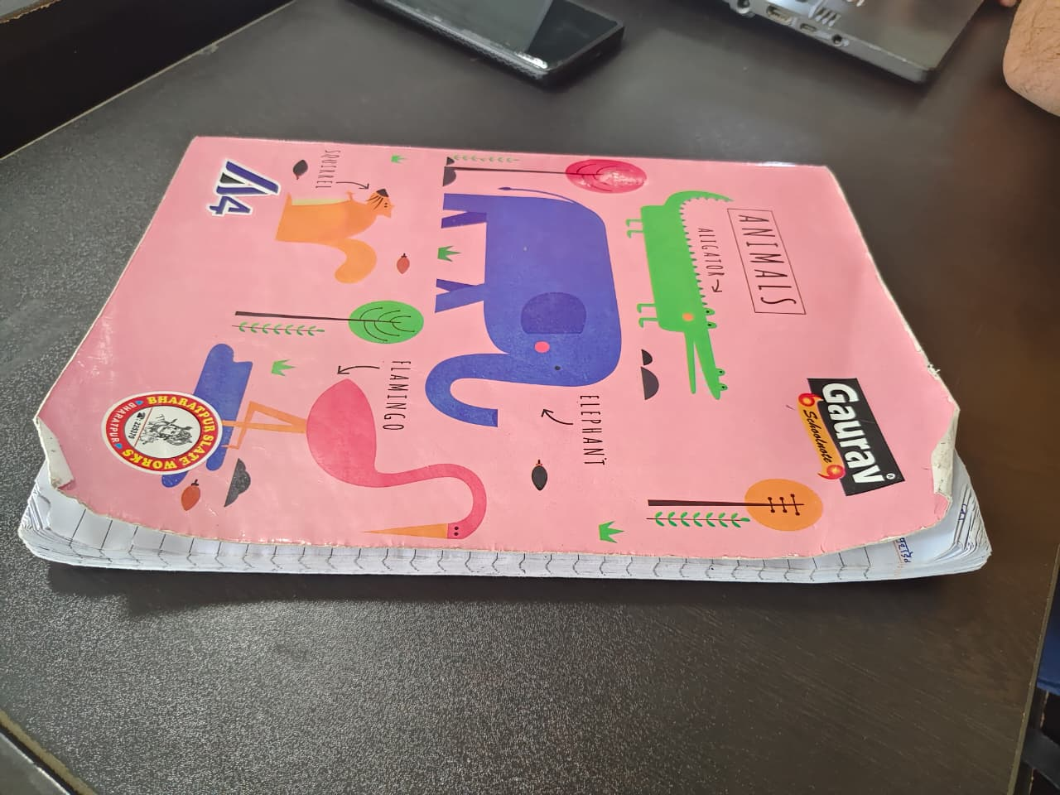

Output Images:

- Output1
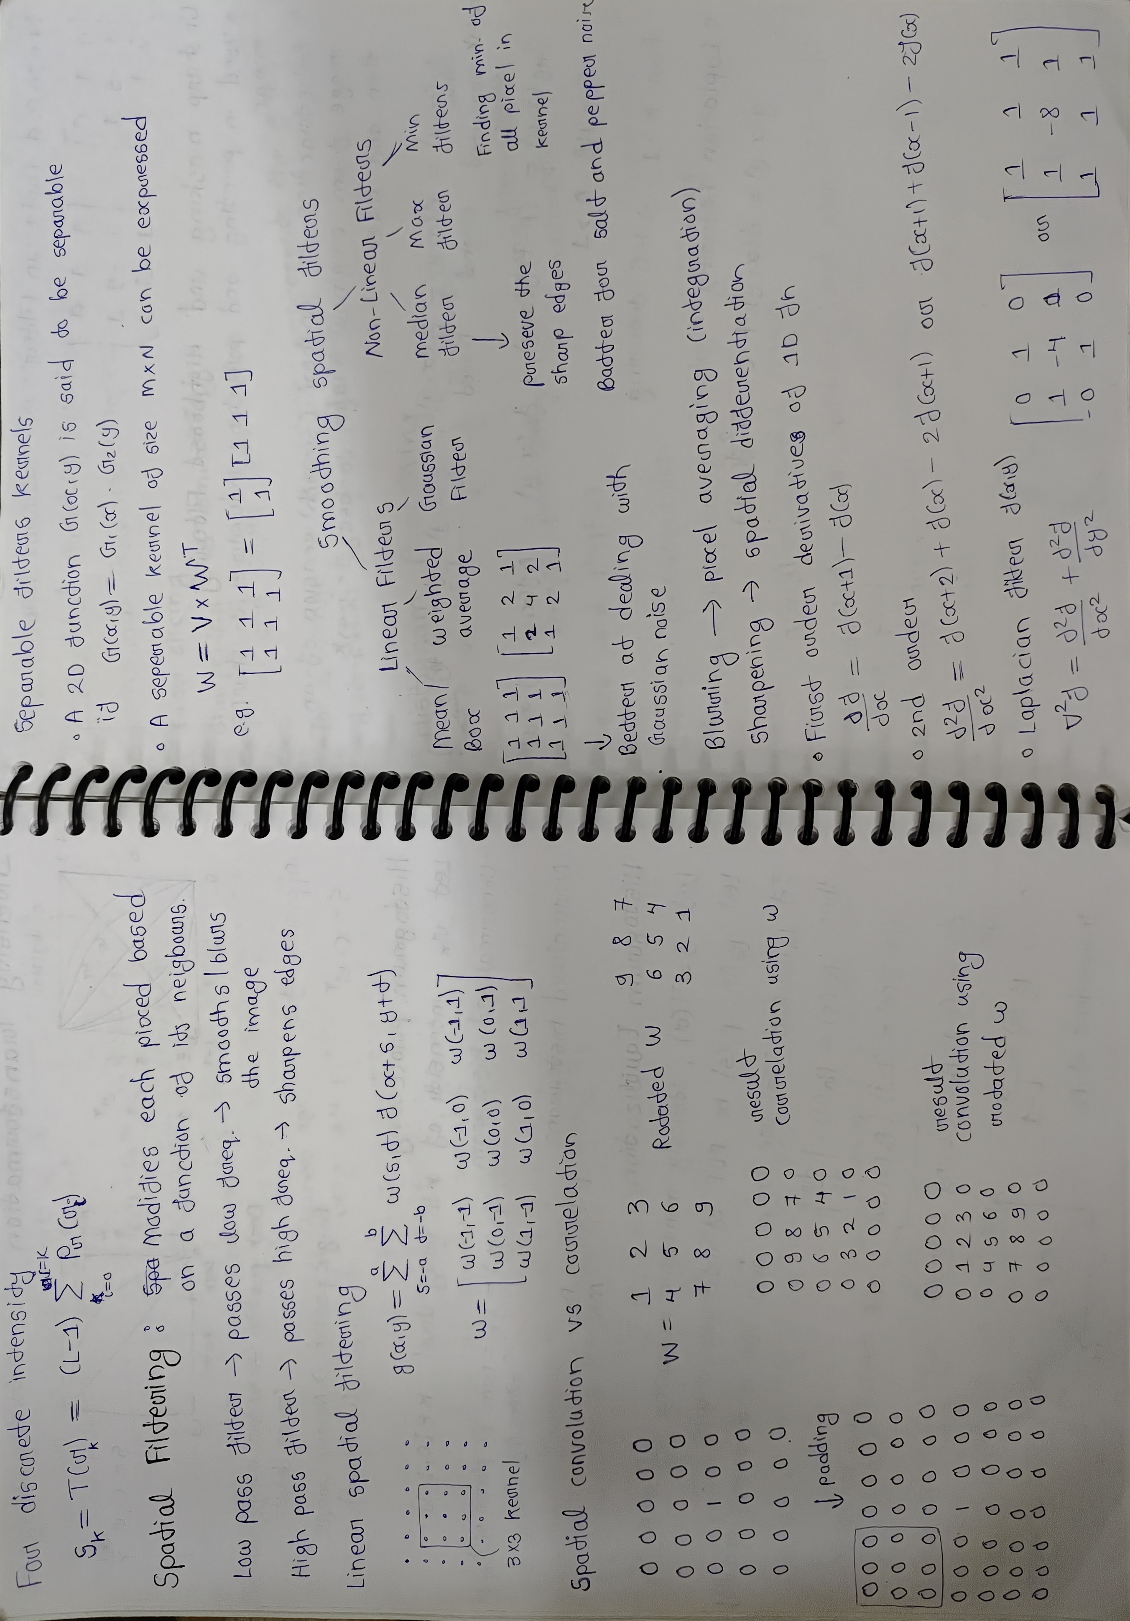

- Output2
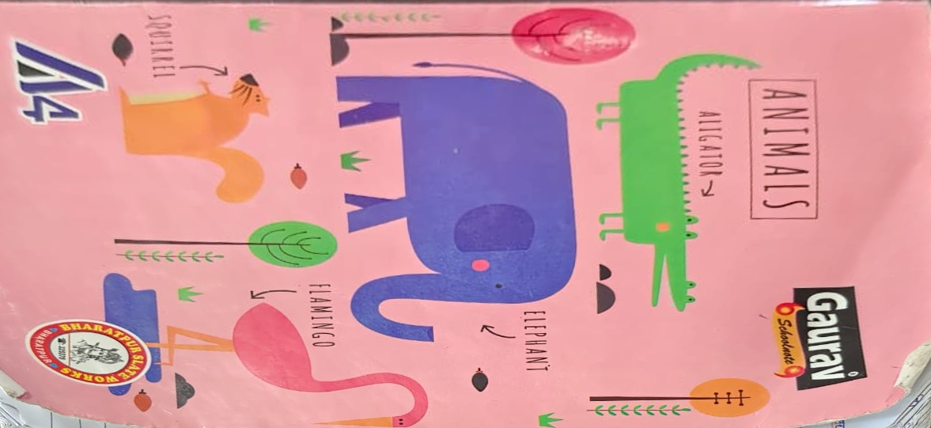

RESULT
1. The algorithm successfully detected the document boundary from the input image.
2. The perspective transformation produced a top-down, properly aligned version of the document.
3. Adaptive thresholding enhanced the clarity and readability, resembling a scanned copy.
4. Output image saved as 'Scanned_Output.jpg'.

LEARNINGS
• Learned how to detect document contours using edge and contour detection.
• Understood the process of applying perspective transformation for top-down view extraction.
• Learned how adaptive thresholding improves contrast and text visibility.
• Gained practical experience in using OpenCV functions like findContours(), getPerspectiveTransform(), and warpPerspective().
• Built a mini document scanning system similar to mobile scanning applications.

